Mid – Term Notes
Week 1 (Chapter 1)

- What is the definition of a market?
  - Defined as all the people or businesses that do buy or could sell a product or service.
- What is a marketing strategy? How many are there?
  - A way to get your product or service in the public eye
  - Product Orientation, Selling Orientation, Marketing Orientation
  - PSM
- What is Product Orientation?
  - Consumer buys the product that they believe is the best, so changes must always be made.
    - Apple iphone for example… although nothing really changes they rerelease and sell more.
- What is selling orientation?
  - The product is fine as-is; it just needs to be exposed.
  - Advertising = Sales
- What is the theorey behind Selling orientation?
  - The more advertising, the more sales.
- What is market orientation?
  - Focusing on consumers to create a market for them.
- What must the people looking into market orientation focus on?
  - Lifestyle
  - Income
  - Needs
  - Wants
  - Demands
- Out of the three, which is necessary?
  - Marketing orientation as people must know whether there is even a market or can be for the product or service they wish to develop and or sell
- What is marketing?
  - Business practice that plans to present an organizations products in a way to develop a relationship with the consumers
- What is known as the marketers responsibility?
  - They must always keep in mind the ethical and moral responsibilities of the product or service they are marketing and how it may affect the society as a whole.
- What is the fundamental role or marketing?
  - To present value to the firm and to the client about a product or service
- What are known as the 6 core aspects of marketing?
  - Satisfying customer needs and wants
  - Entails an exchange
  - Requires product, price, place and promotion decisions
  - Can be performed by individuals and organizations
  - Occurs in many settings
  - Helps create value
- Explain these core aspects individually.
  - Must understand the needs and wants or customers in order to develop products and services to suit them
  - Exchange can happen between any two parties, and not only exchanging for money or such. The seller can exchange products or services for information or convenience
  - 4 P’s
    - Products
      - Goods
      - Services
      - Ideas
    - Price – Everything the buyer gives up in exchange for the product
      - Time
      - Energy
      - Money
    - Place – All activities related to getting the product to the right customer when that customer wants it.
    - Promotion – Communication activities of marketing, used to inform, persuade and influence potential buyers.
  - B2B = Wholesaling, business to business
B2C = All Retailing, Business to Consumer
C2C = Swap meets, consumer to consumer
  - Profit and non-profit as well as in all industries, and countries, most notably developing ones.
  - Must offer something extra that other firms are not offering in order to obtain business. Must find best balance between providing best benefit for consumer all by minimizing cost
- Describe the change in marketing eras
  - 1900-1920 = Production-oriented era
  - 1920-1950 = Sales-oriented era
  - 1950-1990 = Marketing-oriented era
  - 1990-present = Value-based marketing era
- How do firms compete on the basis of value?
  - Must constantly monitor the marketplace in order to create value.
  - They must Follow three steps
    - Sharing information = let everyone know how their roles help the company
    - Value-driven. Benefits vs costs = Evaluate key benefits, focus on them and eliminate costs of less beneficial strategies.
    - Become value driven, establishing relationship = make relationship and use data analytics to help create long lasting and successful relationships
- Why is marketing important?
  - Expands global presence
  - Pervasive across organizations
  - Pervasive across supply chain
  - Makes life easier
  - Enriches society
  - Can be entrepreneurial

Week 2 (Chapter 2)

- What is known as the strategic marketing planning process?
  - Helps identify the purpose of the businesses marketing and sets goals as to what it should achieve and expect.
- List the steps.
  - Step 1 = Business mission and objectives
  - Step 2 = Situation and SWOT analysis
  - Step 3 = Identify opportunities
  - Step 4 = implement marketing mix
  - Step 5 = evaluate performance using marketing metrics
- Describe which phase each belongs to.
  - Step 1 and 2 belong to the planning phase. Step 3 and 4 belong to the implementation phase and they consist of the marketing strategies. Finally, step 5 is the control phase
- Run through the business and mission objectives.
  - A broad description of the firm’s objectives and the scope it tends to take on how to achieve them. Sometimes a slogan like Starbucks = to inspire and nurture the human spirit – one cup, one person and one neighbourhood at a time.
  - Relate the company to the customer
- When are marketing plans normally released?
  - Beginning of a fiscal year, normally in September
- Explain Step 2
  - 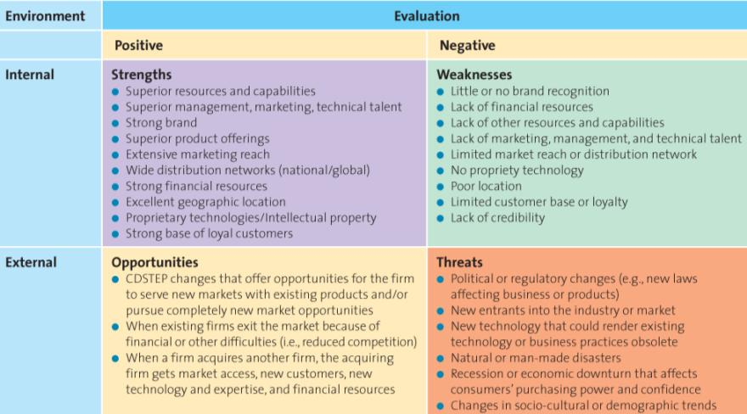
- Explain what you must do in Step 3.
  - Segmentation
    - Dividing the market into distinct group of customers, each group sharing similar wants and needs so that you can make your products specially geared for them
    - Age, gender, religion, location
  - Targeting
    - Evaluating the attractiveness of each segmentation and deciding which group to pursue
  - Positioning
    - Where the firm wants to be within this segment, involves evaluation of the 4 P’s
- Explain Step 4.
  - Allocating resources and evaluating 4 P’s
      - Price should be relatable to the value perceived by the customer
      - Must be available, quickly? Modestly? Rolex vs Kellogg’s watch
      - Promotion = high end GQ magazine for Rolex
- Define Step 5.
  - Evaluate performance and make adjustments.
    - BCG Matric
      - HH
      - HL
      - LH
      - LL
- By using the BCG Matrix, explain which best fits for a company wanting diversification and potential market development?
  - 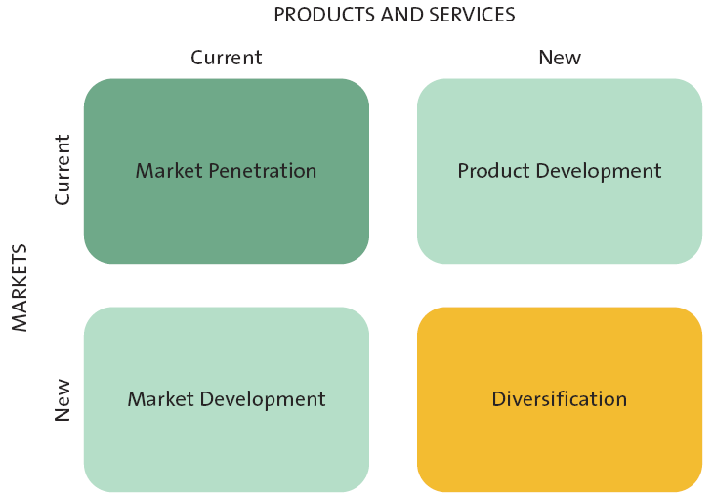
- Explain these growth strategies in the answer above?
  - Market Penetration
    - Use of the existing marketing mix to encourage current customers to become more frequent or attract new customers within target market
  - Market development strategy
    - Employs existing marketing offering to reach new segments
  - Product development
    - Offers a new product or service to the current target market
  - Diversification
    - Introduces a new product or service to a new market segment
- What is a sustainable competitive advantage?
  - An advantage that allows a business to be more successful than another over a long period of time that is very hard to surpass. This is what distinguishes you from the competition and in the minds of your loyal customers.
- List the Attributes to a sustainable competitive advantage.
  - Pedigree
  - Exclusivity
  - Loyalty
  - Recognition
  - Excellence in location and position
- What are the 4 “excellence” require for sustainable competitive advantages?
  - Customer excellence
    - Retaining loyalty, customer service
  - Operational Excellence
    - Efficient operations, excellent supply chain advantages
  - Product excellence
    - Strong band, high perceived value
  - Location Excellence
    - Where is being seen

Week 3 (Ch. 3 and 16 not covered on exam)

- Who is at the heart of the marketing environment? And how are they effected?
  - The consumers
  - By 3 kinds of actions
- Explain how these actions influence the consumers
  - Actions of the company
    - Pricing
    - Advertising
    - Ethics
    - Reputation
    - Social responsibility
  - Actions by competition
    - Same as above
  - Actions by partners in the supply chain
    - Quality
    - Reliability
    - Timelines
    - Social responsibility
- Draw and label the marketing environment analysis and framework
  - 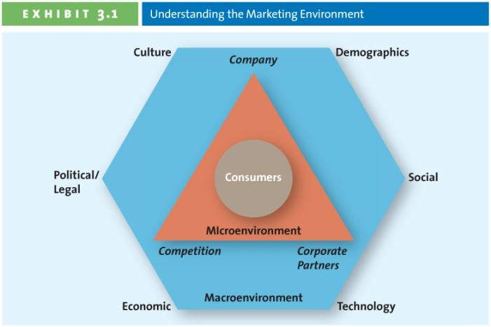
- Which parts make up the microenvironment? Explain them.
  - Competitors
    - Identify and analyze direct and indirect ones
    - Know SWOT
    - CI (competitive intelligence)– get employees to go and check competitor pricing and layout is most basic form
  - Corporate Partners
    - Alliance with competitors, suppliers,
    - JIT systems
  - Company
    - Core competency
    - Existing knowledge, patents and equipment applied to new markets and new products
- List and describe the macro-environmental factors.
Acronym = CDSTEP
  - Culture
    - Hofestede
      - Power Distance
      - Uncertainty Avoidance
      - Individualism – collectivism
      - Masculinity – femininity
      - Long-term vs Short-term
  - Demographics
    - Tweens
    - Gen Y
    - Gen X
    - Baby Boomers
    - Seniors
  - Social Trends
    - Green Consumers
      - Customer who appreciate being provided with environmentally friendly products/services
    - Privacy Concerns
      - Loss of privacy
      - Identity theft
    - Time-poor society
      - Most parents work
      - Many choices about their leisure
      - Much multi-tasking
  - Technological Advances
    - Each allow advance enables us. New ways to communicate, do or think.
  - Economic Situation
    - Foreign exchange currency
    - Inflation
    - Interest rates
  - Political/Regulatory Environment
    - Competition Act
    - Labeling Act
    - Patents

Week 4 (Ch. 4 and 5)

- What is the Consumer Decision Process?
  - Need Recognition
  - Information Search
  - Alternative Search
  - Purchase
  - Post-Purchase Evaluation
- Describe the Need Recognition.
  - Functional need = product that does the job and that is moderately priced/non-specialty
  - Psychological = product that is over the top
  - Citizen watch vs. Rolex watch
- Describe Information Search.
  - Internal search for information = make the decision yourself by researching the product or service and education yourself
  - External search for information = allowing experts or store clerks to sell you the product through bias sales pitches, social media,
- What factors affect the consumer search process?
  - Perceived benefit
  - Perceived cost
    - What must I give up
  - Locus of control
    - Internal
      - I control things
    - External
      - I can’t control anything
  - Perceived risk
    - Actual/perceived
      - Performance
      - Financial
      - Social
      - Physiological
      - Psychological
  - Type of product
    - Specialty good
    - Shopping
    - Convenience goods
- Explain the theory of product dependence
  - One is worth more time then others. For example, university education vs. toothpaste.
- Describe the alternative education step of the consumer decision-making process.
  - Product Presentation
  - Price
  - Brand
- Describe the Post-Purchase Evaluation step.
  - Post-purchase dissonance
    - Reduced by stores thank-you letters and congratulations in order to reinforce your decision
- What factors influence the consumer decision process?
  - Psychological
    - Behavioural
      - The actions we take with regard to the issue at hand
    - Attitude
    - Cognitive
      - What we believe to be true
    - Affective
      - What we feel about the issue at hand
***Learning affects your perceptions and aptitudes, and is affected by social experience***
*** Biggest factor is perception***
  - Social Factors
    - Decision Makers vs Influencers
      - Groups = family + Friends went to the school so you chose you go to it too
      - Provide = information, rewards, self-image = going because you want to be a gee-gee
    - Culture
  - Situational Factors
    - Purchase Situation = buying something because of psychological traitor social factor
    - Shopping = store atmosphere, salesperson,
    - Temporal = our state or mind alters notions of what we are going too purchase
- How does ones involvement with the product affect their decision-making?
  - High involvement with the product causes one to devote more attention, process deeper and develop strong attitude and purchase intentions.
  - Low involvement with the product causes one to listen in their peripherals, and generate weak attitude paying attention to little cues.
- What is known as B2B Marketing?
  - The business of buying or selling goods to be used in the production of other goods and services, for the consumption of the buying organization or the resale by wholesalers to retailers.
- Who is involved in the B2B Marketing?
  - Manufacturers Wholesalers Retailers Customers.
  - Manufacturers do not meet with customers at all
- What makes up B2B Markets?
  - Manufacturers
  - Resellers
  - Institutions
  - Governments
- Depict each sections role in the B2B Market.
  - Manufacturers
    - Buy raw materials and manufacture their own goods to sell to resellers
  - Resellers
    - Sell manufactured goods to the retailers
  - Institutions such as schools, religious groups and museums may receive goods straight from the manufacturer.
  - Government buys goods and services through specialized sellers whom sole job is to sell to the government
- What is the difference between business and consumer markets?
  - Business markets consist or buying and selling among organizations where as consumer markets is to a select person of whom they have the final say on how the product is used.
- What are the market characteristics of the business market?
  - Demand fluctuates, not elastic
  - Larger orders but fewer targets
  - Geographically concentrated
- What are the product characteristics of the business market?
  - Mainly raw and unfinished goods
  - Heavy emphasis on delivery times, financing, after sale services
  - Purchases are based on specifications of the product
- What are the buying process characteristics in the B2B market?
  - Complex
  - Competitive bidding, contracts
  - Qualified, professional buyers
  - Many people part of the decision making process
  - Long term
- What are the marketing mix characteristics within this market?
  - Inelastic price, negotiable
  - Physical distribution and direct selling
  - Technical advertising
- Explain the B2B buying process
  - Need recognition Product Specification Request For Proposal Process Proposal Analysis and supplier selection Order Specification Vendor/Performance Assessment
- Describe each of the 6 stages
  - Need recognition
    - Internally or externally
    - Realized through competition, suppliers or salespeople
  - Product Specification
    - After realizing they have a need for something, the firm looks into alternative solutions and specification they may need to be met.
      - This can be done with one or several suppliers
  - RFP
    - Buying organizations invite suppliers to bid on supplying the required materials/products
  - Proposal Analysis
    - Look at all offers and bids, not only money matters in this situation. Quality, reputation and future considerations also matter
  - Order Specifications
    - Payment occurs as all specifications are given to the chosen supplier with great detail
  - Vendor Analysis
    - Analyze, out of 1, specific “key issues” of the company such as product quality and timing of the production
- What factors may affect the buying process for B2B markets? Describe them.
  - Buying center
    - Decider
    - Initiator
    - Buyer
    - User
  - Organizational Culture
    - System of shared meaning throughout the organization that distinguishes the organization from others.
  - Buying Situations
    - Straight Rebuy
    - Modified Rebuy
    - New buy
- What are some common features within organizational culture?
  - Distinction
  - Identity
  - Commitment
  - Standards
  - Driving force
- What allows for a strong organizational culture?
  - Shared beliefs and values
  - Trust
  - Sense of accomplishment and belonging
  - Satisfaction through several things such as rewards

Week 5 (Chapter 6 – 7)

- Describe the segmentation targeting positioning process and the categories they are split into.
  - Split into three categories as goes
    - Segmentation
      - Strategy/objectives
      - Segmentation Bases
    - Targeting
      - Evaluate segment attractiveness
    - Positioning
      - Select Target Market
      - Identify and develop Positioning strategy
- Describe each part of the segmentation targeting positioning process
  - Strategy/objectives
    - Consistent with company mission and values
    - Derived from mission statement
  - Segmentation Bases
    - Geographic
      - Divide market into separate geographic groups and develop specific marketing plans for each
    - Demographic
      - Divide into groups based on age, gender, etc..
    - Psychographic
      - Divided by human behaviour, values, lifestyles…
      - VALS Framework, RR VS MINI VAN
    - Behavioural
      - Usage rate
      - Loyalty
      - Sought after benefits
  - Evaluate Segment attractiveness (4 steps)
    - Identifiable
      - Who is the market?
      - Are the segments unique?
    - Reachable
      - Know the product exists understand what it can do recognize how they can buy it
    - Responsive
      - React positively to what the firm is offering, allowing them to get closer to the product and push the t o accept the values that the firm is projecting
    - Substantial/profitable
      - Size matter
        - Too small isn’t profitable but also want something that can experience growth
    - Segmentation Strategy
      - 4 ways
        - Mass = everyone is a potential client
        - Differentiated = several segments with different offerings
        - Concentrated = single segment
        - Micro-marketing = tailoring product to meet individuals needs
    - Identify/develop position strategy
      - 5 methods
        - Value
          - Pay more for quality
        - Product attributes
          - Close to home
          - Good reputation
        - Benefits & symbolism
        - Competition
        - Market leadership
- What is the marketing research process?
  - Define research problem Design research project Collect Data Analyze Data Present Action Plan
- Explain each step
  - Define research problem
    - What information is needed to answer the questions
  - Designing project
    - Type of data and type of research
      - Primary/secondary
  - Collect Data
    - Exploratory
      - Observation
      - Focus groups
    - Conclusive
      - Survey
      - Panel
  - Analyzing data
    - Converting data to useful information
  - Presenting results
    - Executive results
    - Body
    - Conclusions
    - Limitations
    - Supplements
      - Visual aids
- What are some advantages and disadvantages of both techniques of data collection?
  - Secondary
    - Pros
      - Timely
      - Inexpensive
    - Cons
      - Not necessarily relevant
      - Bias
  - Primary
    - Pros
      - Specific and relevant to the topic at hand
      - Offers behavioural insights
    - Cons
      - More costly
      - Untimely
      - Sophisticated process and training

Dasani Video
- 5 weeks into launch of water, Dasani found to be contaminated by carcinogenic matter
- Dasani withdrawal, 10m+ pounds, but that’s nothing compared to the toll the reputation took. It was known as the most disastrous marketing failure ever
- Worst PR disaster of all time
- 70’s/80’s trends changed to fitness so coke and Pepsi saw a decrease
- Late 1990’s Aquafina was release by Pepsi, quickly becoming top selling bottled water in the USA
- Water raised in sales, coke slowed down
- Launched Dasani in 1999, by 2001 it was 2nd biggest brand
- Not using mineral water, they used tap water and “add minerals later” making it purified water
- That doesn’t bother the Americans at all, actually it continued its growth
- Europe on the other hand, was not in the same boat. 99% of their drinking water is mineral or spring fed water
- Pepsi couldn’t launch water in Britain due to a clause in their distribution of their cola
- UK had undeveloped water market
- Coke revealed in 2003 they were going to sell “the purest water you can buy” in the UK
- Used NASA designed filtration systems yet they were filtering tap water
- Treated tap water
- All waters before coke in the UK pride themselves on being pure and natural, yet coke pushed on with their tap water = Very High Risk
- You cannot apply rules of soft drinks to water, it should not be made in a factory by man, but rather by natural, made by god
- Coke came in a many small or medium sized companies lost shelf space to the invading company
- Started stepping on the toes of natural mineral water Buxton, by giving free fridges to stores across the UK given they only stock Coke products
- They were restricting local brands because they wanted to sell Dasani
  - Using bully tactics
- Show down in Buxton starting bringing people against Dasani
- Was misleading by using Pure, still water as the slogan seeing how there were mineral salts added to the water which violated the Food Standards Agency Guidelines
- Made people believe it is not manufactured and processed yet that’s what Dasani is
- Before they could look into the claims, a storm blew up around Dasani
- Magazine released feature of Dasani as being a mineral enhanced treated tap water
- Source was tap water from factory in SIDCUP
- Next day, it was all over every paper
- Accused of trying to rip customers off by selling tap water as mineral water
- Made consumers feel cheated
- Coke didn’t back down “Dasani isn’t tap water, it goes through so much filtration it is the purest”
- Mounted PR offensive, but people didn’t listen, negative publicity put the future in question
- Some places threatened to withdrawal if the water didn’t do well after 2 weeks.
- Agencies started launching investigations into the label and the use of pure
- It ranked worst out of 13 in taste according to famous foodie
- “ a comedy of errors”
- Weeks later, through the process of adding minerals, an impure batch of calcium chloride reacted badly causing the water to be contaminated and made Dasani shut down, and put it out of its misery
- Headlines, they were about Dasani being potential cancer causing tap water and that they were failing and pulling the plug
  - 500000 bottles pulled
- Coca cola had a quality problem and must blame it on themselves
- Do not regret the decision to launch the water
- Failure cast a dark shadow over entire Dasani and coke brand
- Coke needs UK to be the #1 drink producer in the world
- But they want nothing to do with it, as they don’t trust Dasani at all
- Might be forced to try again though, to stay alive
- They consider its return as a definite maybe
- Innovation may be necessary

