The Paleozoic Era

The Paleozoic era is divided into 6 periods which can be paired together. The first are the Cambrian and the Ordovician, collectively spanning around a 100 million years. During these two periods, the first invertebrates arise in the ocean and feed on the single celled algae that have become the primary producers of the oceans by the end of the Proterozoic eon. These invertebrates will later evolve to give us earthworms, jelly fish, etc. This means that we are setting up a trophic system in the ocean that continues to today.
In the next two periods, the Silurian and the Devonian, plant life appears for the first time on land. This happens as a result of single celled algae coming together and forming masses of photosynthetic material that accumulates at the edge of the ocean, no longer covered by water but still have access to it, and taking full advantage of sunlight. Often the Silurian-Devonian is known as the age of plants or fishes. All plants make their appearance except flowering plants. During these two periods also, fish evolve from their ancestors, and ultimately move up on land to become the amphibians. During these periods also, insects move up on land and start to digest plant tissue, however the bulk of plant tissue is inaccessible to them, because none of them can digest lignin, the insulating material found in the vascular tissue of plants.
As a result, plants fall to the ground and fossilized, giving the fuels of today.
Carboniferous: vertebrates move up on land and a fungus that is able to digest plant tissue; finally a complete carbon cycle.
The Permian is hit with an extinction event which kills 95% of the diversity. All the living forms of life present today are ancestors of the survivors of that Permian mass extinction event.
In the late Cambrian, we have a mass of mantel that was not sub ducted and did not dissolve. This mass of land, called Laurentia, is in the strategic position of being on the equator (most Solar radiation and warm environment). That continent at that point in time was bare. It has a large continental shelf that allows for sunlight access and the development of biodiversity. Note that in the Cambrian, this land mass is bare, and that ass the Pacific plate pushes against it, it leads to the the formation of mountains that today are the ones we find in British Columbia. Note that the eastern face of these mountains represents the shore of Laurentia.
Out on the edge of Laurentia, the Pacific plate pushes against the x plate, leading to a mountain range that now forms the rockies on the Eastern coast of Canada, containing some of the weirdest fossils. This location is referred to as the Burgess Shales. This location contains fossils for invertebrates. Xxxx
There was an explosion in invertebrate diversity in the Cambrian period, which disappeared later
Anomalocaris was the first big predator on Earth. Its nae means “strange shrimp”
There are other shales found in areas of land mass that were at the equator during the late Cambrian such as the Siberian plate, and have moved by continental drift to form parts of the world such as North China today
The common ancestor to animals is a choanocyte.
Choanocytes are formed of a cell body with extending microvilli that form a circle, and in the middle of that circle is an extending flagellum, that beats to create a water current. Water therefore flows across the narrow spaces between the microvilli and any food particles are trapped and phagocytized by the cell. These choanocytes can live in colonies of two types: as a) a stalk or b) a mat. In both situations, the choanocytes do not display any interaction or communication, but benefit from their ability to collectively pump more water than the sum of water that could be pumped by the individual number of cells, giving them access to more food (i.e they display emergence). When they form a stalk, they are lifted off the ground by a stalk and their cell bodies are bound together. When they form a mat, they are stuck together in a “sheet”form, with their flagella sticking out.

Animalia

Cladistically, Animals are multicellular ingestive heterotrophs with cells performing different functions (speciation). It has choanocytes as one of these varieties of cells and uses collagen for cell adhesion.
It’s important to note that cells with different functions was used to discriminate animals from colonies which are also multicellular but do not display speciation, except for the function of reproduction. Also, it’s important to note that Fungi also arose from choanocytes and that cell adhesion is a character that arose much earlier in the history of biology.
When comparing animal architecture, we do that on the basis of the following:
- Tissues: there are three main types of tissues: the ectoderm, mesoderm, and endoderm. Animals either have none of these tissues, or they have two (all 3 except the mesoderm) and are referred to as being diploblastic, or they have the 3 derms and are referred to as being triploblastic. Note: Mesoderm gives rise to muscles.
- Symmetry and cephalization: Asymmetrical, or radially symmetrical (can be cut across different planes, eg. hydra), or bilaterally (can be cut across one plane only). Bilateral symmetry is a result of cephalization (an anterior end where all the sensory structures are)
- Embryology: Some animals have spiral cleavage, and some have radial cleavage. Look at Dig Div (division is the first branch of the big group in the center
Moreover, gastrulation: blastopores develop into anus first (deutrostomes) or mouths first (protostomes) from blastulas. Note that enterocoely is associated with deutrostomes, and the opposite is true for protostomes.
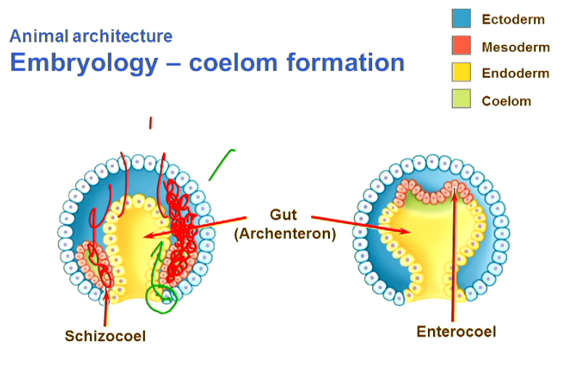

- Body cavities
Animals can be ceolmate, aceolmate or pseudoceolomate. Coelomates have body cavities. Acoelomates have no body cavity. Pseudocoelomate: they have a coelom that is not COMPLETELY surrounded by mesoderm. Note that, coelomate is considered the ancestral state of this character and acoelomate the derived one.

Invertebrates

Porifera

They are the sponges; their autapomorphies (the things they added on to their ancestor) include: they put choanocytes into a highly specialized water pumping system an aquiferous system; it doesn’t have any cell junctions. It arose before tissues arose. Cells are simply glued together using collagen.
They have totipotent cells. The cells can de-differentiate after differentiation back into a stem cell and turn into something else.
They have an asymmetric body. It’s considered asymmetric because there is no oral opening (oral axis) that can be used to determine their symmetry. In terms of structure, they are made of a “cylinder” with one open end. This allows filtered water to flow out of the sponge. The water flows into the spongocoel through pores formed by doughnut shaped cells called porocytes.
The internal membrane of the sponge is formed of choanocytes that make up the choanoderm. The outer layer of squeezed cells form the pinacoderm. Between these derms is the mesohyal which contains cells called spicules that form the cells “skeleton”. The mesohyal also contains cells called amoebocytes that can differentiate to form any of the other cell types in the sponge. The place where the sponge’s “cylinder” is open to release wastes is called the osculum.

Reproduction in sponges
Some choanocytes become sperm cells. Some archeocytes (sponge stem cells) become eggs
Sponges release sperm into the ocean water as a stream from their osculum. If trapped by other sponges of the same species, the choanocytes will enclose it in a vacuole and transfer it to the amoebocytes, which carry it to the egg. If the trapped sperm cell is of a different species, the sperm is phagocytized and used as food.
After Porifera, there are 2 animal symplesiomorphies. The first happens just after the Porifera, and that is the evolving of gap/septate junctions that allow cell to cell communication, plus the loss of choanocytes
(Note that although we lose choanocytes, today’s microvilli have a cytoskeleton similar to that of choanocytes)
The second one comes after the group following the Porifera (the Placozoa) and that is the appearance of tissues (i.e. they develop the other types of junctions and a basal lamina). They also develop digestive tissue.

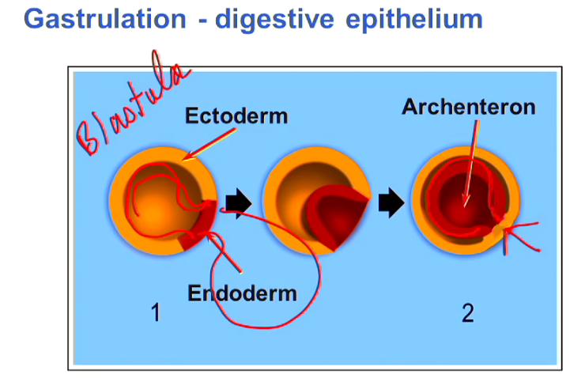

Cnidaria

The group following the placozoa are the cnidaria, and these have the following autapomorphies:
- Cindocytes: cells used for predation; that’s why cnidaria are one of the first predators. Cnidocytes are explosive cells that can fire a structure containing a toxin that immobilizes its prey. These structures are called barbs, and fired from a capsule within the cnidocyte referred to as the nematocyst/cnidocyst)
- Polyp body plan: the one similar to that of sponges but with tentacles sticking out around the mouth. This one has a radial symmetry
- Epitheliomasculature: their muscular system doesnot arise from the mesoderm:

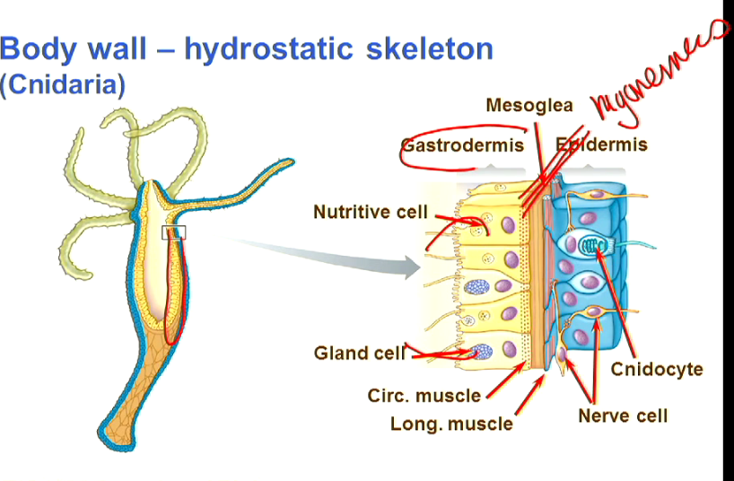
There is an internal derm that forms and incomplete gut and has gland cells that secrete enzymes to digest food, and other cells that take it in by phagocytosis and intracellular digestion, after food has been passed on to it by the tentacles (which have cnidocytes on them) as well as an epidermis of cnidocytes that contain nematocysts. Between them are muscular strands called myonemes. The myonemes are arranged to form circular and longitudinal muscles that work as antagonistic pairs, just like the human digestive system. This arrangement means that the cnidarian can contract one set of these muscles to change shape. In other words, the myonemes form a hydroskeleton.
Note that these animals are carnivores (with the exception of a few herbivorous corals), and that they are diploblastic.
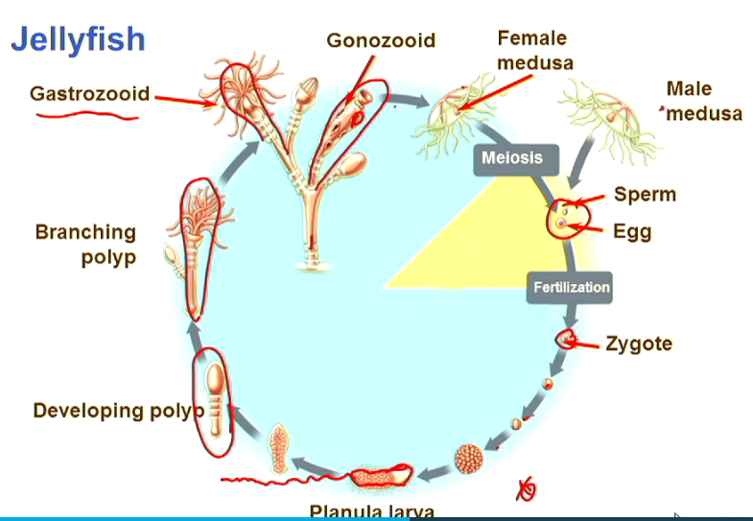
Another form of cnidarian that is different from the one shown in the diagram above is that of medusa (jellyfish). Between the two epithelial layers of jellyfish is an aqueous substance that constitutes a layer called mesoglea. This layer is squeezed by circular muscles that contract and relax. This propels the organism forward. In terms of lifecycle, we have two stages, a polyp and a medusa, where the polyp branches and mesdussas pinch off it. Note that the gastrozoid in the diagram below is specialized for food absorption but the gonozoid is the one that produces medusa. The larva that creeps along the bottom of the ocean to form a developing polyp does that by creeping in one direction, which can be the origin of bilateral symmetry, although looking at the cladogram, we see that it arises after Ctenophera.

[They have a dimorphic life cycle; living first as a sedentary polyp and then as a motile, sexual medusa. The pattern varies in different groups with some cnidarians dividing their life cycle equally between the two stages; for others, either the polyp or medusa dominates. Animals in the phylum are one of only two radially symmetric taxa, the other being the Ctenophora. Because of their symmetry, cephalization is absent and the nervous system consists of a diffuse nerve net extending throughout the body. There is a concentration of nerves around the mouth and the edge of the medusa where sensory rhopalia detect gravity and light to help the animal orient as it swims.
There is no circulatory system, and gas exchange and elimination of metabolic wastes is accomplished by diffusion across the body wall
The hydrostatic skeleton in a polyp consists of the fluid-filled gut, longitudinal myonemes of the epitheliomuscular cells, and circular myonemes of the nutritive muscular cells. Using the elasticity of the mesoglea in the bell and circular myonemes around its margin, a medusa swims by increasing and decreasing the diameter of the medusa, which forces water in and out of the subumbrellar surface.]

Another form of cnidarians are corals. Corals consist of colonies of polyps. They produce minerals that form a protective skeleton around them. Corals form reefs around the Equatorial where there is maximum sunlight, and grow on continental shelves, housing diversity that is comparable to terrestrial rainforests.

PROTOSTOME LINE
Protostomes have 3 main lineages (from the bottom of the cladogram up):
- Ecdysozoa (Get their name from the process of ecdysis aka MOULTING: shedding of the outer exoskeleton in order to be able to increase in size/grow): Presence of a thick, molted cuticle of protein reinforced with alpha-chitin or collagen (this depends on the lineage we go down to); loss of surface ciliature and the coelom absent or present only during the larval stages.

Nematoda
The Nematoda (also called roundworms) and the Nematomorpha have collagen fibers in their cuticle and no circular muscles. Nematoda have a special feeding structure called epitheliomuscular pharynx, and are pseudoceleomate. Since they only have longitudinal muscles, they can only contract a portion of their body and relax the other to move. This makes their swimming ineffective, but that’s not important! Since they form part of the microfauna of the soil, acting as decomposers. 150 cells used for the digestive tract. Instead of nerve cells reaching out to muscle cells, muscles have protoplasmic extensions to nerve cells, reducing complexity. They have a double valve pharynx which is the only one in living organisms. They have a triradiate pharynx that is formed of three muscles that come together to close the two valves associated with their pharynx. These muscles are formed of muscular epithelial cells (the same ones found in cnidaria).
Note: this animal displays miniaturization, which is typical of tiploblastic animals that are pseudocoelomates.

Oynchophora and Arthropoda

The arthropoda and onychophora have their cuticles reinforced with chitin and they manipulate their food with limbs (the only other group that can do this is the vertebrates). Chitin is a polymer of n-acetylglucosaminase, which are glucose moleculose with an acetyl group that bind together to give a biopolymer.
The onychophora (also called velvet worms) have a flexible cuticle which allows them to use a hydrostatic skeleton to move around and move their little legs. They have oral papillae with slime glands and a body wall musculature. Most of the ones we know today are terrestrial. They display segmentation. These segments are referred to as metameres. Two legs per segment and have both circular and longitudinal muscles. Their jaws are legs without claws. They have two appendages at the front that are modified near the mouth and are referred to as oral papilla, which can spray fluid that immobilizes the prey.
Arthropoda have articulated exoskeletons that have joints able to move in only one direction (which creates the need for more limbs). They also have bands of muscles (first time in animalia that muscles are arranged that way - no longitudinal or circular muscles since whole body shape cannot be changed down). at the joints to be able to move those limbs and compound eyes. They include spiders and insects. The only group that is still in water today are the crustaceans.
The trilobites are a group of arthropoda that existed in the cambrian, and they made it through but they went extinct in the Silurian.
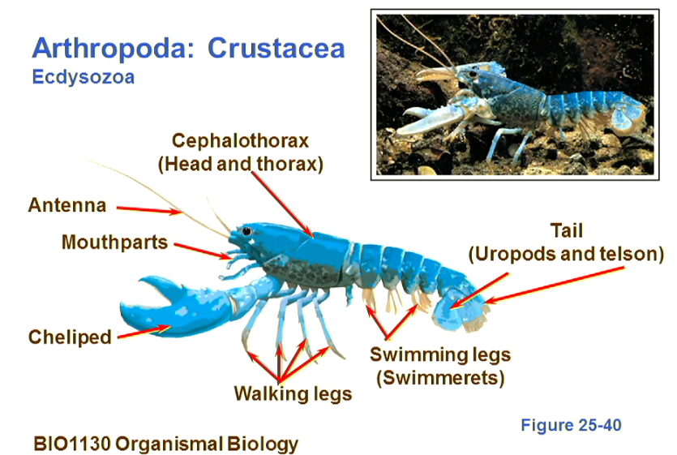
The crustacea give us a good example of tagmatization, where segements fuse together as they perform a common function. This can be seen in the walking leg segements. Notice that the swimming legs also create a water current for females when they are releasing their eggs.
The arthropoda had an ancestor that used filter feeding on algae using the “n” shaped flaps (watch the podcast (slide 57- time: 7:32 – 3rd Podcast).
Note that the zooplankton is mostly small crustacea.

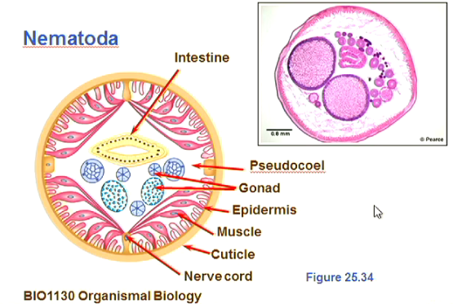

- The Lophotrochozoa: Either primitively sessile with a U-shaped gut and hollow ciliated tentacles (lophophore) or with the presence of the trochophore larva. There is no general agreement on the relationships between the different phyla in the group. Depending on the analysis, the Bryozoa appear as a sister group to annelids or molluscs and placement of sipunculids is difficult. The molecular analysis of this group is one of the most difficult and an alternate interpretation is to show all phyla branching from a single node.
Bryozoa: They sit at the bottom of the ocean, in colonies, using tentacles to feed. They secrete a protective calcium covering (CORALS). They have a gut. The lophophore consists of ciliated tentacles that trap food, which beat to pass on the trapped food to the mouth in the middle. Due to the development of a u shaped gut, their anus is next to their mouth. They can use their hydrostatic skeleton to move their tentacle in or out of the calcium casing. They behave pretty much the same features as cniadrians (an example fo convergent evolution).

The trochophore larva are a development stage in all the trochophores (the group starting at annelida and ending with nemertees on the cladogram). They have a spherical shape with a ciliary band in the middle that propel it through the water and move food into it. It later differentiates through metamorphosis into worms or into clams, molluscs, etc.
PLEASE LOOK AT DIGDIV FOR THE AUTAPOMORPHIES WITHIN THE TROCHOPHORES. THEY ARE DIFFICULT TO CATEGORIZE IN TEXT

Mollusca

Mollusca display adaptive radiation. They always have a shell, whch laied down by an epidermal layer called the mantle. They evolved from protective calcium specules that this group had on their outer surface to protect from predation. It’s body is divided inot a ventral part consisting of a mascular foot that carries on top of it the visceral body organs.
There is a set of muscles that run from the leg to the shell (MANTLE) and that allow the shell to be clamped down when the mollusk is in danger.
The mouth of the mollusk called the radula, and the gills that circulate water unidirectionally, can still function when the shell is pulled down. There is still some space to allow for their functioning.
Notice also that the anus is located in the mantle cavity and that means that the mollusk can excrete while its shell is down.
They have radular teeth that are attached to a structure that can move in and out and can grind against the substrate, eg. Biofilms, organic goo, and sticky things on the rocks and bottom of the ocean. These are the first group to evolve to feed on non-particulate food.
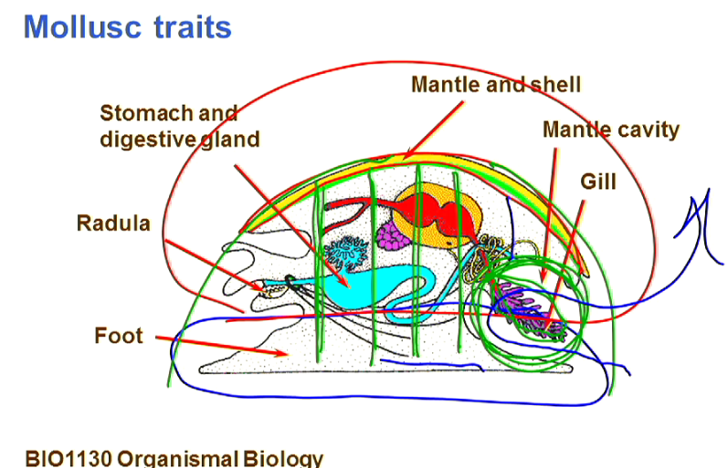
Snails (Gastropods)
They have a shell that protects them from predation and drying out. They are mostly terrestrial animals. hey are hermaphrodites, which means that every individual can fertilize and produce offspring, increasing reproductivity. Note that that it still requires two parents.
To prevent self fertilization, they separate the processes of sperm transfer and fertilization. When they mate, each one stores the others semen in its seminal receptacle, and one it’s time for fertilization, each one transfers the stored semen to its ovary and fusion occurs. At that time, sperm production by the testis is halted.
Terrestrial snails have darts that they try to use ot penetrate the other’s shell. The one that is penetrated behaves more like a female, with its seminal receptacles more open and it’s more likely to receive sperm than transfer it to the other snail.
In another morphology, cephalopods (squids and octopuses) have modified shells that have a conical shape and the muscular leg that existed in gastropods is modified into tentacles and arms that surround the head and the mouth. They propel themselves by jet “pushing” water into their shell. Note that octopuses have a convergent camera eye. The ancestor to cephalopods are the extinct ammonites (not to be confused with amniotes). The only living species that is representative of ammonites are the Nautilas.

How did cephalopods evolve?
In the great Permian extinction, the first vertebrate fish go extinct, and the rivers that wash into the sea bring with them freshwater fish that start to colonize the seawater habitats. These agile fish put the ammonites (with their big size) at a disadvantage, and as time passes, they start to become smaller and grow thinner shells resulting in the octopuses and squids we know today.

In a third morphology, we have clams (bivalves). These clams sit at the base of the ocean. Their morphology is shown below. They filter feed by pumping water into their gills and passing on food particulates to their mouths.

We can see the big differences between the three morphologies described, and that’s why we refer to the group as existing adaptive radiation.

Annelids

They have a larval stage that differentiates into a worm structure. Their mesoderm is segemented in a different way to onycophera in that in this one, each segment acts as a hydrostatic skeleton by itself, i.e. It has its own longitudnal and circular muscles. They have additional bristles that stick out the side of the animal. They are mostly found in marine the environment. They display adaptive radiation.

What was this group’s ancestor?
Let’s look at a worm
- Locomotion: When metameres increase in diameter by contracting their longitudinal muscles, their bristles (setae) stick out, anchoring the organism onto the substrate. When some of the metameres towards the back of the organism have been anchored, the front ones can contract their circular muscles and expand, pushing against the bristles’ friction, moving the mouth forward. One they have done that, the back ones can relax and the cycle repeats to allow locomotion. They opened their mouth and ate their way through thr substrate/soil. This allows them to tap into the ground organic material in the soils and to use the soil for protection from predation.

- The Platyzoa: Loss of the coelom resulting in acoelomate or pseudocoelomate condition and both the metanephridia and circulatory system are lost. The loss of the coelom results in the loss of digestive systems, etc. Flatworms give this group its name. As mentioned before, the pseudocoelomates specialize in miniaturization.

Platyhelminthes/flatworms have incomplete guts without an anus. They have a complex reproductive system associated with hermaphrodism. This is the only group that has all of its organisms as hermaphrodites.

They have circular and longitudinal muscles as well as dorsal ventral muscles that keep the worm flat. They have cilia on their underside and glands that release sticky material that allow it to stick to the ground. It can move in two ways:
- Gliding motion using the metachronal wave of the cilia on the underside.
- By sticking its body using the sticky glands and using the longitudinal muscles to contract its body and move it forward just like we saw in annelids.

The mouth is halfway through the ventral side (in the middle of the organism). This can be explained by the fact that their ancestor had its digestive cells across the mid ventral line and released enzymes onto the substrate beneath, liquefying their food under them.
Their thin bodies and their cement secretion meant that they were difficult ot hunt. Some of them even feed on cnidocytes, using them for protection from predation. They have a perfect SA:V ratio to rely simply on diffusion. They also have coloration on their surface that signals toxicity to predators.
Reproduction: RESEARCH THAT
Most of the ones we have today are parasitic and cause diseases. These can either be the leaf like group called es, and the tapeworms.
Some of the flukes reside in the Liver, using cement glands to stick to their host organ. Because they are flat they don’t interfere with fluid movement in the host organ. They release their eggs into the digestive system; into the faeces. These eggs contain free living miracidium at the larval stage. These are often washed into water, where they aim to target a specific gastropod. Once they do that…(Look at the diagram below)
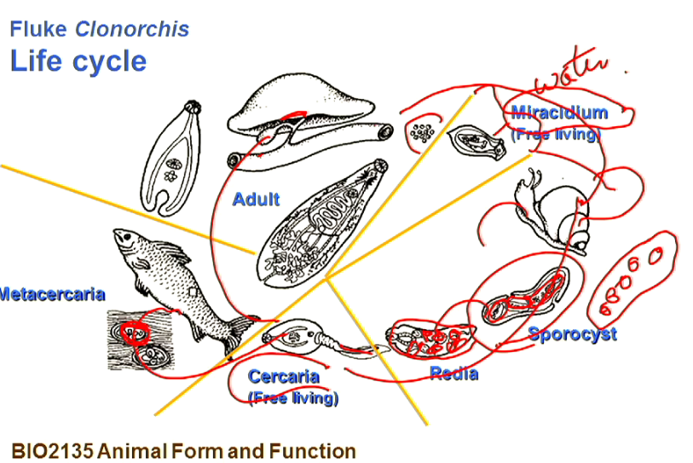

DEUTROSTOME LINE

Echinodermata (star fish)

This group returns back to radial symmetry. It has a water vascular system (do not confuse with the aquaferious system in the Porifera (– spellings)). They have a solid endoskeleton made of plates connected with connective tissue. That connective tissue is innervated, which changes the physical state of the connective tissue between jelly and solid. Their larvae display bilateral symmetry while the adults display radial symmetry (secondarily derived radial symmetry); also called pentaradiate (since it has 5 “arms”). They have tube feet controlled by the water vascular system to pass food on to their mouth. Most of the ones we have today have inverted their motion so that they use their tube feet to walk on the sea ground. Each of these tube feet represents a hydrostatic skeleton. Each foot is independent from the others and has a suction cup so that each of them can stick to the surface while the others move the animal forward.
Their ancestors sat on the bottoms of the ocean (members of this phylum live only in salty water). They held these arms upwards. They trapped organic material that was falling through the water column. They passd that on to the mouth facing up at the junction of the arms.
One of the distinctive characteristics of the phylum is their pentaradiate symmetry. At one time biologists combined them with the radially symmetric cnidarians and named them the Radiata. But, once the bilaterally symmetric planktonic larval stage of echinoderms was identified, it became clear that radial symmetry in the adult was a derived characteristic associated with sessile suspension feeding.

Feeding: The ideal food for starfish is clams. The starfish extends its arms out and clamps the claw, prying it open. It’s digestive system then inverts out and releases digestive enzymes onto the prey. Once the food is digested, it’s absorbed by the digestive system.
Echinoderms move by alternately contracting muscles that force water into the tube feet, causing them to extend and push against the ground, then relaxing to allow the feet to retract.
“Once the foot is attached, longitudinal muscles inside it contract and bend the foot.”

Echinoderms are dioecious, and most of them have excellent regenerative powers and will discard whole arms to satisfy a predator in order to make their escape; lost arms are slowly replaced. Gonads may be either permanent or seasonal, and gametes are released into the surrounding seawater where external fertilization occurs. Development is indirect. Although different types of larvae appear in different echinoderm classes, they're all ciliated and their development follows the typical deuterostome pattern. After being pelagic for a time, the larval stage settles to the bottom and completes its metamorphosis to the adult.

The continents do not absorb as much hat as water. Since land is concentrated

Hox genes

Some hox genes are missing from organisms with radial symmetry. It’s believed that these genes are tehe ones responsible for bilateral symmetry
The end Permian knowck sout aout 60% of the genuses and about 30% of the organisms at the species level.

THE SILURIAN AND THE DEVONIAN
Diversification of the vertebrate fishes. Just under a 100 yrs. One of the groups that fails to make it through is the trilobites. Some of this group survive but they don’t make it through the next extinction event. The Japetus and the paleotethys oceans are where the diversification of fish happen at that point in time. It’s a continental shelf between the land masses that are moving towards Gondwana anad Gondwana itself, to ultimately form Pangea.
RESEARCH THE DEVELOPMENTS OF CHRODATA ON THE CLADOGRAM

The ancestor to chrodata has pharyngeal gill slits, meaning that water passes into the mouth of the organism and filters out through the sides. In this process, cells at the bottom of the pharynx produce mucus, which traps algae and food particulates, and is passed on by cilia upwards where it enters the digestive tract. They have a hollow nerve chord on the dorsal side as opposed to a heart in the onycophora and the arthropoda.
The other adaptation that chrodata develop from their ancestor is the notochord, which is segmented, made of muscle tissue, and runs on the dorsal side of the organism. It has the ability to bend by the contraction of muscles on either side of the notochord. It has a unique structure that is described in the diagram below:
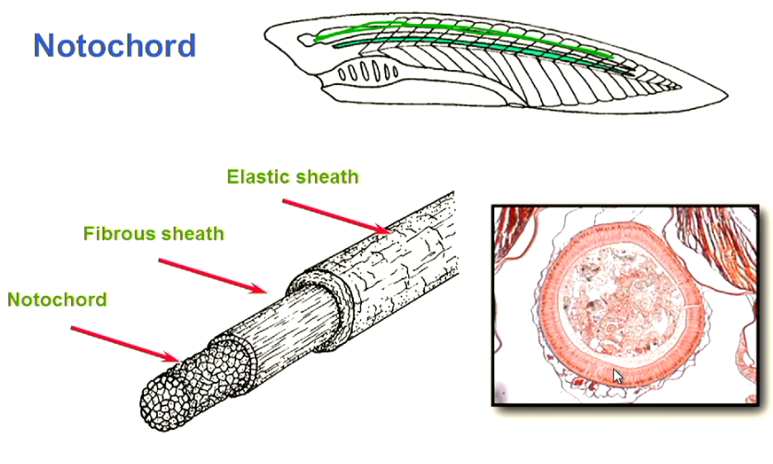

The other unique thing about chordata is the addition of notochord segments beyond the anal opening. It’s the only group that does that, and this process is referred to as post anal segmentation (or a tail)

If we look at the descendants of the chordates, there are 3 groups, one of which is the invertebrates. The other two are the cephalochordata and the urochordata. The cephalochordate are the closest to these three groups’ ancestor, and are still present today. One of the groups representative of cephalochordata are the lancelets, which are sedentary and use cilia to move food into their gills, but apart from that, the feeding mechanism is the same.

Vertebrae have a tripartite brain (made of 3 modalities), protected by a cranium, and with an axial skeleton made of vertebrae. Note that this skeleton is made of vertebrae, unlike the cartilaginous notochord. That cartilaginous tissue has become smaller overtime and acts as a “lubricant” between the vertebrae. There is a debate of whether the vertebrata group should be called vertebrata or craniate, and that has to do with the evolving of the vertebral column and the cranium..did these events occur simultaneously or did the cranium arise before the vertebral column. There is growing support that they arose together. 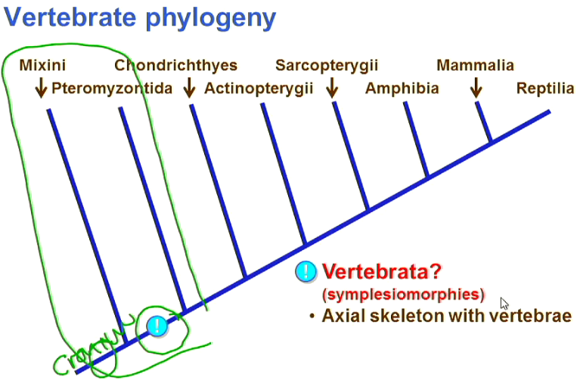

The Maxini (eg. Hagfish), and the Pteromyzontida cannot be considered in the construction of this cladogram because they have become so modified to suite the lifestyles that they have today (i.e. they have lost their vertebrae over time) These two groups are jawless, that’s why we refer to them as agnatha.

The ancestors of this group are the ostracoderms, and from the fossil record, we can see that they have pieces of bone protecting their head, which covered with skin, and that gives them protection against predation, and allows for soe of them to develop a feeding method in which they dive face first into sediments and digest the organic material for food.

One of the agnathins present today and representative of the Pteromyozontida is the lamprey. The lamprey is a parasitic organism that lives on the outside of other bigger organisms, therefore it’s called an ectoparasite.
In terms of structure, it has the chordata’s pharyngeal slits and the agnathin’s unmovable jaw. It breathes through a nostril on the upper side of its head.
It obtains its food by using its keratinized teeth around its mouth to attach itself to a bigger organism. This creates a wound in the bigger organisms body, and the lamprey secrete antincoagulants to prevent the healing of that wound, and feed on the ooz and material that results from the prey’s wound.
In terms of lifecycle, the lamprey lay their eggs in freshwater creeks, which hatch to release of larvae that spend several years in the rivers and then migrate to salty water. When it’s breeding time, adults move to the freshwater to lay eggs and return to the salty water.

In terms of the evolutionary cladogram for invertebrates, we get the gnathostomata after the agnatha. The gnathostomata have jaws and a pair (2 on each side) of fins (the front ones are the pectoral while the hind ones are the pelvic); these help to stabilize the anterior part of organisms so that their heads can remain in a fixed position/direction while the posterior part of the body moves.
Between the pharyngeal gill slits are bones called the gill arches, which grown simultaneoustly from the ventral and dorsal sides of the organism between the slits and help support the gills. These bones are bent back to allow for the front 2 to be used for pumping water through the pharyngeal slits. This is advantageous for the fish as it doesn’t need to swim to pass water through the gills. The jaws first evolve as an adaptation for respiration but over time, they are used as a feeding structure.

Note that one of the big autapomorphies at this point is genome duplication, i.e. the duplication of hox genes twice. This duplication, turned out to be advantageous, allowing for more experimentation and is thought to be the reason behind the great morphological variation we see in chordata when compared to other groups such as insects.
This duplication happens once more in bony fish, which are an expanding group even today.

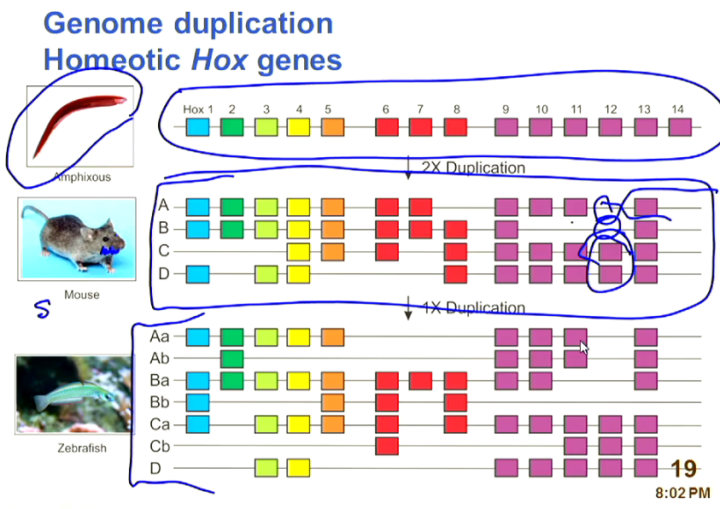
The group that comes after that, the chondrichthyes (aka cartilaginous fish, eg. Sharks) have an axial skeleton that is made of cartilage and appendicular one that supports the fins. Their upper jaw is detached from the cranium (unlike the other groups that follow it). They also have a hetrocercal tail and placoid scales.
The hetrocercal tail is a tail which is larger towards the dorsal side and this means that it exerts a bigger force downwards than upwards. Sharks balance this by using their fins. Note that since these fins are not attached to the axial skeleton, they are only moved by the body wall musculature (which also encloses the axial skeleton), and so they are not very agile.i.e. they can be used only for gradual movements, not sharp ones or hovering either. Some of the adaptations of this group towards a lighter body mass is the cartilaginous skeleton and the productin of oil that diffuses across all tissues, reducing their density. This group swim with their mouths open to push water across their gills (this process is referred to as ram ventilation). This means that sharks are constant swimmers.
The placoid scales are planted and partially made of epidermal tissue. It has a dentin, a pulp, and a pulp cavity. The scales are elongated to one side (the posterior side of the fish). These scales reduce laminar flow (and therefore resistance to motion) by by creating turbulence along the fish’s skin.
The teeth of shark fish are modified scales. They are not used for chewing. All they do is allow the shark to attach to its prey while it tries with sheer body movement to tear its prey into pieces that it can swallow. The teeth often fall away during the process but are regenerated from furrows in the mouth…note that the muscles responsible for clamping the jaw are much stronger than the ones responsible for opening it.
The females produce one egg in one reproductive cycle (i.e. per year). After fertilization, they develop the egg in a leathery bag (made of keratin) called the mermaid’s purse. That purse is then deposited in safe areas in the sea. The egg hatches and the offspring feeds on the egg nutrients until it’s old enough to digest its way out of the mermaids purse. Other groups of shark fish grow the offspring in utero, feeding it through milk glands in the walls, and therefore give birth to live fish.
One of the activities that has reduced the population of sharks (to the point of extinction of some species) is finning, where the fishers hunt the sharks for their fins, and these fins are used to make fin soup, which is a display of wealth in some nations. This has not been brought under control since the fishing happens in international waters that nobody can monitor.

The groups after cartilaginous fish have their skeletons made of bone, with the teeth attached to the jaws (i.e. they don’t simply fall out during feeding as is the case with sharks). Moreover they develop either a swim bladder, as is the case with actinopterygii (ray finned fishes), or lungs, as in sarcopterygii (lobe finned fishes).
Ray finned fishes have fins that are supported by bony rays. This means that the fins are moved up towards the anterior side of the body, and since they are now attached to the axial skeleton they can be moved to allow the fish to hover, but we still have the problem of respiration! Moreover they have a swim bladder (as mentioned in the previous paragraph). Their jaws are also adapted for suction feeding. In that the ancestral jaws at the front expand and close to suck water while a secondary set of jaws with teeth more towards the inside (i.e. they are modifications of the gill arches) are the ones now responsible for chewing.

[RESEARCH OPECULAR GILLS]

In the lobe finned fishes, we get lungs. Their fins are attached to the axial skeleton by actual bones (not bone rays). These lobe fins them to walk on the bottom of the sea and even jump to obtain oxygen when the concentration of oxygen in the water is too low, which is what happens in the Devonian. This ultimately leads to the evolving of amphibians and resembles the beginnings of the tetrapod stance.

Plantae

[Fill in the defining characters of plants]
[The ancestors of plants are the charophytes. The first plants were poikilohydric (they had little control over their water content). When plants first moved onto land, they were challenged by high doses of UV light compared to their terrestrial relatives. They were able to combat this by developing metabolic pathways with enzymes that are less sensitive to UV light. Such metabolic changes are thought to have been achieved through genome duplication, which left at least one copy functional, while allowing for experimentation that the environment could select for/against].[The first plants are likely to have benefitted from a mutual relationship with fungi where they form symbiotic associations known as mycorrhizas. The plant offers the fungi a source of carbon while the fungi help it to break down the soil components for plants to use].
[Compared to early plants’ simple stems, vascular plants developed a more advanced shoot system that allowed leaves and stems to arise from apical meristems. The stems developed branch grow longer, particularly that they are now supported by lignin]

In plants the gametes are produced by haploid gametophytes. Some of the cells form the gametes while others nourish these cells. The structure of cells that creates sperms is called the antheridium, while the one that produces eggs is called the archegonium. In the early development stages, the sperm and eggs were released into the water where they fertilized, but one of the first evolutionary steps is that the archegonia, with the egg cells in them, stay attached to the gametophyte plant, waiting for the sperm to arrive. When sperm arrives, it travels down to the egg to fertilize it, resulting in a diploid cell that divides by mitosis to give a diploid sporophyte, some of whose cells differentiate to give us spores. That sets up the lifecycle of plants.
Liveworts
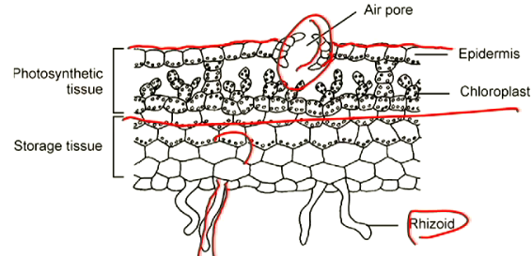
The liverworts represent some of the earliest plants. They have no specialized leaves or vascular tissue; they rely on passive diffusion through the apoplastic and symplastic pathways. Instead of leaves, they have thalli (single: thallus), which are masses of photosynthetic tissue. There are umbrella-like structures that stick out and house the archegonia and disc shaped structures that house the antheridia.
The thallus (shown in the diagram to the right), has root-like structures called rhizoids (we don’t call them roots since they lack vascular tissue). The thallus is divided into two layers. One is photosynthetic with an increased surface area and access to air that moves in through air pores at the top, and the other a storage tissue where the products of photosynthesis are stored. Meanwhile, the archegonia hang from the underside of the umbrella and the sperm cells are in the (gradually) flattened antheridia.
Liverworts rely on splash fertilization to be able to transfer the sper to the eggs. A water froplet fall son the discs and is it splashes up, carries sperms to the archegonia. This is not a very effective mechanism as it doesn’t allow for genetic recombination through sexual reproduction). It’s highly unlikely that a water droplet will splash onto another liverwort. This is not true for all liverworts. For some of them, when dampened, shoot sperm into the air, with the possibility of it landing onto a nearby liverwort and sexual reproduction happening.
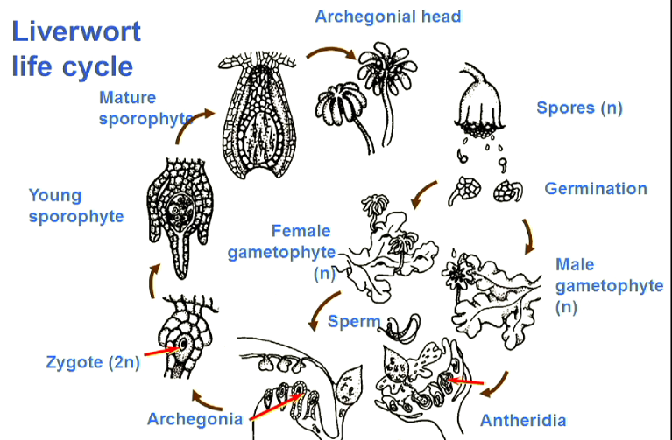
The key point in the lifecycle above is that there is the reliance on the growth of the sporophyte attached to the gametophyte. The big dispersal point here are the spores that are inert and can be washed by rain to germinate in appropriate areas.
Some of the liverworts reproduce asexually: they develop gemma cups, which are splash cups that are made of cells differentiated to form a cup, that when it overflows with water, the water carries gemma away from the plant, and can settle on to the ground to develop a new liverwort.
One of the most important autapomorphies in the plant phylogeny (look up the caldogram on digdiv) is the development of stomata and determinate meristem. The stomata are formed of guard cells that have an inner cell wall that is more flexible than the outer wall. Ions can be moved into the cells, which increases their salinity and creates a water gradient that moves water into the guard cells, making the cells bend against each other and open the stomata. When ions are taken out, the guard cells lose water and return to their original shape, closing the stomata.
The meristem represents a tissue of cells that differentiate to give the different plant structures. There are two types: determinate and indeterminate. The determinate type describes meristem cells that are bound (by their genetic makeup) to follow a certain developmental pathway towards becoming a certain specialized cell, i.e. its fate is sealed. The indeterminate type however, divides to give other meristem cells that can differentiate into any specialized cell type. The significance of this development is that the apical meristem at the end of each branch of the plant is subject, over a long period of time, to genetic and chromosomal mutations that do not affect other meristem tissues, and therefore every branch is subject to its own selection pressure, meaning that selection pressure now acts on apical tissues rather than the whole plant. It also means increased genetic diversity, especially than any changes to one meristem are inherited by its “descendants”.

Mosses
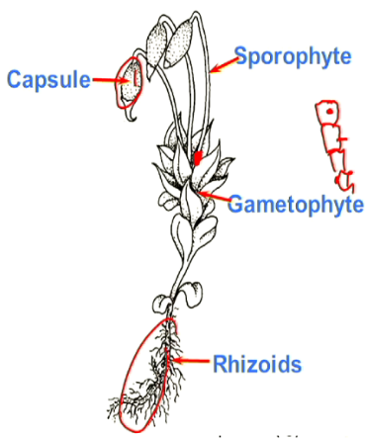
In terms of anatomy, we can see the signinifance of meristem tissue in the way a moss “places” its spore producing tissue. The cell that will ultimately develop into the spore producing tissue is found at the apex of a group of meristem cells that divide to push the cell that will eventually create spore producing tissue into the air. The mosses form a capsule where the spores are grown, and this allows for better dispersal since the spores can now be dispersed by the wind for example. Other than that, they still lack vascular tissue, meaning that they rely on rhizoids to satisfy their water requirements.
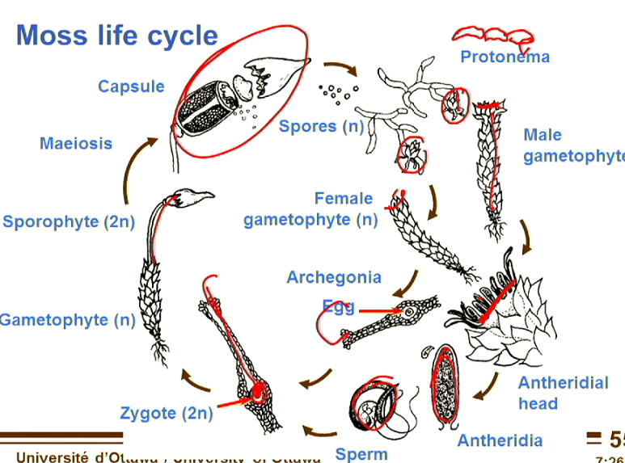
In terms of lifecycle, they have both male and female gametophytes that produce sperms and eggs inside archegonia. The sperm swim to the eggs, fertilizing them to form a zygote that creates divides to create a sporophyte. The sporophyte produces spores in its capsule. The spores are carried by the wind and when they fall onto land, they create a film of plant cells called peotonema that eventually differentiates to create male or female gametophytes, and the cycle repeats.
We refer to the liverworts and the mosses as early seedless plants. In the early devonian, the continents are converging towards Gondwana to form Pangea, but the vegetation looks different from today because we have not yet gotten to the point of vascular tissue to hold the plants up.

Developments along the Plant phylogeny
Along the plant phylogeny, we encounter the tracheophytes, which have trachieds and seive elements (i.e. vascular tissue), and they develop the previously described type of meristem, the indeterminate meristem.
One of the developments is lignin. One of the ways that mosses protected their cells from decay is that they staturated their cells walls with phenol compounds that are toxic to bacteria. Those phenol compounds become more complex and branched over time that we end up with lignin: a toxic, hydrophobic, and indigestable molecule, due to the amount of cross-linking in its structure. Some of the bacteria and fungi will later develop lignase enzymes to digest plant vascular tissue, but for a long period of time, plant biomass accumulates, and fossilizes to give us the fuels of today. This happens mainly during the carboniferous period. We do not usually start out with completely lignified cell walls though. As the vascular tissue develops, the cells develop a secondary cell wall on the inside that contains lignin. The lignin starts with an annular form that eventually develops into spiral and then scaliform shapes, and then reticulate, and ultimately the pitted form, which leaves us with trachieds. Note that one of the important functions of lignin is giving support to the plant.

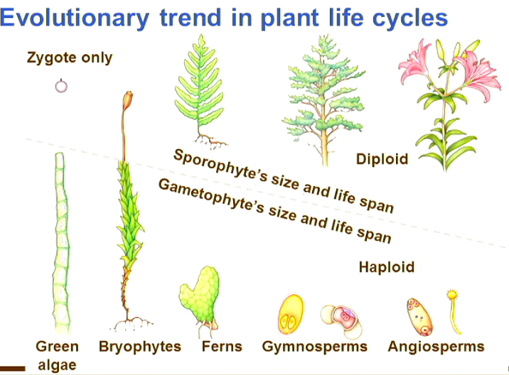
There is a trend in plant life cycles along their evolutionary history, and as time goes by, we get smaller gametophytes with shorter lifespans, ultimately ending with gametophytes internalized into the sporophytes in groups like confers and trees. The two to the left are non vascular whearas the three to the right are vascular.
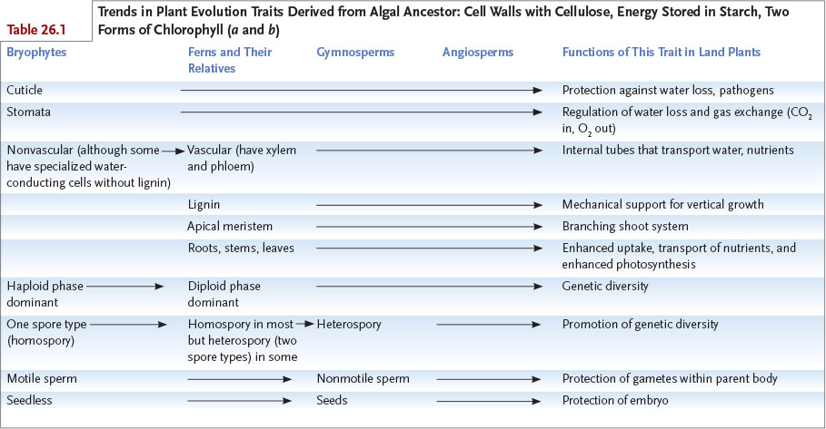
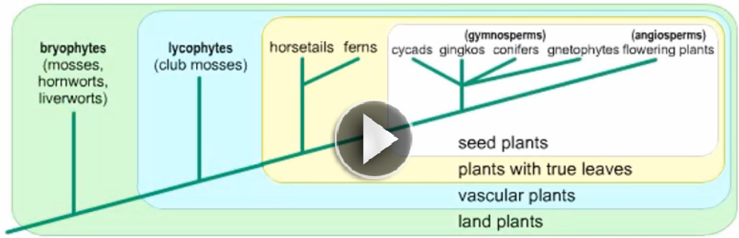

Further up the phylogeny (just before ferns), we get two autapomorphies that occue together, and these are the appearance of true leaves and the inversion of a section of the chloroplast DNA that doesn’t seem to affect the functioning of the chloroplast but is nevertheless indicative of the relationships between the groups of the kingdom.
Even further up, the gynosperms and angiosperms develop seeds, which are a najor innovation.

The late Devonian extinction
In the late Devonian, as plants bloom and we start to develop soils as a result of worm and bacterial activity, organic matter washes into the seas, i.e. the continental shelves. The bacteria and other decomposers in the sea decopose the organic material, using up oxygen and resulting a mass extinction event that kills corals and bryozoa (they only revive about a 100m years later). Armored jawless fish also die in this extinction. Another factor is that the bloom of plants pulls CO2 ut of the atmosphere at a high rate that deprives the planet of its insulation. This extinction event is mostly noticeable in marine environements.

The Carboniferous and Permian periods

Before these two periods, we had insects that fed on plantspores and leafy tissues, however they only take off during these periods.
Ferns
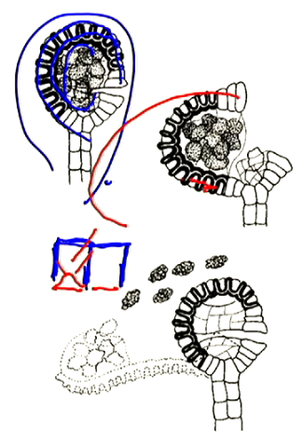
Ferns have special sporangia called leptosporangia. You have a mass of spores and a series of cells around the outside, forming a circle. These cells form chambers with 3 walls are strong and the fourth one, open to the air is weak. As these cells dry, they decrease in volume and the “circle” retracts. Tension develops and the circle opens, catapulting the sporangia into the air space, resulting in better dispersal.
The significance of this is that spores grow into gametophytes far away from the parent sporophyte. This means that the sperm produced are more likely to fertilize an egg of a gametophyte that had a different parent sporophyte.

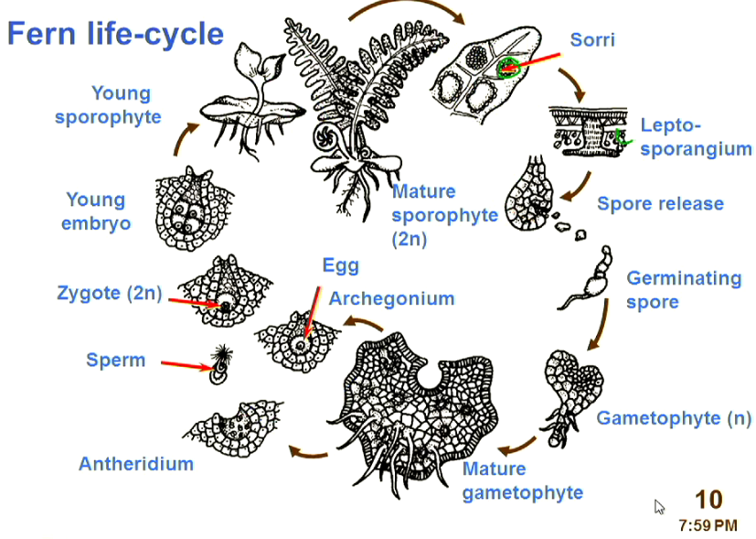
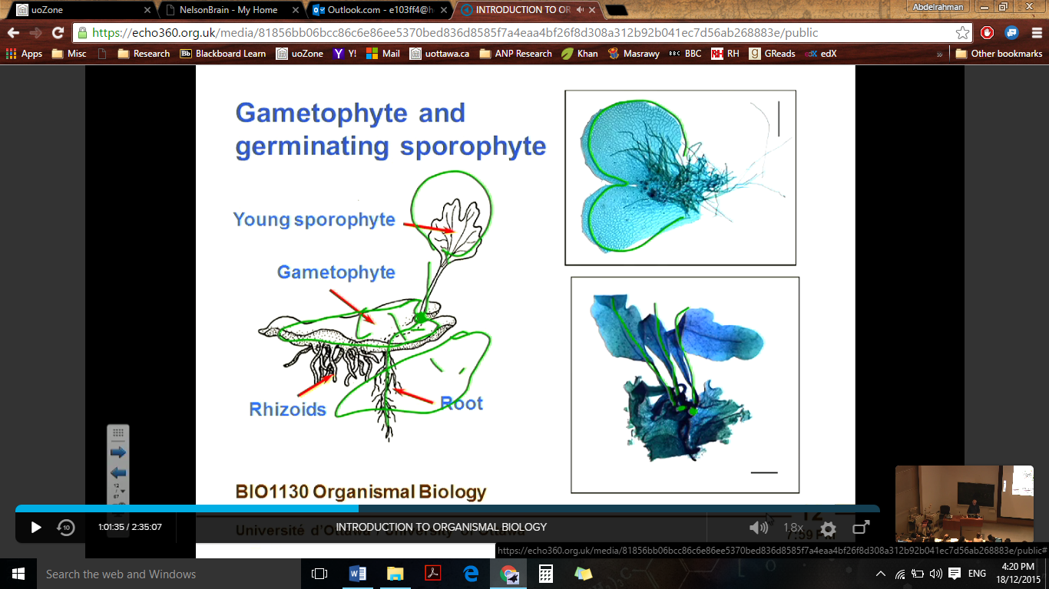

Homosporous and heterosporous plants
[Fill from Podcast]
Gymnosperms (eg. Conifers)
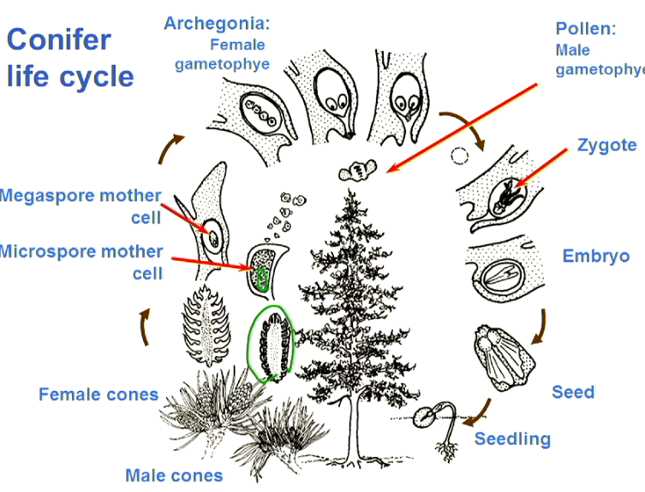
Conifers are heterspores with female gametophytes. They have two types of cones: male and female. The male ones are located at the bottom of the plant while the female ones are located at the top. This makes it less likely that the plant will self fertilize since it’s highly unlikely that an aircurrent will create an uplift of pollen to fertilize the same plant’s egg.
The female cones have a megaspore mother cell that divides by meiosis to give 4 haploid cells, only one of which grows to form the egg inside the archegonium. Meanwhile the male cone has a microspore mother cell and produces 4 haploid cells by meiosis. These 4 haploid cells divide by mitosis to produce cells that eventually become pollen. When the time comes, the males cones release pollen into the air, which is carried by the wind. If the pollen falls on a female cone of the same species, it fertilizes the egg and a seed develops. Eventually, the female cones open their scales and seed is dispersed to the outside. This is illustrated in the lifecycle diagram to the left.
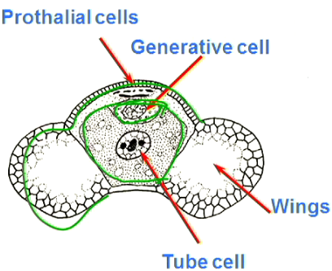
Looking at the pollen structure of gymnosperms, we find that it’s made up of 4 cells that are a result of the mitotic deivision following the meiosis of the microspore mother cell. A tube cell surrounds a generative cell while the other 2 types of cells provide protection for the tube and generative cells and allow the pollen grain to fly easier.

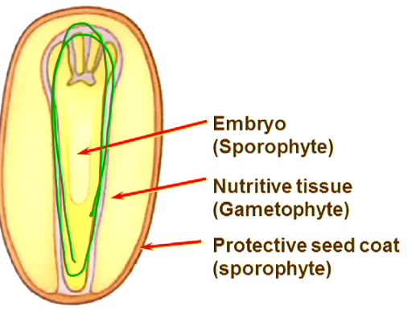
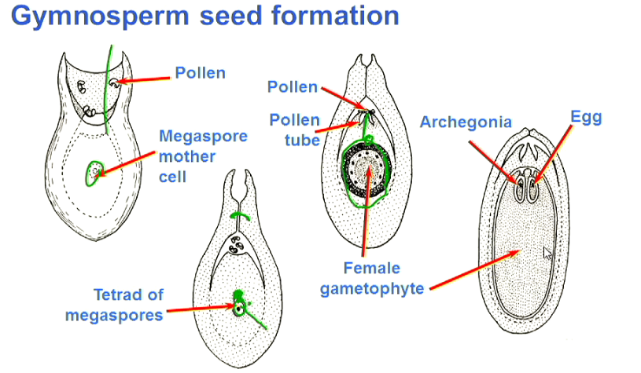
As for the female cone (the pine cone), one of the egg cells form off the the megaspore mother cell divides by mitosis to form the female gametophyte, which sits inside its sac until pollen arrives, in which case the scales close and the tube cell grows a pollen tube through which the generative cell moves to reach the egg cell and combine with it to form a zygote. Note that the HAPLOID egg (i.e. before fertilisation) creates a bunch of other cells that store nutrients that will later give the head start to seed germination. It also leaves one egg cell as the archegonium. Following that the resulting zygote divides by mitosis to give us an embryo, surrounded by haploid nutitive tissue and a casing from the sorophyte plant.
This reproduction strategy is not very effiecient as there is a lot of pollen wasted and all the megasporangia are prepared for fertilization, which may never occur! Thus a lot of energy is wasted, however at that point in time, this method allows the gymnosperms to dominate.

Fungi

Fungi are the first ones that are able to degrade lignin. They have aa haplontic lifecycle and cells that are arranged end to end to form hypae that intercoil to form mycelia. Most of the fungi have septa between their cells, but this is not the ancestral trait. In fact, ancestrally, fungal cells grow their hyphae by extending a single cell longer and longer, while duplicating their nuclei so that they are evenly spaced along the length of the cell. They simply use cytoplasmic flow for communication. This form of growth is possible because at wach pole of the nuclear envelope is a spindle pole body that organises microtubules. It develops microtubular spindles both into and out of the nucleus. During nucleus replication, the spindles attach to the chromosomes, puling them apart from each other, and as the nuclear envelope invaginates, two nuclei are formed. One of the nuclei is then moved by the molecular motors away from the other. This makes it possible for the nuclei to be equidistant as the cell grows.

Reproduction
In terms of reproduction, the cells at the tip of two hypae (one fungus is termed positive; the other negative) create a septa before the last nucleus and then fuse. This is referred to as plasmogemy. Once that happens we have a dikaryotic cell (a cell with two haploid nuclei), and we refer to the chromosomal combination of such a cell as being n+n. This cell remains in that situation, where it might actually form hyphae composed of cells that are septate (?) and dikaryotic. Only until a later poitn in time do the nuclei fuse to give us a diploid cell (this is referred to as karyogamy). Immediately after that, this cell undergoes meiosis to produce haploid spores that can then divide by mitosis to give us more hyphae, completing the lifecycle of a fungus.
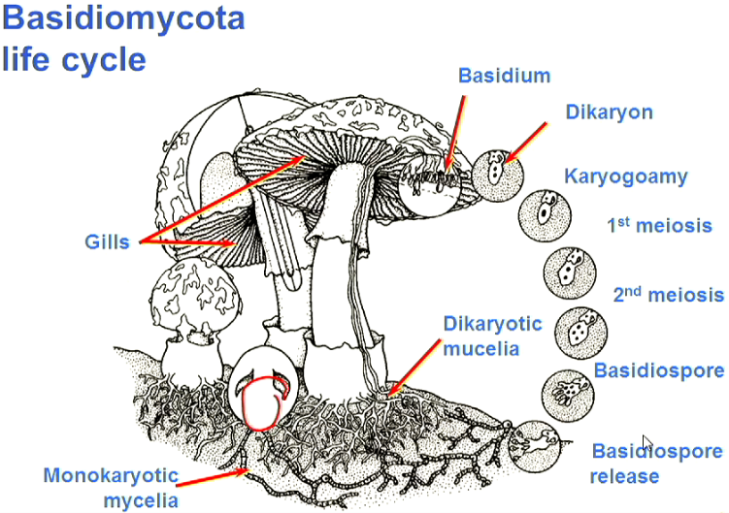
We can see an example of that in the way a mushroom replicates. The mushroom lies in a compact form until rain falls and then the monokaryotic hyphae under the soil transfer the water through the cytoplasm to the rest of the fungus, which inflates, pushing the fruitive body of the mushroom upwards. The mushroom head is formed almost exclusively of dikaryotic hyphae. At the end of some of them have what is called a dikaryion hanging. That dikaryon cell undergoes karyogamy to form a diploid cell (in this case a basidium) that undergoes meiosis to form four spores, that in the case of the mushroom shown to the left are referred to as basidiospores. These ones then migrate, and if they settle somewhere appropriate, undergo meiosis to form hyphae and a new fungus.
The genetic variability in fungi stems from the fact that when two nuclei of two spores come together in plasmogemy and fuse in karyogamy, representing two outcomes of random chromosome segregation, and then undergo meiosis again, we get all genetic possibilities.

Mutualism with plants
It’s very strongly suggested from fossils that there was a strong association (mutualism) between fungi and plants such that fungi provide minerals to the plant while the plant provides carbon to the fungus in the form of sugar. This is especially important since, when plants moved up on land, most of the minerals were inaccessible to them as they were stable in rocks. We get two different formus of this mycorrhizal mutualism:
- Ectomycorrhizal fungi: They grew outside the roots of the plant, sometimes wrapping around them (this does not disrupt water flow though, since fungi are good at water uptake) and penetrating between cortical cells of the root. This can make the extent of the plant’s roots seem larger than it actually is.
- Arbuscualr mycorrhial fungi: They grow INTO the plant’s root CELLS.
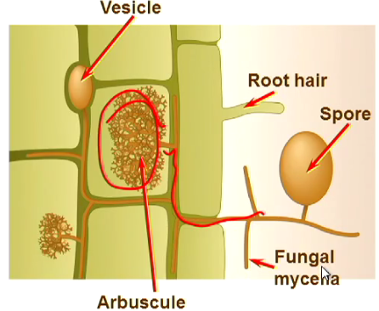

One interesting form is that of a lichen, which forms an association with the fungus wrapping around cyanobacteria (the group that first figured out photosynthesis). It’s interesting in that when the water supply falls short, the whole structure goes dormant (i.e. both the bacteria and the fungus).

[Fungi are heterotrophic eukaryotes that obtain carbon by breaking down organic molecules synthesized by other organisms. Although all fungi are heterotrophs, fungi can be divided into two broad groups based on how they obtain carbon. If a fungus obtains carbon from nonliving material, it is a saprotroph. Fungi that decompose dead plant and animal tissues, for example, are saprotrophs. If a fungus obtains carbon from living organisms, it is a symbiont. Symbiosis is the living together of two (or sometimes more) organisms for extended periods; symbiotic relationships range along a continuum from parasitism, in which one organism benefits at the expense of the other, to mutualism, in which both organisms benefit. Although we often think of fungi as decomposers, fully half of all identified fungi live as symbionts with another organism.
Regardless of their nutrient source, fungi feed by absorptive nutrition: they secrete enzymes into their environment, breaking down large molecules into smaller soluble molecules that can then be absorbed into their cells. This mode of nutrition means that fungi cannot be stationary, as they would then deplete all of the food in their immediate environment. Instead, fungi have evolved the ability to proliferate quickly through their environment, digesting nutrients as they grow. How can fungi proliferate so quickly? Although some fungi grow as unicellular yeasts, which reproduce asexually by budding or binary fission (see Figure 25.14), most are composed of hyphae (“web”; singular, hypha) (Figure 25.3a), fine filaments that spread through whatever substrate the fungus is growing in—soil, decomposing wood, your skin—forming a network or mycelium (Figure 25.3b, c). Hyphae are essentially tubes of cytoplasm surrounded by cell walls made of chitin, a polysaccharide also found in the exoskeletons of insects and other arthropods.
Hyphae grow only at their tips, but because a single mycelium contains many, many tips, the entire mycelium grows outward very quickly. Together, this apical growth and absorptive nutrition account for much of the success of fungi. As the hyphal tips extend, they exert a mechanical force, allowing them to push through their substrate, releasing enzymes and absorbing nutrients as they go. Fungal species differ in the particular digestive enzymes they synthesize, so a substrate that is a suitable food source for one species may be unavailable to another. Although there are exceptions, fungi typically thrive only in moist environments, where they can directly absorb water, dissolved ions, simple sugars, amino acids, and other small molecules. When some of a mycelium’s hyphal filaments contact a source of food, growth is channelled in the direction of the food source.
Nutrients are absorbed at the porous tips of hyphae; small atoms and molecules pass readily through these tips, and then transport mechanisms move them through the underlying plasma membrane. Some hyphae have regular cross-walls or septa (“fences” or “walls”; singular, septum) that separate a hypha into compartments, whereas others lack septa and are effectively one large cell (Figure 25.4). But even septate hyphae should be thought of as interconnected compartments rather than separate cells, as all septa have pores that allow cytoplasm and, in some fungi, even nuclei and other large organelles to flow through the mycelium. By a mechanism called cytoplasmic streaming (flowing of cytoplasm and organelles around a cell or, in this case, a mycelium), nutrients obtained by one part of a mycelium can be translocated to other nonabsorptive regions, such as reproductive structures.
When a fungus releases enzymes into its substrate, it faces competition from bacteria and other organisms for the nutrients that are now available. How can a fungus prevent these competitors from stealing the nutrients that it has just expended energy and resources to obtain? Many fungi produce antibacterial compounds and toxins that inhibit the growth of competing organisms. Many of these compounds are secondary metabolites, which are not required for day-to-day survival but are beneficial to the fungus. As we will see, many of these compounds not only are important in the life of a fungus but also benefit organisms associated with the fungus. Many are also of commercial or medical importance to humans; for example, the antibiotic penicillin is a secondary metabolite produced by a species of Penicillium.
Fungi reproduce by spores, and this spore production can be amazingly prolific, with some species of fungi producing billions of spores per day (Figure 25.5). These spores are microscopic, featherlight, and able to survive in the environment for extended periods after they are released. Reproducing via such spores allows fungi to be opportunists, germinating only when favourable conditions exist and quickly exploiting food sources that occur unpredictably in the environment. Releasing vast numbers of spores, as some fungi do, improves the odds that the spores will germinate and produce a new individual.
Spores can be produced asexually or sexually; some fungi produce both asexual and sexual spores at different stages of their lives. Sexual reproduction in fungi is quite complex. In all organisms, sexual reproduction involves three stages: the fusion of two haploid cells (plasmogamy), bringing together their two nuclei in one common cytoplasm; this cytoplasmic fusion is usually quickly followed by nuclear fusion (karyogamy) in most organisms; nuclear fusion is followed by meiosis to produce genetically distinct haploid cells. As we will see, fungi are unique in that these events can be separated in time for durations ranging from seconds to many years]

When we consider things that move up on land, we got to go back to the arthropoda, as insects go up on land. We should see that this group displays tagmatization, with the head consisting of 6 segments and the thorax is made out of 3. The head is the main sensory organ, with the thorax serving as the attachement point for locomotary parts and the muscles that move them. The abdomen consists of 11-13 segments and encapsulates the body organs (the viscera). This architecture is constant throughout the insects.
One autapomorphy that defines arthropoda is the compound eye, and that is in many ways similar to a computer’s pixelisation. They eye is made of units, each with its own lens, which uses a conelike structure to concentrate light and then each unit passes on its light to a retinular cell to determine the level of color. With each unit displaying (mentally) only one color, the arthropod can then group these “pixels” together to form an image (referred to as a visual mosaic)
Insects also develop flight early on and that allows them to tap into a food resource that no one has tapped into before, and that is the spores of plants. Flight also allows them to escape predation.
This group also developed a way to protect themselves against drying. They have a procuticle that contains the reinfocing chitin, and an epicuticle made of waxes that prevents dehydration. To prootect their gametes from dehydration, the eggs have a shell on them, and the sperms that fertilize internally are enclosed in a spermatophore to protect them.
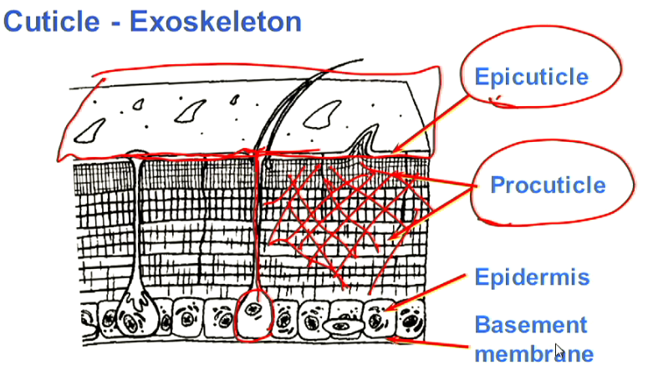

Going back to the vertebrata, all organisms after the lobe finned fishes have the tetrapod stance. The first group after them, the amphebia start to evovle as a result of the dry climate of the Devonian, and since the Devonian is followed by the moist Carboniferous, they never really complete the transition, and as a result, they haven’t found a way to protect themselves against dehydration. Note that it’s difficult to work out specific autapomorphies for this group since the diversity we see today is a small fraction of the one that existed in the Devonian, with many species of that period of time that have gone extinct.
They descend from the lung fish and they all share the autapomorphy of Buccal force breathing. In that they gulp air, and then push it into their lungs, and then later own contract their body muscles to exhale the air out. This can be contrasted to mamalia and reptilia, which PULL air into their lungs.
One of the reasons that the amphibia could not protect their skin against dehydration is that they use it for breathing. They have mucous glands that keep their skin moist to dissolve gases. Amphibia also develop poison glands that secrete poisons or distasteful chemicals onto their skin, meaning that any organism that tries to feed on them is going to eeventually end up spitting them out.
This group relies on flying insects for food, and this ancestrally shared characteristic gurantees their success when they move on land.
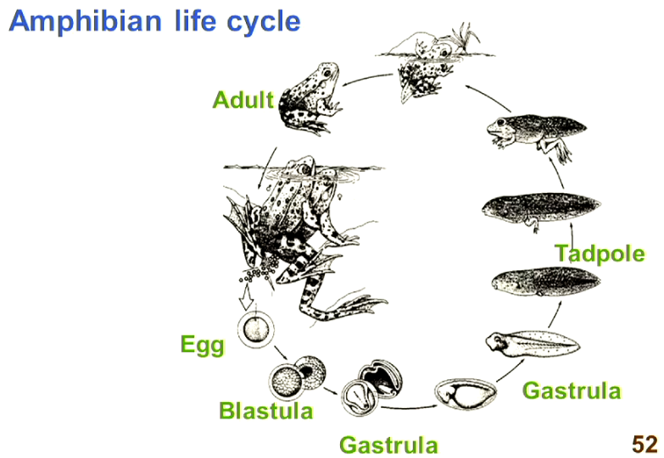
In terms of locomotion, this group was at a disadvantage since their appendages were attached at the sides and they had to actualy use their tails to be able to lift themselves off the ground.
In terms of lifecycle, they are not perfect as they still need to go back to the water to be able to lay their eggs.

[Notes on mass extinctions can be found online]
In the later Permian extinction, it’s thought that a combination of factors, including a flood basalt of the siberian flood basalts and the heating up of the ocean to tempratures higher than 35-40 degrees C, leading to marine anoxia, and sea level change that led to the release of hydrates and the heating up of the planet.
Note that meteorite impacts is only associated with an extinction in the cenozoic.
Plants seem to be able to survive these mass extinctions as well as insects, whose diversity is only affected by the End Permian extinction (about a third of them killed off). It seems that smaller organims are able to endure these extinctions since, at the time of such extinctions, it’s highly likely that some of them were protected in small pockets that allowed tthem to survive.
It’s noteworthy that when these events occur, they are not districuted globally equally and that the animals with a more generalized life form were able to survive, while the highly specialized ones are those whose diversity suffered the most.

Common name for a fern leaf: frond
A folded fern fond: fiddlehead

