- BU111

- Leanne Hagarty
- lhagarty@wlu.ca

- Office Hours - Thursdays 9:30 to 11:00 am and alternate times by appointment … SI is available

- Business 111 Lab Manual - Should be bought new
- Introduction to understanding and assessing the Business Environment - could buy e book with access code or new textbook
- Clicker is not used in the course

- Course websites - wlu.ca/sbe/bu111 & www.pearsoncustom.com/can/wlu_mybuslab/

- Don't make notes on textbook readings, detailed notes are taken in class which appear on exams. Prepare for labs ahead of time!! Download or print the base slides. Review reference material but don't make notes. Review and bring the notes from last class.

- Research Diagnostics worth 4 marks and Individual Business case worth 10 marks. New Venture project is worth 26 marks. Participation in labs is worth 10 marks. Lastly midterm and final are worth 25 marks each and a bonus mark opportunity worth 2 marks … Time management module before september 17th for .5 marks. Note taking part 1 (Sept. 19-24) for .25 marks and part 2 (Sept.26-Oct.1) with quizzes that must be passed. Lastly 4 non-exam SI sessions for .25 marks each.

- WWW.WLU.CA/SI
- SI Sessions are every tuesdays from 7-9pm in room 2C15 and wednesday from 9-11pm in room P1021 for Non-BBA students. Must be there for the two hours. Sunday and Mondays are from 7-9pm in rooms 2C17, P1019 respectively for BBA students.

- Must get access code from new textbook and N6 is other code

- Library Resource Workshop Nov.4 and 5th

- Critical Success factors are the following:

- - Achieving financial performance

- Businesses need to be profitable and collect cash efficiently

- - Meeting customer needs

- Business understands expectations and offers them exactly what is said. Even if needs change the business continues to meet them which allows customers to be loyal

- - Building quality products and services

- Consistent supply quality and offering good customer service. Basically giving what you deserve for what you pay. Understanding the target market is key as well as consistency and reliability (trust)

- - Encouraging innovation and creativity

- R&D, offering products that are ahead and distinguishing from competitors. Employees, Sourcing and Marketing help make it an innovative environment (behind the scenes). Successful companies have to continue to find ways to be innovative to meet the moving quality target and needs and wants.

- - Gaining employee commitment

- Employees who are motivated and feel good about their job treat the business like its their own and ultimately are more engaged, productive and meets the customers needs and wants as well as their own. Avoids employee turnover and is a direct link to other factors.

- - Creating a distinctive competitive advantage

- Doing something different than your competitors that makes your business unique and valuable. It attracts customers which helps with competition over the long run.

- The relationship between a company and its environment:

- Diamond E-Framework is composed of Management Preferences, Strategy, Resources and Organization.

- Management Preferences has to do with the fact that employees and manages are humans with personalities and all have their own preferences which influences the organization itself and which strategies are used.

- Organization has to do with culture, leadership, the actual capabilities of the organization and the organizational structure.

- Resources are divided by, human resources, capital resources and financial resources $.

- The strategy is a critical linking variable that deals with the opportunities the business is pursuing. It is the component that link the inside of the organization with the external environment. Strategy determines the needed resources, organizational capabilities and management preferences.

- The principal logic of the framework is the underlying message that your most successful company is one that gets consistency within the variables despite the changing environment.

- Managers
- - Is there a match between preference and strategy
- - Is there a match between different ranks of managers (inconsistency between levels)
- - Is there a willingness to change?

- Organization
- - What capabilities are required and what do we have right now/need for this strategy?
- - Is it feasible to fill the gap?
- - What type of organizational structure do we need for this strategy?
- - How is the culture (expectations, work culture) and leadership style?

- Resources
- - What resources are required? (capital, number of ppl, skill sets)
- - What do we have right now and how do we fill the gap?
- - Should we change the strategy?

- The external analysis is the process of scanning and evaluation the external environment. The whole purpose of this is to look at the opportunities and threats. There are multiple environments that businesses must face such as general and industry environments.

- External analysis is beneficial for the following reasons:

- - Make managers proactive

- - Provides information used in planning

- - Helps organization get needed resources

- - Helps organization cope with uncertainty

- - Improves consistency and performance

- Challenges include:

- - Forecasts and trend analyses imperfect

- - Rapidly changing environment hard to keep up with

- -Time Consuming

- In order to do an external analysis there are two ways, the PEST model (General environment) and Porters Five Forces(Specific Environment).

- PEST stands for Political, Economic, Social and Technological.

- PEST has to do with the relationship with the Political government and the businesses. This includes the restrictions and regulations for operation. The government sets the taxes, trade agreements and also create incentives and laws for human safety. The government is a big customer itself.

- PEST includes an Economic force in which the economic condition affects businesses. Such things influence costs, potential sales and financial uncertainty for customers. If there is a positive climate there will be growth that is stable where interest and exchange rates(import/export) are good. Slow and steady growth is good for managers as it makes investing predictable and so on. Unemployment can also greatly affect businesses and governments (PPP). If debt levels are high then borrowing becomes more difficult.

- Another aspect is Social which affects how we live, work, consume and produce. These have to do with customs, values and attitudes. What we prefer and the trends in society all affect how we spend our money. The challenge with these factors is that multinational firms must deal with various countries and regions where these elements vary. It takes research of such things like demographics to ensure success. Ethics and values of the society effect the ways business conduct business.

- The last element is Technological which affects what we produce and how we produce. This includes the internet and how it has changed the landscape of buying, selling and communication. Information is now readily available for consumers and likewise suppers and manufactures communicate through databases and systems to ensure customer satisfaction (supply chain/Just In Time Manufacturing). The way products are designed have changed dramatically and technology has made more options available for companies (robots etc.).

- The three most important issues facing Canadian businesses today include:

- - Value of Canadian Dollar

- - Skilled labour shortage

- - Natural/physical environment

- The second external analysis is Porter's Five Forces which includes potential entrants, suppliers,, substitutes, buyers and the rivalry amongst firms which addresses the industrial environment. These elements address how attractive an industry will be. The industry will be profitable depending on the costs that you incur and the price you can sell products for. All five factors affect the profitability. Even though this model can be used with any industry, the relative power and degree of each force changes from industry to industry.

- The first factor is Suppliers. If there are very few suppliers then selection is minimal and then gain the advantage. If it is really expensive, switching costs can be expensive, time consuming and inconvenient. By creating a strategic alliance it solves the issues.

- The next aspect is Potential Entrants where businesses enter the industry with or without ease. New companies bring new technologies, business models and make companies less attractive. These big changes cause pressure on businesses as competition rises. To create barriers for these companies, businesses can use capital intensity, patents and protection, significant skill sets. Loyalty is a key way to stay competitive as well as having access to distribution (exclusive agreements). For entrepreneurs there are many services available by the government because of the fact that the small business employ more people and so on.

- Substitutes increase competition. These are products from different industries that meets needs and wants. As prices of substitutes decrease, the industry prices aren't able to rise prices too much. Switching costs can add up so therefore businesses must make customers feel that they are unique (marketing costs) and that you best match their needs and wants which creates loyalty at the end of the day.

- On the other side there are the buyers themselves. Depending on the industry your customers could be individuals or other companies. It takes power over the customers which is not easy. If products are standardized, there is more power for the companies. If the purchase is discretionary and its not much of a need the buyers have more power. Marketing will be key or alliances can be formed to resolve this problem.

The final force of this model is Rivalry among existing firms which is the most important and powerful. This has to do with putting pressure on profitability from both sides, downward pressure on your prices and the price being paid to survive. The first component is the number of competitors. If there are many competitors of equal size and capability it makes it more intense rivalry. Sometimes the slow or declining growth rate leads to more rivalry. If buyers can move from one product to a competitors product it makes it more intense. If products are more standardized and there is little variation from product to product, it makes the rivalry grow significantly. When there is perishable food items, sellers want to get rid of products really fast.

- The value of the Five Forces Model is to:

- - Predict industry profitability

- - Helps determine whether a firm should enter a particular industry

- - Helps determine whether and or how it can create am attractive position in the industry

- According to Porter himself, the airline industry, the nature of rivalry is intense, constant stream of new airlines despite the low profitability and so on. Soft drinks is the opposite. A company should use the strategy but analyzing the industry, understand the dynamics behind how the industry is changing and evolving and its implications for your business. Positive and zero sum (all participants offer same thing and enter price war where not all can succeed – one must pay price) competition are key terms. For suppliers (key resources, inputs) its not just the physical goods, but rather the space available and the employees such as pilots etc.

- Questions to answer with the Five Forces analysis include the industry being realistic for a new venture, the ability to be better than the competitors at avoiding factors that suppress industry profitability, being unique and meeting needs with differentiated products and finally having a superior business model that present businesses would struggle to duplicate.

- New Venture – Recently formed commercial organization selling goods/services

- Entrepreneurship is more of a mindset, identifying an opportunity and acting upon it by finding to resources to capitalize on the opportunity.

- Small businesses are owned managed entities, where day to day decisions are made by the owner/manager. They are usually not big market players and represent majority of all businesses in Canada. They represent more jobs than large businesses in total and end up coming up with new business ideas etc.

- The entrepreneurial process is influenced by PEST as the opportunity comes from the external environment. The three important elements are the entrepreneur who should have the right experience, passion/commitment, background, knowledge and skills to be suitable. The second element is the idea itself. This is basically if the opportunity is feasible and profitable. Lastly resources that are required should exist and they should be accessible.

- The idea itself is often a paradigm shift (totally different perspective/opinion) and originate from events relating to work or daily life.

- The screening process is as follows:

- 1. Idea creates or adds value for customer
-> Solves problems and meets need
-> Customer willing to pay for it
2. Idea provides a competitive advantage that can be sustained
-> Unique product that is more valuable than others
-> How is it different, are the differences more valuable, can idea be immitated, can it be protected legally?

- 3. The idea is marketable and financially viable
-> Enough customers willing to buy it (market demand)
-> Who are the key competitors
-> Is the market growing, shrinking, concentrated?
-> What are the forces that affect profitability?
Does the idea have low exit costs?
-> Longer time to profitability or greater up-front investment(risky)?

- HOW TO SCREEN FOR NV PROJECT
- Use PEST analysis to assess environment – supportive of idea?
- - Use Five Forces Analysis to determine easy of entry and profitability of industry
- - Use PEST & Five Forces and market exploration to ensure uniqueness of idea
- - Use research of market (library database) to evaluate how big your market is and whether growing/shrinking or stagnant
- - Research expert opinions in the industry
- - Identify and discuss how key trends in the environment and industry affect your idea (opportunity)

- As the business concept has been developed it is important to incorporate information and research. Incorporate experience and customer feedback. Once the concept is finalized, the business plan will be tweaked.

- Accessing resources is key. It is important to try and make do with as few resources as possible or using other peoples. Also if free options are available they should be taken advantage of.

- Debt Financing – interest and control (business incubators, suppliers, companies help each other)

- Equity Financing – no interest, less control (going beyond personal savings – loan) selling parts of the business to new owners who expect share of profits which may take time

- Social Entrepreneurs are creators of innovations that disrupt the status quo and transform our world for the better.

- A market failure is trying to be addressed through innovative solutions.

- Access or quality or affordability are keeping basics away from segments of the population. Social values are the primary objectives for these entrepreneurs unlike the traditional approach with an economic focus.

- Investors will not be your highest priority therefore community stakeholders will be important as you will deal with them to meet the issue at hand.

- 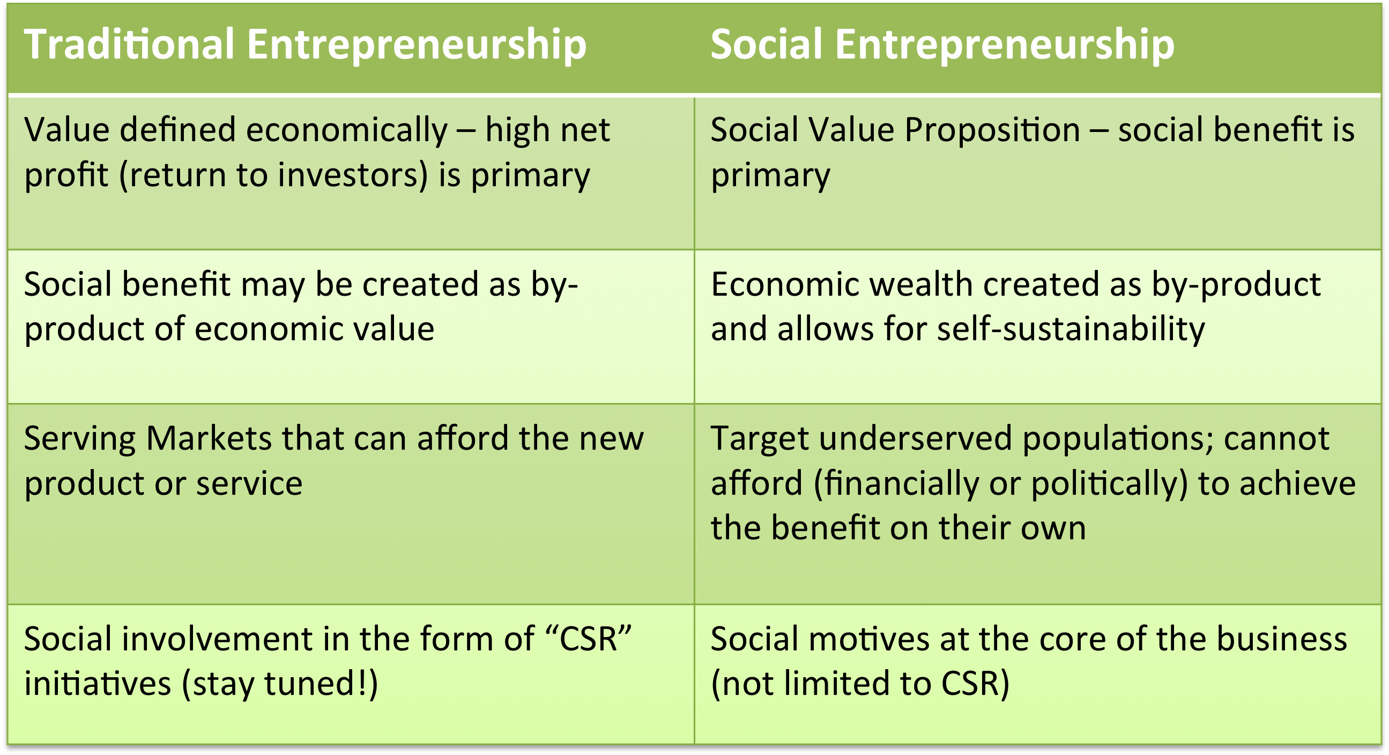

- Technology affects what we produce, how we run our business and much more.

- Technology demands constant learning and scanning as it keeps growing

- Technology has do with physical equipment including human knowledge, work methods, and business processing systems.

- Technology also includes information technology and the various devices for creating, storing and exchanging useful information. This includes consumers (ATM) and businesses (Data Mining)

- Technology comes from the critical success factor of innovation. Businesses purposely invest in R&D where it can be divided into two categories; basic and applied. One focuses on a specific problem while the other doesn’t.

- Paradime shift is when the things get extremely different. This is usually because of technology.

- Opportunities: Products tend to me more innovative, unique and valuable. Information is much more accessible now (sales, profit reports daily), services are improved (track shipping), human labor has been reduced and the quality and efficiency of the workplace satisfy the customers. Barriers can be creative to create competitiveness as well as communication within firms are more common due to the more opportunities. Finally customer products can be customized and designed specifically to meet their needs and wants.

- Threats: Information is costly to develop but cheap to share. New technologies may arise in areas your company can’t address. Technology standard wars arise because sometimes the best technology isn’t the one that everyone follows (wins). As a result of all of this, there is a constant need for leading and as it moves quickly and unpredictably its hard for businesses to be ahead. Time is a cost and information is overwhelming to managers and customers.

- 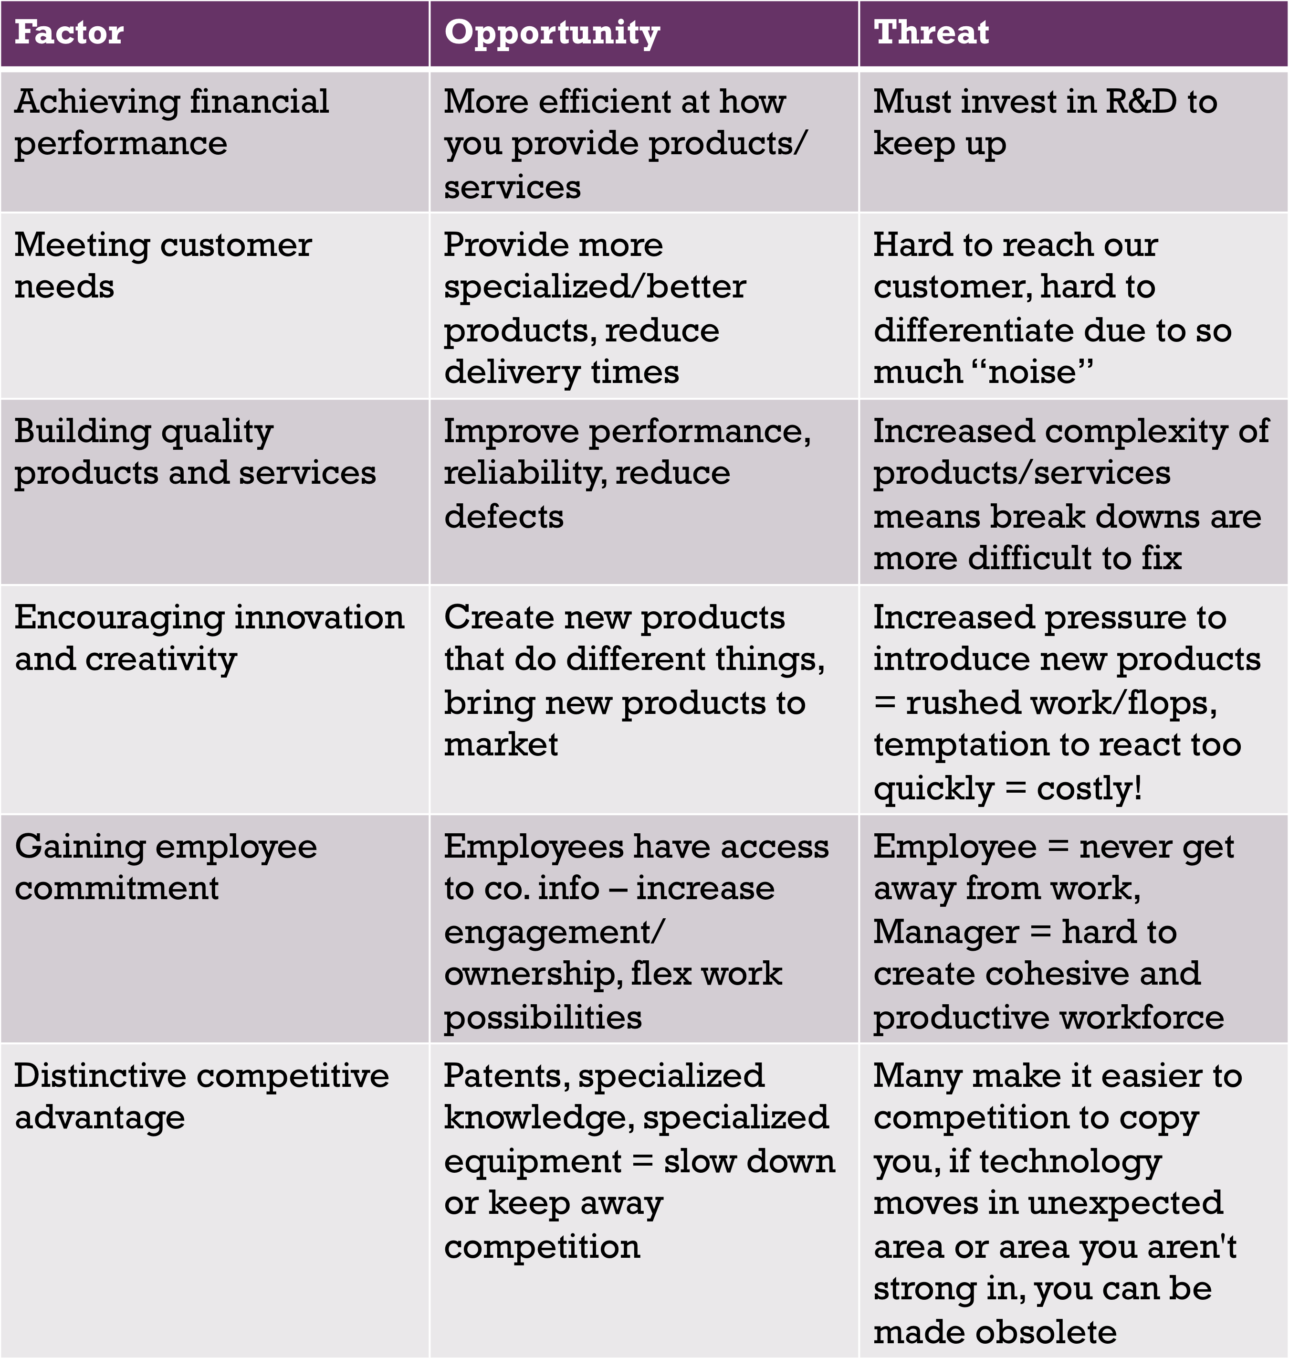Standard wars happen when two formats of a particular product/technology are incompatible formats. It doesn’t make sense for consumers and the industry to support both so there is a battle where there is winner. An example would be Blu-Ray vs. DVD.

- Installed Base: Number of users (Great number, greater influence)
Lock-In: Size of Investment (Invested in asset who’s value has gone down significantly if you want you use the other format)
- Switching costs: Cost of moving (a barrier to entering to the other format making lock-in worse)
Complementary goods: Needed for value, creates a vicious cycle (some companies take care of this themselves)
- Network effects: Value of this format goes up when lots of other users of this format, reduces threats of substitutes (Facebook)

- Key Asset: Intellectual property rights which slows limitation or requires cooperation

- Key Strategies: Gaining control over a large base of users (being aggressive, build early lead), Ability to innovate (don’t be lazy, keep innovating to be ahead) & Strength in Complements (use alliances if not producing yourself)
- If your behind in the standards war you have to find if there is something you can do to lower customer switching costs or a leap in performance for price (getting more for your dollar – tech. advancement). If all fails, you can join the competitor and adopt their technology. 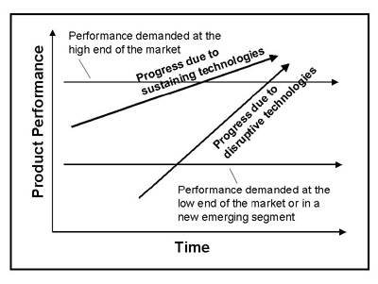

- Sustaining Technology
-> presents improvements to existing products in expected ways
- -> provides mainstream, high margin customers with enhancements in product functionality
- -> existing well established firms normally win (when sustaining technologies are introduced)
- -> get disrupted by lower stream market technologies
- -> respected, incremental, sustain existing model, help continue to make money using business model
- -> In every market there is a room for improvement

- Disruptive Technology
-> different package of attributes that aren’t valued by customers (performs worse than what’s already offered)
- -> products tend to advance performance levels that satisfy (convenient, cheap/good enough) customers who pay for lower performing functioning products (new market in itself) but don’t want to get stuck so must innovate quickly and eventually push up the sustainable companies by improving their standards
- -> new, disrupting firms usually win (established firms don’t usually take advantage of this opportunity)

- Why do large firms fail?
- Managerial – Focus on mainstream customers and don’t think outside. If you only pay attention to their needs(reasonable) and not look broader you are choosing to be safe.
- Organizational – Criteria that is put in place that doesn’t address customer needs. Companies are not willing to change their business structure (distribution, manufacturing). If it had to change or you didn’t have the appropriate skill sets then you would be in trouble.
- If you see the market as unfamiliar and you have never dealt with it because it is small or there is uncertainty for growth, it becomes hard to convince to enter these new markets because it is a risky strategy and seems unproven and unprofitable from the eyes of the large firms.

- Either a companies knowledge and skill sets is being affected an/or the way a businesses is set up including everything from marketing, distribution and so on.
- 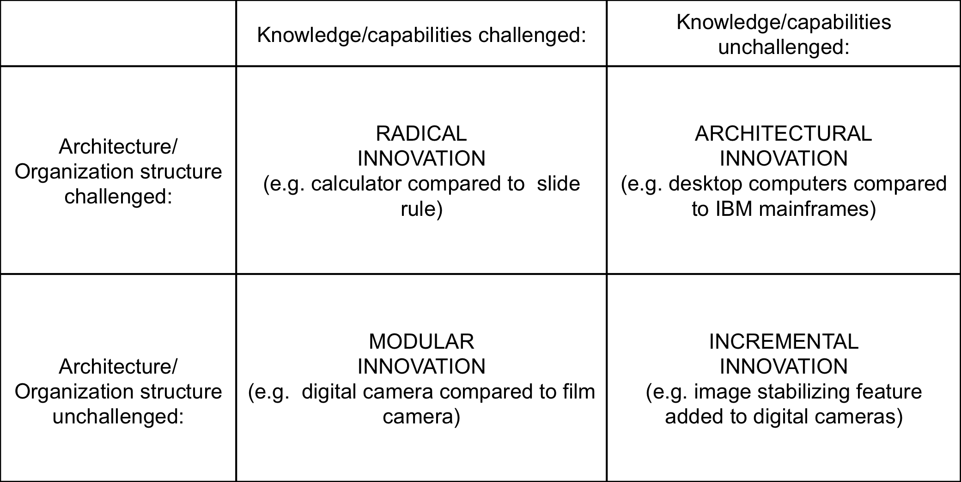
- RADICAL INVOATION – Very challenging for existing companies, no knowledge or capabilities. Challenges their structure to quickly provide and delivering new technology. New companies do better than the existing companies here. (Ex.Calculator)

- ARCHITECTUAL INNOVAYION – The capabilities are knowledge is present but it involves a very different organizational structure (Ex. Desktop computers)

- MODULAR INNOVATION – Challenges skill sets in one area (new) but the organizational structure is not being challenged as it is more simple to switch (Ex. Film to Digital camera)

- INCREMENTAL INNOVATION – Innovation comes along, not a big change for skills or structure so existing companies will do well.

- If you are the smaller firm you must go after the products and idea that the existing companies will not want to fight for or be motivated to stay with (skills/not mainstream/lack of profit). Once you become stronger you can move up the market.

- If you’re the larger firm, to avoid failure it is important that you design products based on their job and function it serves (step outside and focus on that task and identify other groups). It is also good to monitor outside of your industry (the external environment) but also monitor the different models and technologies that can bring change. Considering to invest in younger firms and forming strategic alliances is also a good idea. If you choose to do R&D as a business it is important to separate it from your office entity.

- Financial institutions facilitate flow of money

- Four distinct legal areas /”pillars”:

- - Chartered banks

- Privately owned but highly regulated. This is the largest and most important industry. Responsible for serving individuals, businesses and others by taking money from people who have it and giving it to those who need it. Major source of short term loans for businesses (secured vs unsecured loans).

Make majority of its money through deposit expansion or the “spread”.

The deregulation is the bank act that has regulated the banks and has caused them to compete with each other and to diversify their revenue stream. The consumers now demand more and embrace all the options available for them. Competition from foreign and domestic banks has caused this. Higher expectations and services has caused the banks to react. Now they deal with insurance, investments and much more than before serving from many branches.

The Bank Of Canada is the government organization above the four pillars. Its role is to manage the economy somewhat through guidance and restrictions and manages money supply. In terms of managing money supply, the BOC will either expand (tight economy) or restrict (booming economy) the money supply.

- - Alternate banks

- These include trust companies and credit unions

- - Specialized lending/saving intermediaries

- These include insurance companies, venture capital firms (taking the higher risk) and pension funds – significant institutional investors

- - Investment dealers

- Facilitating trade of securities such as stocks and bonds. All of the big banks have their own investment deals that contribute to revenue. When an organization needs more capital they work with investment banks. Primary markets are where these investment bankers help decide which investments are ideal. Investment banks buys the shares, pays the company and sells it to the investment system to make a spread. The secondary market is the TSX.

- Governments and corporations frequently borrow from foreign banks because of the benefits of choosing them over domestic banks. The international bank structure aims for stability. The world bank is responsible for providing services and funding for national improvements (countries not as independent need money for infrastructure and so on). The international monetary fund promotes stability of exchange rates and provides short-term loans to members (nothing set in stone, more of a peace keeper).

- Relationship to PEST:
Deregulation – Political
Expectations/Demand – Social
International trade - Economic
Consumer changes (online banking) - Technology

BONDS
Bonds can be used as debt for the company and an investment for the one purchasing the bond. This is a legal binding agreement that outlines the interest rate that will be paid for the investment. Bonds are often paid semi annually and this is the fixed rate of return. The fixed term, the principal being repaid at maturity is also outlined. The bondholder is always the first to receive payments before profits are shared to stockholders.

Secured bonds has some type of valuable asset associated with it. An unsecured bond is only backed up by its promise and reputation. These are also referred to as debentures.

A registered bond keeps track of the information of the bondholder for interest payments (coupon). A bearer bond on the other hand does not keep track of who the owner is and sometimes can be stolen and given up by anyone even if not registered by true owner.

Features of bonds include callable, serial and convertible. Callable bonds allows issuing organization to call it back early before maturity date (good for issuer/government). Serial bonds help organizations stagger the maturity dates so that all payments aren’t made out at the same time. Convertible bonds are basically bonds that allow users of corporate bonds to convert bond value into shares (triggered by investor).

Initial value (coupon rate):
-> Prevailing interest rates
-> Credit rating of company/government of issuer (willing to take risk+good credit rate=higher rate)

-> Features favour bond issuer or investors (attractive features means less interest rate)/

Trading price:
-> Relationship of coupon rate being traded and prevailing rates of interest in economy. The old original coupon rate issued stays the same but the interest rates are always changing.

->If economy is strong and there is a good feeling that prices will increase, riskier bonds will seem more appealing

-> If period of time where inflation keeps increasing, bonds seem less attracting because they of their coupon rate still says the same. A bond locks you in to a set rate of return and inflation eats away at the PP.

Ratios:

Yield
Percentage return on any investment

The interest equals the coupon rate x face value (always $1000)

The capital gain/loss equals the face value – purchase price

Approximate Yield to Maturity
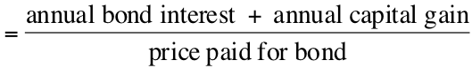
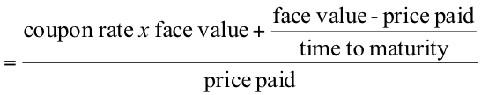 x 100

Annual bond interest (what you made) is calculated on an annual basis

When yield is higher than the coupon rate it indicated capital gain

So long as the yield is the same, the investors are happy. Bonds have lots of things that are unchangeable. What can be changed to the bond to get rid of it and sell it. If bonds have equal risk ratings they can be compared. Investors look for the same yield for comparable risk bonds. The coupon rate cant be changed, the face value cant be changed, neither than the time to maturity. What can change is the price paid. If you change the price paid you can make the yield more attractive to buyers.

Bond pricing:
-> Discount Price (Less than face value)
Coupon rate<Expected Yield
Less attractive it todays bond yields are higher

Must create capital gain to increase total yield to 5% … lower selling/purchasing price
When interest rates go up, bond prices must fall to compensate
-> Premium Price (More than face value)
Coupon rate>Expected Yield
Expected bond yield is lower than coupon rate at the current time

Because interest is offering more than todays yields, it makes sense as a purchaser to pay more and incur a capital loss to get the bond
When interest rates go down, bond prices must increases to compensate
-> Face value
Coupon rate=Expected Yield
Expected bond yields are equal to the current coupon rate
No need to create a capital gain or loss therefore pay the same as face value
When interest rates don’t go up or down, bond prices must stay at face value

So therefore bond prices have an inverse relationship with interest rates of the economy. As interest rates increase, bond prices must decrease and vice versa.

Reading bond quotations:

-> Issuer
-> Coupon (Quarter of a cent)
-> Maturity
-> Price ( Bid and Ask - % of 1000 face value)

-> Yield
-> Change

STOCKS

Issuing company is giving away ownership/equity to investor. Investor may or may no get voting right and dividends. There is no fixed return (maturity date) and their return is variable. Some stocks are more riskier than others.

Common vs Preferred Stock chart

Stock price:
- demand/supply (positive/negative facts)
- primary factors: companies earnings, rumours, bull (rising) vs. bear (falling) markets, economy, interest (preferred stocks), speculation/hype
- Undervalued issue is when the price should be higher than it is currently (attention is getting). Basically stocks that are booming and people just begin to hear about it.

Reading Stocks:
- High (52 week)
- Low (52 week)
- Stock
- Dividend
- High (Daily)
- Low (Daily)
- Close
- Change
- Volume

Volatility and Marketability are evident when reading stock quotations. Prices <$5 move in 1 cent increments and prices >$5 move in 5 cent increments. If a stock is not traded on a particular day it is because the buyers highest bid was lower than the sellers lowest ask.

Other investment vehicles:
- blue chip stocks: high capitalization (established companies)
- small-cap stocks
- penny stocks (don’t usually witness great volatility – speculative, resource companies)
- Canada savings bonds (guaranteed by gov’t)
Capitalization
= share price X number of
shares outstanding
- Guaranteed Investment Certificates (GIC-Banks)
- T-Bills (Loan, short term)
- Mutual funds (diversification)

LEVERAGE
Buying at margin:
-> investing portion of money into stock purchase, brokerage firm will provide loan with interest for remainder
-> Maximum profit is as high as it increases (no ceiling)
- Maximum Loss is unlimited
- Riskier than short selling
- Borrow money instead of shares
- No access to shares

Buying long examples

Margin buying rules:
-> Qualify for margin account
-> Signed hypothecation agreement (securities as collateral for loan)
-> Must pay interest on loan
-> Investors equity in margined stock (Current market value – loan/ Current Market Vale) must always be higher than minimum requirement
Margin call: Broker provides amount to bring % equity back up to minimum requirement by reducing loan. The brokerage max loan is the remaining percent of the CMV. Therefore Current Loan – CMV*remaining percent)

Calculating interest

Short selling:
- Sell shares you don’t own
- Borrow shares and sell at high price without incurring buy price and buy back at lower price
- Borrow from broker
- Short deposit = 150% CMV
- Agreement can be terminated by either party at any time
- Every short sale through stock exchange must be equal or greater than final close price
- Seller is responsible for covering dividends
- Maximum profit = price of short
- Maximum Loss = Uncertain
- Unlimited losses
- Cover short not always at advantageous prices

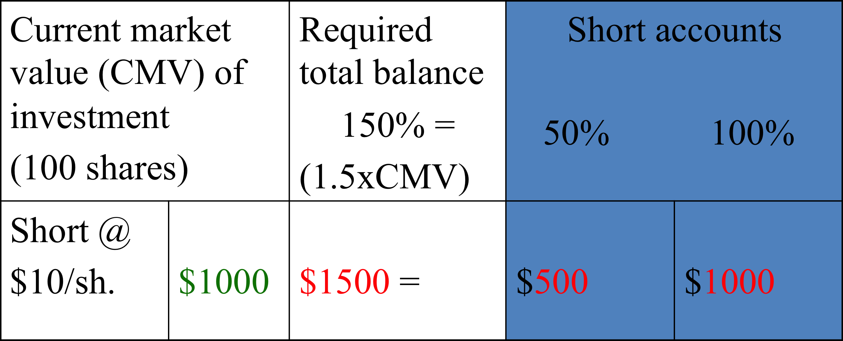

Short selling examples

Short call: CMV rises as price of stock rises so price on account must increase (150% of CMV). Therefore broker gives short call for difference for increasing short account to sit at 150%. Yield becomes less because what we pay increases.

- TO THINK ABOUT:

- Short sell a stock when you feel price of stock will fall
Capital gain = Selling price – Asset price
- Yield = Capital gain/price paid
Price of bond rises if interest rates fall (inverse relationship)
Interest= Loan price x interest rate x #of months/12
- Capital gain= Selling price – (purchase price-PC-SC)
- Leverage – make more than what you would have on your own
- Margin buying and going long if stock appears to go up relatively soon. If stock is increasing but will take a while, margin account incurs interest. Going long means stock will take longer. Short selling if stock price is decreasing
- Margin buying – interest involved, before stock price increasing it might go down
- Margin buying – money vs shares with short selling
- Change to yield when short or margin call occurs.

- Real interest = Interest – Inflation
- Investing is important to help keep up with inflation
- WRITTEN PROBLEMS

