Student Name:

Student Number:

Partner’s Name and Student #:
Demonstrator's Name: Anis

PLEASE NOTE: If ANY of the above information is UNCLEAR or not provided, your grade will NOT be recorded!!

Lab Day (circle): Tues Wed Thurs Fri

Time slot (circle): morning afternoon night

Lab Week (circle): 1 2

Laboratory Report Cover Page

Experiment 3.

Chemical Kinetics

Checklist:
- Raw Data Sheet copy attached
- 9 curves [3 for A vs t; 3 for log A vs t; 3 for log Rate vs log A] attached
- Completed formal report typed and attached

Student’s Initials

Lab 3: Chemical Kinetics
Introduction:
The experiment outlined ahead was designed to introduce the chemist to kinetics and the use of a spectrophotometer. The chemist’s will work in pairs to:
-Prepare a reaction mixture at different pH levels.
-Observe the formation of a coloured complex over a period of time.
-Determine the progression of the reaction using the ability of the coloured complex to absorb light of certain intensity.
-Plot the measured absorbance as a function of the time of reaction.
-Determine the instantaneous rate of reaction at a fixed pH using the above graph.
-Plot the calculated rate as a function of the concentration.
-Determine the partial order of the reaction with respect to one of the reactants.
-Show that the reaction generally follows pseudo first-order kinetics.
It is to be expected that in the graph, %Transmittance as a function of time will lower over time. This is due to the fact that as time passes, the concentration of the Cr(III) will lower during the reaction in the cuvette, leading to a lower absorbance rate of the light being shown. It is also expected to find out the partial order of Cr(III) in this reaction, which can only be found through experimentation. This result is to be expected in all 3 runs done during the lab. Some terminology used during the lab to follow are:
- Rate of Reaction: The change in concentration of the reactants or products over a period of time. It can be determined by calculations:
A + B P
Rate α [A]^n[B]^m
Rate = k [A]^n[B]^m
It can also be found graphically to find the instantaneous rate.
- Order: Must be determined experimentally for each reaction. It is the exponent which concentrations of reactants are used. The values of the orders of reactants added up equal the total order of the reaction. The variables used to display order are “n” and “m” in a reaction.
- Spectrophotometry: the study of the interaction of electromagnetic radiation with matter. It deals with transmittance and absorbance.
To find Transmittance: T= Intensity of light after it passed medium/Intensity of light before it passes the medium.
To find Absorbance: A= -log T
Spectrophotometry can be used to determine concentrations of fairly dilute solutions. The relation between absorbance and concentration is the beer-lambert Law: A= ɛbc
where “b” is the path length and “c” the concentration of the absorbing light. This equation shows that absorbance is directly related to concentration. The unreacted absorption of Cr(III) Nitrate is equal to
A(Cr(III) = A∞ - At

Procedure: (As outlined in the lab manual Pages 8-14) (All equipment used in the lab is based in the manual as well on page 8)

Table:

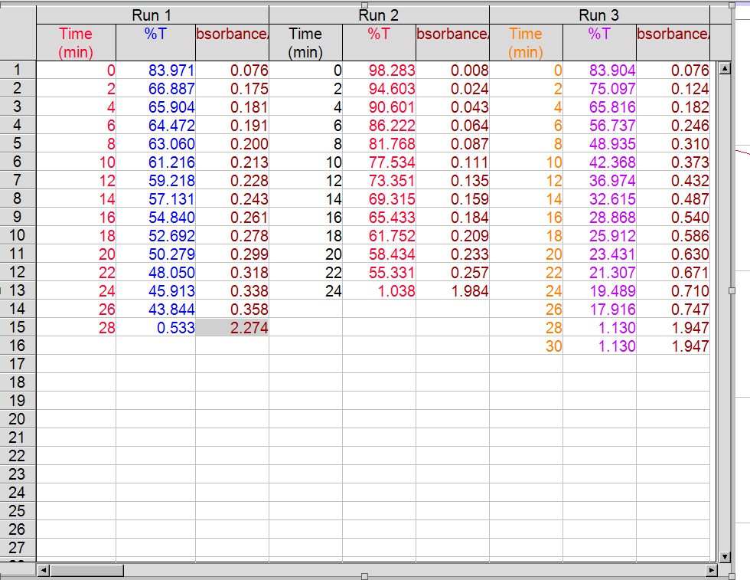

Tables with additional calculations:
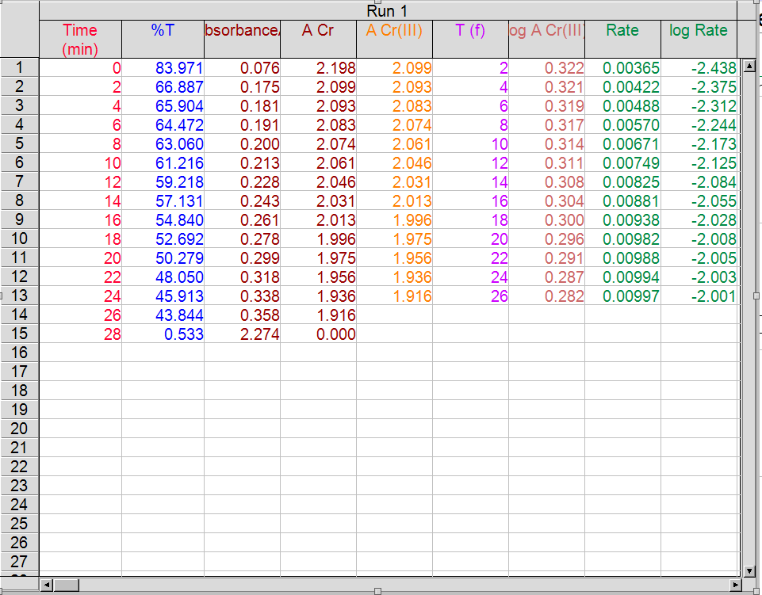
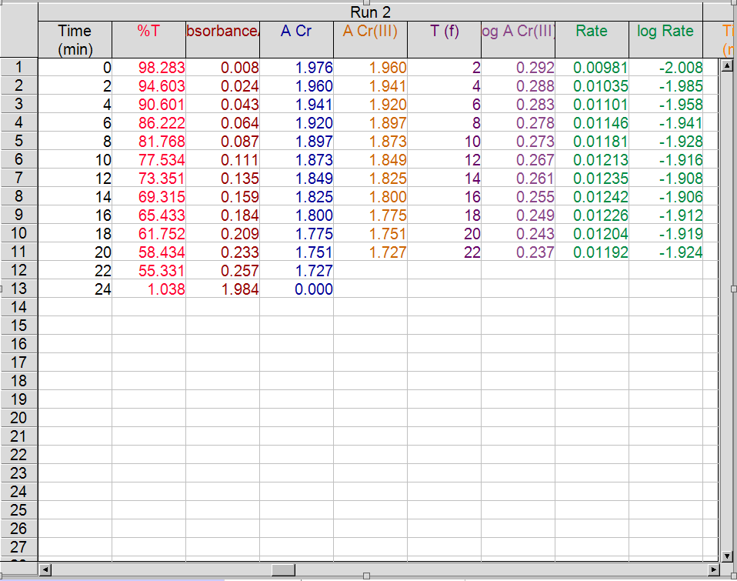
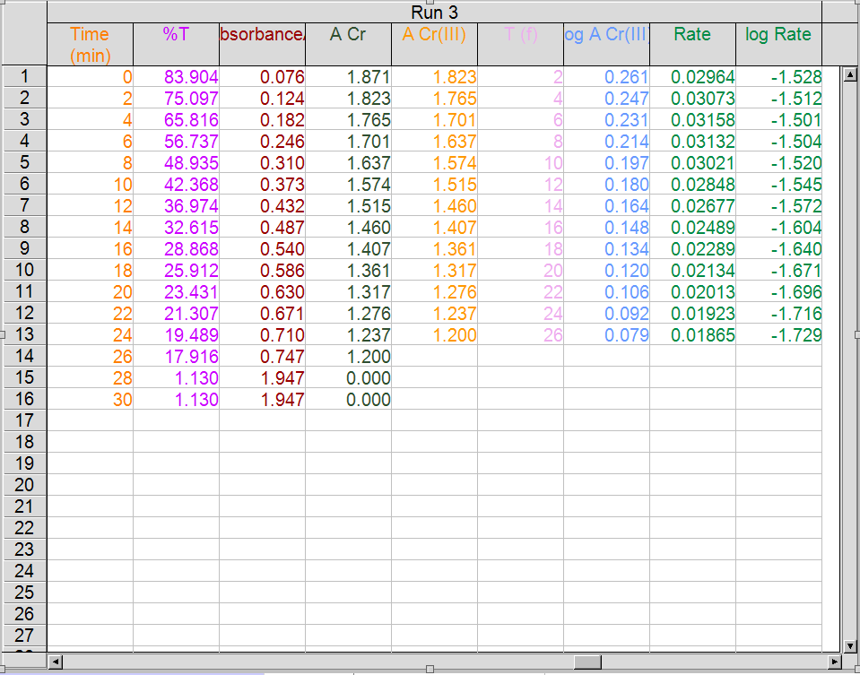
Note: The wavelength for EDTA was 9.686 @ 542.10nm even though it wasn’t explicitly shown in the table above in %Transmittance.
Observations: As the Chromium Nitrate was added to the EDTA, the colour of the solution changed to a light grey colour. When heat was added to the solution, the colour of the solution turned to a dark purple. When the heated and cooled solution were added to the cuvette, the logger pro data showed a spike in %Transmittance. The logger pro data had been relatively constant until the new solution was added. This same pattern occurred for all three trials in all 3 experiments with different pH levels in EDTA. Although, in the first experiment more than 2 drops of EDTA were added (accidently), which effected the reaction.

Calculations:
1.
-with EDTA pH 4.0
A∞ = the final Absorption value on the logger pro data of Run 1.
A∞ = 2.274
-with EDTA pH 4.5
A∞ = the final Absorption value on the logger pro data of Run 2.
A∞ = 1.984
-with EDTA pH 5.0
A∞ = the final Absorption value on the logger pro data of Run 3.
A∞ = 1.947
2.
-with EDTA pH 4.0 (Example Calculation)
ACr(III) = A∞ - At (absorbance at any time)
ACr(III) = 2.274 – ∆At
ACr(III) = 2.274 - 0.358
ACr(III) = 1.916
-with EDTA pH 4.5 (Example Calculation)
ACr(III) = A∞ - At (absorbance at any time)
ACr(III) = 2.274 – ∆At
ACr(III) = 1.984 – 0.257
ACr(III) = 1.727

-with EDTA pH 5.0 (Example Calculation)
ACr(III) = A∞ - At (absorbance at any time)
ACr(III) = 2.274 – ∆At
ACr(III) = 1.947 - 0.747
ACr(III) = 1.200
Partial Order Results: Since in the final graph, all 3 of my experiments had different partial orders, the average of all 3 were taken.
Partial Order Total: (Partial1 + Partial2 + Partial3)/3
Partial Order Total: (0 + 1 + 2)/3
Partial Order Total: 1
Graphs: (all related data Is in the lab table section above)
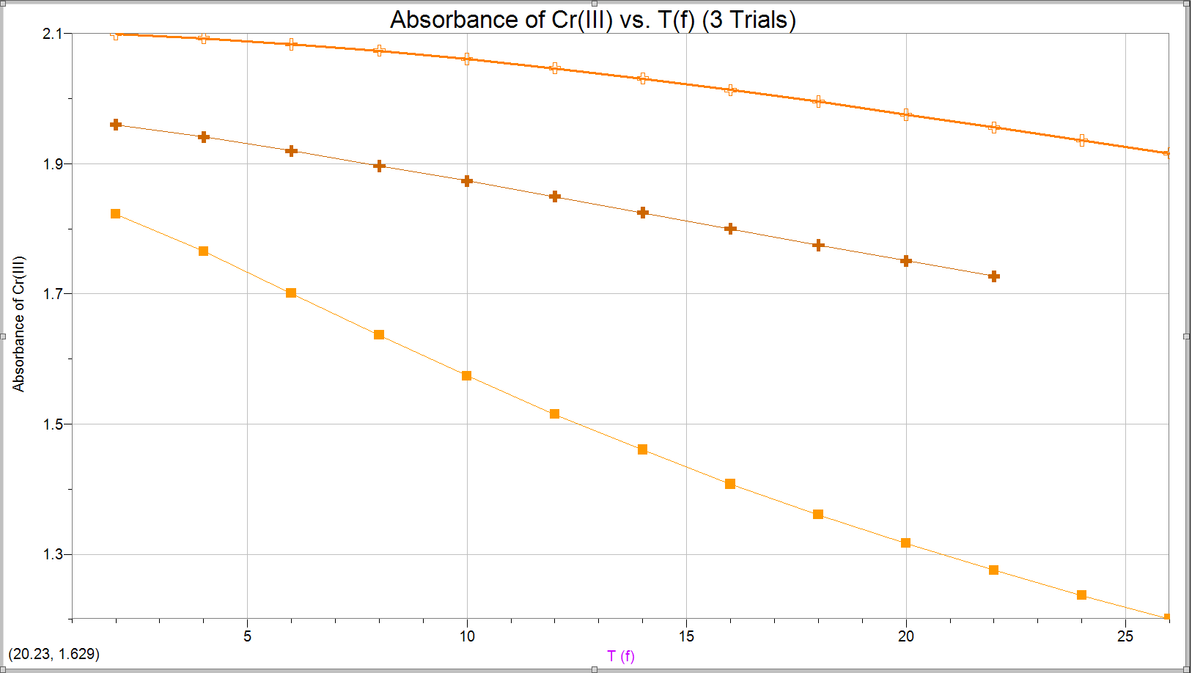

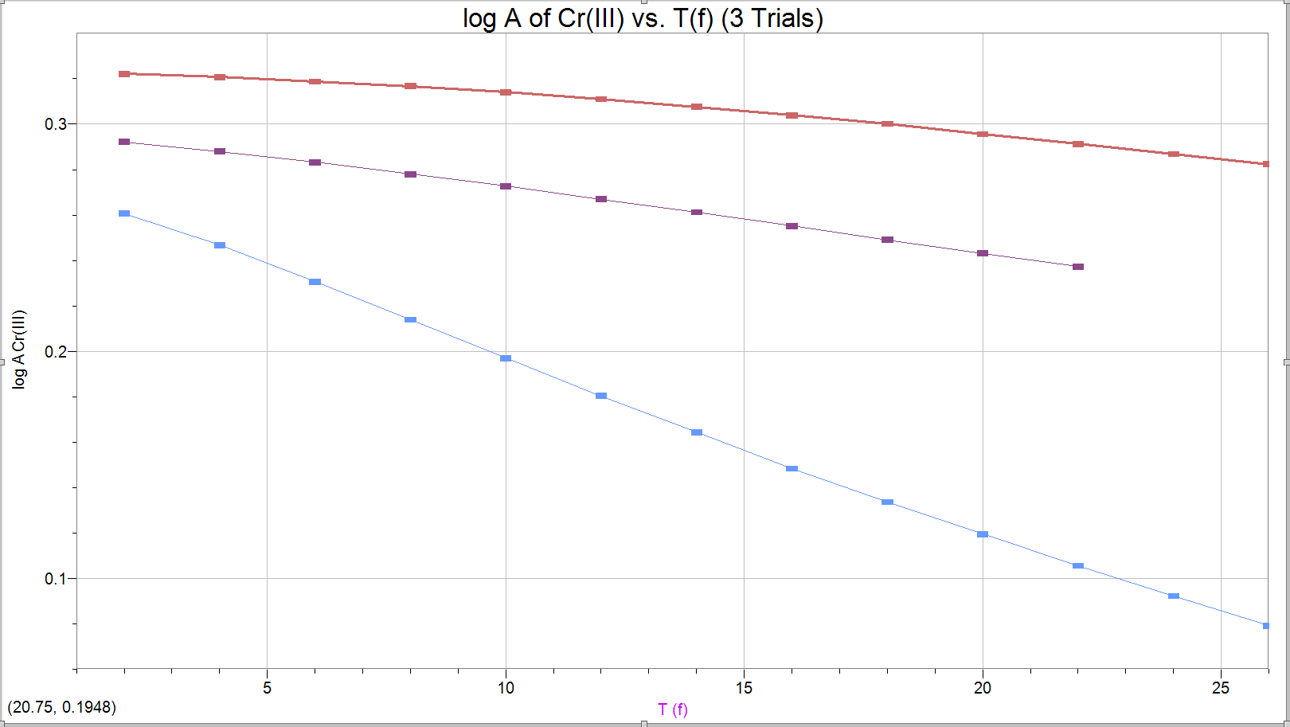
*The plot on the graph above with “Log A Cr(III) vs. Time” is fairly linear when accounting for experimental error, and this tells us that all 3 experiments have constant orders throughout the reaction.*

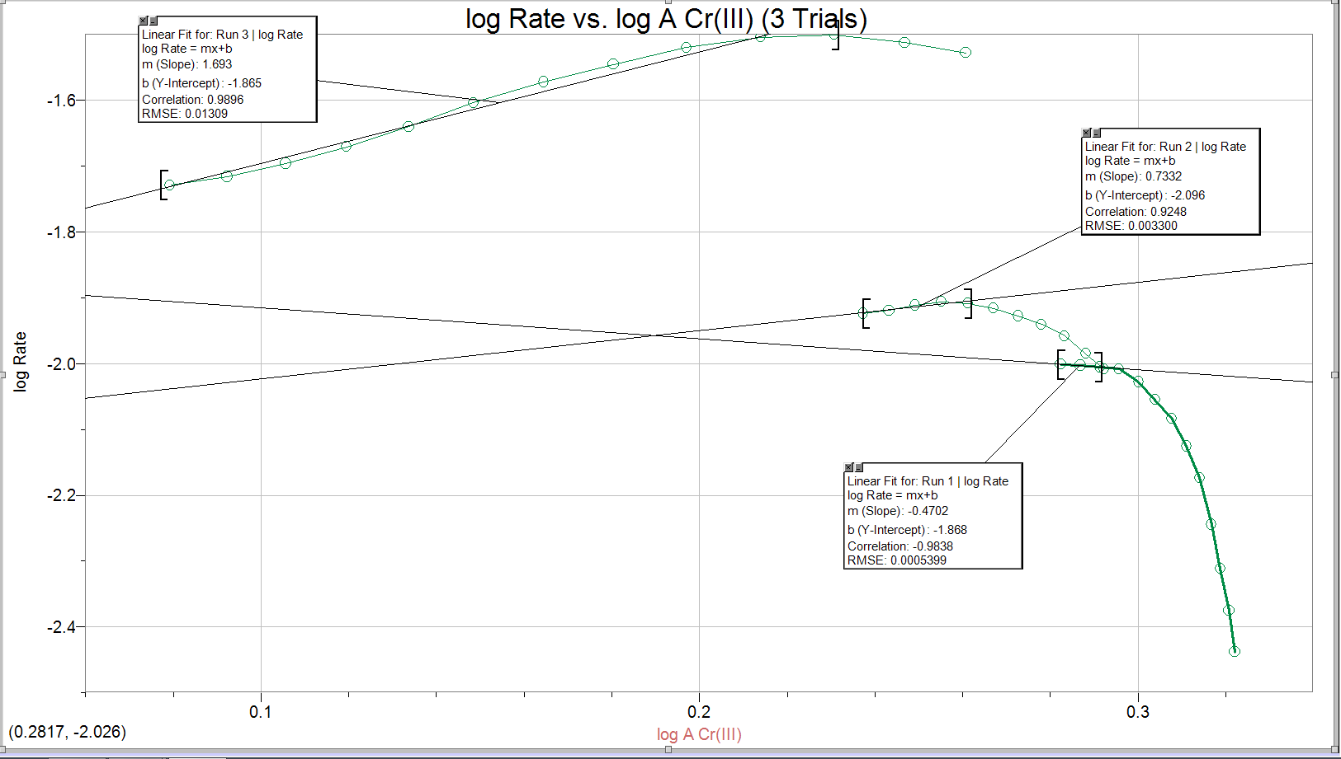
*The partial order is 1, this was calculated in the Calculations section above using averaging. The orders of Cr(III) were determined by the graph above and their slopes. Since when rounded, they equal 0, 1, 2, the average is a partial order of 1 for Cr(III). These 3 values should technically be the same for all 3 reactions because the partial order of a substance in a reaction doesn’t change no matter what outside changes happen, whether it is temperature or pH.*

Discussion:
In this experiment, a cuvette filled with EDTA and Chromium Nitrate was put inside a spectrophotometer to help determine the partial order of Cr(III) at different pH levels of 4.0, 4.5, and 5.0.
In this lab, we were asked to find the partial order of Cr(III) in a reaction with EDTA. The results from the graphs show us a certain pieces of information such as that the light shown through the solution was absorbed more and more as time went on by the Cr(III), that the reaction order of Cr(III) and the rest of the reactants remained constant throughout the reaction, and that the partial order of Cr(III) was 1. It has an order of 1 because the slope of the slope of the plot of A Cr(III) vs. T(f) gives a graph that when the order is 1, the line of the graph goes in a constant decline, which is sort of expressed in the graph above due to the lab errors.
Some sources for error in this lab includes:
- When adding the 2 drops of Cr(III) into the EDTA, a lot more than the recommended dosage of Cr(III) was added, this is harmful to the reaction because Cr(III) is supposed to be the limiting reagent in the reaction, so when the other experiments were supposed to be close to finishing, the first experiment was not nearly as finished, which is why in the graph above, the reaction order is closer to an order of 0, rather than 1.
- When putting the cuvette back into the spectrophotometer, although care was taken when wiping down the cuvette, the glass couldn’t be perfectly cleaned, causing the base %Transmittance to be slightly altered, which in turn, causes almost all of the rest of the data to be skewed. This would cause the partial order to be slightly lower or higher than 1.
- After the cuvette with the heated and cooled solution was added to the spectrophotometer, especially in experiment 1, the experiment was stopped after only 2mins had passed, giving us what could have been only a part of what could have been in regards to how much the Chromium Nitrate and EDTA absorbed the light.
- When the wavelength was being found, there were only 2 decimal places, thus the measurement wasn’t as accurate as it could possibly be, this causes the final partial order to be slightly lower or above what it should be.

Conclusion:
In conclusion, all 3 experiments lead towards different partial orders for Cr(III), but due to separate experimental errors to make these values different, when averaged, the partial order of Cr(III) in this reaction is 1. It was also found that the %Transmittance got lower over the time the experiments were running.

References:
Experiment 3 Chemical Kinetics (2015) retrieved November 8th, 2015. R. Venkateswaran. (Lab Manual)
Ebbing, Darrell D. General Chemistry 3rd ed.; Houghton Mifflin Company: Boston, MA, 1990; p 77.

