Surname (last name): ___________________________________

Given name (First name): _________________________________

Student Number: __________________________________

Chemistry 1311 D
Deferred / Supplemental Exam

February, 2013

Prof: Wendy Pell

There are 16 pages in this exam. A periodic table, formula sheet and solubility chart are provided at the end. You may tear these pages off of the exam and use them to cover your work during the exam.
Any scratch work should be on the back of the exam pages and should be handed in with your exam.

You have 3 hours to complete the exam.

 | Points Possible | Points Earned
2 | 8
3 | 8
4 | 6
5 | 9
6 | 8
7 | 8
8 | 9
9 | 5
10 | 10
11 | 8
12 | 8
13 | 8
Total | 95

1. a)Write the noble gas core electron configuration of the following atoms or ions. Identify the atom/ion as paramaganetic or diamagnetic ?
I) (2 points) ₄₇Ag

II) (2 points) ₈₂Pb⁴⁺

b) (1 points) How could you experimentally determine if an element was paramagnetic or diamagnetic?

c. (3 points) Complete the orbital energy level diagram for ₁₆S and explain the significance of the Aufbau principle, the Pauli Excusion principle and Hund’s rule in the placement and alignment of electrons occupying the 3p orbitals.

2. Draw the Lewis structure, and determine the Valence Shell Electron Pair Repulsion (VSEPR) electron group and molecular geometries of the following molecules.
Include resonance structures and formal charges where appropriate.
a) (4 points) XeF₂ (Is the molecule polar?)

Electron Group Geometry:_________________Molecular Geometry (Shape):______________

Polar ?:__________________________

d) (4 points) NCO⁻

Electron Group Geometry:_________________Molecular Geometry (Shape):______________
3. Initial rate data were collected for the following reaction at room temperature:
2ClO₂ + 2OH⁻ ClO₃⁻ + ClO₂⁻ + H₂O

 | [ClO₂] /M | [OH⁻] /M | Initial Rate
1 | 0.012 | 0.012 | 2.07*10⁻⁴ M s⁻¹
2 | 0.024 | 0.012 | 8.32*10⁻⁴
3 | 0.012 | 0.024 | 4.14*10⁻⁴
4 | 0.024 | 0.024 | 16.6*10⁻⁴

a) (4 points) Determine the rate law for this reaction.

b) (1 point) Determine the average value for the rate constant with the correct units.

c) (1 point) If the rate of disappearance of ClO₂ is 1.2*10⁻³M/s when the [ClO₂] is 0.100 M, what is the [OH⁻]] concentration?

4. The following mechanism, which includes a fast equilibrium step, has been proposed for the reaction of NO with H₂:
a) (1 points)What is the overall reaction predicted by this mechanism?

b) (4 points)What rate law is predicted by this mechanism?

c) (1 point)How might you prove/disprove the proposed mechanism ?

d) (4 points) A chemist studies the above reaction as a function of temperature. He finds that increasing the temperature from 25ºC to 38ºC doubles the rate of the reaction. Determine the activation energy for this reaction.

e) (3 points) What temperature is required to reduce the rate of the reaction to 1/10th that of room temperature?

5. (5 points) Nitric acid is used in the production of fertilizers and explosives. One step in the industrial production of nitric acid is the reaction of ammonia with molecular oxygen to form nitrogen oxide.
In a study of this reaction, a chemist mixed 200 g ammonia (NH₃) with 256 g of oxygen and allowed them to react to completion.
NH₃ + O₂ ⎯→ NO + H₂O (unbalanced)
What masses of NO and H₂O are produced if the percent yield for the reaction is 94 %?

6. a) (5 points) Assign oxidation states to the following:
i) Cl in NaClO₄

ii) S in HSO₄⁻

iii) C in CH₃OH

iv) P in P₄

v) O in O₂F₂

b) (5 points) Balance the following reaction in acid solution:
H₂S + HNO₃ H₂SO₄ + H₂O(l) + NO₂ (g)

6. You would like to determine the K_{a} of the weak acid hydrogen oxalate, HC₂O₄⁻ by titration.
a) (2 points) Which of the following reagents would you use as the titrant? Why?
i) 0.1100 M HNO₂
ii) 0.1100 M NH₃
iii) 0.1100 M KOH
iv) 0.1100 M HCl

b) (2 points) How many ml of your chosen titrant would you need to add to reach the equivalence point if you started with a 0.55 g sample of solid KHC₂O₄ dissolved in 20 ml of water?

c) (5 points) When only 15 ml of 0.1100 M base are added to your 20 ml solution containing 0.55 g of KHC2O4, the pH is measured and found to be 3.98.
i) Complete the following reaction neutralization reaction:

HC₂O₄⁻ (aq) +

ii) Determine the K_{a} for hydrogen oxalate

d) (1 point) What is K_{b} for the oxalate anion, C₂O₄²⁻ ?

e) (4 points)What is the pH at the equivalence point of this titration?

Bonus: Someone spilled concentrated sulphuric acid on the floor in the chemistry laboratory. You want to neutralize the acid, would it be better to pour concentrated NaOH solution or to sprinkle solid sodium bicarbonate over the acid? Explain your choice.

7. The odour from pineapple is due to the presence of the compound ethyl butyrate, which contains only carbon, hydrogen and oxygen. Combustion of 2.78 mg of ethyl butyrate at 20 ºC and atmospheric pressure produces 3.45 ml of CO₂ (g) and 2.584 μl (2.584 x 10⁻⁶ L) of H₂O(l). The density of water at 20 ºC is 0.99820 g/ml.
a) (2.5 points)Determine the % weight of carbon in ethyl butyrate.

b) (2.5 points)Determine the % weight of hydrogen in ethyl butyrate.

c) (1 points)Determine the % weight of oxygen in ethyl butyrate.

d) (2 points)What is the empirical formula for ethyl butyrate?

e) (2 points)Determine the molecular formula of ethyl butyrate given that the molar mass is 116.16 g/mol.

8.) A 1.0 L solution contains 5.85 g of NaCl and 21.23 g of K₃PO₄.
a) (1 points) What ions will you find in the solution ?

b) (4 point) Solid AgNO₃ is added (without changing the volume). Given that the solubility products of AgCl and Ag₃PO₄ are 1.6x10⁻¹⁰ and 1.8x10⁻¹⁸, respectively, identify the precipitate that forms first.

c) (3 points) Is the separation successful? (proof required)

9. Nitric oxide and bromine react to form NOBr(g). NO and NOBr are placed in a 2L reaction vessel at 300K at initial pressure of 15.8 and 82.6 torr, respectively. At equilibrium, the total pressure of the system was 98.7 torr.
a) (1 point) Balance the following reaction:

NO (g) + Br₂(g) NOBr (g)

b) (4 points) Calculate K_{c}

c) (3 points) An additional 0.683 g of Br₂(g) is added to the equilibrium mixture in part b. Determine the total pressure once the new equilibrium is established.

10.a (4 points) Acetylene, C₂H₂(g) and benzene, C₆H₆(l) have the same empirical formula and benzene can be made from acetylene:
3C₂H₂(g) C₆H₆(l)
The enthalpy for complete combustion of acetylene and benzene are -1299.4 kJ/mol and -3267.4 kJ/mol, respectively. Using this information and the standard heats of formation below determine the enthalpy of formation of acetylene and benzene and the enthalpy change for the formation of C₆H₆ from C₂H₂.
CO (g) Δ_{f}H = -110.5 kJ/mol CO₂(g) Δ_{f}H = -393.5 kJ/mol
H₂O(g) Δ_{f}H = -241.8 kJ/mol CO₂(aq) Δ_{f}H = -412.9 kJ/mol

b. (4 points) At 25 ºC and 1 bar, phosphorus is a solid, P₄(solid). It can be burned in excess oxygen gas resulting in the formation of P₄O₁₀(s). The reaction of 10.0 g of solid phosphorus generates enough heat to raise the temperature of 2950 g of water from 19.0 ºC to 39.0ºC. Calculate the enthalpy of formation P₄O₁₀(s). Heat capacity of liquid water is 4.18 J ºC⁻¹g⁻¹; of ice 2.05 J ºC⁻¹ g⁻¹; of steam 1.996 J ºC⁻¹ g⁻¹; ΔH_{vap} 40.7 kJ mol⁻¹; ΔH_{fusion} = 6.0kJ mol⁻¹

Bonus: What was going on in the last slide of the last lecture?

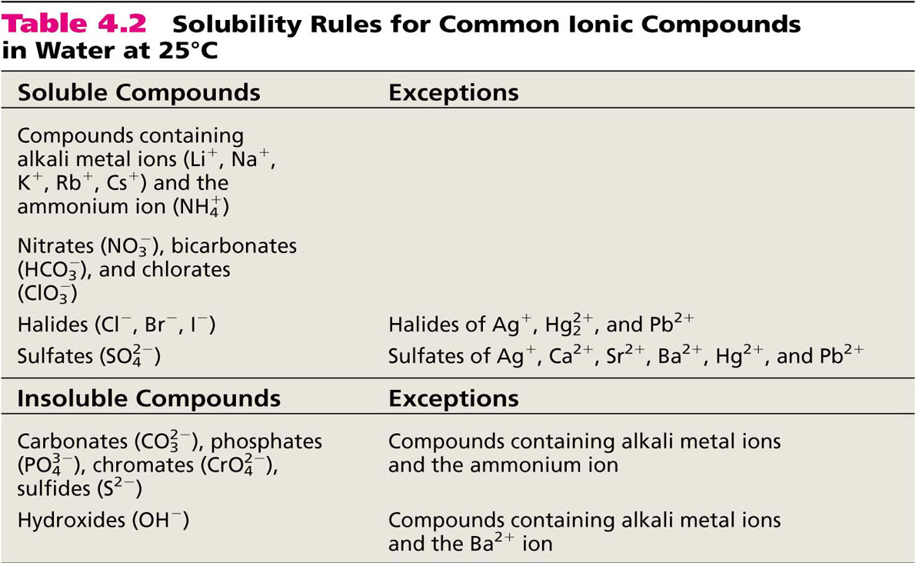

Constants:

Avogadro’s Number (N_{A}) 6.02 x 10²³
Faraday’s constant (F) 96,500 C/mol e⁻

Universal Gas Constant (R) 8.314 J mol⁻¹ K⁻¹ 8.314 kg m² mol⁻¹ K⁻¹ s⁻²
0.08206 L atm mol⁻¹ K⁻¹
0.08314 L bar mol⁻¹ K⁻¹

Planck’s constant (h) 6.626 x 10⁻³⁴ J s
Rydberg Constant (R_{H}) 2.18 x 10⁻¹⁸ J
Speed of light(c) 3.00 x 10⁸ m/s

Conversion Factors :
1 atm = 760 torr
= 760 mm Hg
= 101.3 kPa
= 1.013 bar

EQUATIONS SHEET

Gas Law
PV = nRT
P_{T} = P₁ + P₂ + P₃ + ....
d = m/V = P(MW) / RT
KE = ½ m v_{av}²
P_{A} = X_{A}P_{T}

Acid/Base
pOH = -log [OH⁻]
pH = - log[H⁺]
pH + pOH = 14
K_{a} x K_{b} = K_{w}
pH = pK_{a} + log [A⁻]/[HA]
pH =
K_{w} = 10⁻¹⁴

Kinetics
ln[A]_{t} = -kt + ln[A]_{o}
[A]_{t} = -kt + [A]_{o}
1/[A]_{t} = kt + 1/[A]_{o}
k = A e ^{–Ea/RT}
t_{1/2} = 0.693/k
t_{1/2} = [A]_{o} /2k
t_{1/2} = 1/ k[A]_{o}
ln(k₁/k₂) = E_{a}/R (1/T₂ – 1/T₁)

Thermodynamics
ΔU = q + w
ΔH = ΔU + Δ(PV)
w = -PΔV = -Δn RT
ΔH = q_{p}
ΔHº_{rxn} = ΣnΔHº_{f} (prod) – ΣmΔHº_{f} (react)

q = mCsΔT q = nC_{m}ΔΤ
q = CΔT
ln(K₁/K₂) = ΔH_{o}/R (1/T₂ – 1/T₁)

Equilibrium
K_{P} = K_{C}(RT)^{Δn}


