Macroeconomics Notes: Midterm Winter 2016

INTRODUCTION:
Ten Principles of Economics
- People face trade offs
- The cost of something is what you give up to get (opportunity cost)
- Rational people think at the margin (marginal benefit vs. marginal cost, benefit has to be more than cost)
- People respond to incentives (punishment or payment- carrots or sticks)
- Trade can make everyone better off (not that simple)
- Markets are usually a good way to organize economic activity (externalities: pollution)
- Governments can sometimes improve market outcomes (
- A country's standard of living depends on its ability to produce goods and services
- Prices rise when the government prints too much money
- Society faces a short-run trade off between inflation and unemployment

Economics is more than supply and demand. Study a 360 view of the market between all consumers. Government considered as a whole.

Information on the market (behind supply and demand)-Expansion of #7
- Monopolies are not supposed to have supply curves they are for perfect competition
- Externalities (positive or negatives that affect other people who are not using the good)
- Asymmetric information: not everyone knows everything, gaps in information so people are going to "signal" (showing that you are capable, productive)

Thinking like an economist
Economists play 2 roles:
- Scientists: try to explain the world
  - Scientific method: the dispassionate development and testing of theories about how the world works. Combination between data and having the correct approach. Model that uses effort is not enough there needs to be a theta which represents "smarts".
- Policy advisors: try to improve it
  - Positive statements: attempt to describe the world as it is (can be confirmed or refuted)
    - Statement doesn't have t be true to be positive
  - Normative statements: prescribe how the world SHOULD be. (cannot be confirmed/refuted)
Bank of Canada employs economists

Why economists disagree? i.e. they give conflicting policy advice (not that important)
- Disagree about the validity of alternative positive theories about the world
- Different values, therefore different normative views about what a policy should accomplish

THE FORCES OF SUPPLY AND DEMAND
Words used most often by economists, supply and demand are the forces that make market economies work
- Supply and demand refer to the behaviour of people as they interact with one another in a competitive market: negligible impact on market price between buyers and sellers (not monopoly-NO SUPPLY CURVE)

Market: A group of buyers and sellers of a particular good/service
- Your work is supply, socialist economy only focuses on supply, never demand
- Competitive market: many buyers and sellers each has a negligible impact on market price
  - Not enough market power to move market price
  - (1) The goods offered for sale are exactly the same, (2) the buyers and sellers are so numerous that ni single buyer or seller has any influence over the market price

Demand: behaviour of consumers** finish
- Quantity demanded: (at a certain price, at a point on graph) amount of good that buyers are willing/able to purchase negativly related to price
- Law of demand: Quantity of good demanded falls when the price rises
- Demand schedule: table that shows relationship between price of a good and the quantity demanded
  - Negative sloping line
- Demand curve: a graph of the relationship between the price of a good and the quantity demanded
  - Negative sloping line
- Marginal utility: What you are WILLING to pay
- Market demand: the sum of all the individual demands for a particular good/service (still follows law of demand)

Rule of assumption behind demand curve based on diminished satisfaction the more you purchase cost has to be lower than the amount of satisfaction given. (**lower price the more you buy) satisfaction falls as consumption rises
Shifts in the demand curve: Any change that rises the quantities that purchasers wish to purchase at a given price shifts the demand curve to the right a vice versa
Factors that shift the demand curve:
- Income: (whole curve moves)
  - Normal good: a good for which other things equal, an increase in income leads to an increase in demand (right)
  - Inferior good: a good for which, other things equal, an increase in income leads to decrease in demand (left)
- Price of related goods:
  - Substitutes: two goods for which an increase in the price of one leads to an increase in demand for the other (ex. Chicken vs. beef, both protein, get the same thing out)
  - Complements: two goods for which an increase in the price of one leads to a decrease in the demand for the other (ex, ice cream and ice cream cones)
- Tastes
- Expectations: if you think you are going to get a larger wage in the future you will buy more today. (Less if its an inferior good)
- Number of buyers
*When you move a price of a good and your interested in the variation (price) affecting quantity move ON curve, for any other influences on demand move WHOLE curve

The Supply Curve: Behaviour of sellers, The Relationship Between Price and Quantity Supplied (opposite of demand curve)
Quantity supplied: The amount sellers are willing and able to sell
Supply Schedule: table that shows the relationship between price of a good and quantity supplied
Supply curve: graph of relationship between price of good and quantity supplied
- Always a positive slope
Law of supply: quantity supplied of a good rises when the price of a good rises
Quantity supplied: (point on the line)

Market supply vs. individual supply:
- Individual supply:**
- Marginal cost increases within short term, moves with production
- Market supply: the sum of supplies of all sellers
Shifts in the supply curve: (add quantities move to right)
Price of good itself: represents movement along supply curve
Factors that shift the supply curve:
- Input prices (more expensive move left)
- Technology (better technology produce more)
- Expectations
- Number of sellers (left, decrease)

Supply and Demand Together: determine price and quantity of a good in the market
Equilibrium: Price has reached the level where quantity supplied equals quantity demanded
- Surplus (above equilibrium price): excess supply
- Shortage (lower than equilibrium price): excess demand, prices low but suppliers only willing to sell 4 units
Law of supply & demand: Price of any good adjusts to bring the quantity supplied and the quantity demanded for that good into balance
3 Step Program for Analyzing Changes in equilibrium:
- Decide whether shifts the supply or demand curve (or both)
- Decide what direction the curve shifts
- Use the supply and demand diagram to see how the shift changes the equilibrium price and quantity (once equilibrium is achieved in both markets supply and demand will stop shifting) *prices will be the same
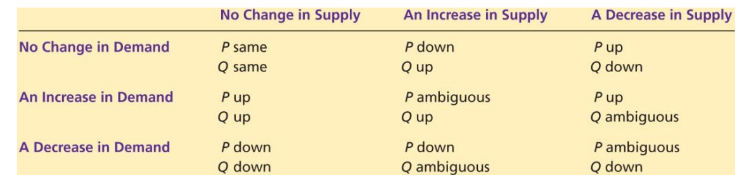

MEASURING A NATIONS INCOME:
Microeconomics: The study of how individuals and how firms make decisions and how they interact in markets
Macroeconomics: Study of economy wide phenomena, including inflation, unemployment and economic growth

Measuring a Nations Income:
Gross domestic product (GDP): measures the total income of a nation; the most closely watch economic statistic because it’s the best measure of a society's economic well-being
- GDP- the market value of all final goods and services produced within a country in a given period of time (measure)
- Adds together many different kinds of products into a single measure of the value of economic activity
  - Includes all items produced in the economy and sold legally in markets
  - Includes the market value of housing services provided by the economy's stock of housing
  - Some products excluded because measuring them is so difficult
  - Includes only the value of final goods
  - The reason is that the value of intermediate goods is already included in the process of the final goods
  - An important exception to this principle: arises when an intermediate good is produced and is added to a firm's inventory of goods to be used or sold at a later date

- Goods and services: GDP includes tangible (food, clothing, car) and intangible services (haircuts, house cleaning, dentist)
  - Includes goods and services currently produced

- Within a Country: GDP measures the value of production within the geographic confines of a country

- In a given period of time: GDP measures the value of production that takes place within a specific interval of time (Usually a year or a 1/4)
  - Measures the economy's flow of income and expenditure during that interval

The components of GDP: Y= C + I + G + NX
Y = GDP
C = Consumption
I = Investment
G = Government purchases
NX = Net exports

The economy's income and expenditure: for an economy as a whole income must EQUAL expenditure

Figure 5.1: The circular flow diagram
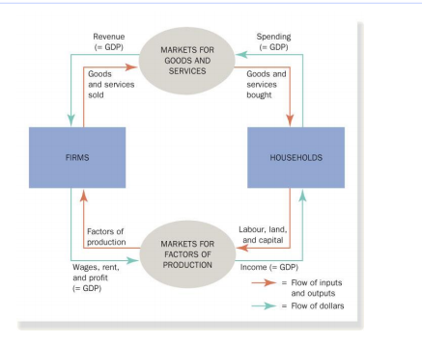
Consumption: Spending by households in goods and services, with the exception of purchasing of new housing
Investment: Spending in capital-equipment, inventories and structures, including household spending on new housing
Government Purchases: Spending in goods and services by local, territorial, provincial and federal governments
Net Exports: The value of a nations exports minus the value of its imports; also called trade balance (pg. 75 study guide- #19)

Other measures of Income:
- Gross national product
- Net national product
- National income
- Personal income
- Disposable personal income

Real (quantity) vs. Nominal (prices) GDP:
If spending rises from one year to the next, one of two things must be true
- The economy is producing a larger output of goods and services
- Goods and services are being sold at higher prices
When studying changes in the economy over time, economist want to separate these two effects
Nominal GDP= (prince per item x quantity of item)
Real GDP (base year, choose one year and keep prices constant throughout using this years prices) = (quantity varied x constant prices)

The GDP Deflator: a measure of the price level calculated as the ratio of nominal GDP to real GDP times 100 (reflects movement in prices) takes out movement of quantities (real GDP)- see formula below *question on exam
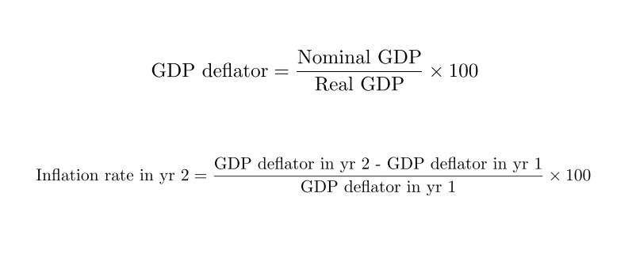

MEASURING THE COST OF LIVING:
The consumer price index is used to monitor changes in the cost of living over time…
When the consumer price index rises, the typical household has to spend more dollars to maintain the same standard of living

Economists use the term inflation to describe a situation in which the economy's overall price level is rising.

The consumer price index (CPI): the overall measure of the cost of the goods and services bought by a typical consumer
- Every month Statistics Canada computes and reports CPI
- It uses data on the prices of more than 600 goods and services

How is the consumer price index calculated:
Calculating the CPI and the Inflation Rate:
- Survey consumers to determine a fixed basket of goods (quantity never moves)
- Find the price of each good in a year
- Compute the cost of the basket of goods in each year
- Choose one year as a base year and compute the consumer price index in each year
- Use the consumer price index to compute the inflation rate from previous year (inflation rate in year 2 formula)

Problems in Measuring the Cost of living:
- Commodity substitution bias
- Introduction of new goods
- Unmeasured quality change
Taken together, these soures of bias cause the CPI to overstate the cost of living by 0.6% (according to bank of canada) http://business.financialpost.com/fp-comment/dont-inflate-inflation

**The GDP Deflator vs. The Consumer Price Index
- The GDP deflator reflects the current level of prices relative to the level of prices in the base year
- Economists and policy makers monitor both the CPI and the GDP deflator to gauge how quickly prices are rising
- Two differences:
  - The GDP deflator reflects prices of goods and services produced domestically
  - The GDP deflator compares the price of currently produced goods and services with the price of the same goods and services produced during the base year

Correcting Economic Variables for the Effects of Inflation: The purpose of measuring the overall level of prices in the economy is to permit comparison between dollar figures from different points in time
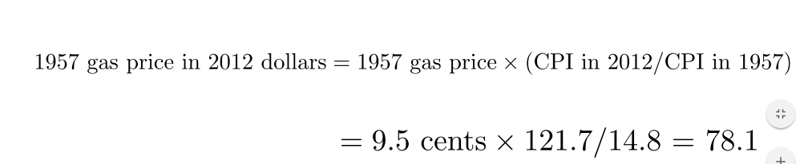
- http://www.bankofcanada.ca/rates/related/inflation-calculator/

Indexation: The automatic correction of a dollar amount for the effects of inflation by law or contract
- COLA: Automatically raises the wage when the CPI raises

Real and Nominal Interest Rates: Interest rates involve comparing amounts of money at different points in time, knowing how to correct for the effects of inflation is important
- Suppose you make a deposit of $1000 in a bank account that pays interest at a rate of 10% a year
  - After one year that account contains $1100 (=principal of 1000 + interest 100)
    - Are you actually wealthier after one year?
- Nominal Interest Rate: Interest rate reported without a correction for the effects of inflation
- Real interest rate: Corrected for the effects of inflation
- Real interest rate= nominal interest rate - inflation rate

PRODUCTION AND GROWTH:
Production & Growth:
- Diversity in living standards and growth rates globally
- How can rich countries ensure they maintain high standards of living
- What policies should poor countries pursue to promote rapid growth to join developed world

Economic Growth Around the World: Data on real GDP per person shows that living standards vary from country
Income per person in Canada:
- 6 times higher than China
- 12 times higher than India

Productivity: Its role and determinants
Explaining the large variation in living standards around the world- summarized by
Productivity: The quantity of goods and services produced from each hour of a worker's time
Productivity is important because:
- Productivity is the key determinant of living standards
- Growth in productivity is the key determinant of growth in living standards
- For a country to enjoy a high standard of living, it must produce a large quantity of g/s

How productivity is determined:
- Physical capital per worker
  - Difference from financial capital (can turn into machine), the stock of equipment and structures that are used to produce goods and services
- Human capital per worker
  - The knowledge and skills that workers acquire through education, training and experience (investment because you accumulate knowledge, comes from word capital) train yourself into producing better
- Natural resources (less important in current days, you can import)
  - The inputs into the production of goods and services that are produced by nature, such as land, rivers and mineral deposits
- Technological knowledge (most important)
  - Get better at producing stuff, society's understanding of the best ways to produce goods and services (faster and more precise, common knowledge of whole society but must make effort to turn into human capital**)

Economic growth and public policy:
- The importance of saving and investment
- Diminishing returns and the catch-up effect
- Investment from abroad
- Education
- Heath and nutrition
- Property rights and political stability
- Free trade
- Population growth

The Importance of Saving and Investment
Because resources are scarce, devoting more resources to producing capital requires devoting fewer resources to producing goods and services for current consumption
- Consequently, the accumulation of capital involves trade off (by saving a lot you invest a lot, consume in future) (if you consume everything today you have nothing left to invest)
- When government encourages saving and investment, they encourage growth and in the long run this raises the standard of living
- If you're not saving enough you can encourage investment by opening economy

Diminishing Returns and the Catch-up Effect
- Successful government policies that raise the saving rate mean that fewer resources are needed to make consumption goods and more resources are now available to make capital good (accumulate capital)
- Capital stock increases which raises productivity and thus leads to higher growth for GDP
- Note, benefits from additional capital becomes smaller over time, so growth slows.
- In long run higher saving rate leads to higher productivity and income that slows over time
  - Known as, diminishing returns: the benefit from an extra unit of an input declines as the quantity of the input increases (cannot grow infinitely, less and less output related to PACE)
  - 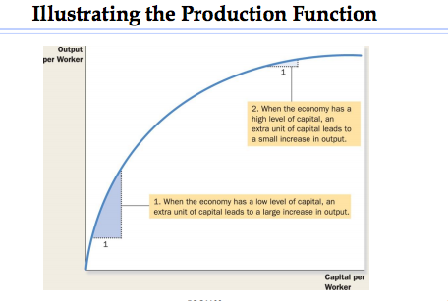
- Diminishing returns to capital has another application:
  - All things equal, it is easier for a country to grow if it starts poor
  - Catch up effect: countries that start off poor tend to grow more rapidly than countries that start rich (not really happening to some according to data, ex. Africa, therefore we need more elements in explanation *related to good institution)

Investment from Abroad: Investment from foreigners is another way for a country to acquire new capital
- Foreign direct investment: A capital investment that is owned and operated by a foreign entity
- Foreign indirect investment: An investment that is financed with foreign money operated by domestic residents (You can't operate company)
- Foreign portfolio investment: (same as above)
Investment from abroad does not have the same effect on all measures of economic activity
- GDP increases because the investment increases Canada's capital stock
- GNP increases by less because the profits generated from the foreign investment return to the country of the investors

- Investment from abroad can help a country grow
- The World Bank tries to encourage the flow of capital to poor countries(linked to international financial system, but HEAVILY linked to American dollar, after WWII you needed to have an economy that you can trust- hence the America's)
- Economic distress often leads to political turmoil, international tensions and military conflict
- The World Bank and the International Monetary were created after WWII to promote economic prosperity around the world

Education: Investment in human capital (education) is at least as important as investment in physical capital for long-run economic success
- Education leads to higher wages and salaries
- Government policy can improve standard of living by giving good schools
- Also important for economic growth because it has positive externalities (the effect of one person's actions on the well-being of a bystander)
- Some poor countries use brain drains: the immigration of many of the most highly educated workers to rich countries, where they can enjoy a higher standard of living (they can't do as much in rich countries)

Health and Nutrition: Healthier workers are more productive **poverty trap/health trap: you start as poor and are exposed to health hazards (education/health) cannot make money to take care of health/education
- The casual link between health and wealth runs in both directions
- Poor countries are poor because populations are not healthy…Their populations are not healthy because they are poor (vicious cycle)
- Policies that lead to more rapid economic growth would naturally improve health outcomes. In turn, this would further promote economic growth.

Property Rights and Political Stability: In a free-market economy, it is invisible hand that brings supply and demand into balance in the many markets.
- For the price system to work, property rights (the ability of people to exercise authority over the resource they own) must be respected
- Political instability is a threat to property rights
- When revolutions are common, there is a doubt that property rights will be respected in the future
- There is less incentive to save by nationals, and foreigners have less incentive to invest
- Countries with an efficient court system, honest government officials and a stable constitution will have higher standards of living

Free Trade:
Poor countries are better off pursuing outward oriented policies that integrate these countries into the world economy (to specialize you need to close industry that causes unemployment)
- Countries that eliminate trade restrictions often experienced the same kind of economic growth that would occur after a major technological advance
- Trade volume is not only determined by government policy but also be geography

Research & Development: Major reason why living standards are higher today because of state of the art technological knowledge has progressed
- Even if most R&D is conducted in private sector there is public interest in promoting such effort
- Knowledge is a public good
- Governments have vested interest in promoting R&D
  - Canadian Government: Funded research in DANDU nuclear reactors, offered research grants from the National Sciences and Engineering Research Council, offering tax breaks to firms that engage R&D, managed the patent system

Population Growth: Large population means a larger total output of g/s.
Stretching natural resources:
- A large population means a larger workforce
- Large population = more consumers
  - Therefore, a large population need not mean a higher standard of living
- Thomas Robert Malthus (1766-1834) argued that an ever-increasing population would continually strain society's ability to provide for itself (opposite to Smith's belief). Growth rate of society is greater than growth rate of production leading to poverty per capita.
  - Mankind was doomed to forever to live in poverty (wrong: bigger population, more smart people, more medicine birth rate high death rate low, high birth rate will even out to be low to meet death rate)- restrictions not needed
Diluting Capital Stock: According to this theory, high population growth reduces GDP per worker because rapid growth in the number of workers forces the capital stock to be spread more thinly
- A smaller quantity of capital per worker leads to lower productivity and lower GDP per worker
- Population growing too fast less and less capital available

SAVING INVESTMENT AND THE FINANCIAL SYSTEM:
Financial System: The group of institutions in the economy that help to match one person's savings with another person's investment (real economy influenced by financial system), gives money to people that need the money for a period of time to pay back at a later date.
Financial institutions can be grouped into 2 categories:
- Financial markets
- Financial intermediaries

Financial markets: Financial institutions through which savers can directly provide funds to borrowers
- The bond market:
  - Bond: a certificate of indebtedness that specifies the obligation of the borrower to the holder of the bond (done by government (lower risk- authority of taxation) & private enterprises- Principle + interest) Date of maturity = when you pay back
    - Debit finance: the sale of a bond to raise money Can only claim money at end of date of maturity
  - Characteristics:
    - The bond's term
    - The bond's credit risk
- The stock market:
  - Stock: represents ownership in a firm and is therefore a claim to its profits. (1. Initial public offering 2. Sell stock at another price by people that acquired the stock in the first place- prices dropped because it is a market)
At end of period: Who gets paid first? Stock or bond owners? A: BOND OWNERS, owners have responsibility (if doing poorly), if doing well stock owners benefit more.
- Equity finance: the sale of a stock to raise money. Prices at which shares trade on stock exchanges determined by supply and demand of stock.
- Stock index: is an average of a group of stock prices
  - Dow Jones Industrial Average
  - S&P/TSX Composite Index
- Derivatives: Bought and sold without knowing what is inside them, therefore you don't know the price (ex. Housing market), helps with risk taking.

Financial Intermediaries: Financial institutions through which savers can indirectly provide funds to borrowers
- Bank: The primary function of a bank take deposits from savers and use these deposits to make loans to people who want to borrow
  - **Investment banking: don't care about deposits, only care about investments
- Mutual funds: an institution that sells shares to the public and uses the proceeds to buy a portfolio of stocks and bonds
  - Allows diversification
  - Access to the skills of professional money managers
  - George Soros

Saving and Investment in the National Accounts:
Accounting: refers to how various numbers are defined and added up
- The national income accounts include in particular, GDP and many related statistics

GDP (or Y) = C + I + G + NX
In a closed economy (not interacting on an international basis ex. North Korea):
NX = 0
Y (GDP) = C (consumption) + I (investment) + G (government)

Y - C - G = I
Y - C - G (grouped are "S")
S (savings) = I (investment) *****
National savings (S): The total income in the economy that remains after paying for consumption and government purchases

Let T denote the taxes collected by government minus transfer payments
National saving can be expressed in two ways:
S = Y - C - G
Or
S = (Y - T - C) + (T-G) (emphasize role of government, will equal 0)

Private saving: the income that households have left after paying for taxes and consumption
- Y - T -C
Public saving: the tax revenue that the government has left after paying for its spending
- T - G

Budget surplus: T (greater than) G (taxes higher than spending) Posterity (asking government to spend less)
Budget deficit: T (less than) G, political economy of budget deficit- incomes are higher = more taxation, more money comes in, therefore our government will hopefully save more. Currently they are spending too much, they do the opposite. In times of crisis government SHOULD spend more, people want posterity, but again the government does the opposite. (they save) = counter inutuity = answer to greek crisis

The meaning of saving and investment:
- Although the accounting identity S=I shows that saving and investment are equal for the economy as a whole this does not have to be true for every individual household firm
- Government Bond isn't an investment it is a saving (in real world economics)

Suppose GDP= $10 billion, consumption = $6.5 billion, the government spends $2 billion and has a budget deficit of $300 million
Find public saving, taxes, private saving, national saving nd investment
Given: Y= 10.0, C=6.5 G=2.0, G-T=0.3
Public saving= T-G = -0.3
Taxes: T = G - 0.3 = -0.3 1.7
Private saving = Y - T -C = 10 - 1.7 -6.5 = 1.8
National saving = Y - C -G = 10 - 6.5 - 2 = 1.5
Investment = national saving = 1.5

Active learning
- Use the numbers from the preceding exercise but suppose now that the government cuts taxes by $200 million
- In each of the following two scenarios, determine what happens to public saving, private saving, national saving and investment
- Consumers save the full proceeds of the tax cut
- Consumers save 1/4 of the tax cut and spend the other 3/4
In both scenarios, public saving falls by $200 million, and the budget deficit rises from $300 million to $500 million
- If consumers save the full $200 million, national saving is unchanged so investment is unchanged
- If consumers save $50 million and spend $150 million, then national saving and investment each fall by $150 million (consumers will always spend a portion) **

The Market for Loanable Funds: the market in which those who want to save supply funds and those who want to borrow to invest demand funds
Supply and demand for loanable funds:
- Saving is the source of supply from loanable funds
- Investment is the source of demand for loanable funds
- 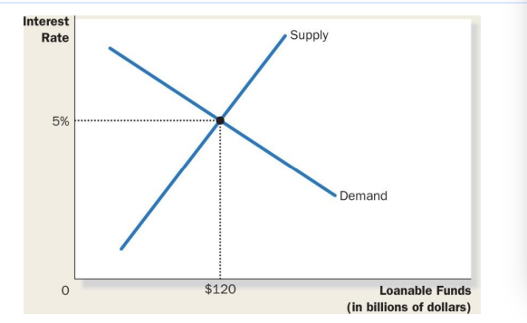
- The interest rate is the price of a loan*

Policy I: Saving Incentives
- A higher saving rate could lead to a higher rate of growth of GDP
- People respond to incentives: (higher interest rate, save more to consumer more in the FUTURE) all about consumption
  - Central bank has a huge influence on interest rate
  - Consumption taxes like GST
  - 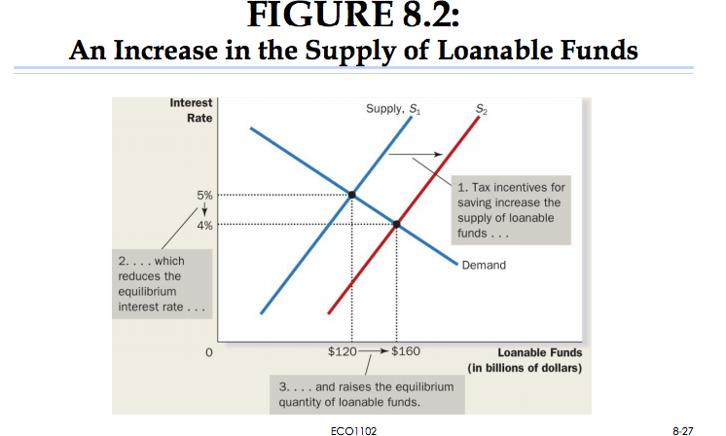
  - RRSPs
  - TSFA
  - RESP
  - Look at chapter 8: pg. 180 example, increase in taxation moves supply
  - Incentives to save more, therefore supply moves to right therefore interest rate is lower, invest more which is good.

Policy 2: Investment Incentives
An investment tax credit gives a tax advantage to any firm building a new factory or buying a new piece of equipment
Save and invest more but interest rate is higher
For assignment make sure you're moving the right curve
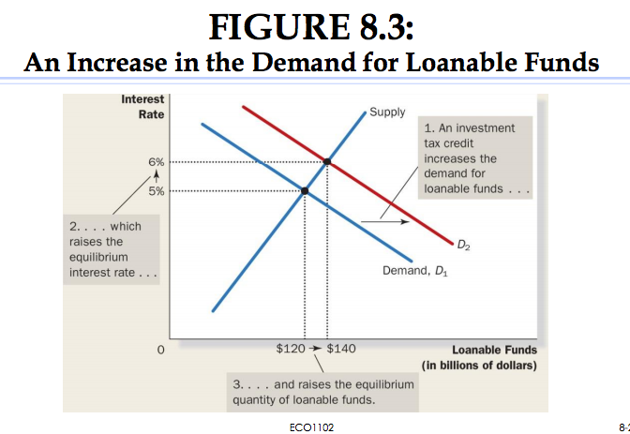
Policy 3: Government Budget Deficits and Surpluses
Government debt: The sum of past budget deficits and surpluses
Crowding out: a decrease in investment that results from government borrowing, if you keep borrowing as a government you have less funds on the market for private investment
Stocks value of variable at certain point, and flows how a variable acts over a period of time
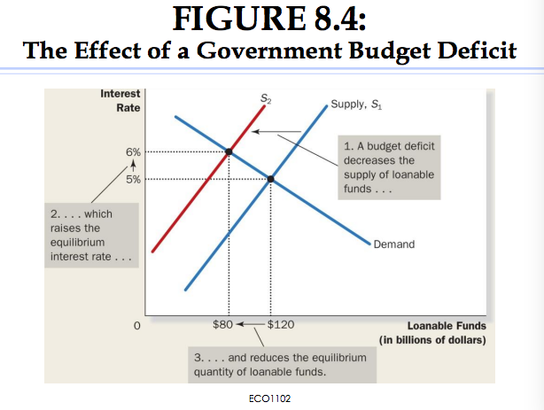
Less investment from firms less economic growth, less income less taxation less government funds available. Today if you invest less you jeopardize economic prospect for future

*title page

