The Cell Cycle

Heredity
All organisms come from other organisms
All organisms resemble their parents
Siblings are NOT identical

Many sperm will try to get into the egg but only will actually succeed
Every organism begins with the fusion of the two cells

This fertilized egg then undergoes cell divisions to allow the cells to multiply and allow the organism to grow.

Cell Theory
Higher organisms fuse their cells (sperm and egg) to make new ones
Dividing cells devote a lot of resources to segregating their chromosomes
They spend more time on dividing the chromosomes then actually growing. Therefore it is very important.
Chromosome – a single strand of DNA
They are either circular (bacteria) or linear (most of everything else)
When the cell is getting ready to divide the chromosome condenses by associating with proteins (histones). The combination of protein and DNA is called chromatin.
When it is alone it looks like a big mass of spaghetti but when it coneenses it is much more structured.
When the DNA wraps around the histone proteins which wrap around other things etc. it becomes very organized and able to undo without getting tangled. This is the reason they do this. They need to be neat.

Karyotype: a way of organizing and identifying chromosomes
You can take a cell that is ready to divide, and squash and dye it. Then you can separate the chromosomes from the protein and then organize the chromosomes into different banding patters. When this is done, it is seen that each chromosome has an exact other one that is identical to it

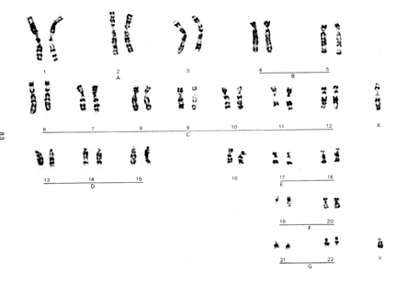

There are 22 pairs of chromosomes in humans. There is another chromosome that is single called the X and the smaller one called the Y.

The number of chromosomes is characteristic of the species.

In eukaryotes, chromosomes come in pairs that look alike
Just before cell division each chromosome has been replicated ones to produce two chromatids.
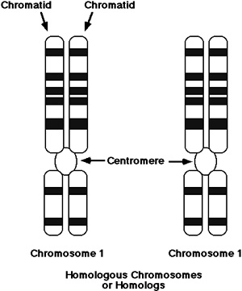
Each chromosome is actually two pieces of DNA (chromatids)

Normally, a chromosome is a single piece of DNA. However, when we look at a karyotyope we are actually seeing two pieces of DNA, the two chromatids bound by a centromere.
We call these Mitotic Chromosomes to indicate that they represent a special case
When the cell goes to divide, each of the two chromatids go to a different daughter cell.
The probability of each daughter cell getting one of each chromatid if it wasn’t designed to do so is extremely low
Organisms need at least one of each chromosome, and mostly also typically need exactly one.

Down Syndrome:
Results from an extra chromosome 21 (there are three of them in the karyotype)
Note: this is the smallest chromosome
IF humans have any other extra chromosomes besides 21, you cannot survive to birth
You also cannot survive missing any chromosomes (excluding the sex ones)

First problem: Make sure the chromosomes are duplicated before the cell divides

Steps of the Cell Cycle:
S phase: duplication of the chromosomes (replication of DNA)
Mitosis: the process in which somatic cells make identical copies of themselves by creating daughter cells that inherit one copy of each chromosome
OR
Meiosis: The process in which germ cells make non-identical copies of themselves by creating daughter cells that have one of each pair
Cytokenesis: The splitting of the cytoplasm (this is least important)

It starts in the G1 phase. This is when the cell undergoes growth and decides when to divide
When decided it goes into DNA synthesis or S phase (duplications chromosomes)
Then it goes into the G2 phase. This is when it generates the means to pull and separate the chromosomes
Then it does mitosis
We can only see this happening during mitosis. The rest is called interphase.

How do we know of the steps?
We can fuck with DNA replication. IT has to check to see if every chromosome has been duplicated. There is a check point at the end of S phase.
When its passed this point it goes into G2 and prepares for mitosis and in mitosis it separates the chromatids into daughter cells.
When you mess with DNA replication (by adding a drung: hydroxyurea) it never proceesds into G2 and mitosis and jus keeps trying to reproduce the DNA
This is how we kknow these phases and check points are real.

The checkpoint can also be disabled with caffeine. Often this would have no effect as rarely does the cell make mistakes however if you do both of the previous experiments, you can't replicate the DNA but the cell will still precede into G2. It doesn’t realize there is not enough DNA and when the cells try to divide, the daughter cells do not get enough DNA and they die.

It knows when each step is ready to move on to next due to various proteins

How do cells know when to divide?
Most cells in the body are not dividing.
The cells that are not dividing are usually arrested in the G1 phase of the cell cycle.
Often they are waiting for signals from other cells to tell them when to divide.
An example of this is in our immunie system. They are idling waiting to fight an infection that may never come.
If the infection ever shows up then the immune cells must divide to fight the invader. They know this by recognizing the antigen on the foreign body which tells the cells to go out of G1 phase and start to divide.

If cells that are not supposed to divide start dividing then this becomes a problem as they are supposed to be not dividing and doing their job.
This can happen is a cells G1 – S checkpoint is defective.
For instance, if the cyclin E protein is always active or over abundant then the cell will repeatedly divide and can become cancerous
When this happens there is cancer or a tumor.

Mechanics of Mitosis
First step is the duplication of the centrosomes, which lie outside the nucleus

Prophase
In prophase the centrosomes start to separate to either end of the nucleus in preparation for pulling the chromosomes apart. At this point microtubules start to radiate out from the centrioles. These are called spindle fibers

During prophase there is also condensation of the chromosomes. There is no longer “spaghetti” as they attach to the proteins to form condensed chromosomes.

ProMetaphase
The nuclear envelope breaks down and the chromosomes are released into the cytoplasm where the centrosomes are and they can now interact.
There are two types of microtubules:
Polar Microtubules: Radiating from one centrosome to the other. The cross and attach and hold the two centrosomes together
KInetochore: Collapses and grows out, over and over again but never bind to other microtubules but they occasionally bind to the chromosomes

Metaphase
Once the chromosomes have bound to microtubules they are pulled in opposite directions. Each chromatid is attached to a different centrosome
Once this happens for all of the chromotids they will all be lined up along the metaphase plate due to the tension from both sides
Then a signal occurs that tells the cell that all microtubules are lined up and the centromeres that hold the two chromatids together releases and each chromatid is pulled to each side of the cell

ANaphase

The chromatids are pulled apart to either side of the cell

Teleophase
Nucleus reforms
Spindle disassembles
Chromosomes uncondense

Cytokenesis
New membrane is formed and the cell splits
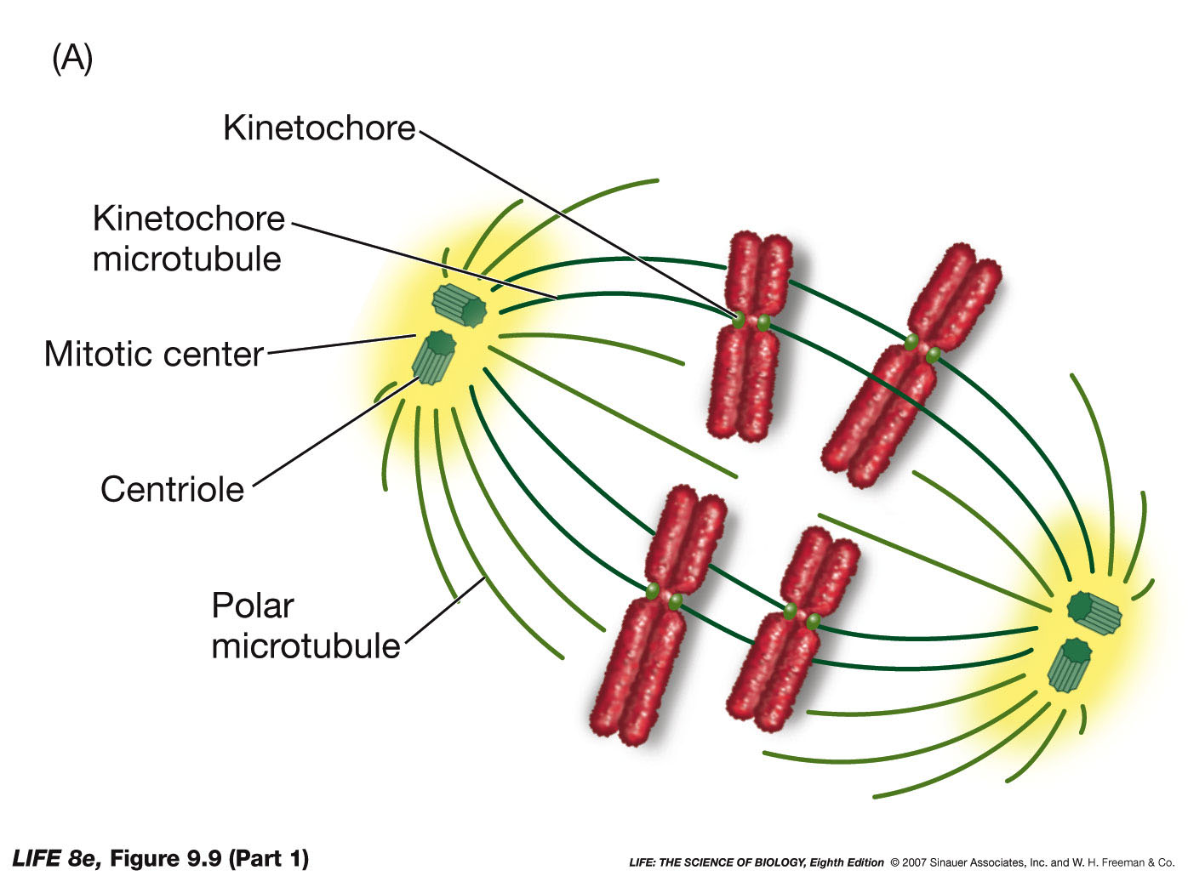

How to make sure this happens:
Keep chromatids paired until its time to segregate them
Have unstable kinetochore microtubules that can probe the cytoplasm and only become stable upon being captured or attached to a kinetochore
Give each chromatid a kinetochore with a geometry such that the two kinetochore microtubules from the same spindle can't capture both chromatids of a chromosome
Have a checkpoint that senses when all the chromatids have been captured and only then allow the chromatids to separate

Cytokenesis
In animals, actin and myosin for a purse string that constricts and divides the cell. Animal cells are soft and squishy so it creates a ring around the center of actin and myosin, which generate force, and contact around to constrict the cell and pinch it into two different cells
In plant cells there are cell walls so this doesn’t work. Instead they generate vesicles that then move to the interface of the two new cells and then fuse to form a new cell wall

Some cells don’t even do this step.
E.g. muscle cells have many nuclei because they go through mitosis without cytokenesis
Mitosis is great for exact copies but not good for differentiation

Mechanics of Meiosis
Before sexual reproduction, you must reduce the number of identical chromosomes (homologs) by half
Therefore when it fuses with another cell that has also reduced its homologs by half there is the right number of chromosomes
n = a set of chromosomes that includes exactly one of each homolog
1n = haploid
2n = diploid
3n = triploid
Somatic cells are 2n and gametes are 1n
When you fuse a sperm and an egg you go back to being diploid

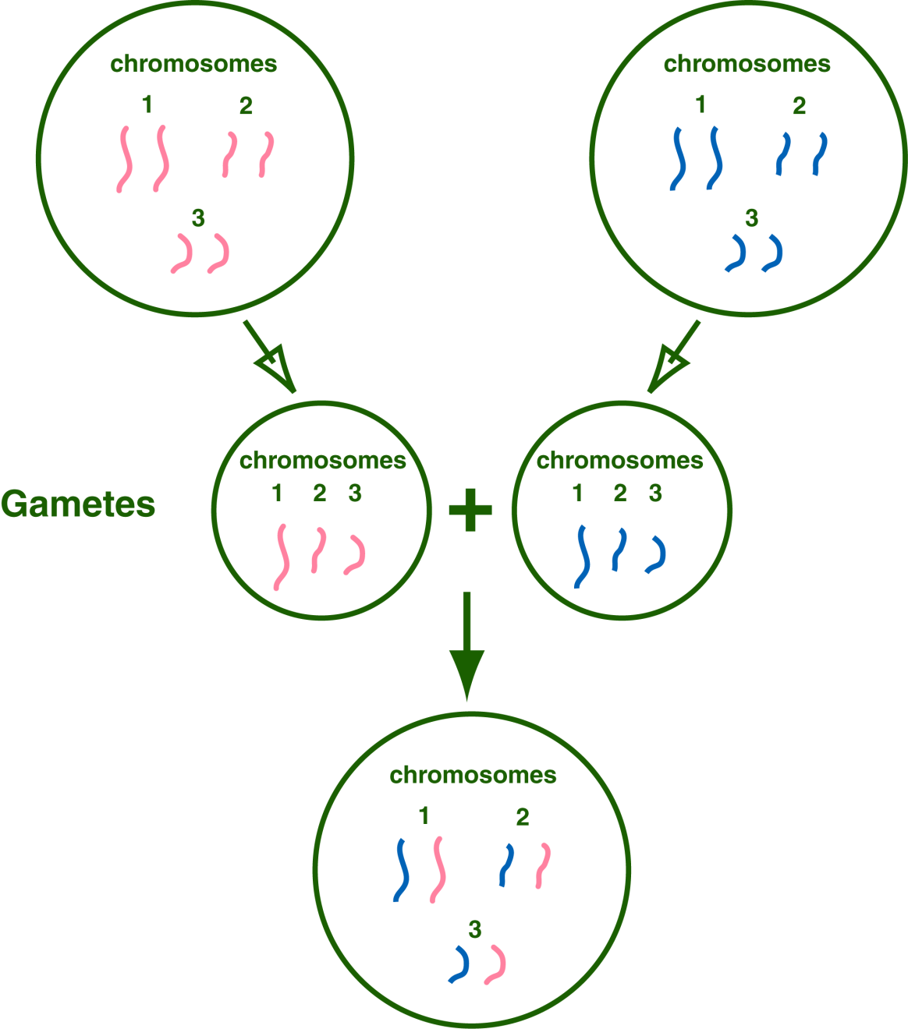

Meiosis is the process in which sex cells are made
The cell has already duplicated it chromasomes (seesms strange but w/w) Each chromasomes has two chromatids and there are 2 of them

Early Prophase:
Chromosomes start to condense
Division of centrosomes and migration to opposite ends

Mid Prophase:
Homologous chromoasomes are lining up with each other (terad)

Late Prophase (prometaphase):
The arms of the homologous chromosomes switch with the other chromosomes. This is called recombination. It is a perfectly equal exchange

Metaphase 1:
IN this case each centromere binds to an entire chromosome, not a chromatid and pulls them apart

Anaphase:
The chromatids now stay attached to each other via the centromere, but the whole chromosomes separate

Now there is a cell that has one of each homolog
But these homologs still consist of two chromatids.
Then we go through meiosis 2
This is exactly like mitosis but with the new crossed over chromosomes
Now there are 4 haploid cells and the chromatids are different because of recombination

Mitosis usually takes about 30 minutes
Cells can arrest in meiosis for a very long time.
E.g. 40 years in prophase for human females

The younger the mother, the greater the chance of down syndrome in a child because the egg cell has undergone years and years of meiosis and the chance of something going wrong is higher.

Some organisms have life cycles that are primarily haploid and have cell cycles
e.g. moss
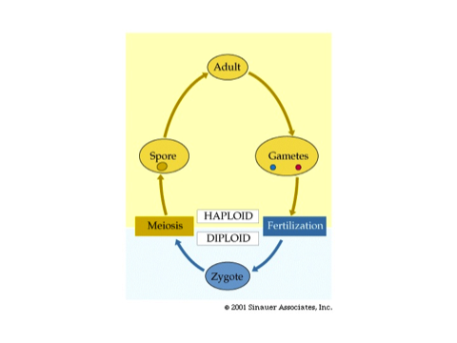

The importance of Ploidy

It’s the reatio of the homologs that are important not the absolute number. As long as it 1:1 or 2:2 etc its good
Odd ploidys: n, 3n, %n tend to be sterile because of problems in meiosis since there are unpaired homologs on the metaphase I plate

Organisms that have higher ploidys are often bigger
People have caused wild strawberry’s to go under wild ploiudy events so that they are octaploid. They are way bigger then can be found in the wild
Multiple ploidies are ok as long as it is even and can undergo meiosis

Heredity: Why We Resemble our Parents

For a given character (color of skin, size) offspring share traits with their parents, but children will not have identical traits for given characters.

Continuous Variation:
There are an infinite number of traits for a human character and these fall along a spectrum
If you take individuals that have extremes, certain traits become blended

Discrete Variation:
There are only two or a few traits for a given character (fur color on mice)

Gregor realized that it was more important to focus on the discrete variation

He used true breeding strains
A round pea plant would always give round peas when breeding with itself and the same would happen with a wrinkled pea plant

His experiment:
He crossed bred a pure bred wrinkled with a pure bred round and all of the prodgeny were round peas. This is not blended inheritance it’s a discrete trait
This lead to the idea that certain traits were dominant over others

There were no wrinkles in any of his pea children.
He wondered where that went.
He crossed the round child peas to each other and found that there were now some wrinkled children (or grandchildren depending how you look at it)
This is approx 3:1 ratio
This worked for all types of characters of peas not just roundness
Every time the same ratio of 3 quarter dominant to 1 quarter recessive would occur
He said if you do this experiment you would always get that same ratio

He deduced this happens because every organism has tow herediaty units (Allesles) for a given character
Round peas have two ronid trait allels
Wrinkled have two wrinkled alleles
He said it would make sense that the prodgeny get one from each parent but since the round is dominant you always get round, but can still get wrinkled in a second generation breeding.

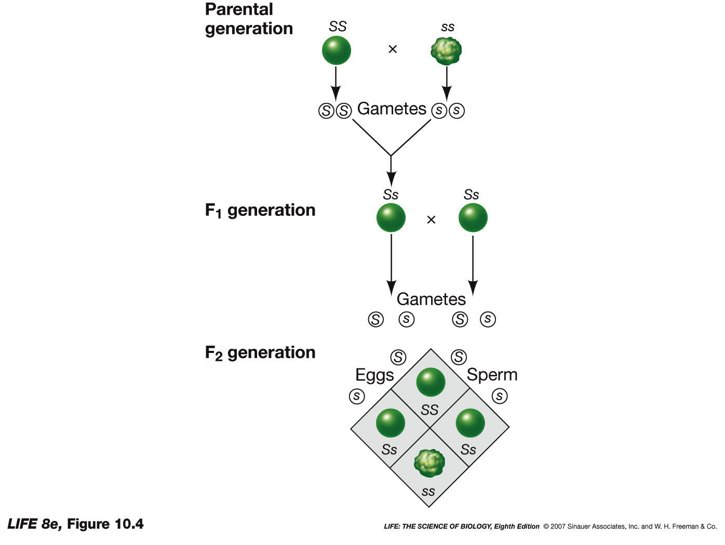
He deduced that hereditary is a discreet thing that moves from parents to children and therefore creates patters. It is not some mysterious thing

Terms:
Unit of heredity – gene
Flavor of genes – allele
Having the two of the same allele – homozygous
Having two different alleles – heterozygous

Probability
The probablility of two independent events is the product of the two probablities of each separate event
E.g.
Probability of getting heads
Coin 1: ½
Coin 2: ½
Getting it both times:
½ x ½ = ¼

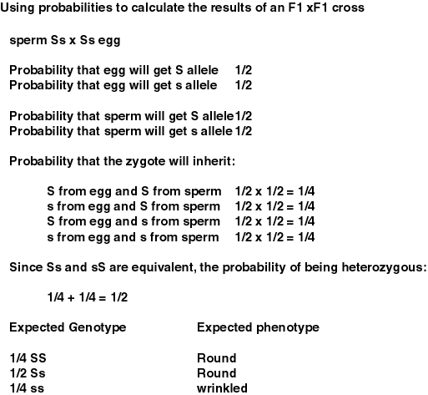

Although flipping heads 2 times is the most likely outcome, it is not likely to happen overall because it still only accounts for 3/8 of the entire set of data. The asame is true for genetics

Genotype: Set of alleles an organism has
Phenotype: The traits that an organism displays

Genotype determines phenotype but because of dominance the phenotype may not uniquely determine the genotype without more information

Law of Independent Assortment:
When you have and indivisual that has variation in two characters can influence each other.

Hypothesis 1: Alleles of different genes stick together:

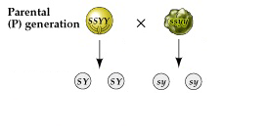
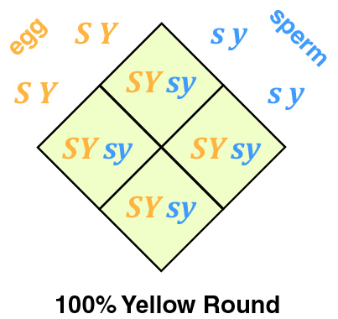

Hypothesis 2:
Alleles of different genes assort independently
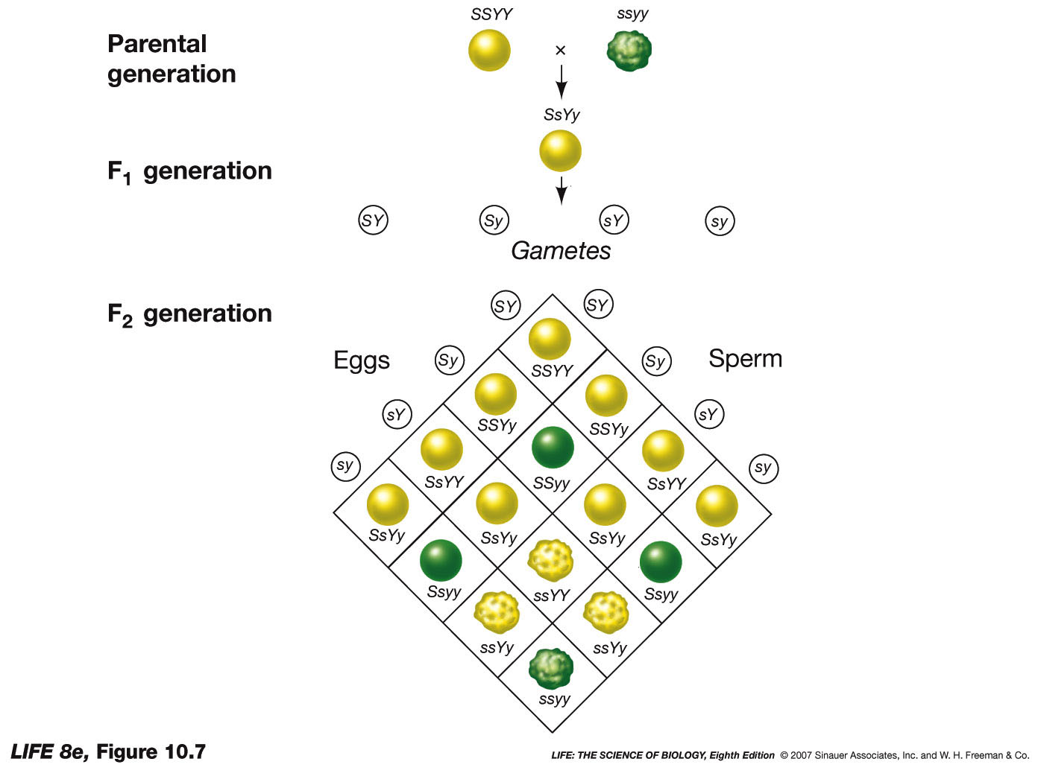
This is exactly what he found. He established the law of independent assorment.

Punnet Square Notes:
- You must know what gamete genotypes are possible and in what proportions
- The number of gamete genotypes = 2^n, where n is the number of genes in consideration
- Some gametes might have the same genotype but must still be included
- IF you are using more then 3 genes you should probably just use probability

Mendel’s Accomplishment
- Heredity exists as discrete units
- The units do not blend in the heterozygote
- THE segregation of the alleles into the gametes and re-associate in the progeny explains the rations of phenotypes
- Alleles of different gens also segregate

Can You see the alleles?
The alleles are on the chromosomes and we can see the chromosomes so can we see them?
We cannot but there is an exception.
In the X and Y chromosomes even though they look different, in meiosis they behave as homologs
We can think of sex as a phenotype.
Therefore we can think of the alleles as chromosomes
XX is female XY Is male
The punnet square shows that there is 50/50 chance of boy/girl

Red/Green Color blindness
Apperas in ¼ of children of unaffected parents
MOr common in males
Only males of unaffected parents are color blind
For females, the father is also colorblind

However these are not the actual ratios. This is because the gene for colour blindness is on the X and Y chromosomes so now there is more then one gene on it (Sex and colour)

THE Y CHRMOOSOME ALWAYS HAS A RECESIVE ALLES BECAUSE IT IS SAMELL AND ONLY HAS A FEW GENES
THE X CHROMOSOME IS BIG AND HAS LOTS
The Y chromosome doesn’t actually have the colorblind gene. It’s the absence of it, which makes one colour blind

Wild Type allele –prominent alleles 99% of people have them
Mutant allele – a change from the wild type, mostly the result of a mutation
Polymorphic allele – an allele that is present in over 1% of the population

The law of independent assortment only applies to genes on different chromosomes
The crossed a Normal fly BbVv with a mutant bbvv

This is the result is they are unlinked

If they are linked:

or

IT actually turns out differently because of the crossing over of DNA

IT was realized thaa the crossing over of chromosomes is a measure of distance.
Recombination frequency is proportional to how far apart certain spots on the chromosome
Bt observing where genes were crossing over we are able to see where each gene lies in the chromosomes
All the genes linked together on a chromosome are called a linkage group

How do we get from two traits (discrete) to infinite (continuous)?
Not all traits are dominant. Some are semi dominant. (Creating a pink flower from a white and red parent)

Also over a community there can be more then two alleles even though an individual only has two.

Also many traits do not derive from just one gene. Often multiple genes must be present or absent for a trait to be aquired

Epistasis:
Where genes interact
There are two genes for mice fur colour
The firsr gene A will allow the mice to have colourf but it doesn’t determine which one
AA – colour
Aa- Colour
aa- white
The second gene B determines brown or beige
BB- beige
Bb- beige
bb- brown
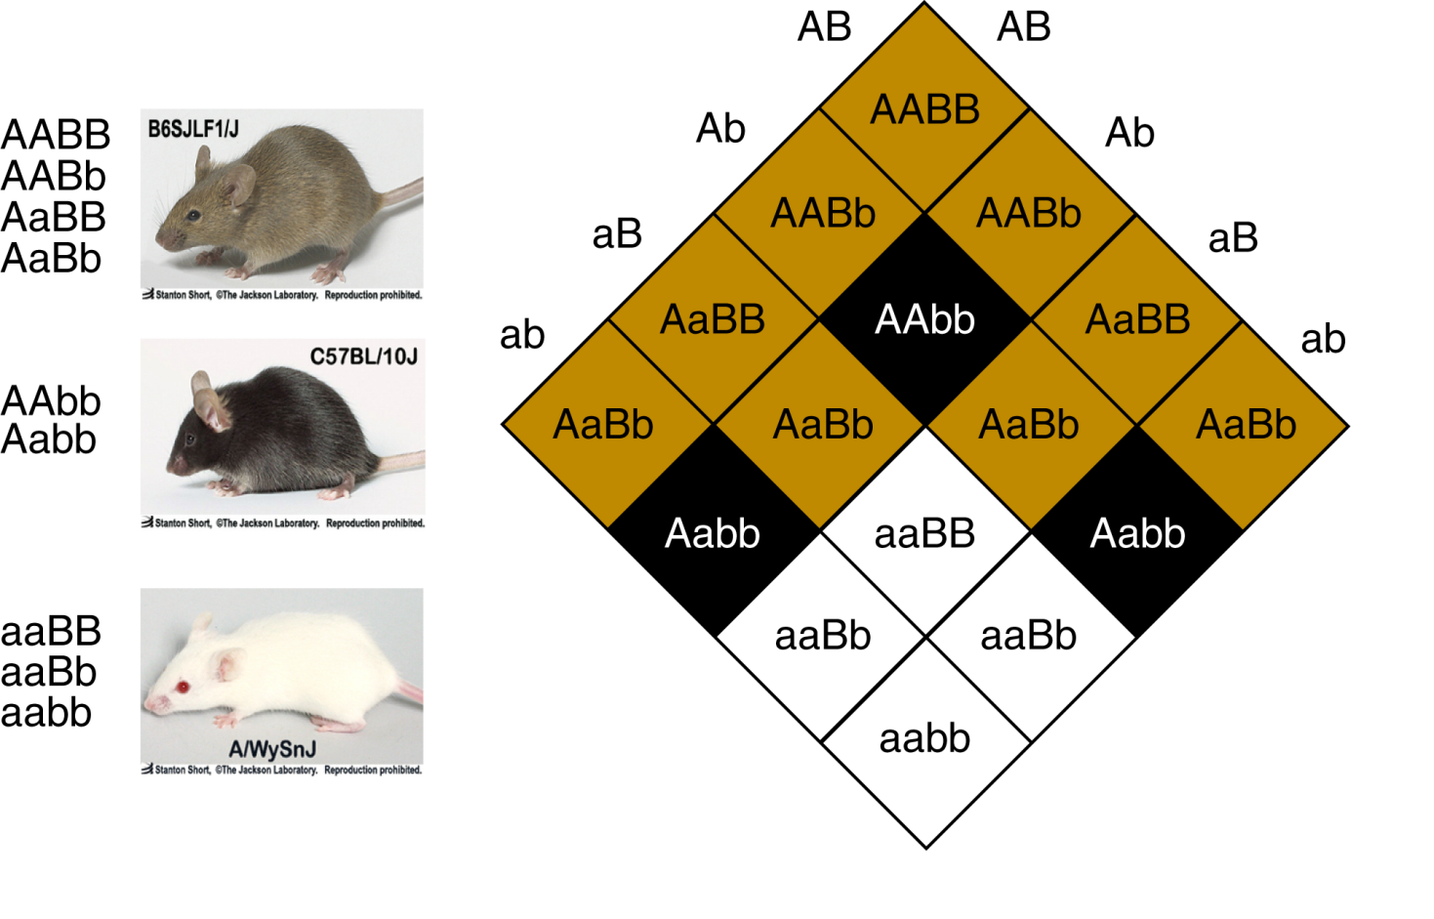
Environmental contribution to phenotype:
Penetrance: perentage of individuals of a given geno that show the pheno
Expressivity: The degree of which the trait is expressed

What contribute:
Number of genes
Number of alleles inpop of genes
Environmental effects

Discovery and the Replications of DNA

How to purify something:
- separate components
- Assay each component

An assay is a way of measuring something
IT can measure a substant like the assay for starch
It can measure and abstract oehenomenon like a assay for memory (mice in a maze)

E.g. Allergy Skin test
First separate things into pure substances
Then test yourself for the allergic reaction.
This is done by pricking oneself which each pure substance (allergen)
Look for the reaction at a specific prick

How to purify DNA
Grind up favorite organism
Extract lipids and proteins with organic solvent
Precipitate with ethanol
This was discovered by Freidrich Miescher

How do you assay for genetic materialness?
Fredrick Griffith and the Transorming principal:
IF you soak an organism in different genetic material it will become that thing.

He was doing experiments with two types of bacteria. S and R strains. The S strains would kill mice when injected with it. The R starin would not. IF you heated the S strain (killing the bacteria) and then injected the mice, they would obviously not dies either.
He then mixed living R strains (not deadly) with dead S strains (also not deadly) and foind that the mice would be killed.
Also if you then extracted the bacteria from the mice and observed it. They were all S strain,
The R strain inherited the S strain DNA and then reproduced to make more of it, killing the mice.

If you mix genetic materil the live R take up the genetic material and become S

They purified the components of the cell anx found that Lipuds , CArbohydraes and Proteins could not convert R to S

DNA however could. This was how they began to see that DNA was the basis of genetics

Does DNA work in other organisms?
Yes. It also works in viruses

Hershey and Chase experiment
Bacteria, like us, can also get viruses. These are called bacteriaphage
They worked with a T2 virus
The virus sits on the bacteria and injects the genetic material into the bacteria and this is used to make more viruses which then burst open the cell

They wanted to see if what was being injected was proteins or DNA
Proteins can be marked with radioactive sulphur and DNA can be tagged with phosphates.

They blended the phage which has been tagged, and mix with the bacteria. They inject whatever they were going to and then they get blended.
The phage gests stripped off the bacteria so all tahts left is the bacteria with whatever was injected into them

They observe S in the bacteria and not P so they saw that proteins were not the genetic material.

Ratios of the Bases in DNA
Not every organism has the same ratio of the bases in DNA.
NO matter what organism you look at, the amount of A always = amount of T and G = C.
However the ratio of A+T/G+C varies with each organism
These are called Chargafs rules.

Crystallography
Via this they found that DNA consists of two strands
These twist to form a double helix
The phosphates are found on the outsides and the base pairs are in the middle
The strands run anti parallel to each other.

Watson and Crick
They proposed that A must always pair with T and G must always pair with C

DNA strands are the reverse complement of each other

The reasons this happens is because these pairings are the only way to form hydrogen bonds

This means you always get a purine with a pyrimidine. Because of this there are no bulges in the DNA as would be the case if two pyrimidines binded

RNA
RNA can also form complementary strands with DNA

The Key to DNA
The sequence of nucleotides is not constrained by the structure.
DNA can accommodate any sequence. An arbitrary sequence can encode info.

IF you take a strand of DNA you can make any sequence and then make the complementary sequence on the other side and it still looks like DNA.

Arbitrary sequences are totally possible.

There are physical constrains on the complementary strand. Once the first strand is made, the second complementary strand is determined and cannot vary.

If you take the two stands apart and them make complementary strands, you have duplicated the DNA

How DNA replicates

Three ideas:
Semiconservative: Take the strands apart and make a complementary strand for each

Conservative: make a new strand of each strand and the two new strands end up together

Dispersive: The new and the old strand somehow get mixed up together

Proof from messelsohn and stall:
They needed an assay to distinguish new DNA from old DNA
They used heavy and light isotopes
IF you make DNA with N 15 it will be heavier then N14
IF you spin it in a centrifuge you can separate light from heavy DNA
The normal DNA will be higher up in the tube

At the first spin they saw that their heavy DNA showed up at the bottom of the tube as expected
Then you put them ina solution with light nitrogen and let them undergo replication. Now they incprporate the light nitrogen into the DNA
Upon a second spin, the new DNA is in the middle (half heavy half light)

Now they replicate again still only able to use light nitrogen
At third spin you get light DNA and half heavy DNA

This distinguishes the semi conservative model from the other models.

To make the DNA you just need the materials and enzymes

You need triphospht nucleotide, DNA polymeraze, Template DNA (to be copied) and a ragged end
Ragged end: This is a tiny extension at the end of a piece of double stranded DNA that is only the single strand. This si used as the template to add the new nucleotides

Problems:
How to pry the stands apart: The enzyme Helicase
How to make ragged ends: The enzyme Primase which makes short RNA primers
Helicase uses energy form ATP to unwind the strands
The strands are pulled apart and the new nucleotides are added to the 3’ end of the origina strand. The top strand is called the leading strand and can continuously add the nucleotides without problem
The bottom strand (lagging) has an issue because since nucleotides cannot be added from the 5’ end of the original DNA, there will be gaps in the DNA. These are called Okazaki fragments.
Primase fills these gaps with RNA primer which then can get filled by DNA polymerase 1
At the end these gaps are stiched together by a ligase to make a complete strand.

Steps:
- Helicse splits the DNA
- SSB Proteins hold them apart
- Primase puts down a segment of RNA primer at the beginning of bnoth stradns (DNA polymeraze cannot attach unless its to a double stranded piece) Also the DNA polymeraze needs a 3’ hydroxyl to attach to (the primer creates this)
- On the leading strand, the Polymerase III begins synthesizing the DNA in the 5’-3’ direction continuously (on the new strand) (the polymeraze follows the helizase complex)
- The lagging strand is added in fragments. DNA polymeraze can't add nucleotides continuously
- As helicaze unzips DNA, RNA primase adds a primer, and then DNA polymeraze binds and synthesise a small segment of DNA until it hits another primer where it then begins again
- It can't do it in one piece, because if the primase waited for the helicase to unwind the whole stand before laying down the primer, the DNA could refold and fuck up replication
- The fragments of DNA are called the okazaki fragments
- Then DNA polymeraze I will turn all the sections of RNA primer into sections of DNA (they can't be left as primers)
- Then the enzyme ligase wil fill in any gaps (phosphate bonds) in the DNA caused by the segmentation

In bacteria:
The process goes smoothly due to the circular chromosome.
For us, there are multiple origins of replication along the chromosome or else it would take forever.

Error Correction:
Sometimes there are mistakes that must be fixed.
DNA poly III has a proffreading thing which chekcs as it synthesisez

Mismatch repair: During meiosis, two chromosomes can be determined which is orgi strand and not. IF they don’t match up it will be fixed

Excision repair: If theres a mismatch, it will rip out a streth of DNA and fill with a comp strand. Half the time it will pick the worng base and not fix anything

UV radiation from sun chenges the DNA. It creates thyamine dimers which is two thyamines beside each other.

The mismatch repair enzymes fix this so we don’t get cancer

Alkaptonurea

This is a conditon where people pee black
It is an inherited thing
It’s a simple medelian gene, dominant or recessive.

IF neither parent is affected, then the children are affected in 3:1 ratio (the gene is recessive)
In one rare case, an affected father had affected children. And 4/8 of the children were affected.
This was a clear test cross of a recessive crossed with a heterozygous
This guy garrod wanted to see why this happened.
HE determined it was the absence of a specific enzyme
He thought that each gene was associated with an enzyme and that since this one was missing, the urine is black
This was correct.

They were missing an enzyme in a metabolic pathway. The gene that was necessary to make this enzyme was defective so it was not made.

Beadle and Tatum
IF its true that enzymes catalyse each step in the pathways in the generation of a substance then they should find mutations in each enzyme by knocking out the genes.

IF you have a mutant in one of the steps eg step B, then it won't be able to make argenine.
However, if you give it Citruline, the component that enzyme B makes, since enzyme C still is effective, the end product (argenine) will still be made.
They found this mutation in enzyme B
Therefore, this thing that they were studying will not grow on the pre cursor, nor Ornathine but it will grow on Citruline because in that medium, argenin can still be made.

IF you find a mutant that grows only in the argenine medium then you know there is a problem with enzyme C
This lead to the idea that each gene corresponds to an enzyme.
“one gene one enzyme hypothesis”
This has since been modified to one gene one protein because not every protein is an enzyme.

The language that the DNA is written in is the language of proteins

Problem:
If you have a nucleus, in a cell, then that is where the DNA is. It is also known that proeteins are made in the cytoplasm.
How does the info from the nucleus get to the cytoplasm?
This is done with RNA

RNA carreis the infor to the cytoplasm so proteins can be made

Central Dogma
Information flows from DNA to RNA to proteins
The info does not got the other way.

RNA is well suited for this because it can carry the same info as DNA it just has an extra hydroxyl group on its sugat
IT can still form double stranded nucleic acids

How this works:
- The DNA splits
- RNA polymerase copies the template strand 5’ to 3’ (does not need a primase)
- Eventually it stops and there is an RNA ciopy of a stretch of DNA which encodes a gene
- This transcript can leave the nucleus and be made into a protein
DNA has a sequnce, proteins have sequence, and there is one gene for one protein so it makes sence that the sequence for the DNA encodes the sequence for the protein

Problem:
How does this work??
How to encode 20 amino acids with only four nucleotides?
Three clearly cannot be a 1:1 correspondents

The reason tree amino acids were formed was because the nucleotide sequence could be read either: AAG AAG or AGA AGA or GAA GAA

For a triplet code thre will be three “reading frames”

Degeneracy of Code:
The DNA sequence uniquely determines the amino acid sequence of a protein, but the reverse is not true

You can't always determine the DNA sequence from the amino acid sequence

How does the ribosome know how to interpret the RNA sequence?
There is no physical law that says that AGA must code fore argenine. Its not like there is affinity or anything
SO why is the sequence the way it is?
It does this with tRNA
There is at least one tRNA (sometimes more) for each amino acid.
The tRNA acts as an adaptor. IT attaches an amino acid to its 3’ hydroxyl on one end and has a certain sequence on the other end. The ribosomes read the RNA (single stranded) and match it up with the complementary sequence on a certain tRNA (anti codons). It then starts stringing together the amino acids that are on the ends of the tRNAs that its reading

How does the amino acid get onto the tRNA
Enzymes bind to the tRNA. The enzyme also has a pocket which binds for the specific amino acid.
When both pieces are bound to the enzyme, it attaches the amino acid to the tRNA

(DOES THIS MEAN THAT THERE ARE TONS OF DIFFERENT ENZYMES?)

It’s this enzyme that notices the tRNA and the correct amino acid

We know this is all true because we can fuck with it. We can take a Phe tRNA and modify the Phe amino acid to be an Alanine
The ribosome will read for the Phe tRNA but will attach the alanine

The same will happen if you change the anti codon.
IF you modigy the aniti codon (change the tRNA) it will still attach the amino acid that’s bound to it

E.g.

The origins of the Code
WE know the code is arbitrary, but this is weird because all organisms share the same genetic code.
How can this be possible?
The code is fixed by convention. Its very hard to change one the code has been made.
This means that we must all share a common ancestor and thus the code is very old.

Transcription Translation and Mutation
Transcription: DNA mRNA

Translation: mRNA protein

** Note** When the mRNA is being transcripted, it is only using one of the sides of the DNA as the RNA is single stranded

One strand of the DNA will be the same as the RNA strand just with Uracil instead of Thyamine

The strand that is not used in transcription is the exact same as the RNA strand as mentioned above and is called the “sense strand’
The other template strand is called the “anti sense strand”

THE TWO STRADNS DO NOT MAKE THE SAME RNAS AND DO NOT MAKE THE SAME PROTEINS.

Which strand gets transcribed is random

How does the cell know which strand it needs to use
There is info in the DNA that doesn’t encode for proteins. Its marking info. IT tells the RNA polymerase and transcription complex where the beginning of the gene is.

The most typical sequence is the TATA box

Translation

The three-frame problem: There are a bunch of ways to read the same thing (see above)
IF the cell made three different proteins per gene, two would be useless

The cell only uses one frame
How does it know which one?
The frame always begins with methianine
Also there is only a single codon that codes for met (aug)

The ribosome has two units. The small and big.
The small unit sits on the 5 end and looks for the aug and the met tRNA. Once it finds it it recruits the big subunit which has two important sites P and A

P site: tRNA starts here.
It then recruits the next tRNA based on the codons and anti codons
The amino acids are strung together and the original tRNA is bumbed off while the new one moves to the P site
The ribosome moves along the mRNA where it then picks up a new tRNA at the A site and the process continues

This keeps happening until the amino acid chain is done

The amino terminal comes out of the ribosome first

How does it know where to stop?
There are certain codons (stop codons) that tell the ribosome where to stop
Whne the stop codon hits the A site, a protein comes in which tells the ribosomes its done and it releases the amino acid chain

The stop codons are: UAA UAG and UGA

Wobble Pairing and the Degeneracy of the Genetic Code
The tRNA anti-codon does not strictly obey base pairing rules.

When the tRNA looks for the codon on the mRNA, it does not need to match completely. Only the first two base pairs must match. The third has “wobble room”
This is on the 5’ of the tRNA and the 3’ of the mRNA

5’ is wobble codon

For histidine for example, the third base, G pairs with a U where it would usually pair with a C

Rules:

Many steps of translation are not sequential. Many ribosomes can simultaneously translate a single mRNA

Ribosomes can begin translating an mRNA before transcription is finished in prokaryotes because they don’t have a nucleus

Proteins can begin to function or fold before translation is finished in all organisms

The role of Mutations

Sickle Cell Anemia:
Autosomal recessive trait in humans
Progressive anemia marked by crises. Risk of mortality.
About 1 in 12 African Americans are heterozygous for the sickle cell allele
The blood platelets fuck up and don’t carry oxygen well.

The main protein in blood is hemoglobin.

The esickle cell disesase causes a mutation in the hemoglobin.
Instead of being normal they form long rods which are deformed and break the cells

Can we prove that the disease changes the amino acid sequence?
Linus Pauling broke up the protiein and compared normal to affected fragments
They then separate according to size and charge.

In the affected protiens one of the fragments has a different placement on the spread because of the different charge. There is a different charge because the amino acids are different as they carry charge

The change was determined that a single amino acid is changed. Glutamate to Valine.

Classifying Mutations

Point Mutations: small changes in the DNA usually affecting one gene.

Chromosomal Mutations: Large changes in chromosomes often affecting many genes.

MIssense Mutations: When a single nucleotide is changed (e.g. G A)

Nonsense Mutations: Whena single nucleotide is changed to becomes a stop codon. Now a protein that’s susuall y 20 aa loing is only 100 long

Deletion Mutation: This is when a nucleotide is removed from the sequence and the reading frame for everything downstream from here is changed. Now all the amino acids brought in will be wrong.
Insertion Mutation: When an extra nucleotide is added. There is the same frame shift effect as above.
Deletion/ addition with on Fram shift: When any multiple of three nucleotides is deleted or added so that one or more amino acids will be effected, but the reading frame will not be screwed

Silent Mutation: (result of degeneracy in the code) When a nucleotide changes but has no effect b/c of wobble room (e.g. GGA GGT) it’s the exact same thing. They both code for Gly

Chromosomal Changes
Deleteing: When a big chunk of the chromosome is ripped out. Shorter chrmosome, fewer genes.

Duplicatiion and deleteing: When two homologous proteins are broken and switched but not equally so the chromosome is fucked up

Inversion: When the order switches in the chromosome
Reciprocal Translocations: Same as Duplication and deletion but not with homologous chromosomes

Mutagens:
Angets that cause changes in the DAN sequence (chemicals radiation, viruses)

Where mutations occur
Which cells get mutated makes a huge difference on the impact
IF you mutate somatic cells, you may get a change in that cell and any daughter cells but whatever change will happen will dies with the host. (it may cause you to die infact!!)

IF the mutation is in the germ cells then the progeny of the person will also have the mutations and this is a way to get variation. The mutation is transmitted to the next generation.

Viral and Bacterial Genetics
Bacteria also use nucleic acids to synthesize protiens and its those which make the organisms what they are

Tobacco Mosaic Virus
He figured it was a disease. Normally you grind it up and but in on a tobbaco plant and see that is transmissible. IF it was a bacteria you could dring it up and filter it and then put it back on a leaf with no disease because it would stay in the filter

If it was a chemical in the ground it would go through the filter

HE realized that there was a nother possibility. Something that went through the filter
He also noticed that it would keep infecting the plant so the ting must have been reproducing. IF it was a chemical it would get diluted and eventually not effect the plant

Virus Classification
Host specificity and pathology
Genetic material (RNA or DNA)
Size and Shape (electron microscopy)

Viruses use all sorts of genetic material.
- SS DNA
- DS DNA
- SS RNA
- DS RNA
- These can be circular or linear
- They can consist of 1 or many chromosome
Viruses are incredibly small

Animal viruses often have a membrane around them

Virus has two main specificities:
Viruses that affect us
Viruses that effect bacteria (phage)

Lytic Cycle:
IT inject its DNA into a bacteria and it hijacks the cell, destroying host DNA. Then there is a lot of replicated viral DNA and extra proteins created. Then a protein lyses the cell and all the new viruses burst out and infect others

Lysogenic cycle:
Some viruses will inject into a cell abut instead of immediately hikjaking it and making more viruses, and destroying the bacteria it will insert its DNA into the genome for the bacterium. The bacteria do not notice and continues to divide and the virus divides with it. When phage decides the bacteria may die, it will pop out of the chromosomes and then go through the lytic cycle.

Eventually both pathways destroy the cells

Promoters: Ways for polymerases to know where genes are
Phages have genes and promoters that control transcription
The promoters controls the sequences of the genes that are being transcribed

Genetics
Phage have DNA so they can also do recombination
If two phage infect the same bacteria, they both inject their DNA and those chromosomes can recombine to form new genomes with new characteristics
The distance between genes is reflected by the rate of recombination

Composition of Human Viruses:

The lipid bylayer is taken from the cell that it infects. The virus makes the rest itself

Influenza is an RNA virus and the gycoptroteins recognize host cell proteins. This is part of its specifity. When this happens it gets endycytosed into the cell it then fuses with the endocytic mempracne which releases the capsid and RNA. THE RNA then gets translated byt eh virus because it doesn’t know. IT inadvertently makes viral proteins which then o shit in the cell which allow for replication of the virus and also makes the envelope glycoprotein and the capsules and then new viruses are made.

They only require a few genes to fully take over our cells. (influenza only has 10 genes)

Animal viruses can undergo recombination as well
E.g. H1N1 was scary because when they looked at its genome they saw that it was a mix of many different viruses (bird, human and pig)

Viruses are also able to to the same as the lysogenic cycle of phage where they chill and replicate until they are ready. An example is HIV
It genome is an RNA which is contained in an envelope

It infects cells and insteadn of using its RNA to be translated, it creates a DNA copy of its RNA genome (retrovirus – they reverse central dogma)
They then insert that DNA into the genome of the host uning an enzyme integrase
Now there is a viral DNA in the chromosomes
THis can then be transcribed into an RNA viral genome and then translated into proteins but the DNA copy remains in the chromosomes
This is why it is very hard to eradicate HIV
Even if you interfere with various processes, it impossible to completely rid of all the cells with viral genomes
Yet we can prevent the disease by preventing replication of the virus
Some drugs kill the cells that accept HIV (the ones that accept HIV have CD4 proteins which match with the glycoproteins on the HIV)
There are also reverse transcription inhibitors, integrase inhibitors and protases inhibitors, which interfere with the assembly of the virus proteins

Chicken Pox
IF you have had chicken pox you can't get it again in that pathology, but you can get shingles, which is the same infection just with a different pathology.
The virus that causes chicken pox (herpes viruses) infects neurons and goes to the spinal cord and hangs out there E.g can have chicken pix at 10 and shingles at 70. IT then travels down nerve endings tot eh ends of the nerves and causes a rash which is shingles

Viruses can remain in our systems for a very logn time and reemerge whenever

Bacterial Sex
Bacteria do not only undergo asexual reproduction
They are able to exchange DNA to maintain diversity

Bacterial Phenotypes:
Oxotrophic:
e.g. they can only grow on certain medium where certain components are present for their growth to happen
Some may need threonine and some may need methionine but they can exchange DNA and have it so they can use either one
This is proff that genetic exhange is taking place

How?
They have a small plasmid which creates a system for moving plasmid DNA from one bacterium to another.
They are small semi circular chrmosomes that only carry a few genes but they are motile.
IF a bacteria has an f plasimid it can create a conjugation tube between tow bacteria and the genes will move from one to the other

They so this by breaking off a single strand, sending it over and then making another strand.

The co transfer of two genes depends on how close they are and explains how when you mix bacterium you can get new ones which characteristics of the two originals

Mapping Genes
Let them form the tubes and as the chromosomes begins to move through you can interrupt this by blending them and ripping apart the tubes .The chromosomes closes to where the F plasmid is integrated will be the first to go through the tube and will show up earliest on in conjugation. The ones father away will need to wait longer before they can be seen in the next bacteria

Bacterial DNA can also move via viruses
Transduction:
When the phage jumps put of the bacterial genome it will carry some of the genome with it. When it gets packaged in a new phage it packages the bacteria genome into the phage head and its then spread to other bacteria

Transformation:
Dead bacterial DNA can be taken up by live bacteria and the DNA is incorporated into the genome. Its not well understood
This can also be done with plasmids
In addition to the F plasmids there are others. Things that they like to exchange on these plasmids are the genes that allow them to resist antibiotics.
This is great for genetically modifying things as well

Gene Regulation
Organisms regulate genes by controlling the promoters for those genes (early genes turn on late genes so the sequence of proteins is proper for lytic infection in viruses)

We don’t want proteins from genes if we don’t need them. We only need an enzyme to break something down if that things is in the environment. There is a low level of the enzyme usually and when the component that is to be broken down is present, the body increases the concentration of the enzyme in the cells.

E.g. Lac Operon
When you eat lactoce cells break it down but the enzymes are only needed whne the lactose is present
They have three genes that they need B galctosidease, B galactosidepermase and a third that is irrelevant
They all get regulated at eh ame times and metabolize lactose
The trnascriptio nis controlled by a prometer. In between teis promoter si a piece of DNA that binds a proein called the lac repressor. This is encoded byu another gene which ahs its own promoter that turn it on. The lac represseor binds to the DNA and as long as its there, the RNA polymerase canot transcribe the genes for the enzymes
It does this with amino acid fingers that tough the minor grove of the DNA to see what the sequence is and has an affinity for certain ones
When you drink lactose the cell realizes because the lactose binds to the repressor. It undergoes allosteric change which makes it no onger bind to the operator. Then polymerize binds to the promore and the genes for the enzymes are transcribes and the enzymes are eventually made.

This is called negative regulation as the regulator normally binds to the operator

Tryptophan operatio
The repressor doesn’t bind tot ehoperator in the normal state so the polymerze makes the gens for tryptophan. IF there is lots of try present then it will bind to a repressor and make it able to bind to the operator on the DNA so that the polymerase cannot trnascrib the genes for tryptophan any longer and the concentrations decrease

This is positive regulation

Bacteria are very good at controlling their genes

The Eukaryotic Genome:
Most of the DNA in Eukaryotes are NOT genes
Tetraploid organisms are bigger then diploid organism because their cells are bigger to incorporate more DNA. They have a bout the same amount of cells just theirs are bigger

IF you look at the skeleton of a T rex and a bird they are very similar. This made people think that dinosayrs anre ancestros of birds instead of more common ly thought, replitles.

Reptiles have a shitload of DNA wile birds do not.
There are certain cells in the bones called osteiplasts that make up the bones, when the cells degrade they leave a mark in the bones and we can see how big the cells are
It was found that the cells of T rexes have relatively small cells worth smaller genomes so it appears as though it is probably a closer relative to birds
Triceratops has a huge genome so it is though that it is a n ancestor of reptiles

Genomes have different sizes:
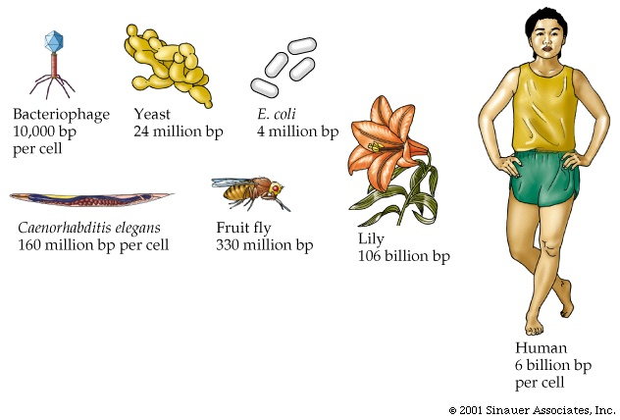
These numbers are the base pairs in cells

There is not a liner relationship between the amount of DNA and the number of genes.
Humans have way more DNA then we need based on the amount of genes we have. (We have 3 billion base pairs of DNA per cell for only 25 000 genes)

What is the rest of it doing?
There are big gaps of DNA that do not encode for protein sequences.
In Eukaryotes (not prokaryotes) They transcribe the entire sequence so that they get all the information including introns (which do not encode proteins) The parts that do encode the proteisn are called exons.
In order to have an mRNA that can translate the protein the unused buts must get removed
They splice out the introns and leave the exons
For how they proved this watch the lecture… not really important

How does this happen
It is done with proteins, they recognize a 5’ splice site or donor site and a 3’ acceptor or splicing site.
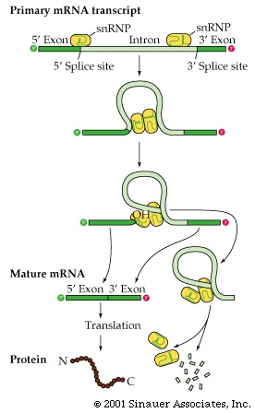

IN addtion to the splicing, the RNA is processed.
RNA Processing:
- A 5’ G cap is added
- Polyadenylation (addition of a polyA tail)

There are a lot of RNA in the cell. The ecell needs to distinguish which is an encoding RNA and whoich RNA do something else.
This processing is used for identifying the RNA

G cap
Its modified guanasine that is attached with a 5’ linkage on the 5’ end of the mRNA. It determiones that the RNA will be an mRNA

Tail
The end of the RNA is not encoded in the protein.
A sequence of “A’s” are added tot eh tail which also identify it as mRNA
These get removed before translation

What does the excess stuff do?
There is a problem with linear DNA when replication and transcription happens
At the end of the chromosome once the primer is ripped to by polymerase I it cannot be replaced because there is no 3’ hydroxyl
Also this happens at both ends
Every time the DNA is replicated the DNA gets shorter because the ends can't get filled in. Eventually the chromosomes get so short that they lose genes
Telomeres
- Non-coding DNA on the ends of chromosomes
- Telomerase puts useless DNA on the end of the chromosome that the body does not mind losing during replication
- 6 base pairs
- Because there are hundred and hundred of theses repeated sequences, the cell can replicate many times without being damaged.
This is very important. Most human cells do not express telomerase. As they replicate the DNA they chromosomes get shorter until as cell cycle checkpoint prevents further division
Cancer cells often express telomerase
People think that this has to do with aging as well.

Centromeres:
These are also non coding DNA

Transposable Elements
Some DNA do nothing for the cell
They exist solely for their own purposes
Some things look a lot like retro viruses but they are not functional viruses, they are just in the genome
Some other things look like degenerate retroviruses
DNA transposons
Pieces of DNA that can excise from the genome then reinsert themselves
This is done with transposase
Gene gets transcribed and translated. The protein comes back and notices repeats at the then end of the genome. IT then splices it out and reinserts its osmewehere else.
It usually gets inserted in a gap but it sometimes goes into a gene and causes a phenotype change
They increase their number by jumping out of one chromosome to another place leaving a big gap. Then the cell fills in that gap because it wants to by looking at the other copy of the DNA (double stranded) so essentially the transposon doubles
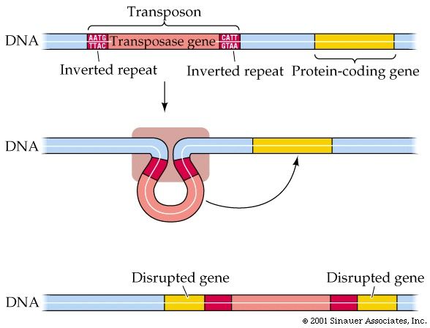

Pseudo genes
mRNA from cellular genes can also be reversed transcribed and reinserted in the genome
These are known as processed pseudo genes. They lack introns because they have been spliced out because it’s a DNA copy of an mRNA copy where the introns have been spliced.

The genome is a complex ecosystem where transposable elements are replicating and moving and competing for survival.
They don’t do anything valuable, they exist because they can replicate and survive (selfish DNA)

Which came first,
How did organisms evolve when they have complex interaction that involve two complex things evolving at the same time
E.g. you need the DNA polymerase gene to make DNA polymerase but you need the DNA polymerase to replicate the DNA and make the protein in the first place
Solution:
Tom Check in the 1980s was looking at splicing and the enzymes involved.
He found that some RNA have self splicing introns (it folds itself up onito a 3D structure that has enzymatic activity which allows it w out itself out of the genome.
These are called ribozymes
This solved the problem
There can be RNAs with enzymic activity, which can be the gentic material as well as the enzyme
Things must have evolved from here

Some organisms must have had just RNA as its genetic material which also acted as their enzymes
The RNA polymerase ribozyme could replicate itself and also could have enzymatic activity that could do the jibs that the cells need.
This would have been before DNA and proteins

Gene Regulation
The reason genetically identical cells and tissues can express different phenotypes in our bodies is because although they have the same gens they do not express the same genes at the same time.

Housekeeping Genes
Fundamental genes that all cells need to carry out their every day processes
E.g. RNA polymerase would be a protein made from a housekeeping gene

How cells control which genes are expressed and which are not
The Lac operon in bacteria is a good example of this (The one that has to do with the downstream genes)

There are many steps from going to a gene to a protein where the cells an control the activity of a gene
The cell can regulate every step
Transcriptional regulation is the main thing between different cells in different tissues
IN Eukaryotes its very similar to prokaryotes
Promoter elements are require
There are accessory proteins that recognize regulatory DNA sequences

In Eukaryotes there are not operators instead there are enhancers

Three eukaryotic RNA polymerases:
Pol I – rRNA
Pol II – mRNA
Pol III – tRNA, snRNA

In eukaryotes the RNA polymerase does not recognize the RNA. There re transcription factors that notice these things (e.g. the TATA box) and then recruit the RNA polymerase

There are also regulatory proteins that bind to the promoters which say that its ok to transcribe the gene

The promoter is the signal where the gene starts (must be at front)
The enhancers can be anywhere

Enhancers and silencers:
Act at a great distance from the promoter
Can be upstream or downstream from the promoter
Can work in any orientation

The enhancers are the main thing which determine which genes are expressed

How do they work?
There are proteins that bind to the enhancers and then can affect the transcription frequency.
Side note: **Anything that binds to DNA to regulate transcription is a transcription factor**

How to make sure things are all transcribed at the same time:
E.g. Stress response proteins that kick in during heat stress.
A single gene can regulate many genes at the same time in unison and this makes the creation of the proteins more efficient when the cell needs it

Histones
The DNA must be organize so its wrapped around proteins called histones.
Histones however are not only on condensed DNA, they are everywhere

What is the right number of X chrmosomes
If its so improtatn to have the right # of chrmosomes, how acna femalses hve tow X and males only one
Turns out it has to do with what your cells do during development
When you have two X chromosomes, during development, eventually one X chromosome is taken at random and knotted into a tiny ball called a barr body
Every time this replicated the daughter cells have the same. This bundles up X chromosomes is inactive so there is only one X chromosome that is translating proteins
A cell will inactivate all but one of its X chromosomes no matter how many there are.
Therefore, one is the proper number to have, but it doesn’t matter how many the cell has, as all but one will become inactivated

E.g. A Calico cat will always be female becaseu it always has two X chrmosomes. One of the chromosoes has the black genes and the other has the yellow gene.
These cats have different pathces of fur because different chromosomes were active or inactive in different parts of the cat

Hetero chromatin:
Darkly stained
More condense
Transcriptionally inactive

Euchromatin:
Lightly stained
Not as condenses
Transcriptionally active

There are remodeling proteins that come ina n stip of the histones so that the cell can undergo transcription.
These are important from regulation

Gene Amplification:
rRNA genes in frogs need to be made a lot.
They amplify the genes (they usually have a botu 1000) to about a million of the genes so that it happesn more
We don’t know how this happens

Post transcriptional control

IT is possible to splice out exons as well as introns
In different tissues certain exons are skipped over when the DNA is spliced
Based on what is spliced or not, a different protein will be translated

Fruit fly sex:
Depending on what sex the fly wants, it spliced ou certain genes in the DNA
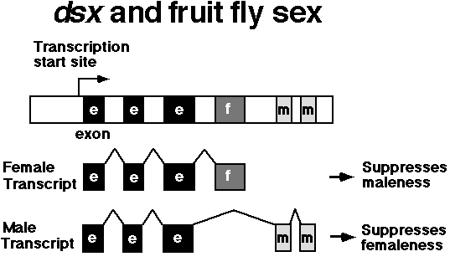

RULE: During splicing, the order of exons in the mRNA is the same as in the DNA however you can skip over as man exons as you like

RNA stability
The cell procees mRNA in ways that affect their stability
To stop translation you need to get rid of any of that RNA in the cell.
How stable an RNA is is determined by 5’ cap and poly A tail as well
The level of RNA is going to determine the amount of protein created.
If you eliminate more of the RNA then you will stop the protein translation

Translational Control:
Once the RNA is stabilized it gets to the ribosome and we have to decide whether or not we actually want to make it into a protein or should we save it for later

RNA interference:
The cells make ina diition to mRNA, very short hairpin RNA that are complementary to the 3’ untranslated region of mRNA. They are trnascriped from completely different genes
They bind to a dicer which then binds to the 3’ untranslated region in the mRNA and that makes it so that the protein cannot be translated and instead is stored

Post translational Control
After the protein is made it too can still be regulated

We spoke of proteins CDK 4 that bind to genes that get transcribes and translated during G1 phase in mitosis called cyclin D. THEese bind and form an active enzyme which binds phosphate groups to other proteins. When this happens it becomes inactive..
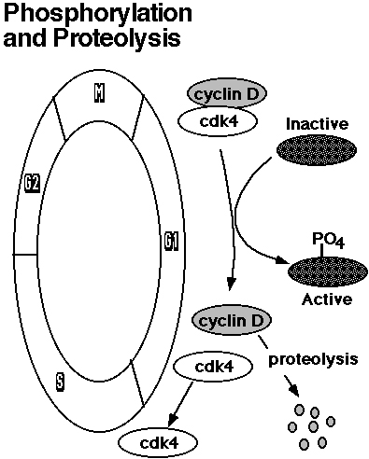

How do eliminate proteins
The cell needs to know which protein to degrade
It has a tag to mark it for death (ubiquinin)
When a protein has been marked, there are a series of protein whose jobs It is to break down the tagged proteins so the amino acids can be reused.

Why there are different mechanism for regulation
There is a balance between speed and efficiency
IF we don’t need a gene any time soon then we want to regulate at the time of transcription
Regulating further down is very fast. IF you need a protein rapidly then it makes sense to make it and then store it inactive so that it can be used when required. This is faster then having to do the whole transcription and translation process.

Genetic Engineering 101

GE – Changing the genotype of an organism to make it more useful or desirable

Selective Breeding:
Used to domesticate animals and plants
Only tech required is the ability to select and breed the next generation
WE could wait for useful mutations to arise by chance but its easier to cross two related species to make them happen

It works…

Maize is derived from teosinte. WTF

Limitations:
IN the 1800s someone had the idea to cross a cabbage and a radish so that none of the plant would be wasted as we usually throw away half of the crops
Unfortunately when you do this, the shitty leaves match with the shitty root and its totally useless LOL
Gene cloning:
Moving a gene from one organism to another

Why?
To make a new organism and gne that expresses a new phenoltype
This also allows us to study a gene in isolation which is valuable

Diabetes and Insulin
We used to grind up pig pancreas to get their insulin and then inject it to treat diabetes
However its slightly different in pigs, there is a single Alanine difference and people had immune reactions to it and it wouldn’t work

What if we could take the human insulin gene and put it in an organism that we could produce in large quantities so we would also produce a lot of insulin
We know that its easy to engineer bacteria with plasmids
Problems:
Where are we going to get the insulin gene?
How to get into the other organism?
How will it be expressed?

When phage attack a bacterial cell, that DNA get expressed which chew up the bacterial DNA
The bacteria have enzymes called restriction enzymes that come in and break up phage DNA but not their own.
These work because they recognize specific sequences of DNA.

E.g. a 6 base pair palindrome. When it sees this it cleaves the strand

These are great for genetic engineering because using the you can cleave DNA in an ordered way and not randomly
Also, these are sticky ends because the base pairing still applies so they still want to pair together

The idea is to take a plasmid, cut it with a restriction enzyme, take the insulin gene, cut with a restriction enzyme to match the plasmid, mix the two together and have them mix and then fuse with ligase to make the phosphate bonds.

Insulin is a human gene and has intron
Bacteria don’t have this because they can't splice it out of their mRNA
We have retroviruses that make DNA copies of RNA genomes that have the introns spliced out

SO we take the mRNA of the gene and use a reverse transcriptase to make a DNA copy without the introns, and then we insert that into the bacteria

We need a primer because all polymerases need that for the 3’ hydroxyl
There is a universal primer that can be used because all mRNA have poly A ends

We make a primer that has all T’s which will bind to the tail of the mRNA and act as a primer

Now we take the double stranded DAN that we have made and insert it into the bacterial plasmid

How do we make sure that we only make a copy of insulin?
We don’t. We make DNA copies of all of the RAN and we put them all into plasmids and all of those into bacteria.
This is a library of all the mRNA in cDNA form in the cell.
Then we go in and find the particular gene we need (in this case insulin)

Once the plasmid is in the bacteria we find which bacteria has the plasmid with the insulin gene

But transformation is very inefficient not all of htme absorb the DNA.
So we insert a gen with and antibiotic restistacne to the ones where we inserted the insulin
Then we grow on an antibiotic so only the ones with the resistacne survive

Then we grow and every colony results in a bacteria with a different plasmid and each with a different human gene

How to find which oine has insulin?
Hybridization:
If we heat the DNA the strands come apart
If we cool they will come back together properly
The temp for which this works will be different for each type of DNA
WE make a short strand of DNA single stranded that is complementary to the DNA that we want to identify and make it radioactive
Then we do this heating process and the strands that we want will become radioactive so we can easily see it.

For annealing temp: Its not just the longest strand that has the highest temp. The specific sequence as well. AT have 2 hydrogen bonds and GC have 3. The tamp has to do with the amount of hydrogen bonds

WE take our colonies all of which have different plasmids and genes. We lyse some of the Bacteria and then wash the with our radioactive probe and the genes we want should stick to it

How to make the bacteria recognize the insulin as a gene
We insert the insulin gene into a new plasmid that is good for expressing genes
It has a promoter a space for the gene and a stop codon
WE put this into the bacteria and it should recognize this and make the insulin

What we want vs what we get:

Sometimes the sticky ends just reform with themselves and fuck up

Sometimes we also get the insulin flipped over because it would still fit
Also sometimes we get two insulin that stick together. IF this happens the proteins wont fold properly

How to prevent this:
Make a gel and put the DNA in wells in it. Then make a voltage diff across the gel.
The DNA is negative and want to move towards the positive charge

Small pieces will move faster through the gel then big pieces will. And there will be a separation
Then we can tell the size of the DNA compared to a standard control one. We know that ones that appear to be the same size are the ones that were created properly.

Now we have our expression vector with its promoter promoting the expression of the protein gene
Now the bacteria will make the human insulin gene and we have huge vats of them.
WE can also add a lac operon before the gene and after the promoter so we control the expression of it with lactose and have the ability to turn it on or off.
Then we can cultivate the bacteria, have them ready to go, and then add lactose so that the gene is turned on and tons of insulin is made.
We harvest the bacteria, purify the insulin and give it out to diabetics.

Cloning an Unknown Gene
Our genetic theory of heredity is the proteins determine the phenotype and that the DNA determines the proteins
Therefore there should be a relationship between the genotype and the phenotype
We do secondary cloning to understand this relationship
It is not as easy as it sounds

Cystic Fibrosis
Characteristic of respiratory infections but also associated with digestive problems and sterilirty
Autosomal recessive trait
Occurs in 1/2500 Caucasian newborns

If we figure out what the gene is we can figure out the protein it codes and then figure out what it does
We could know whats wrong when that potein is missing alwell
OR..
How do you find a gene if you don’t know what protein it makes?
MAP IT
We could find the gene if we could map it to a small enough piece of the chromosome
If we can map a gene to a chromosome we can eliminate allt eh other chromosomes, then if we found a spot on that chromosome then we would know that the specific gene we are looking at has to do with cystic fibrosis

Problems:
There aren’t many phenotypes in humans that show simple Mendilian inheritance
Therefore we can't map phenotypes
You can't do controlled mating in humans

Restriction Fragment Length Polymorphisms
Polymorphisms in the DNA result in the presence or absence of a restriction site
The polymorphisms segregate in a simple Mendelian fashion
We can assay the presence or absence of many of the restriction sites
RFLP’s can be mapped like any other allele

There are certain sites where some people have the site but others do not. There are lots of these in the body
A large percentage of the population have these polymorphisms

You can fio using electrophoresis:
Some people have three site and when cut will have two fragments
Others when the gene is cut will have one fragment

When its run through the gel, there will be one track with two bands and another track with one bigger band

However the whole thing is still a huge smear of DNA how do we find the fragments?

Polymerase Chain Reaction:
How to amplify a small stretch of DNA so that you can study it
We don’t want to look at all DNA , we want to look at the Small fragment that may have the restriction site
We take a tiny bit of template DNA from a positive control of cystic fibrosis and create primers that correspond to the allele ** READ ABOUT THIS I DON’T GET IT
They have a sequence that will anneal to opposite sides of whatever DNA we want to amplify
The DNA that we want then sticks to I and polymeraze makes it
Now we have twice as much as before
Then we do it again and again and then we have a lot of this tiny strand that contains our gene

Every time you do this, the short strands double. The longer strands that include template DNA only increase by one.
THIS WILL BE ON THE EXAM FOR SURE
When you run it on the gel, all you will see is the short piece of DNA because it makes up the majority of the sample
This allows us to look at families with lots of children and see if there is a correlation between a polymorphism and the phenotype we are looking at

RFLP’s are just like genes and alleles

Someitmes we will se an allele in a gene that also changes the restriction site in this case there will be a perfect correlation to them
Most RLFP’s have no phenotype.

Where do they come from?
The RLFP’s are found mostly by trial and error. They go through the genome and try to find them

NOTE: Just because phenotypes and RLFP’s are linked or correlated, this does not mean for sure that one casues the other

Keep going
Mapping only gets you to a group of genes, not down to a single gene.
Then we need to do something else to find the actual gene
WE can just lookfor genes in that region and then look for the one that casuess the phenotype
If we could find all the RNA that correspond to that region of the genome then we can see what gene is there because the gene expresses the RNA
We can take the RNA ftom people with CF and make cDNA from it and then compare it to our sample strand and see if the genes match

The only difference between individuals having CF or not is that CF individuals have a three base pair deletion that corresponds to a Phenylalanine sequence being deleted
That gene encodes a chloride channel expressed in epithelial tissue, which regulates flow across the tissue. If this doesn’t happen then mucous in the lungs gets thick and cannot get expelled. Bacteria accumulate and infections occur.
Even though the gene was found, there is still no cure
It is however useful in a few ways:

Genetic Screening:
Indentify carriers so they can make informed family planning decision
Gene Replacement Therapy
If the CF gene is broken, maybe we can fix it by giving patients a normal CF gene
It is hard to insert a chloride channel into the membrane of your lungs. Its not like insulin
Idea: Take a virus that effects lung tissue and disable it so it can't replicate. Insert the gene into the virus so the virus takes the proper gene there but cannot negatively effect the virus
The problem is that our body still forms immune responses to the virus and also the viruses aren’t that effective and don’t get to most of the tissues

Is the CF allele beneficial?
CF is popular but casues sterility so it is not passed on.
Why is it not selected against?

The normal CF chloride channel is a receptor for S typhii, the cause of typhoid fever.
Individuals that are homozygous for the disease do not pass it on, those that are heterozygous for it, are less likely to not get typhoid
They think that is may also protect against diarrheal diseases (E. coli) as well as asthma

