Student Name:

Student Number:

Partner’s Name and Student #:

Demonstrator's Name:

PLEASE NOTE: If ANY of the above information is UNCLEAR or not provided, your grade will NOT be recorded!!

Lab Day (circle): Tues aft Tues night Wed Thurs aft Thurs night Fri

Lab Week (circle): 1 2

Laboratory Report Form

Experiment 5.

Acid/Base Titrations

Checklist:
- Raw Data Sheet written in pen, signed by TA AND Raw data from LabQuest attached
- Data tables and graphs (6 minimum!) made in Logger Pro attached
- Report Form attached

Student’s Initials:
Data Tables

Table 1. Formation of a stock solution of NaOH

Volume of concentrated NaOH solution (mL) | 4.6mL
Concentration of concentrated NaOH solution (M) | 6mol/L
Volume of stock solution after dilution (mL) | Trail: 1: 2.7mL  2: 5.0mL  3. 5.2mL
Approximate concentration of stock solution (M) | 5.52M

Table 2. Standardization of Stock Solution of NaOH

Data | Trial 1 | Trial 2 | Trial 3
Concentration of Standard Acid solution (M) | 0.100 | 0.100 | NA
Volume of Standard Acid solution (mL) | 10.2 | 10.0 | NA
Volume of stock solution of NaOH (mL) | 15.0 | 13.0 | NA
Concentration of stock solution of NaOH (M) | 0.660 | 0.568 | NA
Average Concentration of stock solution of NaOH (M) | 0.614M

Table 3. Determination of the Concentration of an Unknown Acid

Data | Trial 1 | Trial 2 | Trial 3
Sample Number of Unknown Acid | 4 | 4 | 4
Volume of Unknown Acid solution (mL) | 10.0 | 10.0 | 10.0
Volume of stock solution of NaOH (mL) | 13.7 | 10.1 | 11.6
Concentration of stock solution of NaOH (M) | 6.13 | 6.13 | 6.13
Concentration of Unknown Acid Solution (M) | 2.04 | 2.46 | 2.314
Average Concentration of Unknown Acid solution (M) | 2.27

Observations (all parts of the experiment):

Part 1: Preparing a solution of NaOH by Dilution:

As the 6M NaOH was added to the distilled water, the clear water became slightly less transparent, but not to the point of it being cloudy. NaOH was clear and relatively had no smell.

Part 2: Standardizing the Diluted NaOH solution:

When the phenophtalein was added to the HCl acid, no noticeable changes occurred, both substances were clear and colourless with no smell. As the NaOH was added to the acid solution, it started slowly, but ended up turning light, then dark pink as more NaOH was added. This change occurred around the 11-12pH level

Part 3: Determining the Concentration of an Unknown Acid:

Like in Part 2, the NaOH solution was added slowly, but to an unknown acid mixed with phenolphthalein. As the base was added, the acid solution slowly turned into a pink colour like in Part 2 but at a smaller pH compared to Part 2.

Part 4: Determining the Mass Percentage of Acid in a Juice Sample:

Like in Part 2 and 3, the same set up was in place, but instead of an unknown acid, there was a type of citrus juice. This juice was Triprotic, whereas Part 1 was Monoprotic and Part 2 was Diprotic. The pH where the colour was even lower than in the first 2 parts.

Table 4. Determination of the Mass Percentage of Acid in a Juice

Data | Trial 1 | Trial 2 | Trial 3
Sample Number of Juice | 1 | 1 | 1
Volume of Juice (mL) | 10.0 | 10.0 | 10.0
Volume of stock solution of NaOH (mL) | 10.0 | 10.0 | 10.0
Concentration of stock solution of NaOH (M) | 1.37x10⁻⁴ | 1.30x10⁻⁴ | 1.42x10⁻⁴
Concentration of acid in Juice (M) | 0.032 | 0.029 | 0.039
Average Concentration of Acid in Juice (M) | 0.033
Density of Juice (g/mL) | 0.9974
Molar Mass of acid in Juice (g/mol) | 192.14
Mass Percent of Acid in Juice (%) | 0.636%

GRAPHS: Attach Logger Pro data tables AND graphs (at least 6 [2 per part]) to this form!!

ORIGINALS AT BOTTOM OF LAB
Graphs with statistics

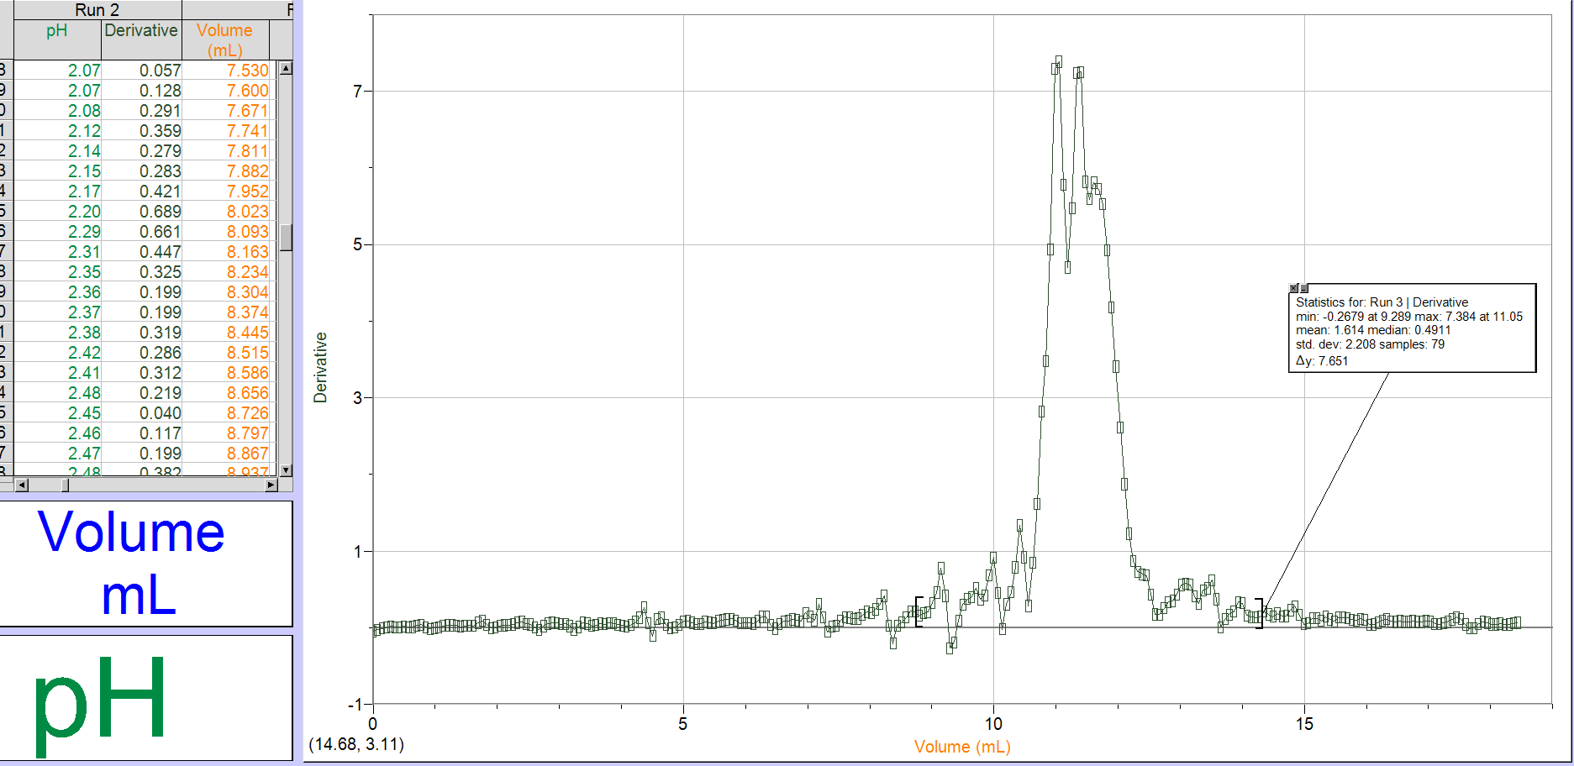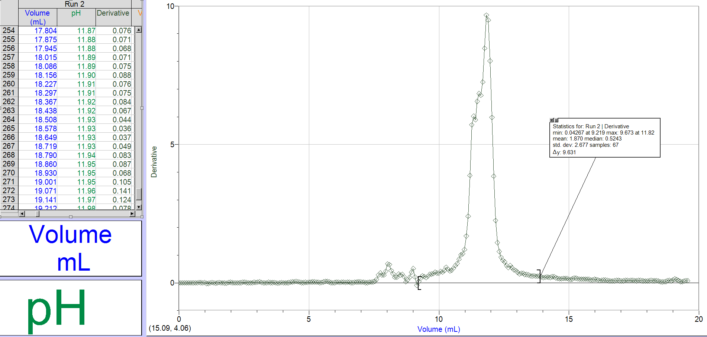

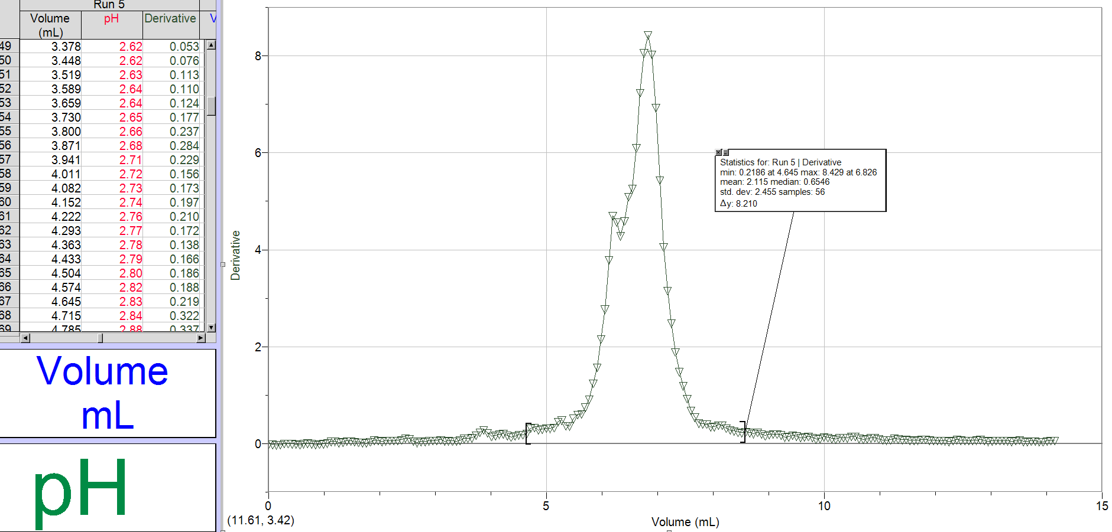
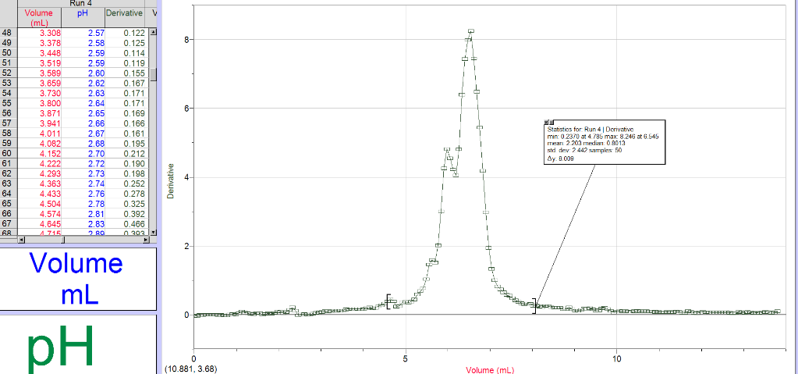
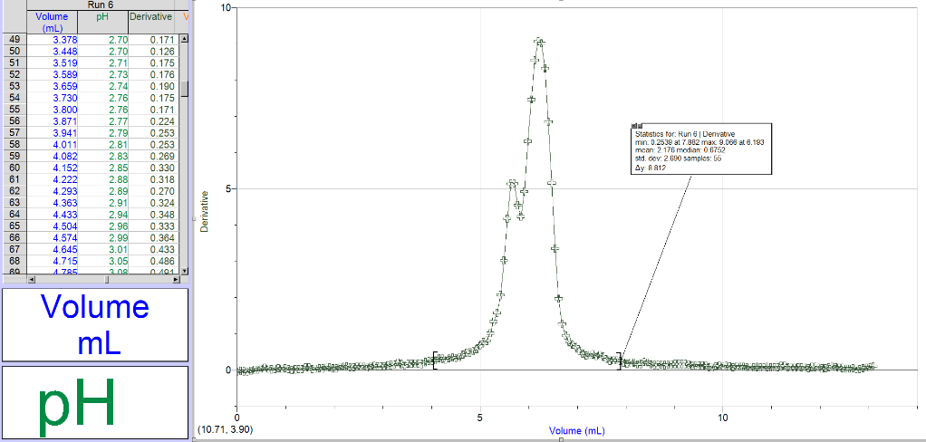

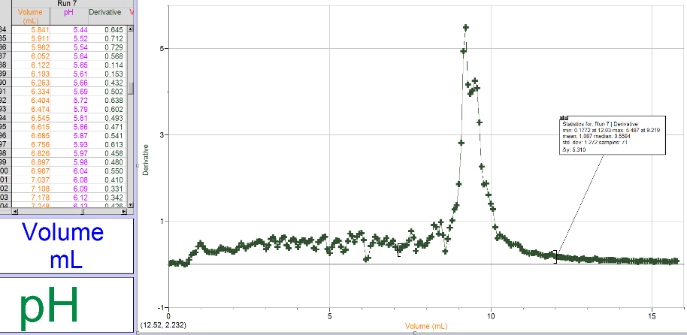
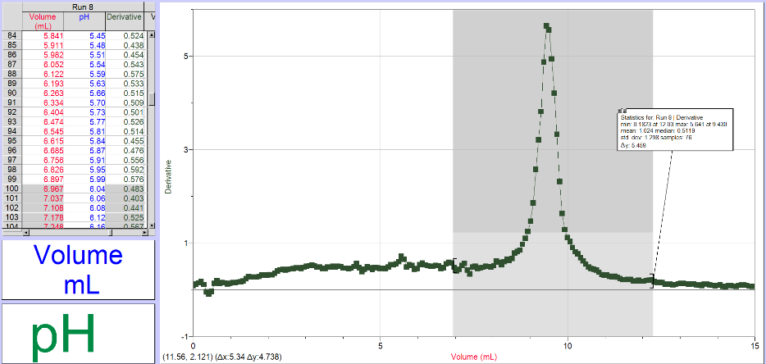
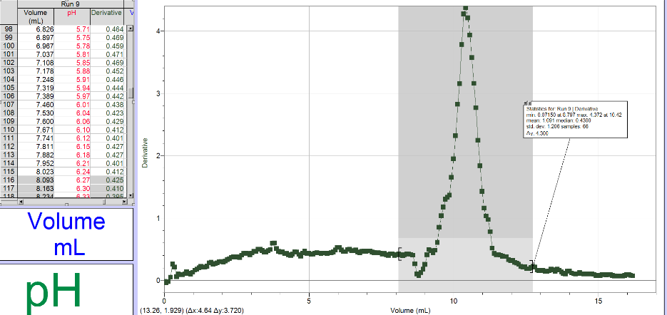

Sample Calculation: (Part 1)

- Approximate concentration of stock solution

C1V1=C2V2
(6)(0.0046)=C2(Trail 2 volume: 0.005)
C2= 5.52M

Sample Calculation: (Part 2)

- Exact concentration of stock solution (from visual endpoint and cV calculations AND by second derivative from titration curve using LabQuest 2 data):

Graph 1:
C_{base} x V_{base} = (b/a)C_{acid} x V_{acid}
C_{base} (0.0015L)=(9.673)(0.100M)(.00102L)
C_{base}=0.660M

Graph 2:
C_{base} x V_{base} = (b/a)C_{acid} x V_{acid}
C_{base} (0.0013L)=(7.384)(0.100M)(.001L)
C_{base}= 0.568M

- Average concentration of stock solution:

Average= (C_{base}+ C_{base})/2
Average= (.660 +.568)/2
Average= 0.614M
Sample Calculation: (Part 3)

- Concentration of Unknown Acid (from visual endpoint and cV calculations AND by second derivative from titration curve using LabQuest data):

Graph 1:
C_{base} x V_{base} = (b/a)C_{acid} x V_{acid}
V_{base} (6.0M)=(8.246)(0.100M)(.001L)
V_{base}=0.000137L NaOH

C_{base} x V_{base} = (b/a)C_{acid} x V_{acid}
(0.000137)(0.614)=(8.246)C_{acid}(.001L)
C_{acid}= 0.0102 x2(diprotic)
C_{acid}= 0.0205

- Average concentration of unknown acid:

Average= (.0205+0.0246+0.0235)/3
Average= 0.0228M

Sample Calculation: (Part 4)

- Concentration of acid in juice (from visual endpoint and cV calculations AND by second derivative from titration curve using LabQuest data):

Graph 1:
C_{base} x V_{base} = (b/a)C_{acid} x V_{acid}
(6.0M)V_{base}=(5.487)(0.100M)(.001L)
V_{base}= 0.0000956L

C_{base} x V_{base} = (b/a)C_{acid} x V_{acid}
(0.000956)(0.614)=(8.246)C_{acid}(.001L)
C_{acid}= 0.0106 x3(triprotic)
C_{acid}= 0.032M

- Average concentration of acid in juice:

Average= (0.032+0.029+0.039)/3
Average= 0.033M

8. Mass percentage of acid in juice:

Mass Percent= (((C_{Acid})(Molar Mass Juice))/((density)(1000)))x100
Mass Percent= ((0.033)(192.14))/((0.9974)(1000))x100
Mass Percent= 0.636%

Discussion (in space provided):

This Lab consisted of 4 parts that have conclusive results. Part 1 was “Preparing a solution of NaOH by dilution” where the NaOH solution was diluted with distilled water to make a much less concentrated NaOH solution to use in the titration process for the following Parts. Part 2 was “Standardizing the diluted NaOH Solution” where the titration of HCl and phenolphthalein occurred, it is a monoprotic acid which is a factor into why it took so long for the solution to turn pink at such a high pH. Part 3 was “Determining the Concentration of an unknown acid” where it was the same set up as Part 2 but instead of HCl, an unknown acid was used which was diprotic. Part 4 was “Determining the Mass Percentage of Acid in a Juice Sample” where is was the exact same set up as the previous 2 parts, but instead a triprotic citric acid was used to be titrated. The volume of NaOH used at the beginning of the experiment wouldn’t have any affect on results. We determined the concentration before we used it to use the formula to find out how much the NaOH was diluted in the water. The volumes observed by Logger Pro compared to when we visually saw a colour change were lesser. The colour change occurred later on compared to when equivalence happened. Some sources of error in this experiment include
- When the NaOH was being put into the dropper, sometimes slightly more or less volume would be added, causing the pressure to drop NaOH into the acid solution to raise. This causes the drops to be more dense or larger, which would cause easier equivalence.
- When doing the 2nd part of the experiment, as HCl was being titrated, the magnet that would help mix up the solution was not working, this caused the NaOH to be less powerful than it was intended, this would cause equivalence to occur later than expected.
- When the juice was being added to a beaker, the juice also mixed with some water, this would cause the density to be lower to be lower during the titration, which would affect the final mass percent of the juice.

Conclusion: (2 sentences. Please note that the values you state as your results in this section will be used to determine your grade out of 5 for the results. Please include your unknown acid number and your juice name in this section.)

The approximate value of NaOH was 5.52M, the exact concentration value of NaOH was an average of 0.614M, the concentration of the unknown acid was an average of 0.0228M. The concentration of the citric acid juice was an average of 0.033M. These values were subject to the sources of error listed in the discussion and could be slightly different.

Graphs
Part 1: Standardizing the Diluting NaOH Solution
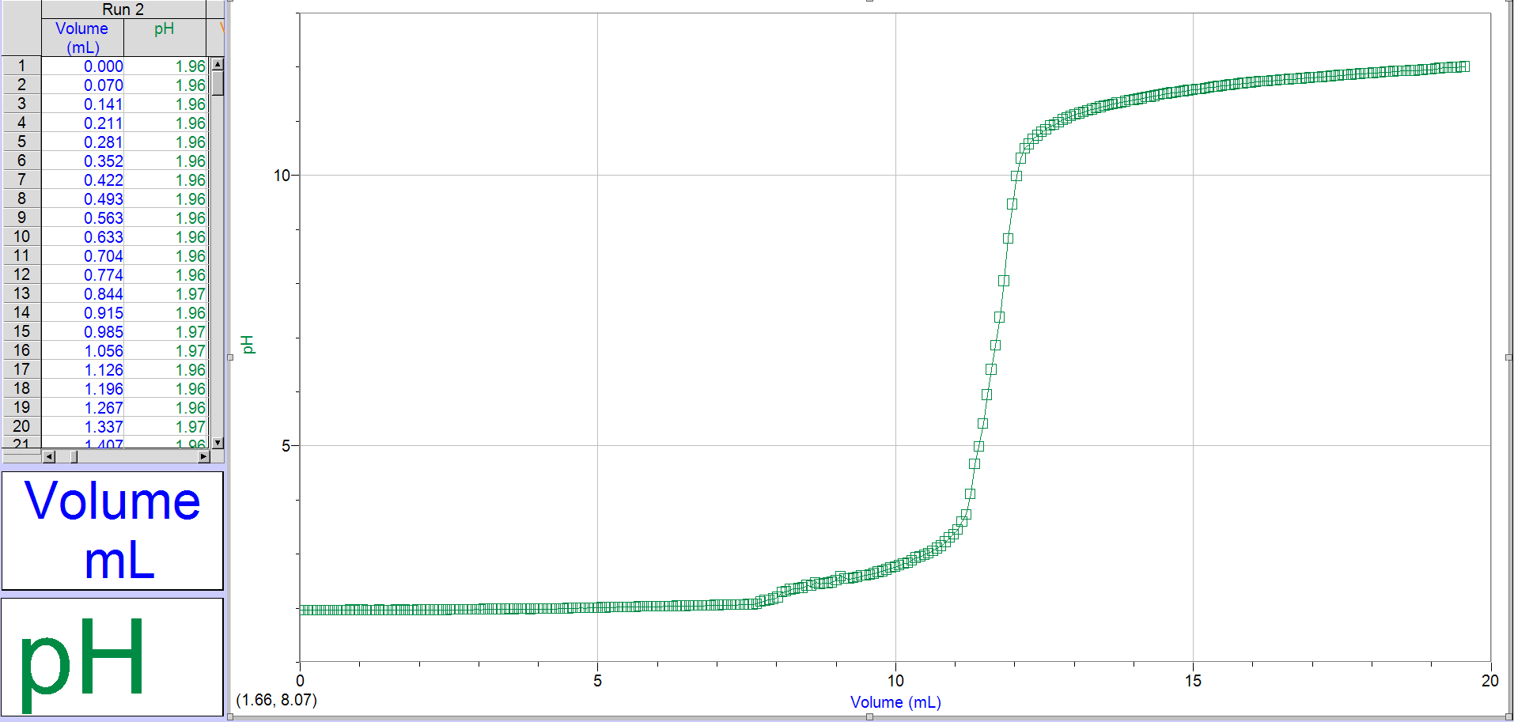

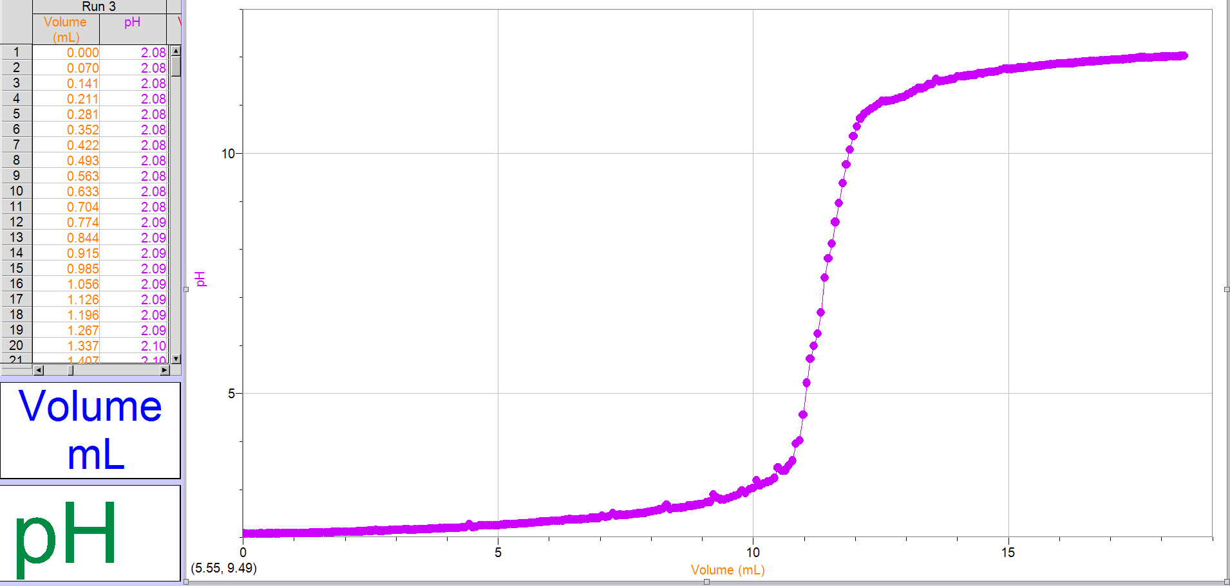

Part 2: Determining the Concentration of an Unknown Acid
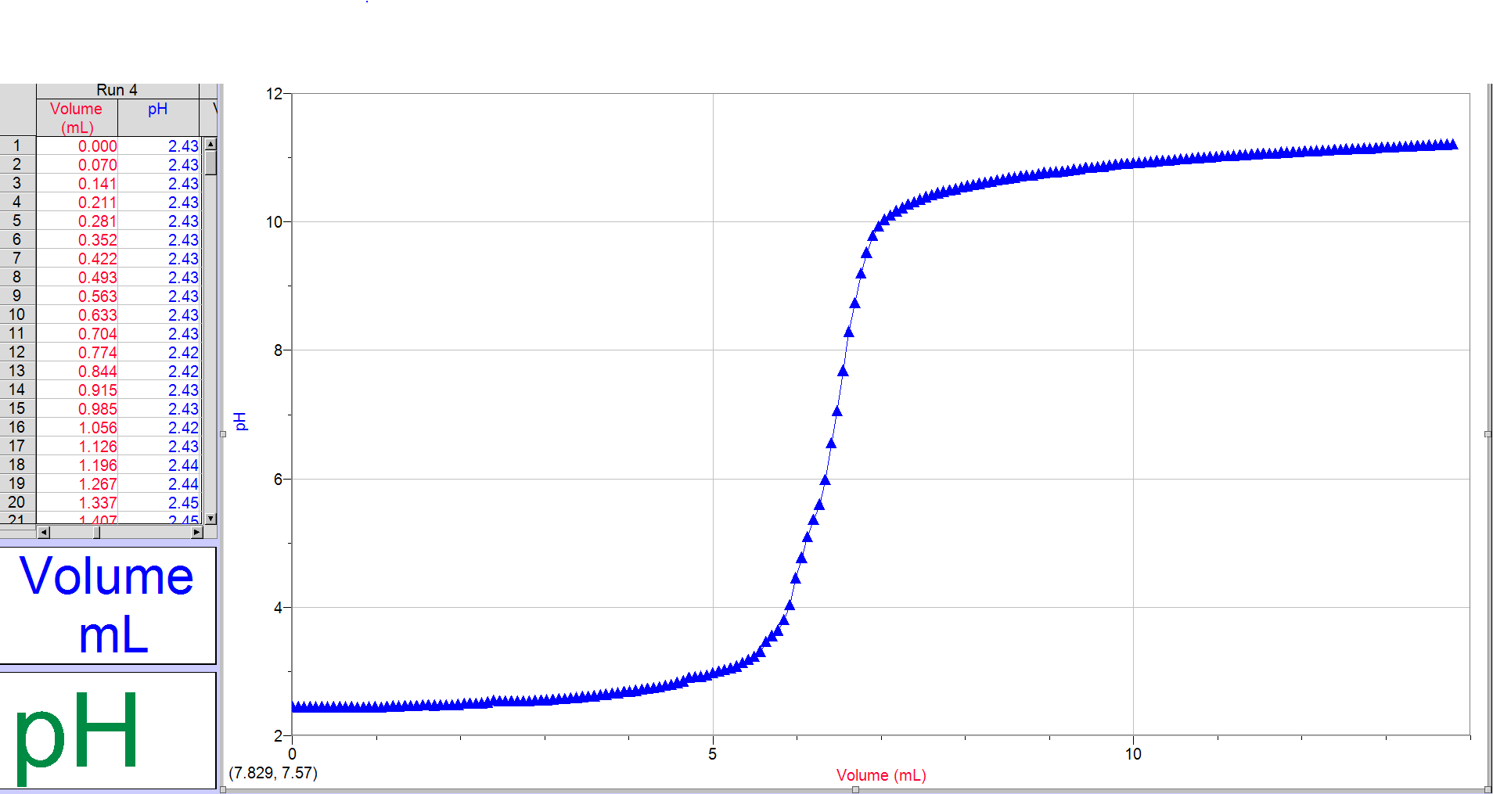
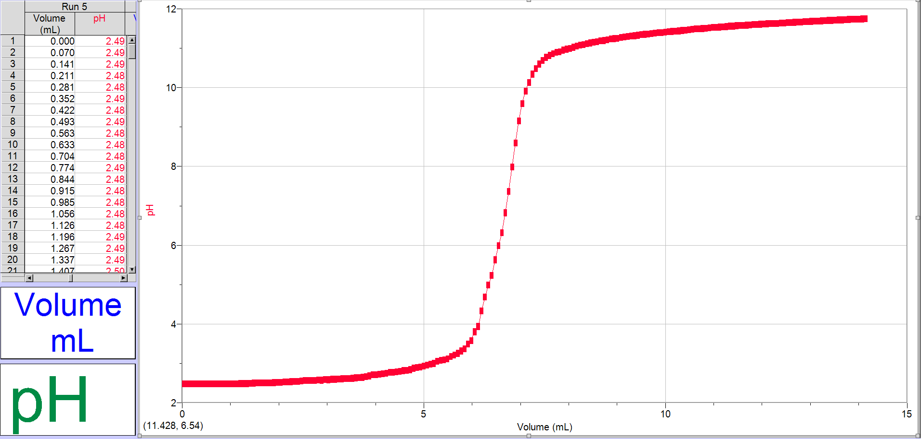
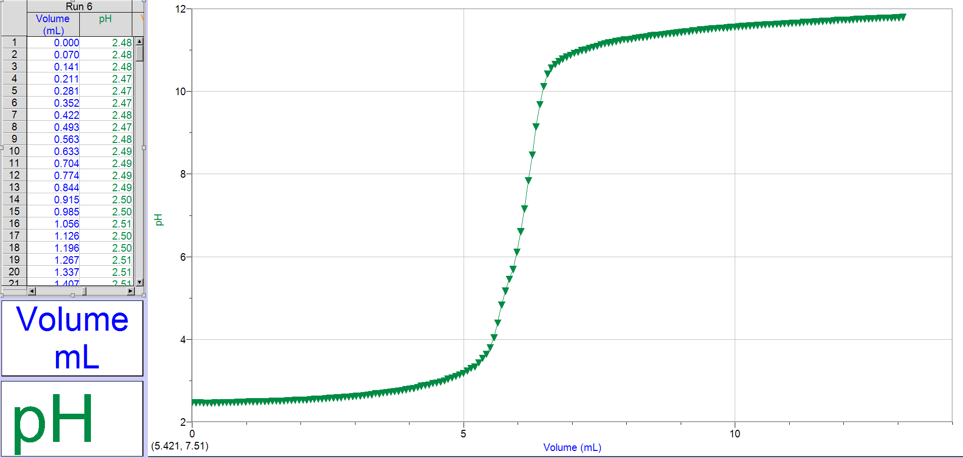
Part 3: Determining the Mass Percentage of Acid in a Juice sample
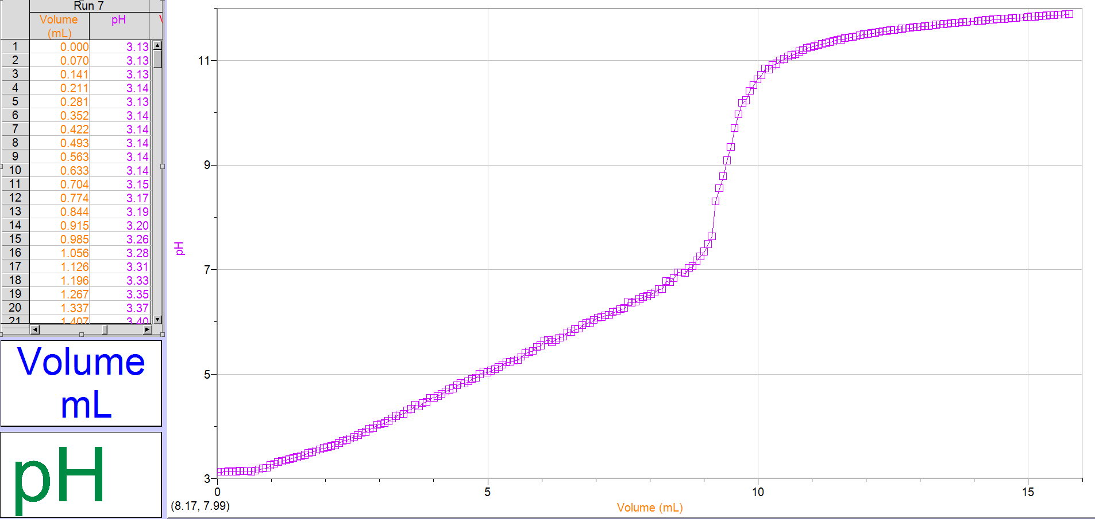
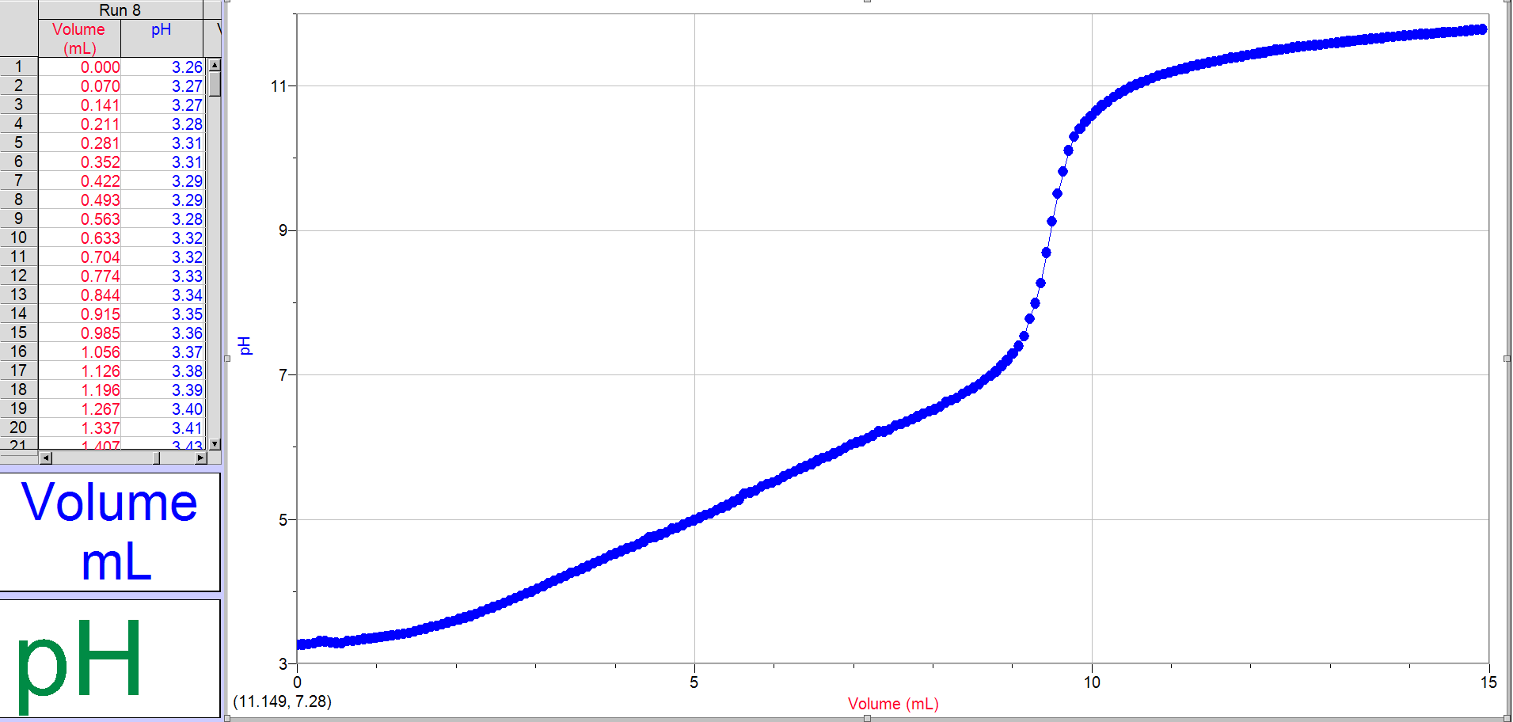
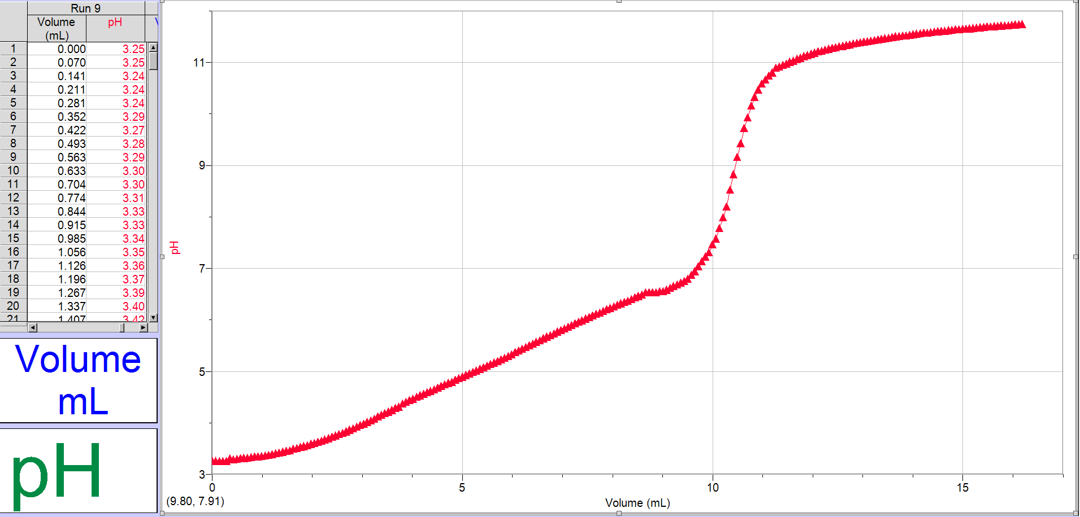

Raw Data

INLUDE RAW DATA

