BIO1140 Introduction to Cell Biology
Learning Objectives

Lectures 2-3 - THE CELL
- What is a cell?

A cell is the basic unit of all living organisms.

Different types of cells assume a wide variety or forms but are all organized according to the same basic plan (all have plasma membrane, DNA-containing central region, cytoplasm).

It was first discovered by Robert Hooke (mid 1600s), who first observed cork and gave its name due to its appearance of “small rooms”.

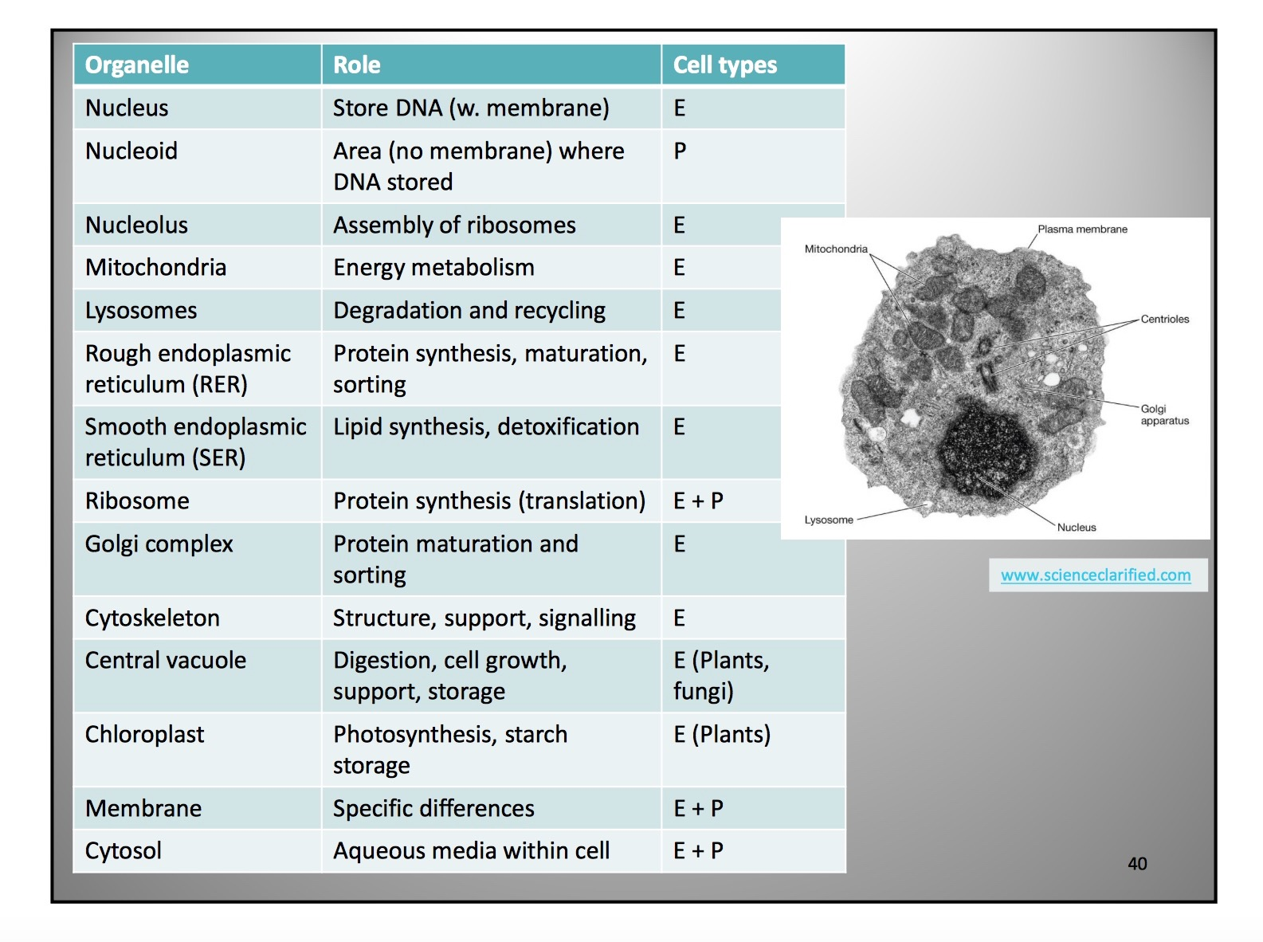
- What is it made of? Name the different organelles and recognize the roles/functions for each.
- What are the different scales/sizes for cells and organelles?

Prokaryote: 1-5 um
Eukaryote: 10-100 um

In order of size
cell membrane
ribosome
mitochondria
prokaryotes
nucleus
animal cells
plant cells

Why are cells small?
Volume: determines the amount of chemical activity that can take place within it
Surface area: determines the amount of substances that can be exchanged between the inside of the cell and the outside environment.

Increasing the diameter of a cell gives a surface area that is insufficient to maintain an adequate nutrient-waste exchange for its entire volume.

By having a higher number of smaller cells in the same amount of space, each of them has more opportunity to get the most out of their surroundings.

ex: prokaryotes (unicellular) are small because it’s more efficient for them and simpler than bigger, more complex organisms.
time to O2 equilibrium is less for smaller cells (0.067s vs 78 days for 0.1mm vs. 1m)

- Explain the theory of the cell and endosymbiosis.

Cell Theory (mid 1800s)
1. All living organisms are composed of one of more cells.
2. The cell is the basic structural and fundamental unit of all living organisms. (Schwann, 1839)
3. Cells arise only from the division of pre-existing cells. (Virchow, 1855)

Endosymbiosis
The theory of endosymbiosis suggests that mitochondria and chloroplasts are descendants of prokaryotic cells. It is thought to have happened with two different types of prokaryotes; one prokaryote engulfing an aerobic procaryote to form a symbiotic relation. What was initially its own organism became part of the organism that engulfed it and as it divided and reproduces, it also divided that portion inside (which lead to it becoming an organelle and allowed the cell to become more complex and lead to the creation of eukaryotes.

Evidence of endosymbiosis

1. Morphology
Shape and size are similar to bacteria/archaea (um)

2. Reproduction
Derived only from pre-existing cells; reproduce by binary fission

3. Genome
Contain their own circular DNA

4. Transcription and translation
Contain a transcription and translational machinery: genes encoded by the genomes are translated into mRNA and translated on the ribosomes, mRNA and tRNA

5. Electron Transport
Membranes have ETCs used to generate chemical energy

6. Sequence
Sequencing of the RNA similar to proteobacteria (mitochondria) and cyanobacteria (chloroplasts)

- What are the main groups or types of cells and how are they different?

Prokaryotes - bacteria, archaea
- DNA is small, located in the nucleoid, is circular and not protected by a membrane (no nucleus)
- cytoplasm contains masses of ribosomes (no organelles)
- 3 layer protection: plasma membrane, cell wall, capsule (glycocalyx = slimy)
- move thanks to flagellum and cilia
- pili enables exchange between two cells
- small; unicellular

Eukaryotes - protists, fungi, animals, plants
- DNA is larger, contained within a membrane-bound compartment (the nucleus) and is linear
- cytoplasm contains organelles
- transport system to go from one organelle to another
- plasma membrane
- larger; mostly multicellular
- plant cells have a cell wall, central vacuole and chloroplasts (no lysosomes or mitochondria)

Ribosomes in prokaryotes and eukaryotes have different rRNA.
Prokaryotes do not have: a nuclear envelope, organelles, an energy transforming unit.

- Understand the different types of microscopy and their requirements for use in cell biology.

Light Microscopy

1. Bright field

2. Dark field

3. Phase-contrast

4. Nomarski

5. Fluorescence

6. Confocal laser scanning

Electron Microscopy

1. Transmission electron microscopy (TEM)

2. Scanning electron microscopy (SEM)

