Chapter 1: Strategic Role of HR Mgmt.
- HR mgmt.(HRM): mgmt. of people in organizations to drive successful organizational performance and achievement of the organization’s strategic goals
- Must finds/hire best people, develop their talent, create productive work environment, and build and monitor these human assets continually
- Primary job of managing the workforce that drives organizational performance and achieves goals
- Attract, retain, engage diverse talent to meet commitments made to customers/shareholders
- Crucial that HR strategy is aligned with company’s strategic plan so that the workforce has the competencies and behaviours required to achieve the strategic objectives
- Human capital: knowledge, education, training, skills, expertise of workforce
- Effective HR practices are related to better organizational performance employee empowerment, productivity, etc. HR contributes to knowledge of firm’s culture, history, processes, context, etc.
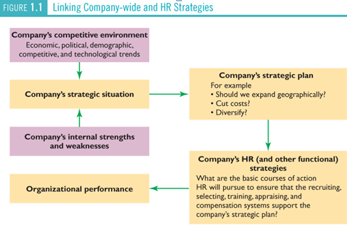
- 3 HR practices (profit sharing, resulted-oriented performance appraisal, and employment security) have strong relationships with important accounting measures of performance (ROA, ROE)
- High performance HR practices have positive relationship with turnover, productivity, and financial performance (gross rate of return on capital)

BRIEF HISTORY OF HRM
- HRM has become more strategic and HR practices have been shaped by society’s prevailing beliefs and attitudes about worker rights, which evolved in 3 stages
- Scientific mgmt.: (Frederick Taylor) focused on production, it is the process of scientifically analyzing manufacturing processes, reducing production costs, and compensating workers based on their performance levels. Mgmt. practice in 1800-1900s emphasized task simplification and performance-based pay to lead to higher wages and profits. However, Mary P. Follett advocated self-mgmt., cross-functional cooperation, empowerment, and managers as leaders (vs. dictators)
- Human RESOURCES movement: Concern for People & Productivity: mgmt. philosophy focusing on concern for people and productivity. There are 4 evolutionary phases.
- Early 1900s: HRM (personnel admin) played a minor role of hiring/firing, payroll department, and benefits administration. Job was mainly ensuring that procedures were followed.
- Union liaison, compliance with new laws, orientation, performance appraisal, employee relations operational efficiency increased but wages did not, causing workers to distrust mgmt. Higher unionization led to HR serving as the primary contact for union representatives. After the depression in 1930s, more laws were enacted so legal compliance was added to responsibilities of HR. In 1940-50s, HRM dealt with impact of the human relations movement.
- Human resources mgmt. emerged with outsourcing of specific HR functions and emphasis on contribution and proactive mgmt. of people. This phase = result of legislation during 1960-70-80s that affected worker human rights, wages, and benefits, working conditions, health, etc.
- Current phase where the role of HR evolved to help organizations achieve strategic objectives. EVERY line manager has responsibilities related to employees as they move through the stages of the human capital life cycle. All potential managers must be aware of the basics of HR.
- 5 critical pieces of knowledge required by HR professionals by propriety order: business acumen, understanding of employment law and legislation, talent mgmt., broad HR knowledge, and employee-labor relations knowledge
- Core competencies that those responsible for HR activities must secure (New roles of HR in phase 4)
- Credible activist: be credible (respected, listened to, trusted) and active (takes a position) in order to optimize the value added to the organization. This role is shared with non-HR positions.
- Culture and change steward: ability to appreciate, help shape, and articulate the corporate culture includes understanding, guiding, and reacting to internal and external stakeholder expectations. Global competition and need for more responsiveness to environmental changes put a premium on employee engagement, the emotional and intellectual involvement of workers in intensity, focus, and involvement. Engaged workers go beyond requirements helps company performance.
- Talent manager and Organizational Designer: HR must embed theory, research, and practice into the processes, policies, and structures of an organization. They are important in lowering labor costs, the single largest operating expense in many companies, particularly service.
- Strategy Architect: HR contributes to strategy by integrating internal/external stakeholder expectations. Through identifying, forecasting, and facilitating organizational responses to a changing internal workforce and volatile external pressures, HR forms/ implements strategy.
- Strategy: company’s plan for how it will balance its internal strengths and weaknesses with external opportunities and threats to maintain a competitive advantage
- Operational Executor: it’s not the content of strategy that differentiates the winners and losers, it’s the ability to execute. HR specialists are expected to be change agents (specialists who lead the company and its workers through organizational change). Flattening the pyramid, empowering workers, etc. helps companies respond quickly to needs and challenges.
- Business ally: goal setting depends on external. HRM and other managers affect environmental scanning to identify and analyze external threats and opportunities. HR supplies info about internal strengths and weaknesses, and help determine how organizations should be structured.
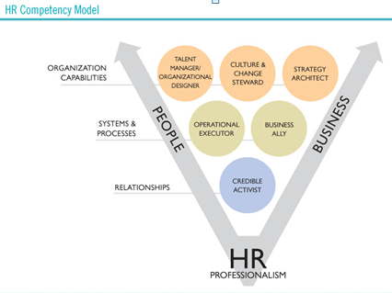

HR Role Continues to Evolve: 5 forces driving this change
- Changing technology: automates basic HR functions (day to day transactions and self-service systems for workers). Instead of maintaining HR technology experts, 50% of companies outsource operational functions of HR (payroll, benefits, recruitment). This shift freed HR from repetitive tasks to focus on more critical functions (decrease turnover, quality of talent, developing leaders, etc.)
- New rules: corporate accounting scandals in early 2000s resulted in more focused alignment of organizational activities with new laws. Financial rises of 2008 included more regulations. HR role is more strategic, to help recover from changes and comply with new rules
- Succession planning: 50% of companies don’t have succession plan for CEO. HR thinks critically about complexities, time, and contingencies that must be considered in succession planning. HR execs are critical to organizational success through mgmt. of succession planning process.
- Identifying top talent: HR continually establishes commitment to talent development that is fair, realistic, aware of limitations, and sustainable (not every worker can be perfect). Better ROI can be secured by focusing on smaller portion of workers.
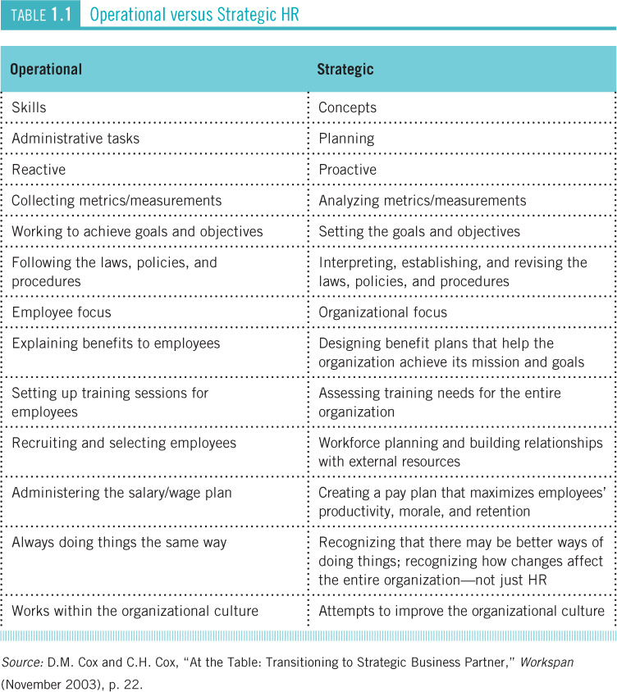
- New breed of HR leaders: rise of CHRO (chief HR officer) or CTO (chief talent officer) confirms the intent of many BoD in elevating and recognizing the role of HR in leadership. HR participation at highest level of organizational decision making marks the transformation of the role of HR from operational expert to strategic expert.

Measuring the Value of HR: Metrics
- Metrics: statistics used to measure activities and results
- HR must measure value& impact of their human capital and HRM practices
- Traditional operational measures focused on amount of activity and costs of HR, but today’s measures must reflect productivity, sales, and quality of people and effectiveness of HRM initiatives that build workforce capability ex: % of first choice job candidates accepting the job offer
- Balanced scorecard: measurement system that translates an organization’s strategy into a comprehensive set of performance measures. Includes financial and operational measures that balance LT and ST actions and measures and human capital mgmt. (ex: % of senior mgmt. positions with fully job-ready successors ready)

ENVIRONMENTAL INFLUENCES ON HRM
- monitor the environment, assess the impact of any changes, and be proactive in responding
6 Major External Environmental Influences
- Economic conditions: affect supply and demand for products/services, which impact # and types of workers required as well as employer’s ability to pay wages and provide benefits. Healthy economy means more hired since demand for products rise. Unemployment rate falls, competition rises for good workers, and training = more important. However, in economic downturn, firms reduce pay and benefits, downsize with early retirement, unemployment rises, etc.
- Productivity: the ratio of an organization’s outputs to its inputs. Canada’s relatively low productivity growth rate is concerning because of increasing global competition.
- Primary sector: agriculture, fishing, trapping, forestry, mining shrunk to only 4% of jobs
- Secondary sector: jobs in manufacturing and construction fell to only 19% of jobs
- Tertiary or service sector: public admin, personal and business services, finance, trade, public utilities, and transportation/communications grown to 77% of jobs, dominate economy
- Many service sector jobs demand highly knowledgeable employees
- Labour market issues: increasing workforce diversity is important. Canada’s workforce is one of the most diverse (cultural values and demographic factors). The proportion of visible and ethnic minorities entering the Canadian labour market is expected to grow the fastest.
- Canada admits the most immigrants per capita; we have over 200 diff. ethnicities
- 2/3 of visible minorities = immigrants, and 20% of Canadian population = visible minorities by 2017
- Employment rate for women converges toward that of men, and companies accommodate working women and shared parent responsibilities ex: onsite daycare, flexible hours
- Women are the sole breadwinners for 29% of dual-earner couples in Canada
- Young Aboriginals = untapped source of employees facing difficulty in getting jobs & advancing, but the Aboriginal population is growing at a rate almost 2x the rest of Canadian population
- Although there is no performance difference in terms of productivity, attendance, and average tenure between those with/without disabilities, those with disabilities experience unemployment rate that is 50% higher than that of able-bodied population, and average income 17% lower.
- Another aspect of diversity is generational differences. There are 4 generations. 50% of Canadians say they’ve clashed with other age group of workers, while 25% workers say they don’t notice age differences. The other 25% thinks the situation provides great learning opportunities.
- Traditionalists: individuals born before 1946 and grew up in era of hardship.
- Baby Boomers (1946-64): largest group; grew up during major optimism and change. They’re retiring now, so the ratio of people not in labour force per 100 people in working population is expected to fall from 44% in 2005 to 61% in 2031. labor shortage
- Generation X: (1965-80) smaller group than Boomers. Also called Baby Busters. They grew up as divorce rates rose, and they provide out-of-the-box thinking that helps deal with uncertainty.
- Generation Y (Millennial, Net Generation): (1980s) children of Baby Boomers, and known as over-involved parents. Beginning to enter the workforce, values CSR, and expects to change jobs often.
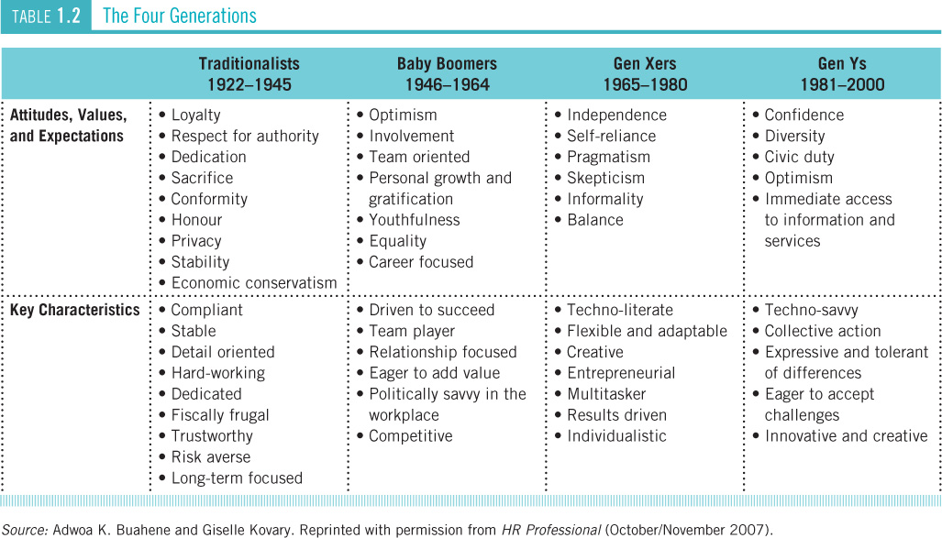
- 50% of Canada has some postsecondary education, so managers are expected to ensure that the capabilities of workers are fully utilized. However, only 26% have marginal literacy skills, meaning that inadequate reading and writing skills have replaced lack of experience as the major reason for rejecting candidates higher level of education overall, but higher level of functional illiteracy
- 15% of working-age Canadians are functionally illiterate: unable to read, write, calculate, solve problems at level required for independent functioning or routine technical tasks takes a toll on organizations accident rates and productivity levels
- Non n standard/contingent workers: workers who do not have regular full time employment status 1/3 of the workforce are part time, home, or self-employed, or have temporary jobs. More women fall into this category than men. Non-standard work is often poorly paid, offers little job security, and is generally not covered by employment legislation.
- Technology: Twitter, Facebook, and other technology is available today to make working in and managing a dispersed workforce easier and enables people to work anywhere. Data control, accuracy, right to privacy, and ethics are controversial topics. Sophisticated computerized control systems monitor employee speed, accuracy, emails, voice mail, phone, and efficiency in some firms.
- Government: may laws impact on employer-employee relationship in Canada. In Canada, 14 different jurisdictions are involved, so employment law is challenging. Also, 10% of the workforce is covered by federal employment legislation. Laws differ greatly among jurisdictions despite certain laws that apply to all employers and employees across Canada, such as EI and Pension Plan. New laws cover HR, employment standards, labour relations, occupational health/safety, compensation.
- Globalization: emergence of a single market for most products/services. This increases competition and leads HR became a source of competitive advantage for some firms. There are more multinational corporations (firms operate outside their headquartered country). Thus, HR professionals must be familiar with employment legislation in other countries and manage ethical dilemmas when labour standards are substantially lower than those in Canada.
- Environmental Concerns: issue especially for younger generations because of sustainability, global warming, pollution, extinction, etc. People want to work for environmentally friendly companies now. Such companies gain market share easier and have strong employee retention.

3 Internal Environmental Influences
- Organizational Culture: core values, beliefs, and assumptions that are widely shared by members of an organization. It’s conveyed through the mission statement, and stories, symbols, ceremonies. The mission statement communicates what the company stands for, provides workers with direction and norms, shapes workers’ attitudes, creates identity, consistency, and loyalty. all managers with HR responsibilities must create and maintain the desired culture because positive culture has positive impact on employer branding, recruitment, retention and productivity
- Organizational climate: prevailing atmosphere that exists in an organization and its impact on employees. Friendly, open, secretive, rigid, flexible, innovative, etc. the factors influencing climate are management’s leadership style, HR policies and practices, and amount/style of communication. Climate is reflected in employee motivation levels, job satisfaction, performance, and productivity. HR plays key role in establishing and maintaining climate.
- Management practices: changed over past decade with many HRM implications. Traditional bureaucratic structure with many levels of mgmt. is being replaced by flatter organizational forms using cross functional teams and increased employee empowerment.

GROWING PROFESSIONALISM IN HRM
- HR must be professionals in performance AND qualifications. Every profession has characteristics
- Common body of knowledge
- Benchmarked performance standards
- Representative professional association
- An external perception as a profession
- Code of ethics
- Required training credentials for entry and career mobility
- Ongoing need for skill development
- Need to ensure professional competence is maintained and put to socially responsible uses
- Every province has an association of HR practitioners that assumes dual roles
- As a professional association serving the interests of its members
- As a regulatory body serving the public
- These 2 roles may conflict, like when disciplinary role of regulator conflicts with professional interests of a member
- The Canadian Council of HR Associations (CCHRA) is the 40k member national body where all provincial HR associations are affiliated member of World Federation of People Mgmt. Associations (WFPMA)
- International {Personnel Mgmt. Association (IPMA) Canada is the national association for public and quasi-public sector HR professionals
- The Certified HR Professional (CHRP) designation is a nationally recognized certification (recognition of having met certain professional standards) for Canadian HR professionals. Managed by CCHRA and administered through provincial HR associations, CHRP is similar to other professional designations like CA. it recognizes member qualifications and experience based on established levels of 187 required professional capabilities in 7 functional dimensions: Professional practice/ Organizational effectiveness/Staffing/ Employee and labour relations/Total compensation/ Organizational learning, training, and development/Occupational health, safety, and wellness
- Senior HR Professional designation (SHRP) is for those who have other internationally recognized designations, or a work history demonstrating leadership, advisory capabilities, strategic orientation, a breath of general business knowledge, and significant impact of their organization and profession.


