Lecture #1- Digestive System
January 11, 2015

Main Digestive Organs (2)

- Alimentary Canal (GI Tract/Gut)
- Mouth, pharynx, esophagus, stomach, small intestine, large intestine
- Continuous muscular tube (mouth to anus)
  - Digests food
  - Absorbs digested fragments through lining into blood stream
  - Excretes end prdt
- Small intestine absorbs nutrients, large absorbs salts/water

- Accessory digestive organs
- Teeth, tongue, gallbladder, salivary gland, liver, pancreas
- Tongue & teeth are the only ones not connected to GI tract by ducts
- Produce secretory prdt saliva, bile, enzymes (for digestion)
- Food in lumen of GI tract outside of body bc needs to be absorbed by lining to enter the body

Digestive organs and peritoneum

Digestive organs in abdominopelvic cavity. Cavity lined w/ slick, friction-reducing serous membranes. Peritoneum is the most common serous membrane…

Visceral peritoneum external surface of digestive organs. Continuous with…
Parietal peritoneum lines walls of abdominopelvic cavity

Peritoneal cavity slitlike space between visceral and parietal peritonea. Contains fluid screted by serous membrane for friction reduction between organs in cavity.

Mesentery fused double layer of parietal peritoneum. Carries BV, lymphatic vessels, and nerves to organs of GI tract. Ventral (liver) and dorsal types. Maintains structure, lipid structure (fat deposits)

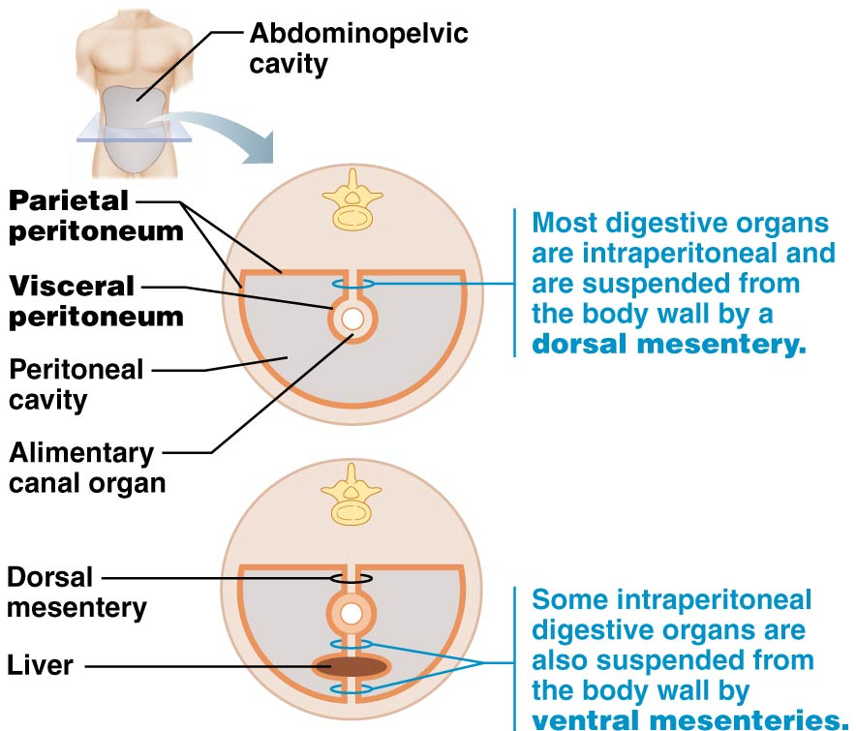

most digestive organs keep mesentery and stay in peritoneal cavity. Pancreas lose mesentery in development and lie posterior to peritoneal cavity (against abdominal wall) called retroperitoneal.

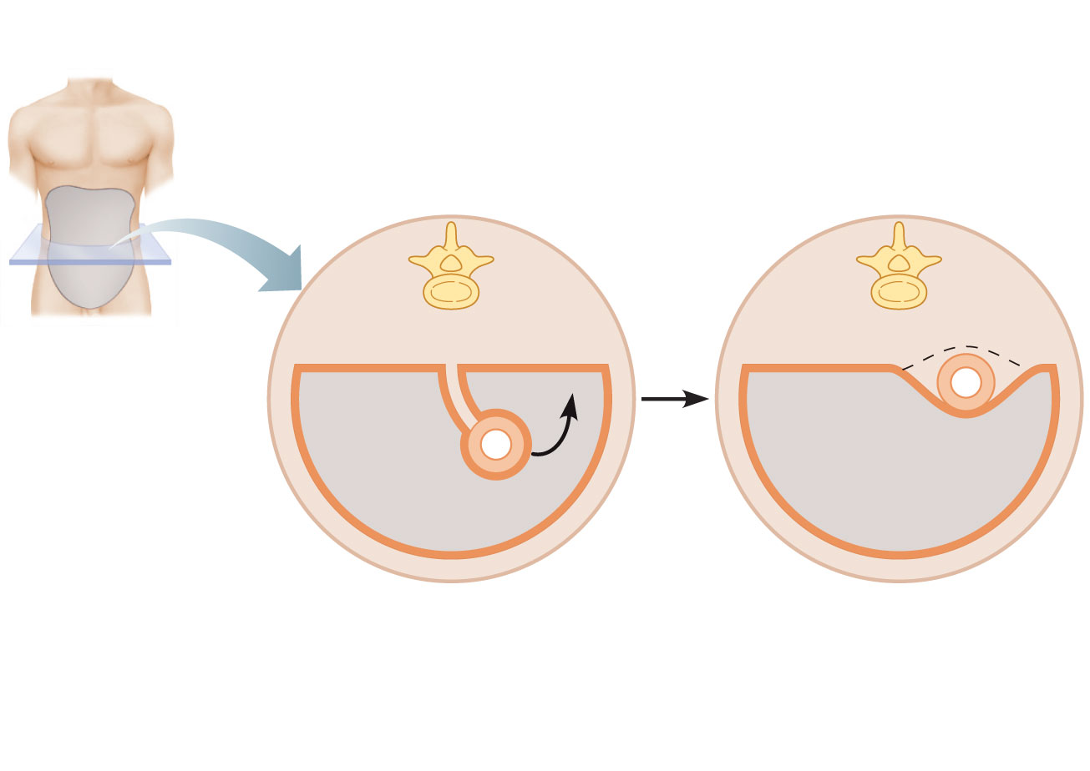
Abdominopelvic
cavity
Mesentery
resorbed
and lost
Alimentary
canal organ
Alimentary canal organ in
a retroperitoneal position

Perionitis- inflammation of peritoneal cavity due to infection. Causes…
- Bacteria leaked from GI tract
- Perforated ulcer (lesion across GI tract)
- Piercing wound
- Appendicitis

Blood Supply Serving GI tract

- Splanchnic circulation: arteries that branch off of abdominal aorta to serve digestive organs & hepatic portal circulation
- Need large blood supply for digestive system bc it’s a muscle that is active
- Arteries below receive ¼ of cardiac output, increased amt after meal
ARTERIES
hepatic
gastric
splenic
sup & inf mesenteric
ORGAN SERVED
liver
stomach
spleen
small & large intestines

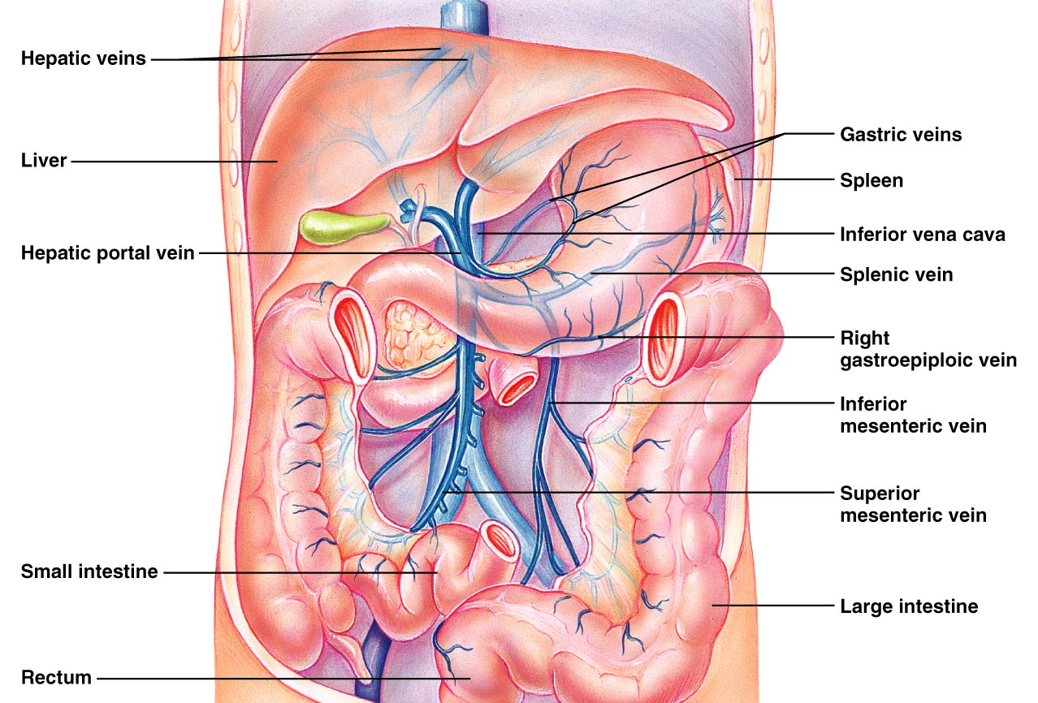

- Inferior vena cava – venous return from abdominopelvic region
- Hepatic portal circulation- venous return from digestive viscera
  - All veins collect into one large hepatic vein. Sent to liver then to hepatic veins to superior vena cava
  - Liver detoxifies/filtrates blood, which is the purpose of the portal circulation

Histology of GI tract wall
- Four layers (internal to external) mucosa, submucosa, muscularis externa (2 layers), serosa
  - Mucosa
    - Secretes mucus, enzymes, hormones
    - Absorbs end prdts of digestion
    - Protects against infection
    - 3 sublayers
      - surface epithelium: columnar + goblet (mucus for easy food passage, protect against invaders and epithelial cells) lots in stomach, enzymes + hormones into stomach/small intestine
      - lamina propria: loose CT w/ capillaries, isolated lymph nodes (immune surveillance), found in bunches in areas (tonsil, appendix)
      - muscularis mucosae: thin layer of smooth muscle, local movement of mucosa, mucosa folds in small intestine to increase SA + better absorption
  - Submucosa
    - Dense CT w/ blood + lymphatic vessels, lymph nodules, nerve fibers. High elasticity for stomach to regain shape after large meal
  - Muscularis externa
    - Major movement (mixing contents)
    - Inner circular layer + outer longitudinal layer
    - Thick sphincters at organ junction, a barrier
  - Serosa
    - Protective= visceral peritoneum
    - Loose CT w/ squamous epithelial cells
- Esophagus surrounded by adventitia not serosa.
  - Fibrous CT to bind structure to tissues (immobile)
- Retroperitoneal organs have BOTH (serosa facing peritoneal cavity AND adventitia on side against dorsal body wall)
Mesentery
resorbed
and lost
Alimentary canal organ in
a retroperitoneal position

Functional Anatomy of GI tract

Mouth
- Buccal cavity
- Bound by lips, cheeks, tongue, palate
  - Tongue- stratified squamous epithelium
  - Epithelium on gums, hard palate, back of tongue = keratinized bc resists abrasion

Lips & Cheeks
- Core of skeletal muscle
  - Orbicularis oris – lips, buccinators- cheeks
  - Speech, hold food
- Red margin- vascularization underneath
- No sweat glands… needs saliva for moistening
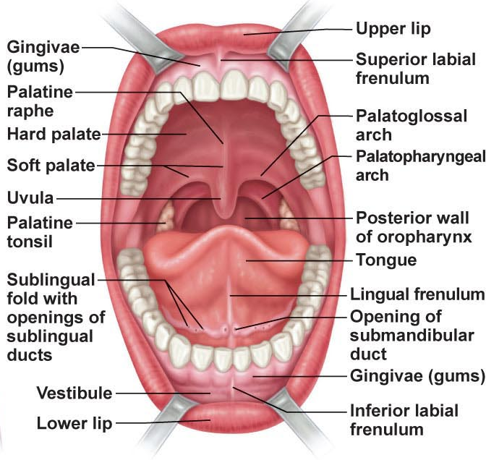

Palate
- Hard (anterior), soft (posterior)
  - Hard- palatine bones & palatine processes of maxilla. Tongue pushes food against ridged surface during chewing
  - Soft- skeletal muscle (no bone), closes off nasopharynx when swallowing
- Palatoglossal/palatopharyngeal arch joins soft palate to tongue and oropharynx (boundary between pharynx and oral cavity)

Tongue
- Interlacing mass of skeletal muscle + taste buds + mucus & serous glands
- Chewing, mixing food w/ saliva, forms bolus
- Speech
  - Intrinsic skeletal muscles- in tongue, not attached to bone, 3 planes (transverse, longitudinal, vertical), changes shape
  - Extrinsic skeletal muscles- attach bone to skull or soft palate to tongue, provide anchor so it can have movement in space
- Lingual frenulum
  - Attach tongue to floor of mouth
  - Tongue tied= frenulum attached (need to cut)
- Median septum divides into 2 identical halves
- Papillae (projections)
  - Filiform: keratin, friction for manipulating foods (ex. Dog drinking water)
  - Fungiform: mushroom shape, scattered, vascular core tht is red, taste buds
  - Circumvallate: V-shaped row @ back of tongue, additional furrow, taste buds
  - Foliate: on side of tongue, taste buds
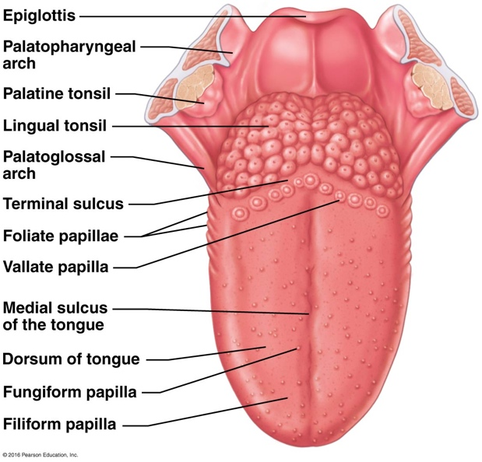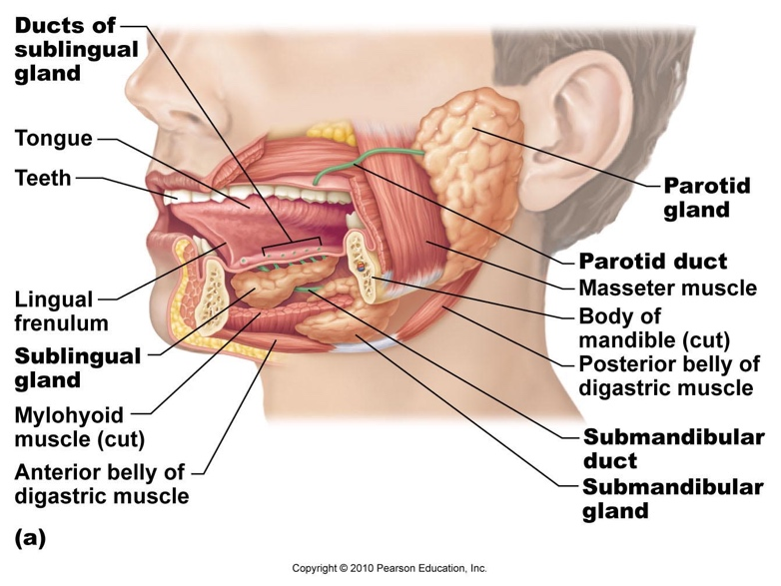

Salivary Glands
- Extrinsic salivary glands
  - Parotid- anterior to ear (between masseter muscle & skin), parotid duct enters oral cavity or vestibule next to 2nd molar, upper jaw, inflamed = mumps
  - Submandibular- medial mandible, duct under mucosa of oral cavity floor, opens at base of lingual frenulum
  - Sublingual- under tongue, anterior to submandibular, opens through MANY ducts into floor of mouth
- Intrinsic salivary glands
  - Buccal- keep mouth moist
- Secretory cells
  - Within each gland
  - Serous (watery) or mucous (thick mucin)
  - Proportion depends on gland

