CHM 1311: LAB #3- CHEMICAL KINETICS

INTRODUCTION: In terms of speeds of chemical reactions they can vary a great amount. They can be extremely fast or very slow. A reaction may give you the products you want and chemical kinetics involves the factors that control the rates of reaction and the different ways how reactions occur. It will further be investigated how the order of the reaction is affected through increasing temperature. This rate is proportional to the product of the concentrations of the reactants raised to a certain power.

If A+BC; then Rate =k [A]^{n}[B]^{m} where k is the rate constant. For graphical representations of the rate an instantaneous rate can be determined by taking the slope at any point. For the above rate equation “m” and “n” refer to the order of the reaction and the total order is “m+n”. A method to determine the order of the reaction is to measure the absorbance- of light in a colored species which allows us to figure out the the change in reaction rate. The change in color seen is a mixture of several reaction intermediates.

In the example of using chromium to get the maximum wavelength at a purple color the rate equation would be: Rate= -d[Cr(III)]/dt= d[Cr(III)-EDTA]/dt = k[Cr(III)]ª[H⁺]^{b}. This analysis relates to spectrophotometry which is the study of the interaction of electromagnetic radiation with matter. Specifically, “absorbance” and “transmittance” will be looked at. Transmittance is defined by the equation of: T= I/I_{o}. T represents transmittance, I represents intensity of light after passing through median, and I_{o} is intensity of light before it passes through the median. The percent transmittance can be calculated by using the equation: %T=T x100%. Absorbance is calculated using: A=-logT= -log(I/I_{o}). T is seen to be the transmittance and not the percent transmittance, and A refers to absorbance.

Spectrophotometry is an analytical tool that can be used to determine the concentration of dilute solutions as long as there is a species present that absorbs large quantities of light at a particular wavelength. The relationship between absorbance and concentration is seen to be called the “Beer-Lambert law”
A=$ε$bc. Where $ε$represents molar absorpitivity coefficient, b represents the path length, and c represents the concentration of the absorbing species in the solution.

When the chromium is heated to 100 degrees Celsius this gives us the value of absorbance at an infinite time. This represents the complete absence of Cr(III). Gives us the equation of: A_{Cr(III)} = A_{infinity} –A_{t} where A_{t} is the absorbance at time=zero.

In terms of graphical representations; if A_{Cr(III)} is plotted as a function of time the partial order can be determined. On this graph the instantaneous rate can be determined by taking the slope of the tangent. As long as the concentration of the H⁺ ion is maintained constant pseudo first-order kinetics can be observed meaning it turns out that the rate is directly proportional to [Cr(III)]

Another equation that can be used is the Log Rate:
Log Rate= a log[Cr(III)] + logk. This can be used to view pseudo first order kinetics. Since we are using absorbance to represent concentration; rate of change of absorbance of Cr(III) gives us instantaneous rate

Peer Reviewed Source: ¹Ham, R.C., J.Am.Chem.Soc., 75,5670(1953)

PROCEDURE: Refer to pages 49-54 in Experiment 3 of “What in the World ISN’T Chemistry, Rashmi Venkateswaran, 2000

DATA AND OBSERVATIONS/RESULTS:

Table 1- Statistics of Transmittance in Calibration of the Lab Quest:

Minimum Transmission Percentage | 3.251% at 39.60 nm
Maximum Transmission Percentage | 19.922% at 613.90 nm
Mean | 7.526 nm
Standard deviation | 4.5197 nm
Samples | 160 nm
∆y | 16.671 nm
Wavelength | 612.40 nm

Table 2- Transmittance in the presence of the 4.0 pH EDTA complex
pH | 4.0
Overall Volume | 10.2 mL
%T at 40 min | 76.223%

Table 3- Transmittance in the presence of the 4.5 pH EDTA complex

pH | 4.5
Overall volume | 10.2 mL
% T at 40 min | 73.726 %

Table 4- Transmittance in the presence of the 5.0 pH EDTA complex

pH | 5.0
Overall volume | 10.1 mL
%T at 34 minutes | 50.167%

Table 5- Qualitative Observations

Trial # | Observations
Trial 1 with 4.0 pH EDTA | - Rapidly turns dark purple when heated  - In cuvette: slightly purple translucent liquid  - After 42 minutes: big decrease in percent transmittance showing a long, steep decrease in the graph
Trial 2 with 4.5 pH EDTA | - Translucent liquid, slightly purple in cuvette  - Solution turns into dark transparent purple color after heating  - After 40 minutes: %T decreases
Trial 3 with 5.0 pH EDTA | - Solution in test tube slightly purple transparent liquid  - In cuvette: slightly purple transparent liquid  - After heating: test tube contains dark transparent purple

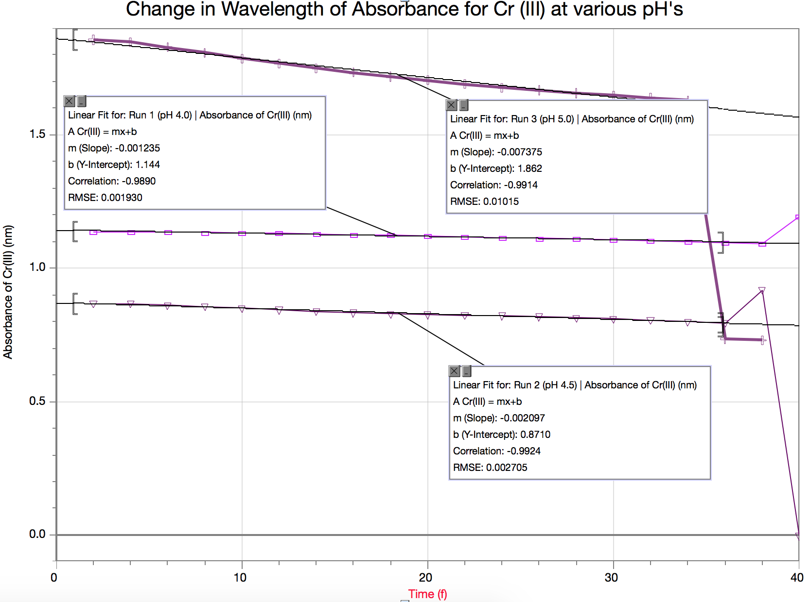
The above plot of the absorbance of Chromium (III) as a function of time is seen to be linear. Since it is linear that means that this is a first order reaction. As well as since rate of reaction is a derivative of the order of reaction; can be assumed that the rate of reaction will be a constant for the linear ordered reactions.

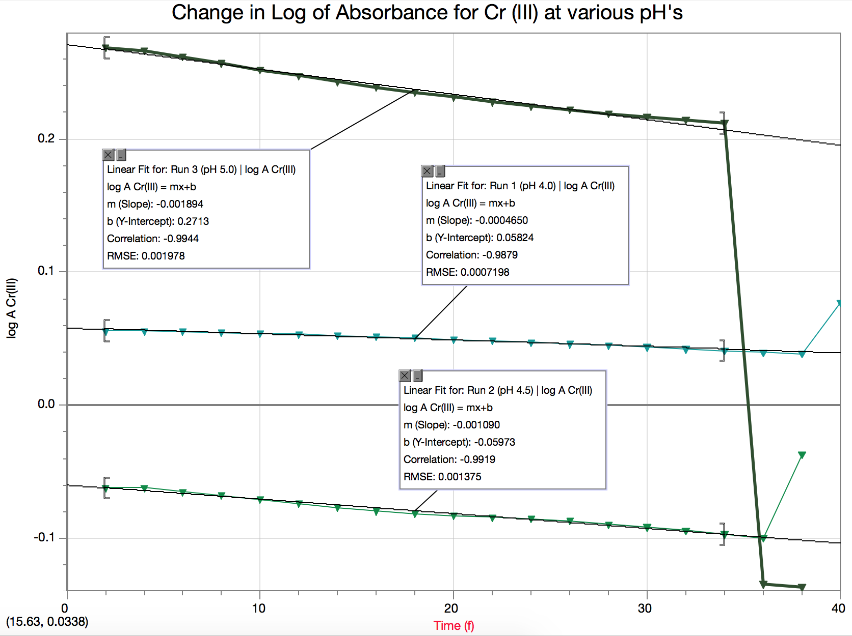

- The graph of log A_{Cr(III)} is indeed linear just like in the graph above. This tells us that the reaction is demonstrating pseudo first order behaviour. Meaning that the reaction is technically second order but can be approximated to be first order under special circumstances

- The derivative graph of the absorbance of Chrominum (III) shows the rate of change at any given point in the Run, table below shows the rate of change at the specific data points on the graphs:

Rate of change of Absorbance of Cr(III) at pH 4.0

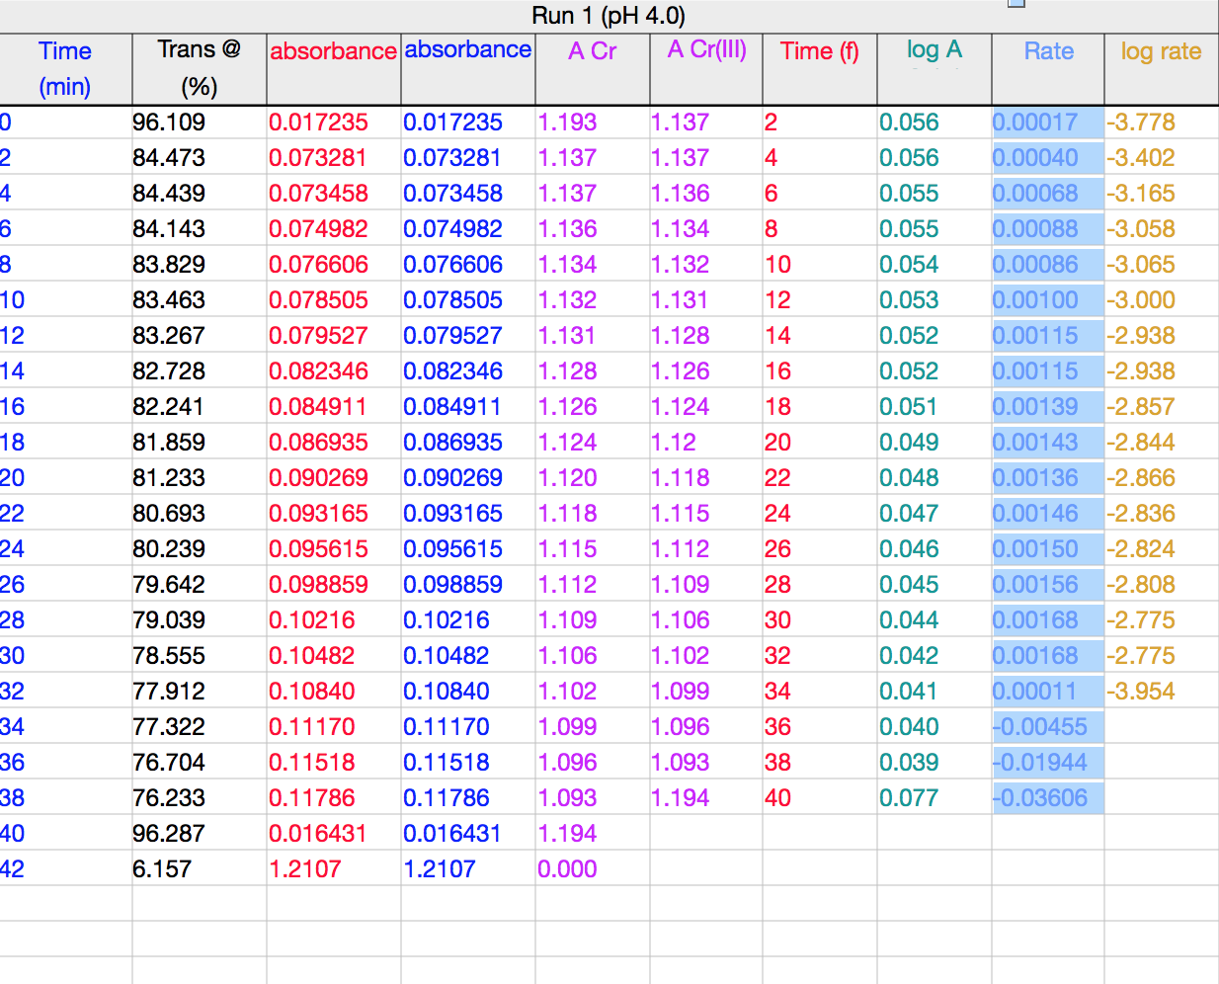

highlighted part shows the rate of change as the negative derivative of the absorbance of Chromium(III) for pH 4.0 at a time of time (f) shown in the column

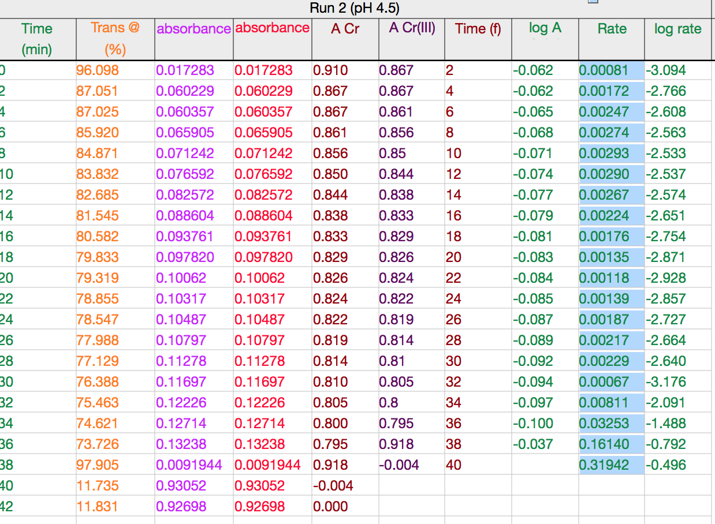

Rate of absorbance for pH 4.5 with same conditions as listed above

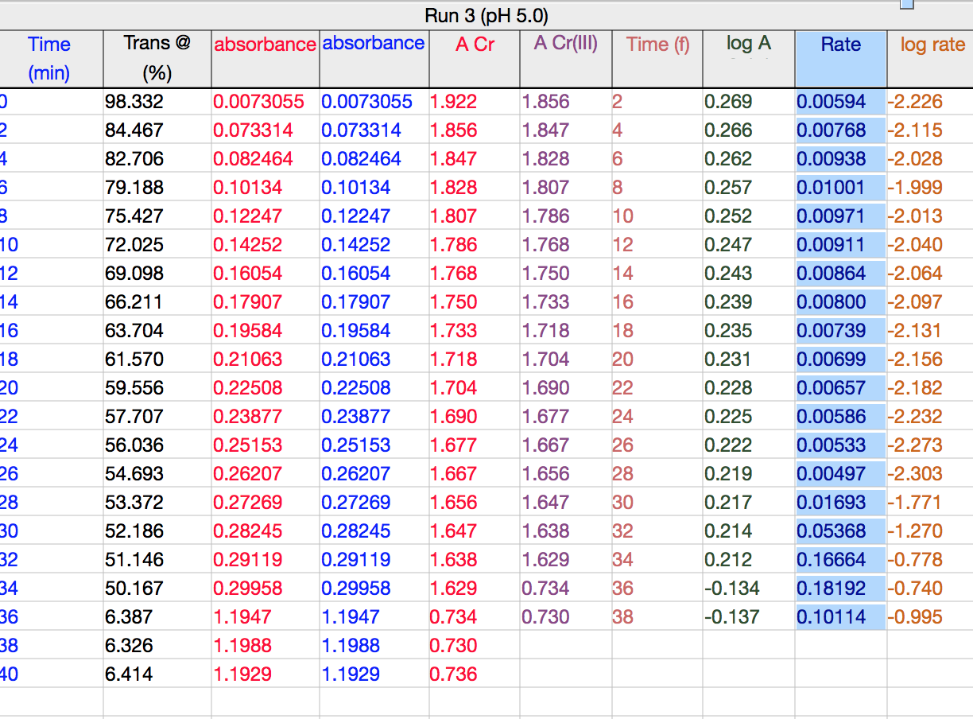

Rate of absorbance for pH 5.0 with the same conditions as listed above

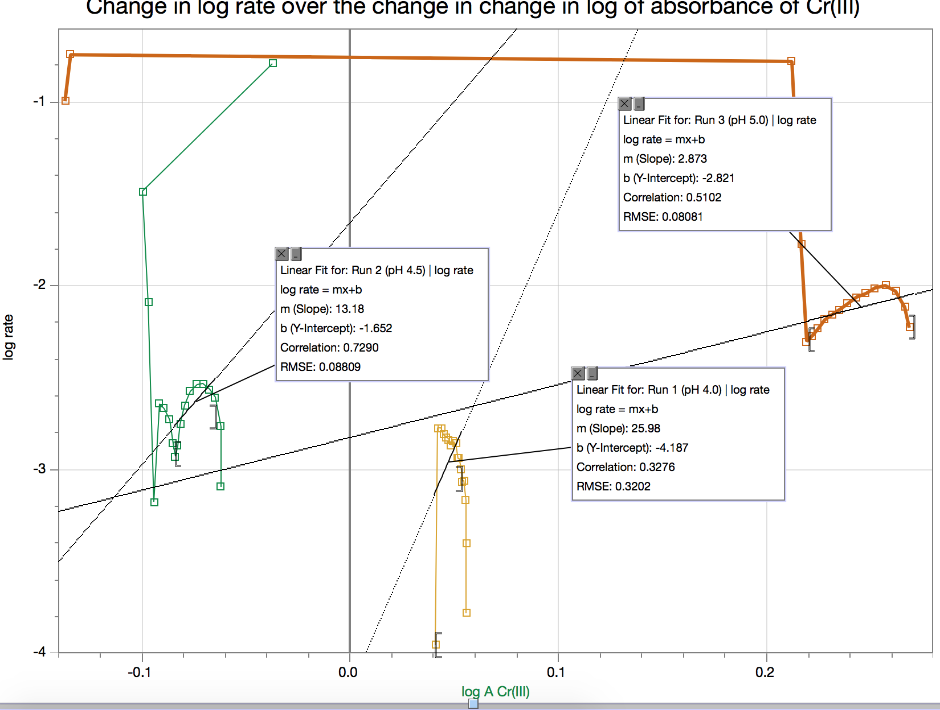

- Can be seen that the partial orders of the above graph are the slopes with respect to the Cr(III) ions. A linear fit can be made for the curve to estimate a steady partial order for a range of values extremely close to each other. For Run 1 (pH 4.0) the partial order is 25.98; the partial order for Un 2 (4.5) is 13.18, and the partial order for Run 3 (pH 5.0) is 2.873. These values are not the same and are not expected to be the same because the absorbance of chromium (III) differs for all three pH’s especially with the slopes and y intercepts and so when the negative derivative of absorbance is found it will give us steeper rates of changes than others, and this steepness is still expressed and differed when the logs of them are taken.

CALCULATIONS:

- A_{Cr(III)=} A_{infinity}-A_{t}

A_{infinity}= final data point
Trial 1:
A_{infinity} =1.2107 nm
Trial 2:
A_{infinity} =0.92698 nm
Trial 3:
A_{infinity} = 1.929 nm

Calculated Values of A_{Cr(III)} for Trial 1; pH 4.0

Time (f) | A_{Cr(III)}; A_{infinity}-A_{t} (nm)
2 | 1.2107- 0.017235 = 1.1934
4 | 1.2107- 0.073281 = 1.1374
6 | 1.2107- 0.073457 = 1.1372
8 | 1.2107-0.074981 = 1.1359
10 | 1.2107 - 0.07660 = 1.1341
12 | 1.2107 - 0.078504 = 1.1322
14 | 1.2107 - 0.079526 = 1.1312
16 | 1.2107 - 0.082345 = 1.1284
18 | 1.2107 - 0.084910 = 1.1258
20 | 1.2107 - 0.086935 = 1.1238
22 | 1.2107 - 0.090268 = 1.1204
24 | 1.2107 - 0.093164 = 1.1175
26 | 1.2107 - 0.095615 = 1.1151
28 | 1.2107 - 0.098858 = 1.1118
30 | 1.2107 - 0.102160 = 1.1085
32 | 1.2107 - 0.104823 = 1.1059
34 | 1.2107 - 0.108397 = 1.1023
36 | 1.2107 - 0.111697 = 1.0990

Calculations only shown for Trial 1 because done the exact same way for Trials 2 and 3

DISCUSSION:

- Sources of error in this experiment include: That the drops of the Cr(III) had not been added to the EDTA at exactly t=0, there could have been a delayed reaction time. This could have affected the results by making the y intercept on the graph 0, and then it would have resulted in a steady spike up before it levels itself out in the pattern it is suppose to be at (ex. Linear for the absorbance of chromium (III) vs. time). If the first example of absorbance vs. time is taken into account as an example a delayed reaction time would have showed what the absorbance was suppose to be 2 or so seconds ago; or how long the delay was which does not provide an accurate representation of what the absorbance is at that actual time. Another source of error could be that too many drops of chromium nitrate were added into the EDTA. More chromium nitrate would cause the complex to turn into a darker purple color which would mean a higher value of absorbance. Besides absorbance it would also affect reaction rate because recall the equation is rate = k[A]^m[B]^n and o a higher concentration would result in higher rate even if the order of the reactions were to remain the same

- Volume and temperature measurements in this experiment are extremely important. Temperature because as the solution is placed in the water bath for 10 minutes or so it ensures that all the chromium (III) ions are absorbed completely into the solution. Without this step the absorbance at infinite time would not be calculated and the partial order with respect the chromium(III) would not be able to be calculated. Volume is important as well because since the rate law equation is concentration depended; concentration is also volume depended. If the same amount of chromium nitrate is added to EDTA into 2 different trials of the experiment but in one you have an excess volume of EDTA and in another you do not have enough the concentration will be greater in the one with the less volume and thus a higher concentration results in a higher reaction rate. In the Beer Lambert Law it is stated that A is directly proportional to c, and so that means A is directly proportional to n/v making it inversely proportional to V

- Felt that data was fairly reproducible because the graphs seemed to be reasonable of the type of behaviour being observed. For example, in the first Absorbance of Cr(III) vs. time graph it was suspected to be linear because the concentration was not changing so the chromium was then being absorbed at the same rate through the reaction. The second graph of log of absorbance vs. time also seems reasonable because since since the slope of the linear absorbance is extremely shallow when the log of it taken that section of the log function will behave linearly as well because it is so stretched out. As well as when the rate function is graphed it is seen to spike up and then stay at a constant for the rest of the time which is reasonable because it is the derivative function of absorbance which is linear meaning that it must be a constant

- The partial order with respect to the hydrogen ion can be predicted to be zero. This is because in order for pseudo first order kinetics to be observed within the reaction and absorbance of chromium the pH must be kept as a constant in respect to the partial order of the chromium(III) ion. It can be seen that pH is independent to the concentration of chromium (III) and the only time it is being affected in the experiment is with the addition of the acidic chromium nitrate at the beginning, but besides that the pH is remaining relatively fixed because the acidity of the EDTA is higher to which a few drops of chromium nitrate will not affect it that much compared to where there is no chromium present before so adding the few drops will introduce a whole other reactant into the rate law

Further discussion Another point to be addressed is that for the different runs the higher the pH the higher the percent transmittance turned out to be. This is because since a higher pH means that the hydrogen ion concentration is not as great the following equation of T=I/I_{o} can be seen. Higher pH means that intensity of light after it passes through a median divided by intensity before it passes through the median is higher at a higher pH. This could be because at a higher pH there are less chromium ions present that help make the solution acidic as well as more chromium ions make she solution darker. Further more a higher transmittance= higher transmittance percentage

CONCLUSION: Can be concluded that the partial orders of Chromium in each of the three runs are: 25.98 in Run 1 for pH 4.0, 13.18 in Run 2 for pH 4.5, and 2.873 in Run 3 for pH 5.0. It can be concluded that the partial order of the chromium ion can be determined by finding the slope of the overall linear fit of the log A Cr(III) vs. log rate graph. As well as it can be concluded that the percent transmittance increases as pH increases

WORKS CITED:

Fabien, I., & Lente, G. (2010). Light induced multistep redox reactions: The diode- array spectrophotometer as a photoreactor. Pure & Applied Chemistry, 82, 195-1973. doi:10.1351/PAC-CON-09-11-16

Silberberg, M., Lavieri, S., & Venkateswaran, R. (2013). Chapter 5: Thermochemistry: Energy Flow and Chemical Change. In Chemistry: The Molecular Nature of Matter and Change (p.202). McGraw-Hill Ryerson Limited

RAW DATA:

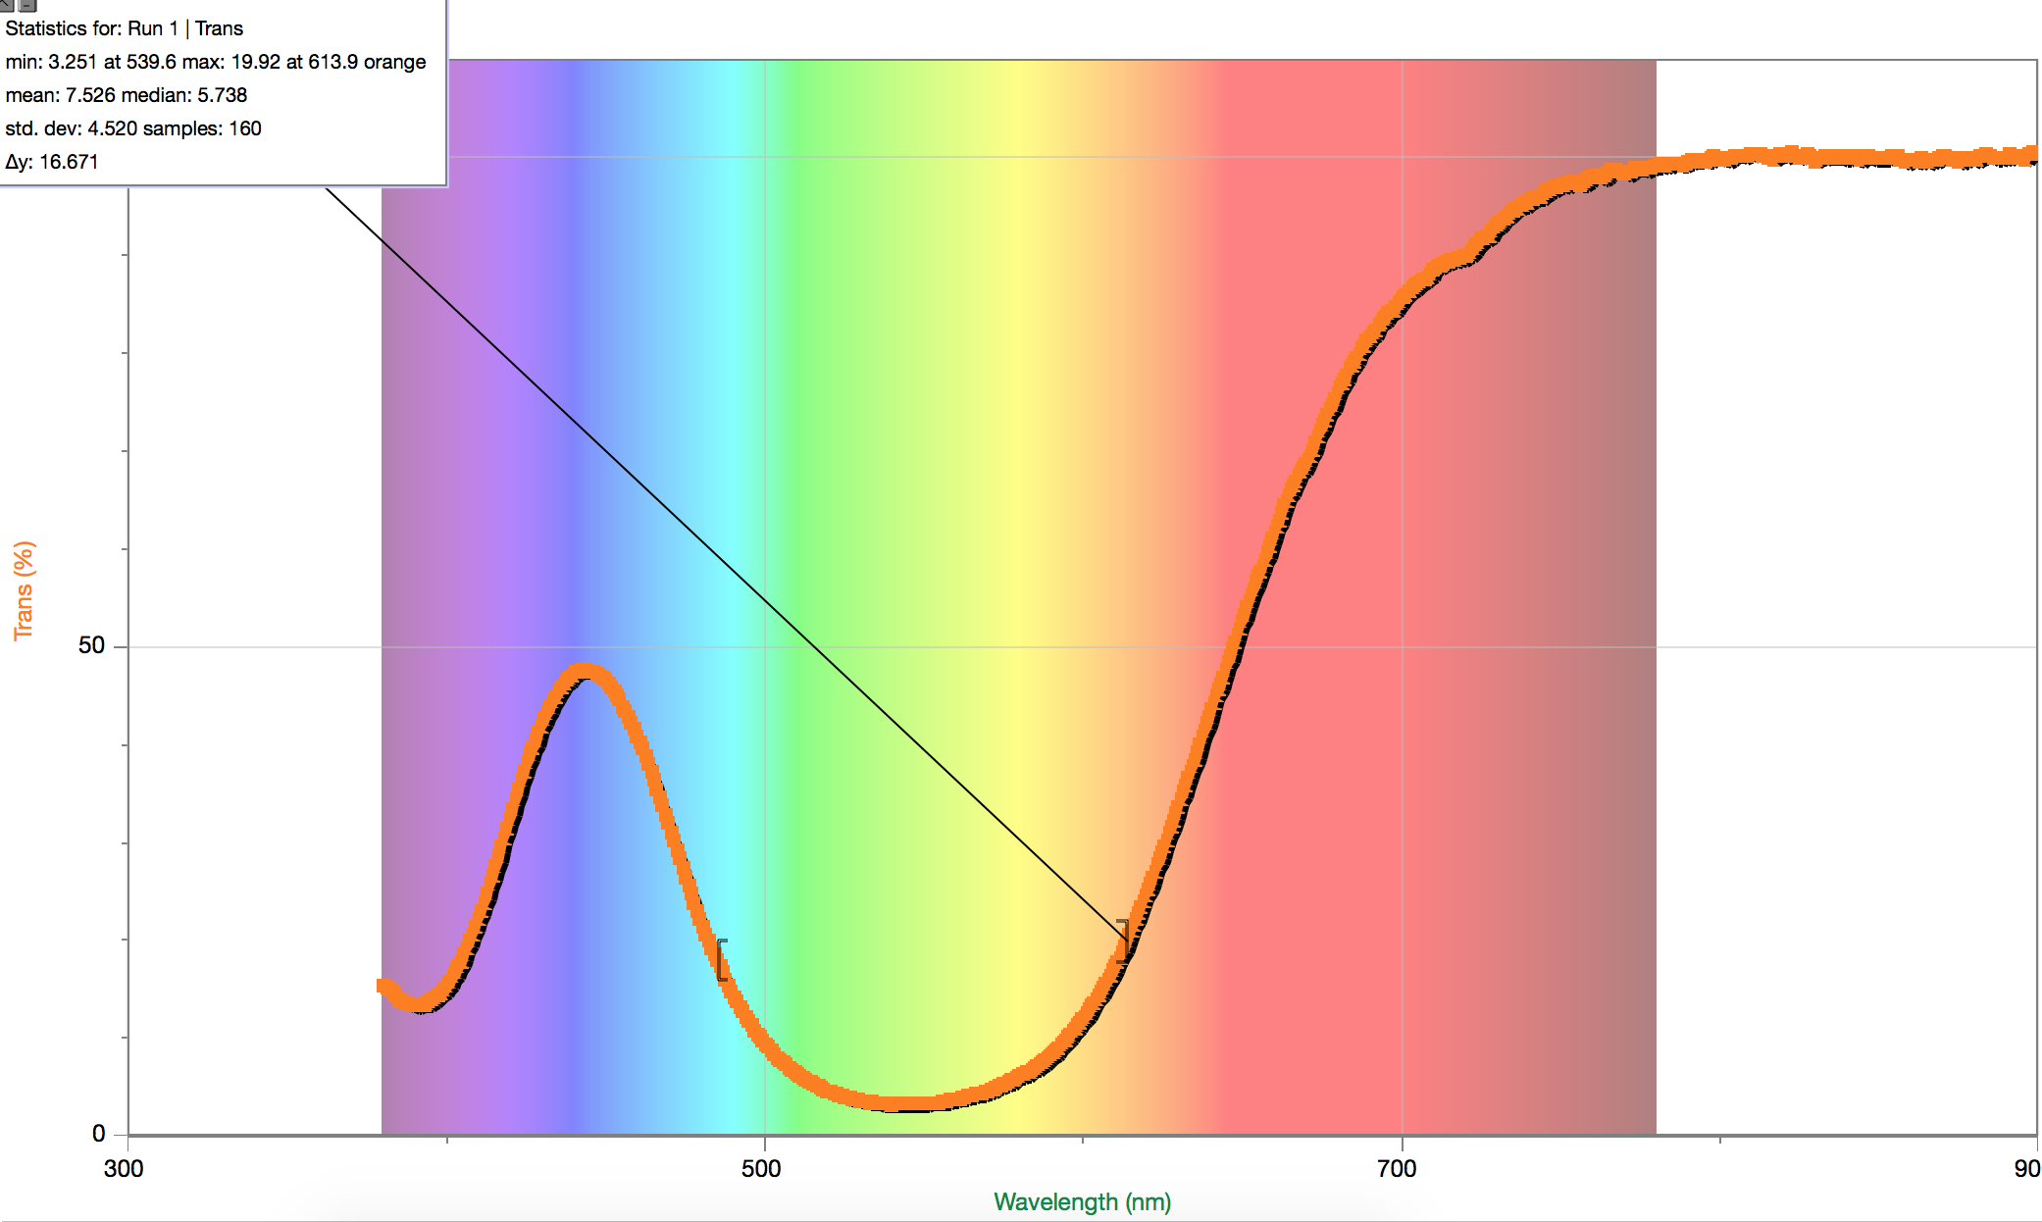

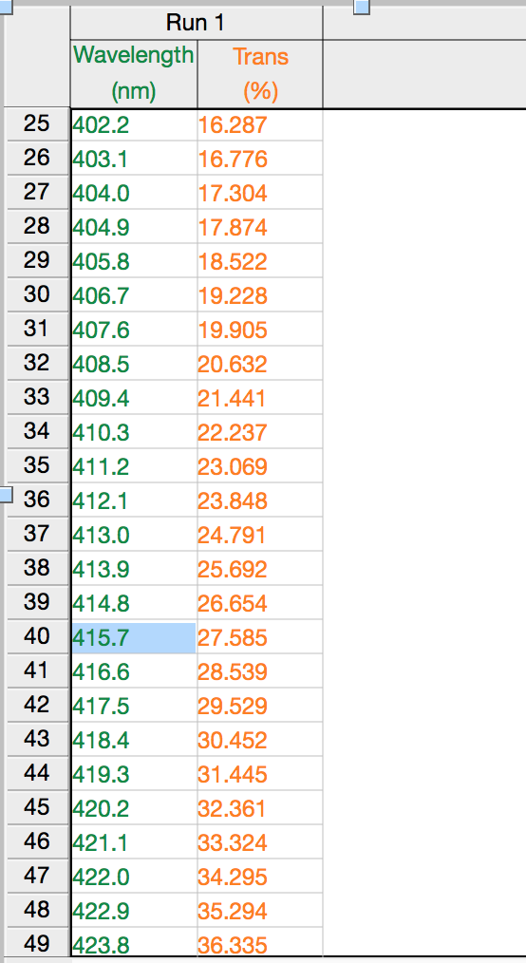
TABLE TO THE LEFT IS FOR THE CALIBRATION

Run 1 pH 4.0
Run 2 pH 4.5
Run 3 pH 5.0


