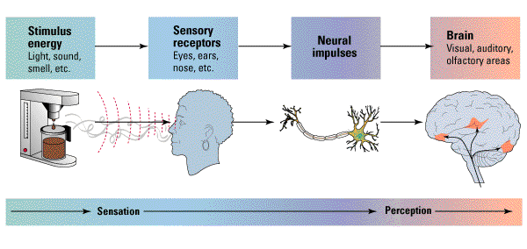
Psychology Midterm 2:

Perception

Sensation occurs prior to perception

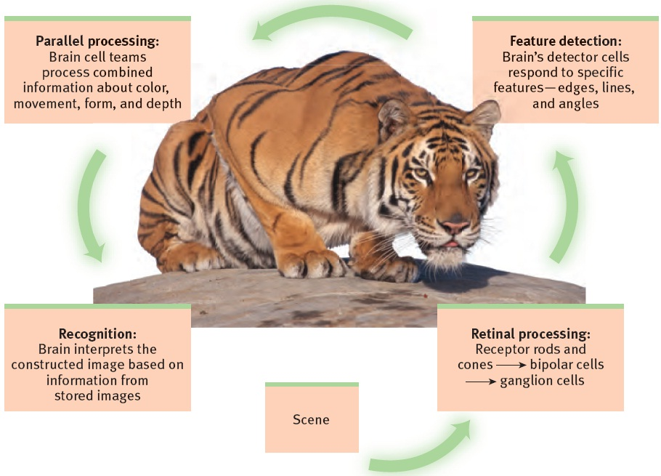
Visual processing is done in the brain – some cortical cells respond to lines in specific orientations (e.g. horizontal) whereas others shapes (e.g. bulls-eyes, spirals, faces). Feature detectors are cells that are sensitive to specific features of the environment (e.g. faces).
Visual Information Processing
When several aspects are simultaneously processed its called parallel processing. Visual scene is divided into colour, depth, form, movement, etc.
Achromatopsia – half black & white half colour

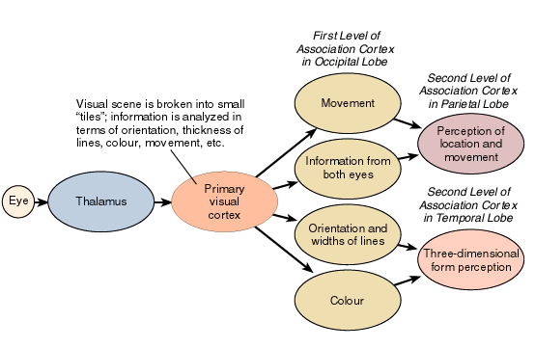
What? Temporal Lobe (Visual Agnosia) not knowing what is is
Where? Parietal Lobe (Visual Neglect) neglect ½ of visual space, cant pay attention to it
Primary Visual Cortex is what you see 1:1 mapped topographically from your retina.
Hemi-neglect (RH damage) draws half of picture asked to draw.

Perception of Form
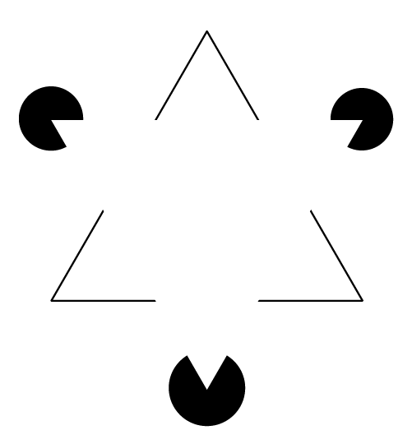
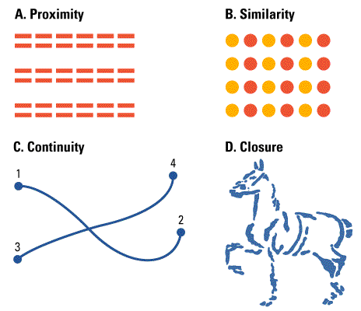
Figure and Ground a boundary is an edge formed by changes in the brightness, colour and texture. Our eye-brain system first discerns an object as distinct from the background. Figure – perceived as a self-contained object. Ground – a formless background against which objects are seen. Difference is in the eye of the perceiver.
Gestalt Laws of Grouping “the whole is greater than the sum of its parts” the black dots appear open because there must be something in front – there’s proximity (closeness), continuity (appearing so even if its not) and closure (as seen with the dots).
Similarity – similar elements group together.
- Seeing 3 pairs of lines
- Seeing columns of orange and red dots
- Seeing lines that connect
- Seeing a horse

Perceptual Processing
- Models of Pattern Perception
  - Templates – store every deviation of objects
  - Prototypes – deviation from global form (flexible) (e.g. 1 word 25 fonts)
  - Distinctive Features – part of prototype
- Bottom-Up/Top-Down Processing

Bottom Up Processing: taking sensory information and then assembling and integrating (see orange things w/ green bushes “what the hell is that” oh its carrots)
Top Down Processing: using models, ideas, and expectations to interpret sensory information (grocery store, “I need carrots” oh there’s carrots) but the same physical stimulus can be interpreted differently, depending on context. Letter B or number 13?

Depth and Distance Perception
Binocular Cues visual cues to depth or distance that require the use of both eyes
Convergence turning inward of the eyes, which occurs when they focused on a nearby object
Retinal Disparity the flight difference in lateral separation between two objects as seen by the left eye and the right eye
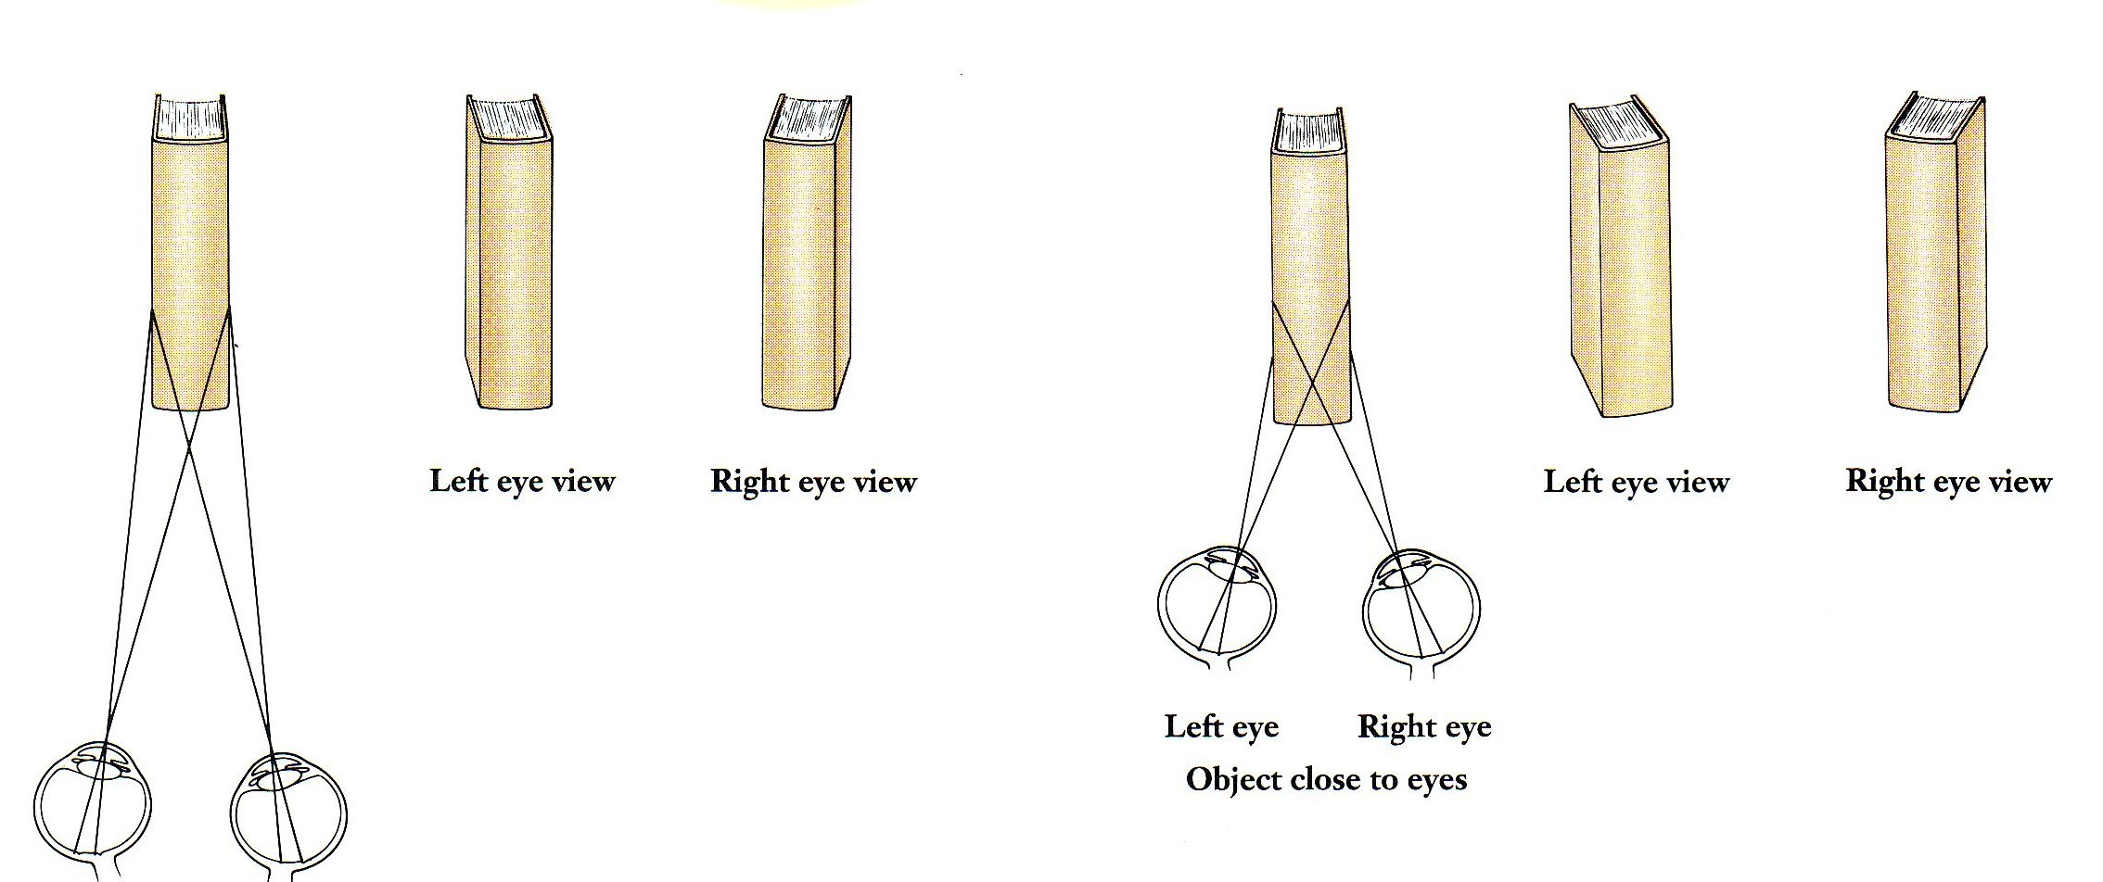
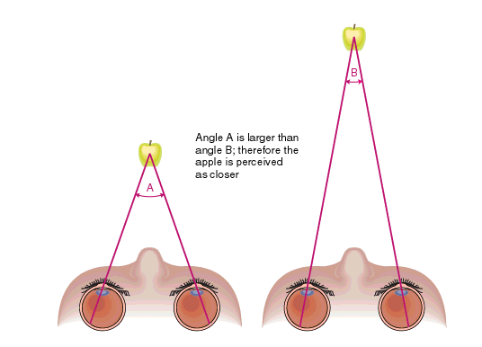

Monocular Cues for Depth/Distance
Retinal Image – the size of the image on the retina is proportional to its distance, an object moved twice as far away produces a retinal image half of what it was before (relative size: if two objects are similar in size, we perceive the one that casts a smaller retinal image to be further away)
Linear Perspective – provides context e.g. two lines of same size placed in triangle, top one seems further away, its touching both sides of the triangle
Texture
Interposition – objects that occlude (block) other objects tend to be perceived as closer
2 rectangles could be (a) two identical rectangles (b) a rectangle and an L shaped object
- Perceptual Constancies – shape/form/lightness/colour constancy/size constancy
Shape Constancy – a figure could be perceived as a trapezoid, but because we recognize the figure as a window and perceive its shape as rectangular
Monocular Cues – relative motion: when we are moving, we can tell which objects are further away because it takes longer to pass them

Consciousness

Consciousness is our awareness of our environment and us. Cognitive Dissociation Attention (1) limited capacity system for attention (2) controlled (focusing latently) and automatic processing (don’t even think about it) – for example, your first drive vs. 3 years later
Selective Attention is the focusing of conscious awareness on a particular stimulus; think of a cocktail party and your ability to attend just one voice among many.
Inattential blindness is failing to see visible objects when our attention is directed elsewhere, it is a by-product of our ability to focus attention on some part of our environment. The conscious mind is in one place at one time.
Change Blindness is failing to notice changes in the environment, we selectively rivet our attention on one thing, failing to notice the other. Out of sight, out of mind. E.g. construction workers switch while people explain instructions to them.
Explicit (declarative) Memory verbal
Implicit (nondeclarative) Memory of motor task
Visual Agnosia is when you cannot put together what something is, you can see it, you know what it would be if you could connect the two.

Altered States – the brain’s auditory cortex responds to sound stimuli even during sleep
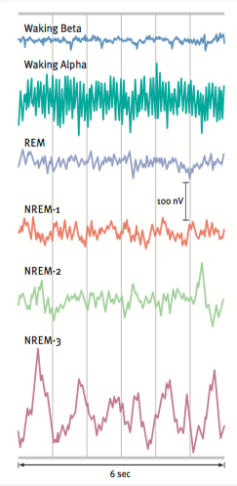
Circadian Rhythm is your biological clock, the Circadian Cycle lasts about a day; it is the regular bodily rhythms (e.g. temperature of wakefulness) that occur on a 24-hour cycle. The rhythm is governed by a region of the hypothalamus called the suprachiasmatic nucleus (SCN). Jet lag is the desynchronization of this.
Our biological clock can be altered by artificial light; it increases the hypothalamus to decrease (morning) melatonin from the pineal gland and increase at nightfall.
Every 90 minutes, we pass through a cycle of four distinct sleep stages.
REM Sleep rapid eye movement sleep is a recurring sleep stage during which vivid dreams commonly occur. The muscles are relaxed (except for minor twitches) but other body systems are active. Dreaming.
Sleep itself is the periodic, natural, and reversible loss of consciousness.
Electrodes measure eye movements, EMG measures muscle tension, EEG measures brainwaves, and cameras may also record body movements.
Alpha waves are the relatively slow brain waves of a relaxed, awake state.
Non-REM sleep stages are when you are getting deeper into sleep but not dreaming yet.

Sleep Disorders
Insomnia – difficulty falling or staying asleep
Narcolepsy – falling asleep uncontrollably, irresistible REM attacks
Sleep Apnea – reflexive gasping for air that awakens the sleeper
Nightmares – anxiety arousing dreams (REM)
Night Terrors – intense arousal and panic (NREM)
Somnambulism – sleepwalking
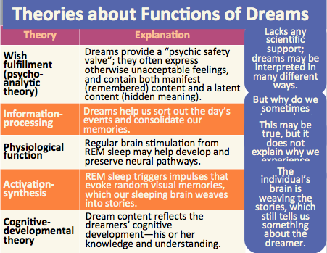
Dreams as Unconscious Wishes
Freud believed that dreams expressed wishes and provided insight to unconsciousness
Manifest Content conscious dream content that is remembered after awakening
Latent Content the unconscious, censored meaning of a dream

Dreams as By-Product of Mental Housekeeping
Unnecessary neural connections are eliminated, important ones strengthened, brain divides information into “wanted” and “unwanted”, what we recall are brief snippets from scanning and sorting that occurs during REM sleep.

Activation Synthesis Theory dreams are from cortical synthesis, the brains attempt to make sense of random signals that fire during sleep.

Sleep Theories:
- Sleep Protects sleeping in darkness when predators loomed about kept our ancestors out of harms way.
- Sleep Helps us Recover helps restore and repair brain tissue.
- Sleep Helps us Remember restores and rebuilds our fading memories.
- Sleep may play a role in the growth process the pituitary gland releases growth hormone

Hypnosis is an altered state of consciousness, is a suggestible state, those under hypnosis cant be forced to do things against their will
Beta (conscious mind) Theta (subconscious mind) Delta (unconscious)

Theories of Hypnosis
Sociocognitive approach – hypnotic behaviors are social actions that reflect what the hypnotized individual believes to be a characteristic of a hypnotized trance (social) the abilities, beliefs and expectations (cognitive)
Dissociation theories – hypnosis is a split in consciousness in which one part of mind operates independently of the rest of the consciousness or disassociation occurs between the executive control system and other systems involved in thinking and acting.

Psychoactive Drugs
Depressants
Effects of Alcohol – slow neural processing (reduced sympathetic NS activity), reduced memory formation (disrupted REM sleep), impaired self control (impaired judgment and inhibition)
- Sedatives
  - Barbiturates – powerful sedative drugs, highly addictive, alleviate tension and bring about relaxation and sleep
  - Benzodiazepines – tranquilizers and no barbiturate sedatives, highly addictive, used in treatment of anxiety disorders and stress related physical disorders (adhesion of GABA on receptors)
- Narcotics
  - Opiates and Opioids – induce relaxation and reverie, provide relief from anxiety and pain, opium (natural) morphine (synthetic) heroin (derived to reduce morphine addiction) and methadone (long half life, used to wean off harder drugs)
Stimulants
Physical Effects – dilated pupils, increased breathing and heart rate, increased blood sugar and decreased appetite, intensify neural activity and bodily functions
- Methamphetamine – triggers the sustained release of dopamine, 8hr of euphoria then irritability, insomnia, seizures, hypertension, violence, depression, time consuming
- Cocaine – blocks reuptake, increasing levels of dopamine (reward), serotonin (mood), and norepinephrine (energy), euphoria for 45min then crash
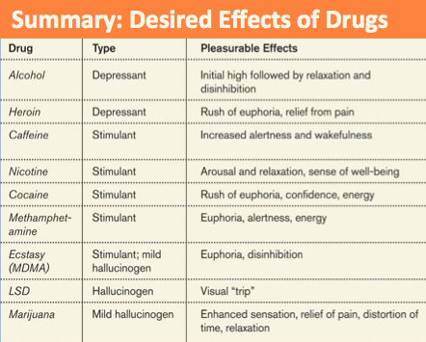
- Ecstasy/MDMA – synthetic stimulant that increases dopamine and serotonin (a lot), euphoria due to CNS stimulations, hallucinations, social connectedness and intimacy (short run – regrets, dehydration)(damaged serotonin-producing neurons aka permanent depression, disruptive sleep)
Hallucinogens
- LSD – interferes with serotonin transmission, causes hallucinations images and other sensations exaggerate reality
- Marijuana/THC – marijuana binds with brain cannabinoid receptors to reduce pain, it amplifies sensations, disinhibits impulses, euphoria, reduces nausea, lack of ability to sense satiety, impaired motor reaction time, affects unborn baby, affects memory/learning ability – brain shrinks in areas processing memory and emotion

Learning and Behaviour

Learning is a relatively permanent change in behaviour due to experience. Behaviourism emphasizes the study of observable behaviour and the role of environment as a determinant of behaviour
Habituation is the simplest form of learning; it’s learning to not respond to an unimportant event that occurs repeatedly.

Classical Conditioning – the process by which neutral stimulus acquires the capacity to elicit a response through association with a stimulus that already elicits a similar or related response

Conditioning Terms –
Unconditioned Stimulus elicits a reflexive response in the absence of learning
Conditioned Stimulus an initially neural stimulus that comes to elicit a conditioned response after being associated with an unconditioned stimulus
Unconditioned Response reflexive response elicited by a stimulus in the absence of learning
Conditioned Response elicited by a conditioned stimulus, occurs after the conditioned stimulus is associated with an unconditioned stimulus

Pavlov’s Serendipitous Discovery – by observing dogs during the digestion Pavlov formulated the theory, the dogs salivated at meat, if a bell is rung and then meat is given they come to associate bell with meat and salivate then

The Biological Significance of Classical Conditioning – ability to learn to recognize stimuli that predict the occurrence of an important event allows the learner to make the appropriate responses faster and more effectively, stimuli that were previously unimportant acquire some of the properties of the important stimuli and can now modify behaviour (token economies)

Basic Principles of Classical Conditioning -
- Acquisition the learning phase that depends on stimulus intensity and the time between stimulus and reward, a neural stimulus that is consistently followed by an unconditioned stimulus will become a conditioned stimulus, the intensity dictates the number of trials necessary for it to become conditioned, timing must be prior to UCS, has to be within 0.5s (e.g. bell rung prior to food being provided)
- Extinction the weakening and eventual disappearance of a learned response, when the conditioned stimulus is no longer paired with the unconditioned stimulus
- Generalization occurrence of responding to a stimulus similar to the discriminative stimulus
  - Phobia (conditioned emotional response) against dogs because a dog bit you once
  - Little albert conditioned to be afraid of white rats with an unconditioned stimulus, then all furry objects
- Discrimination responding only when a specific discriminative stimulus is present (no response to similar stimuli)
  - E.g. text tone vs. phone tone
Operant Conditioning
- The Law of Effect: Thorndike’s idea that the consequences of a behaviour determines whether it is likely to be repeated or not, pleasant outcomes means higher probability whereas unpleasant means lower probability
- Operant Chamber uses the Law of Effect, Skinner developed box to study operant conditioning
- Consequences of Behaviour
Reinforcement stimulus strengthens the probability of the response
Punishment stimulus weakens or reduces the probability of the response.
Positive Reinforcement is when a pleasant consequence follows, making it more likely to reoccur
Negative Reinforcement is the removal of something unpleasant making it more likely to reoccur
Positive Punisher is when something unpleasant occurs after a behaviour
Negative Punisher is when something pleasant is removed after a behaviour
Maintaining Phobias -
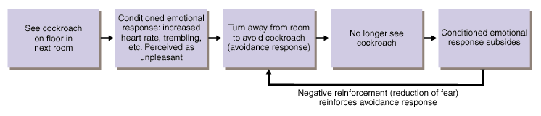
Other Operant Procedures and Phenomena

Vicarious Learning: learning through observation
Mirror Neurons are neurons that are active during observational learning, for example you see someone stub their toe and you cringe, feeling pain.
Bandura’s experiment with the Bobo doll was where he observed and judged children playing with a Bobo doll on their aggression, after exposing them to violent behaviour he judged again and the children reacted very violently, mimicking what was presented to them. Thus antisocial models may have antisocial effects. The likewise is also true.

Shaping: a method of successive approximations
Operant conditioning procedure in which reinforces guide behaviours towards the desired target behaviour through successive approximations. E.g. a rat shaped to sniff mines, a dolphin shaped to detect different shapes.

Schedules of Reinforcement
Continuous Reinforcement is a reinforcement schedule in which a particular response is always reinforced
Intermittent (Partial) Reinforcement a particular response is sometimes reinforced in a ratio or an interval (fixed, variable)

