MIS Week 1
Chap 1: Information systems & business strategy
Information system
Competing in the information age
Examples of the power of business and technology
- Amazon: not a techno company, focus is selling books
- Netflix: not a techno company, focus is renting videos

IS impact on business operations
- Reduce costs and improve productivity
- Improve customer satisfaction and loyalty
- Create competitive advantage

Information systems impact on business operations
- Organizations usually operate by functional areas (marketing, sales, operation, etc.)
- Those functional areas are interdependent

The challenge: bringing separate functions together
The solution: management information system

Difference between IT and IS
- IT: incorporate the people using the system, input, processing, storage, and output
- IS: computer-based tool that people use to work with information and that supports the information. It can be an important enabler of business success and innovation

Information system basics
- Management information systems: the function that plans for, develops, implements and maintains IS hardware, software and applications that people use to support the goals of a company
- MIS is a business function, similar to accounting, finance, operations and HR
- When beginning to learn about IS it is important to understand:
  - Difference between data, info and knowledge
    - Data: raw facts that describe the characteristics of an event (codes and numbers)
    - Info: data converted into a meaningful and useful context (sales, processed data)
    - Knowledge: information that can be enacted upon (pattern, acting on info)
  - IS resources and cultures
    - IS resources: people use IS to transform data into info and info into knowledge
    - Information cultures:
- 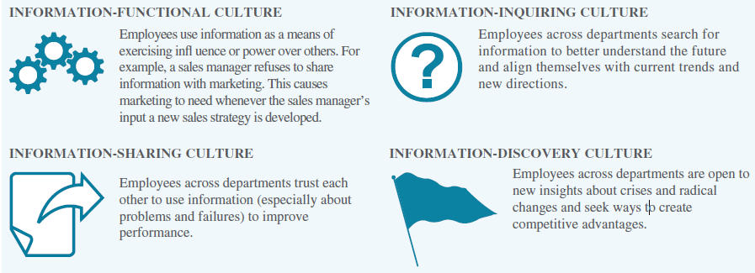

Information system roles and responsibilities
- IS is a relatively new functional area, recent IS strategic positions include
  - Chief information officer: oversees all uses of IT and ensures the strategic alignment of IT with business goals and objectives
    - Also includes: manager, leader and communicator
  - Chief knowledge officer: responsible for collecting, maintaining and distribution the organization’s knowledge
  - “ privacy officer: ensuring the ethical and legal use of information
  - “ security officer: ensuring the safety of IT resources including data, hardware,…
  - “ technology officer: ensuring the throughput, speed, accuracy,…

Gap between business personnel and IS personnel
- Business personnel possess expertise in functional areas such as marketing, accounting and sales
- IS personnel have techno expertise
- Typically causes a communication gap between them

Business strategy
Identifying competitive advantage: survive and thrive an organization must create one
- Competitive advantage: product or service that an organization’s customers place a greater value on than similar offerings from a competitor ex. Service, ability to ship vs. local
- First-mover advantage: organization can significantly impact its market share by being first to market with a competitive advantage
- Organizations watch their competition through environmental scanning
  - Environmental scanning – the acquisition and analysis of events and trends in the environment external to an organization

Three common tools used in industry to analyze and develop competitive advantages
1. Porter’s five forces model is external
- Determines the relative attractiveness of an industry

- Buyer power
  - The ability of buyers to affect the price of an item
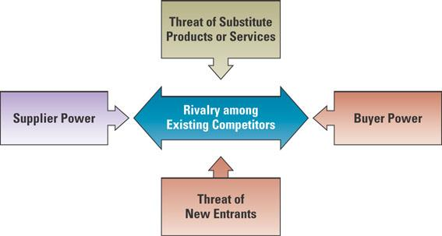
  - Generated for the buyer when it accounts for the largest percentage of a business’s profit
  - Loyalty program
    - Rewards customers based on the amount of business they do with a particular organization
    - Increase switching cost of buyers
- Threat of substitute products/services
  - Switching cost: amount of benefits a consumer must give up to go to another buyer
- Supplier power
  - Ability of suppliers to set prices and terms
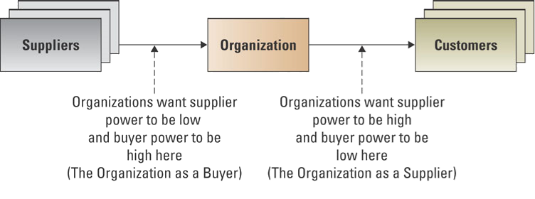
- New entrants
  - Ease of which new competitors can enter a market
  - Entry barrier: feature of a product or service that customers have come to expect and entering competitors must offer the same for survival

Rivalry among competitors
- Amount of direct conflict between businesses in a specific industry
- Product differences
- Unique differences in the features of products/services that influence demand

Identifying competitive advantage
- Organizations watch their competition through environmental scanning
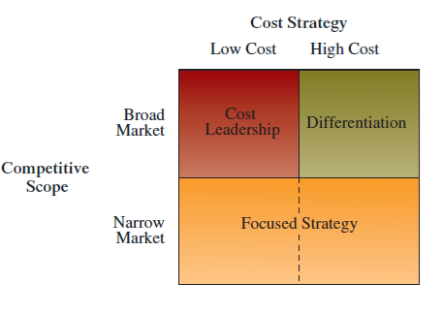
- Environmental scanning – the acquisition and analysis of events and trends in the environment external to an organization

2. Porter’s three generic strategies
- Organizations typically follow one of Porter’s three generic strategies when entering a new market
- Using a single generic strategy makes efficient use of resources
- First Selection is Broad or Narrow focus
- Within Broad Focus choose: cost leadership or differentiation
- Narrow focus is only one
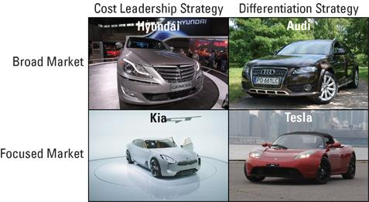
EX. 3 strategies in the car market
- Audi: high quality and technology branding, not market to a specific population, price is higher
- Hyundai: competitive price, the whole population
- Kia: people with a smaller budget
- Tesla: a sports car, not everybody will buy this car

3. Value chains
- Once an organization chooses its strategy, it can use tools such as the value chain to determine the success or failure of its chosen strategy
- Value chain is used internally
  - It is a series of business processes, each adding value to the final product/service
  - One activity alone is not a process
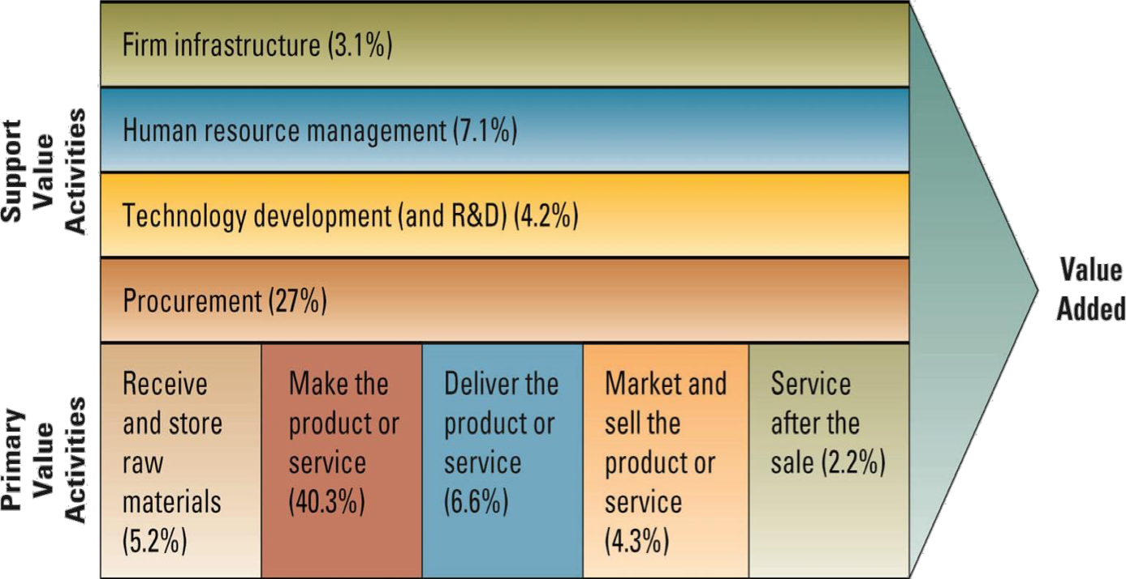
  - process: standardized set of activities that accomplish a specific task

Value creation
- If you don’t take care of the support there won’t be any primary activities
- Support value activities: they are background but essential
- Primary activities: end product is a product or service

Business-driven information systems
- Porter’s Five Forces Model
  - An external analysis of industry forces impacting on the organization
- IS collects, process and reports Environmental Scan information
- IS provides the technology to support strategies to limit the threat of the forces
- Three Generic Strategies
  - The strategic decision a company can make in about its business focus
  - IS can run simulations and models of possible alternatives updated in real time
- The Value Chain
  - An internal analysis that helps a business optimize the value from its functions
  - IS integrates the functions by enabling critical data/information sharing
- Business-Driven Information Systems
  - Information Systems developed to support a business’s competitive strategy
  - Business strategy drives information systems design and choices

MIS week 2
Chapter 2: Decision-making and business processes

Decision-making: What are the reasons for the growth of D-M IS
- Makes decisions faster
- Have to be proactive
- People need to analyze large amounts of information
- “ must make decisions quickly

What level do D-M and problem solving occur?
Everywhere.
- Strategic:
  - Managers develop overall strategies, goals, and objectives.
  - unstructured decisions (no procedures or rules exist to guide decision makers toward the correct choice)
- Managerial:
  - Employees evaluate company operations to identify, adapt to, and leverage change
  - semi-structured decisions
- Operational:
  - Employees develop, control, and maintain core business activities required to run the day-to-day operations.
  - structured decisions (situations where established processes offer potential solutions), routine

transactional data and analytical information
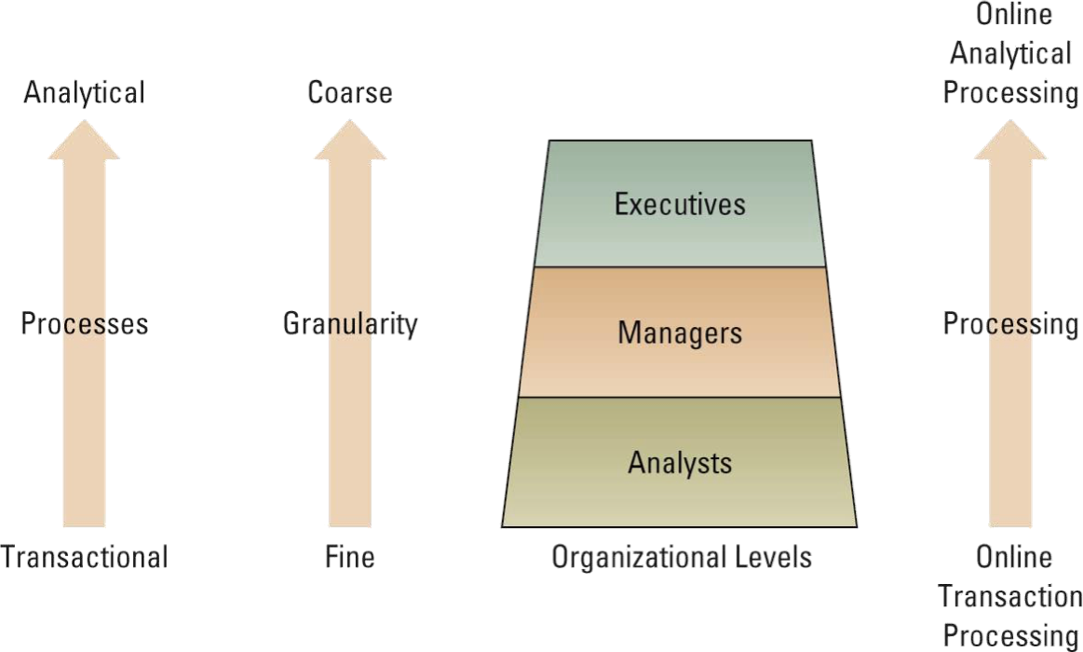

Three major types of IS:
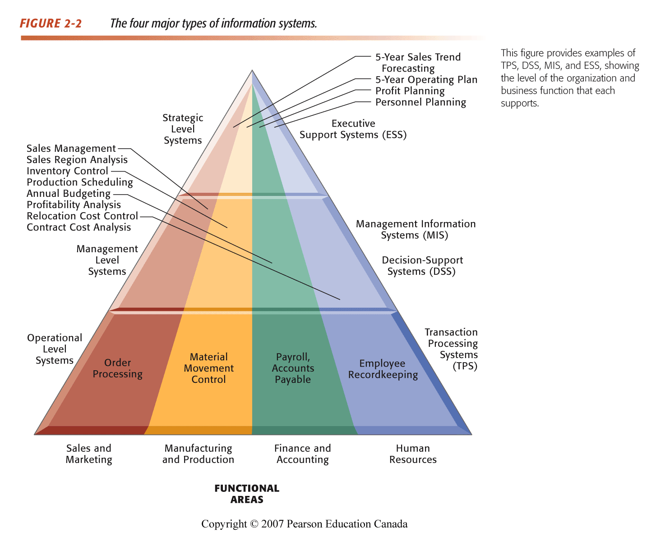
Transaction processing system
- Transaction processing system (TPS) – Basic business system that serves the operational level and assists in making structured decisions
- Online transaction processing (OLTP) – Capturing of transaction and event information using technology to process, store, and update
- Source document – The original
- transaction record

Decision support systems (DSS)
- Models information to support managers and business professionals during the decision- making process
Online analytical processing (OLAP)
- Summarization or aggregation of raw data from transaction systems, and manipulation of information to create business intelligence in support of strategic decision making

3 quantitative models used by DSS
- What-if analysis:
  - Changing one factor in an analysis and observing the change in result
  - ex. Excel scenario manager. What if they +/- price
- Sensitivity analysis:
  - Changing a basic assumption in the analysis and observing the impact on the result; often used for contingency plans
  - increasing or decreasing?
- Goal-seeking analysis:
  - Determining the optimal configuration of resources necessary to achieve a stated goal
  - ex. Excel goal seek. I want this, how to get there
Executive IS: specialized DSS that supports senior level executives within the organization
- How does it differ from a DSS?
  - Broader information, less details
  - It takes into consideration external information
  - Employs visualization tools to display key results
    - Digital dashboard: integrates info from multiple components and presents it in a unified display

Artificial intelligence (AI)
- Simulates human intelligence such as the ability to reason and learn
- Can learn overtime and make decisions by itself
- Robots and Siri
- Mimicking the human brain
- Why create AI:
  - replace people with systems/machines
  - cost less
  - won’t get tired, quicker
  - less errors
  - safety
intelligent system

5 most common categories of AI
- Expert system – Computerized advisory programs that imitate the reasoning (logic) processes of experts in solving difficult problems; requires complete info
  - Most used
  - Based on data
- Neural Network – Attempts to emulate the way the human brain works (e.g., adjusting to new circumstances, functioning without complete information, coping with large amount of info and many variables)
  - Most useful for decisions that involve patterns or image recognition, and where the rules are unknown
  - Fuzzy logic: math method of handling imprecise of subjective info
- Genetic algorithm – An artificial intelligent system that mimics the evolutionary, survival-of-the-fittest process to generate increasingly better solutions to a problem (finds combination of inputs that give best outputs)
  - Analyzes thousands of options choosing the most likely to succeed
- Intelligent agent – Specialized applications that complete online tasks on behalf of its users, requiring decision-making, based on a ‘set of rules’ that can adapt to changing situations
  - Dedicated for online activities
- Virtual reality - A computer-simulated environment that simulates the real world or an imaginary world (e.g., remote manipulation of equipment)
  - Ex. Flight simulations, video games, etc.

Metrics: measuring success
- Project: temporary activity a company undertakes to create a new product, service or result
- Metrics: measurement that evaluate results to determine whether a project is meeting its goals
  - KPIs: key performance indicators: the quantifiable metrics a company uses to evaluate progress toward critical success factors
    - Ex. Number of product return, number of new customers, average customer spending, etc.
  - Efficiency and effectiveness: they are interrelated
    - Efficiency metrics – Measure the performance of IS itself, such as throughput, transaction speed, and system availability. How the system is doing?
      - Throughput: The amount of information that can travel through a system at any point in time.
      - Transaction speed: time a system takes to perform a transaction
      - System availability: number of hours a system is available to users
      - Web traffic:
      - Response time
    - Effectiveness metrics – Measure the impact IS has on business processes and activities, including customer satisfaction and customer conversation rates (“doing the right things”). Impact or end goal of what they achieved.
      - Usability: ease with which people perform transactions or find info
      - Customer satisfaction:
      - Conversion rates
      - financial
Benchmarking
- Benchmark – Baseline values the system seeks to attain. Help assess how a MIS project performs over time
- Benchmarking – A process of continuously measuring system results, comparing those results to optimal system performance (benchmark values), and identifying steps and procedures to improve system performance

Business processes
What is business process?
- Set of activities that have to be related to give you an end product
- Ex: customer check out process, order delivery processes, invoicing process,…
Importance
- Determine bottlenecks, eliminate duplication, etc.
Sample business processes
- Accounting/finance
- HR
- Environmental
- MIS

Understanding the importance
- Customer facing processes: result in a product or service that is received by an organization’s external customer
  - Order processing
  - Customer service and billing
  - Sales process
- Business facing processes: are invisible to the external customer but are essential to the management of the business
  - Strategic planning and tactical planning
  - Training

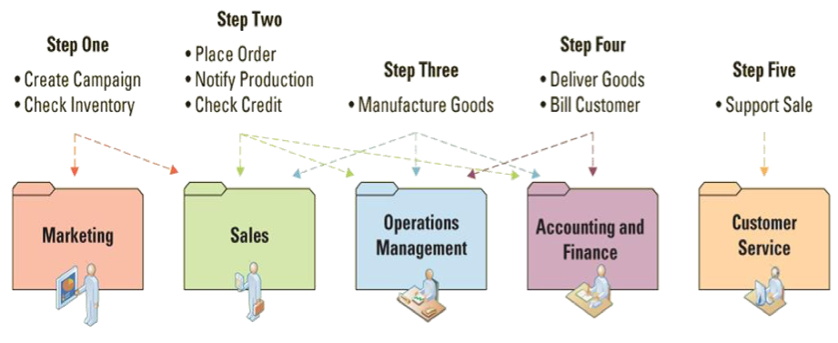
Order to delivery process
Business process modelling
Definition: The activity of creating a detailed flow chart or process map of a work process showing its inputs, tasks, and activities, in a structured sequence

Business process model - A graphic description of a process, showing the sequence of process tasks, which is developed for a specific
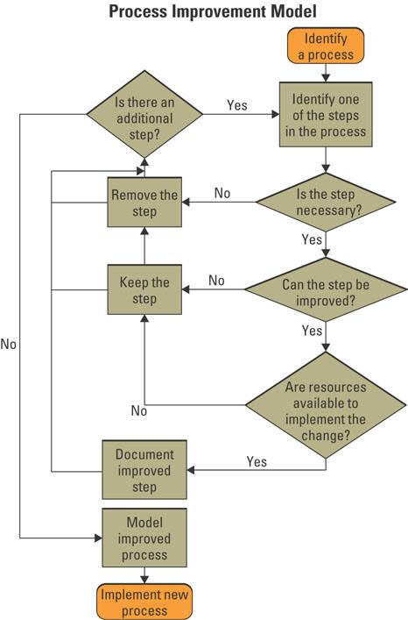
- As-is process model
- To-be process model

Business process re-engineering
- Business process improvement – attempts to understand and measure current processes and upgrade them
  - 3 conditions for initiating a change
    - a pronounced shift in the market the process was designed to serve
    - company is markedly below industry benchmarks on the performance of its core processes
    - regain competitiveness
  - it is a cyclical activity
- Business process re-engineering (BPR)
  - the analysis and redesign of workflow within and between enterprises
  - looks at taking a different path, such as an airplane which ignores the road completely
  - it is revolutionary not evolutionary
  - vision is created and an entirely innovated process is implemented
  - Results in better, faster and cheaper AND re-defining best practices in the industry.
  - Focus must be on core business activities:
    - Does it impact highly on customer satisfaction? – Is it consistent with the strategic direction?
    - Is it crucial for productivity improvement?
    - Does it fall below best in class?



