INRODUCTION TO MEMORY

Video.

Attention is selective
- Focusing awareness on a narrow range of stimuli.
- Filters out irreverent stimuli (e.g, players in black shirts)
- There is a filter where is it?
- “Cognitive Load” moves the filter forward.
-is when someone is mentally busy.
- Refer to diagram on slide (lecture 1, slide 1)
- When divide attention during encoding leads to impaired memory (eg. Word frequency in a conversation)
- ‘Next line’ effect.
- when presenting with a partner and next to speak you don’t listen to the what their saying but focus on yourself and what to say.
WHAT IS MEMORY?
- It’s a reconstructive process: Not a recording
- Its selective and details are excluded, altered, and added
- The stuff we talk about more is not right, because it has been changed so often and not really that important.

HOW DOES MEMORY WORK?
- Encode. Enter information into memory
- Storage. Maintain information in memory
- Recall: retrieve information from memory
- Forgetting: deficiency in one or more of these processes.

ENCODING
- Passive Encoding: simple information may be encoded automatically (e.g., parked car, movie watched last night, word frequencies)
- Active Encoding: more complex information required effortful encoding (studying for a class)
- Massed Practice: studying the night before
- Spaced Practice: Learning is broken up over time.

LEVELS OF PROCESSING
- How much active and passive encoding is needed to be remembered.
REFER TO CHART ON SLIDE (LECTURE 1, SLIDE 5)

ENRRICHED SEMANTIC ENCODING
- Elaboration: association of new information wit previously stores information
- Visual (mental) imagery: a mental image.
High vs. Low
- Easy to make image of are high
- Low not as easy to make image of.
REFER TO PHOTOS ON SLIDE (LECTURE 1, SILDE 6)

Self- referent encoding: relating new information to self.
- Reference to others does not work
Asked to describe someone.
- Negative attention to self works better for depressed people.

CHUNKING
- Combining elements of information to create fewer but larger meaningful chunks of information.

MNEMONICS
- Strategies or tricks for improving memory coding; convert random sequences of information into meaningful chunks of information.

Encoding
Passive
Active
Semantic
Self-referent
Elaboration
Structural
Mental Imagery
Phonemic
Chunking & Mnemonics

SENSORY REGISTER (MEMORY)
- Memory system that momentarily preserves accurate sensory information
  - is used in taste, smell, sight.
  - Visual information (.25 sec); Sperling (1960).
  - Auditory information (<1 sec).
HOW WAS IT TESTED?
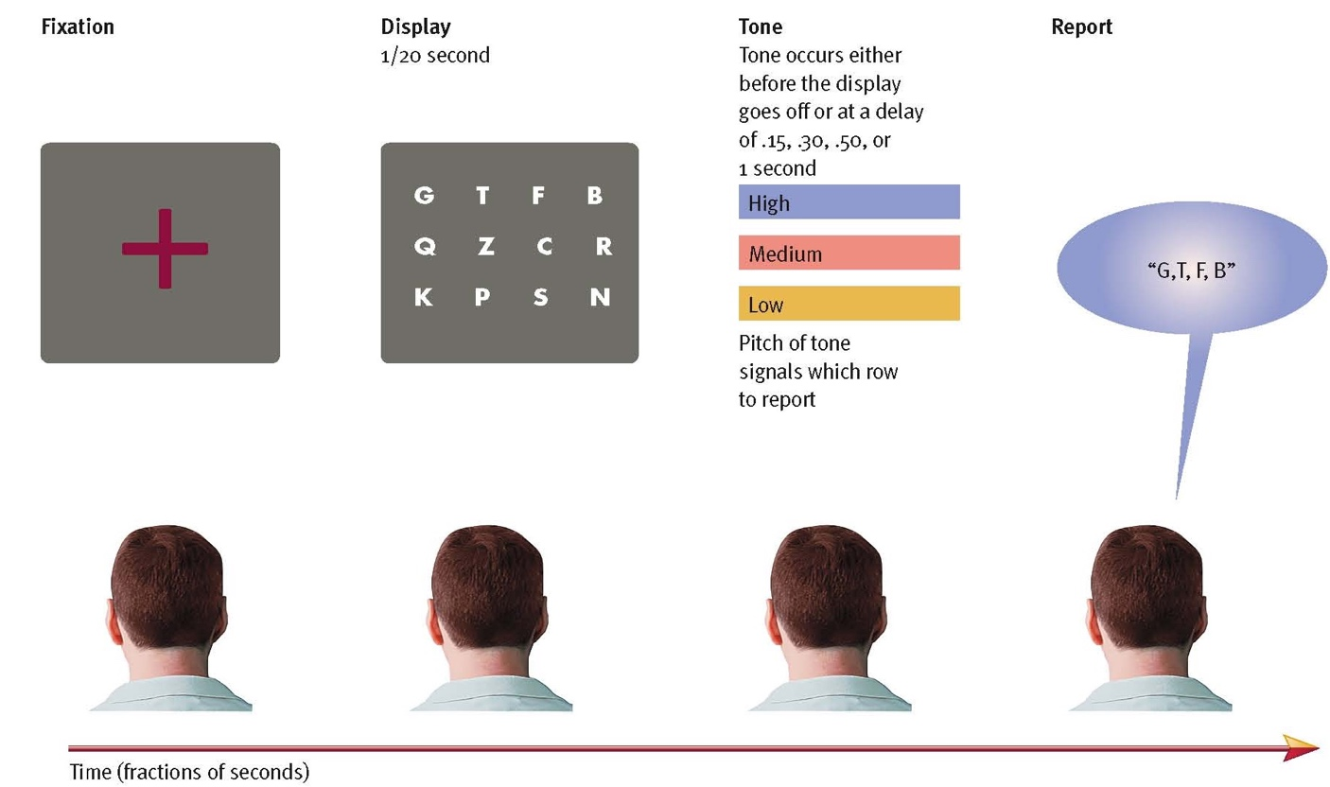

SHORT- TERM MEMORY
- Limited capacity memory system that retains information for 20 to 30 seconds.
- Repeating information is called Inculcation

PETERSON &PETERSON (1959)

- Short term memory helps us function in an everyday life.
  - Example: when getting to traffic light, remembering that its red, when turns green, forget about the red light. Not needed

- Now called working memory: Modularized model of short-term memory (Baddeley, 1992).
- 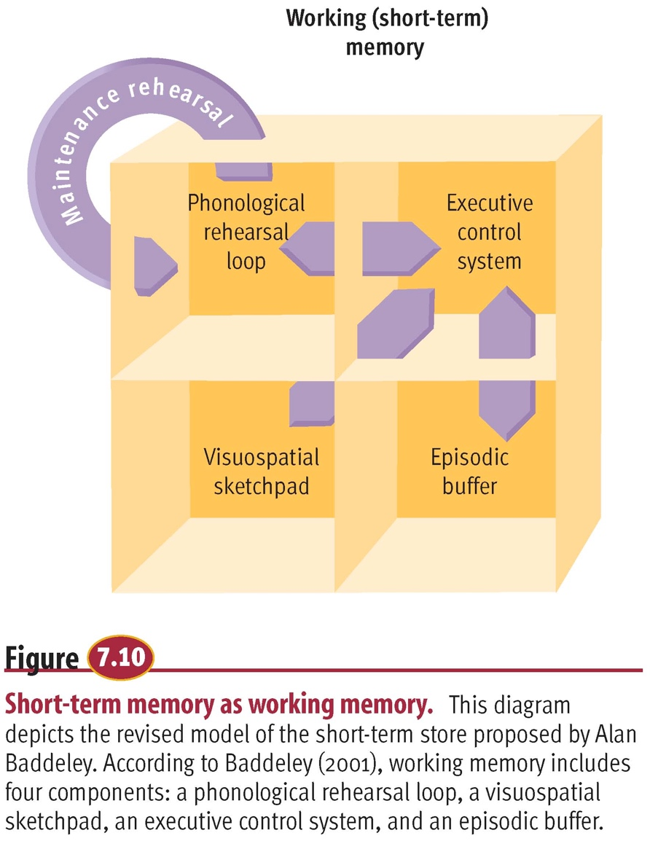
- Episodic buffer: take out information only when needed then not use it anymore but is in long term memory.
- Executive control system: employs attention to the other three modules.
- cant thing about two things in the same module.

LONG TERM MEMORY
- Memory system involved in durable storage of information.
- Unlimited? Permanent?
- Distinct from STM? Case study of Henry Molaison (H.M.)
  - They are distinct from each other
- Information may be organized by phonetic sound:
- Tip-of-the-tongue: errors begin with same letter or sound; same number of syllables and stress pattern.
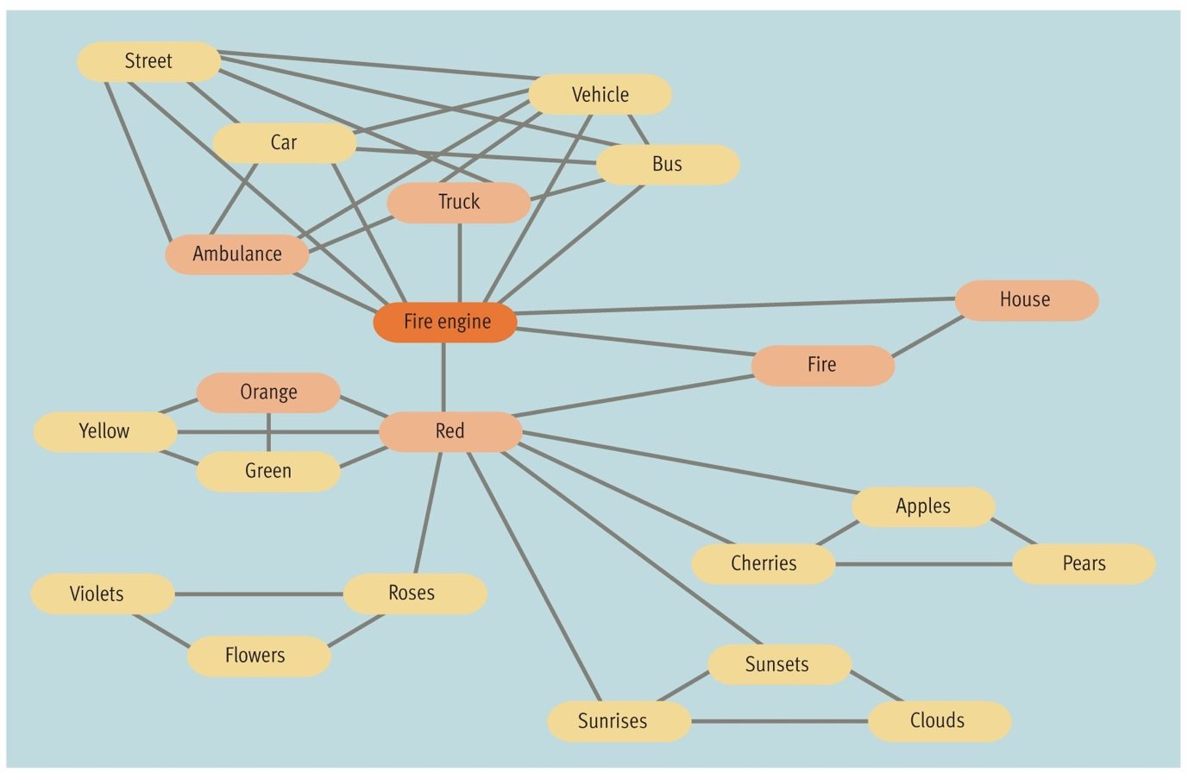
- Distant between the words is how close they relate.
- This how long term memory works
- Case of M.D.
  - Couldn’t recall the name of fruits and veg.
- Many different types of long term memory
Long Term Memory
Prospective Memory
Retrospective Memory
Explicit (declarative) Memory
Episodic Memory
Semantic Memory
Implicit (non-declarative) Memory
Conditioned Reflexes
Procedural Memory

- Prospective memory: remembering things in the futre
- Implicit- can talk about it but cant transfer
- Explicit- cant talk about it so cant transfer to another person.
- Procedural- Muscules remember the action.
- Semantic- memory of knowledge and facts
- Episodic- what you did last weekend, what you watched.

THREE-BOX MODEL OF MEMORY STORAGE
- Atkinson & Shiffrin (1968).
- Three functionally distinct memory stores; not associated with distinct anatomical structures.
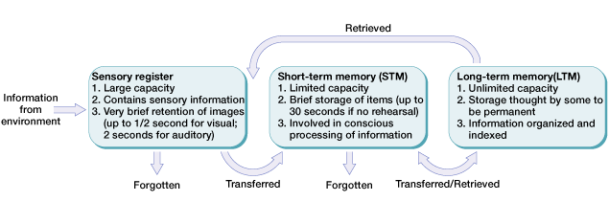
STM:
- Encoding: phonemic
- Forgetting: decay
LTM:
- Encoding: semantic
- Forgetting: interference
- Decay: forgetting due to the passage of time.
- Interference: forgetting due to interference by competing information

