Comm 222: Chapter 3

Perception: the process of interpreting the messages of our senses to provide order and meaning to the environment.
people base their actions on the interpretation of reality that their perpetual system provides, rather than on reality itself
Example: You are the highest paid CEO at your company, yet you perceive that you are paid less than your colleague.

Components of Perception:
There are 3 components to perception: Perceiver, Situation and target

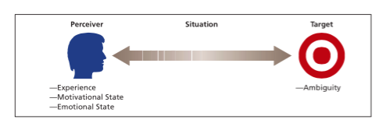
The Perceiver:
Experience, needs and emotions can affect his or her perceptions of a target
Target experience: past experiences lead the perceiver to develop expectations, and these expectations affect current perceptions
Needs: unconsciously influence our perceptions by causing us to perceive what we wish to perceive
Emotions: anger, happiness or fear can influence our perceptions
Perpetual defence: the tendency for the perceptual system to defend the perceiver against unpleasant emotions. “We see what we want to see” or “we hear what we want to hear”, our perpetual system is working to ensure that we do not see or hear anything threatening.
The Target:
Ambiguous targets: easily susceptible to interpretation and addition
Providing more information about the target will not improve perceptual accuracy
The Situation:
Most important effect the situation can have is to add information about the target
Social Identity Theory: A theory that states people form perceptions of themselves based on their personal characteristics and memberships in social categories.
Personal Identity: based on our unique personal characteristics, such as interests, abilities and traits.
Social Identity: is based on our perception that we belong to various social groups, such as our gender, nationality, religion, occupation and so on.
A Model of the Perceptual Process:
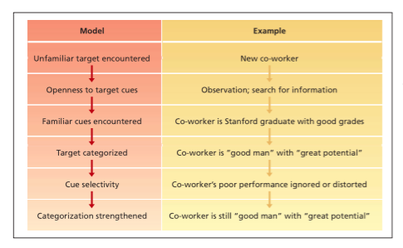
Bruner’s Model demonstrates three important characteristics of the perceptual process:
- Perception is Selective. Perceivers do not us all the available cues, and those they do use are given special emphasis.
- Perpetual Constancy. The tendency for the target to be perceived in the same way over time or across situations.
- Perpetual Consistency. The tendency to select, ignore and distort cues in such a manner that they fit together to form a homogeneous picture of the target.
Basic Biases in Person Perception:
Primary Effect: The tendency for a perceiver to rely on early cues or first impressions. Primary often has a lasting impact.
Recency effect: The tendency for a perceiver to rely on recent cues or last impressions. “Last impression counts most”
Reliance on central traits: personal characteristics of a target person that are of particular interest to a perceiver. Physical appearance is a common central trait in work settings that is related to a variety of job-related outcoes.
Ex: Research shows tendency for those who are “attractive” to also be perceived as “good” especially when it comes to judgements about their social competence.
Implicit Personality Theories: Personal theories that people have about which personality characteristics go together. Implicit theories are inaccurate and they provide a bias for misunderstanding.
Projection: The tendency for perceivers to attribute their own thoughts and feeling to others.
Stereotyping: The tendency to generalize about people in a certain social category and ignore the variations among them.
- Typical categories of stereotyping: race, gender, ethnic background, religion, social class and occupation.
- 3 specific aspects to stereotyping:
- we distinguish some specific category of people (university professors)
- we assume that the individuals in this category possess these traits (absent-minded, disorganized, ivory-tower mentality)
- we perceive that everyone in this category possesses these traits (“All my professors this year will be absent-minded, disorganized and have an ivory-tower mentality)
Attribution: Perceiving causes and motives:
Attribution: the process by which causes or motives are assigned to explain people’s behaviour.
Dispositional attributions: explanations for behaviour based on an actor’s personality or intellect.
Situational attributions: explanations for behaviour based on an actor’s external situation or environment.
Questions to ask yourself when deciding between dispositional or situational causes:
- Does the person engage in the behaviour regularly or consistently? (consistency cues)
- Do most people engage in the behaviour or is it unique to this person? (consensus cues)
- Does the person engage in the behaviour in many situations, or is it distinctive to one situation? (distinctiveness cues)
Consistency Cues: attribution cues that reflect how consistently a person engages in a behaviour over time.
- High consistency leads to dispositinal attributions
- Inconsistent behaviours lead to situation attributions
Consensus Cues: Attribution cues that reflect how a person’s behaviour compares with that of others.
- Unusual, low consensus behaviours lead to more dispositional attributions (the person who acts differently from the majority is seen as revealing his or her true motives)
Distinctiveness cues: attribution cues that reflect the extent to which a person engages in some behaviour across a variety of situations.
- When a behaviour occurs across a variety of situations, it lacks distinctiveness and the observer is prone to provide a dispositional attribution about its cause.
- When a behaviour is highly distinctive, in that it only occurs in one situation, we are likely to conclude some sort of situational attribution
Biases in Attribution:
Fundamental attribution error: the tendency to overemphasize dispositional explanations for behaviour at the expense of situational explanations.
-Example: laziness or poor aptitude might be cited, while poor training or a bad sales territory is ignored.
Actor-Observer Effect: The propensity for actors and observers to view the causes of the actor’s behaviour differently.
-Example: in cases of illegal behaviour the perpetrators and those close to them blame stiff competition or management pressure as cause for their ethical lapses whereas observers might see the perpetrators as immoral or unintelligent.
Self-serving bias: the tendency to take credit for successful outcomes and deny responsibility for failures.
-Example: the vice-president of marketing champions a product that turns out to be a sales success; she might attribute this to her retailing savvy. If the same marketing process leads to failure, she might attribute this to the poor performance of the marketing research firm she used.
Person Perception and Workforce Diversity
Workforce diversity: differences among recruits and employees in characteristics such as gender, race, age , religion, cultural background, physical ability, or sexual orientation.
-The changing workplace
-Valuing diversity
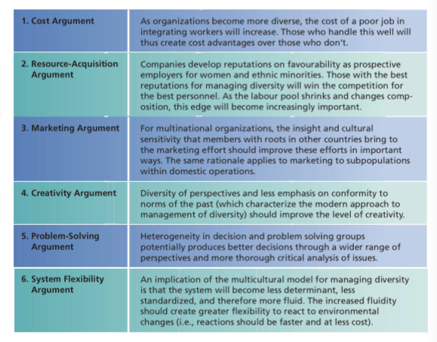

-Stereotypes and workforce diversity
Stereotype Threat: members of a social group feel they might be judged or treated according to a stereotype and that their behaviour and/or performance will confirm the stereotype.
- Racial, ethnic and religious stereotypes: pervasive, persistent, frequently negative, and often self-contradictory. These stereotypes exhibit remarkable stability unless some major event, such as a war, intervenes to change them. Personal experience is not necessary for such stereotype formation. These stereotypes are often contradictory, “they’re lazy” but “they take job opportunities away from the rest of us”.
- Gender Stereotypes: One of the most problematic stereotypes in organizations. Women are severely underrepresented in managerial and administrative jobs.
- Age Stereotypes: knowing that a person falls into a certain age range or belongs to a particular age generation, we have a tendency to make certain assumptions about the person’s physical, psychological and intellectual capabilities.
-Older workers are seen as less productive, creative, logical, and capable of performing under pressure than younger workers. There is also this view that older workers have less potential for development. They are also perceived as more hones, dependable, and trustworthy (stable).
Managing Workforce Diversity
Diversity needs to be managed to have a positive impact on work behaviour and an organization.
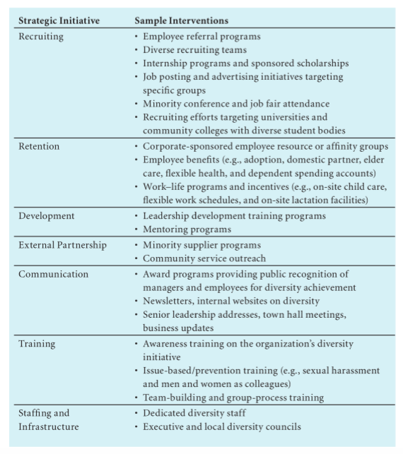

Perceptions of Trust:
Trust: a psychological state in which one has a willingness to be vulnerable and to take risks with respect to the actions of another party. Trust perceptions toward management are based on three distinct perceptions:
- Ability: employee perceptions regarding management’s competence and skills.
- Benevolence: refers to the extent that employees perceive management as caring and concerned for their interests and willing to do good for them.
- Integrity: refers to employee perceptions that management adheres to and behaves according to a set of values and principles that the employee finds acceptable.
Perceived Organizational Support (POS):
POS: employees’ general belief that their organization values their contribution and cares about their well-being.
Positive perceptions of POS leads to the belief that organizations will provide assistance when they need it to perform their job effectively and deal with stressful situations.
Organizational Support Theory: a theory that states that employees who have strong perceptions of organizational support feel an obligation to care about the organization’s welfare and to help the organization achieve is objectives.
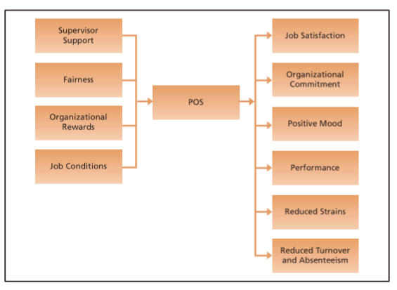

Person Perception in human resources
Recruitment & Selection:
-Signalling theory: job applicants interpret their recruitment experience as cues or signals about unknown characteristics of an organization and what it will be like to work in an organization.
Employment Interview:
- The validity of an interview improves when interviewers conduct a more structured interview
- Interviewers compare interviewees to a stereotype of the ideal applicant, not a bad thing if this ideal stereotype is accurate and requires a clear understanding of the nature of the job in question and the kind of person who can do well in this job
-Interviewers have a tendency to exhibit primary reactions
-Primary reactions: means that information that interviewer received at the beginning of the interview will have an undue impact on the final decision
-Contrast effects: applicants who have been interviewed earlier affect the interviewer’s perception of a current applicant, leading to an exaggeration of differences between applicants
Performance Appraisal
-Organization will want some index of the person’s job performance for decisions regarding pay raises, promotions, transfers, and training needs.
- Objective and subjective measures
- Objective measures are a good way to measure performance but are not easy to compare across a spectrum
- Ex: Snowmobile sales in New Brunswick cannot be compared to snow mobile sales in Halifax
- Due to the difficulties measures present organizations must rely on subjective measures of effectiveness, usually provided by managers
- Manager has many perceptual roadblocks when evaluating subjective measures, especially when employees job activities cannot be monitored directly
- When performance is observable, employees often alter their behaviour when their manager is around
- Rater Errors
- Leniency: the tendency to perceive the job performance of rates as especially good
- Harshness: The tendency to perceive the job performance of ratees as especially ineffective
- Central tendency: The tendency to assign most ratees to middle-range job performance categories
- Halo effect: the rating of an individual on one trait of characteristics tends to colour ratings on other traits or characteristics.
- Similar-to-me effect: a rater gives more favourable evaluations to people who are similar to the rater in terms of background or attitudes.
- Behaviourally anchored rating scale (BARS): a rating scale with specific behavioural examples of good, average, and poor performance.
- Frame-of-reference (FOR) training: a training method to improve rating accuracy that involves providing raters with a common frame of reference to use when rating individuals

