Comm 222: Module 2

Learning: A relatively permanent change in behaviour potential that occurs due to practice or experience.

What do employees learn?

- Practical skills: job-specific skills, knowledge and technical competence.
- Intrapersonal skills: problem solving, critical thinking, learning about alternative work processes and risk taking.
- Interpersonal skills: interactive skills such as communicating, teamwork and conflict resolution.
- Cultural awareness: learning the social norms of organizations and understanding company goals, business operations and company expectations and priorities.

Operant Learning Theory

Operant Learning: learning by which the subject learns to operate on the environment to achieve certain consequences.
B.F. Skinner (1930s), rat and lever experiment with food
Can be used to increase the probability of desired behaviours and to reduce or eliminate the probability of undesirable behaviours.
Reinforcement: the process by which the stimuli strengthen behaviours
A reinforcer is a stimulus that follows some behaviour and increases or maintains the probability of that behaviour.
- Positive reinforcement: the application or addition of a stimulus that increases or maintains the probability of some behaviour. Tend to be pleasant things such as; food, praise, money or business success.
- Negative reinforcement: the removal of a stimulus that in turn increases or maintains the probability of some behaviour. Tend to be averse or unpleasant stimuli (shock, nagging, threat of fines), and we will learn to repeat behaviours that remove or prevent these unpleasant stimuli (still increases the probability of a behaviour). Ex: managers who nag their employees unless the employees work hard.
Organization errors with reinforcement: common errors include confusing rewards with reinforcers, neglecting diversity in preference for reinforcers and neglecting important sources of reinforcement.
- Confusing rewards with reinforcers: Managers “reward” workers with things such as pay, promotions, fringe benefits, paid vacations, overtime work, and the opportunity to perform challenging tasks. They are not reinforcers because organizations don’t make them contingent on specific behaviours that are of interest to the organization like; attendance, innovation or productivity.
- Neglecting diversity in preference for reinforcers: rewarding a workaholic with time off of work, it would be better to assign them a challenging task like work on a very demanding key project. Research shows younger workers (20s-30s) prefer cash rewards and older workers prefer experiential awards like vacation.
- Neglecting important sources of reinforcement: many reinforcers that are not especially obvious.
Performance feedback: providing quantitative or qualitative information on past performance for the purpose of changing or maintaining performance in specific ways. It is most effective when it is (1) conveyed in a positive manner, (2) delivered immediately after the performance is observed, (3) represented visually (graph or chart form) and (4) specific to the behaviour that is being targeted for feedback.
Social recognition: informal acknowledgement, attention, praise, approval or genuine appreciation for work well done from one individual or group to another. When social recognition is made contingent on employee behaviour it can be effective means for performance improvement.

Reinforcement Strategies:
Fast acquisition of some response: continuous and immediate reinforcement should be used. Every time the behaviour of interest occurs the reinforcer should applied.
Persistent behaviour: learned under conditions of partial and delayed reinforcement. It will persist under reduced or terminated reinforcement when nto every instance of the behaviour is reinforced during learning or when some time period elapses between its enactment and reinforcement.

Reducing the probability of behaviour:
Extinction: the gradual dissipation of behaviour following the termination of reinforcement. If a behaviour is not reinforced it will gradually dissipate or be extinguished.
Punishment: the application of an aversive stimulus following some behaviour designed to decrease the probability of that behaviour.
- Does not provide behaviour that replace the unwanted behaviour, must provide an acceptable alternative for the punished response if you want this method to work
- Provokes strong emotional reaction on the part of the individual punished, especially when punishment is delivered in anger or seems unfair
Increasing the effectiveness of punishment:
- Make sure the chosen punishment is truly aversive. Organizations punish chronically absent employees with days off??? This type of punishment acts as a positive reinforcer.
- Punish Immediately. Don’t let behaviours gain strength through repetition before punishing for the first time.
- Don’t reward unwanted behaviours before or after punishment. Managers engaging in horseplay before or after work is getting done.
- Do not inadvertently punish desirable behaviour. Manager who does not use all of his fiscal budget for one year will have the next years reduced and inadvertently punish the prudence of employees.
Social Cognitive Theory: emphasizes the role of cognitive processes in learning and in the regulation of people’s behaviour.
people learn by observing the behaviour of others
people manage their own behaviour by thinking of the consequences of their actions
Traditional reciprocal causation: personal factors and environmental factors work together and interact to influence people’s behaviour

Observational learning: the process of observing and imitating the behaviour of others. We like to use credible, highly known people as models for our own behaviour, like Bill Gates.

Self-Efficacy beliefs: beliefs that people have about their ability to successfully perform a specific task.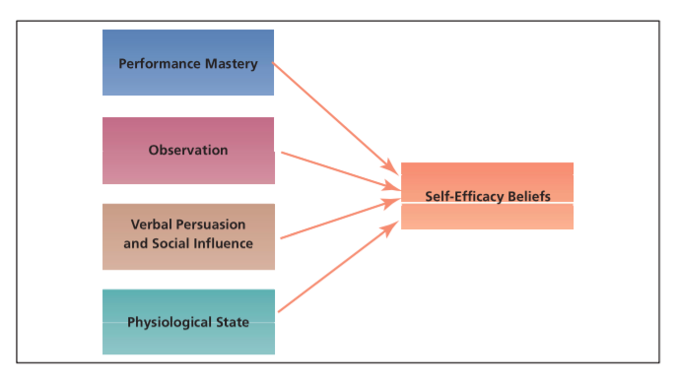
Self-Regulation: the uses of learning principles to regulate one’s own behaviour.
-Basic Process:
- Self-Observation: observing one’s own behaviour
- Self-Evaluation: comparing the behaviour with a standard
- Self-Reinforcement: rewarding oneself if the behaviour meets the standard
Discrepancy reduction: individuals are motivated to modify their own behaviour in the pursuit of goal attainment.
Self-regulation techniques:
-Collect self-observation data
-Observe models
-Set goals
-Rehearse
-Reinforce oneself
Organizational behaviour modification: the systematic use of learning principles to influence organizational behaviour.

Employee Recognition Programs: Formal organizational programs that publicly recognize and reward employees for specific behaviours.
-a form of positive reinforcement in organizational learning practice
-to be effective the program must specify:
- How a person will be recognized
- The type of behaviour being encouraged
- The manner of the public acknowledgement
- A token or icon of the event for the recipient

Peer recognition programs: formal programs in which employees can publicly acknowledge, recognize and reward their coworkers for exceptional work and performance.
Outcomes: job satisfaction, performance and productivity, and lower turnover.

Training & Development Programs: training is planned organizational activities that are designed to facilitate knowledge and skill acquisition to change behaviour and improve performance on one’s current job; development focuses on future job responsibilities.

Behaviour Modelling training (BMT): one of he most widely used and effective methods of training, involving five steps based on the observational learning component of social cognitive theory.
- Describe to trainees a set of well-defined behaviours (skills) to be learned
- Provide a model or models by displaying the effective use of those behaviours
- Provide opportunities for trainees to practice using those behaviours
- Provide feedback and social reinforcement to trainees following practice
- Take steps to maximize the transfer of those behaviours to the job

Career Development: an ongoing process in which individuals progress through a series of stages that consist of a unique set of issues, themes, and tasks.
Career planning: the assessment of an individuals interests, skills, and abilities in order to develop goals and career plans.

Dun & Bradstreet Canada (business information services company)Leadership Action Plan: lists employees’ strengths and career aspirations as well as a plan on how they will achieve their goals. File is reviewed under superior 4 times a year. There is an Internet site also available to perform career assessments and access information about job opportunities within the company.

