Chapter 1
- Organizational Behavior: the field of study devoted to understanding, explaining, and ultimately improving the attitudes and behaviors of individuals and groups in organizations
- Without understanding why employees act the way they do, it is very difficult to find a way to change their attitudes and behaviors at work.
- Be contrasted with two other courses:
- Human resources management: field of study that focuses on the applications of OB theories and principles in organizations
- Takes the theories and principles studied in OB and explores the “nuts and bolts” applications of those principles in organization; it examine the best ways to structure training programs to promote employee learning
- Strategic management: field of study devoted to exploring the product choices and industry characteristics that affect an organization’s profitability
- Focuses on the product choices and industry characteristics that affect an organization’s profitability; it examine the relationship between firm diversification and firm profitability
How organizations can be designed structured more effectively
How managers can manage more effectively

- The Role of Management Theory
- Study of organizations started with the industrial revolution
- Attempts to prescribe the “correct” way to manage an organization and achieve its goals
- Classical View: put heavy emphasis on specialization, coordination, and efficiency
- Scientific management: using scientific methods to design optimal and efficient work processes and tasks
- Bureaucracy: an organizational form that emphasizes the control and coordination of its members through a strict chain of command, formal rules and procedures, high specialization and centralized decision making
- The division of labor with a high level of technical specialization
- A strict chain of command in which every member reported to someone at a higher level in the organization
- A system of formal rules and procedures that ensured consistency, impartiality, and impersonality throughout the organization
- Decision making at the top of the organization
- Human relations view: field of study that recognizes that the psychological attributes of individual workers and the social forces within work groups have important effects on work behaviors

The Contingency Approach: recognizes the dependencies between the classical approach and the human relations approach
- Reflected in a number of the theories and models of OB in which the consequences of situational characteristics thought to depend on characteristics of the individual or vice versa
- Benefits to both approaches
- The contingency approach to management recognizes that there is no one best way to manage
- The general answer to many of the problems in organization is “ it depends”
- An appropriate management style depends on the demands of the situation

Integrative Model of OB (figure): designed to provide a roadmap for the field of organizational behavior

- Individual Outcomes
- Job performance: Two primary goals for their working lives: to perform their jobs well and to remain member s of an organization that t they respect
- Organizational commitment: Two primary goals for their employees: to maximize their job performance and to retain these employees for a significant length of time
- Individual Mechanisms
- Directly affect job performance and organizational commitment (key drivers)
- Job satisfaction: captures what employees feel when thinking about their jobs and doing their day-to-day work
- Stress: reflects employees’ physiological responses to job demands that tax or exceed their capacities
- Motivation: captures the energetic forces that drive employees’ work effort
- Trust, justice and ethics: reflect the degree to which employees feel that their company conducts business with fairness, honesty, and integrity
- Learning and decision making: deals with how employees gain job knowledge and hot they use the knowledge to make accurate judgments on the job
- Employee do not work alone, group factors shape satisfaction, stress motivation, trust, and learning
- Individual Characteristics and Group Mechanisms
- Factors improve those individual mechanisms
- Personality, cultural values, and ability: describe how these personal attributes relate to job performance and organizational commitment
- Teams, diversity, and communication: explore the depend on and relate to on another; describe team processes that explain how groups and teams behave as well as how members communicate and manage diversity
- Power, influence, and negotiation: describe how individuals and leaders acquire power; how power and influence are used to negotiate outcomes and resolve the day-to-day conflicts that characterize organizational life
- Leadership styles and behavior: shifts how leaders behave and the conditions where different styles are appropriate to influence others

- Organizational Mechanisms
- Every company has an organizational structure that dictates how the units within the firm link to other units
- Structures are centralized around a decision-making authority
- Structures are decentralized affording each unit some autonomy
- Organizational culture and change

- The Value of An Integrative Model

Does Organizational Behavior Matter?
- Effective OB can help keep a product good over the long term
- Effective management of OB can help make a product get better, incrementally, over the long term
Building a Conceptual Argument
- Resource-based view: a model that argues that rare and inimitable resources help firms maintain competitive advantage.
- Firms’ resources: knowledge decision making, ability, and wisdom of the workforce as well as the image, culture, and goodwill of the organization
- A resource is more valuable when it is inimitable; it cannot be easily copied
- Inimitable: incapable of being imitated or copied
- History
- A collective pool of experience, wisdom, and knowledge that benefits the organization
- Numerous Small Decisions
- Captures the idea that people make many small decisions day in and day out, week in and week out
- Socially Complex Resources
- People are the source of socially complex resources, such as culture, team work, trust, and reputation
- It is not always clear how they came about, though it is clear which organizations do (and do not) possess them

Research Evidence
- Using hard data to backup conceptual arguments; good people constitute a valuable resource for companies

So What’s So Hard?
- Effective management of OB requires a belief that several different practices are important, along with a long-term commitment to improving those practices
- Rule of one-eighth: the belief that at best one-eighth, or 12 percent, of organizations will actually do what is required to build profits by putting people first

T/F
- Effective leaders possess the same personality traits F
- All workers prefer stimulating, challenging jobs F
- Pay is the best way to motivate most employees and improve job performance F

Organizational Behavior helps us to
- Predict organizational behavior and events
- Explain organizational behavior and events in organizations
- Manage/Improve organizational behavior

The Scientific Method (figure)

- It does not matter what a person’s experience or intuition suggests: the prediction must be tested with data
- They acknowledge that their beliefs must be tested scientifically
- Theory: a collection of verbal and symbolic assertions that specify how and why variables are related, as well as the conditions in which they should (and should not) be related
- Theories are often summarized with theory diagrams, the “boxes and arrows” that graphically depict relationships between variables.
Social Recognition & Job Performance
- How often does social recognition lead to higher job performance?
- Provides insights into their views about the strengths and weaknesses of social recognition
- Be built from observations of people at work, in which case scientists take notes, keep diaries, and pore over company documents to find all the elements of a theory story
- Be built from research reviews, which examine findings of previous studies to look for patterns or themes.
- OB theories once argued that money was not an effective motivator and that the best way to structure jobs was to make them as simple and mundane as possible
- Hypotheses: written predictions that specify relationships between variable
- Correlation: the statistical relationship between two variables; abbreviated r, ti can be positive or negative and range from 0 (no statistical relationship) to +_1 ( a perfect statistical relationship)
- Scatterplot: a graph made from those two columns of numbers
- r = 0.5 Strong; r = 0.3 Moderate; r = 1.0 Weak
- Meta-analysis: a method that combines the results of multiple scientific studies by essentially calculating a weighted-average correlation across studies (with larger studies receiving more weight)

Correlation between social recognition and job performance

Chapter 2
Job Performance
- Employee behaviors that contribute either positively or negatively, to organizational goal accomplishment
- Student
- Professor
- Job performance create problems:
- Employees contribute to their organization in ways that go beyond bottom-line results, and so evaluating an employee’s performance on the basis of results alone might give you an inaccurate picture of which employee are worth more to organization
- Result are often influence by factors beyond the employee’s control—product quality, competition, equipment technology, budget constraints, co-workers, and supervision…
- Even if these uncontrollable factors are less relevant in a given situation, there’s another problem with a results-based view of job performance: results don’t tell you how to reverse a bad year
- Performance feedback based on results does not provide people with the information they need to improve their behavior.
- Job performanceBehavior; Results/Job performance resultsthe outcomes associated with those behavior
- Task performance
- Employee behaviors that are directly involved in the production of goods and/or services.
- The set of explicit obligations that an employee must fulfill to receive compensation and continued employment
- Routine task performance: responses to demands that occur in a normal, routine, or predictable way. (E.g Starbucks: making coffee)
- Adaptive task performance (adaptability): responses to tasks demands that are unpredictable, novel, or unusual.
- Creative task performance: developing ideas or outcomes that are novel and useful (E.g advertising, architecture, software developer)
- Job Analysis: many organizations identify task performance behaviors by conducting a job analysis
- Step:
- Generate a list of activities
- Rating of activities by” subject matter experts” (SME’s)
- Retain most important activities
- National Occupational Classification (NOC)
- A nationally accepted reference to occupations in Canada
- Over 30,000 job titles into 520 job descriptions
- Citizenship behavior
- Voluntary employee activities that may or may not be rewarded but that contribute to the organization by improving the overall quality of the setting in which work takes place
- Interpersonal: benefit coworkers and colleagues and involve assisting, supporting, and developing other organizational members in a way that goes beyond normal job expectations; a team with team members tend to be helpful, respectful and courteous
- Helping
- Assisting co-workers who have heavy workloads
- Aiding them with personal matters
- Showing new employees the ropes when they first arrive on the job
- Courtesy(献殷勤): refers to keeping coworkers informed
- Sportsmanship: involves maintaining a good attitude with coworkers
- Organizational: benefit the larger organization by supporting and defending the company, working to improve its operations, and being loyal
- Voice: speaking up and offering constructive suggestions for change
- Civic virtue: participating in the company’s operations at a deeper-than-normal level
- Boosterism: representing the organization in a positive way
- Citizenship behaviors have a significant influence on the bottom line
- Citizenship has influence on the salary and promotion recommendations people receive, over and above their task performance
- Counterproductive behavior: intentionally hider organizational goal accomplishment (things they mean to do)
- Property deviance: Harms the organization’s assets and possessions
- Sabotage: the purposeful destruction of physical equipment, organizational processes, or company products
- Theft
- Production deviance: reduces the efficiency of work output
- Wasting resources: most common form
- Substance abuse
- Political deviance: intentionally disadvantages other individuals
- Gossiping
- Incivility: communication that is rude, impolite, discourteous, and lacking in good manners
- Get “spiral”: gradually getting worse and worse until a tipping point
- Personal aggression: hostile verbal and physical actions directed toward other employees
- Harassment
- Abuse
- Three Things about Counterproductive Behavior
- There is evidence that people who engage in one form of counterproductive behavior also engage in others; such behaviors tend to represent a pattern of behavior rather than isolated incidents
- Citizenship behavior counterproductive behavior is relevant to any job
- There are circumstances in which counter productive behaviors might even be tolerated for a while because an employee’s task performance contributions are unique or valued highly
What Does it Mean to be A “GOOD PERFORMER”?
- Someone is good at the particular job tasks that fall within his or her job description, whether those tasks are routine or require more adaptability
- The employee engages in citizenship behaviors directed at both co-workers and the larger organization
- He or she refrains from engaging in the counterproductive behaviors that can so badly damage the climate of an organization
Application: Performance Management
- Management by objectives (MOB): a management philosophy that bases an employee’s evaluations on whether the employee achieves specific performance goals
- Behaviorally anchored rating scales (BARS): use of examples of critical incidents (short descriptions of effective and ineffective behaviors) to evaluate an employee’s job performance behaviors directly
- 360-degree feedback: a performance evaluation system that uses ratings provided by supervisors, co-workers, subordinates, customers, and the employees themselves (best for improving and developing talents)
- Problems to use it for promotion or raises
- Ratings vary across sources, there is the question of which source is most “correct”
- Raters may give biased evaluations if they believe that the information will be used for compensation, as opposed to just kill development
- Forced ranking: managers rate subordinates relative to one another
- Social networking systems
- Advantages
- These types of systems provide performance information that is much more timely, relative to traditional practices that measure performance quarterly or even yearly
- It is much better than giving 50 boring presentations over the course of the year and then getting the news from your boss

Figure 2-2

- “Bad apples”—Pattern of behavior
- Not only apple to certain jobs; there will always be things to waste, steal; people to gossip about
- Not only apply to poor performers; research shows a weak correlation. Often the better performers can better get away with it

Chapter 3
Organizational Commitment
- An employee’s desire to remain a member of the organization
- Influences whether an employee stays at the organization (is retained) or leaves to pursue another job (turns over)
- Cost money to find/replace employees
- If commitment is low, employees engage in withdrawal behavior
- Actions that employees perform to avoid the work situation
- May lead to quitting
- High commitmentLow withdrawal
- Voluntary turnover: when employees themselves decide to quit
- Involuntary turnover: when employees are fired by the organization for some reason
- Withdrawal behavior: a set of actions that employees perform to avoid the work situation—behaviors that may eventually culminate in quitting the organization
- Retention risk(离职风险): teetering on the edge of quitting the job (withdrawal>commitment)
Factors that foster Commitment
- Affective Commitment/Emotion-based Reasons: a desire to remain a member of an organization due to a felling of emotional attachment
- Identify with the organization
- Accept the organization’s goals and values
- Why do we want to encourage it
- More emotionally attached
- More willing to exert extra effort
- More citizenship behaviors
- Erosion model: employees with fewer bonds will be most likely to quit the organization
- Social influence model: employees who have direct linkages with “leavers” will be more likely to leave
- Methods to increase affective commitment
- Creating a cooperate culture in which every team member in treated with respect and trust
- Fostering a highly personal employment experience for employees where they fell like “family”
- Promoting opportunities for growth, achievement, and personal development
- Celebrating their personal accomplishments and successes
- Continuance Commitment/Cost-based Reasons (cost to leave/benefit to stay): desire to remain a member of an organization due to an awareness of the costs of leaving
- When there is a benefit associated with staying and a cost associated with leaving, with high continuance commitment making it very difficult to change organizations because of the steep penalties associated with the switch
- Loss of seniority
- Reduction in wages or salary
- Increases by:
- Investment made by employee
- Lack of employment alternatives
- Economic conditions
- Unemployment rate
- Marketability of a person’s sills and abilities
- Do we want to increase continuance commitment?
- Tends to create a more passive form of loyalty
- Negligible (close to zero) or negative relationship with work outcomes, except turnover
- Sometimes staying because they have to
- Focuses on personal and family issues more than the other two commitment types, because employees often need to stay for both work and non-work reasons
- How to increase continuance commitment?

- E.g. Salaries
- Embeddedness
- A person’s links to the organization and the community
- His/her sense of fit
- And what he would have to sacrifice for a job change
- Strengthens continuance commitment
- Provides more reasons to stay
- And more sources of anxiety upon leaving
- Normative Commitment/Obligation-based Reasons: desire to remain a member of an organization due to a feeling of obligation
- Staying is the “right” or “moral” thing to do (“should")
- Could be from:
- Personal work philosophies
- Organizational Socialization
- We want to increase normative commitment; reduction in turnover
- Two ways to build a sense of obligation-based commitment among employees
- To create a feeling that the employee is in the organization’s debt—that he or she owes something to the organization
- The employee might feel obligated to “repay” the organization with several more years of loyal service
- To increase normative commitment
- Organizational support – “wanting to give back”
- E.g. Training and development – pay tuition, support language skill development
- Focused of commitment: the people, places, and things that inspire a desire to remain a member of an organization
Why do we care about commitment?
- Up to 2/3 of Canadians are willing to voluntarily switch jobs
- More of a risk to companies in a competitive market
- Particularly certain skills
- Want to discourage employee withdrawal

Reactions to a Negative Work Event
- Exit: active, destructive response by which an individual either ends or restricts organizational
- Leaving
- Missing meetings
- Not showing up
- Voice: an active, constructive response in which individuals attempt to improve the situation
- Talk to the owner
- Negotiate
- Loyalty: a passive, constructive response that maintains public support for the situation while the individual privately hopes for improvement
- Keep heads down; keeps doing works
- Deal with it
- Do your job, look for opportunities outside
- Perform basic responsibilities
- Neglect: defined as a passive destructive response in which interest and effort in the job declines (more costly than exit)
- Loafing
- Socializing
Withdrawal Behavior
- Psychological Withdrawal (Neglect): mentally escaping the work environment
- Daydreaming
- Looking busy: intentional desire on the part of the employee to look like he or she is working, even when not performing work tasks
- Cyber loafing: using Internet, e-mail, and instant message to avoid doing work-related activates
- Socializing: chatting non-working stuff
- Moonlighting: use work time and resources to do non-work-related activities (find another job)
- Physical Withdrawal (Exit): physical escape from the work environment
- Tardiness: employees arrive late to work or leave work early
- Missing Meetings: employees neglect important work functions while away from the office
- Quitting: employees voluntarily leave the organization
- Long breaks: take longer-than-normal lunches or breaks to spend less time at work
- Absenteeism: missing entire day of work
- Independent Model: predicts that the various withdrawal behaviors are uncorrelated, so that engaging in one type of withdrawal has little bearing on engaging in other types
- For different reasons
- Fulfill different needs
- Compensatory forms model: the various withdrawal behaviors are negatively correlated, so that engaging in one type of withdrawal makes one less likely to engage in other types
- Progression model: various withdrawal behaviors are positively correlated, so that engaging in one type of withdrawal makes one more likely to engage n other types

Trends that Affect Commitment
- Diversity of the workforce
- Increasing diversity of the Canadian labor force
- Aging of the Canadian labor force
- More and more employees are foreign-born: feel less embedded in their current jobs and perceive fewer links to their community and less fit with their geographic area
- The changing employer relationship
- Downsizing: a form of involuntary turnover
- Change the way employees view their relationship with their employers
- To cut cost, but not usually worked
- It harms company profitability and stock price
- “Survivors”: the employees who remain in the organization after a downsizing are often stricken with “survivor syndrome” (anger, depression, fear, distrust and guilt)
- The change in employee-employer relationship—more challenging to retain valued employees
- To find some way to maintain normative commitment
- Psychological contracts: employee beliefs about what employees owe the organization and what the organization owes them
- Transactional contracts: focus on a narrow set of specific monetary obligations
- The organization owes pay and advancement opportunities
- The employee owes attendance and protection of proprietary information
- Relational contracts: focus on a broad set of open-ended and subjective obligations
- The organization owes job security, development and support
- The employee owes loyalty and the willingness to go above and beyond
Application: Commitment Initiatives
- Perceived organizational support: the degree to which employees believe that the organization values their contributions and cares about their well-being
- Organization can be supportive to increase loyalty:
- Providing adequate rewards
- Protecting job security
- Improving work conditions
- Minimizing the impact of politics
- Organizations can engage in specific practices that target the three forms of commitment
- Employer strategies could entre on increasing the bonds that link employees together (affective commitment)
- Allowing employees time to play
- Social Events that encourage employees to interact and develop friendship
- To create a salary and benefits package that creates a financial need to stay (continuance commitment perspective)
- Advancements and promotions
- To provide various training and development opportunities for employees; investing in them to create the sense that they owe further service to the organization (normative commitment)
- Even minor forms of psychological withdrawal often escalate, eventually to the point of absenteeism and turnover
- To stop the progression in its early stages by trying to root out the source of the reduced commitment

Chapter 4
Job Satisfaction: a pleasurable emotional state resulting from the appraisal of one’s job or job experiences
- It represents how you feel about your job and what you think about your job
- 81% of Canadians report being satisfied with their jobs and like the people they work with
- Top drivers of job satisfaction:
- Corporate culture
- The opportunity to use skills
- The opportunity to learn
- The ability to be creative
Why are some employees more satisfied more than others?
- Employees are satisfied when their job provides the things that they value
- Value: things that people consciously or unconsciously want to seek or attain
Commonly Assessed Work Values
- Pay
- Promotions
- Supervision
- Co-workers
- The work itself
- Altruism
- Status
- Environment
Value-Percept Theory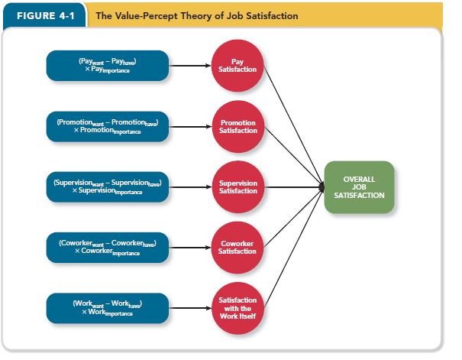
- Job satisfaction depends on whether you perceive that your job supplies the things that you value
Dissatisfaction=(V want-V have)(V importance)
- People evaluate job satisfaction according to specific “facets” of the job
- Pay satisfaction: employees’ feelings about the compensation for their jobs
- Is it as much as they deserve?
- Is it adequate?
- We compare ourselves to others
- We expect equity
- Promotion Satisfaction: how company handles promotions
- Are promotion policies fair
- Are they implemented fairly
- Based on ability?
- Better wage, personal growth, and more prestige
- But some don’t want to have it (more responsibility and increased work hours)
- Supervision satisfaction: feelings about their boss, including his or her competency, communication, and personality
- Is the boss competent, polite?
- Can they help me attain the things that I value
- Depends on whether supervisors provide rewards for good performance, help employees obtain necessary resources and protect employees from unnecessary distractions
- Are they generally likable
- Depends on whether supervisors have good personalities, as well as values and beliefs similar to the employees’ philosophies
- Coworker satisfaction: feelings about their co-workers, including their abilities and personalities
- Can they help me do my job
- Critical: most of us rely on to some extent on our co-workers when performing job tasks
- Do I enjoy being around them
- Important, we spend just as much time with co-workers as we do members of our own family
- Pleasant and fun co-workers: make work week go much faster
- Disrespectful and annoying co-workers: make one day like an eternity
- Satisfaction with the work itself: feeling about their actual work tasks
- If focus on what employees actually do
- Are the tasks challenging, interesting?
- Do they make use of key skills
- Boring jobs might be easier, but they’re not necessarily better
- Strongest influential facets: with the work itself > supervisions/co-worker>promotion/pay
- Reason to be strongest: we spend a significant time with our works
Question: Which of the five facets contribute most to overall job satisfaction? (in order of significance, highest to lowest)
- Pay, promotions, supervisor
- Supervisor, co-worker, pay
- Work, supervisor, co-worker (but all facets are positively correlated to overall job satisfaction)
- Work, pay, supervisor
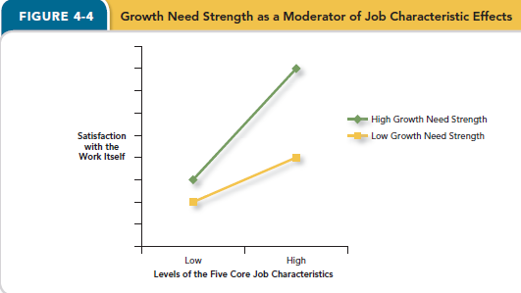
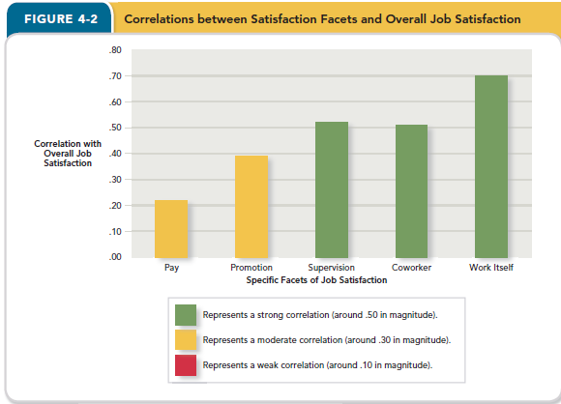
Job Characteristics Theory
- A theory that agues that five core characteristics (variety identity, significance, autonomy, and feedback) combine to result in high levels of satisfaction with the work itself
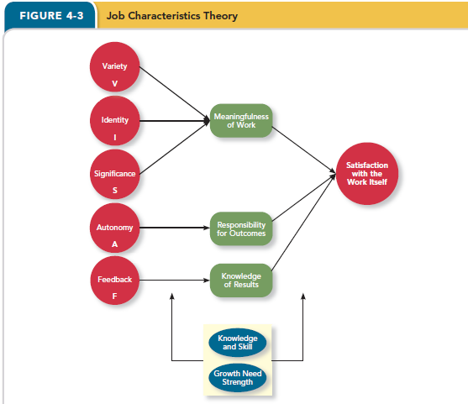
Critical Psychological States
- Meaningfulness of work: degree to which work takes are viewed as meaningful something that “counts”
- Responsibility for outcomes: degree to which employees feel they are key drivers of work quality
- Knowledge of results: the extent to which employees knowhow well they are doing
- Variety: involves a number of different activities; uses different skills and talents
- E.g. Doctors
- Identity: completing a whole piece of work from beginning to end with a visible outcome
- Low: everyone has something to point to
- High: Truck driver
- Significance: impact on the lives of other people; it really matters and impacts society as a whole
- E.g. Social workers, teachers, firefighters
- Low: washroom attendant
- High: fireman
- Autonomy: provides independence and discretion to the individual doing the work
- Low: airline reservationist (had no free)
- High: Jazz Musician
- Feedback: from the job itself about how well the worker is performing (not supervisor)
- Overall the job characteristics are moderately to strongly related to work satisfaction
- Low: government project coordinator
- High: waitress

Question: But, do all employees want more variety, autonomy.
Answer: not necessarily, depends on Job characteristic Moderator:
- Knowledge and sill: the degree to which employees have the skills and knowledge needed for their jobs
- Growth need strength: the degree to which employees wish to develop themselves further
Job characteristic moderator: both of these increase the strength of the relationships within the model
- If lack of moderator, variety and autonomy would not increase their satisfaction very much

- Employed job characteristics theory to help improves satisfaction among their employees:

1) Assessing the current level of the characteristics to arrive at a “satisfaction potential score”; results in job enrichment

Growth Need Strength as a Moderator of Job Characteristic

Job Enrichment: when job duties and responsibilities are expanded to provide increased levels of core job characteristics
- Duties and responsibilities are expanded
- Provide more variety, identity, autonomy
- Enrichment can:
- Boost job satisfaction levels
- Heighten work accuracy and customer satisfaction
- -ve: training and labor costs tend to rise as a result of such changes
Moods and Emotions
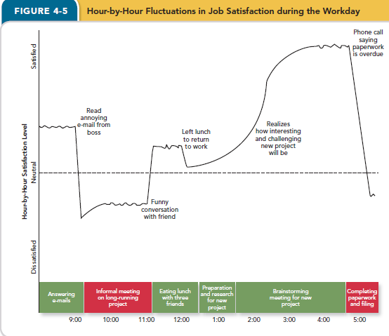
- Job satisfaction reflects what you think and feel about your job
- Rational
- Emotional
- A satisfied employee feels good about his or her job on average]
- Moods
- Are states of feeling, often mild in intensity, that last for an extended period of time
- Not explicitly directed at or caused by anything
- I’m feeling grouchy; I feel good
- Pleasant & engagement
- Affective events theory: describes how workplace events can generate emotional reactions that impact work behaviors
- Emotions
- Feelings that are often intense, last for only a few minutes, and are directed at (and caused by) someone or some circumstance
- Emotions are always about something
- I’m feeling angry at my boss
- Positive Emotion: feelings of joy, pride, relief, hope, love and compassion
- Negative emotions: feelings of fear, guilt, shame, sadness, envy and disgust
- Emotional labor
- Is the need to manage emotions to complete job duties successfully
- Flight attendants: put on happy face in front of passengers
- Retail salespeople: trained to suppress any annoyance to a customer
- Emotional contagion
- The emotion can be transfered from one person to another
- Shows that one person can “catch” or “be infected by” the emotions of another person
- Customer service representative

How Important Is Job Satisfaction?
- Job satisfaction does predict job performance
- Job satisfaction is moderately correlated with task performance
- Satisfied employees do a better job of fulfilling the duties described in their job descriptions
- Positive feelings foster creativity
- Improve problem solving and decision making
- Enhance memory and recall of certain kinds of information
- Improve task persistence and attract more help and support from colleagues
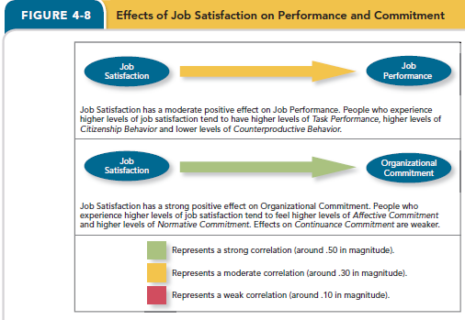

- Job satisfaction is strongly correlated with affective commitment
- Strong with normative commitment
- Feel obligation to remain with their firm and a need to “repay” the organization for whatever it is that makes them so satisfied
- Not related to continuance commitment
- Because satisfaction does not create a cost-based need to remain with the organization
- Job satisfaction is strongly related to life satisfaction
- Life satisfaction: the degree to which employees feel a sense of happiness with their lives in general
- People feel better about their lives when they feel better about their jobs
- How many hours do we spend at work everyday
- Increase in job satisfaction have a stronger impact on life satisfaction than do increases in salary or income
Tracking Satisfaction
- Access job satisfaction
- Focus groups
- Interviews
- Attitude surveys: often the most accurate and most effective
- Provides a snapshot of how satisfied the workforce is and, if repeated over time, reveal trends in satisfaction levels
- Comparing attitude survey results before and after change
- Job Descriptive Index (JDI): a facet measure of job satisfaction that assesses an individual’s satisfaction with pay, promotion opportunities, supervision, co-workers, and the work itself
- Strength: the questions are written in a very simple and straightforward fashion so that they can be easily understood by most employees
- Surveying as much as possible
- Anonymoushonest
- Be administered by the firm’s human resources group or an outside consulting agency
- Job in General (JIG): assess overall job satisfaction; companion survey

Chapter 5
Stress
- A psychological response to demands when there is something at stake for the individual, and when coping with these demands would tax or exceed the individual’s capacity or resources
- Stressor: the demands that cause people to experience stress
- Strains: the negative consequences that occur when demands tax or exceed a person’s capacity or resources
Why are some employees more “stressed” than others
- Transactional Theory of Stress: explains how stressors are perceived and appraised, as well as how people respond to those perceptions and appraisals
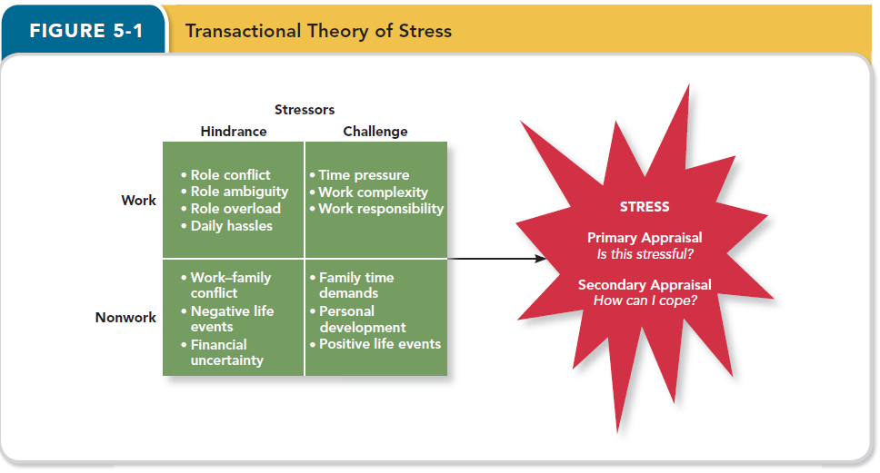
- Primary appraisal: evaluating of whether a demand is stressful and if it is, the implications of the stressor in terms of personal goals and well-being
- E.g. Cashier: would not likely feel that daily transactions are overly taxing or exceeding their capacity; but dealing with credit card crash downan opportunity to learn and demonstrate the type of competence that often is rewarded with satisfying promotions and pay raises
- Benign(良性的) job demands: job demands that are not appraised as being stressful
- Work Hindrance Stressors: stressors that tend to be appraised as thwarting(阻碍) progress toward growth and achievement
- E.g. Dealing with equipment breakdowns or unhappy customers has little to no benefit to the employee in the long term
- Trigger negative emotions such as anger and anxiety
- Role conflict: refers to conflicting expectations that other people may have of us
- Call center operator; OC Transpo
- Because effectiveness in this aspect of the job can require a great deal of time, call center operators are put in a position in which they simply cannot meet both types of expectations
- Role ambiguity: refers to the lack of information regarding what needs to be done in a role, as well as unpredictability regarding the consequences of performance
- Students, new employees
- Often experienced among new employees who haven’t been around long enough to receive instructions from supervisors or observe and model the role behaviors of more senior colleagues
- Role overload: occurs when the number of demanding roles a person holds is so high that the person simply cannot perform some or all of the roles very effectively
- Daily hassles: reflects the relatively minor day-to-day demands that get in the way of accomplishing the things that we really want to accomplish
- Devil Wears Prada
- E.g. having to deal with unnecessary paperwork, office equipment malfunctions, conflict with abrasive co-workers, and useless communications
- Challenge stressors; stressful demands that are perceived as opportunities for learning, growth, and achievement
- Often trigger positive emotions such as pride and enthusiasm
- Time pressure: the sense that the amount of time allotted to do a job is not quite enough
- Work complexity: the degree to which job requirements (knowledge, skills, and abilities) tax or just exceed employee capabilities
- Work responsibility: the number and importance of the obligations that an employee has to others
- Air traffic controller, who may be accountable for the lives of tens of thousands of people everyday, is very high
- Non-work hindrance stressors: stressors experienced outside of work may have effects that “spill over” to affect the employee at work
- Work-family conflict: a form of role conflict in which the demands of a work role hinder the fulfillment of the demands in a family role (or vice versa)
- Negative life event: events such as a divorce or death of a family member that tend to be appraised as a hindrance
- Financial uncertainty: uncertainties with regard o the potential for loss of livelihood, savings, or the ability to pay expenses
- Non-work challenge stressors
- Family time demands: the amount of time committed to fulfilling family responsibilities
- Personal development: participation in activities outside of work that foster growth and learning (volunteer work, sports-related training, participation in local government)
- Positive life events: events such as marriage or the birth of a child that tend to be appraised as a challenge
How Do People Cope With Stressors
- Secondary appraisal: when people determine how to cope with the various stressors they face
- Coping: behaviors and thoughts used to manage stressful demands and the emotions associated with the stressful demands
- Method of coping
- Behavioral coping: physical activities used to deal with a stressful situation
- E.g. a person confronted with a lot of time pressure at work might choose to cope by working faster
- E.g. avoiding work: coming in late, leaving early, or even staying home
- Returning home from the assignment prematurely
- Cognitive coping: thoughts used to deal with a stressful situation
- E.g. thinking of different ways of accomplishing the work efficiently
- Convince themselves that the hassles are no that bad after all
- Focus of coping: does the coping attempt to address the stressful demand or the emotions triggered by the demand
- Problem-focused coping: behaviors and cognitions of an individual intended to manage the stressful situation itself
- Attempted to address the time pressure by working harder
- Focused on how to accomplish the work more efficiently
- Emotion-focused coping: behaviors and cognitions of an individual intended to help manage emotional reactions to the stressful demands
- Used avoidance and distancing behaviors to reduce the emotional distress caused by the stressful situation
- Employee reappraised the demand to make it seem less stressful and threatening
- Coping strategy have implications for how effectively people can meet or adapt to the different stressors that they face
- Choosing a coping strategy:
- The set of beliefs that people have about how well different coping strategies can address different demands
- Depends on the degree to which a person believes that he or she has what it takes to execute the coping strategy effectively
- Degree to which people believe that a particular strategy gives them some degree of control over the stressor
- Nature of the stressful demand itself determines how people develop a sense of control
The Experience of Strain
- Physiological strains: reactions from stressors that harm the human body
- Occur in at least four systems of the human body
- Stressors can reduce the effectiveness of the body’s immune system, which makes it more difficult for the body to ward off illness and infection
- Stressors can harm the body’s cardiovascular system, cause the heart to race, increase blood pressure, and create coronary artery disease
- Stressors can cause problems in the body’s musculoskeletal system
- Tension headaches, tight shoulders, and back pain
- Stressors cause gastrointestinal system problem
- Stomach aches, indigestion, diarrheas and constipation

- Psychological strains: negative psychological reactions from stressors such as depression, anxiety, and anger
- Burnout: the emotional, mental and physical exhaustion from coping with stressful demands on a continuing basis
- Behavioral strains: patterns of negative behaviors that are associated with other strains
- Grinding one’s teeth at nigh
- Being overly critical and bossy
- Excessive smoking
- Compulsive gum-chewing
- Overuse of alcohol
- Compulsive eating

Accounting For Individuals in The Stress Process
- Type A behavior pattern: people who tend to experience more stressors, to appraise more demands as stressful, and to be prone to experiencing more strains
- Strong sense of time-urgency and tend to be impatient, hard-driving, competitive, controlling, aggressive, and even hostile
- Reasons for Type A being important:
- It may have a direct influence on the level of stressors that a person confronts
- It influences the stress process itself
- It has been directly linked to coronary heart disease and other physiological, psychological, and behavioral strains
- Individual factors affect the way people manage stress
- Social support: the help people receive from others when they are confronted with stressful demands (provided by both coworkers or outside friends); moderators affect relationship between stressors and strains
- Instrumental support: the help people receive that can e used to address the stressful demand directly
- Emotional support: the help people receive in addressing the emotional distress that accompanies stressful demands
- High level of social supportprovide a person with instrumental or emotional resources that are useful for coping with the stressor, which tends to reduce the harmful consequences of the stressor to that individualrelationship between stress and strain tends to be weaker
- Low level of social supportthe person does not have extra coping resources available, sot the stressor tends to have more harmful effectsstronger
- Type B behavior pattern: essentially, as the opposite of Type A
- Generally patient, relaxed, easygoing, and at times lacking an overriding sense of urgency
Summary: Why Are Some Employees More Stressed Than Others(P123)
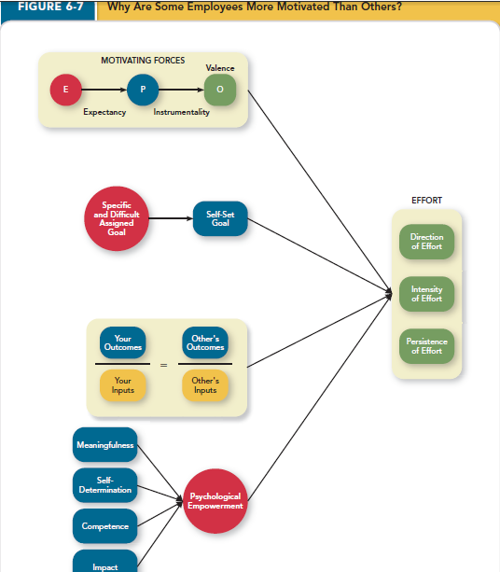

How Important is stress

Chapter 6
Motivation
- The extent to which persistent effort is directed toward a goal
- Text: a set of energetic forces that determine the direction, intensity, and persistence of an employee’s work effort
- Effective job performance require high level of both ability and motivation
- Determines the:
- Intensity of effort: how hard an employee works
- Persistence of effort: for how long
- Direction of effort (towards organizational goals): what are you doing right now
- Engagement: a widely used term in contemporary workplaces that has different meanings depending on the context; most often refers to motivation but it can refer to affective commitment

Why Are Some Employees More Motivated Than Others
- Intrinsic Motivation: motivation that stems from the direct relationship between the worker and the task
- Doing something because it is inherently interesting or enjoyable – task performance serves as its own reward
- Extrinsic Motivation: that stems from the work environment external to the task itself
- Doing something to get a reward
- Commissions, benefits
Theories of Motivation
- Expectancy theory: a theory that describes the cognitive process employees go through to make choices among different voluntary responses
- Premise: people will be motivated to perform work activities that they find attractive, feel they can accomplish and lead to valued outcomes
- Employees need to see clear links between effort, performance and outcomes
- Based on perceptions of individual worker
- Expectancy – the belief that exerting a high level of effort will result in successful performance on some task
- Subjective probability, ranging from 0 to 1 (1=100% chance of success)
- EffortPerformance
- Affected by Self-efficacy
- The belief that a persona the capabilities needed to succeed
- Employee who feel more “effecaciou” for a particular task will tend to perceive higher levels of expectancy—and therefore be more likely to choose to exert high levels of effort
- Past accomplishments vicarious experiences, verbal persuasion, emotional cues
- E.g. Hard work (Effort)
- Perceived relationship between hard work and reaching goals
- Instrumentality – the belief that successful performance will result in some outcome(s)
- Subjective probability ranging from 0 (no chance) to 1 (a mortal lock)
- PerformanceOutcomes
- E.g. Secured new client (Performance)
- Perceived relationship between a Good Performance and a raise
- Not many employees perceive this
- Valence – degree to which an outcome is valued by an individual
- Positively valence (preferred having outcome to not have it) salary increases, bonuses, and more informal rewards
- Negative (preferred not having outcome to have it)
- Or zero (don’t care)
- 0 to 10
- Needs: groupings or clusters of outcomes viewed as having critical psychological or physiological consequences
- Outcome is more attractive when helping satisfy needs
- Attractiveness of many rewards varies across cultures
- Employees underestimate how powerful a motivator pay is to them
- People differ in how they view the meaning of money: the idea that money can have symbolic value (achievement, respect, freedom) in addition to economic value (men>women; older>younger)
- Maslow’s Hierarchy
- Self-actualization
- Esteem
- Belongingness
- Safety
- Physiological
- Force – total direction of effort
- Motivational Force = (E P) x
- The sum symbol in the equation
- Motivational force equals zero if any one of the three beliefs is zero
- Goal Setting Theory: goal setting theory views goals as the primary drivers of the intensity and persistence of effort
- Goals: the objective or aim of an action and typically refer to attaining a specific standard of proficient, often within a specified time limit
- Assigning employees specific and difficult goals will result in higher levels of performance
- Specific and difficult goals: goals that stretch an employee to perform at his or her maximum level while still staying within the boundaries of his or her ability
- Difficult goal: stretches employee to perform at their maximum level while staying within the boundaries of their ability
- Need to affect people’s self-set goals:
- The internalized goals that people use to monitor their own task progress
- Increases the intensity and persistence of effort, if goals move from moderate to difficult
- If assigned goals are unable to change internal goals, motivation and performance will be unaffected
- Hard self-goals can trigger the creation of strategies
- As managers:
- Affect moderators on task performance
- Feedback – updates on employee progress toward goal attainment
- Task complexity – the degree to which the information and actions needed to complete a task are complicated (information, degree of change, actions)
- Specific and difficult affections are twice strong on simple tasks than on complex tasks, even though goals benefit more on complex tasks
- Goal commitment: degree to which a person accepts a goal and is determined to try to reach it
- Highassigning specific and difficult goals to employees will have significant benefits for task performance
- Lowthe effects become much weaker
- Strategies of fostering goal commitment: rewards, publicity, support, participation, resources
- S.M.A.R.T goals with reads directly linked to goal achievement (how)
- Specific
- Measurable
- Achievable
- Results-based
- Time-sensitive
- Equity Theory: motivation also depends on what happens to other people
- Compare the inputs
- My outcomes/my inputs = Other’s outcomes/ Other’s inputs
- Compare ourselves to a comparison other: another person who provides a frame of reference for judging equity (ratio is balanced)
- “Cognitive Calculus”
- Any imbalance in ratios triggers equity distress – an internal tension that can only be alleviated by restoring balance to ratios
- 3 possible outcomes of equity theory comparisons
- “=” no actions needed
- “<” grow your outcomes by talking to your boss or by stealing from the company; shrink your inputs by lowering the intensity or persistence of effort
- “>” shrink your outcomes (yeah, right! Let’s see what we can do about those inputs); grow your inputs through more high-quality work or through some “cognitive distortion”
- Cognitive distortion: reevaluation of the inputs an employee brings to a job, often occurring in response to equity distress
- Internal comparison: comparing oneself to someone in your same company
- External comparisons: comparing oneself to someone in a different company
- Psychological Empowerment: the belief that work tasks contribute to some larger purpose
- Meaningfulness: a psychological state reflecting one’s feelings about work tasks, goals, and purposes, and the degree to which one feels that work tasks contribute to society and fulfill one’s ideals and passions
- Self-determination: a sense of choice in the initiation and continuation of work tasks
- High level:
- Choose what tasks to work on
- How to structure those tasks
- How long to pursue those tasks
- Strong driver of intrinsic motivationallows people to pursue activities that they themselves find meaningful and interesting
- Instill
- By delegating work tasks
- Trusting employees to come up with their own approach to certain tasks
- Competence: a belief in ones ability to perform work tasks successfully (=self-efficacy)
- Strong sense of itbelieve they can execute the particular behaviors needed to achieve success at work
- Bring with sense of pride and mastery
- Managers instill competence by:
- Providing opportunities for training and knowledge gain
- Expressing positive feedback
- Providing challenges that are an appropriate match for employees’ skill levels
- Employees build by
- Engaging in self-directed learning
- Seeking out feedback from their managers
- Managing their own workloads
- Impact: reflects the sense that a person’s actions “make a difference”—that progress is being made toward fulfilling some important purpose
- Manager instill by:
- Celebrating milestones along the journey to task accomplishment (task that span a long time frame)
- Employee instill by:
- Building the collaborative relationships needed to speed task progress
- Initiating their own celebrations of “small wins” along the way
How important is Motivation
- Motivation has a strong, positive effect on Job Performance
- Strongest job performance effect is self-efficacy/competence
- Difficult goals are the second most powerful motivating force
- The motivational force described by Expectancy Theory is the next most powerful
- Perceptions of equity have a somewhat weaker effect on task performance

Chapter 7

Why Are Some Authorities More Trusted Than Others? (Three different sources of trust in a particular authority)
- Trust: the willingness to be vulnerable to and authority based on positive expectations about the authority’s actions and intentions
- Trust only becoming an issue when an individual is dependent on and vulnerable to the actions of another party
- Disposition-based Trust: trust that is rooted in one’s own personality, as opposed to a careful assessment of the trustee’s trustworthiness
- Has more to do with trustors instead of authority
- High trustorsTrust propensity: a general expectation that the words, promises and statements of individuals can be relied upon
- High trust propensitymight be fooled into trusting others who are not worthy of it
- Low trust propensitymight be fooled by not trusting someone who is actually deserving of it
- Trust propensity is a product of both nature and nurture
- Also affected by the nation where we live
- Cognition-based Trust: trust that is rooted in a rational assessment of the authority’s trustworthiness
- Trustworthiness: characteristics or attributes of a person that inspire trust, including competence, character, and benevolence
- Cognition-based trust is driven by authority’s “track record”
- Gauge the track record of an authority along three dimensions:
- Ability: the skills, competencies, and areas of expertise that enable an authority to be successful in some specific area
- Benevolence: the belief that the authority wants to do good for the trustor, apart from any selfish or profit-ventured motives
- Integrity: the perception that an authority adheres to a set of values and principles that the trustor finds acceptable
- Affect-based Trust: trust that depends on feelings toward the authority that go beyond any rational assessment of trustworthiness
- More emotional than rational
Justice
- Justice: the perceived fairness of an authority’s decision making
- Distributive Justice: the perceived fairness of decision-making outcomes
- Whether decision outcomes, such as pay, rewards, evaluations, promotions, and work assignments, are allocated using proper norms
- Procedural Justice: the perceived fairness of decision-making processes
- Fostered when authorities adhere to rules of fair process
- Rules:
- Voice: giving employees a chance to express their opinions and views during the course of decision making
- Correctability: provides employees with a change to request an appeal when a procedure seems to have worked ineffectively
- These rules improve employees reactions to decisions, largely because they give employees a sense of ownership over the decisions
- Four rules: procedural justice is fostered when authorities adhere to it that serve to create equal employment opportunity
- Consistency
- Bias suppression
- Representativeness
- Accuracy
- Examples:
- Rules can be used to make hiring practices more fair by ensuring that interview questions are unbiased and asked in the same manner across applications
- Used to make compensation practices more fair by ensuring that accurate measures of job performance are used to provide input for merit raises
- Interpersonal Justice: the perceived fairness of the interpersonal treatment received by employees from authorities
- Interpersonal justice is fostered when authorities adhere to two particular rules
- Respect rules: pertains to whether authorities treat employees in a dignified and sincere manner
- Propriety rules: reflects whether authorities refrain from making improper or offensive remarks
- Violation of the respect and propriety rules looms much larger than adherence to those rules
- Informational Justice: the perceived fairness of the communications provided to employees from authorities
- The justification rule is fostered when authorities adhere to two particular rules/increases when
- Justification rule: decision making procedures and outcome in a comprehensive and reasonable manner
- The truthfulness rule: requires that those communications be honest and candid
- Reasons for informational justice being too common
- Sharing bad news is the worst part of the job for most managers, leading them to distance themselves when it’s time to play messenger
- The managers worry about triggering a lawsuit if they comprehensively and honestly explain the reasons for a layoff, a poor evaluation, or a missed promotion

Ethics
- Ethics: the degree to which the behaviors of an authority are in accordance with generally accepted moral norms
- Two primary models:
- Prescriptive: with scholars in philosophy debating how people ought to act using various codes and principles
- The dominant lens in discussions of legal ethics, medical ethics, and much of economics
- Descriptive in nature: with scholars relying on scientific studies to observe how people tend to act based on certain individual and situational characteristics
- The dominant lens in psychology
- Unethical behavior: behavior that clearly violates accepted norms of morality
- Employees: discrimination; harassment
- Customers: invading privacy; violating contract terms
- Financiers: falsifying financial information; trading securities based on inside information
- Society: violating environmental regulations; exposing the public to safety risks
- “Merely ethical” behaviors: behavior that adheres to some minimally accepted standard of morality
- Obeying labor laws
- Complying with formal rules and contracts
- “Especially ethical” behaviors: behaviors that exceed some minimally accepted standard of morality
- Charitable giving
- Whistle-blowing: employees’ exposing illegal or immoral actions by their employer
- A whistle-blower risks retaliation by other members of the organization, especially when he or she lacks status and power
- Telling the truth, exposing things
- It can bring significant improvements to the ethical culture in an organization over the long term

Why Authorities Act in an Ethical or Unethical Manner
- Four-component model: a model that argues that ethical behaviors result from the multistage sequence of moral awareness, moral judgment, moral intent, and ethical behavior

- Moral Awareness: recognition by an authority that a moral issue exists in a situation
- What determines whether a person/authority ‘sees’ the moral issues at stake?
- Depends in part on characteristics of the issue itself, as some issues have more built-in ethical salience than others (moral intensity)
- Moral Intensity: the degree to which an issue has ethical urgency (situational factors)
- Driven by two general concerns:
- High in moral intensity if the potential for harm is perceived to be high
- Someone could diein the hospital
- Something that will happen right a way
- How many people are going to be affected?
- High in moral intensity if there is social pressure surrounding it
- Depends on the way authorities observe and perceive the events that happen around them (moral attentiveness)
- Moral attentiveness: the degree to which people chronically perceive and consider issues of morality during their experiences (individual factors)
- Moral Judgment: when an authority can accurately identify the “right” course of action
- Affected by: moral development and principles
- Cognitive moral development: as people age and mature, they move through several states of moral development, each more mature and sophisticated than the prior one
- Ethical dilemma used to assess moral development: used to measure moral development of a person
- Conventional stage: right vs. wrong is referenced to the expectations of one’s family and one’s society
- Emphasize the laws, rules, and orders that govern society
- Moral sophistication: right vs. wrong is referenced to a set of defined, established moral principles (<20% reach it)
- Moral principles: prescriptive guides for making moral judgments
- Moral principles used in the principled stage
- Consequentialist
- Utilitarianism: an act is morally right if it results in the greatest amount of good for the greatest number of people—sometimes termed the “greatest happiness principle”
- Egoism: an act is morally right if the decision maker freely decides to pursue either short-term or long-term interests. Markets are purported to limit the degree to which one egoist’s interest harm the interests of another
- Non-consequentialist
- Ethics of duties: an act is morally right if it fulfills the “categorical imperative”—an unambiguously explicit set of three crucial maxims
- the act should be performable by everyone with no harm to society
- The act should respect human dignity
- The act should be endorsable by others
- Ethics of right: an act is morally right if it respects the natural rights of others, such as the right to life, liberty, justice, expression, association, consent, privacy, and education
- Virtue ethics: an act is morally right if it allows the decision maker to lead a “good life” by adhering to virtues like wisdom, honesty, courage, friendship, mercy, loyalty, modesty, and patience
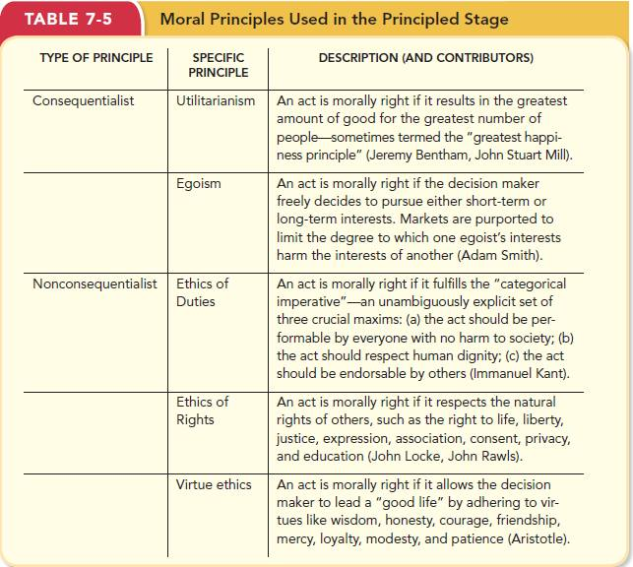
- Moral Intention: degree to which someone is committed to the moral course of action
- What influences whether someone intends to ‘do the right thing’?
- Organizational culture/norms
- Moral Identity (individual factor): the degree to which a person views himself or herself as a moral person
- People with strong moral identities define themselves as compassionate, generous, honest, kind, fair, and hard-working
- It moderates the effects of moral judgment on ethical behavior
- When morality is not an important piece of their identity, their moral principles have no relationship with their actual behavior
- Moral behavior: turning ‘intention; into actual moral behavior

How Important is Trust
- Trust has moderate positive effect on job performance
- Trust is moderately correlated with task performance
- Employees who are willing to be vulnerable to authorities tend to have higher levels of task performance
- It also influences citizenship behavior (more likely) and counterproductive behavior (less likely)
- The willingness to accept vulnerability changes the nature of employee-employer relationship
- Economic exchange: work relationships that resemble a contractual agreement by which employees fulfill job duties in exchange for financial compensation (don’t trust authorities)
- Social exchange: work relationships that are characterized by mutual investment, with employees wiling to engage in “extra mile” sorts of behaviors because they trust that their efforts will eventually be reward (trust increase)
- Trust has a strong positive effect on organizational commitment
- Trusting an authority increases the likelihood that an emotional bond will develop, particularly if that trust is rooted in positive feelings for the authority
- Employees who are willing to be vulnerable to authorities tend to have higher levels of affective commitment (emotional attached) and higher levels of normative commitment (obligation).
- No effect on continuance commitment (cost)
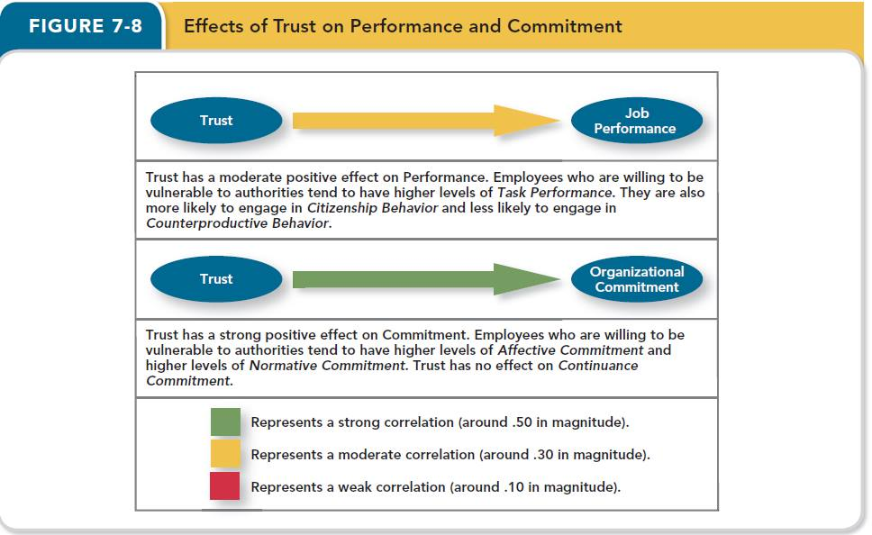
McWane
- Robert: whistleblower
- Especially ethical behavior
- Personal costs > Personal Benefits
- Organizational costs < organizational benefits (arguably)
- CSR
- CSR: a perspective that acknowledges that the responsibilities of a business encompass the economic legal, ethical and citizenship expectations of society
- Ethical component: organizations have an obligation to do what is right, just, and fair, and to avoid harm. Beyond just legal obligations – ethical culture
- Goal-setting theory
- Goals can narrow our focus
- Ordonez et al (2009)
- Aggressive/production goal setting within an organization increases the likelihood of creating an organizational climate ripe for unethical behavior
- Multiple safeguards may be necessary to ensure ethical behavior while attaining goals (e.g. leaders a s exemplars of ethical behavior, making the costs of cheating far greater than the benefit, strong oversight)
- Expectancy theory
- Valence of outcomes is strongly attached to needs
- McWane targeted desperate people

Chapter 8

Learning and Decision Making
- Learning: relatively permanent changes in an employee’s knowledge or skill that result from experience
- Decision making: the process of generating and choosing from a set of alternatives to solve a problem
- The more knowledge and skills employees possess, the more likely they are to make accurate and sound decisions
Why Do Some Employees Learn to Make Decisions Better Than Others?
- Expertise: knowledge and skills that distinguish experts from novices and less experienced people
- Types of Knowledge
- Explicit knowledge: knowledge that is easily communicated and available to everyone
- Where would we find this type of knowledge?
- Books
- Internet
- Tacit knowledge: knowledge that is learned through experience
- Difficult to describe; knowledge in practice, in action
- Learn best by doing
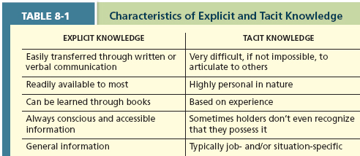
- Methods of learning
- Reinforcement
- We learn though reinforcement observation, and experience
- Operant conditioning/reinforcement: we learn by observing the link between our voluntary behavior and the consequences that follow it
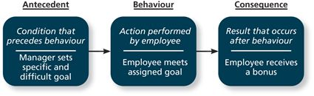
- Contingencies of reinforcement: four specific consequences used by organizations to modify employee behavior
- Two contingencies that increase desired behavior
- Positive reinforcement: when a positive outcome follows a desired behavior
- Most common type of reinforcement
- Increased pay, promotion, praise
- Negative reinforcement: when an unwanted outcome is removed following a desired behavior
- E.g. Perform a task to so that you will NOT be reminded (e.g. wear hard hat to stop reminders or penalties)
- Two contingencies that decrease undesired behavior
- Punishment: an unwanted outcome follows an unwanted behavior
- Suspension, overtime
- Extinction: when there is the removal of a consequence following an unwanted behavior
- Stop laughing at off-color jokes
- Schedules of reinforcement: the timing of when contingencies are applied or removed
- Continuous reinforcement: a schedule of reinforcement in which a specific consequence follows each and every occurrence of a certain behavior
- Athletics
- Fixed interval schedule: a schedule whereby reinforcement occurs at fixed time periods
- Fixed time period
- Pay check
- Workers are rewarded after a certain amount of time, and the length of time between reinforcement periods stays the same
- Variable interval schedules: a schedule whereby reinforcement occurs at random periods of time
- Different time periods
- Supervisor
- When you do something good once in a while
- Fixed ratio schedule: a schedule whereby reinforcement occurs following a fixed number of desired behaviors
- Getting paid per unit
- Delivering flyers
- According to number of items they produce
- Variable ratio schedules: a schedule whereby behaviors are reinforced after a varying number of them have been exhibited
- Real-estate
- Sales people
- Variable schedules lead to higher levels of performance than fixed schedules

- Learning through observation
- Social Learning theory: people in organizations learn through the observation of others
- Behavioral modeling: employees observe the actions of others, learn from what they observe, and then repeat the observed behavior
- Goal Orientation
- Learning orientation: building competence is deemed more important than demonstrating competence
- Enjoy working on new kinds of tasks
- View failure in positive terms
- Performance-prove orientation: focus on demonstrating their competence
- Want others to think favorably of them
- Performance-avoid orientation: also focus on demonstrating competence
- So that others will not think poorly of them (concerned about avoiding failure)
- Methods of Decision Making
- Programmed decisions
- Somewhat automatic; recognizable; dealt with it before
- With experts, any come across as a ‘gut feeling’ or intuition
- Intuition: an emotional decision based on quick, unconscious gut feelings
- When is intuition most important?
- High pressure; crisis situation
- Non-programmed decisions
- Situations which are new, complex, and not recognized
- More common at senior levels of the organization
- How to proceed with non-programmed decision
- Rational decision-making model
- Decision-making problem (based on a number of assumptions)
- Limited information
- Bounded rationality: decision makers do not have the ability or resources to process all available information and alternatives to make an optimal decision
- Satisficing: results when decision makers select the first acceptable alternative considered
- Also, tend to come up with alternatives that are familiar
- Faulty Perceptions (Decision-making must rely on perceptions)
- Perception: the process of selecting, organizing, and retrieving information about the environment
- Selective perception: see the environment only as it affects them and as it is consistent with their expectations
- You only see what you want to see
- Projection bias: belief that others think, feel, and act the same way that they do
- Social identity theory: people identify themselves by the groups to which they belong
- Judge others by their group memberships
- Stereotype: occurs when people make assumptions about others on the basis of their membership in a social group
- All politicians are dishonest; all farmers work hard
- Heuristics: use to reduce uncertainty; simple, efficient, rules of thumb
- The availability bias: the tendency for people to base their judgments on information that is easier to recall
- E.g. Afraid of flying? Focus on all of the negative news and this is refuted by statistics
- Decision-making biases

Anchoring | The tendency to rely too heavily, or “anchor” on one trait or piece of information when making decisions even when the anchor might be unreliable or irrelevant.
Framing | The tendency to make different decisions on the basis of how the question or situation is phrased.
Representativeness | The tendency to assess the likelihood of an event by comparing it to a similar event and assuming it will be similar.
Contrast | The tendency to judge things erroneously on the basis of a reference that is near to them
Recency | The tendency to weigh recent events more than earlier events.

- Faulty Attributions
- Attribution: the way that we explain or attribute people’s behavior – to internal or external causes
- Fundamental attribution error: people have a tendency to judge others’ behaviors as due to internal factors
- Self-serving bias: we attribute our own failures to external factors and our own successes to internal factors
- Attribution Process (Three questions that will determine if an internal or external attribution is made)
- Consistency: does this person always do this when performing this task?
- Consensus: did others act the same way under similar situations?
- Distinctiveness: does this person tend to act differently in other circumstances?
- An internal attribution will occur if there is low consensus, low distinctiveness, and high consistency
- An external attribution will occur if there is high consensus, high distinctiveness and low consistency

- Escalation of commitment: the decision to continue to follow a failing course of action
- A tendency to escalate their commitment to previous decisions, even in the face of obvious failures

- Examples of attribution process:
E.g. Angela did not compete her work assignment
- Angela frequently does not compete her work, her co-workers usually do, and her previous supervisor reports that she had issues when working for him
- Internal:
- Highconsistency
- LowConsensus
- LowDistinctiveness

E.g. Mike did not complete his work assignment
- Mike frequently does not complete his work, his co-workers are often incomplete, but he did not have nay problems in his previous role
- External Situation:
- HighConsistency
- Consensus
- Distinctiveness

E.g. Samantha did not complete her work assignment
- Samantha is seldom incomplete with her work, neither are her co-workers, and she was equally reliable in her previous job
- External Temporary situation
- LowConsistency
- HighConsensus
- LowDistinctiveness

Chapter 9
Personality, Cultural Values, and Ability
- Personality: an individual’s characteristic patterns of thought, emotion, and behavior
- Use adjectives called traits: recurring trends in people’s responses to their environment
- E.g. responsible, easy-going, polite, and reserved
- Culture Values: shared beliefs about modes of conduct in a given culture, that influence the development of personality traits
- Both Personality and culture values capture what people are like as individuals
- E.g. Nation’s culture: traditional, informal, risk-averse, or assertive
- It can influence the development of people’s personality traits, as well as how those traits are expressed in daily life
- Ability: relatively stable capabilities people have to perform a particular range of different activities
- Captures what people can do as individuals
The Big Five
- Conscientiousness (尽责的): dependable, organized, reliable, ambitious, hardworking, and persevering
- Conscientiousness has the biggest influence on job performance
- Prioritize accomplishment striving -- a strong desire to accomplish task-related goals
- Work harder and longer on task assignments
- Conscientious salespeople’s organizational skills were particularly valuable during their first year of employment, and their ambitious nature became more critical as they gained tenure and experience
- What kind of job would this be helpful in?
- Agreeableness: warm, kind, cooperative, sympathetic, helpful, and courteous
- Prioritize communication striving – desire to obtain acceptance in personal relationships as a means of expressing personality
- Focus on “getting along”
- Beneficial in some positions
- Not as beneficial in others
- Service job: face-to-face, direct, verbal contact
- Extraversion (外向的): talkative, sociable, passionate, assertive, bold, and dominant
- Easiest to judge in zero acquaintance situations: situations in which two people e have just met
- Prioritize status striving – reflects a desire to obtain power and influence within a social structure as a means of expressing personality
- Tend to be high in positive affectivity – dispositional tendency to experience pleasant moods (e.g. enthusiasm, excitement, happiness)
- Care a lot about being successful and influential and direct their work efforts toward “moving up” and developing a strong reputation
- Leadership role
- Tend to be happier about their jobs
- Positive affectivity: a dispositional tendency to experience pleasant, engaging moods such as enthusiasm, excitement, and elation
- Best suited to what types of jobs?
- Salesman
- Front person/public relations
- Elections/Politicians
- Neuroticism: nervous, moody emotional, insecure, and jealous. (Opposite is emotional stability – this is what you want in a job)
- Second-most important
- Synonymous with negative affectivity – tendency to experience unpleasant moods such as hostility, nervousness and annoyance
- More likely to appraise situations as stressful
- Less likely to believe they can cope with the stressors that they experience
- Lower level of job satisfaction
- Important for job performance?
- Strongly related to locus of control – whether people attribute the causes of events to themselves or to the external environment
- Tend to hold an external locus of control (chance, luck, fate)
- Less neurotic people tend to hold an internal locus of controlbelieve their own behavior dictate events
- Examples?
- External and Internal Locus of Control (Table 9-1)
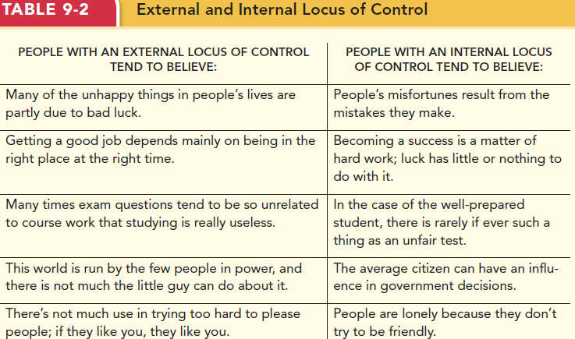
- Openness to experience: curious, imaginative, creative, complex refined, and sophisticated
- Also called “Inquisitiveness” or “Intellectualness”
- Tend to be more adaptable and quick to identify when the “old way of doing things” is no long effective, excelling at the search for a new and better approach
- Valuable in what type of jobs?
- Jobs that are very fluid and dynamic, with rapid changes in job demands
- Engineers/Scientists
- Artistic and scientific fields
(Exhibit 2-5 How the Big Five Traits Influence OB)

Cultural Values
- Culture: the shared values, and beliefs that result from common experiences of members of a society
- Transmitted across generations
- Influences the development of our personalities
- Also shapes the way our traits are expressed
- Values Across Cultures
- Geert Hofstede’s study
- Discovered five basic dimensions
- Individualism/collectivism: the degree to which a culture has a loosely (individualism) or tightly (collectivism) knit social structure
- Power Distance: the degree to which a culture accepts unequal power distribution (high power distance)
- Uncertainty avoidance: the degree to which a culture tolerates ambiguous situations (low uncertainty avoidance) or feels threatened by them (high uncertainty avoidance)
- Masculinity/femininity: the degree to which a culture values stereotypically male traits (masculinity) or stereotypically female traits (femininity)
- Long-term/short-term orientation: the degree to which a culture stress values that are short-term vs. long-term
- Past- and present-oriented: respect for tradition and fulfilling obligations
- Future-oriented: persistence, prudence, and thrift
- Cross-cultural Comparisons
- Project GLOBE (Global Leadership and Organizational Behavior Effectiveness) know general
- Impact of culture on the effectiveness of various leader attributes, behaviors and practices
- Findings:
- Identified 9 different dimensions, some the same as Hofstede
- 5 are conceptually different
- Cultures divided into
- Power Distance
- Uncertainty Avoidance
- Collectivism – differentiated between 2
- Institutional collectivism: where formalized practices encourage collective action and collective distribution of resources
- In-group collectivism: where individuals express pride and loyalty to specific in-groups
- Gender Egalitarianism: the culture promotes gender equality and minimizes role difference between men and women
- Assertiveness: the culture values assertiveness, confrontation, and aggressiveness in social relationships
- Future Orientation: the culture engages in planning and investment in the future while delaying individual or collective gratification
- Performance Orientation: the culture encourages and rewards members for excellence and performance improvements
- Humane Orientation: the culture encourages and rewards members for being generous, caring, kind, fair, an altruistic (无私心的)
- Why is this important?
- Need to avoid “ethnocentrism”: one who views his or her culture values as “right” and values of other cultures as “wrong”
- Cultural differences can influence many things…
- Reactions to change
- Management style
- Rewards preferences
- We are in a global community

How can we describe what employees can do?
- Abilities capture what people can do
- 3 general categories
- Cognitive abilities: are capabilities related to the acquisition and application of knowledge in problem solving
- Verbal ability: various capabilities associated with understanding and expressing oral and written communication
- Oral communication: the ability to understand spoken words and sentences
- Oral expression: refers to the ability to communicate ideas by speaking
- Written expressions: refers to the ability to communicate ideas in writing
- Quantitative ability: capabilities associated with doing basic mathematical operations and selecting and applying formulas to solve mathematical problems
- Number facility: the capability to do simple math operations
- Mathematical reasoning: refers to the ability to choose and apply formulas to solve problems that involve umbers
- Reasoning ability: diverse set of abilities associated with sensing and solving problems using insight, rules, and logic
- Problem sensitivity: understanding when there is a problem or when something may go wrong
- Deductive reasoning: applying general rules to specific problems
- Inductive reasoning: combining specific information to form general conclusions
- Originality: developing new ideas
- Spatial ability: capabilities associated with visual and mental representation and manipulation of objects in space
- Spatial orientation: refers to having a good understanding of where on is relative to other things in the environment
- Visualization: the ability to imagine how separate things will look if they were put together in a particular way
- Perceptual ability: the capacity to perceive understand, and recall patterns of information
- Speed and flexibility of closure: refers to being able to pick out a pattern of information quickly in the presence of distracting information, even without all the information present
- Perceptual speed: refers to being able to examine and compare numbers, letters, and objects quickly
- General mental ability: the general level of cognitive ability that plays an important role in determining the more narrow cognitive abilities
- People who are high on verbal abilities also tend to be high on reasoning, quantitative, spatial and perceptual
- Emotional Intelligence: a human ability that affects social functioning
- Self-awareness: the appraisal and expression of emotions in oneself
- Other awareness: the appraisal and recognition of emotion in others
- Emotion regulation: being able to recover quickly from emotional experiences
- Use of emotions: the degree to which people can harness emotions and employ emotions to improve their chances of being successful (in whatever they are seeking to do)
- Physical Abilities
- Strength: the degree to which the body is capable of exerting force
- Stamina: the ability to engage in prolonged physical activity
- Flexibility & Coordination
- Flexibility: the ability to bend, stretch, twist, or reach
- Extent flexibility: degree of bending, stretching, twisting of body, arms, legs
- Dynamic flexibility: speed of bending, stretching twisting of body, arms, legs
- Coordination: the quality of physical movement in terns if synchronization of movements and balance
- Gross body coordination: coordination movement of body, arms, and legs in activities that involve all three together
- Gross body equilibrium: ability to regain balance in contexts where balance is upset
- Psychomotor abilities: the capacity to manipulate and control objects
- Fine manipulative abilities: keeping hand and arm steady while grasping manipulating and assembling small objects
- Control movement abilities: making quick, precise adjustments to a machine while operating it
- Response orientation: quickly choosing among appropriate alternative movements
- Response time: quickly responding to signals with body movements
- Sensory abilities to capabilities associated with vision and hearing
- Near and far vision: seeing detail of an object up close or at a distance
- Night vision: seeing well in lowlight
- Visual color discrimination: detecting differences in colors and shades
- Depth perception: judging relative distances
- Hearing sensitivity: hearing differences in sounds that vary in terms of pitch and loudness
- Auditory attention: focusing on a source of sound in the presence of other sources
- Speech recognition: identifying and understanding the speech of others
- How important is Personality
- Conscientiousness affects job performance
- Key driver of typical performance – performance in the routine conditions that surround daily job tasks
- More likely to engage in citizenship behaviors
- Tend to be more committed
- Ability is a driver of maximum performance – performance is special circumstances that demand a person’s best effort
- Situational strength: the degree to which situations have clear behavioral expectations, incentives, or instructions that make differences between individuals less important
- Trait activation: the degree to which situations provide cues that trigger the expression of a given personality trait

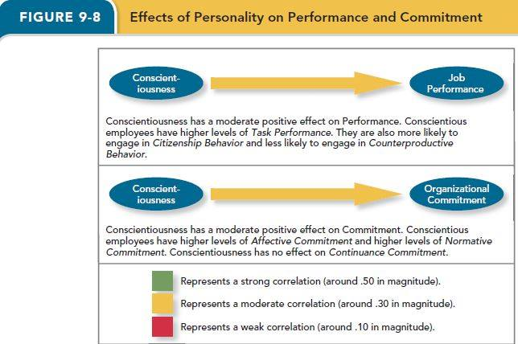

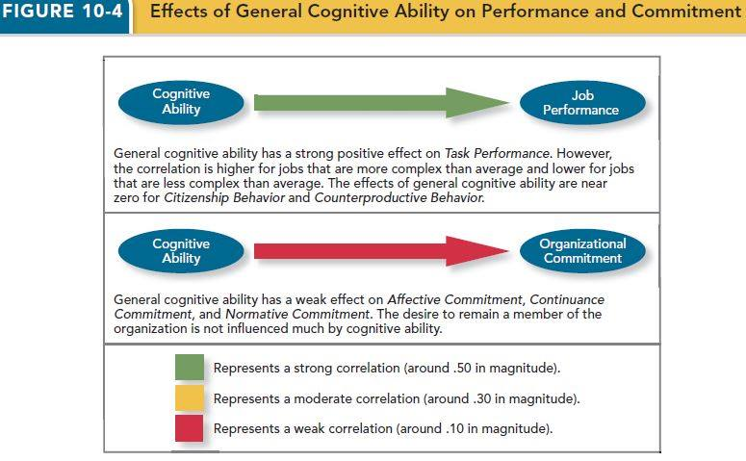

Chapter 10

- Team: consists of two or more people interaction interdependently to achieve a common goal related to some task-oriented purpose
- How is a team different than a group/why teams are special?
- The members have a specific task-related purpose
- Produce joint products
- Their interactions revolve around a deeper dependence upon one another
- Shared accountability
- A team is always a group, but a group is not always a team!
- Types of teams
- Work teams: a relatively permanent team in which members work together to produce goods and/or provide services
- Long life span
- High member involvement; members have specific job duties
- Focus on the accomplishment of core operational-level production and service tasks
- E.g. sales team
- Management teams: a relatively permanent team that participates in managerial-level tasks that affect the entire organization
- It participate in managerial-level tasks that affect the entire organization
- Responsible for coordinating the activities of organizational subunits to help the organization achieve its long-term goals
- Members: heads of departmentscommitment to the team is offset somewhat by the responsibilities they have in leading their unit
- Parallel teams: a team composed of members from various jobs within the organization that meets to provide recommendations about important issues
- Can be both permanent and temporary
- Project teams: a team formed to take on one-time tasks, most of which tend to be complex and require input from members from different functional areas
- Action teams: a team of limited duration that performs complex tasks in contexts that tend to be highly visible and challenging
- Aircraft flight crews
- Surgical teams
- Virtual team: a team in which the members are geographically dispersed, and interdependent activity occurs through e-mail, Web conferencing, and instant messaging
- Stages of Team Development
- Forming: try to understand the boundaries and expectations
- Storming: remain committed to ideas – can trigger conflict
- Norming: realize that they need to work together to accomplish team goals
- Performing: members are comfortable working within their roles – the team makes progress toward goals
- Adjourning: disengage. Members may experience anxiety and other emotions
- Punctuated Equilibrium: at the initial team meeting, members make assumptions and establish a pattern of behavior that lasts for the first half of its life
- Team Interdependence
- Task interdependence: the degree to which team members interact
- How they are linked
- Rely on others for information, materials, and resources
- Pooled Interdependence
- Lowest degree of coordination
- Members complete their work independently
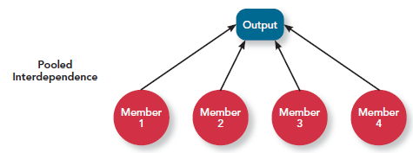
- Sequential Interdependence
- Different tasks are done in a prescribed order
- Specialists
- Interaction
- Hand-offs (outputs become inputs)
- Not other way around
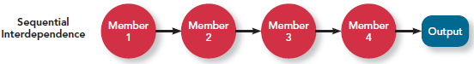
- Reciprocal Interdependence
- Members are specialized to perform specific tasks
- Not a strict sequence
- Members interact with a subset of members
- E.g.
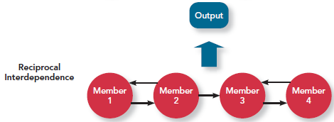
- Comprehensive Interdependence
- Requires the highest level of interaction and coordination
- Each member has a great deal of discretion – collaborative effort
- Increase in comprehensive interdependence may decrease productivity, but increase team to adapt to new situations
- E.g. car manufacture/IT firms (different specializations)
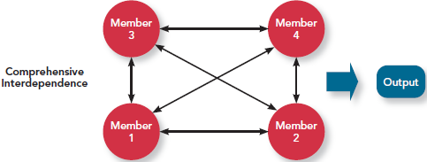
- Goal interdependence: the degree to which team members have a shared team’s goal and align their individual goals with the vision as a result
- High level: formalize mission statement that members buy into
- Clearly describe what the team is trying to accomplish in a way that creates a sense of commitment and urgency among team members
- Outcome Interdependence: the degree to which team members share equally in the feedback and rewards that the team earns
- High level: when team members share in the rewards that the team earns
- Pay, bonus, formal feedback and recognition, pats on the back, extra time off
- Higher outcome increase the amount of information shared among members, which promotes learning and ultimately team performance
- Low level: individual members receive rewards and punishments on the basis of their own performance, without regard to the performance of the team
Team Composition
- The mix of people who make up the team
- Five Aspects of Team Composition:
- Member Roles
- Roles: the behavior a person is generally expected to display in a given context
- Team task roles: refer to behaviors that directly facilitate the accomplishment of team tasks
- Orienter: establishes the direction for the team
- Devil’s advocate: offers constructive challenges to the team’s status quo
- Energizer: motivates team members to work harder toward team goals
- Team building roles: refer to behaviors that influence the quality of the team’s social climate
- Harmonizer: steps in to resolve differences among teammates
- Encourager: praises the work of teammates
- Compromiser: helps the team see alternative solutions that teammates can accept
- Individualistic roles: reflect behaviors that benefit the individual at the expense of the teamfoster negative feelings among team members, serves to hinder a team’s ability to function and perform effectively
- Aggressor: “put down: or deflates fellow teammates
- Recognition seeker: takes credit for team successes
- Dominator: manipulates teammates to acquire control and power
- Member Ability: team members provide a wide array of abilities, both physical and cognitive
- Disjunctive tasks: tasks with an objectively verifiable best solution, the member who possesses the highest level of the ability relevant to the task will have the most influence on the effectiveness of the team
- Conjunctive tasks: the team’s performance depends on the abilities of the “weakest link”
- Additive tasks: tasks for which the contributions resulting “add up”
- Member Personality
- Agreeable
- Tend to be cooperative and trusting
- More concern about team interests, they should work hard on behalf ot the team
- Less apt to speak up and offer constructive criticisms that might help the team improve
- Promote positive attitudes and smooth interpersonal interactions
- Conscientiousness
- People tend to be dependable, work hard to achieve goals
- Low conscientiousstrong negative effectdivert attention, time-consuming, low effectiveness
- Extraverted
- Perform effectively in interpersonal contexts
- More positive and optimistic in general
- Too highunproductive conflict/power struggles
- Team Diversity: the degree to which team members are different from one another
- Value in diversity problem-solving approach: a theory that supports team diversity because it provides a larger pool of knowledge and perspectives
- Similarity-attraction approach: a theory explaining that team diversity can be counterproductive because people tend to avoid interacting with others who are unlike them
- Surface-level diversity
- Refers to diversity regarding observable attributes
- Race, ethnicity, sex, ad age
- Negative effect will disappear because of similarity-attraction issues
- Differences tend to decrease over time – overcome stereotypes
- Need to be aware of similar-to-me bias
- Deep-level diversity
- Attributes that are less easy to observe initially
- But that can be inferred after more direct experience (values, attitudes, etc.)
- Differences tend to increase over time – can reduce effectiveness
- For agreeableness and extraversion: better to have diversity/mix of members
- Team Size: a larger team tends to be better:
- For management and project teams (complex tasks, knowledge intensive)
- Not for production tasks (routine, less complex)
- Ideal number
- Impossible to say for certain
- Research on student work groups – tend to be most satisfied with 4 and 5

Communication
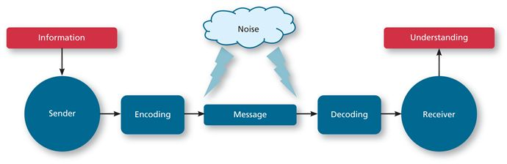
- The process by which information and meaning is transferred from a sender to a receiver
- Interpersonal communication: involves one-on-one information exchanges between two individuals
- Factors that influence communication
- Communicator competence: skills involved in encoding, transmitting, and receiving messages
- Gender differences: men tend to use a style of communication that helps them achieve and maintain status, power, and independence, whereas women tend to send messages and use a style that builds and strengthens their relationship
- Man: showing off ability; telling stories or jokes; being direct ask someone to do something
- Women: showing concern and supports; compliments; being indirect sending message to someone
- It may lead to misunderstanding between males and females
- Noise: interferes with the message being transmitted
- Extra effort to send and receive messages when there is noise is needed
- Information richness: the amount and depth of information that gets transmitted in a message
- Highest level: when face-to-face
- Body languages; facial expression; tone of voice
- Receive feedback immediately, verify right a way
- Lowest level: computer-generated reports
- Moderate level: personal written note
- The appropriate level depends on the nature of the team’s situation: the greater the level of complexity in the work being accomplished by the team, the more likely it is that the benefits of information richness outweigh its costs
- Network structure: the pattern of communication that occurs regularly among each member of the team
- All channel: highly decentralized, every member can communicate with every other member (students)
- Circle
- Y
- Wheel: highly centralized, all communication flows through a singer member; official leader make final decisions

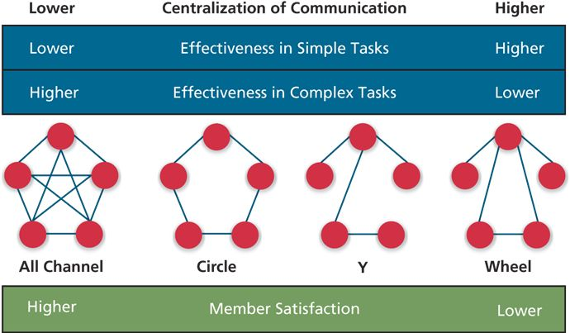

Team States
- Specific types of feelings and thoughts that coalesce in the minds of team members as a consequence of their experience working together
- Cohesion: a team state that occurs when members of the team develop strong emotional bonds to other members of the team and to the team itself
- Groupthink: behaviors that support conformity and team harmony at the expense of other team priorities
- Potency: a team state reflecting the degree of confidence among team members that the team can be effective across situations and tasks
- Promoted in teams in which members are confident in themselves and their teammates and when the team has found success in the past
- Mental Models: the degree to which team members have a shared understanding of important aspects of the team and its task
- Transactive memory: the degree to which team members’ specialized knowledge is integrated into an effective system of memory for the team

Chapter 11
- Power: the ability to influence the behavior of others and resist unwanted influence in return
- Five major types of power that can be grouped along tow dimensions
- Organizational power
- Legitimate power/formal authority/authority: derived from a position of authority inside the organization
- Reward power: when someone has control over the resources or rewards another person wants
- Coercive power: when a person has control over punishments in the organization (fear/punishment, don’t tend to use it)
- Poor form of powernegative feelings
- Personal power
- Expert power: derived from a person’s expertise, skill, or knowledge on which others depend
- Referent power: when others have a desire to be associated with a person
Contingency factors: factors that affect the strength of a person’s ability to use power to influence others
- Substitutability: the degree to which people have alternatives in accessing resources
- Discretion: the degree to which managers have the right to make decisions on their own
- E.g. if your boss is forced to follow organizational policies and rules, her ability to influence your actions is reduced
- Centrality: represents how important (“central”) a person’s job is and how many people depend on that person to accomplish their tasks
- Visibility: how aware others are of a leader’s power and position
Using influence
- Influence: the use of behaviors to cause behavioral or attitudinal changes in others
- We can use “tactics” to influence others in organizations toward organizational goals (Figure 11-2)
- Influence tactics: individuals depend on number of tactics to cause behavioral or attitudinal changes in others
- Most effective
- Rational persuasion: the use of logical arguments and hard facts to show someone that a request is worthwhile
- Inspirational Appeals: an influence tactic designed to appeal to one’s values and ideals, thereby creating an emotional or attitudinal reaction
- Consultation: an influence tactic whereby the target is allowed to participate in deciding how to carry out or implement a request
- Collaboration: an influence tactic whereby the leader makes it easier for the target to complete a request by offering to work with and help the target
- Moderately effective
- Ingratiation (讨好): the use of favors, complements, or friendly behavior to make the target feel better about the influencer (more effective in long-term strategy)
- Personal Appeals: influence tactic in which the requestor asks for something based on personal friendship or loyalty
- Exchange: an influence tactic in which the requestor offers a reward in return for performing a request
- Apprising: an influence tactic in which the requestor clearly explains why performing the request will benefit the target personally (something results from the action)
- Least Effective
- Pressure: an influence tactic in which the requestor attempts to use coercive power through threats and demands
- Coalitions (联合): an influence tactic in which the influencer enlists other people to help influence the target
- They will respond to influence tactics:
- Resistance: when a target refuses to perform a request and puts forth an effort to avoid having to do it (least effective)
- Compliance: when targets of influence are willing to do what the leader asks but do it with a degree of ambivalence
- Internalization: a response to influence tactics where the target agrees with and becomes committed to the request (most effective)
- If power in organizations is used to further one’s own self-interests, what is it called? Is it good or bad?
- Organizational politics: individuals’ actions that are taken to further their own self-interests
- But it may being the same direction as the organization-nor necessarily bad
- This is called Political skill
- The ability to understand others at work and use that knowledge to enhance personal and/or organizational objectives
- Certain environments contribute to (negative) office politics (11-4)
- Two aspects:
- Networking ability
- Social astuteness
- Two capabilities
- Interpersonal influence: involves having an unassuming and convincing personal style that is flexible enough to adapt to different situations
- Apparent sincerity: involves appearing to others to have high levels of honesty and geniuses
How to use your influence? (Conflict resolution) 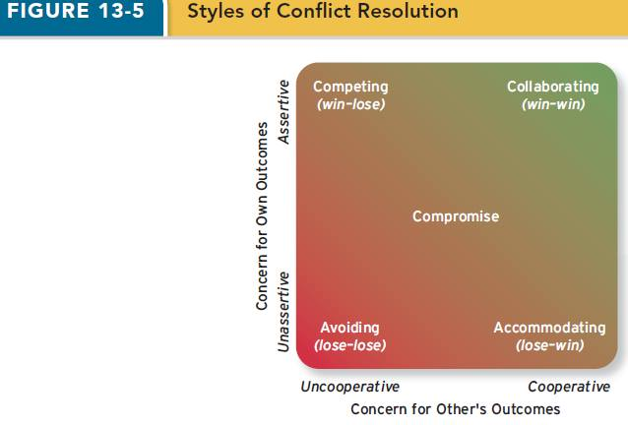
- To manage organizational conflict
- Avoiding: low assertiveness of one’s own interests and low cooperation with the other party
- One party wants to remain neutral, stay away from conflict, or postpone the conflict to gather information or let things cool down
- “Hiding your head in the and”
- When is this sensible response?
- The issue is trivial
- Want to remain neutral
- Information is lacking
- Postpone conflict – e.g. people need to cool down
- The opponent is very powerful and hostile
- Doesn’t really resolve the conflict
- Accommodating: cooperate with the other party (high cooperation, low assertiveness), while not asserting one’s own interests (unselfish)
- It can be an effective strategy when:
- You realize that you are wrong – can learn, show reasonableness
- The issue is more important to the other party
- You want to build good will; harmony/stability
- You have less power anyway – going to lose
- Competing: maximizes assertiveness and minimizes cooperation
- A conflict resolution style by which one party attempts to get his or her own goals met without concern for the other party’s results
- It can be effective when:
- Emergencies – no time
- You have a lot of power
- You are sure of your facts – welfare of the company
- Unpopular issues – truly win-lose
- You will not have to interact with the other party in the future
- Compromise: combines intermediate levels of assertiveness and cooperation
- It is a sensible reaction when:
- There is conflict stemming from scarce resources
- Have equal power but mutually exclusive goals
- You need a good fallback position if other strategies fail
- Collaborating: maximizes both assertiveness and cooperation/work together
- An attempt to secure an integrative agreement that fully satisfies the interests of both parties (a win-win resolution)
- Works best when:
- Conflict is not intense
- Each party has information that is useful to the other
- Take time to share information, work through differences/feelings that have interfered in the past

Using influence during Negotiation
- A process among interdependent parties attempt reach agreement about their differences
- Negotiation Strategies
- Distributive bargaining: a negotiation strategy in which one person gains and the other person loses
- Integrative bargaining: a negotiation strategy that achieves an outcome that is satisfying for both parties
- Negotiation Stages
- Preparation: each party determine what its goals are for the negotiation and whether the other party has anything to offer
- BATNA: a negotiator’s best alternative to a negotiated agreement
- Exchanging information: each party makes a case for its position and attempts to put all favorable information on the table
- Bargaining: success at this stage depends mightily on how well the previous two stages have proceeded
- Closing and commitment: this stage entails the process of formalizing an agreement reached during the previous stage

How Important are Power and Influence

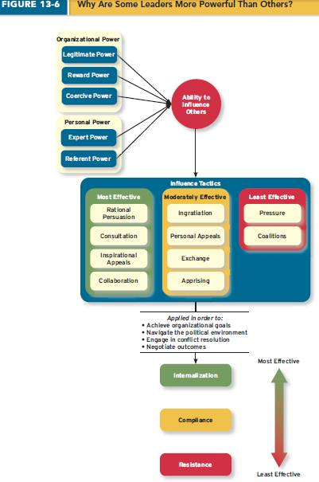

Chapter 12

Leadership – Top 10 Questions
- What is leadership?
- The use of power and influence to direct the activities of followers toward goal achievement
- Some people in organizations occupy formal or assigned leadership roles with authority to direct employees
- Legitimacy power
- Individuals might also emerge to occupy informal leadership roles
- Expert power
- What does it mean for a leader to be “effective”?
- Improves performance, commitment & well-being (like to work there)
- How measured?
- Objective measures of unit performance (sales, profits)
- More subjective measures – focus on followers
- E.g. employee surveys (unit or dyads) – Leader-Member Exchange Theory
- Role taking: the phase in a leader-follower relationship when a leader provides an employee with job expectations and the follower tries to meet those expectations
- Role making: the phase in a leader-follower relationship when a follower voices his or her own expectations for the relationship, resulting in a free-flowing exchange of opportunities and resources for activities and effort
- High-quality-exchange dyad: frequent one-on-one exchanges of information between the leader and the member, mutual influence, support, and attention (ingroup; higher level of communications)more likely to exhibit organizational citizenship behaviors
- Low-quality-exchange dyad: marked by more limited exchange of information, influence, latitude, support, and attention (outgroup; lower level of communication)
- Are leaders ‘born’ or ‘made’?
- Early “Great Person” theories looked for a particular characteristics – Born!
- Both – leaders are born with a certain set of traits – more linked to emergence that effectiveness
- Leaders can also be “made” – trained
- What traits/characteristics are related to leader emergence and leader effectiveness?
- Leader effectiveness: the degree to which the leader’s actions result in the achievement of the unit’s goals, the continued commitment of the unit’s employees, and the development of mutual trust, respect and obligation in leader-member dyads
- Leader emergence: the process of becoming a leader in the first place
- Emergence – Big 5 (except neuroticism..) + general cognitive ability, high energy, stress tolerance and confidence (Table 12-2)
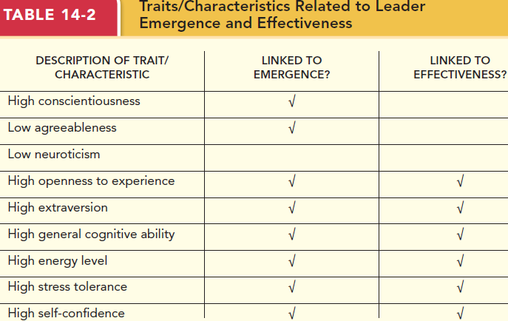
- What four styles can leaders use to make decisions (leader decision-making styles)? (Figure 12-2)
- Autocratic Style: a leadership style where the leader makes the decision alone without asking for opinions or suggestions of the employees in the work unit
- Consultative style: a leadership style in which the leader presents the problem to employees asking for their opinions and suggestions before ultimately making the decision him- or herself
- Facilitative style: a leadership style in which the leader presents the problem to a group of employees and seeks consensus on a solution making sure his or her own opinion receives no more weight than any other else’s
- Declarative Style: a leadership style where the leader gives the employee the responsibility for making decisions within some set of specified boundary conditions
- What factors combine to make these styles more effective in given situation? (Figure 12-3)
- 7factors to consider
- TIME-DRIVEN model of leadership
- Decision significance
- Importance of commitment
- Leader expertise
- Likelihood of commitment
- Shared objectives
- Employee expertise
- Teamwork skills
- Model suggests that situational aspects are more important than just the leader him/herself
- What do leaders do every day?
- Two dimensions capture most of the day-to-day leadership behaviors in which leaders engage.
- Initiating structure: the extent to which the leader defines and structures the roles of employees in pursuing goals (task oriented)
- Highmore active role in directing group activities and prioritize planning, scheduling, and trying out new ideas
- Initiation: originating, facilitating, and sometimes resisting new ideas and practices
- Organization: defining and structuring work, clarifying leader vs. member roles, coordinating employee tasks
- Production: setting goals and providing incentives for the effort and productivity of employees
- Consideration: the extent to which leaders create job relationships characterized by mutual trust, respect (relationship orientation)
- Membership: mixing with employees, stressing informal interactions, and exchanging personal services
- Integration: encouraging a pleasant atmosphere, reducing conflict, promoting individual adjustment to the group
- Communication: providing information to employees, seeking information from them, showing an awareness of matters that affect them
- Recognition: expressing approval or disapproval of the behaviors of employees
- Representation: acting on behalf of the group, defending the group, and advancing the interests of the group
- Emphasis one if for both
- Life cycle theory of leadership: a theory stating that the optimal combination of initiating structure and consideration depends on the readiness of the employees in the work unit
- Readiness: the degree to which employees have the ability and the willingness to accomplish their specific tasks
- Telling: when the leader provides specific instructions and closely supervises performance
- Selling: when the leader explains key issues and provides opportunities for clarification
- Participating: leader behavior in which the leader shares ideas and tries to help the group conduct its affairs
- Delegating: leader behavior in which the leader turns responsibility for key behaviors over the employees
- How does transformational leadership differ from transactional leadership?
- Transformational: inspiring followers to commit to a shared vision that provides meaning to their work
- Laissez-fair Leadership: when the leader avoids leadership duties altogether
- Transactional Leadership: the leader rewards or disciplines the follower on the basis of performance
- Passive management-by-exception: the leader waits around for mistakes and errors, then takes corrective action as necessary
- Active management-by-exception: leader arranges to monitor mistakes and errors actively, and takes corrective action when required
- Contingent reward: more active and effective leadership the leader attains follower agreement on what needs to be done using rewards in exchange for adequate performance
- “Carrot and stick”: passive management-by-exception; (stick) active management-by-exception (stick); contingent reward (carrot)
- Serving as a role model for followers develop their potential
- Dimensions of transformational leaderships (4Is)
- Idealized influence: the leader instills pride in me for being associated with him/her
- Inspirational motivation: the leader articulates a compelling visions of the future
- Intellectual stimulation: the leader gets others to look at problems from many different angles
- Individualized consideration: the leader spends time teaching and coaching
- How does leadership affect job performance and organizational commitment?
- Transformational leadership affects job performance of the employees who report to the leader
- Employees with transformational leaders tend to have
- Higher levels of task performance
- Higher levels of organizational citizenship
- Have higher levels of motivation and trust their leader more
- Higher organizational commitment
- Can leaders be trained to be more effective?
- Yes.
- Often training focuses on specific skills
- Can also train on decision-making styles for different contexts or leader behavior
- What is the difference between a manager and a leader?
- Manager promote stability while leaders press for change and only organizations that embrace both sides of the equation can survive

Chapter 13
- Organizational Structure: how jobs and tasks are divided and coordinated between individuals and groups within the company
- Organizational chart: represents every job in the organization and the formal reporting relationships between those jobs
- Five elements of Organizational structure
- Work specialization: the degree to which tasks in an organization are divided into separate jobs
- Division of labor: have only one single task all day long
- Highlylose the ability associated with employees who can be flexible in what they dofail to upgrade their abilities
- Low job satisfaction (low variety)
- Chain of command: answers the question of “who reports to whom?” and signifies formal authority relationships
- Hierarchy of authority
- Span of control: represents how many employees each manager in the organization has responsibility for
- Narrow span: important if the manager has substantially more skill or expertise than the subordinates/increase labor costs
- Moderate span: best for productivity
- Centralization: aspect of structure that dictates where decisions are formally made in organizations
- Highly: only top management will make the decisions
- Decentralized: important with organization grow larger
- Formalization: the degree to which rules and procedures are used to standardize behaviors and decisions in an organization
- Elements in Combination
- Mechanistic organizations: efficient, rigid, predictable, and standardized organizations that thrive in stable environments
- High formalization
- Rigid and hierarchical chain of command
- High work specialization
- High centralization
- Narrow spans of control
- Organic organizations: flexible, adaptive, outward focused organizations that thrive in dynamic environments
- Low formalization
- Weak or multiple chains of command
- Low specialization
- Wide spans of control
- Organizational Design: the process of creating or changing the structure of an organization
- Need to “fit” with:
- External business environment: stable environment vs. Dynamic
- Customers
- Competitors
- Suppliers
- Distributors
- Strategy: organization’s goals and objectives and approach to market
- Low-cost producer strategy: rely on selling products at the lowest possible cost (mechanistic)
- Differentiation strategy: people will pay more for a product that’s unique in some way (changing environment, organic)
- Technology: how the organization transforms inputs into outputs
- More routinemore mechanistic
- Vice versa
- Size: number of employees
- Largermore mechanistic
- Common Organizational Forms
- Simple structures: features one person as the central decision-making figure
- Perhaps the most common form of organizational design…because there are more small organizations than large ones
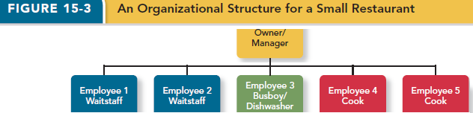
- A bureaucratic structure: an organizational form that exhibits many of the facets of the mechanistic organization
- Bureaucratic Structure
- Functional structure: employees are grouped by the functions they perform for the organization
- Efficient with narrow focus, fewer product lines or services, and a stable environment
- Weakness: individuals wrapped up in their own goals and view points that they lose sight of the bigger organizational picture
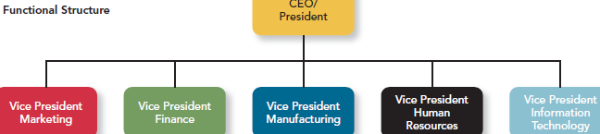
- Multi-divisional structures: employees are grouped into divisions around products, geographic regions, or clients
- Product structures: group business units around different products that the company product
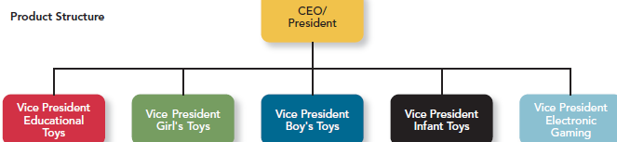
- Geographic structures are generally based around the different locations where the company does business
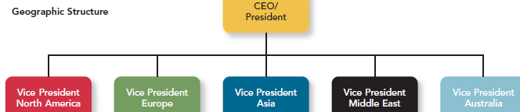
- Client structure: employees are organized around serving customers
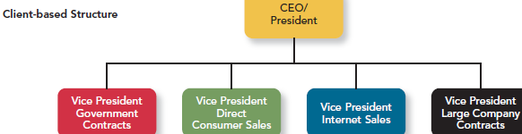
- Matrix structures: a more complex form of organizational design that tries to take advantage; combines a functional and multidivisional grouping
- Functional structure
- Product structure at the same time

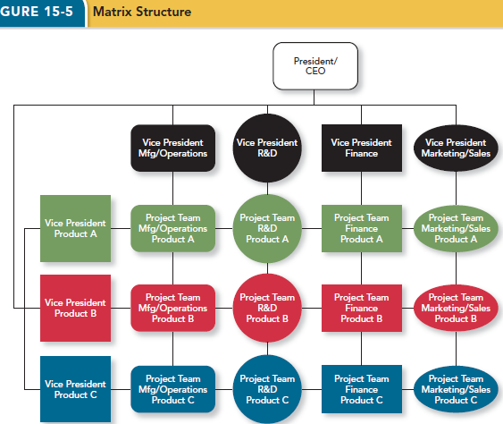
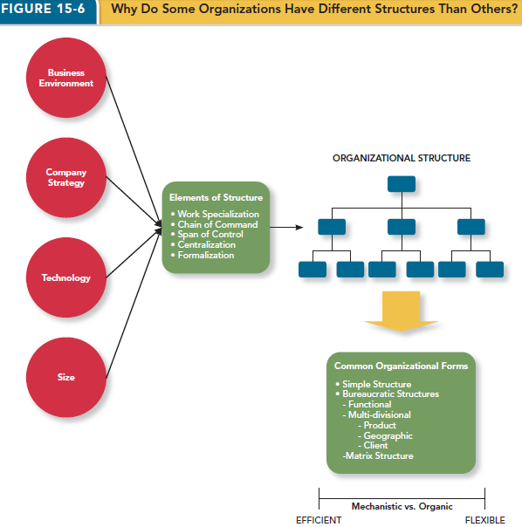

Chapter 14
- Organizational culture: the shared social knowledge within an organization regarding the rules, norms, and values that shape the attitudes and behaviors of its employees
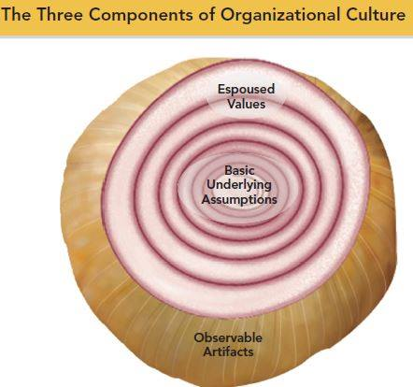
- Culture Components
- Basic underlying assumptions/values:
- Taken-for-granted beliefs, values, philosophies
- So ingrained that employees simply act on them rather than questioning them
- Fact assumption
- Espoused values
- The beliefs, philosophies, and norms that a company explicitly states
- E.g. Published documents, verbal statements made to employees by managers, information on the website
- Exposed values vs. Enacted values…
- “Walk the talk”
- Observable artifacts: the manifestations of an organization’s culture that employees can easily see or talk about
- Symbols: the images an organization uses, which generally convey messages
- E.g. corporate logo, web site, uniforms, etc.
- Physical structures: the organization’s buildings and internal office designs
- E.g. office layout and design
- Does top management work in a separate section in the building
- Language: the jargon, slang, and slogans used within an organization
- E.g. slogans, acronyms
- Stories: anecdotes, accounts, legends, and myths passed down from cohort to cohort within an organization
- E.g. founder(s), anecdotes, myths
- Rituals: the daily or weekly planned routines that occur in an organization
- Ceremonies: formal events, generally performed in front of an audience of organizational members
- Organizational Culture Types
- Networked culture: an organizational culture type in which employees are friendly to one another, but everyone thinks differently and does his or her own thing
- Communal culture: an organizational culture type in which employees are friendly to one another and all think alike
- Fragmented culture: an organizational culture type in which employees are distant and disconnected from one another
- Mercenary culture: an organizational culture type in which employees think alike but are not friendly to one another
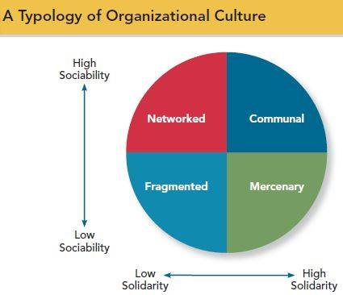
- Specific Culture Types
- Customer Service Culture: focus on service quality
- It changes employee attitudes and behaviors toward customerhigher customer satisfaction and sales
- Safety Culture: safety of employees
- Diversity Culture: focus on fostering or taking advantage of a diverse group of employees
- RBC: hiring people who have the technical, behavioral and diversity requirements for the position being filled
- Investing heavily in training throughout the company
- and by promoting internal mentoring relationships
- Creativity Culture: focus on fostering a creative atmosphere
- Culture Strength
- A strong culture: employees agree about he way things are supposed to be (high consensus) and their behaviors are consistent with those expectations (high intensity)
- Strong culture does not mean good culture
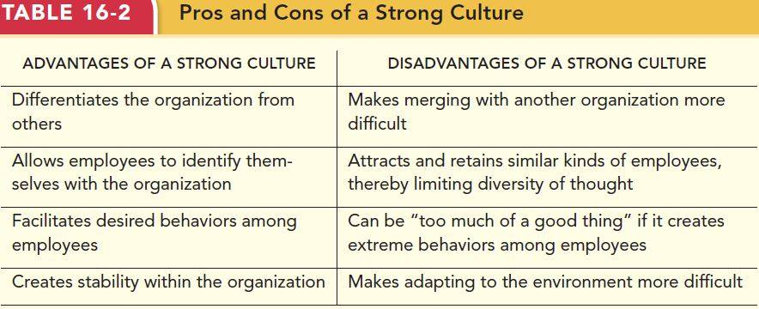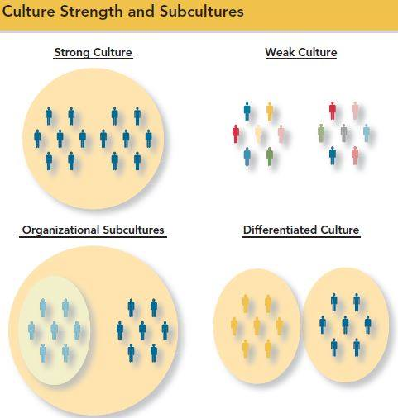
- Are cultures consistent?
- Subculture: The hardware and software division have rather different beliefs, values and assumptions.
- Counterculture: a subculture whose values do not match those of the organization
- Building & Maintaining an Organizational Culture
- Socialization: process by which employees learn the social knowledge that enables them to understand and adapt to the organization’s culture
- Anticipatory stage: prior to an employee starting work
- Encounter stage: begins the day an employee starts
- Reality shock: a mismatch of information that occurs when an employee finds that aspects of working at a company are not what the employee expected it to be
- Understanding and adaptation: start to internalize the organizational norms; newcomers come to learn the content areas of socialization and internalized the norms and expected behaviors of the organization
- Managing Socialization
- How can organizations minimize reality shock and promote socialization
- Realistic job preview (RJP): need to determine the Person-organization Fit
- Newcomer orientation sessions
- Mentoring programs
- Culture Change
- When culture change is needed what can be done
- The change process involves three sequential steps
- Unfreezing: occurs when the organization comes to some realization that the status quo is unacceptable
- The change initiative: binging in a new leader, introducing a new reward system or implanting a new training program
- Refreezing: the newly developed attitudes and behaviors need to “harden up” becoming entrenched as new norms, values, and shared understandings
- Issues: e.g. culture clash, improper diagnosis, resistance
- Drivers of culture change
- Changes in leadership
- Merger and acquisitions

