Analysis of the phenotypical manifestations and CXCR4 pathway associated with the rare immunodeficiency disorder WHIM

Biology 2B03
November 18th, 2012

Abstract. WHIM syndrome is an acronym derived from its characterizing clinical features; warts, hypogammaglobulinemia, recurrent bacterial infections and myelokathexis. Many patients exhibit a subset of the associated symptoms with the majority suffering from neutropenia given failure of neutrophil bone marrow egression. Manifestation of this phenotype derives from a C-terminal truncating frameshift/nonsense mutation on the G-protein coupled chemokine receptor, CXCR4 (ligand CXCL12/SDF-1). Notably, some patients have a wild type copy of this gene but share comparable CXCR4 pathway dysfunction. The aberrant chemokine allele causes diminished desensitization and receptor internalization which leads to enhanced response via continuous G-protein activation. Effective treatment may be accomplished through the CXCR4 agonist Prelifaxor, which blocks the CXCL12-mediated signalling cascade.
Introduction
WHIM syndrome is a congenital immunodeficiency defined by its prevailing clinical symptoms; Warts, Hypogammaglobulinemia, recurrent bacterial Infections and Myelokathexis (Kawai &Malech, 2009). The disorder arises from a C-terminal truncating mutation of the intracellular domain associated with the chemokine receptor, CXCR4. The gene is mapped to a 12 cM stretch on locus 2q21 and the mutation follows an autosomal dominant pattern of inheritance where most afflicted patients exhibit heterozygous genotypes (Diaz & Gulino, 2004):(Kawai & Malech, 2009). The CXCR4 receptor is composed of 352 amino acids and lies within the superfamily of G-protein coupled receptors (GPCR) (Kawai &Malech, 2009). This receptor has high affinity for the stromal cell-derived factor 1 (SDF1; also known as CXCL12) and successful association with its only specific ligand serves a key role in regulating leukocyte and neutrophil homing to, and release from the bone marrow(Diaz & Gulino, 2004). The mutation causes continuous activation of the chemokine receptor, inducing exaggeratedchemotaxis which eventually causes apoptosis of mature neutrophils as they permanently adhere to the bone marrow. Clinical onset of WHIM is thought to occur in childhood but the age of the patient during diagnosis, and the manifestation of symptoms vary significantly across those afflicted (Kawai & Malech, 2009). Accordingly many cases display only a subset of the associated physiological changes making for a difficult diagnosis. Nevertheless, such changes include reduced gamma globulin, leukocyte and neutrophil counts respectively associated with the onset of hypogammaglobulinemia and myelokathexis. Furthermore, the majority of affected individuals displayed characteristic infections including pneumonia, sinusitis, cellulitis, thrombophlebitis among many others (Kawai & Malech, 2009).Patients tend to exhibit lowered immune response given the low levels of neutrophils caused by their failure to egress from the bone marrow. The consequential infections are induced by encapsulated bacteria rather than viruses; most show unaffected responses to common viral infections with predisposition to bacterial infections instead. Typical responsible pathogens include but are not limited to Haemophilus influenzae, Streptococcus pneumoniae, Klebsiella pneumoniae, Staphylococcus aureus, and Proteus mirabilis (Kawai & Malech, 2009).In additionWHIM patients that exhibit warts experience, in some cases, severe warts on their hands, feet and trunk whereby the subsequent mucosal leasions become directly linked to HPV infection (Kawai & Malech, 2009).
Wild Type Signalling Pathway
CXCR4 as mentioned before, is a chemokine GPCR and hence contains 7 transmembrane α-helices with a cytoplasmic amino terminus and an extracellular carboxy terminus. Multiple kinases dynamically regulate phosphorylation of specific sites on the intracellular domain. This can downregulate the receptor and/or cause a signalling cascade via G protein dissociation, indirectly leading to chemotaxis and many other responses. The G-protein is heterotrimeric, composed of α-, β- and γ-subunits whereby the former contains a guanine nucleotide binding pocket with intrinsic GTP-ase activity. The remaining two form a tightly bound complex. CXCR4 association with its only ligand, CXCL12, induces a conformational change in the chemokine receptor which dissociates the heterodimer β- and γ-subunits (Gβγ) and triggers activation of the G-protein-αi subfamily (Gαi) (Bachelerie, 2010). Such is achieved by the ligand-mediated exchange of GDP for GTP in the nucleotide binding pocket. As per Figure-1 Gαi will go on to inihibit adenylyl cyclase regulated cyclic adenosine monophosphate (CAMP) production and activate phosphoinositide 3-kinase (PI3K). Gβγ will activate phospholipase C (PLC) which in turn causes inositol triphosphate (IP3) transduction leading to intracellular mobilization of Calcium ions (Nimmagadda & Woodward, 2011). This G-protein heterodimer is also responsible for promoting chemotaxis via downstream triggering of the mitogen-activated protein kinase (MAPK) and co-activation of IP3. IP3 triggers gain of function in several types of kinases such as AKT, FAK and ERK1/2 which induce other signal transduction pathways that lead to chemotaxis, survival proliferation and regulation of associated gene expression. The JAK/STAT pathway can also be activated via CXCR4 but is independant of the G-protein in many other processes (Nimmagadda & Woodward, 2011). Regulation of the system is elicited by high concentration of the agonist (CXCL12), GTP hydrolysis to GDP in the G-protein, and G-protein-coupled receptor kinase (GRK)-dependant phosphorylation of Serine (Ser) and Threonine (Thr) residues on the cytoplasmic domain of CXCR4 (Bachelerie, 2010). This will respectively promote desensitization of the receptor, reassociation of the G-protein subunits, and an increase in receptor affinity for β-arrestins. The arrestins will promote internalization of CXCR4 into early endosomes and its breakdown via ubiquitin-mediated transport to lysosomes (Bachelerie, 2010). Another notable modulation arises from the dimerization of CXCR4 and CXCR7 which terminates all signaling, this is not shown in Figure-1. However, the monomer of CXCR7 is able to compete for CXCR4’s ligand, CXCL12, suggesting it is able to regulate CXCR4 signalling. When active, CXCR7 may bind to β-arrestin to signal through PLC/MAPK pathways increasing cell survival in gliomas regardless of G-protein activation (Bachelerie, 2010);(Duda et al., 2011).
Mutations associated with WHIM
The mutated allele cxcr4 exhibits a carboxy terminus truncated by 10 to 19 residues. In most patients this is a result of a single dominant point mutation, substituting a cytosine base pair for a guanine on the 1013th nucleotide. Instead of coding for the Ser 338th residue, the codon now corresponds to a premature stop codon; otherwise known as a nonsense codon (Bachelerie, 2010). The less common variant of this truncation is created by a single point mutation which instead results in a frameshift. In either case, deletion of the CXCR4 C-terminus prevents its internalization into early endosomes for subsequent ubiquitination and degradation. Such impairment comes from the lack of C-terminal 15 Ser and 3 Thr residues which would have otherwise been phosphorylated by GRK to downregulate CXCR4. The extend of this impairment also varies given the variable size of the deletion; Ser positions 324, 325, 338 and 339 have the greatest impact. Notably, residual internalization of the receptor remains, speculatively due to preserved Ser residues 324 and 325 (Bachelerie, 2010). Nonetheless, a similar situation was observed in two unrelated WHIM patients carrying a wild type (WT) copy of the CXCR4 gene suggesting genetic heterogeneity. Upon exposing leukocytes from these patients to protein kinase C inducer phorbol ester PMA, an internalization response was achieved; suggesting that the malfunction lies within the phosphorylation by the agonist (Bachelerie, 2010). Phosphorylation by GRK’s 2,3,5 and 6 was undertaken in WHIM cells to differentiate the extent of their roles in internalization; only GRK3 was able to restore CXCR4 responsiveness. To solidify this claim, siRNA interference in WT cells was shown to reduce receptor internalization which also marked the inability of the remaining in-vivo GRK’s to make up for the absence of GRK3 (Bachelerie, 2010). Another notable consequence of WHIM is the diminished desensitization of CXCR4 which leads to prolonged activation of the G-protein and its respective signalling cascade. Moreover, this may be linked to abnormal triggering of the β-arrestin pathways. For instance, β-arrestin regulation of ERK1/2 is dependant upon GRK3 and GRK6 phosphorylation. Both respectively phosphorylate the far C-terminal region and proximal Ser residues; while GRK3 was shown to promote the recruitment of β-arrestin to the chemokine receptor, GRK6 exhibited opposite effects (Bachelerie, 2010). In addition to showing GRK’s have some endowed specialization, this result is consistent with the above mentioned internalization experiments by Bachelerie (2010) because β-arrestin negatively regulates this pathway;
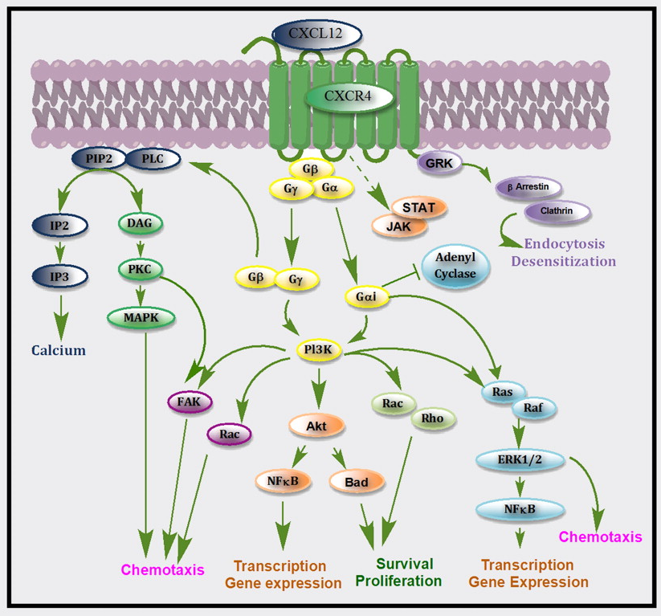
Figure 1. Illustration of CXCR4/CXCL12 signal transduction pathway (Nimmagadda & Woodward, 2011).
...we have ectopically expressed GRK3 in cells from a WHIM patient having a wild type CXCR4 gene and harboring a selective decrease in GRK3 protein. This leads to the normalization not only of the CXCR4 internalization but also of the CXCL12-promoted chemotaxis. Conversely, GRK3 silencing in control cells results in a WHIM-like phenotype (i.e. enhanced CXCL12-promoted chemotaxis). Our results suggest that GRK3 negatively contributes to the regulation of CXCR4-promoted chemotaxis (p. 193).

Evidently, an understanding of the specific roles played by the regulating elements of these signalling cascades is key fortheir successful manipulation and suppression of WHIM.
Treatment options and conclusion
Individuals suffering from WHIM may be treated by administration of granulocyte colony-stimulating factor (G-CSF) and/or repeated intravenous injection of gamma globulin (IVIG). Both of these treatments physically address the reduced gamma globulin, leukocyte and neutrophil counts respectively linked to hypogammaglobulinemia and myelokathexis. However, such treatments are expensive and nonspecific, often proving difficult to administer and often showing marginal results (McDermott et al., 2011). The Food and Drug Administration (FDA) has recently approved an antagonist for CXCR4, AMD3100 or otherwise known by the trade name Plerixafor. This compound is equipotent and equieffective as an inhibitor which blocks the active site of both WHIM mutated CXCR4 and its wild type counterpart (McDermott et al., 2011). In the case of the WHIM CXCR4, the exaggerated signalling and reduced down-regulation will be suppressed upon association with AMD3100. As an antagonist, the drug will inhibit agonist-mediated effects without eliciting a new response itself. Ultimately, this should normalize neutrophil and haematopoietic progenitor cells (HPC) homing/retention to the bone marrow (McDermott et al., 2011). Clinical trials are consistent with this; tested patients show increased leukocyte blood levels, with peaks ranging from 3 to 12 hours among many subsets (neutrophils, lymphocytes, monocytes, etc...). No notable side effects were found, nor was maximum blood count of any leukocyte subset exceeded (McDermott et al., 2011).
Evidently treatment relies on a pivotal marker of WHIM syndrome. Such resides in the form of increased activation of the CXCL12/CXCR4 axis caused by dominant gain-of-function frameshift/nonsense mutations (Bachelerie, 2010). Delineation of the underlying mechanisms of this chemokine receptor pathway is warranted for complete understanding of WHIM pathogenesis and treatment of related CXCR4-dependant disorders. Those who suffer from the associated bacterial infections, warts and low leukocyte/gamma globulin levels may seek relief in treatment via Plerixafor. Nevertheless, further research should be conducted with particular focus on the currently unknown mechanisms that govern HPV susceptibility in WHIM patients.

References:

Bachelerie, F. (2010). CXCL12/CXCR4-axis dysfunctions: Markersof the rare immunodeﬁciency disorder WHIMsyndrome. Disease Markers, 29, 189-194. doi: 10.3233/DMA-2010-0736

Diaz G., Gulino V. (2004). WHIM Syndrome (Warts Hypogammaglobulinema Infections Myelokathexis). Orphanet Encyclopedia, 1-3.

Duda G., Kozin S., Kirkpatrick N., Xu L., Fukumara D., Jain R. (2011). CXCL12 (SDF1α)- CXCR4/CXCR7 Pathway Inhibition: An Emerging Sensitizer for Anticancer Therapies? American Association for Cancer Research, 2074-2075. doi: 10.1158/1078-0432.CCR- 10-2636

Kawai T., Malech H. (2010). WHIM Syndrome: Congenital Immune Deficiency Disease. Current Opinion in Hematology. 16(1), 20-26. doi: 10.1097/MOH.0b013e32831ac557
Nimmagadda S., Woodward L.(2011).CXCR4-Based Imaging Agents. The Journal of Nuclear Medicine, 52, 1665-1669. doi: 10.2967/jnumed.111.097733

McDermott D., Liu Q., Ulrick J., Kwatemaa N., Anaya-O’Brien S., Penzak S., Filho J., Priel D., Kelly C., Garofalo M., Littel P., Marquesen M., Hilligoss D., DeCastro R., Fleisher T., Kuhns D., Malech H., Murphy P. (2011). Journal of the American Society of Hematology, 118(18), 4957-4962.doi: 10.1182/blood-2011-07-368084

