PROBLEM STATEMENT
Who is this firm, what have they done, and why are we talking about them?

EXTERNAL ANALYSIS

* Industry: Define the industry you are talking about

1) General Environment (7 segments) – macro level
The broader society dimensions that influence an industry and the firms within it

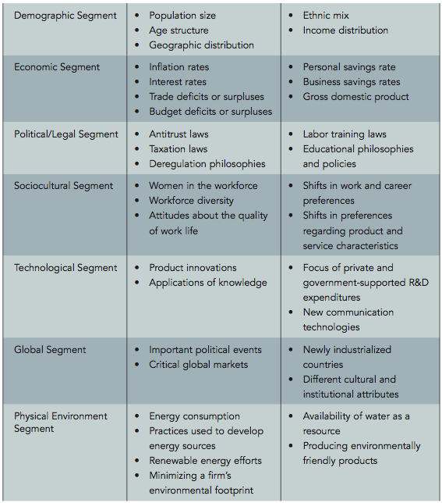

2) Industry Analysis
- Industry = group of firms producing products that are close substitutes
- Affects a firm’s strategic competitiveness and ability to earn above-average returns
- An industry’s profit potential is a function of Porter’s 5 forces
Set of factors directly influencing:
- A firm’s competitive actions and responses
- The competitor analysis
- An industry’s attractiveness

PORTER’S 5 FORCES (*Don’t have to do all 5 forces, can still figure out industry attractiveness)

Forces that determines an industry’s attractiveness, to determine if the company should stay in the industry, and if so, what it can do to perform well
Forces that impacts the average rate of return for the firms

* ATTRACTIVE INDUSTRY – high profit potential:
- High: barriers to entry (low threat of substitutes) – less competition
- Low: threats from substitutes
- Low-Med: rivalry amongst competitors
- Low: Bargaining power of buyers
- Low: Bargaining power of suppliers
If you’re in an attractive industry, stay in there. In not, then get in there.
To make an industry attractive, go buy one of your suppliers to lessen supplier’s power

- Threat of New Entrants
- A highly profitable industry tends to attract new entrants, which drive consumers’ cost down, resulting in less revenues and lower returns.
- Firms try to erect barriers of entry to keep number of new entrants low
- Barriers to Entry:
  - Economies of scale (new entrant needs to sell products at low cost)
  - Product differentiation (new entrant needs to spend on advertising if there is a lot of product differentiation)
  - Capital requirements (if industry requires a lot of capital, number of new entrant will decline)
  - Switching costs (cost of going from one supplier to a different supplier)
  - Access to distribution channels (need to persuade distributor to carry product)
  - Cost disadvantage independent of scale (when existing firms already have cost advantages such as own technology, have access to raw materials, purchased desirable locations, etc.)
  - Government policy (controlled by govn’t requiring license/permits)
  - Expected retaliation (retaliation from existing firms, especially if it has a major stake, industry growth is slow; Ex. Airline industry)
- Threat of Substitutes
- Substitutes = products/services with similar function that limit the prices firms can charge (the more substitutes there are in the industry, the more threat there is in the industry)
- Substitutes are a threat if switching cost for customer is low and if substitute’s product cost is lower and quality is equal or greater.
- To reduce treat of substitutes: increase customer value (increase product quality, service, location)

- Rivalry Amongst Competitors
- Numerous or equally balanced competitors (more rivalry, no good)
- Slow industry growth (firms start battle to increase market share by attracting competitors customers)
- High fixed costs / High storage costs (high fixed cost no good; firms tend to maximize their productive capacity leading to high inventories and price cutting)
- Lack of differentiation / Low switching costs (lack of differentiation leads to less customer loyalty and increased firm rivalry)
- High strategic stakes (when it’s important for competitors to perform well in market)
- High exit barriers (the cost of leaving industry is high when firm has specialized assets (airline), fixed exit costs, strategic interrelationships)

- Bargaining Power of Suppliers
- If supplier power is high, then that’s bad (you want supplier power to be low, so you only need to worry about buyers)
- If supplier power is high, then they can dictate the price (increase prices) and offer reduced quality
- Suppliers are powerful when:
  - Supplier industry is dominated by a few firms
  - Supplier’s products have few substitutes to the firm (buyer)
  - Firm (buyer) is not an important customers to the supplier
  - Supplier’s product is an important input to the firm’s (buyer’s) product
  - Suppliers’ products are differentiated (firm will not want to switch suppliers – there’s high switching cost for firm)
  - Supplier poses credible threat of forward integration

- Bargaining Power of Buyers
- Buyers = customers as a group of a firm/industry
- Buyers strive for reduced cost, high quality, and high service
- Buyers are powerful when:
  - There are many buyers or they purchase a large portion of an industry’s total output
  - Purchase made by buyers account for a significant portion of industry’s sales (revenues)
  - Products are undifferentiated
  - Buyers face low switching costs (can switch to another firm at low cost)
  - Buyer presents a credible threat of backward integration
  - Product unimportant to quality
  - Buyer has full information (info on manufacturer’s cost, online shopping)

On Exam, can say that according to Porter, the industry is not attractive, however the company should not leave the industry just yet, as there are many growth opportunities that the company can explore, do well, and grow their margins.

3) Competitor Analysis
- Competitors’ strengths, weaknesses, strategies, capabilities, competitive advantage
  - Shows us who’s doing well and not well in the industry
  - Helps identify what are the key success factors (KSF) based on the strategies and capabilities of the winning company in the industry
- Understanding the actions of competitors clearly contributes to the firm’s ability to compete successfully within the industry
  - What drives the competitor, as shown by its future objectives
  - What the competitor is doing and can do, as revealed by its current strategy
  - What the competitor believes about the industry, as shown by its assumptions
  - What the competitor’s capabilities are, as shown by its strengths and weaknesses

KEY SUCCESS FACTORS (KSF)

What does it take to be a winner in this industry? (based on competitor analysis)
What key success factors are necessary to be successful in this industry?
- What functions, activities or business practices are valued and demanded by the market conditions and by the customer needs?
- What is it that the company must do to compete in the market and to be perceived by the customer as adding value to the business relationship?
- What factors are important in the customer decision process that generate an order?
- Why does the customer select your company over the competition?

INTERNAL ANALYSIS
By studying the external environment, firms identify what they MIGHT CHOOSE TO DO (for their internal operations)

RESOURCES

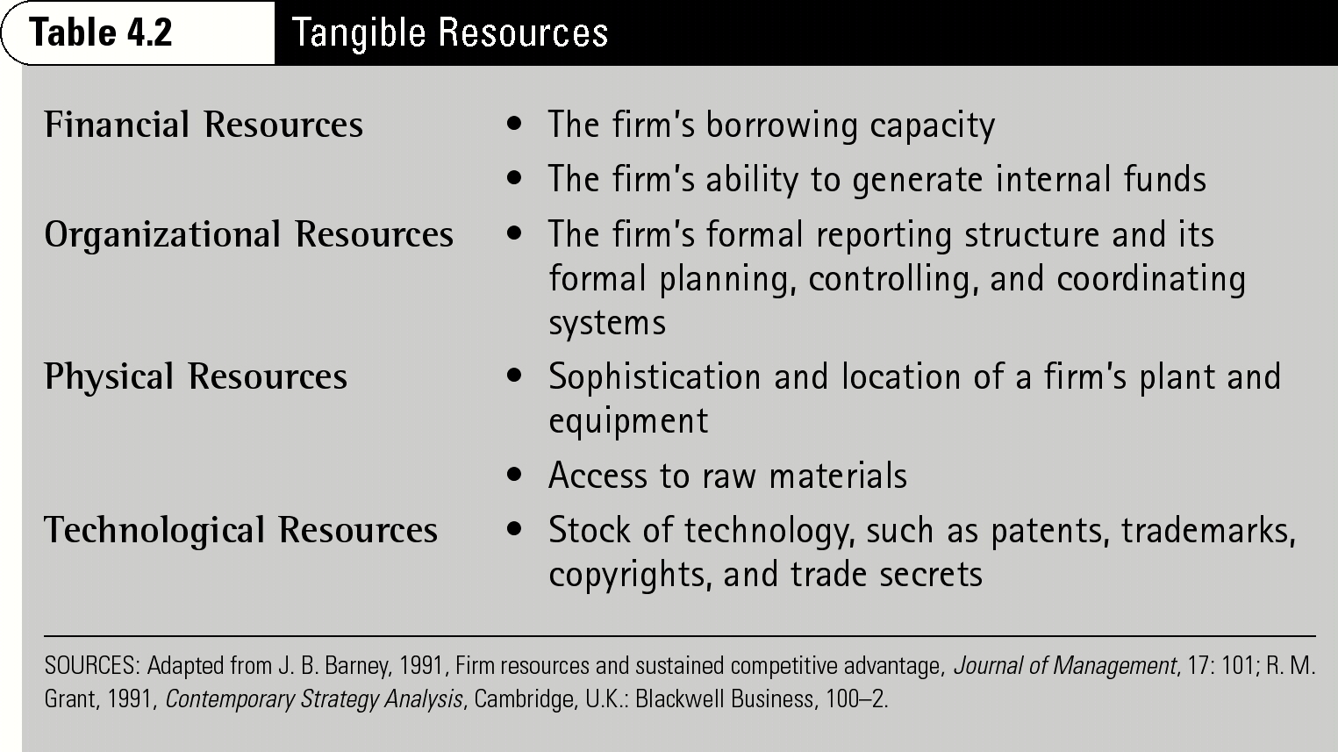

Intangible Resources are becoming increasingly important, as it is harder to achieve

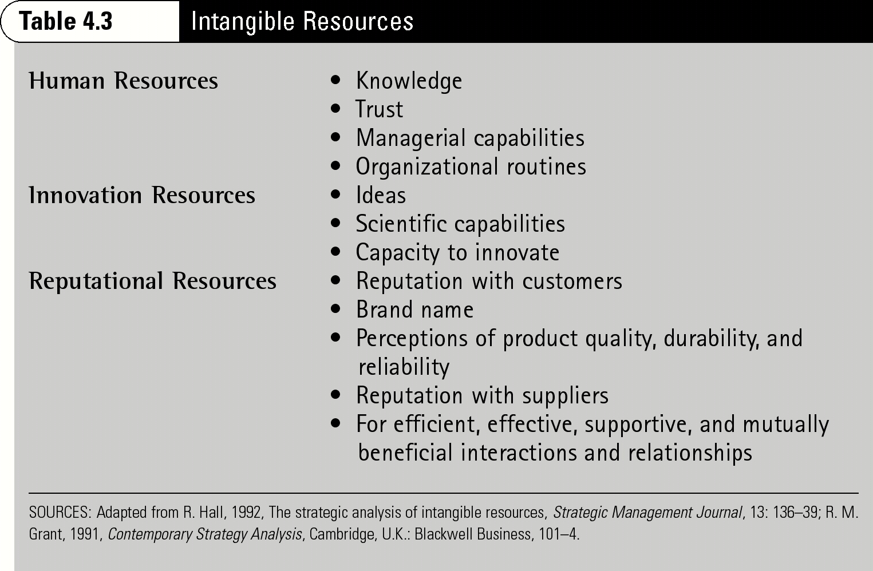

Financial Analysis
- Is the firm in a healthy and profitable financial situation?

CAPABILITIES
- Unique skills and knowledge
- Are often developed in specific functional areas
- Are activities that a firm performs exceptionally well relative to rivals
- Are activities through which the firm adds unique value to its goods or services over an extended period of time

ON EXAM, do:
- Human Resources: The firm has a strongly motivated CEO that leads the company well and provides exceptional benefit to its employees
- Research & Development: Innovation of a platform
- Marketing: Customer centricity

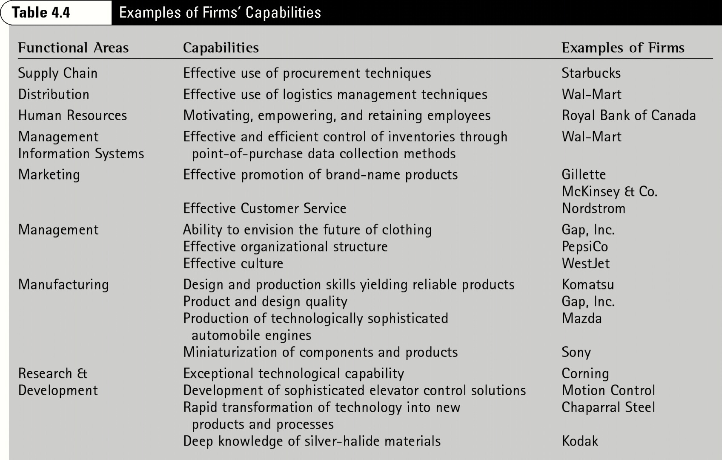

CORE COMPETENCIES

= Capabilities that serve as a source of competitive advantage for a firm over its competitors
= Capabilities that possess VRIN
In order to be a source for competitive advantage, capabilities need to possess four attributes (and thus become core competencies)

VRIN (Conduct VRIN for each capability)
The capabilities that possess all 4 attributes of VRIN are the firm’s core competencies
- Helps the company determine what they are good at today
- What are the core competencies that make you stand out, to help you win in the industry? How do these core competency help you generate ideas?

- Valuable
  - Allows the firm to exploit opportunities or neutralize threats in its external environment
- Rare
  - Possessed by few, if any, current and potential competitors
- Imperfectly imitable (Costly to Imitate)
  - When other firms cannot obtain it or must obtain it at a much higher cost
- Non-substitutable
  - When there are no equivalents

*** DO THIS TABLE ON EXAM TO DETERMINE WHICH AREAS (CAPABILITIES) THAT THE FIRM HAS A SUSTAINABLE COMPETITVE ADVANTAGE IN & WHAT KIND OF RETURNS IT HAS

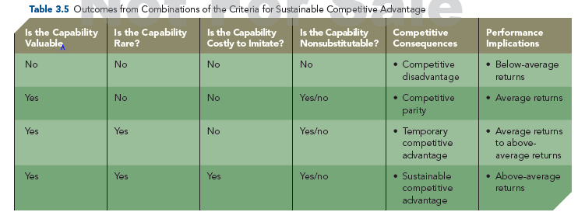

* ONLY WAY A FIRM CAN RETAIN A SUSTAINABLE COMPETITIVE ADVANTAGE IS IF IT CONTINUES TO INNOVATE.

*** A firm has achieved strategic competitiveness (competitive advantage) when its core competencies (capabilities that meet VRIN) match its opportunities (from external analysis).
VALUE CHAIN

= useful tool to identify and understand internal sources of competitive advantage (ie, where value is created)

Which activities create value?
Indicate which areas of the value chain the firm is doing well in and not so well in
Where there is weakness (Ex. Product & technology development), perhaps look into OUTSOURCING (this can be an ALTERNATIVE)

- Outsource to…
  - Increase flexibility
  - Improve business focus
  - Gain access to world-class capabilities
  - Accelerate re-engineering benefits
  - Share risks (mitigate)
  - Free resources (unprofitable areas) for other purposes
  - Reduce capital investments
  - Seek greatest value
- Invest in...
  - Activities which can create and capture value
  - Activities which neutralize threats or are necessary to ongoing organizational tasks.
  - Capabilities critical to the firm’s success
  - Activities that stimulate the development of new capabilities and competencies

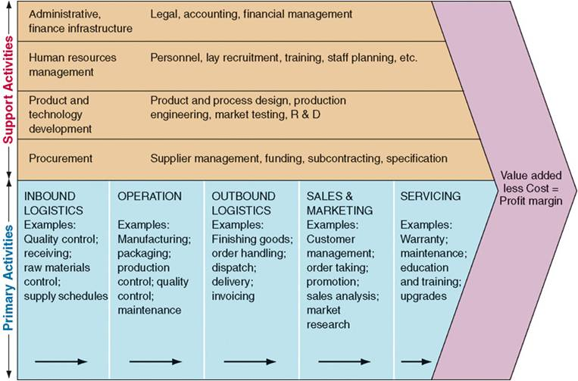
SWOT ANALYSIS
*** Conduct a SWOT analysis after External and Internal Analysis.
Summary (the big take-away), which will be brought up in the ALTERNATIVES & RECOMMENDATIONS

TYPES OF STRATEGIES
- Business-level
- Corporate-level
- Merger and acquisitions
- International
- Cooperative

BUSINESS-LEVEL STRATEGY

The positioning of the company compared to its competitors
Business-level strategy is the core strategy of the company – the strategy that the firm forms to describe how it intends to compete in a product market.
= An integrated and coordinated set of commitments and actions that a firm uses to gain a competitive advantage by exploiting core competencies in specific product markets.

How do we position ourselves in the market to attract our target market?

- Participation strategy. Which product markets do I compete in?
- Competitive strategy. How can I serve existing customers better and attract new customers? How do I align my operating model to deliver my customer proposition?
- Organization strategy. How do I mobilize my organization (structure, processes)? What is the role and mix of my leadership team?

Good Strategy
- The whole point of doing an internal analysis is to see what we’re dealing with
  - Our future projects should be based on what has already been done
- Need consistency across the business make sure there are no contradiction across the business
- Make sure that the strategy can be done (is executable) with existing assets, capabilities and resources (because having an idea and plan is easy, but implementing it is different)

CUSTOMERS play a central role when selecting the business-level strategy of a firm -- The way the company positions itself in the market greatly depends on its customers:

- Who are the customer groups to be served? (Market segmentation)
- What needs do the customers have that the firm seeks to satisfy? (Product features and performance)
- How can the firm use core competencies to satisfy customer needs?
- How much is the target customer willing to pay to have these needs fulfilled?

Generic Approaches for a Firm’s Business-Level Strategies (Competitive Strategy)
- Cost leadership (realizing that customers are cost-conscious, want to pay a little as can)
- Differentiation (sell products that are different, unique)
- Focus (have a focus –sell product to everyone or have it available to only certain markets)

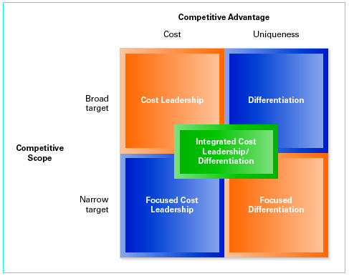

- Cost Leadership Strategy (broad target, low cost)
Example: Walmart: sells you cheap food, diverse products

- Cost Leadership (how to obtain a cost advantage)
  - Offer no-frills, standardized products/services for the average customer
  - Offers low-cost products with competitive levels of differentiation
  - Focuses on efficiency so costs are lower than competitors’ costs

- Risks
  - Loss of competitive advantage to newer technologies
  - Failure to detect changes in customers’ needs
  - Competitors’ ability to imitate the cost advantage through their own unique strategic actions

- Differentiation Strategy (broad target, unique)
Example: Gucci: clothes, accessories, jewelry, different product ranges and categories (but all under the name Gucci), Apple products, Rolex watches

- Differentiation (how to obtain a differentiation advantage)
  - Offer products/services with unique features for which customers are willing to pay price premium
- Raise performance of product/service
- Increase customers’ reluctance to switch to non-unique product
  - Raise the willingness to pay a premium with only a slight increase in costs
- Configure value chain/activity system accordingly
  - Differentiate their products along as many dimensions as possible.
  - The less similarity to competitors’ products, the more buffered a firm is from competition with its rivals.

- Risks
  - Customers decide that differences between the differentiated and the cost leader’s product are not worth a higher price
  - Firms can’t sufficiently differentiate a product to create value for which customers will pay a premium price
  - Competitors offer similar products at a lower cost
  - Counterfeiters offer a cheap “knockoff” of a differentiated good or service (fake designer bags).

- Focused Cost Leadership (narrow target, low cost)
- & Differentiation Strategies (narrow target, unique)
Cost Leadership: Example - Kia
Focused Differentiation: Example - uniqueness, mazarati, BMWi car (rare sports car

- Focused
  - Integrated set of actions taken to produce goods / services that serve the needs of a particular competitive segment (Customer / industry)
  - Create value by using the focused cost leadership strategy or the focused differentiation strategy.
  - Firms must have the core competencies required to provide more value to the specific market segment than competitors serving the entire industry.

- Risks
  - A competitor is able to focus on an even more narrowly defined market segment
  - Industry-wide competitors decide to focus on specific customer segments
  - The differences are reduced between the needs of a specific market segment and those of the rest of the industry

- Integrated Cost Leadership / Differentiation Strategy (DUAL ADVANTAGE)
Example: Zara

- Integrated
  - Provide relatively low cost products with valued differentiated features.
  - Use primary and support activities to produce differentiated products at relatively low costs.
  - Critical Success factors include: Flexible Manufacturing Systems, Information Networks, TQM (total quality manufacturing) Systems

- Risks
  - A firm that produces products/services that lack sufficient low cost or differentiation.
  - To be “stuck in the middle”, i.e. lacking a strong commitment to or expertise with either type of generic strategy (being stuck in the middle, where the customers doesn't’t know who you are anymore)
- Ex. Louis Vuitton who now sells $200 handbags; regular customers may feel like Louis Vuitton bags aren’t so special anymore; isn’t so exclusive since it’s more affordable and more people are purchasing them

CORPORATE-LEVEL STRATEGY

= actions a firm takes to gain a competitive advantage by selecting and managing a group of different businesses competing in different product markets
Organizations that are involved in more than one business and industry
Example: General Electric competes in 16 industries (appliances, aviation, etc.)
How the firm manages its business and how it grows

- Portfolio strategy. What is the right size and mix of my portfolio of businesses? Which businesses will drive growth? Which businesses will fund growth?
- Value-added strategies. What synergies can I capture across businesses (shared assets and capabilities) that will deliver more value than the sum of the parts?
- Management model. How do I manage a my portfolio of businesses (structure , processes)? What is the role of the centre?
- Capital model. How do I allocate capital and other scarce resources?

- Actions a firm takes to gain a competitive advantage by selecting and managing a group of different businesses competing in different product markets
- Value created through economies of scope & market power
- Value determined by degree to which businesses are worth more under the management of the company then under any other ownership

Corporate Strategies in Which a Firm Can Grow
- Market Development: moving into different geographic markets (international expansion)
- New market, same product
- Product Development: developing new products and/or significantly improving on existing products
- Existing/same market, new products in those markets
- Horizontal Integration: acquisition of competitors; horizontal movement at the same point in the value chain
- Acquiring a competitor, develop economies of scale
- Example: Chrysler wants to sell products to more people, perhaps they can acquire a competitor (pay them, but keep the lower brand name)
- Vertical Integration: becoming your own supplier or distributor through acquisition; vertical movement up or down the value chain
- When a company produces its own inputs (backward integration) or owns its own source of output distribution (forward integration)
- Buying a company that is in our industry; becoming your own supplier or distributor through acquisition

DIVERSIFICATION
A manager should consider the following questions:
- What can our company do better than any of its competitors in its current markets?
- What strategic assets are needed to succeed in the new market?
- Can we catch up to or leapfrog competitors in the new market?
- Will diversification break up strategic assets that need to be kept together?
- Will we be simply a player in the new market or the leader?
- What can we learn by diversifying and are we structured to learn it?

DIVERSIFICATION STRATEGY
Diversification is an integral part of corporate strategy
3 reasons to diversify

- Value creating diversification **IMPORTANT** - DRIVES DIVERSIFICATION
- Economies of scope (cost savings by sharing resources)
- Market power (related diversification)
- Financial economies (unrelated diversification)

Two ways diversification strategies can CREATE VALUE
(Don’t need to have both to create value – synergies that are created when 2 companies are brought together)
- Operational relatedness
- Sharing resources/activities between businesses
- Corporate relatedness
- Transferring core competencies between business units
- Includes managerial and technological knowledge, experience and expertise
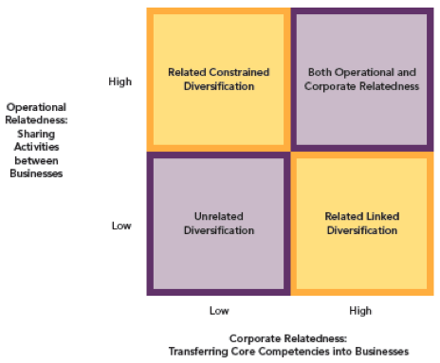

In related diversification, activity sharing and skills transfer are key success factors
- Understand business interrelationships, value chains, and drivers for competitive advantage
- Sharing activities can lower costs
- Achieve economies of scale
- Increase capacity utilization
- Move down the learning curve
- Requirements
- Existence of strong corporate identity
- Corporate mission that emphasizes the importance of integrating business units
- Reward system that emphasizes more than just business unit performance
- Examples
- Sharing of distribution network and sales force

In unrelated diversification, companies apply an investor’s logic (financial economies)
- Acquire sound, attractive companies
- Businesses are autonomous
- Acquiring corporation supplies needed capital
- Add professional management/control to the businesses
- Business unit managers’ compensation based on unit results
- Key success factors (how to make sure managers stay in unrelated diversification)
- Managers have more detailed knowledge of firm relative to outside investors
- Firm can reduce risk by allocating resources among diversified businesses, although shareholders can generally diversify more economically on their own
- Value-neutral diversification (Ex. Burger King acquiring Tim Hortons to reduce paying taxes)
- Tax laws, antitrust legislation
- Uncertain future cash flows
- Value-reducing diversification (doesn’t really happen anymore)
- Diversify managerial employment risk
- Increase managerial compensation

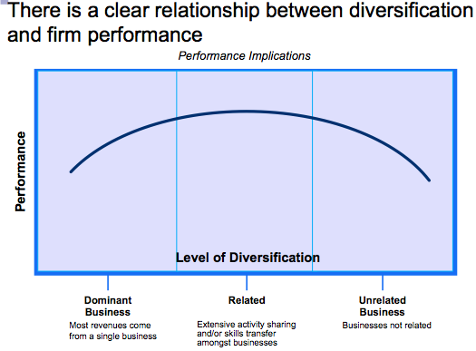

ALTERNATIVES

MERGER & ACQUISITIONS STRATEGY

Why M&A is so popular as a business strategy
- Intent of M&A strategy is to increase firm’ strategic competitiveness and value; the reality is, historically returns are close to zero so it rarely works as planned

- Can be used because of uncertainty in the competitive landscape
    - Increase market power because of competitive threat
    - Spread risk due to uncertain environment
    - Shift core business into different markets
- Popular strategy in the U.S. for many years
- Source of firm growth and above-average returns
- Heavily influenced by external environment
    - Tight credit markets
    - Political changes in foreign countries’ orientation toward M&A

- Firms use M&A strategies to create value for all stakeholders though M&A value creation is challenging
- GOOD NEWS: Shareholders of ACQUIRED firms often earn above-average returns from acquisitions
- BAD NEWS: Shareholders of ACQUIRING firms earn returns that are close to zero: In 2/3 of all acquisitions, the acquiring firm’s stock price fell immediately after the intended transaction was announced
- This negative response reflects investors’ skepticism about projected synergies being captured

Differences between: MERGERS, ACQUISITIONS, TAKEOVERS

Mergers
- Two firms agree to integrate their operations on a relatively coequal basis.
- Few true mergers actually occur, because one party is usually dominant in regard to market share or firm size.
Acquisitions
- One firm buys a controlling, or 100 percent, interest in another firm
- Intent is to make the acquired firm a subsidiary business within its portfolio.
- Most common
- Related, horizontal or vertical
Takeover
- Target firm does not solicit the acquiring firm’s bid.
- Hostile Takeover: Unfriendly takeover that is unexpected and undesired by the target firm

Reasons for Acquisitions (7)

- Increase market power – horizontal, vertical, related acquisitions
Whether horizontal (competitors) or vertical (across value chain – suppliers, distributors), acquisitions can bolster market power and leapfrog the acquirer into a position of leadership through economies of scale/scope, market share or five forces related competitive advantage

- Overcome entry barriers to new markets or regions
Economies of scale & Differentiated products (cross-border acquisitions are often made to overcome entry barriers)

- Avoid product development cost; increase speed to market
Acquisitions allow a firm to gain access to new and current products that are new to the firm

- Lower risk – compared to developing new products
Compared with internal product development, acquisitions are less costly, have faster market penetration, have more predictable returns due to the acquired firms’ experience with the products

- Increase diversification
The quickest and easiest way to change its portfolio of businesses
Both related and unrelated diversification (though related diversification is often met with greater success)

- Reshape the company’s competitive scope
An acquisition can reduce the negative effect of an intense rivalry on a firm’s financial performance and can reduce a firm’s dependence on one or more products or markets.

- Learn and develop new capabilities
Firms acquire other firms with different but related and complementary capabilities in order to build their own knowledge base

***IMPORTANT***
If looking to use acquisitions as an alternative, then think about it as part of the IMPLEMENTATION PLAN so you can achieve the opposite of the “Problems with Acquisitions”

Problems in Achieving Acquisitions

- Acquisition strategies are not problem-free, even when pursued for value-creating reasons
- Research suggests:
  - 20% of all mergers and acquisitions are successful
  - 60% produce disappointing results
  - 20% are clear failures, with technology acquisitions reporting even higher failure rates
- Greater acquisition success accrues to firms ability to:
  - select the “right” target
  - avoid paying too high a premium (by doing appropriate due diligence)
  - integrate the operations of the acquiring and target firm effectively and retain the target firm’s human capital

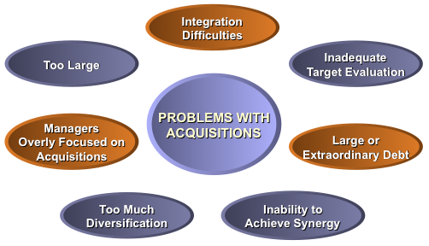

Too Much Diversification
- Diversified firms must process more information of greater diversity.
- Increased operational scope created by diversification may cause managers to rely too much on financial rather than strategic controls to evaluate business units’ performances
- Strategic focus shifts to short-term performance
- Acquisitions may become substitutes for innovation
- Over-diversification leads to a decline in performance, after which business units are often divested
- Even when a firm is not over-diversified, a high level of diversification can have a negative effect on its long-term performance

Too Large
- Additional costs and complexity of management may exceed the benefits of the economies of scale and additional market power, creating diseconomies of scope
- More bureaucratic controls result from size:
  - Formal rules and policies ensure consistency of decisions and actions
  - Formalized controls often lead to relatively rigid and standardized managerial behavior
- The firm may produce less innovation

What Effective Acquisitions Look Like

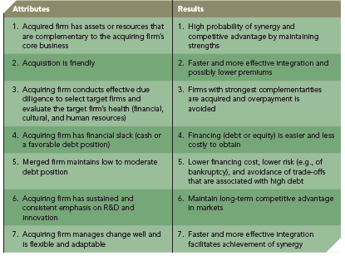

Restructuring Strategies (Changes to the businesses/financial Structure due to Acquisition Failure)

- Downsizing
  - Reduction in employees and/or units
  - May or may not change composition of businesses in the company's portfolio
- Downscoping
  - Eliminating businesses unrelated to firms’ core businesses
  - Strategies: divesture, spin-off or other means
- Leveraged buyouts (LBOs) –
  - One party buys all of a firm's assets to take the firm private
  - 3 types: management, employee , whole-firm
  - Protection against a capricious financial market
  - Allows owners to focus
  - A form of firm rebirth to facilitate entrepreneurial efforts

INTERNATIONAL STRATEGY

Domestic Markets VS Global Markets

Globalization is forcing firms out of their comfort zones
- DOMESTIC MARKETS (more predictable/less risky than Global markets)
  - Stable
  - Predictable
  - Less complex
  - Globalization is reducing the number of domestic-only markets
There are few companies that operate only domestically. Recently, they are forced to operate outside, due to globalization.
Example: Wal-Mart case – Wal-Mart expanding to Canada
Starbucks case – Starbucks have possibility of expanding internationally

- GLOBAL MARKETS
  - Unstable
  - Unpredictable
  - Complex and risky
  - Globalization is enabling global markets

Reasons for going Global?
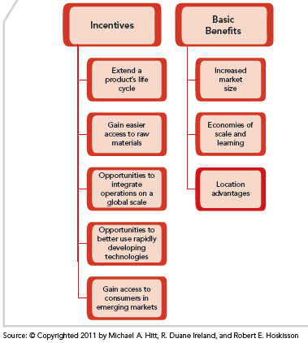
Major Benefits associated with Internationalization (3)

- Increase market size
  - Domestic market may lack the size to support efficient scale manufacturing facilities (larger international markets can offer higher potential returns)
- Increase economies of scale and learning
  - Expanding size or scope of markets helps achieve economies of scale in manufacturing as well as marketing, R&D and distribution
  - Resource and knowledge sharing between country units can act as a multiplier for the firm’s core competencies
- Develop a competitive advantage through location
  - Access to low-cost labour
  - Access to other critical resources (raw materials, energy, suppliers)
  - Access to new and potentially lucrative customer base

Example:
In North America, a lot of the raw materials needed to produce products in the technology industry are found in East Africa.
What North American companies would probably do is globalize and expand in East Africa – try to make some negotiations to enter the East African market

TYPES OF INTERNATIONALIZATION STRATEGIES

Business-Level Strategies

Goal of Business-Level Strategy:
How does the company position themselves to compete against its competitors?
You can look at the characteristics of the domestic market to know how to position themselves

Firms are heavily influenced in their business level internationalization strategies by dynamics in their domestic markets

- Domestic resources and capabilities are the building blocks for international capabilities and core competencies.
- Porter argues that conditions in a firm’s domestic market either help or hinder the firm’s international business-level strategy implementation.

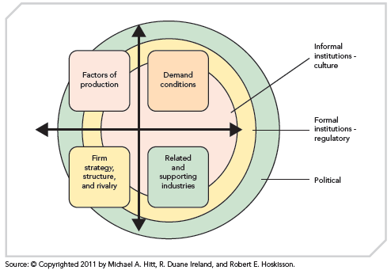

4 Characteristics, domestic resources: These 4 domestic resources help the company position themselves
- Factors of Production: Raw materials needs to produce the products and services in that country
- Demand conditions
- Firm strategy, structure, and rivalry
- Related and supporting industries

Corporate-Level Strategies

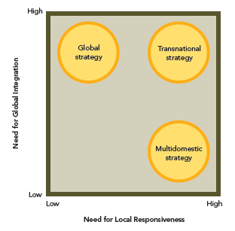

- Multidomestic strategy
HIGH “need for local responsiveness”, LOW “need for global integration”

  - Strategy and operating decisions are decentralized to strategic business units (SBU) in each country
  - Products and services are tailored to local markets
  - Business units in each country are independent
  - Assumes markets differ by country or regions
  - Prominent strategy among European firms due to broad variety of cultures and markets
  - Strategy results in less knowledge sharing for the corporation as a whole (Not a lot of knowledge sharing occurring)
  - KEY ASSUMPTION: country/cultural differences → need for local responsiveness
  - ADVANTAGE: local responsiveness
  - Example: Unilever

- Global strategy
LOW “need for local responsiveness”, HIGH “need for global integration”
- Firm offers standardized products across countries, with competitive strategy dictated by the home office
- Strategic and operating decisions are centralized at the home office
- Involves interdependent SBUs operating in each country
- Home office attempts to achieve integration across SBUs, adding management complexity
- Produces lower risk
- Emphasizes economies of scale
- Less responsive to local market opportunities
- Requires resource sharing and coordination across borders (hard to manage)
  - KEY ASSUMPTION: universal demand → need for global integration
  - ADVANTAGE: global efficiencies
  - Example: Maersk

- Transnational strategy (***most prominent strategy for a company to go global)
HIGH “need for local responsiveness”, HIGH “need for global integration”
This is becoming increasingly popular mix of global efficiency and local responsiveness
- Seeks to achieve both global efficiency and local responsiveness—competing goals
- Requires both Centralization (global coordination and control) and Decentralization (local flexibility)
- Global competitive landscape fosters intense competition, thus pressures to reduce costs, while at the same time information sharing has intensified the desire for specialized, customized, differentiated products
- Firm must pursue organizational learning to achieve competitive advantage
- Challenging, but becoming increasingly necessary to compete in international markets
- Increasingly popular as a strategy
- ADVANTAGE: BOTH
- Local responsiveness and global efficiencies
- Example: Starbucks in China

How to Enter International Markets

RISK & CONTROL INCREASES AND IT GOES DOWN (Exporting New Wholly Owned Subsidiary)

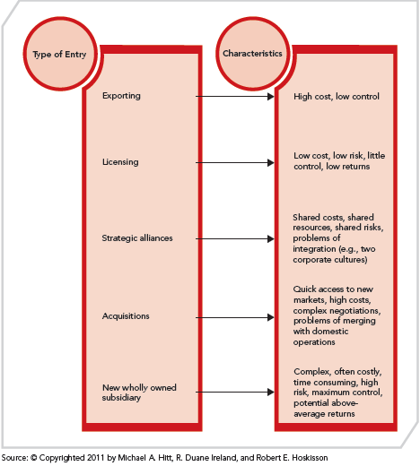

- Exporting
the firm sends products it produces in its domestic market to international markets
- Involves low expense to establish operations in host country
- Often involves contractual agreements
- Involves high transportation costs
- Tariffs maybe imposed
- Low control over marketing and distribution

- Licensing
agreement that allows a foreign company to purchase the right to manufacture and sell a firm’s products within a host country’s market or set of markets
  - Involves low cost to expand internationally
  - Allows licensee to absorb risks
  - Has low control over mftg. and marketing
  - Involves risk of licensee imitating technology and product

- Strategic alliance
collaboration with a partner firm for international market entry
- Involves shared risks and resources
- Facilitates development of core competencies
- Involves fewer resources and costs required for entry
- May involve possible incompatibility, conflict, or lack of trust with partner
- Difficult to manage

- Cross-border acquisition
a firm from one country acquires a stake in or purchases 100% of a firm located in another country
  - Allows for quick access to market
  - Involves possible integration difficulties
  - Is costly (debt financing)
  - Has complex negotiations and transaction requirements

- New Wholly Owned Subsidiary
a firm invests directly in another country/market by establishing a new wholly owned subsidiary
  - Is costly
  - Involves complex processes
  - Allows for maximum control
  - Has the highest potential returns
  - Carries high risk

WHAT IS THE BEST SOLUTION???

- Export, licensing, and strategic alliance: good tactics for early market development
- Strategic alliance: used in more uncertain situations
- Wholly owned subsidiary may be preferred if:
- Intellectual Property (IP) rights in emerging economy are not well protected
- Number of firms in industry is accelerating
- Need for global integration is high
- Acquisitions or wholly owned subsidiary: secure a stronger presence in international markets

CHOOSE _____, IF:
Choose Exporting if:
- The firm has no foreign manufacturing expertise and requires investment only in distribution.

Choose Licensing if:
- The firm needs to facilitate the product improvements necessary to enter foreign markets.

Choose Strategic Alliance if:
- The firm needs to connect with an experienced partner already in the targeted market or it needs to reduce its risk through the sharing of costs.

Choose Acquisition if:
- The firm must act quickly to gain rapid access to a new market (and corruption is not an issue).

Choose Wholly Owned Subsidiary if:
- The firm’s IP rights are not well protected, the number of firms in the industry is growing fast, and the need for global integration is high.

COOPERATIVE STRATEGY

There’s a trade-off:
1) enter new market quickly and split the pie, or
2) wait and roll the dice: either take the whole pie OR lose out completely

WHY COLLABORATE? (look for a partner so you can speed things up)
- Firms collaborate for the purpose of working together to achieve a shared objective.
- Cooperating with other firms is a strategy that:
    - Creates value for a customer
    - Exceeds the cost of constructing customer value in other ways
    - Establishes a favorable position relative to competitors
- Examples of cooperative behavior known to contribute to alliance success:
  - Actively solving problems
  - Being trustworthy
  - Consistently pursuing ways to combine partners’ resources and capabilities to create value (how are we going to work together)

REASONS FOR COLLABORATING DEPENDS ON THE TYPE OF MARKET A FIRM COMPETES IN

- Slow Cycle markets: Competitive advantage is shielded from imitation for long periods of time and imitation is costly
  - Gain access to a restricted market
  - Establish a franchise in a new market
  - Maintain market stability (e.g., establishing standards)
  - Rare today
  - E.g., steel industry

- Fast Cycle markets: Competitive advantage is not shielded, preventing long term sustainability
  - Speed up product or service development
  - Speed up new market entry
  - Maintain market leadership
  - Form an industry technology standard
  - Share risky R&D expenses
  - Overcome uncertainty
  - E.g., entertainment industry, Telecoms

- Standard Cycle markets: Competitive advantage is moderately shielded from imitation
  - Gain market power by reducing overcapacity
  - Gain access to complementary resources
  - Establish scale economies
  - Overcome trade barriers
  - Pool resources for large capex projects (E.g., airlines)
STRATEGIC ALLIANCES
Strategic alliances are the main reasons firms engage in collaboration strategies

- Strategic alliance = cooperative strategy in which firms combine resources and capabilities to create a competitive advantage
- ** Partners don’t need to get along, they just need to agree on certain things
- There are three types of strategic alliances:
  - Joint ventures (most difficult because you’re creating a new independent firm)
    - Two or more firms create a legally independent company to share resources and capabilities to develop a competitive advantage
    - Optimal for firms combining resources and capabilities to create competitive advantage that is different from individual advantages, and when highly uncertain, hypercompetitive markets are targeted

  - Equity strategic alliances
    - Two or more firms own different percentages of the company they have formed by combining some of their resources and capabilities for the purpose of creating a competitive advantage
    - Many foreign direct investments, such as those companies from multiple countries are making in China, are completed through an equity strategic alliance

  - Non-equity strategic alliances
  - Two or more firms develop a contractual relationship to share some of their unique resources and capabilities to create a competitive advantage
    - Separate independent company NOT established, thus no equity positions: less formal, fewer partner commitments, and intimate relationship among partners is not fostered
    - Includes:
    - Licensing agreements
    - Distribution agreements
    - Supply contracts
    - Outsourcing commitments

Level of Riskiness of strategic alliances
Joint Venture Equity Strategic Alliance Non-Equity Strategic Alliance

BUSINESS-LEVEL VS CORPORATE-LEVEL COOPERATION STRATEGIES

Business-level Strategies
Firms combine resources and capabilities to create competitive advantage by competing in one or more product markets
  - Firm can move into new products (potentially), can move up/down, side to side of the value chain (vertical and horizontal)

Corporate-level Strategies
Firms combine resources and capabilities for the purpose of expanding their operations

  - Commonly broader in scope and more complex then business-level cooperation strategies and, therefore, more challenging and costly to use.
  - Diversifying alliances: sharing resources and capabilities in order to penetrate new product/service or geographic markets
  - Synergistic alliances: creating economies of scope through sharing of resources and capabilities
  - Franchising: where a firm (franchisor) uses a franchise as a contractual relationship to describe and control the sharing of resources and capabilities with its partners (franchisees)

RECOMMENDATION

IMPLEMENTATION PLAN

