COMM210 MIDTERM PREP
DYER BOOK
CH.1 CRITICAL THINKING
- Analyze the Validity in a Text
- Skills: Claims, Evidence, Rhetoric, Underlying Assumptions
- Identifying Claim
- Describe and Evaluate supporting Evidence
- Uncover Assumptions and Values
- Determine Soundness of Casual Logic
- Deconstruct Use of Persuasive
CH.2 CLAIM
- Major Conclusions of a written work that the author is trying to persuade readers to accept
- Explicit/Implicit: Straight Forward/Harder to Find
- Position: Beginning (Short Article), Title (Newspaper), Ending Conclusion(Article)
- Cue Words: Therefore, Thus, In summary, Clearly, In short, As a result, In fact, The data show that, etc.
- Contestable Claim:
- Not commonly accepted knowledge
- Often introduce new ideas that awakes curiosity
- Sometimes presented as if it were a fact
- Cannot stand on their own
- Uncontested (Unproblematic)Claims:
- Consistent with own experience and observation
- Facts independent of interpretation
- Agreement among experts or strongly supported general claims (COMMON SENSE)
- Technical or mathematical claims
- Presenting Your Claims
- Present main ideas with clarity and emphasis
- Claim near the beginning or end
- Cue words
- Utilize Title and make the claim memorable
- Presenting Others Claims
- Intelligible and fair summary
- Concept lists and concept maps
CH.3 EVIDENCE (ARGUMENT = CLAIM+EVIDENCE)
- Any Statement that is a response to the question “Why is this true” (Statistics, Details of Past Events, Anecdotes, and Written account)
- SPAARC
- Sufficiency: Enough amount of evidence to avoid fallacy of generalization
- How much: importance of claim, potential damage that would occur if a claim is wrong.
- When evidence is insufficient to support a claim: hasty generalization
- Jump to conclusion without sufficient evidence: Fallacious thinking
- Precision: No ambiguous words, numbers, and direct quotes
- Sometimes substitute for accuracy
- Accuracy: I am tall – accurate but not precise
- Independent and infallible source of information (Otherwise unable to judge)
- Precision of evidence
- Grammar or spelling mistakes (inaccurate quotations)
- Authority: People with training, credentials, experiences (CURRENT PREFERABLE)
- Citation from professionals creates authority
- Context Dependent: A legal argument needs authoritative legal sources
- Fallacy (謬誤) of false appeal to authority: we commit when we accept the testimony of someone who expertise in the relevant area
- Fallacy of argument and populum means “appeal to the people”
- Representativeness: Is this evidence representative of many people?
- Clarity of Expression: Quantitative data should be interpreted, leave nothing unexplained
- Significance of evidence should be clearly stated
- Direct quotations should be interpreted
THEORIES
#1 Alfred Chandler – Enduring Logic of Industrial Success
- Major Claim: If firms want to benefit from these economies (Scale and scope):
- Flow of materials must be kept constant
- National and International marketing and distributions functions must be created
- Teams of lower and middle managers need to be recruited.
- Secondary Claim: Unrelated diversification leads to problems in long run; Business ownership patterns have diminished the likelihood of many firms’ long term success; First movers
- Concept List

- Scale Vs scope
- Functional division, MGMT hierarchy, geographical expansion
- 1st movers Vs Challengers
- Research and Development (Innovation)
- Related and unrelated diversification
- Entrepreneurial Enterprise (Staying small)
- Separation of top and middle “MGMT” (In case of unrelated diversification)
- Stock market pressure (Due to ownership pattern)
- Short-term thinking (Due to market pressure)

- Definition:
- Ownership pattern: Many different owners = Against Chandler then decision are difficult to make; people disagree.
- Unrelated diversification: Coffee Vs. shoes
- Related diversification: For making products that are related (Shoes and shoe laces)
- Functional division: CEO, VP, and managers.
- MGMT hierarchy: Upper management (C-Suite), Middle Management (Regional and plant managers), lower management (Team leader, assistant, foreman, shift manager).
#2 Greiner – Evolution and Revolution
- Major Claim: Organizational growth is characterized as a series of DEVELPOMENT phases (Phases of Evolution) which is prone to CRISIS (Phase of Revolution) where company’s organizational structure and specific management style changes. As company works well in one phase bring on a crisis in the next (natural process to go through stages)
- Secondary Claim: Phases should not be skipped and growth is inevitable; top managers whose style is no longer appropriate should resign.
- 5 Phases of Growth:
 | Phase 1 | Phase 2 | Phase 3 | Phase 4 | Phase 5
Evolutionary Phase of Growth | Creativity | Direction | Delegation委託 | Coordination | Collaboration
Management Focus | Make and sell | Efficiency of operations | Expansion of Market | Consolidation of organization | Problem solving and innovation
Organizational Structure | Informal | Centralized and functional | Decentralized and geographical | Line staff and product groups | Matrix of teams
Top-Management Style | Individualistic and entrepreneurial | Directive | Delegative | Watchdog | Participative
Control System | Market results | Standards and cost centres | Reports and profit centres | Plans and investment centres | Mutual goal setting
Management Reward Emphasis | Ownership | Salary and merit increases | Individual bonuses | Profit sharing and stock options | Team bonus
Eventual Type of Crisis | Crisis of Leadership | Crisis of Autonomy | Crisis of Control | Red-Tape Crisis | ?!?
**The speed at which industry goes through the stages is related to the market environment of Industry 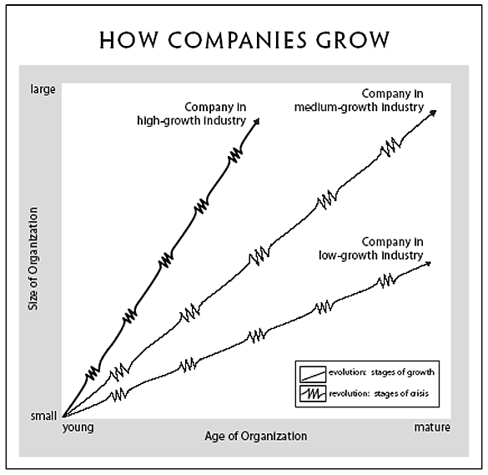
#3 Tannenbaum and Schmidt – How to choose a leadership pattern
- Major Claim: Suggest a framework which managers may find useful in grappling with this dilemma
- Secondary Claim:
- The problem of being democratic and keeping control and authority is a rising problem in our current society
- The leaders are confused between a “strong and permissive” leadership
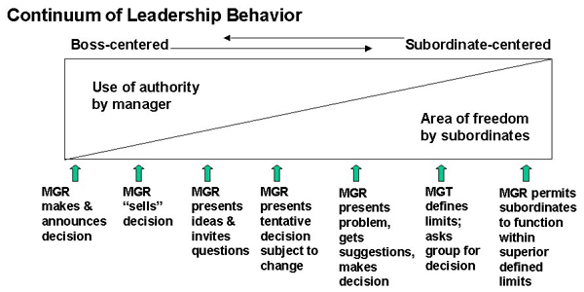

- Factors Affecting Managerial Style Decision
1) MANAGERS
- Value system (How they feel about “individuals” making decision?)
- Confidence in subordinates
- Own leadership inclinations
- Feelings of security in an uncertain situation
2) SUBORDINATES
- High need for independence
- Readiness to assume responsibility to decision’s making
- High tolerance for ambiguity
- Identify with the organization’s problems and goals
- Have knowledge and experience
- Learned to be part of decision making
3) SITUATION
- Type of organization
- Group effectiveness (Old Group Privilege)
- The problem itself
- The pressure of time
- Long-run strategy (What are going to be the impacts of the current decision?)
- Achieving objectives

