LO 3.1 Recognize business as just one institution in society
Pluralistic society: is one where influence or power is decentralized by dispersing it among a variety of institutions
- No one institution is completely independent of others, but each institution does possess some autonomy to pursue its own interests.

LO 3.2 Define and Identify Stakeholders
- Stakeholders: : An individual or group who can influence and/or is influenced by the achievement of an organizations purpose.
- All stakeholders have expectations, such as reasonably priced and good-quality products, adequate wage levels, good working conditions, and a clean, safe environment.
- List of different types of stakeholders:
  - Owners: Those individuals or groups who have invested in a corporation in the form of equity or shares; usually referred to as shareholders.
  - Directors
  - Employees
  - Customers or Consumers
  - Lenders and Creditors
  - Suppliers
  - Service Professionals
  - Dealers, Distributors, and Franchises
  - Business Organizations
  - Competitors
  - Joint Venture Participants
  - Non- Government Organizations
  - Society at Large
  - Education Institutions etc.
  - Media

LO 3.3 Understand dynamic nature of stakeholders’ Influence
Why are stakeholders important to a firm?
What can happen to the firm if managers do not properly identify and satisfy the interests of their firm’s stakeholders?
Why is it important to categorize stakeholders?
Do stakeholders have differing goals and power/influence over time?
- The interaction between the corporation and stakeholders is very much a balancing act. If priority is given the profits for shareholders at the expense of benefits to employees or consumers, then these stakeholders will react, possibly reducing the quality or quantity of their work.

LO 3.4 Recognize Managers’ Responsibilities
- Managers Responsibilities
- Identify stakeholders
- Understand how corporation currently views stakeholders
- Examine how each stakeholder will or might influence firm.
- Assess opportunities and threats.
- Rank stakeholders by influence.
- Prepare programs or policies detailing low to cope with stakeholders.

LO 3.5 Formulate Arguments For and Against the Stakeholder Concept
Arguments For the Stakeholder concept
- Simply good business
- Ignoring stakeholder interests can have substantial economic consequences (e.g., employees, customers, lenders, etc.
- Provides more systematic approach to recognizing stakeholder expectations and deciding how to respond
Arguments Against the Stakeholder concept
- Problems of categorization (e.g., how to identify and prioritize stakeholders)
- Challenges in meeting expectations (e.g., tradeoffs among the stakeholders)
- Dilution of top management focus (e.g., away from financial performance)
- Impracticality of shared governance (e.g., focus still on shareholders)

LO 3.6 Define and issue and issues management/ LO 3.7 Understand the purposes and benefits of Issues Management
Issues Management: A systematic process by which the corporation can identify, evaluate and respond to those economic, social, and environmental issues that may impact significantly upon it.
- Process which the corporation responds to economic, social, and environmental issues.
- Benefits:
  - Corporations are more likely to maintain a competitive advantage over rivals;
  - Corporation is less likely to make a serious social or ethical mistake.
  - Detect issues earlier and develop appropriate responses much sooner

Purposes for Issues Management
- Minimize surprises relating to events or trends in society by serving as an early warning system
- Prompts managers to be more systematic in coping with issues and stakeholder concerns
- Mechanism for coordinating and integrating management of issues

LO 3.8 Describe an issue Life Cycle

Issue Life Cycle

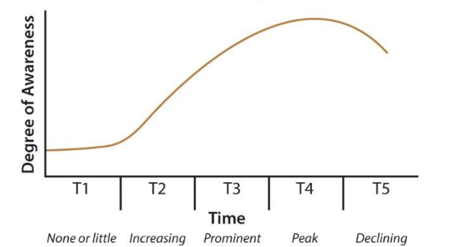
Example: Global Warming would be T2-T3 because people are becoming aware of it but we don’t need to solve it yet.

LO 3.9 Understand the Issues Management Process
The Issues Management Process
- Identification of issues
- Analysis of issues
- Raking or prioritizing of issues
- Formulating issue response
- Implementing issue response
- Monitoring and evaluating issue response

LO 3.10 Understand the importance of Crises Management
Crisis Management
An approach involving planning and removing much of the risk and uncertainty, allowing the corporation to achieve more control over events

Crisis Management Cycle
Stage 1—Avoiding the Crisis
Stage 2—Preparing to Manage the Crisis
Stage 3—Recognizing the Crisis
Stage 4—Containing the Crisis
Stage 5—Resolving the Crisis
Stage 6—Profiting from the Crisis

Chapter 4

LO 4.1 Explain Stakeholder Analysis
Stakeholder Engagement: Efforts by a corporation to understand and involve relevant individuals, groups, or organizations by considering their moral concerns in strategic and operational initiatives.
A corporation can increase its understanding of these stakeholders by answering the following questions.
- Who are our stakeholders?
- What are their stakes?
- What opportunities and challenged are presented to our firm?
- What responsibilities does our firm have to all its stakeholders?
- What strategies or actions should our firm take to best deal with the stakeholder challenged and opportunities?

LO 4.2 Describe Stakeholder Management Capability
Stakeholder Management Capability: The ability of managers to identify stakeholders and their influence, to develop the organizational practices to understand stakeholders, and to undertake direct contact with stakeholders.
- Example: The stakeholder map should include names of non- governmental organizations influencing the corporation.
LO 4.3 Understand Stakeholder Matrix Mapping
Matrix Mapping: A technique of categorizing an organizations stakeholder by their influences according to two variables.
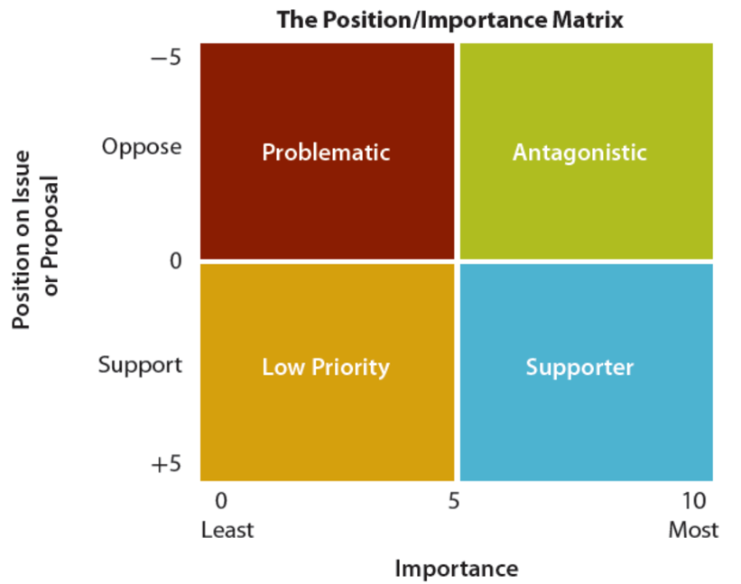
Problematic Stakeholders – Those who would oppose the organizations course of action and are relatively unimportant to the organization.
Antagonistic Stakeholders – Those who would oppose or be hostile to the organizations course of action and are very important to the organization.
Low priority stakeholders – Those who support the organizations course of action and are relatively unimportant to the organization.
Supporter Stakeholders – Those who would support the organizations course of action and are important to the organization.

LO 4.4 Discuss Diagnostic Typology of Organizational Stakeholders
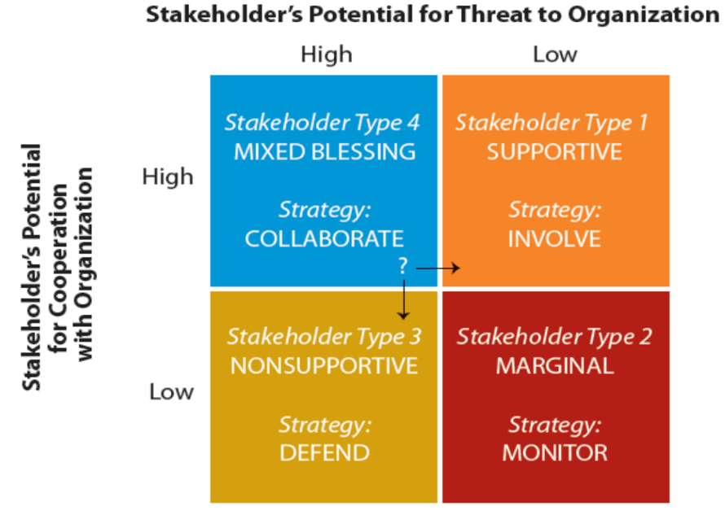
Supportive Stakeholder: This is the ideal stakeholder, providing support by being a low threat and high on potential cooperation. Ex, Employees, Managers.
Marginal Stakeholder: These stakeholders are neither highly threatening nor especially cooperative.
Nonsupportive stakeholder – These stakeholders have a high threat potential but low cooperation potential. Ex, Media, Government.
Mixed Blessing Stakeholder – These stakeholders play a major role in the organization as their threat and cooperation potential are high.
LO 4.5 Apply Stakeholder Identification and Salience typology
Salience: The degree to which priority is given to competing stakeholders.
- Power: The ability to get a firm to do something that it would not otherwise do based on force, threat, incentives, etc.
- Legitimacy: Perception or assumption that the actions of an entity are desirable, proper, or appropriate.
- Urgency: The degree to which a stakeholder’s claim or relationship calls for immediate attention.

LO 4.6 Understand Stakeholder Influence Strategies 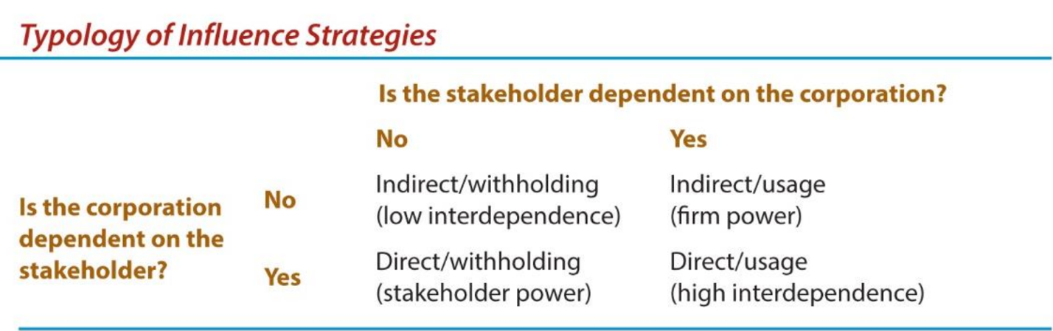
Indirect/usage: Represents no difficulties for the firm.
Indirect/withholding: Exists where the stakeholder encourages a customer of the corporation to withhold its business unless the corporation supplied goods in a particular form or condition.]
Direct/withholding: Is illustrated by a consumer boycott, and if successful, the stakeholder has the power.
Direct/usage: Example, KFC restaurants directing suppliers to provide chicken that were produced under specified humane conditions.
LO 4.7 Understand use of Stakeholder Collaboration

Old and New Approached to Corporate – Stakeholder Relations
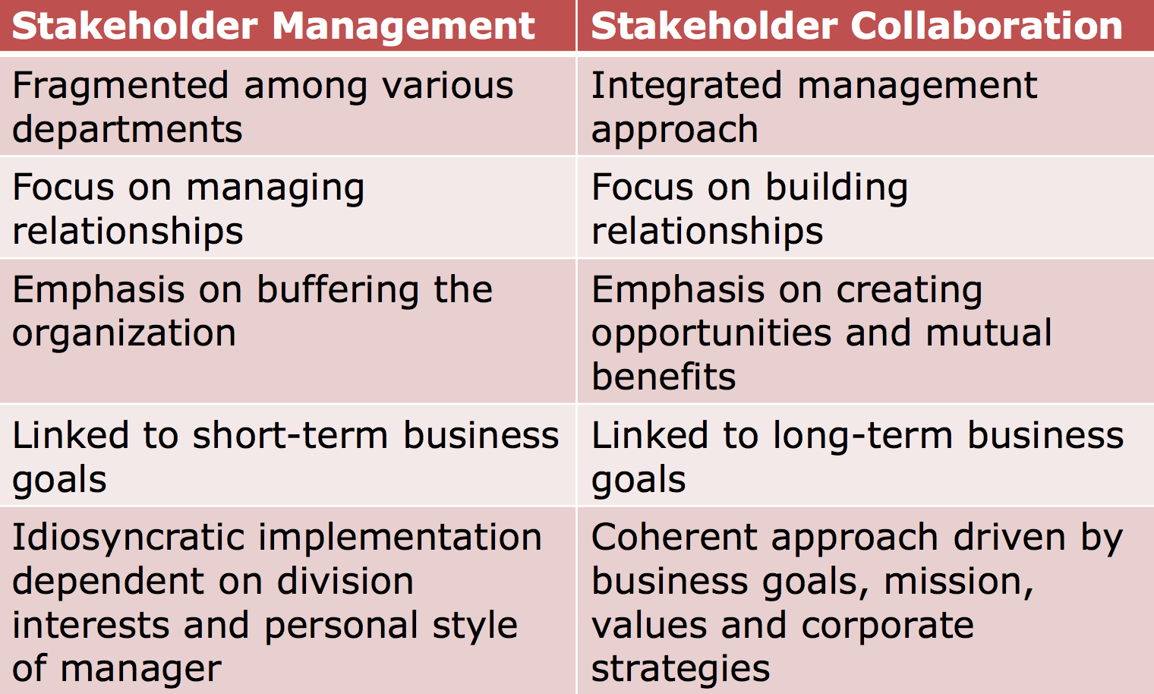

LO 4.8 Understand Social Capital in relation to Stakeholder theory
Social Capital: Any aspect of a corporation’s organizational arrangement that creates value and facilitates the actions of stakeholders within and external to the corporation.
Question: What are the benefits to the firm of creating social capital?
- It facilitates cooperation and coordination that minimizes transaction cost, such as boycotts, legal actions, negotiations, and disruptions in product.

Chapter 13

LO 13.1 Define Non-Governmental Organizations (NGOs) and describe NGO issues

NGO: Is any group that holds shared values or attitudes about an issue confronting society ad advocates for changes relating to the issue.
- Also called public interest, special interest.

What are the issues NGO’s face?
- Climate issues
- Wildlife extinction
- Poverty
- Animal rights
- Economics
- Technology
- Workers/ human rights

LO 13.2 State The Case For and Against NGOs

For
- They generate ideas, knowledge and solutions, disseminate information on issues, and, of course pressure for results.
- Can be agents for change, and can confer legitimacy when governments cannot act alone.
LO 13.3 Identify NGO Strategies to influence business
How do NGOS try to influence business?
- Pressure on governments to change policies
- Damaging publicity
- Picket Manager’s homes
- Organize boycotts
- Develop anti-business documentaries
- Support anti-business documentaries

Strategies for Relationships with NGOs

Continuum of possibilities: From resist to capitulate to pre-empt
Do not underestimate NGO’s influence
Reversing a decision from a project shouldn’t be viewed as a defeat
Sometimes selective concessions are sufficient
Sometimes better to deal with “realist” NGO, not radical ones
A pre-emptive strategy may be feasible
Proactively engage NGO

LO 13.4 Outline partnership Relationships with NGOs
Four key ingredients to a successful partnership:
- Corporate and NGO leaders must show leadership
- The corporation must be open to change
- Must be a commitment to being committed
- Partners must have a shared goal
LO 13.6 Explain The Interaction Between Business and the Media
Business complaints:
- Reporters not sufficiently knowledgeable
- Only interested in “bad” news
- Inherent bias
- Do not respect “off the-record” comments

Media complaints:
- Businesspeople dishonest
- Use excuse that they are only accountable to shareholders
- Overreact to reporting process

Chapter 7

LO 7.1 Describe Corporate Social Responsibility (CSR)
Corporate Social Responsibility: The way a corporation achieves a balance among it economic, social, and environmental responsibilities in its operations so as to address shareholder and other stakeholder expectations.

Key Elements of CSR:
Corporations have responsibilities beyond the production of goods and services.
- These responsibilities involve helping to solve social problems.
- Corporations have a broader constituency than just stockholders.
- Corporations have impacts beyond simple marketplace transactions.
- Corporations serve a wider range of human values than just economic values.
Principles of CSR
- Business and society are interwoven rather than distinct entities
- Expectations are placed on business due to its three roles: institutional; organizational; and individual.
- These three roles can be expressed in terms of three principles of corporate social responsibility: legitimacy; public responsibility; and managerial discretion.

LO 7.2 Debate Pros/Cons of CSR

FOR
- Business must satisfy society’s needs.
- Prevents public criticism and government regulation.
- Investors and consumers support CSR.
- Addressing social problems can become financial opportunities.
  - They can lead to profits, lower costs, and reduced risks.
- Improves public image.

AGAINST
- Profit maximization is the primary purpose of business
- Business is responsible for shareholders.
- Business involvement in social matters increase costs.
- Business lacks training in social issues.

LO 7.3 Appreciate various Social Responsibility Theories
Amoral view
- Traditional view of business as merely profit-making entity
Personal view
- Corporations are like people and can therefore be held accountable for their actions
Social view
- Corporations are social institutions with social responsibilities

LO 7.4 Explain The Pyramid of CSR

All Businesses should follow this model.
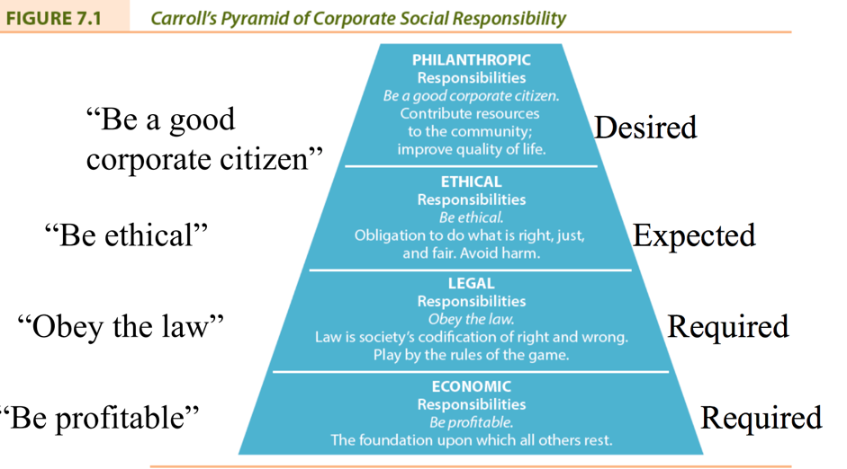

LO 7.5 Define Contemporary CSR Concepts
Corporate Sustainability: Refers to activities demonstrating the inclusion of social, environmental and economic responsibilities in business operations as they impact all stakeholders.
Triple Bottom Line: Evaluates a corporation’s performance according to a summary of the economic, social, and environmental value the corporation adds or destroys.
Social Impact Management: is the field of inquiry at the intersection of business needs and wider societal concerns that reflects the complex interdependency between these two realities.

LO 7.6 Define Corporate and Business Citizenship

Corporate Citizenship: Occurs when a corporation demonstrates that it takes into account its complete impact on society, environment and economy.
Business Citizenship: Includes the responsibilities of corporate citizenship on a local and national basis and extends it to a global or universal scope.

Chapter 8

LO 8.1 Identify different Responses to Corporate Social Responsibility
LO 8.2 Define Corporate Philanthropy
The effort of business to contribute to society socially, manifested by donations of money or goods and services in kind, voluntarism (where corporate employees work for social causes), and sponsorship of events that contribute to society.
For: Public Image, Employee commitment, reputation with suppliers, neighbours.
Against: Costs associated, people feel it’s the governments job, wasting shareholders money.
Includes:
- Cause-related marketing: The purchase of a particular product results in a donation being made by a corporation to a non-profit organization’s program.
- Strategic giving: An attempt to rationalize the shareholder interests with corporate philanthropy whereby the corporation benefits directly from the funds given.

LO 8.3 Define Corporate Voluntarism
The time and talent employees commit to community organizations with support and/or consent from employers who recognize the value of such efforts to society.
Forms of support:
- Providing facilities, allowing time off, assisting with personal expenses incurred while undertaking voluntary activities, special recognition to employees
- Corporate policies regarding voluntarism: encouraging; enabling; and promoting

LO 8.4 Define Corporate Sponsorship
A partnership which has been established for mutual benefit between a business sponsor and an event or a non-profit.
Examples: sports, cultural, and educational events, literacy, race relations, drug abuse, environmental issues, etc.
- Arguments for: brand image, awareness, targeted marketing
- Arguments against: cause association

LO 8.5 Define Social Venture Philanthropy
The investment of human and financial resources by corporations in non-profit community development agencies to generate a social return instead of only a financial one.
- Also known as social venturing, the new philanthropy, and high engagement philanthropy.

LO 8.6 Define Social Enterprise and Entrepreneurship
A model of business operation where some or all profits are deliberately used to further social aims.
Two types:
(1) non-profit enterprises that contribute all profits to social initiatives (i.e. Shorefast Foundation);
(2) for-profit enterprises that divide profits between social initiatives and shareholders (i.e. Google)
Social entrepreneurship involves the activities undertaken to enhance social wealth in some innovative way
Social Entrepreneur: An innovative, visionary leader of a non-profit with real-world problem-solving creativity and a high awareness of ethical considerations.

What do you think are they key barriers to fully integrating CSR/ Sustainability into organizations?

CSR Measurement

What should be measured
- Resources
- Environment
  - Alternative energy, to save money
  - Carbon Emissions
- Asking employers
- Are they doing for presentation or are they doing it for the general well being of society.
- Measure profits
- Waste
  - Recycling
  - Reduced, raising profits.
- Stakeholder Surveys

What do you think are the future trends in CSR reporting?
- Balanced Scorecard

Chapter 9

LO 9.1 Understand CSR Measuring and Reporting
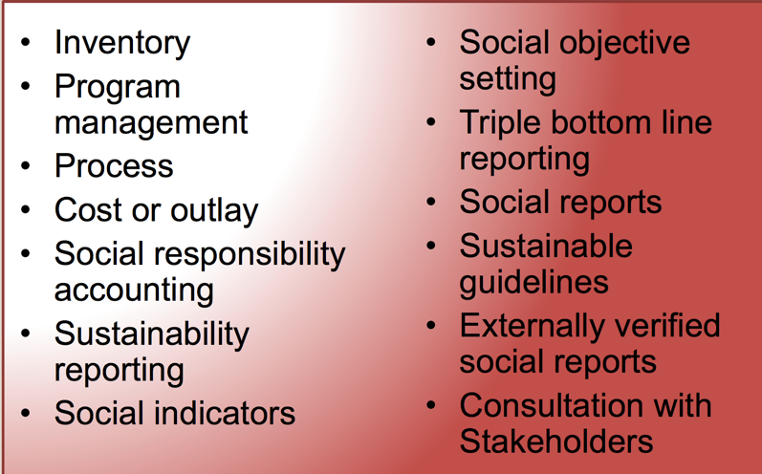
The ultimate in social reporting is to evaluate the corporations performance on these standards and to have the results externally verified.

LO 9.2 Define Corporate Reputation in relation to CSR
Why Report?
- Enhances corporate reputation and trust
- Provides some protection against crisis
- Stakeholders expect accountability and transparency
- CSR linked to profitability

LO 9.3 ID Stakeholders who Influence CSR reporting
- Employees
- Consumers
- Society at Large
- NGO’s
- Media
LO 9.5 Discuss Social Auditing and Reporting Criteria
Measures performance in 7 areas:
- Community (9 criteria)
- Employee (19 criteria)
- Customer (7 criteria)
- Supplier (9 criteria)
- Environment (6 criteria)
- Shareholder (6 criteria)
- International operations (4 criteria)
LO 9.9 Discuss The Future of CSR and Social Reporting
Fad-and-fade scenario:
- Awareness and practice of CSR will decline significantly
Embed-and-integrate scenario:
- CSR is accepted, continuous enhancement continues
Transition-and-transformation scenario:
- incremental changes to CSR are insufficient, redesign of corporation necessary/

Chapter 5/6

Decision Making
- Define the problem
- Identify alternatives
- Evaluate the alternative
- Make decision
- Implement the decision
- Evaluate the decision

Problem: Company falsifying drug data

Identify Alternatives
- Fine print – market
- Media – whistleblowing
- Go to HR – ethics committee
- Talk to someone – supervisor
- Exit – Leave your job
- Changing the frame of the problem – change the perception

Evaluate the Alternative
- Teleology (Act in a way that generates the greatest benefit for largest number of people
  - Balance of harms/benefits
  - Most good/ most people
  - Consequences
- Virtue Ethics (Act in a way that is open, honest, proud.)
  - Couldn’t live with yourself
  - Integrity
- Deontology (Act in a way that a similar decision would be reached by others)
  - Role reversal
  - Put yourself in the shoes of others.

Ethical Systems Vs Value Judgments/ Moral Standards
- Value Judgments: Subjective evaluations of what is considered important
- Moral Standards: The means by which individuals judge their actions and the actions of others.

Influences become the bases for an individual’s value judgments and moral standards that determine behavior

Three levels of assessing ethical implications
- Teleology
- Virtue
- Deontology

What might be some other potential ethical issues in business?
- Abuse
- Unsafe Working Conditions
- Harassment
- Fraud
- Conflict of Interest
- Tax Invasion
- Corruption

What companies come to mind when you think of major business ethics failures?
- Volkswagen
- Enron
- KPMG
- FIFA
- BP

Why Ethical Programs Fail?
- Managers are morally imperfect
- Self- interest
- Rationalization and self-delusion
- Threat of formal sanctions
- Threat of informal sanctions
- Tolerance to risk taking behavior
- Pressure in particular situations

Ethics Officers
- Independent manager
- Reports to the board of directors of CEO
- Reviews complaints or information from anyone in the organization or any stakeholder
- Studies situations and recommends action
- Responsible for the ethics program

Ethics Committees
- Comprising management, employees

What are some of the main issues that concern whistleblowers?
- Personal risk
- Remain silent, quit, or disclose wrongdoing?
- Does obligation to employer supersede obligation to self, profession, or industry?
- Will whistleblower be believed?
- Is whistleblower hero or snitch?
- Who should the whistleblower contact?
- What will the consequences be?

Code of conduct: explicitly states what appropriate behavior is by identifying what is acceptable and unacceptable.
Code of ethics: a statement of principles or values that guide behaviour by describing the general value system within which a corporation attempts to operate in a given environment.

Challenges in Ethics Business
- Indicating ‘just do the right thing’ is insufficient (i.e., too open ended)
- It’s not easy to be ethical
- Unethical behaviour not just due to a few bad apples
- People always have been (and always will be) unethical
- Most believe (due to implicit bias) that they behave ethically towards others
- Despite designing and implementing comprehensive ethics programs and an active role by management in emphasizing ethical behaviour, misbehaviour will still occur

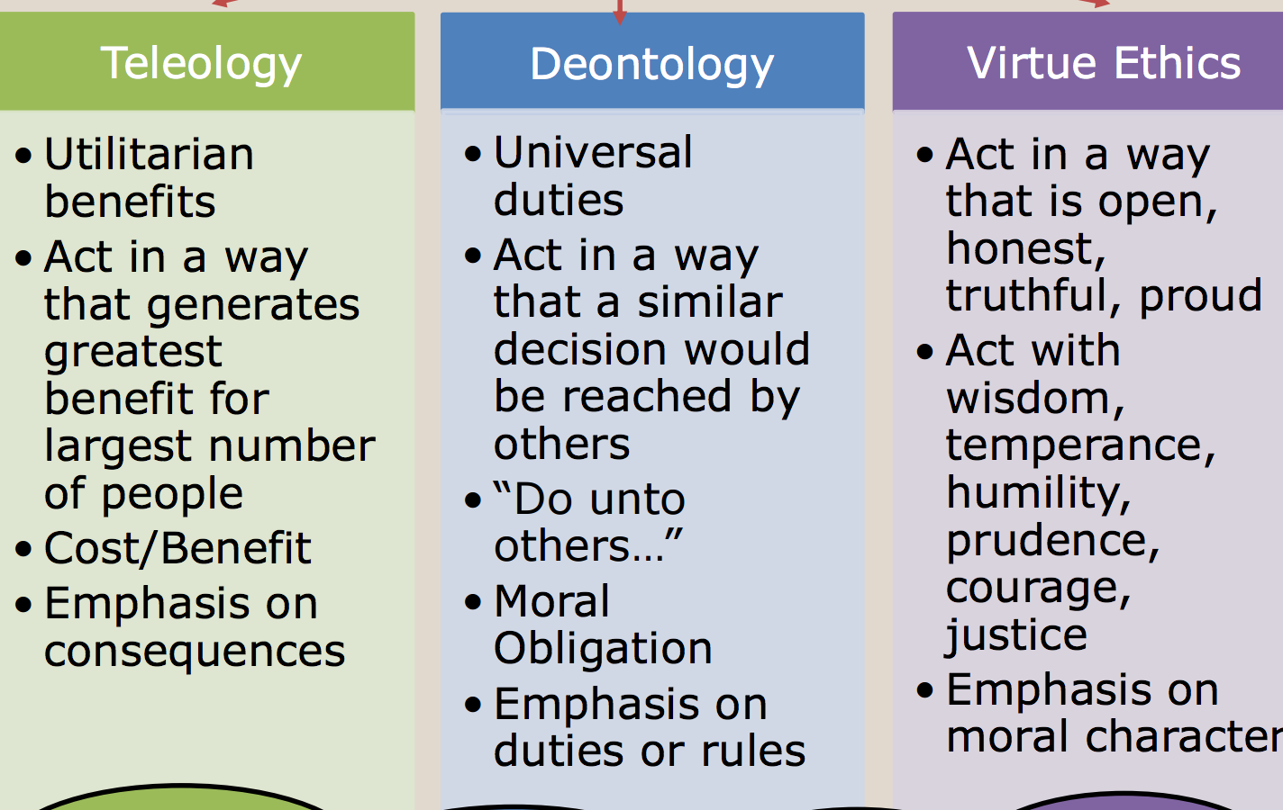
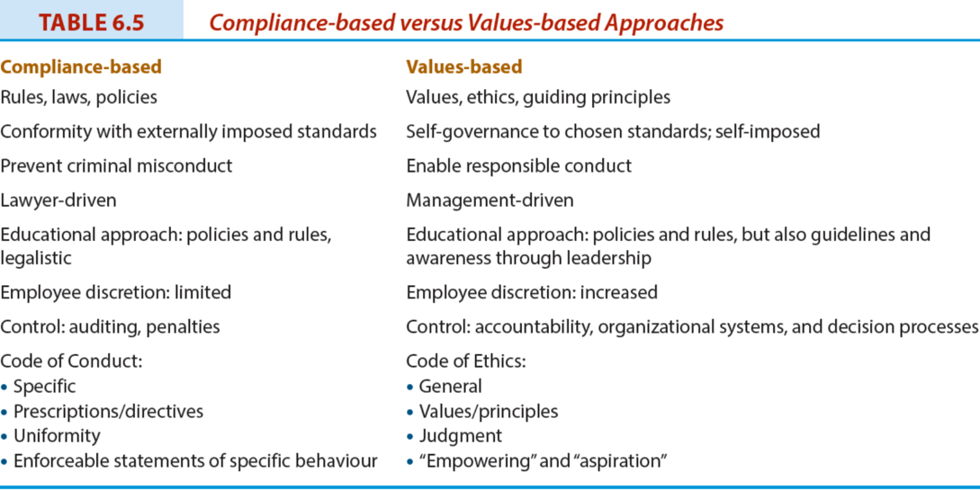

Chapter 10 – Regulating Business

Market Regulation
- No need for government imposed laws or regulations
- Laissez faire approach
- Government does not interfere with business
- Consumers can force companies to behave in particular ways by refusing to purchase goods or services or through boycotts

Self Regulation
- Corporate self-discipline regulation
  - mission, values statement, codes of conduct or ethics
- Industry self-regulation
  - voluntary codes
- Self-regulation involving stakeholders
- Negotiated self-regulation
- Mandatory self-regulation

Government Regulation
- Necessary, because can’t trust business to regulate itself
- Government provides countervailing power to business by reflecting society’s concerns
- Yet, criticized for being oppressive, ineffective, costly, rigid and weakly enforced

Scope of Government Regulation
- is the protector of various societal interests against business exploitation
- is the protector of business and producer interests
- is the owner of business enterprises (e.g. Canada Post)
- directly manages (through regulation) large areas of private business activity (communication, energy etc.)
- is a major purchaser of goods and services produced by businesses.
Lobbying
- All attempts to influence directly or indirectly any government activity, and includes any attempt to influence legislators, their staff members, public administrators, and members of regulatory agencies.
- Business lobbying attempts to influence:
  - Making or amending of legislation and regulations
  - Making or changing of government policies or programs
  - Government decisions in the awarding of grants, contracts, contributions, or any similar benefits
  - Government appointments to boards, commissions, and any other public office
Business Lobbying
Benefits
- Offset the influence of other groups.
- Opinions or perspectives must be made known to governments if informed decisions are to be made about public policies affecting business.
Criticisms
- Practices unethical (e.g., bribes, gifts, improper political contributions, blackmail).
- Business lobby too powerful.
- Business has unequal access to government.
- Cost of business lobbying passed on to consumers.

Corporate Welfare
- Any action by municipal, provincial, or federal governments that gives a specific corporation or an entire industry a benefit not offered to others
- Industries appear increasingly willing to advocate for and accept government assistance

The Corporate Agenda
The real or imagined alleged domination of public policy or government programs by corporations or business organizations in their own best interests.
The corporate agenda might include:
- Reduction of government involvement
- Deregulation of business and industry
- Reduced corporate taxation
- Enactment of free trade agreements and support for globalization

Impact of Changing Government Involvement

Deregulation: the reduction of government influence or impact over the economy allowing for a freer and more efficient marketplace
- Pros: more competitive business environment, resulting in higher productivity, more efficiency, and lower prices
- Cons: reduced environmental quality standards, greater financial uncertainty, and market control by monopolies.
Privatization: Strengthening of the market at the expense of the state
- Provision of public service by the private sector • Degrees of privatization (i.e. complete or partial)
- Techniques or forms of privatization (i.e. divestiture, contracting out)

Ethical Implications in Business- Government Relationship
- Appropriateness of government involvement and interference in business operation
- Matter of accessibility to government
- Favouritism to some corporations regarding loans, grants, or protection
- Endorsement of political candidates or parties can be perceived as expecting favours in future
- Lack of transparency in relationship between government and business

Chapter 11
Corporate Governance: The processes, structures, and relationships through which the shareholders, as represented by a board of directors, oversee the activities of the corporation.
- “For most corporations, the basic governance structure is this: shareholders vote for, and hence empower, a board of directors, who then have a fiduciary responsibility to look out for shareholders’ interests. The board hires a CEO, who is accountable to the board. The CEO (sometimes with input from the board) hires a management team, and so on.
- At each step, there is a flow of power down the chain (from shareholders through to front-line employees), and a flow of accountability back up that chain.”1

The People Who Run Canadian Business
Owners
- Direct ownership (e.g., shareholders); or
- Indirect ownership (e.g., mutual fund holders)
Boards of Directors
- Elected by shareholders
- Must fulfill legal and fiduciary obligations
Managers
- Top Managers are hired by boards of directors
- Oversee operations of corporation

Role of the Owner Stakeholder
- Owners, also referred to as investors or shareholders, are key stakeholders in a capitalist system as they provide a major portion of the capital to finance corporations.
- Governing system: The processes, structures, and relationships through which decisions are made.

Rights of Shareholders
- Secure ownership registration
- Capability to transfer ownership
- Access to relevant corporate information
- Participation and voting at shareholder meetings
- Election and removal of board members
- Share in profits of the corporation

Shareholder Democracy: Passive versus Active Shareholders
Shareholder Democracy: the exercise of power by owners to ensure they are treated fairly and enjoy equally the privileges and duties of ownership
Passive shareholders: do not attempt to influence the affairs of the corporation even though they have a legal right to do so.
Active shareholders: participate in the governance of the firm to the full extent allowed by law.

Responsibilities of the Board
Board of Directors: group of individuals elected by shareholders to govern or oversee the corporation’s affairs.
- Fiduciary duties: obligations of directors to shareholders that are prescribed by laws or regulations.
- Board’s written mandate must include board’s satisfaction with integrity of CEO and other executives and that they are creating a culture of integrity (Canadian Stock Exchanges)
- Board must apply high ethical standards and take into account the interests of stakeholders (OECD, 2004)

Balancing Power in the Corporation and Criticism of Corporate Governance Reform
Rebalancing Power:
- CEOs have been too powerful
- New balance of power emerging among management, board, professional services (e.g., lawyers, auditors)
- Directors now playing bigger role in strategic decision making and ethical responsibilities
- Auditors more cautious
- Legal counsel representing everyone
- Some shareholders more active in pressuring boards
Criticism of Reform
- Audit fees have increased
- Management attention diverted away from operation of business
- Additional costs have made North American business less competitive in global market
- Changes may not make a difference to firm performance or in protection of shareholders
- Approach should be principles based, not rule-based

Board Membership & Structure
Independent director: A director who is free from any interest and any business or other relationship which could, or could reasonably be perceived to, materially interfere with the director’s ability to act in the best interests of the corporation.
- Board committee examples:
  - audit; finance; human resources; pension; compensation; nominating; governance; and strategic planning.
  - Audit committee is required to have independent members
  - Most experts recommend separation between the role of the board chair and the CEO.
Corporate Governance and Performance
- Some research suggests that good corporate governance affects firm performance • Effective boards:
  - Are accountable and independent
  - Have experienced, knowledgeable and effective directors with the highest level of integrity
  - Have clear roles and responsibilities
  - Engage with stakeholders

Ownership, Governance, and CSR

Directors are encouraged to ask five questions about the corporation’s ethics management:
- What is the strategy to manage ethics?
- Who is responsible for ethics in our company?
- Are people in our firm equipped to recognize and resolve moral dilemmas?
- Are people in our firm provided with a safe opportunity to discuss ethical issues of concern?
- Do we reward or punish ethical integrity and moral courage if it has a negative impact on the bottom line?

Chapter 12 Ethics in the Workplace

Employee loyalty
- Commitment by employees to the organization they work
- Employers can also demonstrate loyalty to employees
- Measuring loyalty can be difficult
- Loyalty can go to one’s self or one’s job, rather than the corporation
Employee engagement
- The emotional and intellectual commitment of an individual or group to an organization that supports building and sustaining business performance.

What do you think are the key drivers of employee’s engagement?
- Good leadership
- Co-workers
- Employee appreciation
  - Awards
- Corporate culture
- Good communication
- Opportunity for growth

Potential Ethical Issues in Business
- Right to privacy
Discrimination: The preferential (or less than preferential) treatment on bases not directly related to qualifications of the job or job performance
  - Gender
  - Age
  - Minorities
  - Race and social origin

Workplace Privacy
- Privacy of personal information is regulated by the federal government’s Personal Information Protection and Electronic Documents Act (PIPEDA) and other provincial legislation.

Employment equity
- The fair and equal treatment of employees
Diversity Management
- Voluntary initiative beyond what is required by law to eliminate discrimination

Competitors and Competition
- Competition is necessary for an effective market economy and benefits the consumer
- But can lead to questionable practices:
  - industrial spying, espionage, sabotage, eavesdropping, hiring competitor’s key employees
  - Causes: cutthroat global economy, aggressive competitive tactics, and shorter product cycles
  - Concentration of corporate power: Concern over collaboration and higher profitability

Factors determining competitive behaviour
- Entrepreneurship; deregulation and privatization; technology; decline of natural monopoly; mergers/takeovers; global trends in trade

Consumer and Consumption

Consumer rights: To choose, to be heard, to education, to redress, to be informed, to safety, to a healthy environment
Consumer sovereignty: consumers dictate goods and services to be provided • elements of democracy are present, Consumers make their own choices, economic system operates more efficiently when consumers determine production
Consumers and the marketplace • Concerns: high information costs, misleading advertising, unsafe goods
Suppliers and the Supply Chain
Supply chain
- The route a product travels from the procurement of raw materials, the transformation into intermediate goods and then final products, and the delivery to consumer through a distribution system to its ultimate disposal by the consumer
Extended producer responsibility
- “An environmental policy approach in which a producer’s responsibility, physical and/or financial, for a product is extended to the post-consumer stage of a product’s life cycle.
Business-to-business: Commercial activity where one corporation sells goods or services to another corporation rather than to consumers.
- Buyers are increasingly recognizing suppliers who are committed to considering social and environmental responsibilities

The supply chain is regulated by the Canadian Competition Act to prevent suppliers not taking advantage of their customers:
- Exclusive dealing, tied selling and market restrictions
- Price discrimination
- Price maintenance
- Refusal to deal

Case
- Who are the stakeholders in this case?
- Media
- Environment
- Community
- Vale
- Government
- NGO’s
- Employees
- What is their influence and/or how are they influenced by the situation?
- Government – Definitive stakeholder
- Community – They have legitimacy and urgency, not power
- Vale – They have power, urgency, not legitimacy
- What are the issues involved?
- The environment of the lake
- Pollution
- Toxic Water
- How can Vale justify the decision to dump toxic waste in the lake?
- Its legal
- Its benefitting more people, cost/benefit analysis
- Deontology – Do onto others
Chapter 14 – The Environment

Environmental issues confront virtually all aspects of the corporation, from the input of resources to the manufacturing process, and from workplace conditions through to the way products are packaged and sold.
Commons: Any resource used as though it belongs to all.

Defining Environmental Ethic and Sustainable Development

Environmental ethic: the set of values or principles that govern a corporation’s practices relating to the environment.
Sustainable development: development ensuring that the use of resources and the impact on the environment today does not damage prospects for the use of resources or the environment by future generations.
Business Sustainable Development: Adopting business strategies and activities that meet the needs of the enterprise and its stakeholders today while protecting, sustaining, and enhancing the human and natural resources that will be needed in the future.”

Environmental Concerns in Business and Society
Acid rain , Air pollution, Ecosystems, Energy production and consumption, Nature and wildlife, Ozone, Pollution, Waste management, Water quality, Climate change/ global warming

Environmental NGO Influence
- Environmental non-governmental organizations (ENGOs): groups that hold shared values or attitudes about the challenges confronting the natural environment and advocate for changes to improve the condition of the environment.
- Such groups (e.g., Greenpeace) influence corporations through protests, blockades, boycotts, and annual shareholder meetings.

Measuring and Reporting on Environmental Sustainability
- Type and amount of materials used
- Source of energy and efficiency of use
- Source and quality of water
- Impact on biodiversity
- Reduction of emissions, effluents, and waste
- Product design that minimizes impact
- Compliance with environmental laws
- Use of efficient transportation

The Environment: Threat or Opportunity
Threat:
- Corporate image may deteriorate
- Revenues may suffer if customers are lost
- Investors may decide not to invest
- Material and production costs may increase
- Financial penalties increasing
- Insurance premiums can increase
- Government may enact stricter legislation

Corporate Opportunities
- Reputations likely enhanced
- Customers attracted
- Investors attracted
- Costs reduced through recycling/conservation
- More competent staff attracted
- Better integration with local community
- New technologies or expertise developed
- More efficient ways of producing products found

Market- Driven Environmentalism
Standard Environmentalism: Government regulation occurs when it is a necessary remedy for market’s failure to provide environmental amenities
Market Environmentalism: Economic incentives created by market are more effective at protecting the environment than government intervention
Environmentalism affected by market factors: Economic growth, free trade, property rights

Chapter 15 – Globalization

Globalization: a process of decreasing constraints on the interactions among the nations and peoples of the world.
Economic globalization: the integration of fragmented markets into a global economy.
Political globalization: the process by which world power relationships change, and there is a loss of sovereignty by the states.
Social or cultural globalization: the emergence of a worldwide cultural system.

Globalization and the Implications for Business
- Damage to the environment
- Support for oppressive regimes
- Criticism of marketing practices (e.g., tobacco, pharmaceutical, baby formula, etc.)
- Arms trade
- Treatment of employees (e.g., sweatshops)
- Treatment of indigenous peoples
- Genetic modification of plants and animals
- Corruption and bribery

Institutions of Globalization

- Supranational Institution: an international organization that transcends national boundaries where the member states share in decision making on particular issues pertaining to the members
- The World Bank: Provides financial and technological assistance to developing countries.
- The International Monetary Fund (IMF):Fosters financial stability, international trade, employment, and reduction of poverty.
- International Labor Organization (ILO): An agency that seeks to promote social justice and internationally recognized human and labor rights.
- World Trade Organization (WTO): Coordinates agreements reducing trade barriers.

International Non-Governmental Organizations (INGOs)
- INGOs are groups that hold shared values and attitudes about the issues relating to globalization and advocate for changes to improve conditions in developing countries •
- INGOs put pressure on corporations and governments
- INGOs are also referred to as transnational non-government actors (TNGOs) or transnational social movement organization (TSMOs)

The Debate Over Globalization

FOR
- Trade leads to more efficient production of better goods and services
- Better opportunities for employment and higher incomes
- Standard of living has increased
- Transfer of capital, technology, intellectual property, skilled labour

AGAINST
- Benefits received by only a few
- Creates unemployment
- Increased poverty and inequality
- Causes periodic financial crises
- Destroys local environment
- Destroys cultures
- Violates human rights
- Questionable payments made
- Disrespect of intellectual property

Human rights: The fundamental rights and freedoms to which all individuals, groups, and societies are entitled (e.g., sweatshops).

Corruption: The abuse of entrusted power for private gain (e.g., bribery)
- Bribery: making questionable payments, or bribes, to government officials to influence their decisions
- Three types of bribery assessed included:
- Bribery of high-ranking politicians or political parties
- bribery of low-level public officials to ‘speed things up’
- the use of personal or familiar relationships to win public contracts.

Chapter 16 – Sustainability

Sustainability strategy: A plan that views economic, ethical, social, and environmental responsibilities more intensively and integrates corporate social responsibility (CSR) into all facets of the corporation’s operations. Also referred to as a CSR strategy

Strategic management: The process through which a corporation establishes its mission and objectives, analyzes the environment and resource capabilities in order to formulate strategy, creates the organizational systems and processes needed to implement the strategy, and devises mechanisms for evaluating performance

Sustainability Strategy and Purpose
Vision: A statement of what the corporation wants to become or where it wants to be at some date in the future.
Mission: An enduring statement that specifies in broad, even philosophical, terms the organization’s “reason for being” and what distinguishes it from similar organizations.
Values: The basic assumptions about which ideals are considered desirable or worth striving for

- Sustainability Strategy and Formulation

- Assessment of the external environment in which the corporation operates
- understand when and how this environment influences the corporation.
- Assessment of internal resources and capabilities
- Allows corporation to determine its ability to take advantage of opportunities in the environment and to overcome any threats.
- Establishment of objectives
- The ends the corporation seeks to achieve through its existence and operations.
- CSR strategy options and selection

- Sustainability Strategy Implementation

Sustainability implementation includes:
- designing the corporation’s structure;
- allocating resources;
- developing information and decision-making processes;
- managing human resources, including such areas as the reward system, approaches to leadership, and staffing

- Sustainability Strategy Evaluation
- It is important to have continuous monitoring and reviewing of the strategic management process
- It has become important to incorporate social policies into the strategic management process:
  - Business legitimacy depends on it.
  - Government can legislate compliance regulations.
  - Business’s success and continued existence are interrelated with social policies.

