LECTURE 1
Historical views of Marketing:
- Plato – salesmen are weakest in bodily strength and little use for any purpose
- Cicero – Merchants are to be accounted vulgar, the profit they make is falsehood
- Veblen – advertising is meretricious, appeals to “fear and shame”, worthless packaged goods at bloated prices
Modern view:
- Newsweek – most powerful competitive weapon is marketing
- Greyser, HBS – marketing is central to success
- Peter Drucker- Whole business from customer’s viewpoint
Marketing concept: key to achieve org goals consisting of determining needs and wants of target markets, delivering desired result more effectively and efficiently than competitors.
- Concentrate on needs of the buyer, not needs of the seller
Marketing: process of maximizing company profits (s/t and l/t) by creation of superior value, customers
Pillsbury: resealable tub was good idea but prices 20% higher than regular tube and contained less
- s/t: booming sales l/t: sales drop and selling only 1 flavor (choco chip)
Product distribution: some companies don’t want to associate themselves with Wal-mart because WM forces them to maintain a lower than regular price and their brand can be diminished as “everyday” or “casual:. Ex: whole foods does not want to be seen at WM because they’re a specialty brand
The Marketing Concept:
- Needs: state of felt deprivation ex: I’m hungry
- Wants: Needs shaped by culture and individual personality ex: I’m hungry, I want fries and Coke
- Demands: wants backed by buying power ex: I have money to buy this meal and I am willing to get it
- Products: anything that can be offered to a market for attention, acquisition, use or consumption which might satisfy a need or want
- Customers’ decision criterion:
  - Customer Value: Benefit that the customer gains from using a product compared to the cost of obtaining a product benefit > cost
  - Customer satisfaction: depends on product’s perceived performance in delivering value relative to a buyer’s expectations
- Meeting needs and wants:
  - Exchanges: Act of obtaining a desired object from someone by offering something in return
  - Relationships: process of creating, maintaining and enhancing ongoing exchanges or transactions
- The market: set of all actual and potential buyers of a product or service
- Marketing myopia: mistake of paying more attention to products than to benefits and experiences produced by these products
- Designing a Customer-driven marketing strategy
Concepts:
- Production: consumers will favor affordable and accessible products
- Product: consumers want highest quality, management → continuous product improvements
- Selling: products need large-scale selling and promotion effort
- Marketing: know needs and wants of target market, deliver satisfaction better than competitors
- Societal: consider consumers’ wants, comps requirements, consumer and society’s L/T interests
Kodak: thought they were in the business of film making, lost out to digital cameras, they are in the storytelling business
Classic marketing approach:
- Market-driven
- “give customer what they want”
- Good for markets with high buyer familiarity
- Assumes buyers evaluate choices based on fixed value concepts
Alternative marketing approach:
- Market-driving
- “help customers learn what they want”
- Good for rapidly evolving markets with growing number of novel products
- Assumes buyers can learn and evolve with new value concepts
CRM (customer relationship management): overall process of building and maintaining profitable customer relationships by delivering superior customer value and satisfaction
- Costs 5-10 times MORE to attract a new customer than it does to keep a customer satisfied
- Markets must look at lifetime value of customer
- Customer equity: total customer values of all the company’s current and potential customers
- Not all customers are profitable, treat customers as assets, need to be managed and maximized
- Customer-managed relationships: Consumers, empowered by technology, interact with companies and with each other to shape their relationships with brands
- Consumer generated marketing: brand exchanges created by consumers, invited and uninvited. Consumers play an increasing role in shaping their own brand and those of other consumers.
- Partner relationship management: work closely with partners in other departments and outside the company to bring more value to customers.
Customer lifetime value: entire stream of purchases that ONE customer makes over a lifetime loyalty
- CLV can be negative if customer keeps buying but doesn’t pay, sometimes company might want to give customer money to “fire” them and get them off their books as negative value
Marriage kit – consumers buy more in the first 6 months of marriage than avg HH does in 5 years
- Buy more of the products included in marriage kit ex: Tide, Mr Clean, etc…
Marketing is a process – more than selling and advertising
- Analyze needs
- Predict wants
- Estimate demand
- Predict when
- Determine where
- Estimate price
- Decide promotion
- Estimate competition
- Provide service
Strategic Planning: managerial process of developing and maintaining a strategic fit between the org’s objectives and resources in its changing market environment.
- Steps
  - Define company mission: mission statement → corporate level
  - Set company objectives and goals
  - Design business portfolio: analyze current, shape future, BCG matrix, expansion grid
  - Plan marketing and other functional strategies → business unit, product and market level
Portfolio analysis: process where management evaluates products and business that make up company
Grow-share matrix: portfolio planning method, evaluates comp’s SBUs in terms of market growth rate and relative market share
Mission statement: org’s broad purpose, often identifies:
- Customers
- Markets
- Products
- Technology
- Values
Evaluating a mission statement: market-oriented (not focused on products), realistic, motivational, consistent with market environment
Corporate goals convert the mission into targeted levels of performance
- Ex: Customer satisfaction: over 4.5/5.0 customer online review
Strategic Business units (SBUs): segments of a company → beauty, fabrics, baby, health & grooming
Value chain: internal depts. That add value to design, produce, market, deliver and support a firm’s products
Value delivery network: made up of company, suppliers, distributors to work together to improve performance of entire system
Limitations of BCG analysis:
- Independence assumption
  - Does not account for synergies
  - Cannot explain cannibalization
- Not powerful for future planning
- Limited info used
  - Market attractiveness = growth?
  - Competitive position = market share?

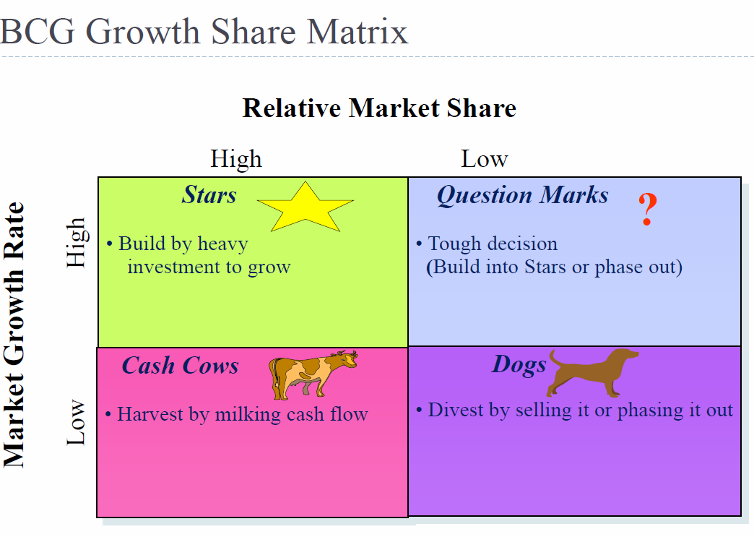
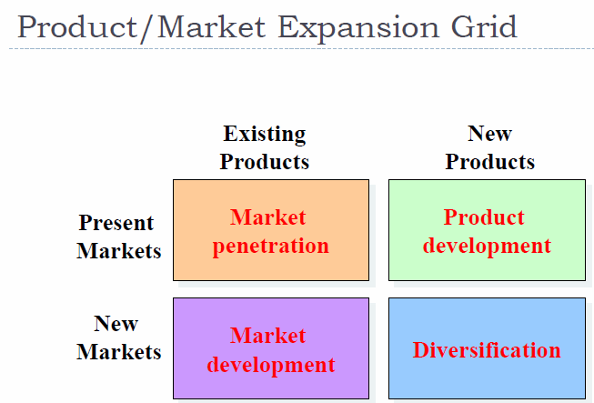
Market penetration: make more sales to current customers without changing products
- Add new stores, improve advertising, prices, suggest new usage, service or store design
Market development: develop new markets for current products
- Identify new demographic or geographic markets
Product Development: offer new products to current markets
- New styles, flavors, colors or modified products
Diversification: new products for new markets
- Start or buy new businesses
Marketing implementation: turning marketing strategies into marketing actions to accomplish objectives
Marketing control: measuring and evaluating results of marketing strategies and taking corrective action to ensure objectives are achieved
Return on marketing investment (marketing ROI): net return from marketing investment divided by the costs of the investment
Planning phase
- SWOT analysis: complete analysis of company’s situation
  - Internal: Strengths, Weaknesses
  - External: Opportunities, threats
- Customer-focused marketing strategy (STP): segmentation, targeting, positioning
  - Targeting and positioning
  - Managing marketing mix (4 Ps) product, place, price, promotion

Company’s microenvironment: actors close to the comp that affect its ability to service its customers
- Company
- Customers
- Competitors
- Public
Company’s macroenvironment: larger societal forces that affect the microenvironment
- Demographic: more ppl are divorcing, stay at home dads, increased # of working women
- Economic: children increasing in developing countries, decreasing in developed countries
- Natural: teenagers are very susceptible to peer influences
- Technological: forces that create new technologies creating new product and market opportunities
- Political: increase legislation, social responsibility emphasis
- Cultural: ex… ads catered to LGBT community
LECTURE 3
Marketing Research: process of acquiring market info to improve marketing decisions
- Firms get marketing research from customers and firm gives 4Ps to customers
- Dove example: Women want to be beautiful in their own unique way
Marketing Info Systems (MIS) – info needed by managers can be obtained from:
- Internal data: computerized collection of consumer and market info from data sources within the company network → Pharmaprix points card – customers are giving info
  - Gathered via customer databases, financial records + operation reports
  - Advantages: quick, easy access to info
  - Disadvantages: incomplete, inappropriate to particular situation
- Marketing Intelligence: collection and analysis of public info about competitors and developments in the marketing environment (i.e. technological)
  - Competitive intel gathering activities have grown
  - Many sources of competitive info exist
Procedure for Marketing Research:
- Define purpose - why? What should it tell us?
  - Objective
  - Specific questions – is taste the most important aspect of cola preference?
  - Hypotheses - do not identify the cola by taste alone
- Plan research - How should research be carried out?
- Observation is either correct or otherwise
- Perform research: collecting and analyzing data – what do we do with the data?
- Z test for p>0.5
- Interpret and report findings: - what do we do with the results?
- Include recommendations based on research results
“The formulation of the problem is often more essential than the solution” - Albert Einstein
Research Plan – classification of research types:
- Exploratory: insights into general nature of problem, possible decision alternatives, relevant variables to consider
  - Little is known about situation
  - Gain ideas and insight about problem
  - Determine factors/variables may potentially be influential
  - Research outcome: list of potentially influential factors
- Descriptive: accurate snapshot of some aspect of market environment ex: age, personality
  - Summary measures, question is clearly defined
  - Characteristics of relevant groups
  - Research outcome: summary measures of characteristics

- Causal: whether one variable causes or determines the values of other variables – dependent
  - Used to establish cause and effect among variables
  - Outcome: X1 (higher advertising) → Y (increase in sales)
- Necessary conditions for causality:
  - Temporal antecedence – cause must come before effect (A before B)
  - Covariation (correlation)
  - Absence of rival explanations – no plausible explanation for B except A, ceteris paribus
Correlation does not mean causation
Spurious correlation types:
- Reverse causation: ex – more firemen fighting a fire, bigger fire is. Therefore, firemen cause fire.
- Third common causal factor: does wearing a seatbelt reduce death risk in a car accident?
- Conincidence: Since the 1950s, both CO2 level and crme levels increase sharply. So CO2 levels cause crime.
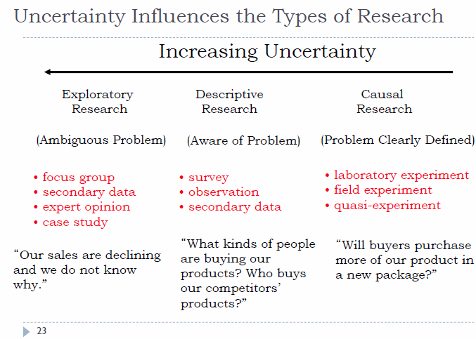

Data Sources:
- Primary: collected by researcher, specific objective
  - Advantages: more reliable, used in all research designs, better for specific objectives
- Secondary: collected by 3rd party, no specific objective
  - Advantages: cheaper, easy to obtain, best for exploratory research
Qualitative research: small samples, non-structured data procedures, initial insights about problem
- Should not be used to recommend final course of action
- Main methods: focus groups, in-depth interviews, observation
  - Focus groups are best for preliminary research – thoughts and feelings about products
In-depth Interviews:
- One respondent
- One researcher leads the discussion
- Laddering as a technique – follow-up question baes on respondent’s answer
Classic observation – researcher does not communicate with the people being observed ex: eye tracking
Projective techniques: unstructured and indirect way of asking questions, encourage people to project their ideas.
- Word association: list of words , first word that comes to mind
  - Measures: frequency, elapse time, # of respondents who don’t respond at all
- Sentence completion
- Picture response & drawings – describe the picture – draw likely buyers of a brand
- ZMET: collect a set of pictures representing their thoughts and feelings about the topic
Qualitative research:
- Results are not representative
- Difficult to interpret i.e. what respondent really mean
- Still very important to obtain initial understanding of the markets and consumers
Survey Data: useful for descriptive research
- Advantages: standardization and completeness, ease of administration, suitable for statistical analysis
- Main problems: “I don’t care”, easy to do wrong
- Online contact method is the most efficient (flexible, control of interviewer, speed of data collection, cost)
Ethnographic research: form of observational research where observers watch and interact with consumers in their “natural environment”
Types of Sampling Methods:
- Non-Probablity: some elements have ZERO change of being selected
- Convenience: cheap convenient, ex: person on the street, popup window on website
- Judgment: expert opinion, “techy” consumers
- Snowball
Drawback of non- sample: may not be representative of target pop, difficult to project sample to target pop.
Used: exploratory research, when prob. Samples are too expensive

- Probablity: very element has known probability in sample, adv: quantify amount of error because using sample instead of census
- Simple Random: each element has known prob, comp generated random numbers, requires list of pop. elements
- Cluster: inexpensive to conduct 2 step procedure:
- Pop is divided into mutually exclusive and exhaustive subsets
- Random sample of subsets is selected
- Homogeneity across clusters, heterogeneity within clusters
- Stratified: must know each stratum size… 2 step procedure –
- Divide target pop. Into subsets or strata (mutually exclusive and exhaustive), based on one or more characteristics
- Simple random sample is chosen from each subset
Reasons for using stratified sample:
- Increase precision (lower sampling error)
- Ensure different subgroups are represented
Why don’t we ask people what they want?
- People don’t really know what is possible
- People don’t always know their needs
- People don’t want to tell you why they do what they do
- People don’t know why they do what they do
- Sometimes asking them changes their behavior
LECTURE 4
Consumer Behaviour: activities of consumers in obtaining, using and disposing of goods and services, including the decision process that precede and follows these actions
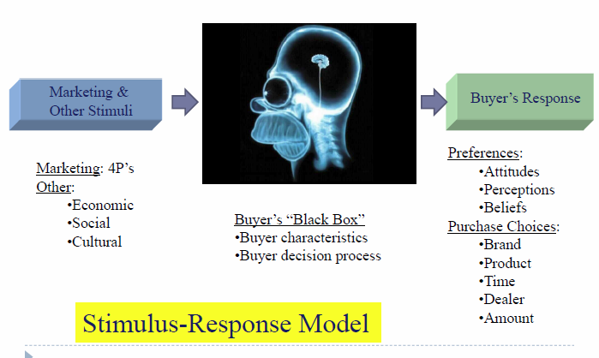
Factors influencing consumers:
- Cultural: culture, subculture, social class
- Social: reference groups, family, roles and status EXTERNAL
- Personal: age and stage in life cycle, occupation, lifestyle, personality and self-concept
- Psychological: motivation, perception, learning, beliefs and attitudes INTERNAL
Lifestyle: person’s pattern of living as expressed in their psychographics
- Measure’s a consumer’s AIOs (activities, interests, opinions)
Personality: unique psychological characteristics that lead to consistent and lasting responses
- Brands also have personalities which consumers might identify with
Motivation: need that drives the person to seek satisfaction of the need
Maslow’s hierarchy of needs: market opportunity to provide needs
- Physiological: medications, generic foods, supplements for athletes
- Safety: smoke detectors, insurance, seat belts
- Social: cosmetics, clothing, entertainment making and maintaining relationships
- Self-esteem: clothing, furniture, liquor, hobbies
- Self-actualization: education, hobbies
Perception: how to reach consumers?
- Exposure: consumer must see your billboard
- Attention: consumer must look at your ad
- Perception: consumer must take in message
- Selective attention: screen out most info to which they are exposed
- Selective distortion: interpret info to support beliefs
- Selective retention: remember good points about a brand they like and forget good points about competing brands
Reality IS Perception: what is perceived is not necessarily true but it’s reality for them, it affects their actions
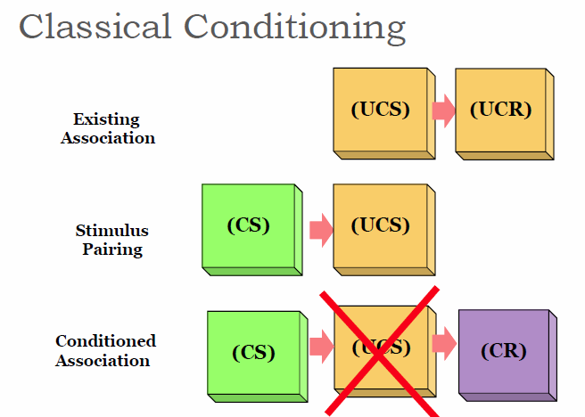
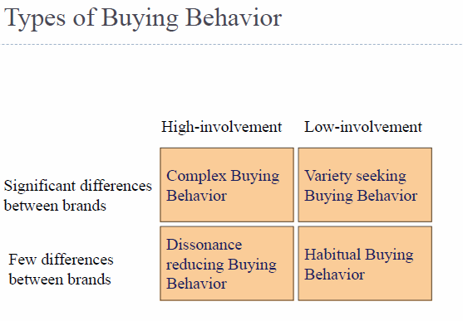
Buyer decision making process:
- Need recognition: not a need, marketers must know why consumers need something
- Internal stimuli: hunger, thirst
- External stimuli: rain, heat
- Ex: bottled water vs tap water
- Info search: search for alternatives
- Personal sources
- Commercial sources
- Public sources: mass media
- Experiential sources: handling, examining
- Evaluation of alternatives
- Evaluate different attributes differently
- Highly product’s strengths in info stage
- Purchase decision: choosing an alternative based on
- Attributes of the alternative
- Other consumers’ attitudes
- Value net of cost to acquire (convenience to store)
- Post-purchase evaluation: value consumed
- Discrepancy between consumer’s expectations and perceived performance
- Cognitive dissonance: buyer discomfort caused by post-purchase conflict
Types of reference groups: aspirational, associative and dissociative (wanting to not look old)
Compliance: tendency to yield to influence
- More likely to occur in public than in private
- Can be triggered, automatic, efficient

LECTURE 5
Segmenting: dividing market into smaller groups with distinct needs, characteristics
- Benefits: better meet consumer demands, better use marketing mix
- Understand customer needs and segments: ex people don’t like to drink Pepsi in the morning
- Segmentation: marketer’s view of the consumer
Bases of segmentation:
- Geographic: region, city size, urban vs. rural, climate ex: Costco in Cali vs Costco here
- Demographic: age, gender, religion, nationality ex: Vespa for women or older men
  - Life cycle: newlyweds have “sharpened” memory and loyalty, open to changes
  - “pure” demographics doesn’t work so add psychographic element to it
- Psychographic: social class, lifestyle, personality, values
  - Difficult to identify
  - Often closer to “real” segmentation
  - Tells “why” people consume, not just “who”
    - Ex: old people → higher value on security → insurance
  - More determinant of consumer behaviour but harder to measure
- Behavioural: usage occasion (typecasting), usage experience, frequency, loyalty, benefit
  - XXX chocolate for snowy winter, Corona beer on beach
- Additional factors for international segmentation: political, legal, culture, economic
Necessary conditions for good segments:
- Homogeneous within
- Heterogeneous between
- Targetable
  - Measurable: identifiable based on observations
  - Accessible: marketing activity
  - Substantial: large enough to make business sense
  - Actionable: resources should be available
  - Differentiable: distinctive behaviour
  - Stable: across time
Targeting: evaluating each market segment’s attractiveness and selecting one or more segments to enter

Target marketing strategies:
- Undifferentiated marketing (mass-marketing)
  - Economies of scale
  - Less investment
  - Vulnerable to competition focusing on segments
- Differentiated marketing (segmented marketing)
  - Higher combined sales
  - Better and stronger position
  - Potential problem with economies of scale
  - Cannibalization
- Niche marketing: narrowly defined group, small market → needs are not being served
  - Good when company resources are limited
  - Achieve a strong position ex: Whole Foods in the Organic food market
  - Large market share of a small market
Selecting Segments to Target
- Segment size and growth
  - Market potential and sales potential
  - Projected growth rate
- Segment structural attractiveness
  - Competitors
  - Manufacturer-retailer relationship (bargaining power)
- Company objectives and resources
  - Consistent with long-term objective
  - Feasible
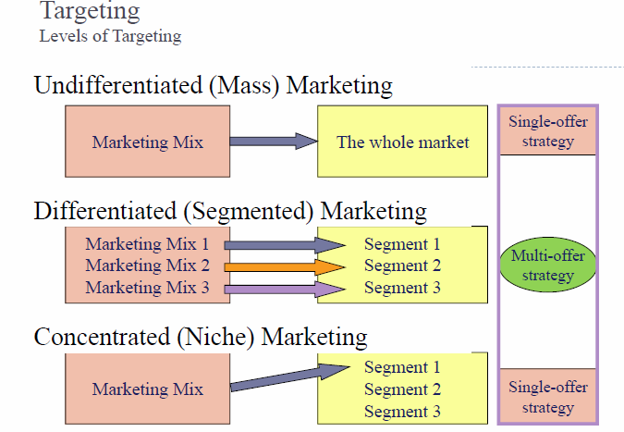

Positioning (value proposition): arranging for a market offering to occupy a clear, distinctive and desirable place in the minds of target customers. INCLUDE 4 Ps
Define the product/firm/brand’s place relative to the market’s:
- Needs, not wants
- Consumer perceptions, beliefs and attitudes
- Competitive offerings
Choosing a positioning strategy
Choosing the right competitive advantage
- How many differences to promote?
  - Unique selling proposition
  - Several benefits
- Which differences to promote?
  - Important: does it matter to consumers?
  - Distinctive: is it different?
  - Superior: better?
  - Communicable: can you explain?
  - Pre-emptive: can your competitors catch up?
  - Affordable: does consumer benefit exceed cost?
  - Profitable: does additional profit exceed additional cost?
Components of positioning statement:
- Target segment and need
- Brand
- Concept
- Point of difference
Ex: To busy, mobile professionals who need to always be in the loop, Blackberry is a wireless connectivity solution that gives you an easier, more reliable way to stay connected to data, people, and resources while on the go.
Swatch disrupted the watch market because it said we’re not a jewellery item or a low budget, every day tool.
- Price: affordable ($40)
- Product: colorful designs, hundreds of designs, see through watch
- Promotion: little advertising
- Place: no jewelry stores, only dept stores, sop-in-shop systems, etc…

Perceptual map: represents position of product in customer’s mind
- Representation of several competitors
- 2-3 key dimensions
- Ideally, consumers want product to be high on both dimensions (top right), brand closest to ideal point has highest consumer preference
- Help managers see unmet customer needs which they can capitalize on
  - Improve under-performing product

Position: consumer’s view of the firm
- Positioning: using 4 Ps to affect the firm’s position

- Positioning techniques:
  - Product attributes
  - Benefits sought by consumers
  - Away competitors (Avis #2 away “try harder” from Hertz) or toward competitors
Differentiation: differentiating the market offering to create superior customer value.
- Why divide market? Not everyone likes the same things, variation in preferences
  - Germans don’t like spicy food, Portuguese people do
- Gap: appealing to all has resulted in sales to too few, needs a niche, nobody LOVES Gap
- Ford: started with model T, used positioning to target different customers
Consumers prefer heterogeneity: ideal points for laptop weight – pounds



