ADM1301 - Social Context of Business

Chapter 1

Key Terms:

Ethics of business: The rules, standard, codes, or moral principles that provide guidance for morally appropriate behaviour in the decision making related to business operations.

Stakeholder: An individual or group who can influence and/or is influenced by the achievement of an organizations purpose.

Corporate Social Responsibility: The way a corporation achieves a balance among its economic, social and environmental responsibilities in its operations

Corporate Sustainability:

Approaches to Ethical Thinking

- Deontological Ethics: An approach to ethics that determines goodness or rightness from examining the acts, rather than from the consequences of the acts. Focuses on moral obligations, duties and rights.
- Teleological Ethics: An approach to ethics that focuses on outcomes, or results of actions. The decision is believed to be good if the end result is good.
- Virtue Ethics: An Approach to ethics that emphasizes the individuals character or identity, and focuses on being instead of doing. Based on the character of individual, if they have good traits decisions will be good.

The Canadian Business System

- Economic System: An arrangement using land, labour and capital to produce and exchange goods to meet the needs and wants of a society.
- Capitalism: An economic system that allows for private ownership of the means of production. Assumes that economic decision making is in the hands of individuals.
- Free enterprise system: An economic system characterized by ownership of property by individuals and enterprises.
- Laisses faire capitalism: An economic system operating with the absolute minimum interference by individuals and enterprises.
- Responsible Enterprise System: An economic system operating as a free enterprise system but incorporating the element of accountability.
- Stakeholder Capitalism: An economic system in which corporations accept broader obligations beyond financial ones for shareholders.
- Clean Capitalism: An economic system that incorporates the social, economic and ecological cost into the prices we pay.

Legitimacy: belief in the rightness of an institution, in this case the appropriateness of our business system to supply the goods and services wanted by Canadian society.
Social license: is the privilege of operating in society with minimal formalized restrictions based on maintaining public trust by doing what is acceptable to stakeholders in the business and society relationship.

Chapter 3 and 4 September 17, 2015
______________________________________________________________________________

Issues Management: A systemic process by which the corporation can identify, evaluate, and respond to those economic, social and environment issues that may impact significantly upon it.

Issues Management Process
- Identification of issues

What are the mega issues that affect the different parts of the global food and beverage industry?

Raw Materials
- Pesticide use, Forced Labour, Unfair wages, Deforestation, Overfishing, Water damage, Water/ air pollution, Animal cruelty, Slavery
Suppliers
- Waste, Infrastructure, Health risks
Manufacturers
- Toxic waste, Quality control, Poor employee training, Energy Consumption
Distribution
- Outsourcing, Pollution from transportation
Retail
- Over inflation, Predatory pricing
Consumer
- Over consumption, Consumer health, Moral conflict, False advertising

- Analysis of issues
  - How do the impacts found in 1? Impact businesses.

- Ranking or prioritizing of issues
  - How important is the issue? Does is impact me? My Business?
  - Stakeholder: An individual or group who can influence and/or is influenced by the achievement of an organizations purpose.
- Formulating issue response
  - Reducing the problem, helping the energy problem
- Implement issues response
- Monitoring and evaluating issue response

Stakeholder Identification and Salience

Salience: The degree to which priority is given to competing stakeholders.
Power: The ability to get a firm to do something that it would not otherwise do based on force, threat, incentives, etc.
Legitimacy: Perception or assumption that the actions of an entity are desirable, proper, or appropriate.
Urgency: The degree to which a stakeholder’s claim or relationship calls for immediate attention.

Stakeholder Engagement: Efforts by a corporation to understand and involve relevant individuals, groups, or organizations by considering their moral concerns in strategic and operational initiatives.
Social Capital: Any aspect of a corporation’s organizational arrangement that creates value and facilitates the actions of stakeholders within and external to the corporation.

Chapter 3 Stakeholders
Pluralistic Society: One where influence or power is decentralized by dispersing it among a variety of institutions.
Stakeholder: An individual, or group who can influence and/or is influenced by the achievement of an organizations purpose.

Defining and Identifying Stakeholders
- All stakeholders have expectations, such as reasonably priced and good-quality products, adequate wage levels, good working conditions, and a clean, safe environment.
- List of different types of stakeholders:
  - Owners: Those individuals or groups who have invested in a corporation in the form of equity or shares; usually referred to as shareholders.
  - Directors
  - Employees
  - Customers or Consumers
  - Lenders and Creditors
  - Suppliers
  - Service Professionals
  - Dealers, Distributors, and Franchises
  - Business Organizations
  - Competitors
  - Joint Venture Participants
  - Non- Government Organizations
  - Society at Large
  - Education Institutions etc.
  - Media
- Managers Responsibilities
- Identify stakeholders
- Understand how corporation currently views stakeholders
- Examine how each stakeholder will or might influence firm.
- Assess opportunities and threats.
- Rank stakeholders by influence.
- Prepare programs or policies detailing low to cope with stakeholders.
Stakeholder Theory: We must get permission from all groups involved before we make stockholder decisions.
Stakeholder concept: is a systematic approach to recognizing the complex combination of desires and expectations in today’s society and deciding whether to respond.

Arguments For the Stakeholder concept
- Simply good business
- Ignoring stakeholder interests can have substantial economic consequences (e.g., employees, customers, lenders, etc.
- Provides more systematic approach to recognizing stakeholder expectations and deciding how to respond
Arguments Against the Stakeholder concept
- Problems of categorization (e.g., how to identify and prioritize stakeholders)
- Challenges in meeting expectations (e.g., tradeoffs among the stakeholders)
- Dilution of top management focus (e.g., away from financial performance)
- Impracticality of shared governance (e.g., focus still on shareholders)

BP Oil Spill: Deep Water Horizon
- Big Oil spill in Gulf of Mexico
  - Stake Holders
  - Employees: Their safety, future employees have negative thought about BP.
  - Media: Give bad media coverage about BP.
  - Wildlife: Damaged wildlife living within the ocean.
  - Shipping Partners: Imports and exports would be blocked off from the spill.
  - Environment: Our whole environment is being polluted.
  - Tax Payers: All the money to clean up the spill is from tax payers.
  - Competitors: Attracting new businesses because of the negative issue.
  - Government: Reputation of how they solved the issue.
  - Community: Affects their living conditions.
Issues Management: A systematic process by which the corporation can identify, evaluate and respond to those economic, social, and environmental issues that may impact significantly upon it.
- Process which the corporation responds to economic, social, and environmental issues.
- Benefits:
  - Corporations are more likely to maintain a competitive advantage over rivals;
  - Corporation is less likely to make a serious social or ethical mistake.
  - Detect issues earlier and develop appropriate responses much sooner

Purposes for Issues Management
- Minimize surprises relating to events or trends in society by serving as an early warning system
- Prompts managers to be more systematic in coping with issues and stakeholder concerns
- Mechanism for coordinating and integrating management of issues

Issue Life Cycle

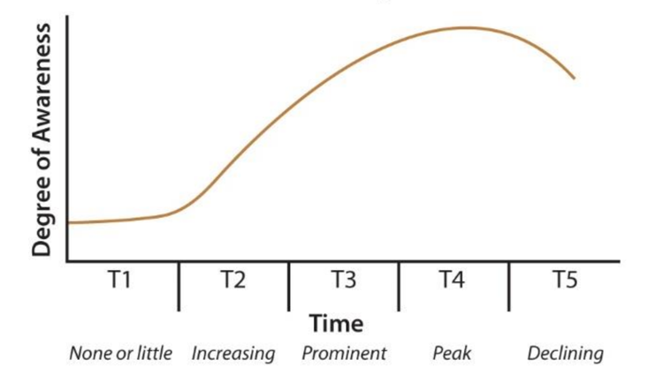
Example: Global Warming would be T2-T3 because people are becoming aware of it but we don’t need to solve it yet.

The Issues Management Process
- Identification of issues
- Analysis of issues
- Raking or prioritizing of issues
- Formulating issue response
- Implementing issue response
- Monitoring and evaluating issue response

Crisis Management
An approach involving planning and removing much of the risk and uncertainty, allowing the corporation to achieve more control over events

Crisis Management Cycle
Stage 1—Avoiding the Crisis
Stage 2—Preparing to Manage the Crisis
Stage 3—Recognizing the Crisis
Stage 4—Containing the Crisis
Stage 5—Resolving the Crisis
Stage 6—Profiting from the Crisis

Chapter 13
September 24,2015
______________________________________________________________________________

Civil Society: Is composed of the voluntary, community, and social organizations or institutions that contribute to the function of society but are not related to or supported by government.

NGO: Is any group that holds shared values or attitudes about an issue confronting society ad advocates for changes relating to the issue.
- Also called public interest, special interest.

What are the issues NGO’s face?
- Climate issues
- Wildlife extinction
- Poverty
- Animal rights
- Economics
- Technology
- Workers/ human rights

How do NGOS try to influence business?
- Pressure on governments to change policies
- Damaging publicity
- Picket Manager’s homes
- Organize boycotts
- Develop anti-business documentaries
- Support anti-business documentaries
- Disrupt annual meetings

Four key ingredients to a successful partnership:
- Corporate and nog leaders must show leadership
- The cooperation must be open to change

The Media Stakeholder

- Dealing with the media is part of manager’s responsibilities
- Legitimacy of business ids dependant upon publics knowledge of events and issues
- Information spread through newspapers, social media, television

The media and CSR
- Ethical, social and environmental responsibilities of business of increasing interest to public
- This has led to increased coverage

