Topic 5: The Lymphatic System
Final Notes

2 Systems:
Lymphatic system: returns fluids that have leaked from the vascular system back to the blood. Consists of lymphatic vessels, lymph, and lymph nodes.
Lymphoid organs and tissues: provide the structural basis of the immune system. These play essential roles in the body’s defense mechanisms and its resistance to disease. Structures include spleen, thymus, tonsils, lymph nodes, and others.

Lymphatic job is to maintain the fluid volume of the circulatory system
-Blood comes into capillary bed, intertwined with lymphatics: HP and OP force fluid out of the blood at arterial ends of the beds, and cause most of it to be reabsorbed at the venous ends. Some of the supply remains behind in the interstitial space, becomes part of the interstitial fluid, as much as 3 L daily.
-Blood returned to the cardiovascular system by lymphatic vessels (called lymphatics). These vessels are intertwined with the capillary bed and collect the leaked fluid.
-Lymph: fluid in vessels, once interstitial fluid enters the lymphatic system it is called lymph.
-Lymph nodes: clean blood before returning into cardiovascular circulation
-At one point or another, entire volume will flow through lymphatic organs. It has specialized cells that recognize foreign agents, when they are detected, they (a) destroy them, (b) send out a signal to immune system to destroy more
-Doctors can tell based on the texture of the lymph nodes in the throat, whether there is an infection, whether a cancer has metastasized… Lymphatics have extremely important function

Vessels
-Some of fluid is returned, but most flows through lymphatic vessels. The moment interstitial fluid enters lymphatic capillary, it is called lymph.
-Transport of lymph begins in lymphatic capillary. Are widespread, but absent in bones, teeth, bone marrow, and entire CNS (whose excess fluid drains into cerebrospinal fluid).
-Are remarkably permeable due to 2 structural modifications:
(a) Endothelial cells forming their walls are not tightly joined. The edges of adjacent cells overlap each other loosely, forming easily-opened, flaplike mini-valves
(b) Collagen filaments anchor endothelial cells to surrounding structures so that any increase in interstitial fluid volume opens the mini-valves, rather than causing the lymphatic capillaries to collapse
-So, when fluid pressure in the interstitial space is greater than the pressure in the lymphatic capillary, the mini-valve flaps gape open, allowing fluid to enter the capillary. However, when the pressure inside is greater, it forces the mini-valve flap shut, preventing lymph from leaking back out.
-A low-pressure system, same structures as veins to move blood.
-Lacteals are a special kind of lymphatic capillary, they transport absorbed fat from the small intestine to the bloodstream. Called this because of milky white lymph that drains through them. This fatty lymph, chyle, drains from the fingerlike villi of the intestinal mucosa.
-When we eat a meal, water-soluble molecules are absorbed directly. Fat-soluble molecules need to go through the lymphatic system to be absorbed

-Lymphatic capillary afferent lymphatic vessel lymph node efferent lymphatic vessel lymphatic trunk collecting duct subclavian vein

Larger Lymphatic Vessels
-Capillaries merge into series of lymphatic collective vessels that get bigger and bigger eventually dump into one of two ducts.
-Collecting lymphatic vessels have the same three tunics as veins, but the collecting vessels have thinner walls and more internal valves, and they anastomose more.
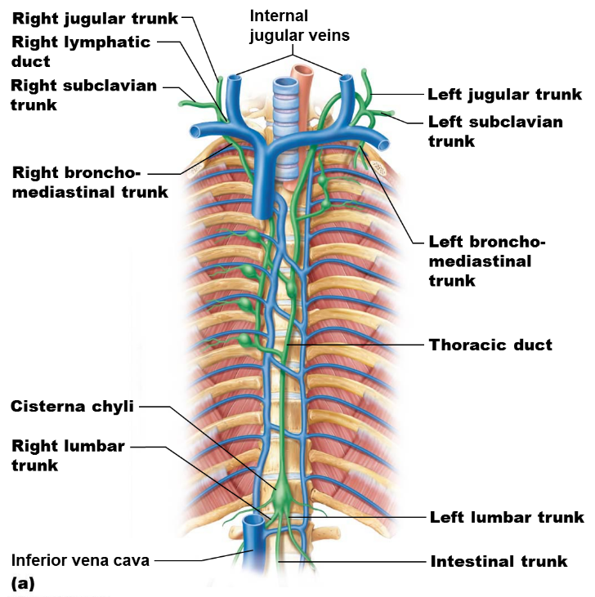
-Lymphatics in the skin travel along with superficial veins, while the deep lymphatic vessels of the trunk and digestive viscera travel with the deep arteries.
-Largest collecting vessels unite to form lymphatic trunks. Major trunks are named for regions from which they drain lymph.
-5 lymphatic trunk pairs to memorize

-Lymph is eventually delivered to one of two ducts in the thoracic region.
2 lymphatic ducts:
-Right lymphatic duct drains right upper arm and right side of the head and thorax
-Thoracic duct drains the rest of the body, is much larger. In about half of individuals, the thoracic duct begins as an enlarged sac, the cisterna chyli, located in the region between the last thoracic and second lumbar vertebrae.
-Each terminal duct empties its lymph into the venous circulation at the junction of the internal jugular vein and subclavian vein on its own side of the body.

Lymph Transport
-It’s a vein-like low-pressure system, the lymphatic system lacks an organ acting as a pump
-Same mechanisms used by veins: (a) milking action of active skeletal muscles, (b) pressure changes in thoracic cavity during breathing, and (c) a valve system to prevent backflow
-Also: smooth muscle in the walls of all but the smallest lymphatic vessels contracts rhythmically, helping to pump the lymph along
-Physical exercise increases the flow of lymph. *Immobilization of injured area keeps needed inflammatory materials in the area for faster healing.
-Still, lymph transport is sporadic and slow.

Lymphedema: anything that prevents the normal return of lymph to the blood and results in a short-term but severe localized edema. Ex. hen tumors block the lymphatics or when lymphatics are removed during cancer surgery. In some cases, the situation can improve if some remaining lymphatic pathways enlarge. One kind is lymphoitis

Lymphoid Cells
-Lymphoid cells consist of immune system cells found in lymphoid tissues together with the supporting cells that form the scaffolding of these tissues.
-In addition to draining lymph, a lot of these structures have immune cells in them. Because whatever is in the bloodstream will eventually go through these structures, it makes lymphatic system ideally situated to deal with infectious agents, anything that has been able to come through epithelial layer.
1. Lymphocytes: cells of the immune system. Begin their life in red bone marrow and mature in:
-B-cells: protect the body by producing plasma cells, daughter cells that secrete
antibodies into the blood or other fluids. Antibodies mark antigens for destruction.
-T-cells: manage immune response (signals, tamper), and some attack and destroy foreign cells. Mature in the thymus. This process of maturation is very important in preventing immune system from turning against body
-These lymphocytes protect the body against antigens (anything provoking an immune response)
2. Macrophages: “big eaters”, engulf foreign agents and cells that have been infected. They phagocytize foreign substances and send out signals to activate T-cells.
3. Reticular cells: fibroblast-like cells that produce the reticular fiber stroma, which is the network that supports the other cell types in lymphoid organs and tissues.

Lymphoid Tissues
-An important component of immune system, because it
-Houses and provides a proliferation site for lymphocytes
-Furnishes an ideal surveillance vantage point for lymphocytes and macrophages
-Mainly composed of reticular CT, macrophages live here
-Found in all lymphoid organs except thymus.
-Found in lamina propria (just beneath epithelial layer)
2 varieties:
1. Diffuse lymphoid tissue: loose arrangement of lymphoid cells and some reticular fibers, found in every body organ. There is no structure to it. Large collections in GI tract mucous membranes
2. Lymphoid follicles (lymphoid nodules): more structure, are solid, spherical bodies consisting of tightly packed lymphoid cells and reticular fibers. Have germinal centres that contain dividing (proliferating) B-cells. Once these centres are activated they can ramp up B-cell production in response to cues. Distributed throughout body, form part of the lymph nodes.

Lymphoid Organs
-All organs have reticular connective tissues that house T-cells, B-cells, and macrophages
-Have the ability to deal with it on site
2 categories:
(a) Primary lymphoid organs: where B and T cells mature: red bone marrow and thymus. While both kinds of cells originate in the bone marrow, B cells mature there and T cells mature in the thymus.
(b) Secondary lymphoid organs: where mature lymphocytes first encounter their antigens and are activated. Include lymph nodes, spleen, and MALT (mucosa-associated lymphoid tissue): tonsils, Peyer’s patches in the small intestine, and appendix (areas where cells can come across an antigen and generate an immune response). Lymphocytes also encounter antigens and are activated in the diffuse tissues.
-Although all lymphoid organs protect the body, only the lymph nodes filter lymph. The other secondary lymphoid organs typically have efferent lymphatics draining them, but lack afferent lymphatics.

Lymph Nodes
-Need to know about its anatomy
-Lymph nodes are the most important secondary lymphatic organs, cluster along lymphatic vessels of the body. There are hundreds of them, but most are not visible because they are usually embedded in CT.
-Tiny bean-shape-like structures, tend to be clustered throughout lymphatic vessels, etc. where they converge.
-5 locations contain a lot in the body: cervical, axillary, inguinal, vertebral column, mesenteric
-Palpated by doctors to see if swollen (cannot palpate mesenteric and vertebral column)
-2 Main Functions:
(a) Filtering the lymph: macrophages in the nodes remove and destroy microorganisms and other debris that enter the lymph from the loose CT, preventing them from being delivered to the blood and spreading to other parts of the body
(b) Immune system activation: are strategically located sites where lymphocytes encounter antigens and are activated to mount an attack against them

Lymph Node Structure
-Bean-shaped, less than 2.5 cm in length. Each node surrounded by a dense fibrous capsule from which CT strands called trabeculae extend inward to divide the node into a number of compartments. The internal framework (stroma) of reticular fibers physically supports its ever-changing population of lymphocytes.
-Histologically, there are distinct regions: cortex (outer) and medulla (inner).
-Cortex contains densely-packed follicles with germinal centres heavy w/ dividing B cells in response to activation of immune system. Body has to ramp up production of defense mechanism to deal with foreign bodies. These will swell when extra B-cells are being produced
-Medulla houses T cells in transit. Also has medullary cords, thin inward extensions from the cortical lymphoid tissue, and contain both types of lymphocytes. Throughout the node are lymph sinuses, large lymphatic capillaries spanned by crisscrossing reticular fibers. Macrophages reside here, phagocytize foreign matter as lymph flows by. Additionally, some lymph-borne antigens in the percolating lymph leak into the surrounding lymphoid tissue, where they activate lymphocytes to mount an immune attack against them.
-Fewer efferent than afferent vessels in the node: there are 5 afferent lymphatic vessels, that means that 5 are bringing lymph into the structure, but only 2 efferent vessels (points of exit). Like a traffic accident, flow slows way down. This is done on purpose, want to slow it down so the system can examine the lymph. Allows immune system to survey the blood and destroy foreign agents. When it comes out, has been filtered

Other Lymphoid Organs
1. Spleen: is the largest lymphoid organ, about the size of a fist. Is in upper left quadrant, curls around stomach. Provides a site for lymphocyte proliferation and immune surveillance and response. Also has blood cleansing functions; after extracting aged/damaged RBCs and platelets from the blood, its macrophages remove debris and foreign matter.
5 main functions:
- Site for lymphocyte proliferation, immune surveillance & response
- Blood cleansing
- Stores RBC products (iron) for recycling, also releases breakdown products of RBCs to blood for processing by the liver
- Stores blood platelets and monocytes for release into the blood when needed
- May be a site for erythrocyte production in the fetus
All these functions are the domain of the spleen. Often described as a blood reservoir, storage system. People with a ruptured spleen can bleed to death.
2 histological areas:
(a) White pulp: where immune functions take place, so it is composed mostly of lymphocytes (macrophages and T cells) suspended on reticular fibers. Form clusters around central arteries
(b) Red pulp: where worn-out RBCs and bloodborne pathogens are destroyed, so it contains huge numbers of erythrocytes and the macrophages engulf them. It is essentially all splenic tissue that is not white pulp
-Unlike lymph nodes, the capsule of the spleen is quite thin. Consequence: is prone to rupturing

MALT Tissues
-Not organs, not cells, are somewhere in between. Are a set of lymphoid tissues strategically located in mucous membranes throughout the body. Help protect from pathogens that seek to enter our bodies.
-Historically, it was thought that these structures had no function in the body.
2. Tonsils
-Ring of lymphoid tissue at the entrance of the pharynx (throat, open to outside), where they appear as swellings of the mucosa. Possibility of microbes entering it high. In this tissue you have macrophages and B-cells.
Have tonsillar crypts, which trap bacteria and particulate matter, so that the bacteria work their way into the lymphoid tissue, where most are destroyed. This provokes a wide variety of immune cells to have a memory for the trapped pathogens. Want microbes to get caught in them so that they can be dealt with.

4 kinds, named according to location:
a) Palatine tonsils (pair): located on either side of base of throat, can become inflamed (tonsillitis). These are the largest tonsils and the most often infected. In the past, used to remove them, now we treat the condition because we know they have a use
b) Lingual tonsil: collective term for lumpy collection of lymphoid follicles on base of tongue
c) Pharyngeal tonsil: cusp of where nose meets throat. When inflamed, called adenoids
d) Tubal tonsils: surround the openings of the auditory tubes into the pharynx.

3. Aggregates of Lymphoid Nodules
(a) Peyer’s Patches: large clusters of lymphoid follicles, structurally similar to tonsils. Are located in the wall of the distal portion of the small intestine. Surveys movement of lymph through that area, destroy bacteria and generate memory lymphocytes.
(b) Appendix: a tubular offshoot of the first part of the large intestine and contains a high concentration of lymphoid follicles. Is in an ideal position to prevent bacteria in the intestine from breaching the intestinal wall, and to generate many memory lymphocytes for long-term immunity.

Memory lymphocytes: subset of cells that can recognize foreign agents and destroy them. This is the principle behind vaccines. Most of the B-cells dealing with an infection will die, but some memory B-cells will remain. These, when they encounter the agent for a second time, make the response faster and more robust.
-Bacteria grow exponentially, divide quickly. If you had to wait until the bacteria reached a particular point in the body before generating a response might be too late to fight it. Idea of lymph nodes is that no matter its point of entry, it will find the immune system and generate a response.

4. Thymus: when T-cells are made in the red marrow, they to the thymus. Here, T lymphocyte precursors mature to become immunocompetent lymphocytes. Here, they learn to distinguish between self and foreign. “Go to school”. They become able to defend us against specific pathogens in the immune response.
Get rid of all the T-cells that would be detrimental to the body. Only the ones that work well are released.
-From time of birth to puberty, it grows and gets bigger and bigger. Highly active during the first year of life. Immunal competence is taking place/ Once you hit puberty, it starts to atrophy. By the time you get to adulthood, thymus is essentially shriveled up. It has served its purpose. By old age, it has been replaced almost entirely by fibrous and fatty tissue and is difficult to distinguish from surrounding CT.
-Structure is like a cauliflower head: flowerets represent the thymic lobules, each has a cortex and medulla. Most thymic cells are lymphocytes.
-Only lymphoid organ that doesn’t directly fight antigens
-Is a primary lymphoid organ, differs from secondary in 3 ways: (a) has no follicles because it lacks B cells, (b) does not directly fight antigens, serves as a maturation site, and (c) the stroma of the thymus consists of epithelial cells rather than reticular fibers. These epithelial cells provide the physical and chemical environment in which T lymphocytes mature.
-*Stroma consists of star-shaped thymocytes that secrete thymosin and thymopoietin. This allows the cells to be able to distinguish between cells and other cells.
-By the time an auto-immune disease kicks in, the thymus is atrophied and gone. The medical side does not understand what happens. Why was the body working well for years, and then it starts attacking its own cells?
-When you have an auto-immune disorder, you take medications that suppress your immune system. This means that you are more prone to being sick.

Final exam is semi-cumulative.
-85% covered for information after last midterm
-Diagrams, short answer, MC
-Study the first two midterms, you will be fine. Will not be the same questions from old midterms, but will be the SAME material covered in those midterms.

