COMM 226

MODULE 1

MOORE’s LAW= the density of circuits (number of transistors per square inch) on an integrated chip is doubling approximately every 18 months. Ratio of price to performance for computes is decreasing.

MIS is important for future bus professionals who need to assess, analyze and apply emerging info tech to business.

But today, because of Moore's Law, because the cost of data storage and data communications is essentially zero, any routine skill can and will be outsourced to the lowest bidder.
Shifts in the nature of org, favor strong non-routine cognitive skills

- Abstract Reasoning-> the ability to make and manipulate models.
- System Thinking -> ability to model components of system, connect inputs and outputs that help define system as a whole
- Collaboration-> 2+ people working together to achieve a common goal, giving/receiving critical feedback in effective manner
- Ability to Experiment -> making a reasoned analysis of opportunity, envisioning solutions, eval possibilities and develop most promising ones

MIS – Management Information System
- Processes (way of doing smg), Info System, Info (using data to provide knowledge to do jobs)
- -Management (creating, monitoring + adapting of process, I.S., and info)
-Use (tasks and responsibilities)
- Goals and Objectives (I.S. to meet business needs)
Industry Structure (Porter’s Five competitive forces determine industry profitability)
- Bargaining power of customers (↑Supply, ↓Dem=↑Cust. Power)
- Bargaining power of suppliers (↓Supply, ↑Dem= ↑supplier’s power)
- Threats of substitutes (intro of new prod/serv which can substitute)
- Threats of new entrants (↓barriers, ↑entrants)
- Rivalry among existing firms (pricing, quality and innovation)
Four competitive strategies model (FIDC):
- Cost (cost leader)
- Differentiation (differentiate product)
- Industry-wide (employ strategy across industry)
- Focus (on a particular industry segment)

How does competitive strat determine value chain structure?
- Value – amt of $ customer is willing to pay for resource, prod, serv
- Margin – the difference between what consumers is willing to pay and the cost the company incurs when moving the goods through the value chain.
- Value chain – network of activities that improves the effectiveness (value) of a service.
- Primary activities –value added directly to the product (ex: shipping materials).
- Inbound logistics (receiving, storing, disseminating inputs to products)
- Operations (transforming input to final prod)
- Outbound logistics (collecting, storing, physically distributing)
- Sales and Marketing
- Cust. Service (assisting cust’s use and enhancing value)
- Support activities (indirectly contribute to primary acts)
- Procurement (selection of vendors +negotiations surrounding purch acts)
- Technology Department
- Human Resoucres (recruiting, compensation, training)
- Firm Infrastructure (gen. Management, finance, accounting, legal and gov affairs)
Competitive strat-> Bus processes -> I.S. to support processes

Ethics Guide
-Categorical Imperative (one should behave only in a way that one would want to beh to be a universal law)

MODULE 2

What is a business process?
-a sequence of activities for accomplishing a function (ex. Booking a flight online)
- Documenting Bus. Processes by creating an abstraction of the process using standardize techniques
  - BPMN –Bus Process Model and Notation (global standard for this purpose)
  - Roles and Actors (activities performed by one actor. Actors are people but can also be computers (ex: order tracker)
  - Swimlanes (separate the various roles in the process model)

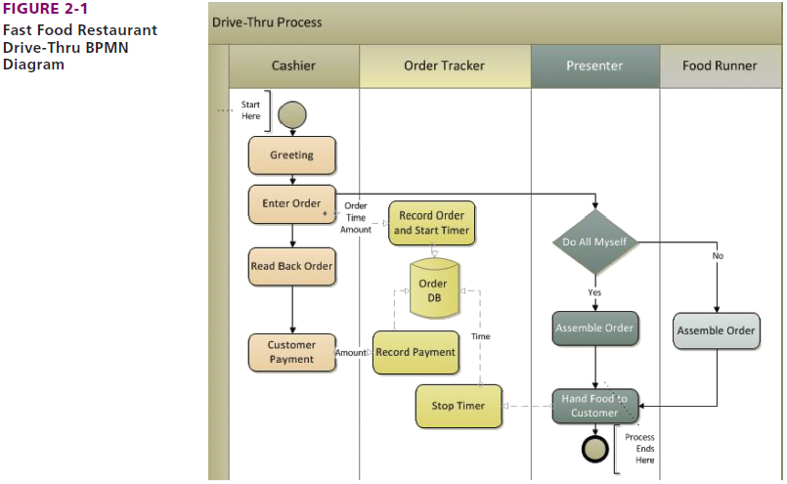 Swimlanes

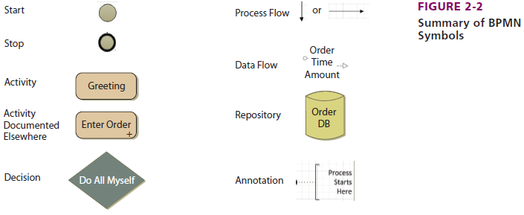

*How much detail is enough? -> include as many activities to avoid ambiguity
Why do orgs standardize bus processes? -> to provide benefits
- Enforce Policies
- Provide Consistent Results (regardless of the actor playing a role in the process, the activities and decisions are performed in a consistent manner)
- Scalability (to be able to replicate the process and implement it in new areas as an organization grows)
- Reduce Risk (reducing the potential for error that exists when different employees do things differently)

System –group of components interacting to achieve some purpose
Information system – a group that interacts to create information.
- hardware (electronic components)
- software (programs that run/operate systems; tells hardware what to do)
- data (blocks of information; bridge btw machine side and human side)
- procedures (the way to get to the desired object)
- people (actors that interact with the system)

*How to use the five component model?
-recognize that people are the key
-make each component work (easier to troubleshoot issues)
-Assess the scope of new systems
-components are listed in order of ease of change and extent of org disruption (ex. Easier to replace a computer than replace a person)

How do Bus Processes and I.S. relate?
-I.S. can support several processes
-Procedures (set of instructions for a person that must be followed to operate the information system; In short, an information system will have a different procedure for each process it supports)

Structure Processes (formally defined, standardized processes)
Dynamic Processes (less specific, more adaptive and intuitive)
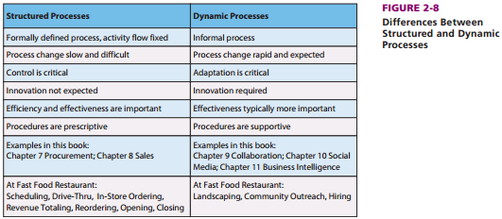

What is information?
-This is knowledge derived from data (data is fact and figures)
-Processed data
-Data presented in a meaningful context.
-A difference that makes a difference.

Common elements of definitions ^:
1. Information is more than data (it’s meaningful: power to change minds)
2. It varies from person to person
3. Located inside you (Info is data that a person processes with their brain)

How to use info?
- Challenge to Communicate info (everyone interprets it differently)
- Recognize that all new/different I.S. are frustrating at first
- Work with teams can be an effective way to understand and ID new differences
- Stay curious

What are factors to have quality data?
1. Accurate (correct and complete)
2. Timely (on time for intended use)
3. Relevant (to both context and subject)
4. Sufficient (ignore the data you don’t need)
5. Worth its cost (value must > cost)

Ethics Guide
- Informing about Misinforming

MODULE 4

Hardware Components
- The CPU (central processing unit) -> ‘Brain’ of computer and may have more than one. (2 CPUs= Dual-processor)
- To run a program or process data, the CPU first transfers the program or data from disk to main memory. Then, to execute an instruction, it moves the instruction from main memory into the CPU via the data channel or bus. The CPU has a small amount of very fast memory called a cache. The CPU keeps frequently used instructions in the cache.
- Random Access Memory (RAM) -> contains program instructions for application programs and a browser. It also contains instructions for the operating system.
- Storage Hardware ->save sata/programs (cds, thumb drives…)
*Types of Hardware: PCs, tablets, smartphones, servers, server farms

Computer Data (Binary digits ‘bits’ that are either 0 or 1)
- Byte =8 bits
- One character on key board= 1 Byte
- A kilobyte, abbreviated K, is a collection of 1,024 bytes.
- A megabyte, or MB, is 1,024K kilobytes.
- A gigabyte, or GB, is 1,024 megabytes
- A terabyte, or TB, is 1,024 gigabytes.
- A Exabyte is 1024 TB
* The small amount of very fast memory of CPU is cache (large cache is expensive since it’s so fast) and CPU speed is measured in Hertz.

Volatile Memory (temporary, lose everything if powered off): cache and main memory
Non-Volatile Memory: found in optical and magnetic disks

Operating systems: tend to be large and complicated programs that control the computer’s resources
- Non-Mobile OS (windows)
- Mobile OS (IOS, android)
- Server OS (unix, Linus OS)

Virtualization -> one computer hosts the appearance of many computers
- PC Virt -> user can have diff systems on same hardware
- Server Virt ->server computer hosting 1+ other server computers
- Desktop Virt ->server hosts many versions of desktop OS

**When we buy software, like a Microsoft Windows operating system, we don’t own the software, but rather own a license to use that software

Types of Apps
- Horizontal application software: software that can be used across various industries
- Vertical App: is more specific to an industry
- One-of-a-kind App: developed for a specific, unique need

How to Purch Apps?
- Off-the shelf software
- Off the self with alterations software
- Tailer-Made (custom-developed software)
Firmware is computer software that is installed into devices such as printers, print servers, and various types of communication devices.
- Open source system (the source code is freely available to the public)

Native Apps - which run on just one operating system
Thin-client applications - which run in browsers on many different operating systems
-limited by capabilities of browser which cannot offer the full capabilities of the underlying operating system and hardware

What Characteristics Quality Mobile User Experience?
- User interface (UI) - the presentation format of an application. It consists of windows, menus, icons, dialog boxes, toolbars, and so on, as well as user content.
- User experience (UX) - refers not only to the UI, but also to the way that the user responds to the application.
- Feature content and supporting direct interaction
- Context-sensitive chrome (visual overhead in a computer display. Because of limitations in screen size for most mobile devices, mobile applications eliminate chrome as much as possible.
- Animation and lively (capture your attention with motion and sound)
- Design to scale and share (They should be designed to scale up and down and be able to share the display effectively.
- the Cloud (the utilization of data and computing resources)
Data Communication
- LAN (local area networks)
  - small/home offices to connect multiple computers (SOHO LANS)
  - wired connection (use of network interface card NIC)
  - wireless connection (connect to an access point WNIC)

Protocols provide rules by which communication can take place (speak in same language)
- IEEE (Institute for Electrical and Electronic Engineers)
o Ethernet protocol standard / IEEE 802.3 (wired connections)
o Wi-Fi / IEEE 802.11 (wireless)
- Bluetooth

How to connect LAN to internet?
-When you connect to the Internet, you’re connecting to a WAN (Wide-area network). A common method for doing this is through an Internet Service Provider or an ISP.
ISPs provide users with legitimate access to the Internet. ISPs pay for this access and charge their customers fees to access the Internet through them.
-SOHO LANs can connect to an ISP to gain access to a WAN. To do this, digital data from the computer needs to be converted to analog data so it can be transmitted. To perform this conversion, we use a modem, or DSL, which is a digital subscriber line that operates over a telephone line.
-Cable modems transmit over a television cable.
-Wireless connections typically involve mobile devices that access the WAN via a wireless LAN or WAN. To connect via a WAN, wireless connection protocols are required.

INTERNET - a network of networks that connects to a network or networks, and is used to access the Web. It’s also important to note that the Internet consists of tens of thousands of LANs and WANs.
Other Protocols
- TCP/IP Architecture (scheme of five protocol types arranged in layers
- HTTP –Hypertext Transport P. (used by browsers to request and send info over internet)
  - HTTPS (secured version of HTTP if info is sensitive and needs protection)
- SMTP –Simple main transfer P. (used for email transmission
- FTP –File Transfer P. (used to move files over internet)
- URL –Uniform Resource Locator (address on the internet; consists of protocol and domain name)
What Processing Occurs on a Typical Web Server?
- Web Storefront -> web server that is set up so you can sell products (ex. E-commerce)
- Three-Tiered Architecture
  - User Tier (consists of computers, phones + other devices with browsers that can access Web pages
  - Server Tier (A request from the user tier goes to the server tier, and the response is in the form of a Web page. We define the servers as Web servers. These are programs that run on the server tier and manage traffic, sending and receiving Web pages to and from clients)
    - Web Farm (This concept of multiple Web servers for a single Web site)
- Database Tier (computers that run a database management system which processes requests to retrieve and store data
- Hyper Text Markup Language (HTML) -> most common language for defining the structure and layout of Web pages
  - HTML tags <> (A tag is a notation used to define a data element for display or other purposes)
  - Hyperlinks –href (a pointer to another Web page.
**An HTML tag is used for creating a hyperlink and is followed by the attribute for that tag, which is “href”. The value following this attribute will define the Web page that the hyperlink will display when selected.

Why is the CLOUD the future for most orgs?
-defined as the elastic leasing of pooled computer resources over the Internet

- Elastic (amt of resources used can be increased/dec dynamically, programmatically and in a short period of time)
- Pooled (when many different organizations use the same physical hardware. That hardware is shared through virtualization)
- Internet (resources are accessed via Internet protocols and standards, which are additions to TCP/IP that enable Cloud-hosting vendors to provide processing capabilities in flexible yet standardized ways)
*Adv: speed, econ of scale, known cost structure, (cost of processors, data communication and storage is very low)
*Disadv: loss of control of pricing and policy, dependent on vendor, at risk of security and system failures
Types of Clouds
- SaaS –software as a service (organizations can gain access to not only hardware infrastructure but also an operating system and application programs)
- PaaS –platform as a service (vendors provide hosted computers, an operating system, and possibly a DBMS to the consumer)
- Iaas –Infrastructure as a service (the Cloud hosting only a bare server computer or disk drive)
Ethics Guide
- Showrooming -> the practice of visiting a store or stores in order to examine a product before buying it online at a lower price

Chapter 5: Using IS to improve processes
Process is how organization organizes their work activities.
Recap:
IS are applied to processes.
Activity – a task within a business process
Resource – item, people, computers and so on.
Actors – human resources or computer hardware
Role – a list of activities performed by one actor.

Characteristics of processes:
•Stability of flow – structured or dynamic (informal)
•Scope
- Operational (routine, everyday work, hard to change, more computers than other processes, high frequency, TPS Transaction Processing System)
- Managerial (allocation and resource use, medium frequency, MIS Management Information System)
- Strategic (broad scope, resolve organizational issues, more people than other processes, low frequency, ESS Executive Support System)
•Objectives – the desirable goal.
- Efficient (creates more output with less/same input)
- Effective (helps achieve the organizations strategy)
**Most common processes: operational with efficiency objectives and strategic processes with effectiveness objectives.
Types of information systems
1.TPS Transaction processing systems – operational (workers)
2.MIS Management information systems – managerial (middle managers)
3.DSS Decision support systems (senior managers)
4.EIS Executive information systems / ESS Executive Support Systems – strategic (executives)

2) What are examples of common business processes?
The value chain – A series of value-adding activities (primary and support activities).
- Value chain – network of activities that improves the effectiveness (value) of a service.
- Primary activities –value added directly to the product (ex: shipping materials).
- Inbound logistics (receiving, storing, disseminating inputs to products)
- Operations (transforming input to final prod)
- Outbound logistics (collecting, storing, physically distributing)
- Sales and Marketing
- Cust. Service (assisting cust’s use and enhancing value)
- Support activities (indirectly contribute to primary acts)
- Procurement (selection of vendors +negotiations surrounding purch acts)
- Technology Department
- Human Resoucres (recruiting, compensation, training)
- Firm Infrastructure (gen. Management, finance, accounting, legal and gov affairs)
3) How can Management Improve Processes -> means that a process better achieves its objectives based on its measures.
•Process objectives: Specify and improve
-Up to the manager to decide and specify and to make sure they meet the organizational strategy. Classify as effectiveness or efficiency, make explicit, obtain agreement.
•Process measures are quantities assigned to attributes (Metrics aka key performance measure).

4) How can IS improve processes?
Managers must specify and communicate appropriate measures for each objective that are:
-Reasonable (valid and compelling)
-accurate (exact and precise)
-consistent (reliable)
Different Ways:
1. Improve an activity (effectiveness or efficiency)
ex. Driving activity improved by GPS
2. Improve data flow among activities and linkage (impact of 1 activity on another).
Ex. Display order process data on GPS in Delivery Process
3. Improve control of activities (control limits behaviour)
4. Use of automation (the computer takes over a former human-role).
5. Improve Procedures (payment procedure and payment process performs better)
5) Non-IS process improvements
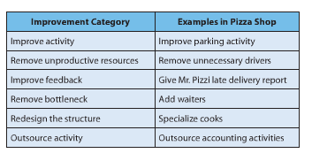
**Six sigma – seek to improve process output by removing defects and minimizing variations.
6) How do process teams diagram process improvement?
Improvements always include a team, actors in the process, management, IT analysts and business analysts.
•As-is diagrams: diagrams of the current process (how the process works and what it should look like when finished)
•Ought-to-be diagrams: diagrams of suggestions for improvement. BPNM diagrams are usually used.

6) How can IS hinder a process?
Information silo: data needed for a process activity is unavailable because it is stored in an isolated, separated IS. Can make process inefficient, ineffective.
Solution: duplicate the data
Why does this problem exist?
- organizational departments prefer to control the systems they use
- departments set up their own databases (analyse the costs and benefits of the systems of using their own fairly narrow measures)
- only when many processes in many departments all rely on the same IS do the savings really accumulate
- departmental IS is more affordable; enterprise systems can cost as much as 10 to 50 times as much as a single department application
•Fix: Store a single copy of data in a shared database and revise business processes to use that database (feature of the ERP systems).

7) How can SOA improve processes?
Services-Oriented Architecture: new IS approach designed to make it easier to share data amongst process activities. Design in which every activity is modeled as an encapsulated service and exchanges among those services are governed by standards.
•Service: repeatable task a business needs to perform
•Encapsulation: hides data within containers so services can communicate
•Standards: standardized formats for data exchange

MODULE 5
Chapter 6: Supporting processes with ERP systems (PS&I)
ERP is a type of IS system that improves a process across an entire organization.
1) What problem does an ERP system solve?
ERP system has data consolidated in one central database
- Enterprise application integration (EAI): solves silo problem by providing layers of software that connects info systems together. Cheaper than ERP.
- Connects information silos via new layer of software
- Enables existing application to communicate and share data
- Provides integrated data
- Leaves department information systems as is but providing an integration layer over the top
- Enables a gradual move to ERP
- Enterprise resource planning (ERP): Creates a single database and provides processes that are integrated with each other. Increases purchasing process, standardization, and gives us bargaining power over suppliers.
- Single consistent IS
- Integrate process data from departments such as accounting, human resources, sales and operations into a single system
- By consolidating the data in one place, the data are always up to date and available in real time to be used by any process in the organization
- Costs are reduced.
2) What are the elements of an ERP system?
*Current ERP systems are particularly strong in the areas in which they were first developed, such as manufacturing and supply process
•Material requirements planning (MRP) to efficiently manage inventory, production, and labour.
•Manufacturing resource planning (MRPII) added financial tracking capabilities as well as the opportunity to schedule equipment and facilities.
•JUST IN TIME (JIT) synchronizes manufacturing and supply - manufacturing occurs just as raw material arrive
•The Sarbanes Oxley act (SOX) required companies to exercise greater control over their financial processes, and ERP systems addressed that new requirement
An ERP system must be able to integrate processes of:
1.Supply chain management (SCM)
2.Manufacturing (MRPII, JIT)
3.CRM – customer relationship management
4.Human resources
5.Accounting
The five components of an ERP:
1. Software – uses configuration/customization to meet customer requirements without changing program code. ;
2. Data – Database design & initial configuration data. Doesn’t contain company’s actual operational data. ERP collaborates with DBMS (create, process and administrate) to update data in the database. Transactional data (data for an event), master data (doesn’t change from transaction to transaction) organisational data (ex: location of warehouses)
3. Hardware – Each ERP needs storage, clients, printers, cables, scanners, etc.
4. Procedures –instructions & methods for users to interact with the application. Gives control over a process. Expensive & timely (training required).
5. People – Users (the one using the ERP, implementing the system), IT analysts(supports, maintain and adapt the system after implementation) or consultant(work for another part and helps implement the system, budget and plan).
Inherent process: ERP also specify specific processes for the implementing organization.
3) What are the benefits of an ERP system?
- Implement processes that are industry best practices, inherent processes that integrate well the main benefits
- Real-time data sharing (see trends and respond quick)
- Management more insightful and provides better oversight
- Information silo problem is solved (departments no longer create and maintain their own purchasing database)
4) Challenges of implementing ERP
Not done well, the losses can be huge since the process is long and expensive. Challenges:
1. Implementation decisions:
- Select the right ERP vendor (long term relationship)
- Gap between the ERP system and the business requirements from strategic planning (what should the ERP do?)
- Configuration (bill of material (specify the raw material), order size, tracking of material and so on)
- Data issue comes with different formats
- Cutover pressure is the transition period

2. People challenges:
- Work is changed
- Top management involvement after initial decision to implement (should be frequent)
- Management oversells capabilities – don’t oversell the vision of what the system might do
- Perceived threat to department autonomy, avoid collab breakdowns
- Failure to specify objectives & measures for new processes
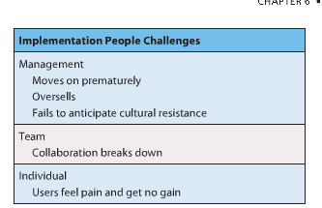
**ERP upgrades often encounter resistance and surprise. Try to justify the upgrade. Be aware of the lock in of a customization of the ERP. There should be a long-term strategy for upgrades.
5) What types of organizations uses ERP?
1. ERP by Industry type – Manufacturers in aerospace, automotive and industrial equipment have an effective use of ERP.
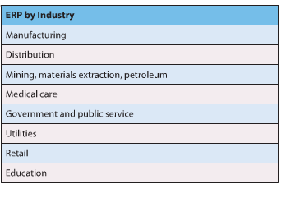
2. ERP by Organization size - range from all sizes: small, midsized and multibillion dollar ones. Key difference is the availability of skilled businesses and IT analysts that allow them to implement the systems better.
3. International ERP – designed to work with multiple currencies, manage international transfers of goods and inventories, work effectively with international supply chains.
6) Who are the major ERP vendors?
Comprehensive ERP systems support the major processes in business.
ERP products:
1. SAP: offers the most extensive ERP products, largest customers
2. Oracle : combo of in-house and acquired products. Intensely competitive company w/ strong technology base, large customer base.
3. Infor: privately held corporation that has acquired ERP products (Baan). Many solutions.
4. Microsoft Dynamics: 4 products acquired by acquisition (AX, Nav, GP, Solomon). Not well integrated with Microsoft Office. Uncertain product direction.
5. Epicor: strong industry specific solutions (retail). Configurable, cheaper.
7) What makes SAP different from other ERP products?
“System, applications and products”
•Offers training and consulting within its services
•The price varies because it sometimes takes several years to set up an ERP system
•Can speed up the process w/ industry-specific platform.
•Training for the employees is a long process.

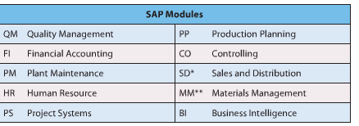
SAP Software:
-business suite
-SAP ERP
-SAP CRM
-SAP SRM
-SAP SCM
-SAP NetWeaver

MODULE 6
CHAPTER 5 – Database and Content Management
1) What is content?
Content is related to intellectual property. It is a form of creative endeavour that can be protected through a trademark, patent, copyright, industrial design, or integrated circuit topography. It varies by industry.
*Organizations may store data, documents, spreadsheets, presentations, web pages, text from blogs, Twitter, or discussion boards, graphics, video files and video logs, audio files, etc.
2) How can content be organized?
Content management includes:
•management of content data
-efficient and effective storage and processing of bytes
-handled by database management systems (DBMS), isn’t enough today
•presentation of content
-Content management system (CMS) helps companies organize the presentation of content. Doesn’t just organize documents, CMS seeks out documents across the whole organization and gives access to this content.

3) What is the purpose of a database?
Database -> keeps track of things: a self-describing collection of integrated records. Spreadsheets keep lists of single concepts / Databases keep lists involving multiple themes.
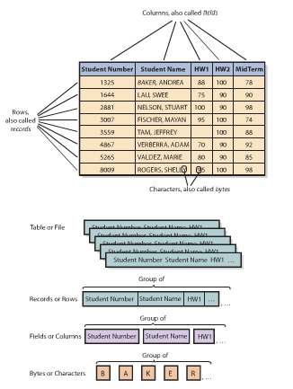
4) What does a database contain?
Hierarchy of data elements:
1. Byte is a character of data (8 bits)
2. Bytes are grouped into columns/fields
3. Columns grouped into rows/records
4. Rows are grouped into tables/files

- Database – a collection of tables plus relationships among rows.
- Metadata – describes the structure of the database, data that describes data (makes database more useful than spreadsheet and easier to use).
- Key – used to express a column that identifies a certain row in a table. Every table has a key.
- Foreign key – keys in a different table than the one in which they reside.
- Relational database –database using tables and represent relationships using keys and foreign keys.
- A database is self-describing this means that it contains a description of its own content (metadata).
5) What is a DBMS and what does it do?
•A database itself is not useful, you need a database application system to make is accessible and useful.
•DBMS (database management system) – a program used to create, process (delete, modify, read or insert data) and administer (ex: set up security, backups etc.) a database. Licensed from vendors.
- Open source: Microsoft, Oracle, IBM, MySQL
- DBMS products – DB2 from IBM, Access and SQL Server from Microsoft, Oracle from Oracle
- Corporation, MYSQL – an open source DBMS
- User – Database application – DBMS – Database
1. Creating the Database and Its Structures
•Use the DBMS used to create tables, relationships and other structures in the database
•Use to define a new table or modify tables
2.Processing the Database
•DBMS processes database
•Applications use DBMS to read, insert, modify, or delete data
•Structured Query Language (SQL)= international standard for processing a database
3.Administering the Database
•DBMS provides tools to assist in administration of database
•Can be used to set up a security system
•Used to back up data
•Add structure to improve performance
•Remove data
6) What is a database application?
Databases can have more than 1 application and each application can have multiple users.
•A collection of forms, reports, queries and application programs that process a database.
- Forms – used to modify, delete, read and insert data.
  - Reports - show data in structured context, may compute values
  - Queries - means of getting answers from database data
  - Application programs
-process specific logic to business need
-enables database processing over Internet
!serves as intermediary between Web server and database
!responds to events
!reads, inserts, modifies, deletes data
- Multiuser processing – multiple people use a database. Problems: lost-updatewhen two users use a database and the database updates wrong, inaccurate results.
7) What is the difference between an enterprise DBMS and a Personal DBMS?
1. Enterprise DBMS
- process large organizational and workgroup databases
- many users, many database applications
- DB2, Microsoft’s SQL server, Oracle
2.Personal DBMS
- designed for smaller, simpler database applications
- fewer than 100 users
- Access, dBase, FoxPro, Paradox, R:Base
Application extension 5A
1) Who will volunteer?
Find & track volunteers (how many years they’ll come back, their effectiveness and personal info)
2)How are database application systems developed?
!Database application system consists of:
1.Database
2.DBMS
3.One or more database applications
!Database application consists of:
1.Forms
2.Reports
3.Queries
4.Application programs
!Database Application Development Process
1.Developers interview users to find the requirements
2.Analyze existing reports, forms and user activities.
3.Summarize requirements in a data model (a summary of the data : entities & relationships)
4.Create database design (tables with foreign keys)
5.Design implemented in database
6.Database filled with user data

3)What are the components of the Entity-relationship data model?
!Techniques for creating data model
oEntity-relationship data model (E-R)
oUnified modeling language (UML)
!E-R model components
oEntities (things) stored in database, something a user want to track (Physical object or logical construct/transaction: customer, salesperson, item, order, contract).
o Attributes describe the characteristics of entities
o Identifier is an attribute whose value is associated with ONE entity.
oAll entities have relationships among them. (Crow’s foot – the lines between entities.)
!1:1 relationship (single entity to single entity)
!1:N relationship (one-to-many entities)
!N:M relationship (many-to-many entities)
oCardinality - # of entities that can be involved in relationship (maximum vs minimum)
4)How is a data model transformed into a database design?
Database design is the process of converting data into tables, relationships and data constraints.
1.Transforms entities into tables
2.Expresses relationships
3.Defines foreign keys
4.Shows data constraints
2concepts:
1.Normalization:
The process of converting poorly structured tables into well-structured tables.
Data integrity problems:
!Different names for the same entity
!Produces incorrect and inconsistent information
!Resolve by eliminating duplicated data
Normalizing for Data Integrity
!Eliminate data duplication
!Slower to process
!Construct tables such that every table has single topic
2.Representing relationships:
!Designer creates table for every entity
!Entity identifier becomes primary key of table
!Attributes of entity become columns
!Represent relationships between tables, add foreign key to one or more tables
5)What is the users role?
!The ones deciding what the database should contain
!Change the database while in the modelling state, later will only be time consuming
!Must insure that model reflects an accurate view of business.
6)So how will volunteer?
A database must reflect the way users think about their activities.
- Consultant creates data model based on interviews with users

-Data model reviewed and approved
-Database tables constructed
-Primary and foreign keys selected based on interviews
-Microsoft Access database created
-Relationships indicated
-Forms and reports constructed.
Application Extension 5B – Using Microsoft Access
How do I create tables?
The primary key is underlined and the one in italic is the foreign key. They go through an example using the “volunteer” business.
Be clear with the naming of different columns etc.
You can follow the steps using your own Microsoft Access.

Module 1:
Chapter 1- Updated in third edition. Use glearningcampus slides.

Module 2:
Chapter 4- Updated and moved to chapter 3 in third edition. Use glearningcampus slides (although you may wish to read the chapter in eConcordia as the material covered, Hardware and Software, is still the same.) There is also further notes to Hardware and Software in glearning.

Module 3:
Chapter 3- This chapter has been removed, no need to read.

Module 4:
Chapter 2- This is the same chapter as in glearningcampus. You may use either the slides in glearning or the chapter in eConcordia. Also refer to the BPM resources in glearning.
Chapter 5- Read. (The second part is simply referring to the textbook, there is no first part to worry about.)

Module 5:
Chapter 6- Read.
Chapter 7- Continues the discussion on ERP's using SAP as an example. Read as it provides a good supplement to chapter 6.
Appendix 7- You will not be using SAP in the online section, no need to read.

Module 6:
Chapter 5- Read. This is the chapter you need to read in order to complete the assignment.

Module 7:
Chapter 6- No need to read. This chapter has been removed in the third edition and replaced with Business Intelligence. The slides are available in glearningcampus (Chapter 8.)

Module 8-11:
These are the same, simply read the chapters in eConcordia

Chapter 8
Q1 What Challenges Do Managers Face When Making Decisions?
-Decision making process is much more complicated for three reasons:
  - The concept of rationality is hard to define
  - Good outcomes may occasionally result from irrational processes, and bad outcomes can result from good processes
  - Humans intend to be rational, but there are limits on our cognitive capabilities
3 Ackoff Assumptions
  - Manages have no problem making decisions if they have all data they need. However, its uncertainty and complexity which make it challenging
  - Poor decisions cuz they lack info, but its Information overload
    - Digital universe is doubling in size every two years
    - Data is growing at the rate of 40 percent a year
    - Occurs inside and outside of organizations
  - Managers know the data they need, but its Data quality
-Raw data usually unsuitable for sophisticated reporting or data mining
  - Dirty data
  - Values may be missing
  - Inconsistent data
  - Data not integrated
  - Data can be too fine or too coarse (granularity)
  - Too much data
    - Too many attributes (columns)
    - Too many data points (rows)

Q2 What Is OLTP, and How Does It Support Decision Making?
If you are collecting data electronically and processing the transactions online, then you are using an online transaction processing (OLTP) system.
-Real-time processing
  - Transactions are entered and processed immediately upon entry
    - Examples: airline reservation systems, banking systems
-Batch processing
  - System waits until it has a batch of transactions before the data are processed and the information is updated
    - Example: transfer of all daily branch transactions to the central office for processing

Q3 What Are OLAP and the Data Resource Challenge?
- Online Analytic Processing (OLAP) systems focus on making OLTP-collected data useful for decision making
  - OLAP provides the ability to sum, count, average, and perform other simple arithmetic operations on groups of data
  - OLAP report has measures, or facts, and dimensions

Q4 What are BI Systems, and How Do They Provide Competitive Advantage?
A business intelligence (BI) system is a system that provides information for improving decision making.

RFM Analysis: Way of analyzing and ranking customers according to their purchasing patterns
A simple technique that considers
  - How recently (R) a customer has ordered
  - How frequently (F) a customer orders
  - How much money (M) the customer spends per order

Q5 What Are the Purpose and Components of a Data Warehouse?
The purpose of a data warehouse is to extract and clean data from operational systems and other sources and to store and catalogue that data for processing by BI tools

A data mart is a data collection that is created to address the needs of a particular business function, problem, or opportunity. An electronic commerce (e-commerce) company, for example, might create a data mart storing clickstream data that are pre-sampled and summarized so as to enable the analysis of webpage design features.
Users in the data mart obtain data from the data warehouse that pertain to a particular business function. Such users do not have the data management expertise that data warehouse employees have, but they are knowledgeable analysts for a given business function.
Data mining is the application of statistical techniques to find patterns and relationships among data and to make classifications and predictions.
Q7 What are typical data-mining applications?
With unsupervised data mining, analysts do not create a model or hypothesis before running the analysis. Instead, they apply the data-mining technique to the data and observe the results. With this method, analysts create hypotheses after the analysis to explain the patterns found.
One common unsupervised technique is cluster analysis. Using this technique, statistical techniques identify groups of entities that have similar characteristics. A common use for cluster analysis is to find groups of similar customers from customer order and demographic data

Q7 What are typical data-mining applications?
- With unsupervised data mining, analysts do not create a model or hypothesis before running the analysis. Instead, they apply the data-mining technique to the data and observe the results. With this method, analysts create hypotheses after the analysis to explain the patterns found.
One common unsupervised technique is cluster analysis. Using this technique, statistical techniques identify groups of entities that have similar characteristics. A common use for cluster analysis is to find groups of similar customers from customer order and demographic data
- With supervised data mining, data miners develop a model prior to the analysis and apply statistical techniques to data to estimate the parameters of the model. For example, suppose marketing experts in a communications company believe that cell phone usage on weekends is determined by the age of the customer and the number of months he or she has had the cell phone account. A data-mining analyst would then run an analysis that estimates the impact of customer and account age. One such analysis, which measures the impact of a set of variables on another variable, is called a regression analysis.
Neural networks are another popular supervised data-mining technique used to predict values and make classifications, such as “good prospect” or “poor prospect” customers. The term neural networks is deceiving, however, because it connotes a biological process similar to that in brains. In fact, although the original idea of neural nets may have come from the anatomy and physiology of neurons, a neural net is nothing more than a complex set of possibly nonlinear equations

