Chapter 3: Organizational Commitment

Organizational Commitment
- Employee retention
- Employee engagement

Why is Commitment Important?
- Turnover is expensive
  - 0.5 annual salary (+benefits) for hourly employees
  - 1.5x for salaried employees
  - 5x for execs
- Time to train new employees (Deloitte survey)
  - 6 months until working proficiently
  - 18 months until integrated in culture
  - 24 months until employees are truly aligned with strategic mission of company
- Unengaged employees are expensive

What does it mean to be committed?
- Picture you have been working for 5 years; why do you choose to remain a member of the organization
- Emotion-based reasons
  - Ex. You would miss friends and atmosphere
- Cost-based reasons
  - Ex. I am due for a promotion soon, I get good benefits
- Obligation-based reasons
  - Ex. Boss has invested time in you, organization started your career

Types of Commitment
- Affective commitment
  - Often connected with our relationships to others
  - Two models that focus on affective commitment:
    - Erosion
    - ????
- Continuance commitment
  - an employee’s desire to remain with an organization due to the awareness of the costs of leaving
  - they feel like they HAVE to stay
  - 2 main underlying factors of continuance commitment:
    - Alternatives: what are my other options?
    - Embeddedness: connection and sense of fit with organization, community, family; investment into organization and community (not emotional, but resource-based) ex. Time investment, network, community resources
- Normative commitment
  - Employees desire to remain with the organization due to a feeling of obligation
  - Reciprocity, investment in/ commitment out

What type of Commitment?
- “we just bought a house in a great neighbourhood, close to the kids’ school”
  - continuance
- “I am the only one trained to use the new system, my coworkers would be lost without me. I have to stay until they know how to use it”
  - normative
- “I have invested so much time into tis organization, I serve on multiple committees, I should be getting that big promotion soon”
  - continuance
- “My work is really fulfilling, I love getting a chance to see the people I help and my organization facilitates feedback from our clients”
  - affective
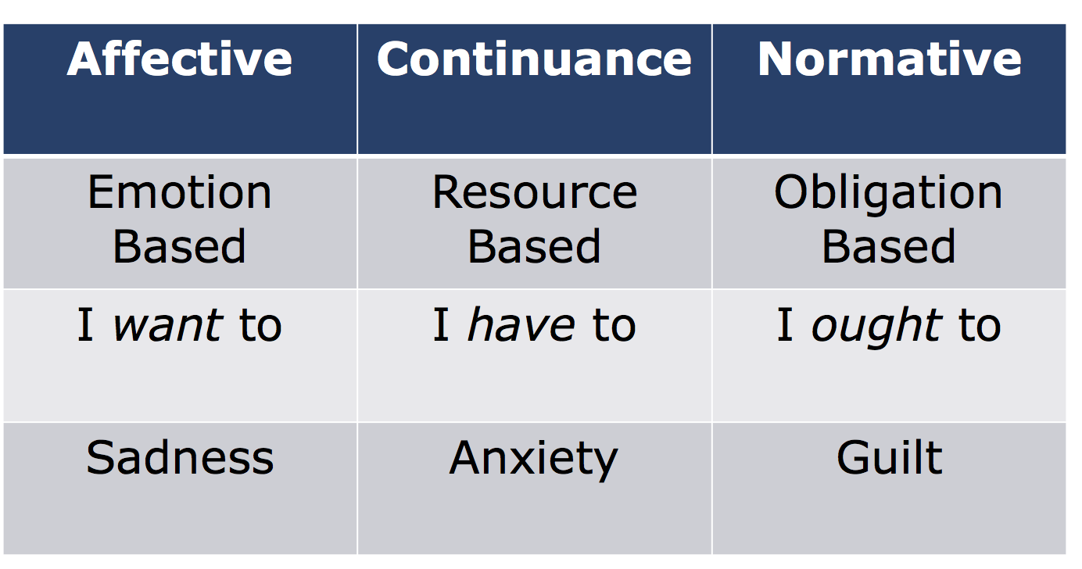

- types of commitment are dynamic and complex
- employee’s commitment can have different targets (focus)

What type of commitment does a company promote?
- If they support their employee’s MBA education – normative
- If they develop their employees’ skills through in-house training programs

How do employees respond to negative work events?
- Function of their level of commitment
  - Voice concerns (+)
  - Loyalty (+)
  - Neglect (-)
  - Exit (-)

Withdrawal
- Physical withdrawal (exit)
  - Being late, missing meetings, taking long breaks, being absent, quitting
- Psychological withdrawal (neglect)
  - Daydreaming, looking busy, socializing, moonlighting (using company resources to contribute to their own company), cyberloafing, taking longer than what is needed to complete a task

What is the impact of continuance commitment on withdrawal behaviours?
- It depends… classic
- Based solely on few alternatives (generally bad)
- Embeddedness (not always bad)

Recap
- Commitment captures the intent to remain, types of commitment capture the “why”
- Affective commitment has consistent positive effects; continuous commitment “it depends”
- Turnover is expensive, but so are withdrawn employees

