Chapter 2: Job Performance

Comcast and Job Performance
- How job performance is defined
  - Based on results or employee behaviour
- How job performance is measured
  - % of disgruntled customers retained
- How job performance is rewarded
  - According to specific targets that are met
  - Small hourly wage + (payout – penalty)
  - Incentive gates:
    - If a rep retains 85% of calls or more => get 100% of payout
    - If a rep retains 80-84% of calls => get 75% of payout
    - If a rep retains less than 75% of calls => lose all of payout

Defining Job Performance
- How do we define job performance in order to motivate the best possible behaviours and generate the best possible organizational outcomes?
  - Job Performance: Employee behaviours that contribute either positively or negatively to organizational goals
- Two elements:
  - Results – objective measures of outcomes
    - Pros: easy to assess, objective/comparable
    - Cons: doesn’t capture “beyond the bottom line”, not always controllable, no focus on improvement/ no “why”
  - Behaviour – specific behaviours employees engage in

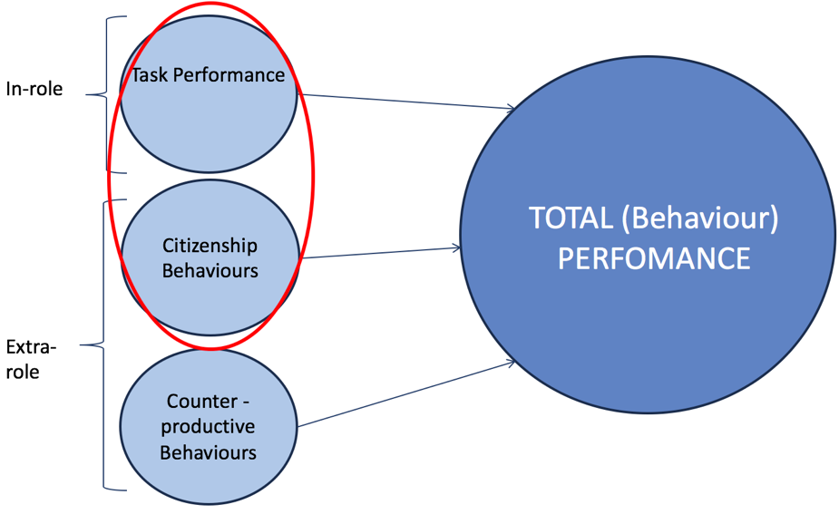

Behaviour
- Task performance
  - 3 subtypes:
- routine (habitual response to predictable tasks)
- adaptive (thoughtful responses to unpredictable tasks)
- creative (novel and useful ideas)
- Citizenship Behaviours
  - Voluntary behaviours that contribute to achieving organization goals
  - Can be interpersonal or organizational (OCB-I vs. OCB-O)
  - Relevant in virtually every job
  - Subtypes:
- Helping (I)
- Courtesy (I)
- Sportsmanship (I)
- Voice (O)
- Civic virtue: going above and beyond, volunteer (O)
- Boosterism: outside of work you are portraying the organization positively (O)
- Counterproductive behaviours
  - Intentional behaviours that hinder the achievement or organizational goals
  - Can be interpersonal or organizational
  - Relevant to all jobs
  - Subtypes:
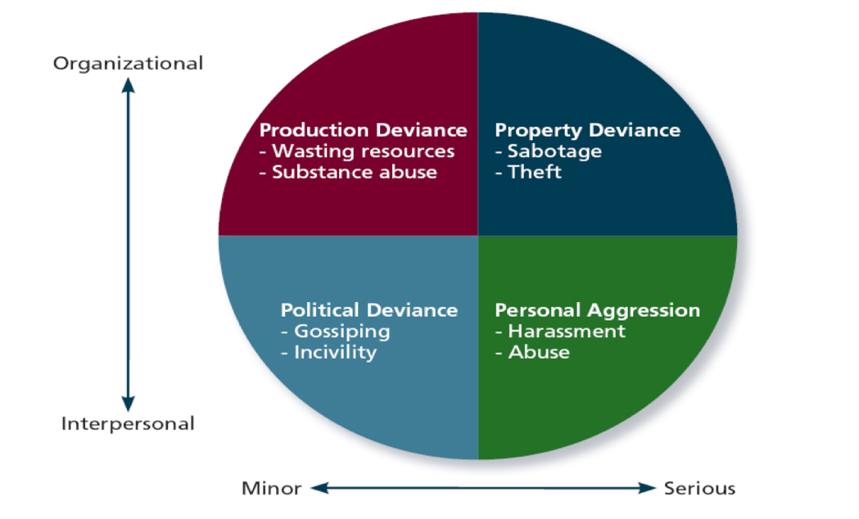
  - Surveillance and theft
    - Weak negative but non-significant relationship with counterproductive work behaviours
    - Strong negative AND significant relationship with citizenship behaviours

Important takeaways
- Breaking down into types = greater insight
- Change => multiple outcomes

The War for Talent
- What is the war for talent?
  - Hire people who are from high respected business schools (assess potential)
  - Deep seated belief that having better talent at all levels is how you outperform your competitors
  - Forced ranking
    - A – the stars; need to be challenged and encouraged to follow passions
    - B – need to be nurtured and affirmed; could one day be stars
    - C – the dogs; need to shape up or ship out
- What is the talent myth and why is it destructive?
  - Defines talent abstractly
    - They assess potential over performance
    - Move stars around so much no one can actually assess performance
    - Lou Pai – lost millions of dollars in two failed business ventures and was still considered a star
    - Louise Kitchin – in her role because she wanted to be there
  - Self-serving and narcissistic people “make it”
    - Indulge and fawn over stars
    - Put stars above customers
    - Begin to define themselves by the description of talent
  - Focus on the individual rather than the system
    - They believe in stars because they don’t believe in systems
    - Organizations must coordinate (the system should be the star)
    - Job performance should be defined based on what the system needs
    - Encouraged poaching
    - Jack Welch: A’s bleed charisma and are filled with passion
    - Exhibit the four E’s of leadership:
      - High energy
      - Can energize others; common goals
      - Have the edge; difficult decisions
      - Ability to execute; deliver on promises
  - Focus on the individual rather than the system
    - Ex. Hockey teams draft best players

Other Job Performance Tools
- Management by objectives
  - Agreed upon goals
  - Objective and specific goals
  - Results based performance
  - Changes, environmental pressures
- BARS (behaviourally anchored rating scales)
  - Assesses behaviours
  - Quantification
- 360 degree feedback
  - multiple stakeholders
  - employees complete
  - limitations:
    - time, difficulty, tension/relationships

Good practices for job performance tools
- comfortable time and space
- give employees input/ a voice
- open lines of communication
  - keep in loop of procedures
  - should know what is on forms
- pilot testing
- use multiple indicators

