COMM 223- Midterm
LECTURE 1
Marketing concept: the key to achieving organizational goals consists of determining the needs/wants of target markets + delivering the desired satisfactions more effectively/efficiently than competitors
Concentrate → needs of buyer, NOT needs of seller
Marketing: the process of maximizing company profits (short/long-term) through creation of superior value for customers relative to competition
The Core Marketing Concept:
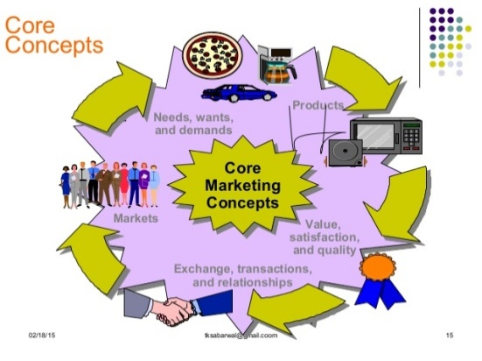
Needs: state of feeling deprivation (e.g.: hunger)
Wants: needs shaped by culture/individual personality (e.g.: “I want a hamburger and fries”)
Demands: wants backed by buying power (e.g.: I have money to buy this meal → I’m buying it)
Meeting customer needs and wants:
Products: anything that can be offered to a market for attention, acquisition, use or consumption and that might satisfy a need/want.
Customer’s Decision Criterion:
Customer value: benefits customer gains from using product compared to cost of getting product
Customer satisfaction: depends if product’s perceived performance in delivering value can meet buyer’s expectations
How Consumers Meet Needs and Wants:
Exchanges: obtaining a desired object from someone, offering something in return
Relationships: process of creating, maintaining and enhancing ongoing exchanges/transactions
The Market: the set of all actual/potential buyers of a product/service
LECTURE 2
Marketing Management Orientations:
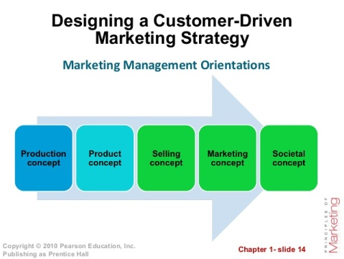
Marketing Approaches
Classic Marketing Approach (stick to basics) | Alternative Marketing Approach (innovation)
- Market-driven  - “Give customer what they want.”  - Matches well with markets containing products with high buyer familiarity  - Assumes buyers evaluate choices based on fixed value concepts | - Market-driven  - “Help customers learn what they want”  - Matches well with rapidly evolving markets with growing number of original products  - Assumes buyers can learn/evolve with new value concepts

Customer Relationship Management (CRM):
- General process of building/maintaining profitable customer relationships by delivering superior customer value/satisfaction.
- It costs 5-10x more to attract a new customer than it does to keep current one satisfied
- Marketers → concerned with lifetime value of the customer
- Customer equity: total customer values of all of the company’s current/potential customers
- Ideal relationships with customers → treating customers as assets that need to be managed/maximized
- Different customers = different CRM strategies
Customer Lifetime Value (CLV):
- The value of the entire stream of purchases that ONE customer would make over a lifetime of sponsorship
- E.g.: Lexus estimates one customer = $1,170,000 in lifetime sales
- CLV can end up negative→ e.g.: customer buys but does not pay
Strategic Planning: managerial process of developing/maintaining a strategic fit between organization’s goals and resources in its changing market environment
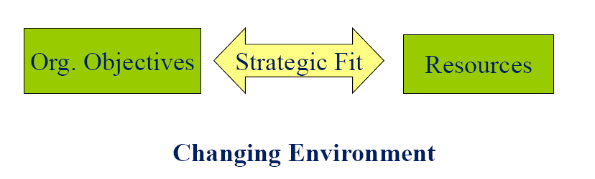
Steps in Strategic Planning:
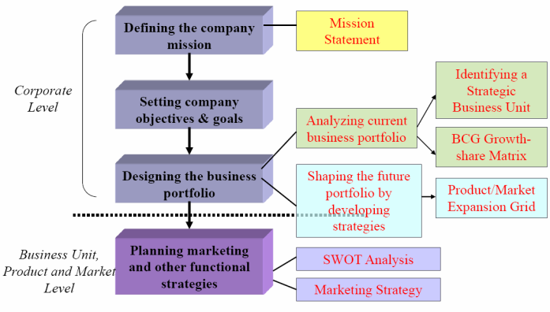
- Mission statement:
- statement of organization’s broad purpose; what it wants to accomplish in the big picture
- statement of the organization’s scope, often identifying its customers, markets, products, technology and values
Evaluating a Mission Statement:
- Market oriented: focus on meeting consumer needs
- Realistic: don’t be delusional
- Motivational: inspire employees
- Consistent with the market environment: be up to date

- Corporate goals:
- Convert the mission into targeted levels of performance
- Measurable, achievable, unequivocal

- Business Portfolio: P&G example
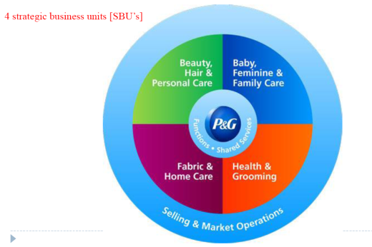
- BCG Growth Share Matrix
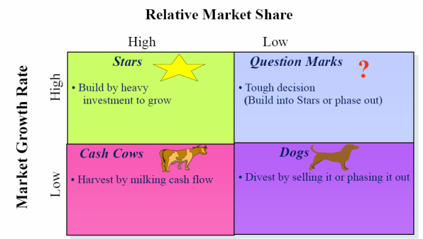
Limitations of BCG analysis:
- Independence assumption
-does not account for synergies
-cannot explain cannibalization
- Not powerful for future planning
- Limited information used
-market attractiveness= growth?
-competitive position = market share?

Product/Market Expansion Grid:

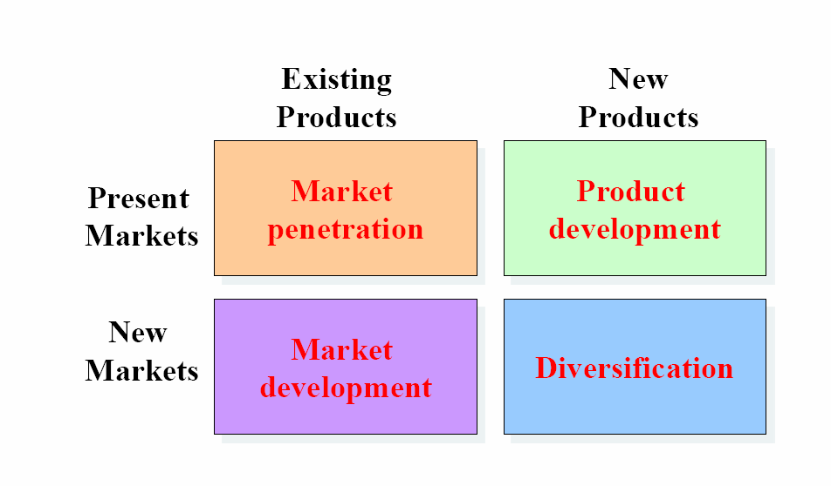

Market Penetration:
- Making more sales to current customers without changing its products
- How? →Add new stores in current market areas, improve ads, prices, service/store design, suggest a new usage
Market Development:
- Develop new markets for its current products
- How? → Identify new demographic/geographic markets
Product Development:
- Offering new products to current markets
- How? → new styles, flavors, colors, modified products
Diversification:
- New products for new markets
- How? → Start up/buy new businesses
Planning Phase:
- Situation analysis (SWOT): complete analysis of company’s situation
- Customer-focused Marketing strategy (STP): targeting/positioning + managing marketing mix (4 P’s)
SWOT analysis: formal framework for identifying/framing organizational growth opportunities
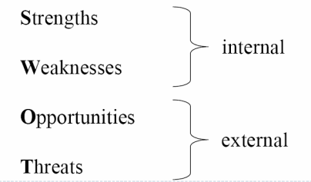
Marketing Environment:
- Company’s Microenvironment:
- Consists of the actors close to the company which affect its ability to serve customers
- The company, customers, competitors, suppliers, marketing intermediaries, publics
- Company’s Macroenvironment:
- Consists of the larger societal forces that affect the microenvironment
- Demographic, economic, natural, technological, political, cultural-environment.
- E.g.: more people are divorcing and separating
Age groups:
- Children: (generally speaking)
- Increasing in developing countries
- Decreasing in developed countries → does NOT imply ↓ spending
- Expenditure on baby/kids products depends on culture
- Teenagers
- Easily switch brand preferences
- Easily liable to peer influences
- Young adults
- 18-25 have ↑ (gen Z)
- 26-36 have ↓ (gen Y)
- Middle-aged segment
- Baby-boomers
- Elderly
- Proportion growing strongly in industrialized nations
- Cognitive/perceived age often different from actual age
- Want ads to appeal to them, but not too obvious
- Have a lot of discretionary income, but:
- often don’t need to spend
- are often careful spenders
- have more time (use coupons, buy during off-peak hours)
- Newspapers and AM radio
- Shop earlier
- Declining sensory abilities

Attractive Age groups:
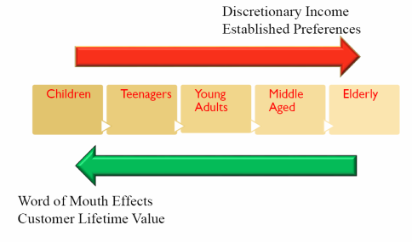
Technological environment: includes forces that create new technologies creating new product/market opportunities
Political environment: increase legislation and social responsibility emphasis
LECTURE 3
Marketing Research: the process of acquiring market information to improve marketing decisions
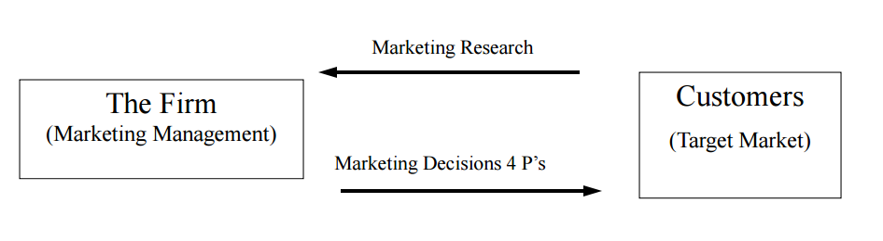
*4 P’s = Product, pricing, placement, promotion
Marketing Information System: information needed by managers can be obtained from…
- Internal data
- Computerized collection of consumer and market info from data sources (i.e.: accounting) within the company network
- Gathered via customer databases, financial records and operations reports
- PROS: quick, easy access to info
- CONS: incompleteness, inappropriateness to a particular situation
- Marketing Intelligence
- Collection/analysis of publicly available information about competitors/developments in the marketing environment (i.e.: technological)
- Competitive intelligence gathering activities have grown
- Many sources of competitive info exists

Procedure for Marketing Research:
- Define purpose of the research
- Why should we do the research?
- What should the research tell us?
- Plan the research
- How should the research be carried out?
- Perform the research
- Collecting/analyzing data
- What should we do with the data?
- Interpret and report the findings
- What do we do with the results?
Research plan: classification of research types
- Exploratory:
- Gives insights into the general nature of a problem, possible decision alternatives, and the relevant variables to consider
- Used when little is known about the problem/situation → to develop initial hunches/insights and to provide direction for any further research needed
- Used to gain ideas and insight into the research problem
- Used to determine what factors/variables/constructs may potentially be influential
- Research outcome: a list of potentially influential factors/variables
- Descriptive:
- Provides an accurate snapshot of some aspect of the market environment
- Used when the research objectives/questions are clearly defined and summary measures are needed to address the research questions
- Used to describe the characteristics/composition of relevant groups or units
- Research outcome: summary measures (of characteristics)
- Causal/Confirmatory/Experimental:
- Shows whether one variable causes or determines the values of other variables
- Used to identify/establish cause-and-effect among variables
- Used to understand tight connections between management actions and observed outcomes
- Research outcome: and X & Y relationship → if X occurs, Y happens
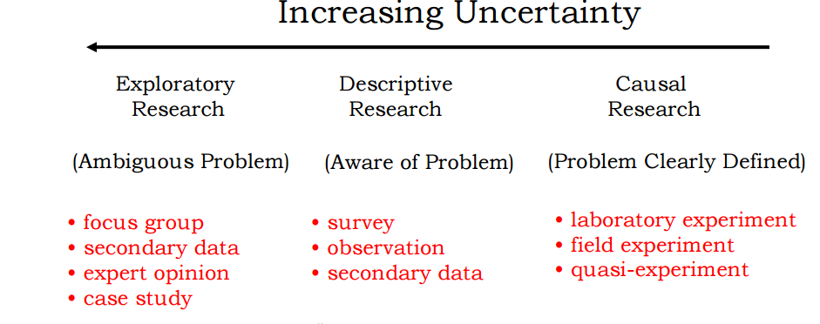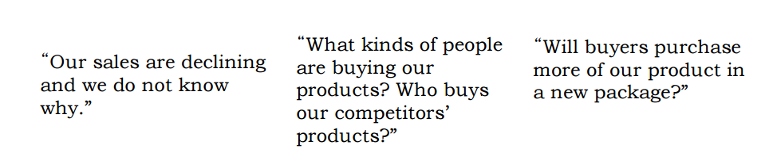
Descriptive vs. Causal Studies: Correlation and Causality
- Correlation DOES NOT = Causality
- Reverse causation: the more firemen fighting a fire, the bigger the fire is going to be. Therefore, firemen cause fire
- A third common causal factor: does wearing a seatbelt reduce death risk in a car accident?
- Coincidence: since the 1950’s, both the atmospheric CO2 level and crime level have increased sharply. Hence CO2 = crime
Experiments for Causal Relationship:
- Goal: to determine causality
- Conditions necessary to establish causality
- The cause must precede the effect (A before B)
- No plausible explanation for B other than A
- Ceteris Paribus (all things being equal)
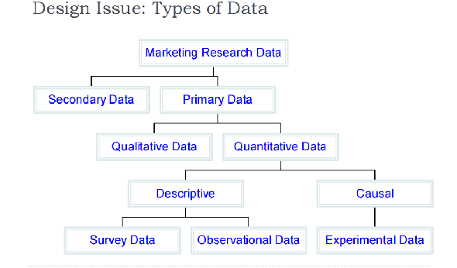
Primary vs. Secondary Sources
Primary
- Collected by researcher
- Addresses a specific research objective (survey data, questionnaire, etc)
PROS of Primary:
- More reliable
- Better suited to specific research goals
- Used in exploratory, descriptive, and causal research designs
Secondary
- Typically collected by a 3rd party (not the researcher)
- Collected without specific research objective (census, store audits)
PROS of Secondary:
- Cheaper than primary data
- Easy to obtain
- Best for exploratory research
Qualitative Research:
- Involves: small samples + non-structured data collection procedures
- Provides: initial insights, ideas of understanding of the problem
- Should NOT be used to recommend final course of action
- Main methods
- focus group: a group discussion, best for preliminary research
- in-depth interviews: one respondent, one researcher leads discussion, encourages uninhibited responses, laddering (follow-up question based on respondent’s answer) as a technique
- observation: involves recording the behavioral patterns of people, objects and events in a systematic manner
Projective Techniques:
- unstructured/indirect form of questioning which encourages the respondents to project their underlying motivations, beliefs, attitudes or feelings regarding the issues of concern
- Examples:
- word association: respondent responds to a list of words, reacting to them with the 1st word that comes to mind
-Measures: frequency, time limit, # of respondents who don’t respond at all
- sentence completion
- picture response and drawings
- ZMET: Zaltman Metaphor Elicitation Technique
-elicitation of respondent’s unconscious thoughts via non-literal or metaphoric expression
-respondents are asked to collect a set of pictures that represent their thoughts and feelings about the topic of interest
Survey Data:
- Useful for descriptive research
- PROS:
- Standardization/completeness
- Ease of administration
- Access to unobservable perceptions
- Suitable for statistical analysis
- CONS:
- “I don’t care”
- Easy to do wrong

Types of Sampling Methods:
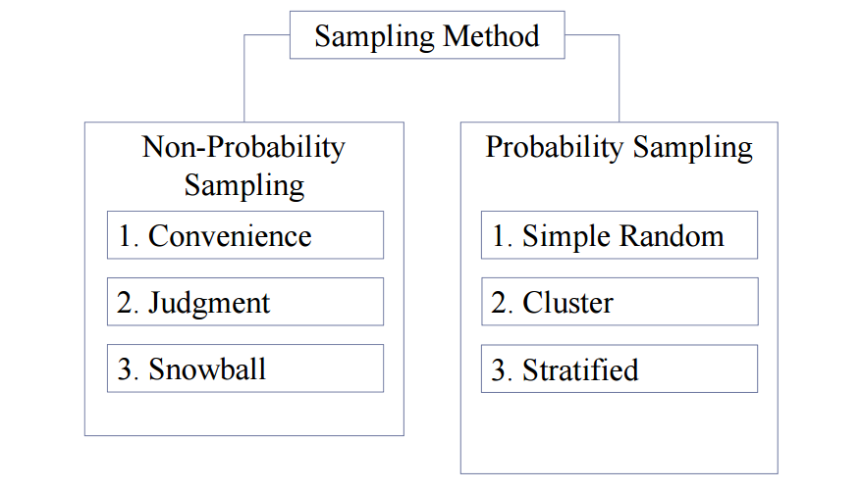
Probability vs. Non-Probability Sampling
- Probability sampling: every element of the population has a known probability of inclusion in the sample
- PRO: one can quantify the amount of error that is introduced because a sample is used instead of a census
- Simple random sample: computer generated random numbers
- Stratified sample:
- Use it to increase precision and ensure different subgroups are represented
- To use this method researchers must have knowledge on the size of each stratum in population
- Two step procedure:
- The target population is divided into subsets or strata
- Mutually exclusive/exhaustive
- Strata are based on one of more characteristics (e.g.: age, gender, state, store size)
- A simple random sample is chosen from each subset
- Cluster sample:
- cost friendly
- require homogeneity across cluster and heterogeneity within cluster
- Two step procedure:
- Population is divided into mutually exclusive/collectively exhaustive subsets
- Random sample of subsets is selected
- Non-probability sampling: some elements have zero chance of being selected
- Convenience sample: “person on the street” survey, popup window on website, mall intercept
-cheap, convenient, but often opinionated
- Judgement sample: expert opinion, “techy” consumers
- Snowball sample
- CONS of non-probability sampling:
- sample may not be representative of target population
-difficult to project sample results to target population
- Circumstances under which a non-probability sample may be used:
- Exploratory research, e.g.: focus groups
- When probability samples are too costly
Why don’t we just ask consumers what they want?
- People don’t know what they want
- People don’t always know their needs
- People don’t want to tell you why they do what they do
- People don’t know why they do what they do
- Sometimes asking them changes their behavior
LECTURE 4
Consumer behavior: the activities of consumers in obtaining, using and disposing of goods/services, including the decision process that precede and follows these actions
Consumer behavior model:
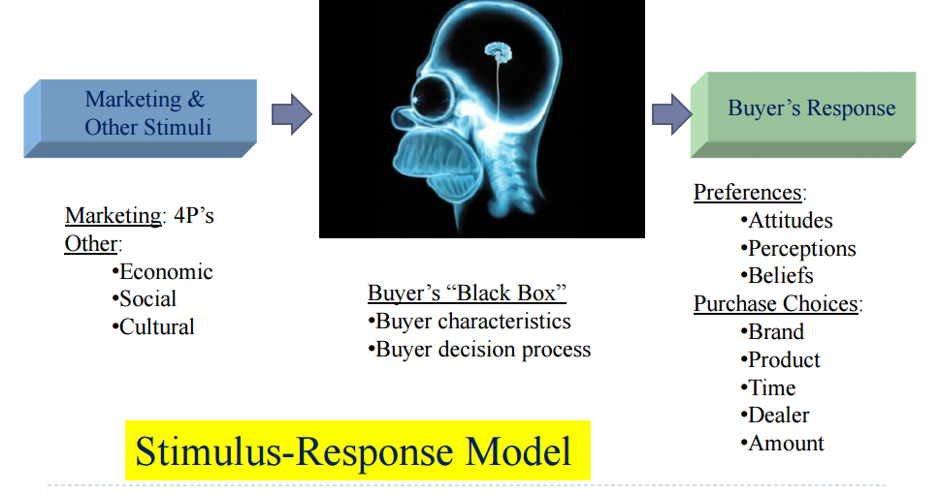

Factors affecting consumer behavior:
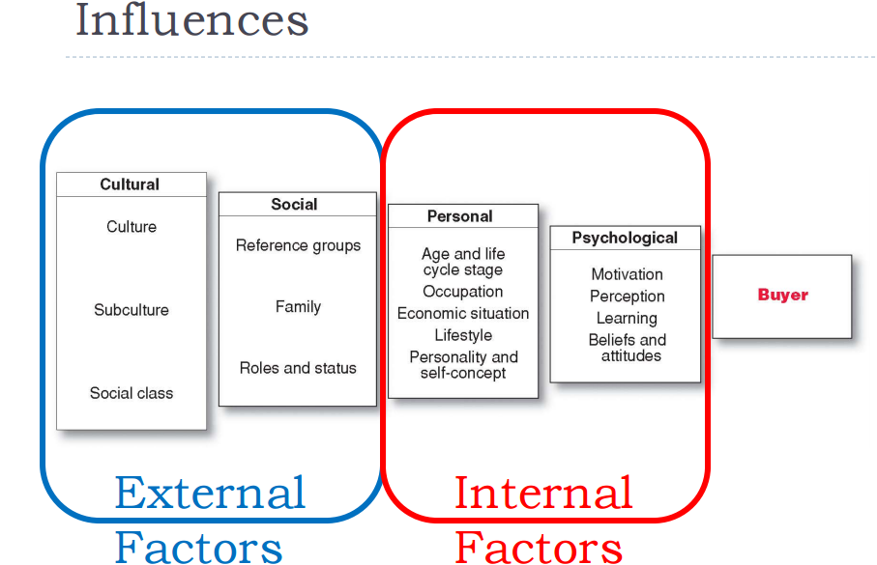

Internal factors:
Personal factors
- Age and life cycle stage
- Occupation
- Economic situation
- Personality
- Refers to the unique psychological characteristics that lead to consistent and lasting responses to the consumer’s environment
- Brands also have personalities →consumers are likely to choose brands with personalities that match their own
- Lifestyle
- person’s pattern of living as expressed in his/her psychographics
- measures consumer’s AIOs (activities, interests, opinions) → capture person’s pattern of acting/interacting in the environment
Psychological Factors:
- Motivation: drives person to seek satisfaction of need
- Perception: process by which people select, organize and interpret info
- Learning: changes in individual’s behavior arising from experience
- Belief: descriptive though that a person holds about something
- Attitude: person’s consistently favorable or unfavorable evaluations, feelings and tendencies toward an object/idea
Psychological Influences Motivation
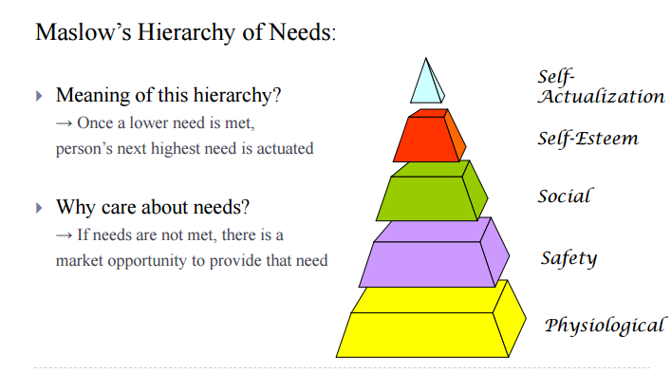
- Physiological needs: generic foods, medication, special drinks, supplements for athletes
- Safety needs: smoke detectors, preventative medicines, insurance, social insurance, retirement investments, seat belts, burglar alarms
- Social needs: cosmetics, clothing, entertainment, house
- Esteem needs: clothing, furniture, hobbies, automobiles, watches
- Self-actualization: education, hobbies, sports, adventure, vacations, books, gourmet foods, museums
Psychological Influences: Perception and How to reach consumers
- Exposure: e.g.: consumer must SEE your billboard
- Attention: e.g.: consumer must LOOK at Ad message
- Selective attention: people screen out most of info to which they’re exposed to
- Selective distortion: people interpret info in a way that will support their beliefs
- Selective retention: people will remember good points made about a brand they favor and forget good points about competing brands
- Perception: e.g.: consumer must TAKE IN message
Perception = Constructed Reality:
- Reality = perception
Perception is Crucial in Consumer Behavior:
- What is perceived is not necessarily what is true
- What consumers perceive is what is reality for them; it affects their actions

Psychological Influences: Classical Conditioning
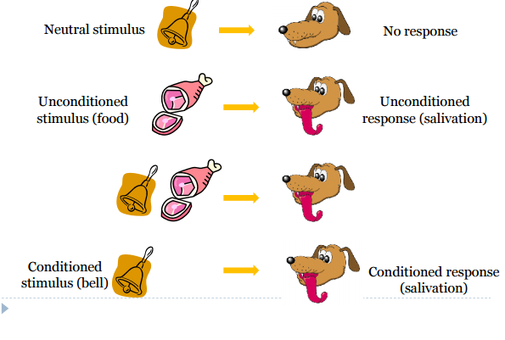
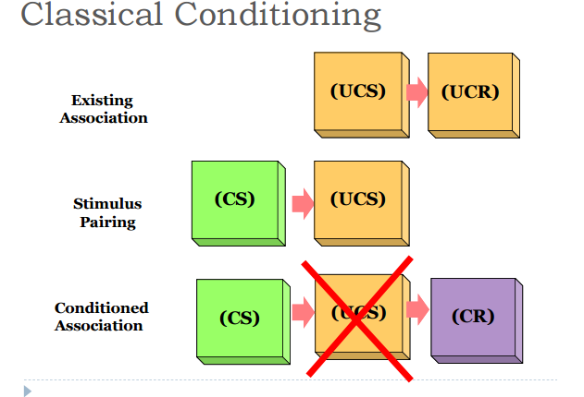

Types of Buying Behavior
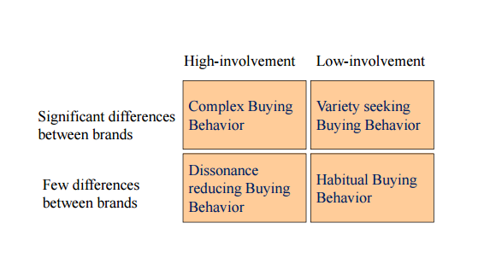
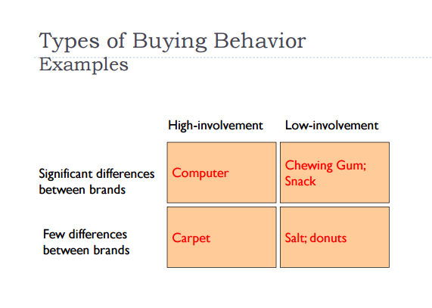
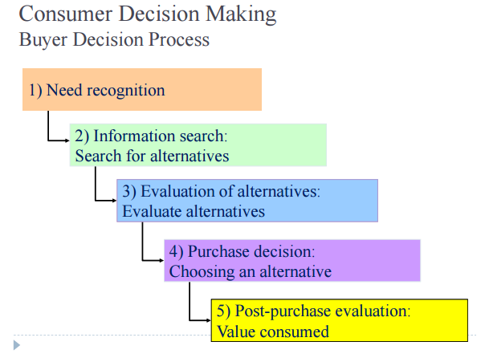

- Need recognition
- Stimuli
-internal: hunger, thirst
-external: rain
- Need recognition does NOT equal need
- Consumers may not always identify their needs, marketers should help them recognize them
- Marketers must know why consumers need something, while consumer do not need to
- Information search
- Personal sources: family + friends
- Commercial sources: ads, internet
- Public sources: mass media, consumer org.
- Experiential sources: handling, examining, using the product
- Evaluation
- Most buyers evaluate multiple attributes (i.e.: product characteristics), each of which is weighted differently
- Marketer’s perspective → highlight products strengths in info stage. If features = benefits consumer, product will stand out
- Purchase decision
- Consumer chooses the alternative the “best” solves the problem based on…
-attributes of the alternative
-other consumers’ attitudes
-value net of cost to acquire (e.g.: proximity to store)
- Post-purchase evaluation
- Discrepancy between: consumer expectations vs. perceived performance
- Cognitive dissonance: buyer discomfort cause by post-purchase conflict
External Factors:
Cultural Influence
- Culture: learned values, perceptions, wants and behavior from family and other important institutions
- Cultural shifts can be good market opportunities
- Subculture
- Smaller groups with shared value systems
- E.g.: francophones vs. Anglophones
- Social class
- Divisions based on social/economic status
- Distinctions can be unclear in some cultures like Canada

Social Influence
- Family
- Wife/husband, parents/children
- Groups
- Membership
- Reference groups
- Opinion leaders
- Online social network
Sources of Socio-Cultural Influences
- Opinion leaders
- More likely to create WOM than others
- Characteristics of opinion leaders
- Similar to receiver
- Greater status
- Involved with the product
- Outgoing
- Seek others’ opinions themselves
- Market mavens
- Have a lot of info about the marketplace in general
- Initiate discussions with consumers and respond to requests from consumers for market info
Types of Reference Groups: person/group that influences your behavior
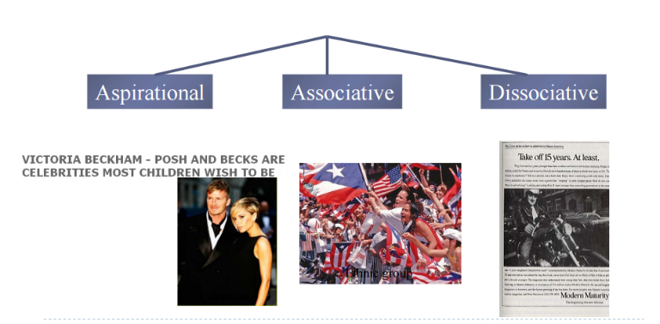

Compliance
- Tendency to be influenced
- More likely to occur publicly than privately
- Can also occur in response to some trigger
- Automatic
- Efficient
- Compliance tactics
- Authority
- People defer to experts
- Experts provide shortcuts to decisions requiring specialized info
- Social Proof
- We determine what is correct partially because of what others think is correct
- E.g.: “most popular”, “best selling”
- Laugh tracks for TV comedy (makes you want to laugh)
Socio-Cultural Influences: Reference group – Influence on Product/Brand choice
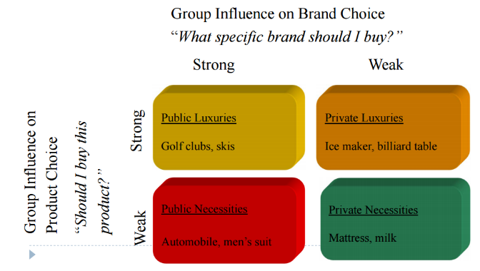
LECTURE 5
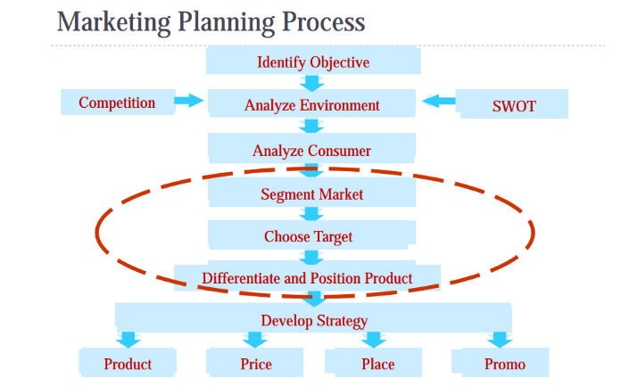

Market segmentation:
- Dividing the market into smaller groups with distinct needs, characteristics, or behaviors that might require separate marketing strategies/mixes.
- Bottom line: not everyone likes the same things and preferences variate
Targeting: evaluating each market segment’s attractiveness + choosing one or more segments to enter
Differentiation: differentiating the market offering to create superior customer value
Positioning (Value proposition): arranging for a market offering to occupy a clear, distinctive, and desirable place in the minds of target consumers
Market Segmentation Benefits:
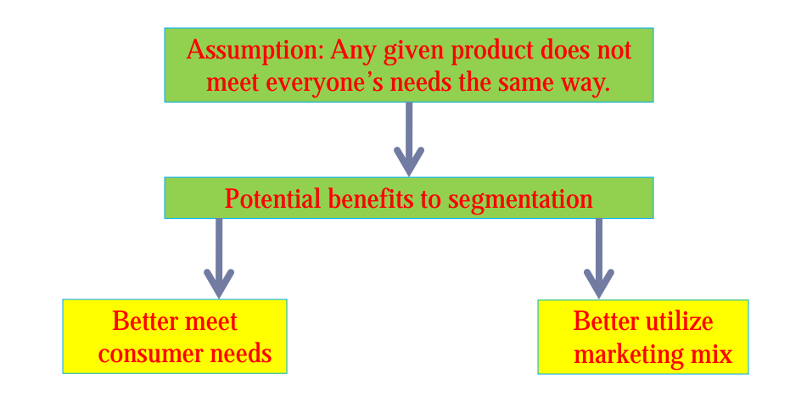
Bases of Segmentation:
- Geographic Segmentation
- By region
- Urban vs. rural
- City size
- Climate
- Demographic Segmentation:
- Age
- Income
- Gender
- Family size
- Life cycle: The traditional family life cycle
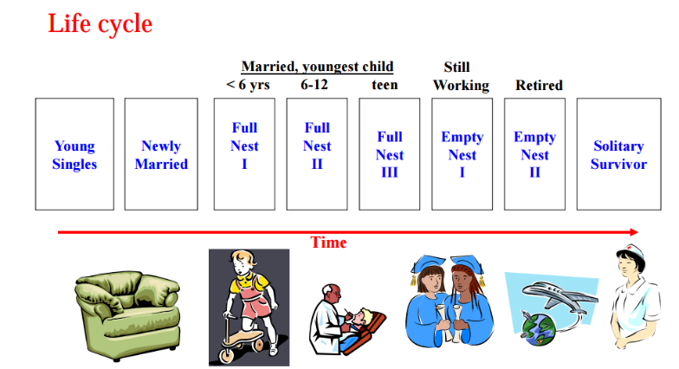
- Different stages of life cycle: why are they important?
- “Sharpened” memory, loyalty (e.g.: newlyweds)
- Open to changes (e.g.: Ford Freestyle)
- Education
- Religion
- Nationality
- Demographic segmentation doesn’t always work!
- People from same demographic segment may exhibit very different preferences
- People from different demographic segment may exhibit very similar preferences
- Solution: add Psychographics Segmentation
- Psychographic Segmentation:
- Social class
- Lifestyle
- Personality
- Values
- Compared to geographic/demographic:
- Usually difficult to identify
- Often closer to “real” segmentation
- Consumer characteristics that are not evident:
- Not overt (obvious), but covert (discrete) characteristics
- Tells you why people consume, not just who consumers
- Psychological and sociological variables. E.g.: consumer personalities, values and lifestyles
- More determinant of consumer behavior, but harder to measure than demographics
- Example:
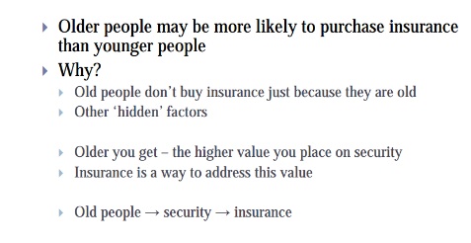
- Behavioral Segmentation:
- Usage occasion (typecasting)
- Particular holiday-specific product
- “XXX chocolate for snowy winter”
- Usage experience
- “I haven’t bought it”
- “I had bought one”
- “I currently own it”
- Usage frequency
- Loyalty
- Benefit
- International Market Segmentation:
- Political factors
- Legal factors
- Religions
- Culture
- Economic factors
Necessary conditions for good segments:
- Homogenous (consistent) within
- Heterogeneous (diverse) between
- Targetable
- Measurable (identifiable based on observables)
- Accessible (for marketing activity)
- Substantial (large enough to make business sense)
- Actionable (resources should be available)
- Differentiable (distinctive behavior)
- Stable (across time)
Targeting: Levels of Targeting
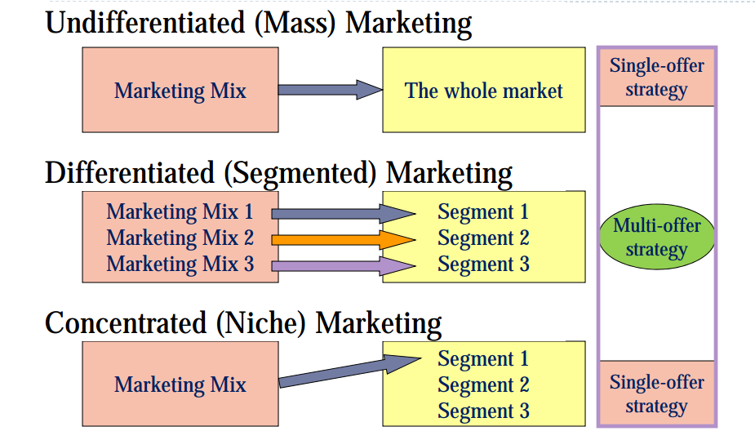
Target Marketing Strategies:
- Undifferentiated Marketing (Mass-marketing)
- Economies of scale (produce large quantities and benefit from lower average costs)
- Less investment
- Vulnerable to competition focusing on segments
- Differentiated Marketing (Segmented)
- Higher combined sales
- Better/ stronger position
- Potential problem with economies of scale
- Cannibalization (a reduction in sales volume, sales revenue, or market share of one product as a result of the introduction of a new product by the same producer.)
Target Marketing Strategy
- Niche marketing
- Narrowly defined group, typically a small market whose needs are not being well served
- Good when company resources are limited
- Achieve a strong position
- Large market share of a small market
Selecting Segments to Target:
- Segment size + growth
- Market + sales potential
- Project growth rate
- Segment structural attractiveness
- Competitors
- Manufacturer-retailer relationship (bargaining power)
- Company objectives + resources
- Consistent with the long-term objective
- Feasible
Positioning (Value Proposition)
- Define the product/firm/brand’s place relative to the market’s
- Needs
- Consumer perceptions, beliefs and attitudes
- Competitive offerings
- Segmentation + positioning
- Segmentation: the market’s view of the consumer
- Position: the consumer’s view of the firm
- Positioning: using the 4P’s to affect the firm’s position
Choosing a Positioning Strategy
- Choosing the right competitive advantages
- How many differences to promote?
- Unique selling proposition
- Several benefits
- Which differences to promote?
- Important: does it matter to consumers?
- Distinctive: is it different?
- Superior: is it better?
- Communicable: can you explain?
- Pre-emptive: can you competitors catch up?
- Affordable: does consumer benefit exceed cost?
- Profitable: does additional profit exceed additional cost?
Positioning Statement
- Components
- Target segment and need
- Brand
- Concept
- Point of difference
- Example
- Too busy, mobile professionals who need to always be in the loop, Blackberry is a wireless connectivity solution that gives you an easier, more reliable way to stay connected to data, people, and resources while on the go.
Perceptions and Positioning
- Perceptual map
- Spatial representation of several competing products/services
- Conveys perceptual info in 2-3 key dimensions
- Represents the position of the product…from consumer perspective

- Example:
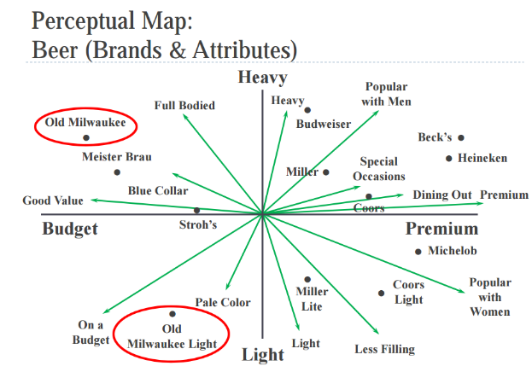

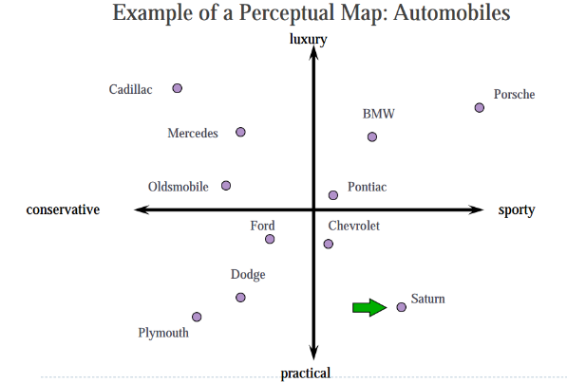
Integrating Perceptions/Preferences
- The consumer’s ideal point represents the trade-offs being made among key attributes
- Brand closest to the ideal point = highest consumer preference
- Consumers are most likely to choose the product for which they have the highest preferences
Perceptual maps help managers to:
- Investigate where unmet customer needs potentially exist
- Identify where competitors might be vulnerable
- Gain insights into how an under-performing product might be repositioned
Positioning: techniques
- The product/service can be positioned in many ways:
- Product attribute(s)
- Benefits sought by consumers
- Competitors (towards or away)
- Example: BMW, Avis

