Introduction to Culture
Lesson 2
Part 1: What is anthropology?
-A humanistic discipline that studies the diversity of human kind in its cultural manifestations.
-Started with a focus on small-scale societies, uncovering details of people’s lives though sustained contact known as participant observation, which is conducted during fieldwork.
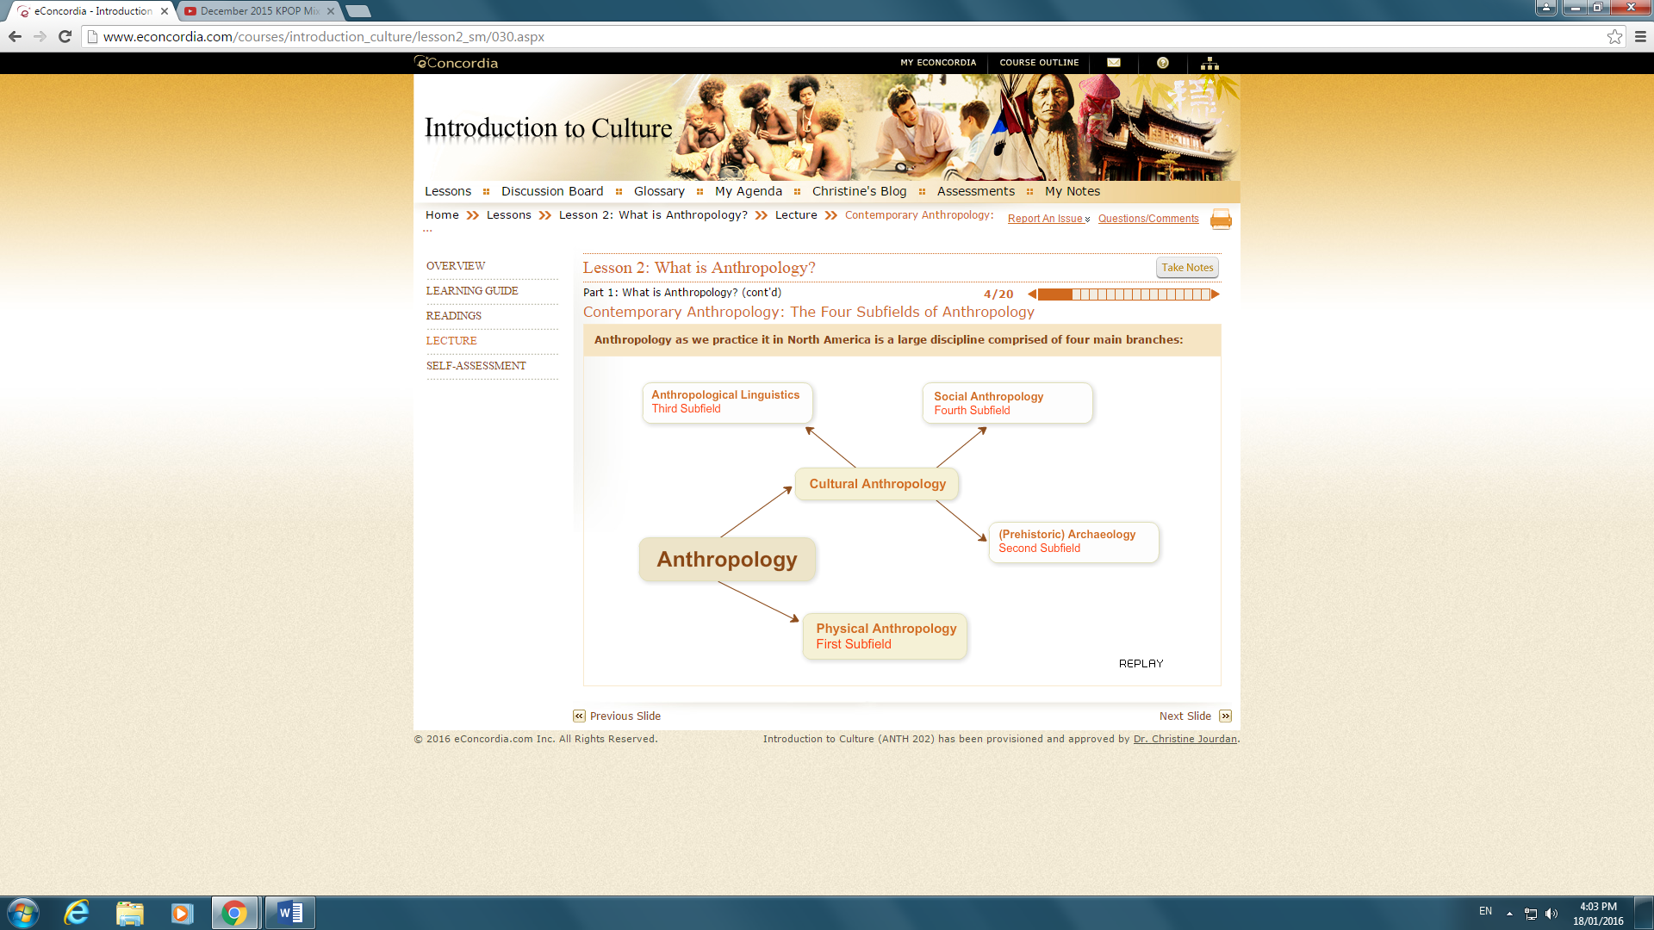
-Physical anthropologists (first subfield) study the physical dimension of human beings; divided into paleontologists and primatologists.
(Paleontologists study human evolution (paleontology) => how pre-human creatures became human beings, the ancestry of Homo sapiens. + Primatologists study the social life and behaviour of non-human primates (chimpanzees and gorillas) in the wild and captive, and experiment in animal psychology and ape language.)
-Archaeologists (second subfield) are interested in finding objects (bones, fire) and artifacts (pottery, ornaments) because of what they can tell about the social life that once existed - revealing ways of life or presence of sacred rituals.

(Pre-historic vs. Historic Archaeology: Pre-historic archaeology studies societies that never left written records, whereas historic archaeology studies societies that did leave a written record.)

-Linguistic anthropologists (third subfield) are trained in linguistics and anthropology and study the relationship between language and the rest of culture => how speech and language are used to signal identity or status, express thoughts and knowledge, label the world around them, etc.
(Through comparative methods, this can provide information on migration and how people without writing systems were related in the past. + Also interested in birth and death of languages, language and gender/nationalism/ethnicity/social class, ethnography of communication, how the context of communication affects the choice of language in any speech community => what is said to who, when it is said and how it is said.)
-Cultural and social anthropologists (fourth subfield) often study contemporary societies anywhere in the world and the specialization in particular dimensions of social life (arts, economy, political life, religion) has caused fragmentation.)

Part 2: History of the discipline
-It was believed that societies developed in easily observed stages; this false assumption put Western societies ahead of all others– serving as justification for many acts of decimation or forced social transformations and the colonization of much of the world by European countries.
-Ethnocentrism: the belief that the moral standards, belief systems, arts, etc. of one's own society are superior to those of other societies.
(Common to some extent, a measure of ethnocentrism can be proof of successful socialization and enculturation of the individual and contentment. An extreme presence is rejected by anthropology and leads to intolerance.)
- Cultural relativism: Understanding of societies in terms of their own logic rather than ranking or judging them by outside standards.

Part 3: How does anthropology work?
- Participant observation: Living alongside your participants (the people you are studying) is a crucial part of your fieldwork as well as taking notes of all your observations.
(Interviews are also an important part of the research process, allowing further understanding through in-depth questions with individuals and are thus an important tool for eliciting information + Archives can also be helpful for finding information on the history and background of the area as well as demographics and statistics. + Use of tools such as recorders, camcorders and cameras in the process of gathering audio and visual material allows interviews to be easily captured and transferred.)
- Fieldwork is not an easy process and success depends on the acumen (insight/wisdom) and industriousness of the researcher, the soundness of the research project and on personal qualities + often takes anthropologists away from loved ones and/or in to cultural contexts that require adjustment to new ways of being, talking and etiquette and new timetables, forcing them out of their comfort zones.
-When researchers are brought into worlds so different from their own they can experience culture shock accompanied by frustration and difficulties adjusting. It is important to be able to recognize this as it can occur unexpectedly.
-The relationship created with the people anthropologists work with is important. A relationship of mutual respect and trust aids in productive research + it depends on the anthropologists’ people skills and traits (intellectual honesty, patience, tact, humour, independence, care).
Self-assessment
1. Which of the following is not a subfield of anthropology?
a) Physical anthropology
b) Linguistic anthropology
c) Sociocultural anthropology
d) Paleontology
e) Archaeology
2. "Armchair anthropology" differs from "verandah anthropology" in that:
a) Armchair anthropologists traveled to colonized countries where they conducted research but did not live with the people they were studying. Verandah anthropologists stayed home and studied cultures from afar.
b) Verandah anthropologists traveled to colonized countries where they conducted research but did not live with the people they were studying. Armchair anthropologists studied cultures from afar.
c) Armchair anthropologists were functionalists whereas verandah anthropologists were strict evolutionary anthropologists.
d) Verandah anthropologists pioneered participant observations, while armchair anthropologists relied on the written accounts of explorers and missionaries.
e) Verandah anthropologists were strict functionalists while armchair anthropologists were evolutionary anthropologists.

3. Informed consent:
a) is used solely by hospitals or medical professionals to obtain the consent of clients prior to any medical procedure.
b) requires that all research participants sign an informed consent form to ensure ethical research.
c) requires that the researcher acquire the written consent of government officials prior to conducting research.
d) obliges the researcher to sign a consent form specifying that he or she will act ethically in the field.
e) requires the researcher to inform participants of the intent, benefits and possible effects of the study and obtain their consent either in writing or orally.

4. In their interview, Drs. Gewertz and Errington explain their reasons for going to Papua New Guinea for their PhD fieldwork. Today, these reasons would no longer be valid because:
a) Doing research in a far away place is no longer required.
b) Papua New Guinea does not want anthropologists to work there any longer.
c) The discipline of anthropology has changed very much over the last 20 years.
d) Researchers are not allowed to do research in so-called exotic places any longer.
e) a) and c)

5. Rapport is:
a) the trusting relationship that must be gained with a gatekeeper before access to the field is obtained.
b) the sacred relationship between community members in the Trobriand Islands.
c) trust gained through gift giving.
d) a trusting relationship between the researcher and the study population.
e) also known as "going native" or the researcher integrating herself or himself completely in the community under study.

6. A young and unmarried female researcher is likely to face more difficulties than a young and unmarried male researcher because:
a) people in most cultures consider a young unmarried female on her own extremely unusual.
b) she is at greater physical risk than her male counterpart.
c) women in the community where she is studying may react to her with suspicion and jealousy.
d) it will be impossible for her to conduct research in any male-dominated field or community such as the male gay community.
e) she will be limited to studying a smaller number of topics, for example the geishas of Japan.

7. Reverse culture shock:
a) is a condition that obliges many anthropologists to abandon their former homes and go live in their research community.
b) is the stress felt by immigrants as they migrate to a new country.
c) is the stress and feelings of discomfort that an anthropologist may experience returning home from the field.
d) is the cultural shock that anthropologists from Asia, Africa or Latin America may experience conducting fieldwork in Canada, the United States or Europe.
e) occurs when an individual who has become completely assimilated into another culture must return to his country of origin.

8. Participant observation:
a) is no different than "hanging out" in a research community.
b) requires the anthropologist to adopt the lifestyle of the people being studied.
c) is rendered impossible when the Hawthorne effect is present when the fieldworker is conducting research.
d) requires reflexivity and subjectivity while carefully observing and writing about what has been observed in the field.
e) has been abandoned by contemporary anthropologists who now privilege interviews and questionnaires.

9. Triangulation:
a) involves using multiple methods and sources when conducting research to ensure greater perspective.
b) requires the use of both qualitative and quantitative methods.
c) involves both inductive and deductive approaches to research to ensure greater validity.
d) requires that teams of researchers conduct ethnographic fieldwork in a common research project.
e) involves the use of statistics to ensure that research conforms to scientific standards and acceptable margins of error.

10. Collaborative research:
a) is an approach to learning about cultures that involves the anthropologist working with researchers from other disciplines as partners and teammates rather than competing researchers.
b) is an approach to learning about cultures that involves the anthropologist working as a consultant hired by a given population to conduct research on their culture.
c) is an approach whereby the researcher trains local community members to conduct research on their own culture.
d) is an approach whereby researchers work with local researchers as teammates and collaborate as coauthors in publishing accounts of the research.
e) is an approach to learning about culture that involves the anthropologist working with members of the study population as partners and teammates rather than strictly as subjects.

11. According to your text, the four subfields of anthropology are archaeology, physical anthropology, classical archaeology and anthropological linguistics.
a) True
b) False

12. Primatology is the study of primitive cultures and mores.
a) True
b) False

13. Ethnology is another word for cultural anthropology.
a) True
b) False

14. The use of anthropological data to offer practical solutions to contemporary problems within society is called applied anthropology.
a) True
b) False

15. A testable proposition concerning the relationship between a particular set of variables is called:
a) paradigm
b) hypothesis
c) theory
d) deduction

16. The species to which we all belong is called:
a) Homo sapiens
b) Homo Economicus
c) Genus Homo
d) Homo neanderthalensis

17. The greatest distinction of anthropology is that it is global and _____________ in its approach.
a) restrictive
b) comparative
c) general
d) true

18. In the late 19th century, professional linguistics existed.
a) True
b) False

19. The most important anthropological paradigm used in 19th century Europe was:
a) Ecological anthropology
b) Evolutionary anthropology
c) Structural anthropology
d) Symbolic anthropology

20. Boas’ thought that anthropology as a science should:
a) describe all societies of the world before they disappeared
b) analyze kinship systems around the world
c) understand evolutionism
d) prevent social change from taking place

Lesson 3
Part 1: The Concept of Culture
-Culture: -The learned behaviors and symbols that allow people to live in groups. The primary means by which humans adapt to their environments. The way of life characteristic of a particular human society
-The learned system of beliefs, feelings, and rules for living around which a group of people organize their life.
-Distinctively human; transmitted through learning; traditions and customs that govern behavior and belief.
-The system of knowledge more or less shared by members of a society.
(Anthropologists called ‘interpretive’ will focus on the symbols and thoughts of a cultural group. Materialists’ will focus on the learned behaviours and lifestyles of peoples. However different their approaches may be, all anthropologists agree that culture refers to learned (and somewhat shared) patterns of behaviour and thought.)
- Culture emerged through group formations and the development of language and the ability to use symbols + addressing natural/social needs through a system of rules.
(Human needs are diverse and complex and accordingly, so are culture.)
- Culture is learned: -The system of rules or behaviour or values is transmitted to the young ones through the process of socialization.
- We raise our children in order for them to be socially adapted human beings.
- Most of what is being transmitted is symbolic in nature = how to behave according to our culture.
- Has nothing to do with genetics (example: adoption)
- We are born with ability to culture + in a cultural group but not born with a culture.

- Conceptions about gender roles are symbolic, they can vary from society to society and they change over time.
- Culture is symbolic: -The meaning of cultural elements is arbitrary and unpredictable.
- A symbol doesn’t bare any direct relation with what they represent (example: V sign)
-Culture is shared: - Sharing of culture reflected in the socialization of members in ways that contribute to understanding of common rules, meanings and behaviours.
-Allows for mutual interpretations, symbolic meanings, messages and intentions to flow.

- People in the same cultural group can have very different opinions and ways of understanding the world. People have different tastes, different expectations, and different outlooks on things. Within the same cultural group, people will have different values, goals and systems of meanings.

- In all societies, basic distinctions exist between individuals in terms of age and gender. + What people can or cannot do, may or may not do, may or may not say, is linked to their memberships into social groups defined by their gender and their age.
-In multicultural societies, other factors such as race, ethnicity and indigeneity have provided additional ways of ‘classifying’ people according to their skin colour, ethnic origin and native status.
-When people are part of a cultural group they are not passive recipients of prepackaged systems of meanings, behaviour and thought. + They develop their own opinions and ideas. + They engage the dominant culture according to gender, class, experience, age, etc. + Lead them to have different visions of what their culture is.
-Some fully approve of the dominant model and embrace it while others reject it. It is the engagement with culture that leads to socio-cultural change. + When groups of people recognize themselves as having different ways of engaging the cultural world in which they live = subcultures.

- In some societies, young people have modes of expressions, behaviour and values that may be significantly different from those of their adult counterparts: they dress differently from their parents, they listen to different kinds of music, and they use different words.

Part 2: The Culture Change
- Changes happen with innovation, cultural interactions and inventions.
- Cultural interactions are often associated with diffusion or borrowing + make us reflect about what we are (naturalization)
- Not all changes are linked to technology.
- Opposing concepts such as "traditional" and "modern" tend to oversimplify the complexities of cultural change.
- The most important forms of change are often associated with contact with outside groups.
- Anthropologists have identified four models of cultural interaction:
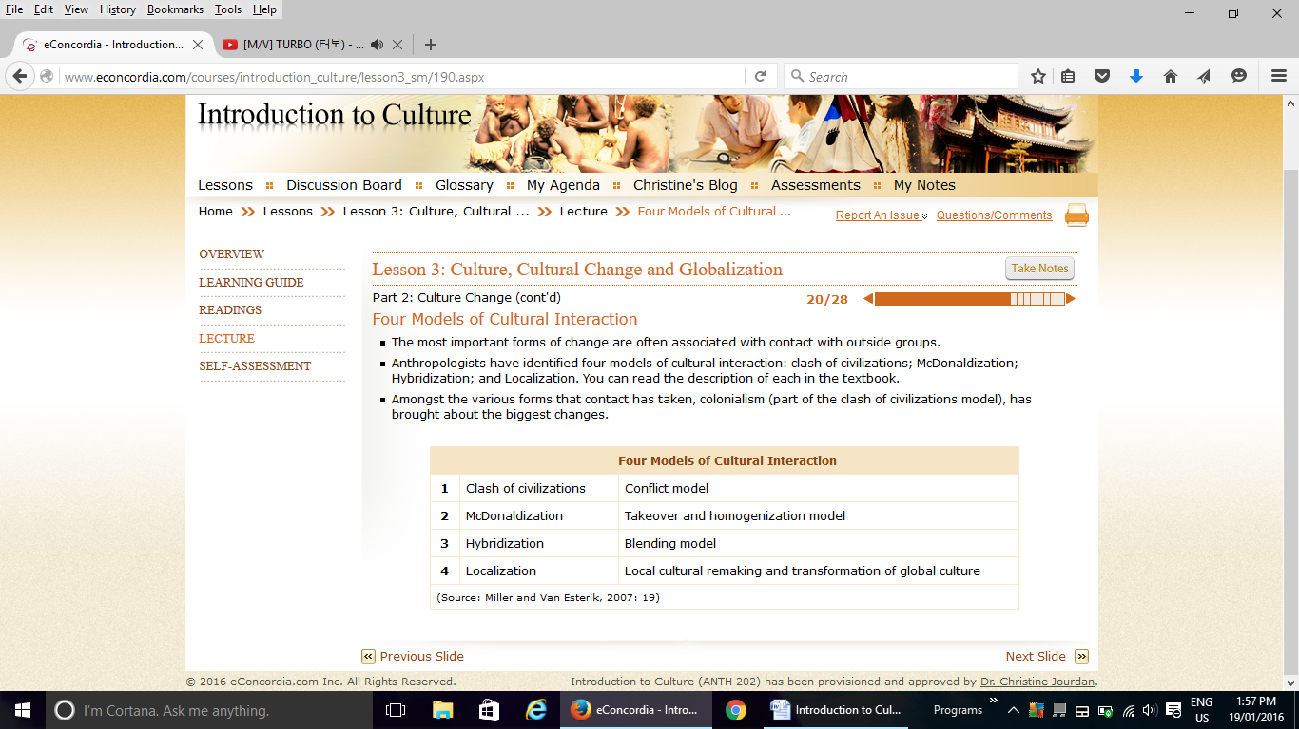
- Colonialism (part of the clash of civilizations model), has brought about the biggest changes. –
- Most empires had an agricultural mode of subsistence.
- Colonization has not only affected individual groups located within former states, but it has also created new countries by amalgamating different ethnic groups and cultural groups into one geopolitical entity.
-For quite some time after they became independent, post-colonial states throughout the world have also been economically weak, and very often remained dependent on the economies of the former colonial powers. Even after independence, many former colonies had retained a form of economy that supplied raw commodities to the former colonial powers (coffee, sugar, cocoa, minerals, etc.) and served as a market for the sale of manufactured goods.

Part 3: Globalization
- Affects everything
- Culture is best understood as a way of life and a way of thinking about the world that is changing with the passage of time and through contact with other cultural groups.
- Cultures are the product of the interaction between individuals and social groups. In the process, they keep changing: through invention by individuals; through contact with other cultural groups; and through social transformations that cultural groups go through during their history.
- Some changes are incremental, while others are so dramatic that it is possible to think of them in terms of a revolution.
Self-assessment
1. In addition to the four traditional fields of anthropology, which of the following has been proposed as a fifth field of anthropology?
a) applied
b) forensic
c) social
d) evolutionary
e) paleolithic
2. Symbols are arbitrary, conventional and prescribed, but some people are also emotionally attached to them.
a) True
b) False

3. The "Garbage Project" conducted by archaeologists excavating a landfill can be applied by policy makers as the research:
a) proved that rapid decomposition of waste produced large quantities of methane, a greenhouse gas.
b) highlighted the sheer volume of polystyrene and plastics in landfills.
c) demonstrated to the dismay of planners that paper by its sheer volume was a major culprit in the filling up of landfills.
d) demonstrated that newsprint that decomposes in landfills could be used as compost.
e) demonstrated that diapers and plastics were releasing toxins into underground aquifers.

4. Descriptive linguistics is:
a) the study of the structure of languages.
b) the study of non-verbal language.
c) the study of language change over time.
d) the study of the relation between language and sentence.
e) the study of language phonetics.

5. What was the purpose of Miner's description of the Nacirema culture?
a) He wanted to make the familiar strange.
b) He was conducting "salvage" ethnography to record the culture of a people threatened with assimilation and cultural extinction.
c) He wanted to make the strange familiar.
d) He was writing an ethnographic account of a remote people located in the tropical jungle of Amazonia.
e) He wanted to demonstrate how cultures evolved over time.

6. Which of the following pairings is not correct?
a) Franz Boas, personality and culture
b) Sir Edward Tylor, armchair anthropology
c) Bronislaw Malinowski, participant observation
d) Marvin Harris, cultural materialism
e) Claude Lévi-Strauss, structuralism

7. Franz Boas promoted the detailed study of individual cultures within their own historical contexts. This approach is called:
a) historical functionalism
b) cultural relativism
c) functionalism
d) historical particularism
e) structural functionalism

8. Franz Boas' research on the height, weight and head size of 17,000 immigrants:
a) demonstrated that some migrant groups were innately inferior.
b) is an example of evolutionary anthropology.
c) conclusively showed that body size and shape can change quickly.
d) revealed minimal change between generations, even those born in the United States.
e) conclusively demonstrated that African Americans were racially superior.

9. How would cultural materialists analyze the practice of elimination in villages in India?
a) They would study the ecological advantages that village practices provide and how social norms enforce advantageous practices.
b) They would analyze the symbolic significance of clean and unclean.
c) They would study class conflict and how practices of elimination enforce social hegemony.
d) They would seek out the underlying social structures.
e) They would seek to deconstruct power-knowledge relations.

10. Hybridization is also called:
a) cultural crossover
b) McDonaldization
c) localization
d) global assimilation
e) Marxism

11. People who do not share all life-style characteristics with the rest of society are said to be in a:
a) group culture
b) holistic culture
c) sub culture
d) coop culture

12. Sir Edward Tylordefined culture as consisting of patterns of acting as well as patterns of:
a) behaviour
b) instinct
c) thought
d) social behaviour

13. Failure to comprehend the role enculturation plays in maintaining each group’s patterns of behavior and thought lies at the heart ofthe phenomenon known as:
a) ethocentrism
b) sexism
c) subordination
d) the relativity of truth
14. Which is not an example of diffusion?
a) Cereal eating in the United States of America
b) The use of paper on which to write
c) The invention of the light bulb by Thomas Edison
d) The use of the English language in Australia

15. The method which involves living for extended periods among a peopole and participating in their daily round of activities is named:
a) participation
b) practicing observation
c) careful observation
d) participant observation

16. Culture is unique to human beings, while other types of animals may live in groups of societies.
a) True
b) False

17. Symbols are arbitrary meaningful units or models we use to represent reality.
a) True
b) False

18. Cultural understandings are shared equally by all members of a particular society.
a) True
b) False

19. ‘Man, those people sure do some stupid, immoral things. I’am glad our culture has devised superior methods of dealing with that problem’. This is an example of:
a) ethnocentrism
b) clear, logical reasoning
c) cultural relativism
d) comparative normativism
e) multicultural mores

20. The standards by which members of a society define what is good or bad, desirable or undesirable, holy or unholy, and beautiful or ugly are called:
a) values
b) norms
c) mores
d) folkways
e) set by instinct

Lesson 4
Part 1: The Origin of Language
-Communication: the transmission of meaningful messages from one individual to another. This simple sentence, however, implies a great deal: meaning is at the basis of communication. + meaning to exist, these messages must take place in a form that makes sense to the interlocutor.
-Language is a code for communication consisting of a set of symbols and a set of rules for constructing messages => these symbols are arbitrary and conventional, used by peoples in societies and passed from generation to generation, and they can be oral, written or signed (like sign language).
- As a tool for communication, language is central to culture.
- Linguistic anthropologists look at social interactions and meanings through the study of discourse and speech.
- Speech is language in action (different from language), and by studying speech, we can know language and the role it plays in social relationships.

- The key to understanding how language appeared is to examine its functions: communication between people, store knowledge, think, and express emotions.
- Theory of communication that seeks to integrate purely physical considerations with cognitive and social ones. It explains that language did not appear once Homo Sapiens appeared and physical evolution was over. We will never know how language began for sure, and we will never know the time at which it became more beneficial to communicate through a voice-based system of symbols rather than through a visual system of symbols and signs.

Part 2: What is Language?
- We know the sounds that belong to our language and those that do not.
- We also know the place of some combinations of sounds.
- We know how to combine sounds in the right order in order to produce meaning.
- Phonology: sound systems
- Morphology: how words are put together
- Lexicon: the vocabulary
- Syntax: the grammar
- Characteristics of language:
1. Arbitrariness means that the relationship between sound and meaning is irrelevant => words are symbols: their meanings are defined by culture, not label.
2. Conventionality and arbitrariness combined allow us to create new words, assign them meaning, and change meaning as needed, and so on.
3. Productivity allows us to communicate different messages by combining various elements of language. Thus we can modify and refine the meanings of sentences to fit the context (situation) in which they are spoken (tone, volume used to indicate urgency, etc.)
4. Displacement allows us, through language, to talk about the past or future; permitting us to enter a world of abstraction since we cannot see the past or future.
(Human language is a communication system that is open while those of animals are closed.)
Part 3: Language and Culture
- Language is the repository (bank) of meaning and is a tool used to communicate meaning. How it is used and what the use signals about human relationships is what is important to anthropologists.
- American linguist Noam Chomsky has shown that humans are predisposed for language learning.
- The key to language acquisition is in socialization (the social process associated with learning how to become a member of one’s own society), just like culture.
- Socialization to use language (language acquisition by children in the context of family life) and socialization through language (socialization of children into culture through language).
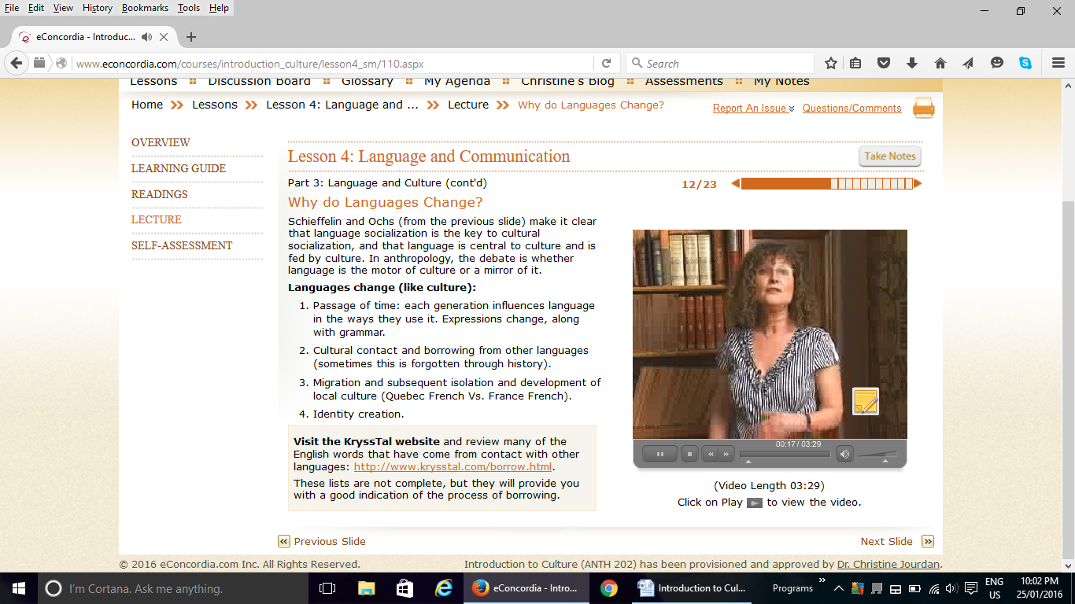
- Lexicostatistics: Show how languages are related and group them into families by comparing patterns of sound changes between languages. Comparison of words likely to be found in each language because they encode elements of everyday life shared by all societies.
- Knowing how languages are related is important to anthropologists and archaeologists when attempting to understand the geographical origins of a given group => examining whether two groups with similar cultural traits may have originated from the same peoples.
- Language changes reflect a healthy culture where new generations spout new ideas and ways of being appeared and push language in different directions.
- Languages have disappeared when their speakers and cultures have come under attack throughout
- Globalization of popular culture through English is having a similar effect elsewhere. TV programs, songs and print media give more prominence to one language. English has become a lingua franca (a language of universal communication used to overcome linguistic gaps that exist in multilingual encounters).
- Socioeconomic value is being associated with the dominant language and people give in to this and move away from their own language. It is when whole communities shift that ancestral languages become obsolete and disappears.
- National education systems that teach in one "national" language are responsible for many disappearances, for the government is giving social legitimacy to one language and forcing speakers of other languages to learn it.
- Language death is when a language disappears, which entails a process of endangerment stages.
- There are 6000 languages present today and, while diversity is high, the forces of colonization, globalization and education threaten them. + New languages may appear when sociolinguistic situations allow them to develop. + They are created by the contacts between diverse populations speaking different languages and in social circumstances where learning the other languages is impossible.
- Social jargons like Verlan or new languages are created not only as a means of communication but as a symbol of identity as well.
- Verlan was originally used to keep information away from those in authority, and it spread as a language of resistance to authority and identity (now used by disenfranchised youths).
- There is a strong association between language and identity and it is fraught with emotional considerations. Does your ability (or lack thereof) to speak Greek affect your identity as a Greek person?
- The association between language and identity has led governments to create language legislation.
- Is language such a powerful tool that it creates grooves of expression that predispose us to see the world in a particular way? (Saphir) VS Is language a mirror of culture, reflecting cultural beliefs and preoccupations about the world? (Whorf)
-Anthropologists agree that there is a relationship between language and thought, but not one where language determines thought. Rather, they see it as an influence on the speaker's thinking and worldview (weak reading of the hypothesis).
- Languages also develop vocabularies that reflect local cultural realities and preoccupations
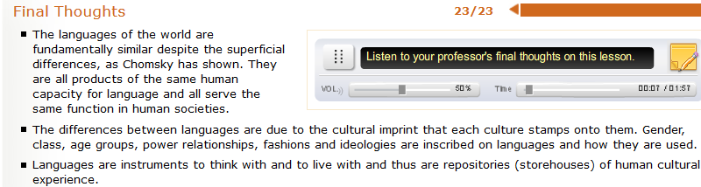
Self-assessment

1. A meaningful sound is a:
a) phone
b) phoneme
c) morpheme
d) vowel
e) consonant

2. _________ refers to the ability to refer to events and issues beyond the immediate present.
a) displacement
b) productivity
c) call system
d) semantics
e) phonetics

3. Human language has _________, or the ability to create an infinite range of understandable expressions from a finite set of rules.
a) flexibility
b) elasticity
c) productivity
d) proclivity
e) universality

4. _________ refers to the study of the meaning of words, phrases and sentences
a) linguistics
b) phonetics
c) morphetics
d) semantics
e) sociolinguistics

5. The term _________ refers to social inequality in access to new and emerging information technology, especially access to up-to-date computers, the Internet and training related to their use.
a) electronic curtain
b) digital divide
c) digital marginalization
d) digital chasm
e) divide

6. Which of the following would be an example of observer's paradox?
a) children under study stop talking about "boogers" when the principal walks into the classroom.
b) while having lunch at a research participant's home, she changes the topic of conversation when her husband walks in to the room.
c) an hour into an interview, a research participant relaxes and starts talking much more informally, using some profanity and colloquialisms.
d) while doing research, a researcher seeks to speak informally, adopting local idioms.
e) during an interview, a research participant refrains from swearing.

7. The Sapir-Whorf hypothesis:
a) says that a people's language affects how a person thinks and sees the world.
b) says that a population's reality shapes its language.
c) says that intelligence can be measured using language mastery.
d) says that new words cannot be learned without experiencing the reality they represent.
e) says that humans can understand reality even if they do not have the words to describe that reality.

8. Tag questions are:
a) questions that prod the listener to speak.
b) rhetorical questions used by the speaker to solicit an emotional reaction.
c) questions seeking negation placed at the start of a sentence.
d) questions seeking affirmation placed at the end of sentences.
e) questions using the "five W's."

9. All early writing systems use _________, symbols that convey meaning through a form or picture resembling that to which it refers.
a) ideagraphs
b) logographs
c) ideagrams
d) glyphs
e) pictographs

10. The best example of language shift is:
a) Cree children learning the Cree language at school.
b) an immigrant living in Vancouver learning English in an ESL class.
c) a French speaker who speaks his language with great difficulty after living in New York for 30 years.
d) the child of Guatemalan refugees who only speaks English as his parents refused to speak Spanish in his presence.
e) a global language displacing indigenous languages.

11. Which language has a superior ability to project images of the future?
a) English
b) Hungarian
c) Cantonese
d) None of the above

12. In English, certain obligatory categories seem to reflect a social bias in favor of:
a) whites
b) males
c) females
d) administrators

13. The fact that the Hungarian and Finnish languages were once the same indicates that they belong to the same.
a) dialect
b) language
c) family
d) genetic stock

14. The sounds that native speakers perceive as being distinct are:
a) morphemes
b) allophones
c) telephones
d) phonemes

15. Human languages are inherently flexible and creative and not closed systems. This human language trait is called productivity.
a) True
b) False

16. The English word ‘dogs’ contains one free morpheme and one bound morpheme.
a) True
b) False

17. Modern anthropologists think that language determines thought.
a) True
b) False

18. Scientific attemps to teach apes to speak human languages have been extremely successful, especially with chimpanzees.
a) True
b) False

19. Words in human languages seldom have any necessary connection with the concrete objects or abstract symbols they represent. This human language trait is called:
a) displacement
b) productivity
c) clarity
d) arbitrariness

20. Linguistic differences in pronunciation, vocabulary, or syntax that may differ within a single language are known as:
a) honorifics
b) dialects
c) glottos
d) sublanguages

Lesson 5
Part 1: Why Religion?
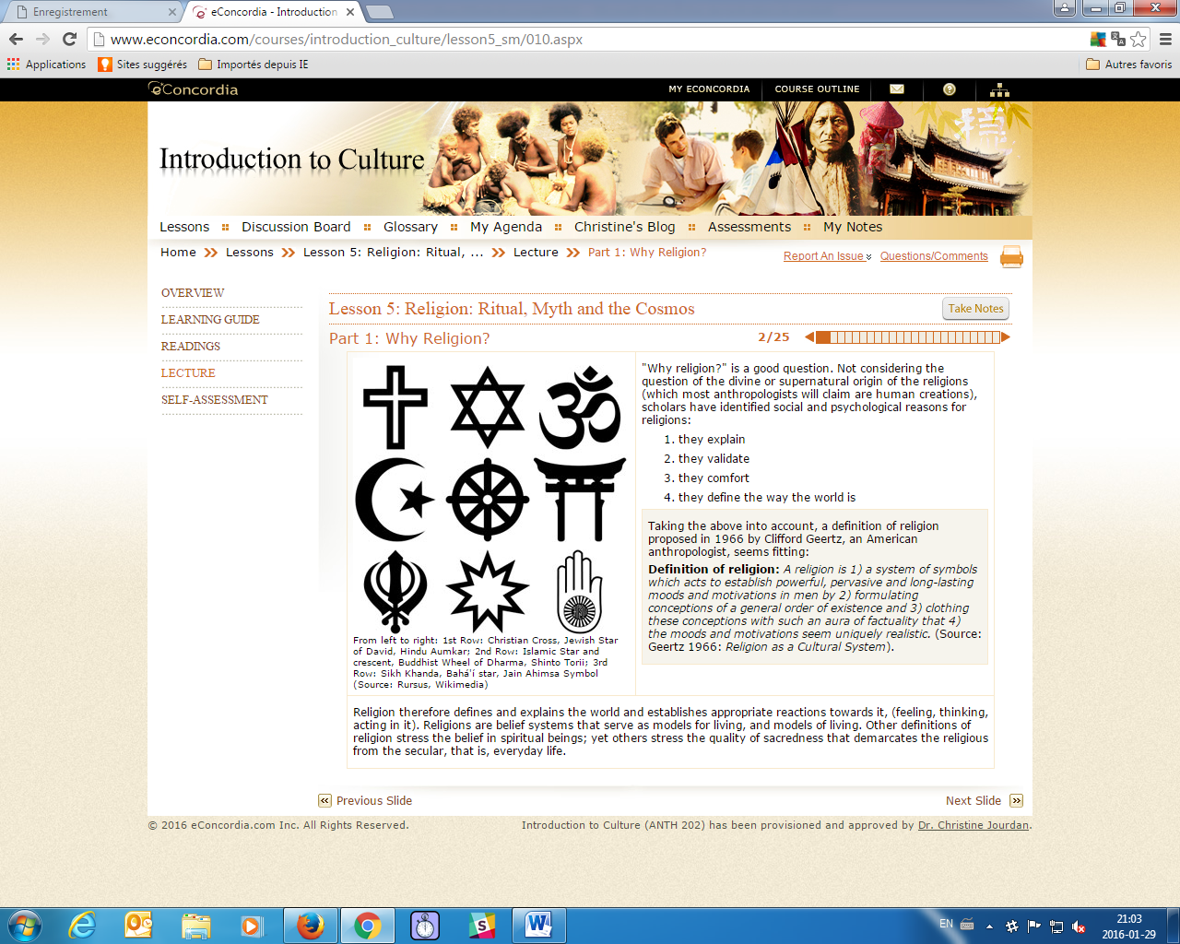
Part 2: Varieties of Religious Beliefs
- Religions also vary with regards to the deities and agencies they posit, and with how people relate to them.
- Some religious systems, such as animism, believe in the presence of indwelling spirits (ghosts, tree spirits, and other spirit beings) while others, such as animatism, posit the presence of diffuse spiritual power.
- Mana: Something that possess power…

- Religions are expressed through myths, doctrines and rituals.
- Rituals: Reinforcing collective sentiment and social integration+ beliefs in action. Well-performed rituals are the ways to honor deities or spirits, to propitiate them, to appease them, and to communicate with them.
- Myths: Sacred texts (oral or written) that seek to explain the order of things and the state of the world. They usually explain how things came to be the way they are: myth of origin, myth of creation.
- Doctrines: Establish the rules (for human behavior, and for behavior vis-à-vis the supernatural beings and the spirits. They are formal statements.
- Rituals are the channels through which one communicates with the supernatural beings, with spirits or with ancestors. If the rituals are not performed perfectly, then the desired effect might not take place. Rituals include the performance of religious ceremonies, the sacrifice of animals during these ceremonies, the offering of food to spirits or deities, and various types of prayers, incantations and music that favour communication with deities or spirits. Some rituals are secret from the rest of society (such as the one Lianiamae is performing, left), others are communal events (such as religious services), and yet others are individual (individual prayers).

- Life-Cycle Rituals (rites of passage): they are often associated with or given salience through religion. Think of marriage blessed by priests, briss performed by the Rabbi or funeral rituals.
- Communitas: Help people achieve a sense of unity with each other. During rituals, people’s individuality can be subsumed to an overwhelming feeling of belonging. Note that communitas takes place as well in non-religious rituals or events.
- Pilgrimages: Travel rituals for the purpose of religious devotion. Remove a person from daily life and this distance can transform inner self and open ones soul. Three stages: 1. Segregation from everyday life 2. Liminal stage where the person is not on the world or off the world 3. The person comes back and transformed and re-enters the normal world a higher status

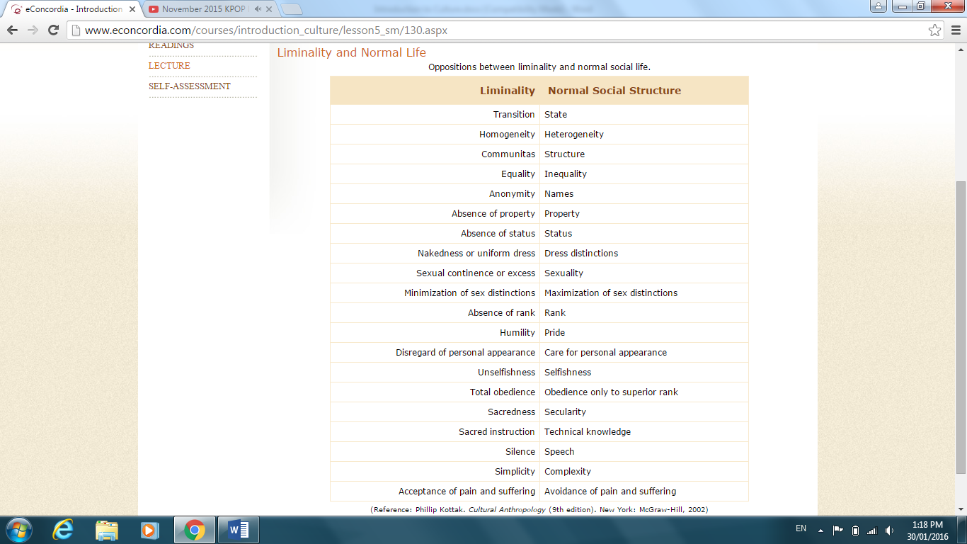
- Magic: The attempt to compel supernatural forces and beings to act in certain ways. Nothing happens by accident or chance. It always works, if not, do it again.
Part 3: Religion in Daily Life: Social Control
- Religion serves to reinforce social control by enforcing moral codes and setting rules for appropriate social behaviour.
- There are religions in which daily life and religious life are intertwined in such a way that social behaviour is often presented as having a divine origin.
- Religion is used by the powers that be to justify or reinforce social practices that seek to control the behaviour of all or some members of the society.
- Religions provide guidelines for social behaviour: rules necessary for the maintenance of social order are more powerful if they are attached to threats or rewards from a supernatural power.
Part 4: Religion and Change
- Even though religions tend to support the social order, they are also agents of change and sometimes revolution
- Revitalization movements: Organized movements, usually surrounding a prophetic leader, that seek to construct a more satisfying culture, either through re-establishing all or parts of a religion that has been threatened by outside forces or by adopting new practices and beliefs.
- Cargo cults: Form of revitalization movements that sprang up in Melanesia, the South Pacific, in response to Western and Japanese influences.
- Ghost dance: Proper practice of the dance would reunite the living with spirits of the dead, bring the spirits of the dead to fight on their behalf, make the white colonists leave, and bring peace, prosperity, and unity to native peoples throughout the region.
- Syncretism: Major crises, such as colonialism, for instance, lead to the adoption of sets of new symbols and rituals, while the meaning of life remains the same. Syncretic means the synthesis of old and borrowed elements.
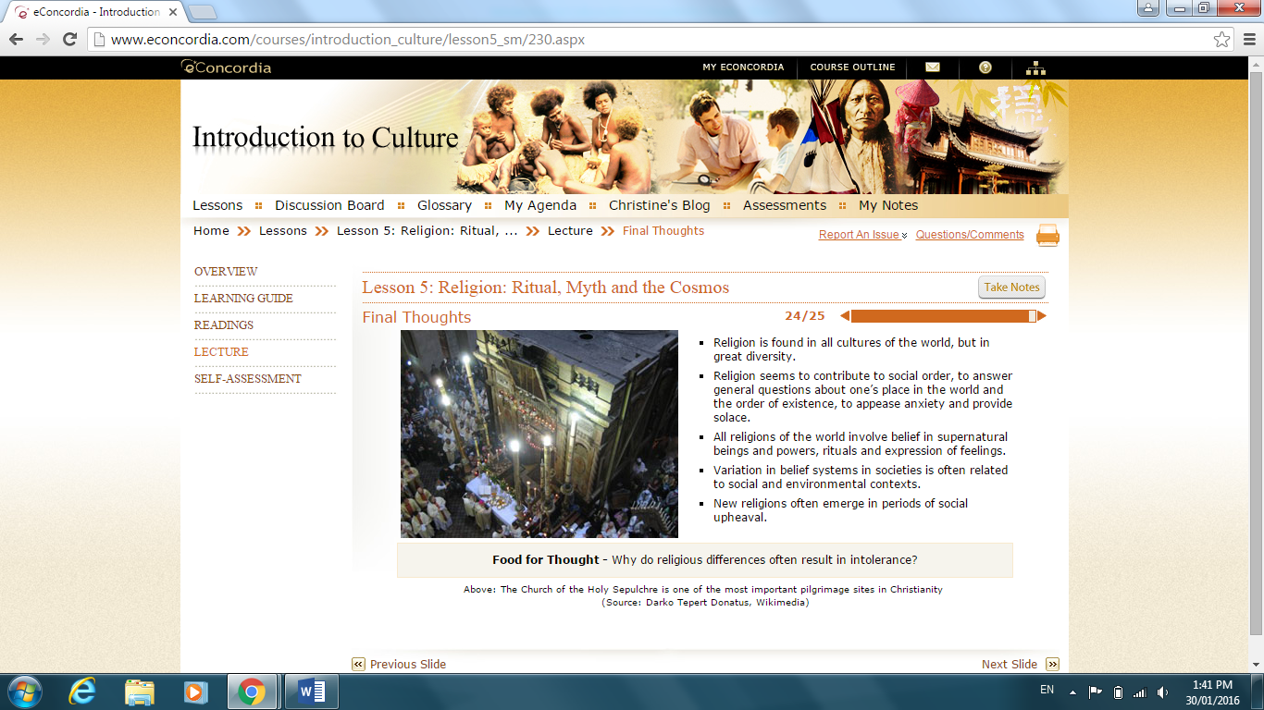
-
Self-assessment
1. The stereotypical "voodoo doll" would be an example of:
a) imitative magic
b) contagious magic
c) shamanism
d) animatism
e) both A and D

2. Edward B. Tylor:
a) argued for a functionalist explanation of religion whereby religion reinforced group solidarity.
b) argued for a functionalist explanation of religion whereby religion reduced anxiety and uncertainty.
c) argued for a cultural evolutionary model whereby religions evolved from animism to monotheism.
d) argued for a cultural evolutionary model whereby religions evolved from atheism to monotheism.
e) argued for a Marxist understanding of religion as the "opiate of the masses."

3. Bronislaw Malinowski explained why myths:
a) help individuals deal with the conceptual contradictions between life and death, good and evil.
b) provide a charter for society in that they express core beliefs and teach morality.
c) store and transmit information related to making a living and managing economic crises.
d) help individuals deal with fear and uncertainty.
e) are the product of historical processes and there are no universals.

4. _________ refers to belief systems in which the supernatural is conceived of as an impersonal power.
a) Animism
b) Animatism
c) Monotheism
d) Polytheism
e) Atheism

5. Saami sacred spaces:
a) were marked by monumental stone structures built over many generations.
b) were feared and avoided so as not to offend the spirits.
c) are now museum sites attracting thousands of tourists.
d) were sites of human sacrifice.
e) were repressed as sites of sacrifice with the arrival of Christianity but not forgotten.

6. Which statement is true about all rituals?
a) They are sacred and conform to the beliefs expressed in myth and doctrine.
b) They occur regularly in a periodic fashion or at set times in the life cycle.
c) They are the enactment of beliefs expressed in myth and doctrine.
d) They are a patterned form of behaviour generally having to do with the supernatural realm.
e) They are performed in sacred spaces under the guidance of a religious specialist.

7. Cross-cultural research indicates that puberty rituals for girls are likely to occur where:
a) female labour is important and valued.
b) female menstruation is seen as threatening.
c) females are oppressed by patriarchal institutions.
d) female labour is not valued and is of secondary importance to the community.
e) boys undergo puberty rituals.

8. How do priests differ from shamans?
a) priests oversee religious rituals.
b) a priest requires a long period of apprenticeship.
c) priests never participate in healing rituals.
d) priests perform periodic state rituals.
e) priests are never hereditary.

9. The world religion with the largest number of followers is:
a) Christianity
b) Hinduism
c) Buddhism
d) Islam
e) Judaism

10. A _________ is usually organized by a prophetic leader who seeks to construct a more satisfying situation by reviving all or parts of a religion that has been threatened by outside forces.
a) messianic cult
b) revitalization movement
c) resistance religion
d) protest religion
e) revival cult

11. Stories about the actions and deeds of supernatural powers are called:
a) rituals
b) crisis rituals
c) myths
d) custom stories

12. Which statement about religion is true?
a) There are some primitive societies that have not religion.
b) All religons believe in the existence of gods.
c) people who live in complex societies are less religious than those who live in simple societies.
d) Some form of religion is universal among human societies.

13. Emile Durkheim’s theory of religion stressed the idea that:
a) the function of religion was to repress psychologically disruptive desires.
b) religion served to enhance the power of society’s elites.
c) all religious practices derived from a sense of human dependence upon and awe of natur.e
d) when people periodically congregate for the performance of religious rituals they are promoting social solidarity.
14. The use of rites and spells intended to cause supernatural forces to harm others is called:
a) witchcraft
b) sorcery
c) divination
d) shamanism

15. The belief that kin groups have a mystical relationship with specific animals, plants or inanimate objects is known as:
a) totemism
b) shamanism
c) individualism
d) nature worship

16. A cargo cult is a:
a) revitalization movement
b) ecclesiastical movement
c) ancestral cult
d) totemism

17. Belief in spiritual beings is called a superstition.
a) True
b) False

18. It is ethnocentric to define religion as ‘belief in God’.
a) True
b) False

19. Pilgrimages such as the Grand Pardon in Rocamadour, France:
a) are important travel sites for pilgrims
b) are important rituals for believers
c) are touristic events
d) are not about the journey, but about the destination

20. The logic of magic is that:
a) accidents happen
b) the shaman is fallible
c) nothing happens by accident or chance
d) it works all the time

