Chapter 4: Job Satisfaction

Job satisfaction
- A pleasurable emotional state resulting from the appraisal of one’s job or job experiences; represents how a person feels and thinks about his/her job
- The more people like their jobs the more likely they will be satisfied based on intrinsic motivations

Why are Values Important?
- One way of looking at job satisfaction => does it satisfy my values?
- Value fulfillment
- Value-percept theory job satisfaction depends on whether an employee perceives his/her job supplies those things that he/she values most
- Dissatisfaction = (V_{want} – V_{have}) x (V_{importance})
    - Ex. Billy makes $100 000 annually. How likely is he satisfied with his job overall?
      - It depends on what does he want to make, how important salary is to him, and how satisfied he is with other aspects of his job
    - Commonly assesses work values
      - Pay, promotions, supervisions, co-workers, work itself, altruism, status and environment

How do we track job satisfactions via values?
- Job descriptive index
  - Specific tool to track job satisfaction
- Strengths
  - Simple questions, easy to use, tracks 5 most commonly assessed factors, scoring includes neutral level, publically available benchmarks, compare across time

Correlations between satisfactions facets and overall job satisfaction
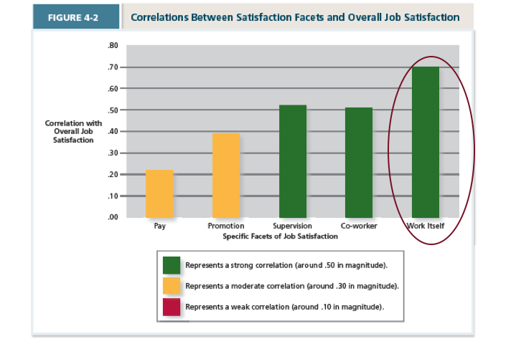
What determines satisfaction with the work itself?
- Job characteristics theory
    - How do we design jobs?
      - Structuring the methods and relationship of jobs in order to satisfy technological and organizational requirements… as well as the social and personal requirements of the job holder
    - Three critical psychological states:
      - Meaningfulness of work
      - Responsibility for outcomes
      - Knowledge of results
    - Ex. Job design at Ford
    - Research shows that simple and specialized jobs are boring (easy but not always satisfying)
    - 5 characteristics:
      - variety
      - identity - degree to which job requires full completion of the task, see job from start to finish
      - significance - degree to which the job has a substantial influence on other people (society as a whole)
      - autonomy - degree to which job provides freedom; individual has their own accountability
      - feedback - clear info on how job was done
    - job enrichment: designing jobs in a way to increase satisfaction with work
    - ex. Toyota
      - work in teams (V)
      - car completed by team (I)
      - stop the line production (A)
      - team quality checks (F)

Does Having a Bad Day affect our job satisfaction?
- mood and emotion fluctuations
    - mood: states of feelings, mild intensity, last for a while, not directed towards anything
    - emotions: intense feelings, can be short, clearly directed towards something
    - affective events theory
      - how workplace events can generate emotional reactions that impact work behaviours and satisfaction
      - emotions (good and bad) impact subsequent interpretations, actions, etc.
      - ex. Your boss asks you to come see them immediately
    - emotional labour: must push down your emotions – may cause an outburst
    - emotional contagion: when someone has a strong emotion it spreads to others


