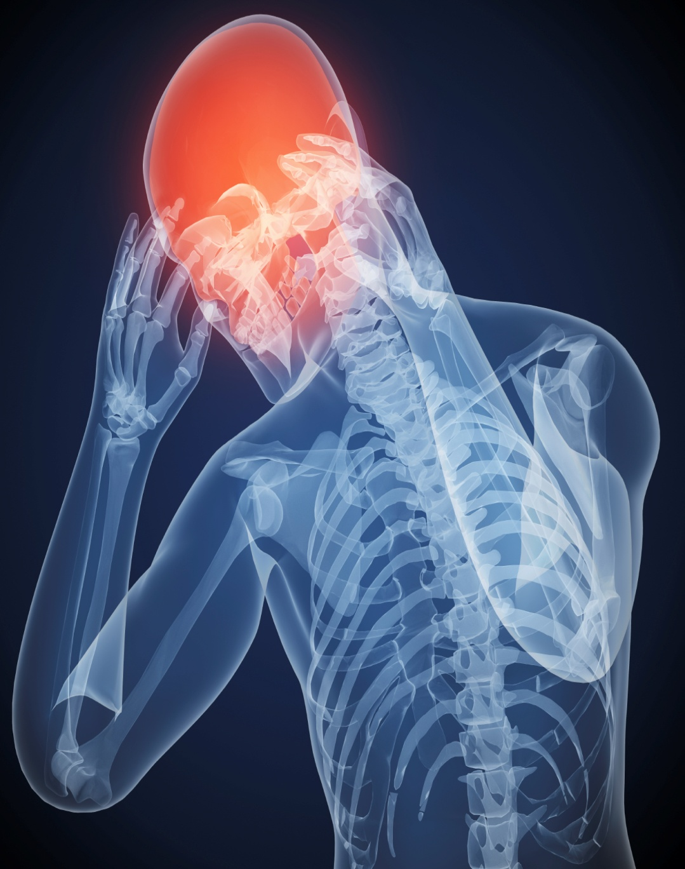
Grant Application for Research
The Long Term Damages of Concussions on Athletes
2013
Amgar Ouri
Amgar-Boutboul & Associates
10/9/2013

Table of Contents

Contents
Project Description 3
Timeline and Schedule for Appraisal 4
The Budget 5
The Potential Value of the Reasearch 6
Bibliography ……………………………………………………………………………………………………………………………………………7

Project Description

Amgar-Boutboul & Associates’ goal is to research a way to protect athletes’ brains from major concussions that could possibly lead to permanent brain damage. It has been proven that “Damage to the brain caused by concussion can last for decades after the original head trauma, according to research presented at a recent AAAS (American Association for the Advancement of Science) Annual Meeting” (Nordqvist, 2013). Once the grant is accepted we would like to use the money to research a way to decrease the amount of long-term damage caused by severe concussions.

Timeline & Schedule for Appraisal

The research period has been estimated to be four years long. This includes a year of preparation, a year of testing, a year of analyzing results, and a year of finding conclusions to our results. We will work closely with the General Health Hospital of Nova Scotia that is why the project is expanded to this amount of time.
Conclusions
Analyzing
Testing
Preparation

The Budget

The Budget has been settled to 40 000 $ a year for the four years for a total of 160 000 $ for the whole project. The money will be divided into three sections: equipment (athletes, engineers, and technicians), salaries, and research development.
 | Equipment | Salaries | Research & Development
2014 | 30 000$ | 10 000$ | 0$
2015 | 15 000$ | 15 000$ | 10 000$
2016 | 7000$ | 20 000$ | 13 000$
2017 | 0$ | 20 000$ | 20 000$

(Increased Concussion Awareness in Football)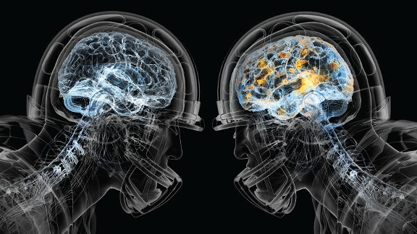

Potential Value of the Research

With the help of the grant, this project could lead to an eventual way of preventing long-term consequences on the athletes. It could also lead to future technologies like special helmets and new facilities for athletes. The idea of players getting injured and risking their entire life has no place in our professional sports organisations. This research project will find solutions to this problem.

(Mendler) (Brady, 2011) (Gallagher, 2013) (Carter) (htt)

Bibliography
(n.d.). Retrieved from http://www.discuss-hockey.com/2012/01/nhl-concussions-no-one-is-safe/
Beaumont Neurosciences. (n.d.). Retrieved from http://neurosciences.beaumont.edu/concussion
Brady, K. A. (2011, 03 09). NHL stars' injuries place spotlight on concussions . Retrieved from US today: http://usatoday30.usatoday.com/sports/hockey/nhl/2011-03-07-sidney-crosby-nhl-concussions_N.htm
Carter, D. S. (n.d.). Why I’m Serious About Concussions. Retrieved from louisvilleorthopedics.com: http://louisvilleorthopedics.com/tag/football-concussion/
Gallagher, T. J. (2013, September 15). The NFL and Concussions. Retrieved from www.personal.psu.edu: http://www.personal.psu.edu/afr3/blogs/siowfa13/2013/09/the-nfl-and-concussions.html
Increased Concussion Awareness in Football. (n.d.). Retrieved from www.personal.psu.edu: http://www.personal.psu.edu/dvs5363/assignment6.html
Mendler, A. (n.d.). Concussions in Sports. Retrieved from andrewmendler.worldpress.com: http://andrewmendler.wordpress.com/tag/concussions/
Nordqvist, J. (2013, 02 18). Concussions Cause Long-Term Effects Lasting Decades. Retrieved 10 10, 2013, from Medical News Today: http://www.medicalnewstoday.com/articles/256518.php

