Genetics Notes
January 15
** started class by doing a little quiz thingy, ((scantron with Sarah and josh))
- FOXP2 and speech: Gene expression case
Transcription and translation
Typical language development, these are the bare minimums for kids, a lot of kids break these milestones.
Are these milestones or kids phenotypes? Are these milestones linked to genes? Yes they are phenotypes they can be measured.
Squares are males, circles are females, shaded means they have the given condition. Half of the people in the family had speech disorders.
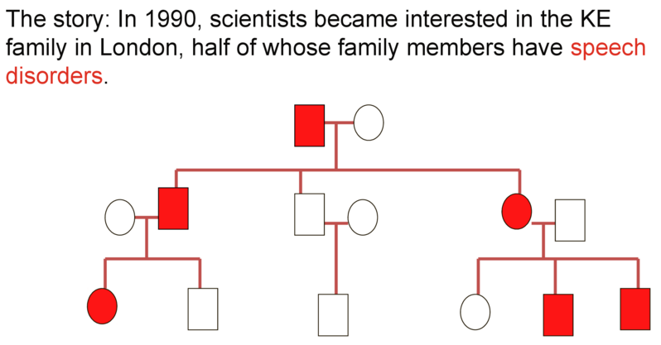
The doctors have done other tests that show the unaffected people do far better on speech tests, this is a measurable phenotype, which could potentially be linked to a gene. There are also links to brain activity and function. The sequence is a phenotype that can change a protein. In this case the gene plays havoc with the promoter region of genes that alter the creation of other genes.
January 19
There is a drunken gene, if a mutation occurs in the gene you will have alcoholism, although everyone has the drunken gene.
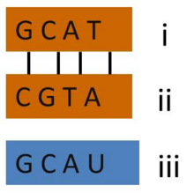
Back to foxp2 the speech impediment doesn’t allow them to reach the milestones that are pre-set that most people reach, all people have the foxp2 gene. When a mutation occurs in this gene, the speech impediment is expressed.
Q: (Figure left) which strand is the coding strand?
A: DNA has a coding strand and a template strand, the template strand is read, while the coding strand will be the same as the RNA strand that is being produced. The coding strand (i) while the template strand is (ii) and the RNA stand being produced is (iii).

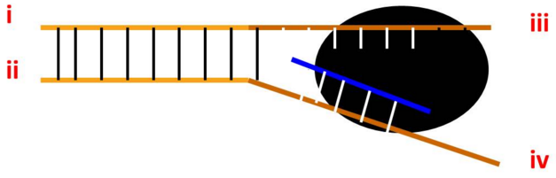
The black blotch is RNA poly RNA moves on the template 3’-> 5’ the top strand is the coding strand while the bottom stand is the template strand and the RNA strand being created is the complimentary strand.
5’ of the coding stand = i
3’ of the coding strand = iii
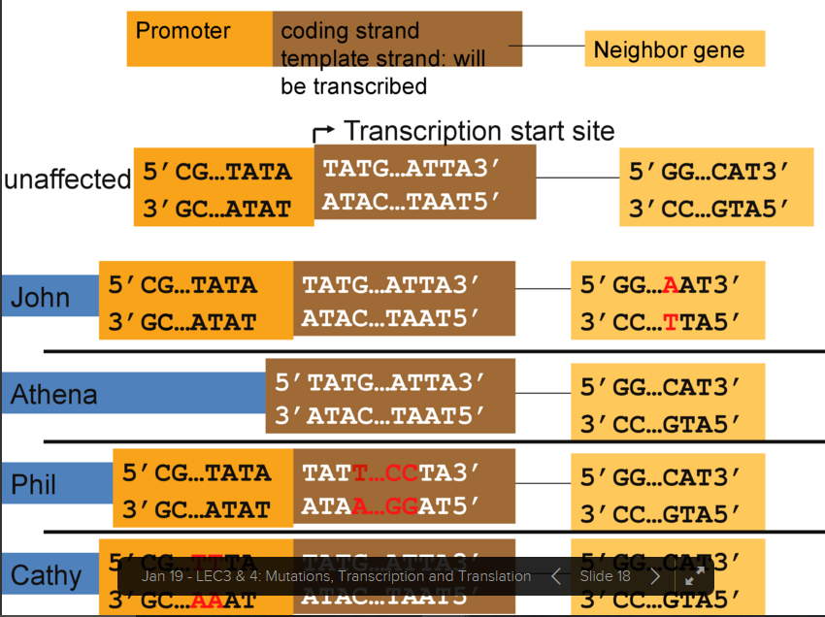
John the neighbouring gene has been a factor, the neighbouring gene could be a transcription factor that affects the gene before the affected gene.
Athena cannot make the gene because there is no promoter region
Phil depends on the type of mutation that occurs it could be a silent, missense or frame shift to carrying degrees of severity
Cathy the promoter could be improved or made worse, this could mean more or less of the gen I being made
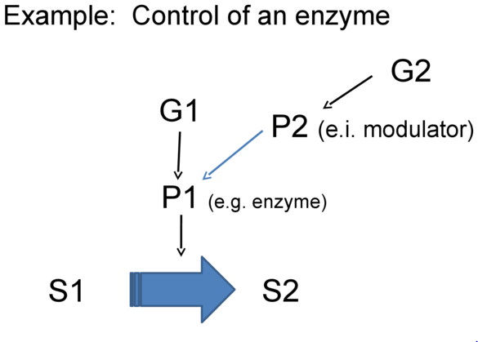
G= gene, P=Protein, S= Trait
G2 allows for the inhibition of G1
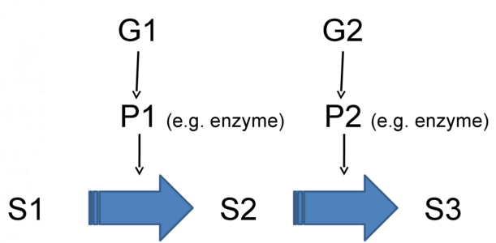

Things to read on…
Promoter region
Transcription
Translation
Transcription factor
“A gene has a specific locus”
January 22
From DNA to mRNA to the protein
Transcription goes from DNA to mRNA
Translation
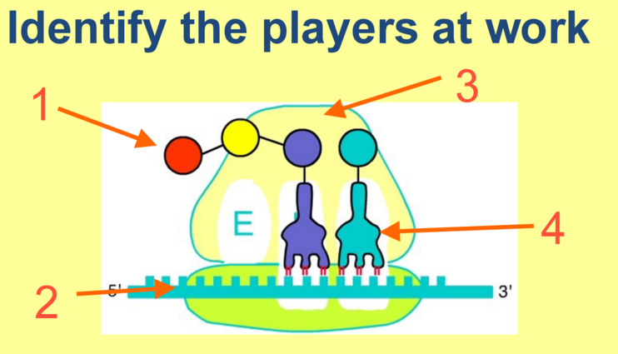
1 are amino acids
2 is mRNA
3 is a ribosome
4 is a tRNA

Slide 6 the answer is cba
The ejector site is nearly always empty.
If a drug were to bind to the ejector site
In order to create the polypeptide bond the ribosomes needs to move the tRNA over, if it doesn’t move over there is no amino acid chain created.
There is enzyme activity that is made of protein that links the ribosomes together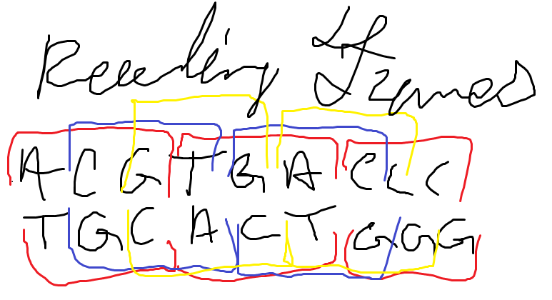
A potential reading frame is a series of readable codons based on the available shift of the start codon

Slide 9 the answer is c 3…. The start codon must be in frame with a stop codon. There are two start codons in frame with 2 stop codons, although there is another side to this piece of DNA.
Slide 10, kind of a trick question he asked mRNA not protein stop codons are irrelevant
1 2 skip a few 52
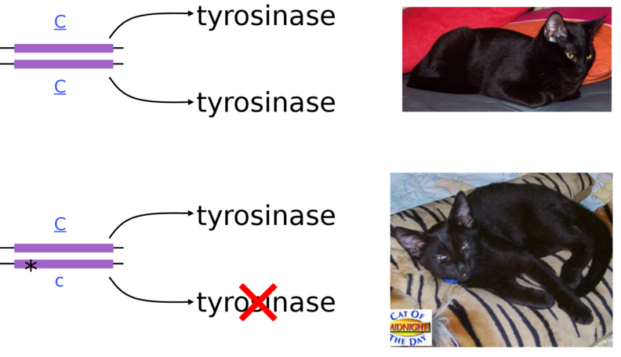
Loss of function mutations most are recessive. Because is diploid organisms they still have one copy that works and that one is able to compensate for the lazy shite other one. Usually one wild type allele is able to compensate for the mutant phenotype
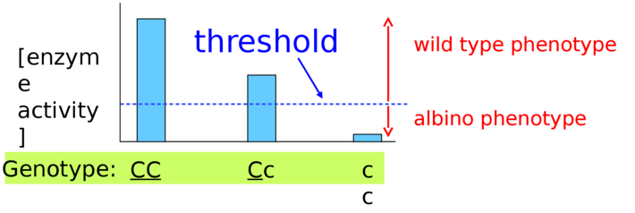
A given threshold gives the phenotype, if one allele is enough to surpass the given threshold the condition is dominant

Haplo insufficiency
When hetero zygous express the homo recessive phenotype, this is because
Co dominance – red white pink when hetero individuals express somewhere in the middle because one allele is enough to do some but not all of the work
January 26
Anatomy: primary and secondary characteristics, genitalia body hair, pelvis, etc
Physiology such as estrogen and testosterone levels
Other ways to determine sex can be chromosomes, chromosomes are olny visible during nuclear division and they must be stained.
Base pair -> DNA > histones > (telomere, centromere) > sister chromatids > chromosomes
see slide 12
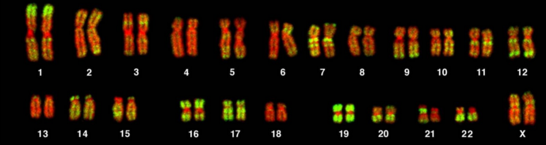
There are two homologous chromosomes in diploid organisms. In this example there are two x chromosomes meaning that this organism is female.
Karyotype is which chromosomes you have ex (xx) or (xy)
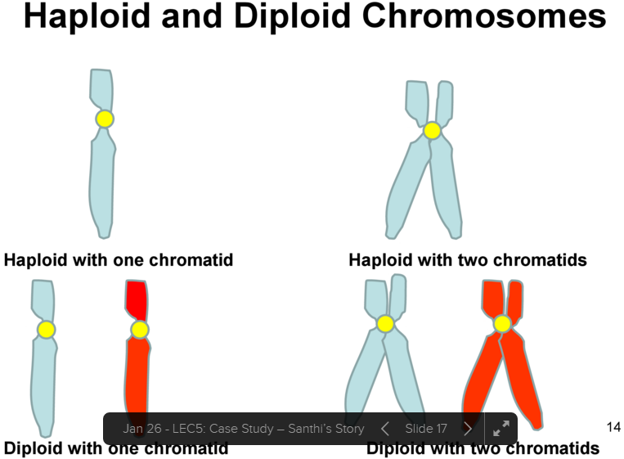
When we talk about ploidy we are talking about a cell/ organism not individual chromosomes.

Review meiosis and mitosis
Independent assortment, means that there is a 50/50 chance that a daughter cell will get a homologous chromosome from mom vs dad.
Crossing over during meiosis : there is nearly always a one to one swap for chromosomes although it is possible that chromosomes do not always exchange evenly and chromosomes can end up with either too much or too little n a given chromosome.
Sex determination
The y chromosome has an sry gene when is a transcription factor that activates weather or not the person while be male or female if the transcription factor is activated then the person will be a male
watch the video on slide 44
sex reversal occurs in 1/20 000 births
how could a y chromosome be missing the sry gene, x and y can cross over and the sry gene can be passed to the x chromosome from the y, leaving the y without the sry gene and producing a phenotypic female and a genotypic male
If baby is xx and has sry gene is male
If baby is x y and has no sry is female

January 29
Guest lecturer: ethics with in genetics
Analytical validity: if the genetic reader can isolate the correct gene
Clinical validity: How accurate the test actually is.
Clinical, personal, and public health utility: is there anything you can do about it? If you have a genetically
February 2
In order for mutations to be seen the mutation has to be heritable.
Mutations can only occur in replication. In tautomeric shifts, the wrong base pair is added due to weird electron resonance, [slide 15] these are typical point sense mutations. Ex c and a pair together, this is the first round of replication. Now in the second round of replication the two strands of DNA are no longer the same.
Some chemicals are similar to base pairs and the cheicals can be inserted in place of the nucleotides.
When light and radiation hits bases the electrons resonate differently, bases an form covalent bonds to neighbouring bases.
There can be more than one mutation that can cause something, ex
February 5
Question one the answer is a, AA and aa respectively have the same alleles. By modifying histones you can change how tightly dna is compacted and which genes are expressed. Repetitive DNA codes for nothing, there are markers within repetitive DNA.
Don’t worry about SINEs and LINEs
Linked vs unlinked genes, crosses, the further away two genes are the more likely they are to cross over
Slide 35 “giving away answers to the lab”
Draw meiosis on the cue card

