Trial 1
When RE = 0Ω
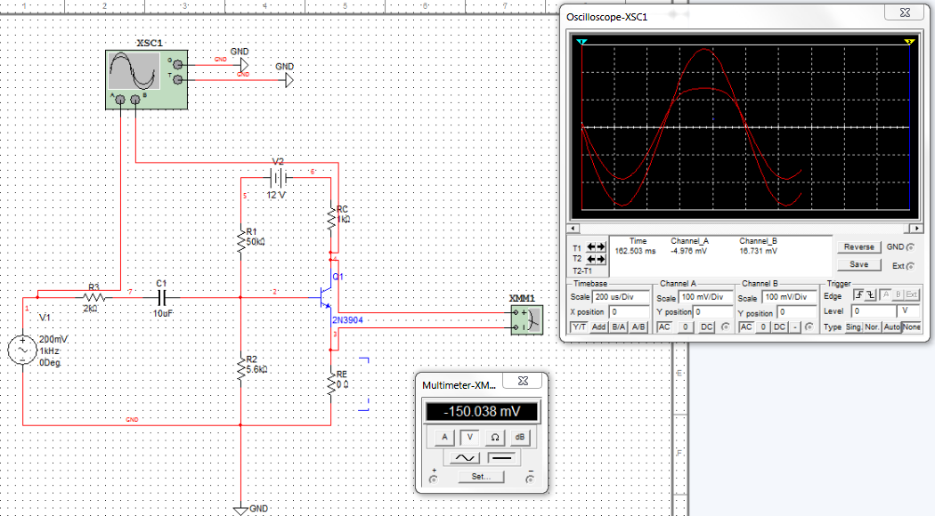
Trial 2
When RE = 500Ω
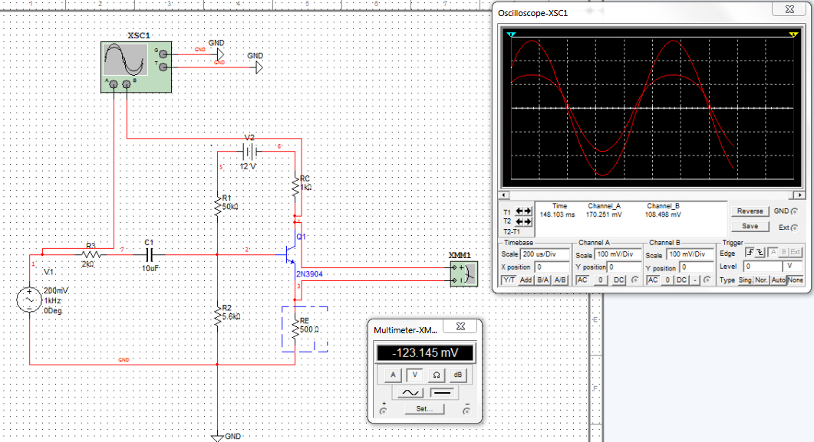
Trial 3
When RE = 1000Ω
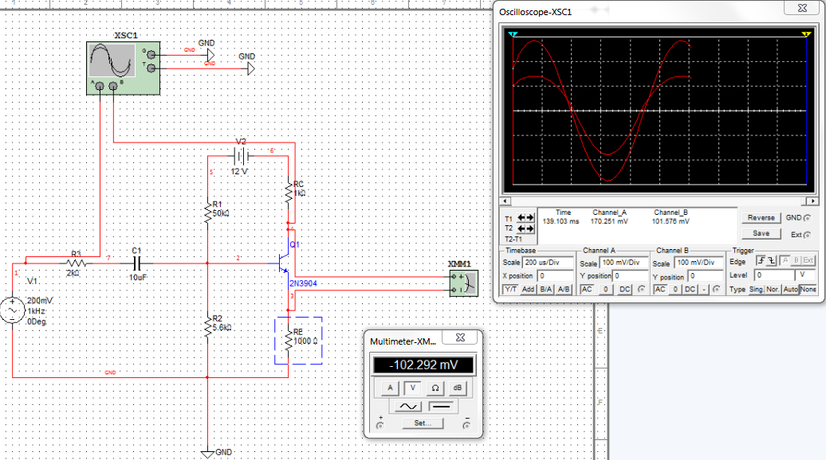
Trial 4
When RE = 1000Ω with RL added in the circuit


