CHAPTER 3 (Reporting and journalizing)

Transactions- economic events that must be recorded in the financial statements.

Assets = Liabilites + SE
 | Debit effect | Credit effect
Assets | + | -
Liabilities or SE | - | +

The normal balance of an account is on its increased side

Steps in the journalizing process
- Analyze each transaction
- Record transaction as a journal entry
- Transfer information to appropriate accounts in the general ledger
- List of all the accounts and their balances at specific times

Trial balance- List of all the accounts and their balances at a specific time, the purpose is to prove that debits=credits, used to help keep perpetual financial statements.

CHAPTER 6 (inventory)

Inventory must be taken for 2 reasons
- To insure inventory records are accurate
- To determine the amount of inventory lost and why

Proper inventory measurement companies must have a good level of internal control

Examples of internal control:
-Employees counting inventory cannot be responsible for record keeping
-Barcodes that are counted at the checkout
-Double counting
-Pre numbered inventory tags

Factors determining item ownership
- Apply freight (shipping) concepts
FOB shipping point- Indicates that it is the buyer’s responsibility to pay shipping. In addition, the title to the goods is transferred at shipping point. This means that the buyer should report goods in transit as inventory.

FOB destination- Indicates that the seller incurs delivery charges and ownership changes when the item arrives at its destination. Buyer should not report goods in transit as inventory, instead goods are reported once they arrive.
2. Ownership of consigned items remains with the owner (the consignor) not the holder (consignee)
3. Goods taken home “on approval” by a customer are still owned by the company (free trial items)

Inventory cost determination methods:
- Specific identification
- Cost Formulas (FIFO or Average)

Specific Identification is only used in the perpetual inventory system and tracks the physical flow of goods. It is known to be expensive and time consuming and not worth the effort. It is only required when:
-Actual costs of each item can be determined
-Goods are easily distinguishable (ie. Cars with license plates)
-Goods made for specific projects

First-in, First-out (FIFO)

On the statement of financial position merchandise is recorded at most recent (current) cost in the current assets section of the statement of financial position

On the income statement cost of goods sold is recorded as an expense at the oldest inventory cost on the income statement.

Average is only used when physical flow of inventory cannot be measured (i.e gas, fountain soda)

Lower of cost and net realizable value

When the net realizable value (fair) value is less than cost, the value is written down (lcnrv rule)

Nrv(net realizable value)= Selling price – any costs to make product ready for sale

Inventory turnover ratios:

Average inventory = (start inventory + end inventory)/2
Inventory turnover = Cost of goods sold/ Average inventory [higher is better]
Days in inventory = 365/inventory turnover [lower is better]
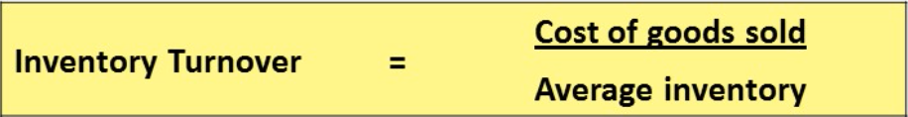

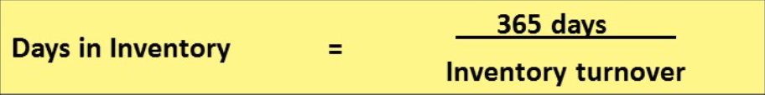

CHAPTER 8 (reporting and analyzing receivables)

Overview of receivables

-Amounts due to business from its customers or other entities
-Expected to be collected in cash
-They represented contractual rights to receive cash or another financial asset

Types of Receivable
- Accounts receivable
-Amounts owed by customers due to the sale of goods and services
-A receivable is recorded when service is provided on account or at point of sale
-A receivable is reduced when cash is collected or at point of sale
- Notes receivable
-formal credit instrument (written promide to pay)
- Other receivables

CHAPTER 9 (reporting long lived assets)

Property, Plant and Equipment- Long lived resources that a company controls; they have physical substance and are sometimes referred to as fixed or capital assets.

Determining the cost
Consists of:
- Purchase Price + Any Duty or tax – any rebate or saving
- Any shipping , freight or delivery charges (are compounded)

Operating Expenditures- Immediately charged as a revenue expense
-recurrent expenditures that are short lived

Capital Expenditures- Capitalized (charged-ish) as an asset
- Benefit future periods (ie installation of ac in van)

Important examples of determining cost:
Land Improvements- The cost of structural improvements made to the land (e.g. Paving, fencing, and parking lots)
-They are recorded separately from cost of land

Buildings- All expenditures related to the purchase or construction of a building
-When a building is purchased costs include purchase price, closing costs (legal fees, title, insurance) and costs required to make the building ready.
-when a building is constructed its fees consist of (Contract price, Architect fees, building permits, excavation costs, interst during construction

Equipment- Costs include purchase price, shipping and handling, assembly and installation.

Depreciation- to record debit depreciation expense and credit accumulated depreciation. Depreciation is the systematic allocation of the cost

Cost- The purchase price + anything to get the product to you
Useful life- an estimate of the life the asset will be useful for
Residual value- an estimate of the amount that will be received upon the disposal of an asset.

Depreciation methods

Straight line- Is the most commonly used method of calculating depreciation and has 2 steps (straight line is typically 20%)

Step1: Solve the depreciable amount

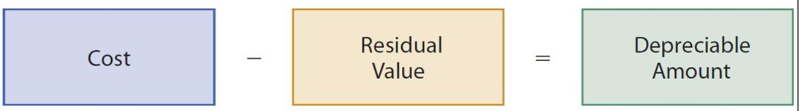

Step 2: Solve the depreciation expense

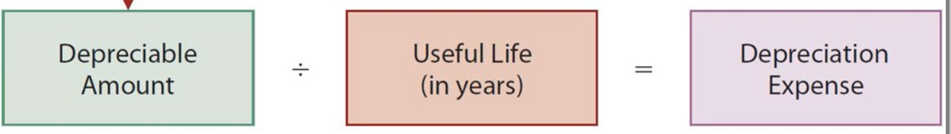

-depreciation is constant over all years of useful life

Diminishing Balance- Produces a decreasing annual depreciation expense over an assets life, as depreciation is calculated based on the carrying amount of an asset

-Annual depreciation expense is calculated by multiplying the carrying amount by the depreciation rate 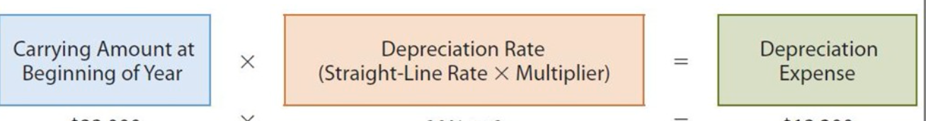

Units-of-production- Useful life is expressed in terms of production or activity expected from the asset

-three step

step 1: solve Depreciable Amount

step 2: Solve Depreciable Amount per Unit

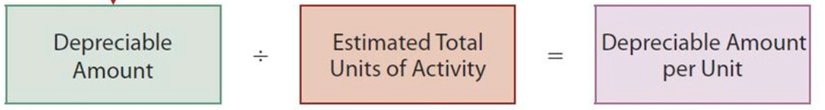

step 3: Solve Depreciation Expense

Revising Periodic Depreciation

Needed if:
-Capital expenditures during useful life
-Impairment losses
-Change in the estimated useful life or residual value
-Change in pattern in which the asset’s economic benefits are consumed

Disposal
- Update depreciation (even if for a fraction of a year)
- Calculate carrying amount (CA= Cost-Accumulated depreciation
- Calculate gain or loss
- Record disposal

(journal entry Dr-Debit, Cr- Credit)
Dr Cash
Dr Accumulated Depreciation
Cr Asset
Cr Gain on disposal

Impairment- when carrying amount of asset exceeds its recoverable amount

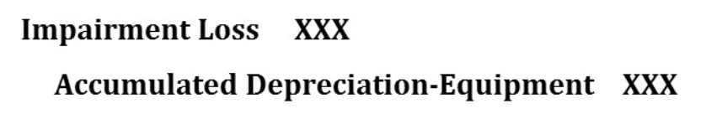

Revising periodic depreciation

Revision needed if- Capital expenditures during useful life
-Impairment losses
-Change in the estimated useful life or residual value
-Change in the pattern in which the asset’s economic benefits are consumed

Disposal of PPE

- Update depreciation
-Must be updated fir the fraction of the year the item was in service for
- Calculate carrying amount
-Carrying amount= Cost – accumulated depreciation
- Calculate gain or loss

Presentation of long-lived assets

-Presented in the statement of financial position as property, plant and equiptment.

-Disclose cost and accumulated depreciation

-Presented in the Income Statement as Depreciation expense and gains or losses on disposal, under the operating section

Return on assets= Profit/ Average Total Assets (higher is better)

-expressed as a percentage
-indicates the % of profit generated by each dollar invested in assets

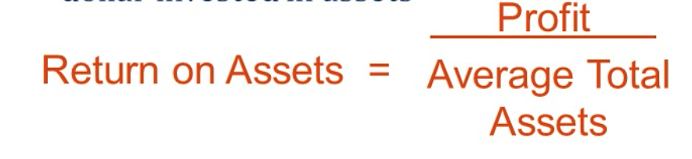

Asset Turnover= net sales/ Average Total assets (higher is better)

-expressed in “times per year”

- Indicates how many dollars of sales are generated by each dollar invested in assets

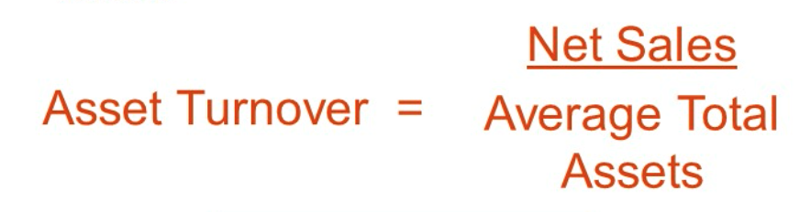

Profit Margin-together, profit margin and asset turnover explain the return on assets ratio

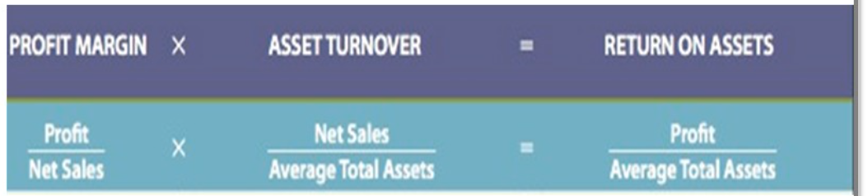

To increase return on asset:

Increase profit magin (increase price or decrease costs)

Increase Asset Turnover (increase Sales volumes or decrease Asset base)

Chapter 13 (Cash flow statements)

Purpose of the statement of Cash Flows:

Helps users assess- A company’s ability to generate cash
-A company’s needs in using this cash

This is useful in determining
-Company’s ability to generate future cash flows
-Investing and financing transactions during the period, ad effect upon capital
- Making comparisons with other companies

Definition of cash (Cash may include cash equivalents)
-Short term, highly liquid investments that are readily converted to cash within a short period of time (usually 3 month)
-May not be included in future depending on outcome of IASB/FASB project

Classification of Cash Flow

-Operating activities
-Cash effects of transactions that create revenues and expenses that enter into determination of profit
- Includes relevant noncash current assets and current liabilities on the statement of financial position (eg. The related account is an income statement account)

-Investing activities
-Purchasing and disposing of long-term investments and productive long-live assets using cash
-Lending money and collecting the loans
-Generally includes non-current asset items (eg. Property, plant, equipment)

-Financing activities
-Obtaining cash from issuing debt and repaying the amounts borrowed
-Obtaining cash from selling common and preferred shares and paying dividends
-Generally includes non-current liabilities, and shareholders’ equity items on the statement of financial position

Significant noncash activities- If it does not affect cash, do NOT report it in the statement of cash flow.
-Report in separate note or supplementary schedule to the financial statements
-Ex: Isue of debt to purchase assets, Issue of shares to purchase assets, conversion of debt to equity, exchange of PPE

Preparing the statement of Cash Flow:

Step 1: Prepare operating activities section
-Determine the net cash provided (used) by operating activities by converting profit from an accrual basis to a cash basis
-Conversion may be done by either indirect method or the direct method
-Direct method is preferred by standard-setters
-Most companies prefer indirect method
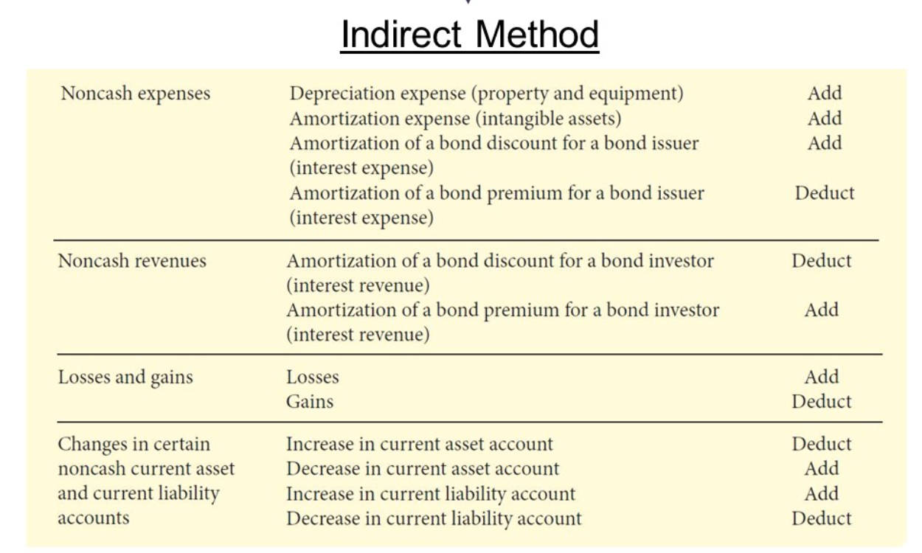
Step 2: Prepare investing activities section
Step 3: Prepare financing activities section
Step 4: Complete the statement of cash flows

Consigned merchandise- Merchandise that is not owned by the party in possession of the goods. For example, a craftsperson might have produced 100 ornate wood items. In order to sell the items, the person asks a local merchant to take five of the items on consignment. This means that the merchant has possession of the five items and will attempt to sell them for a commission, but the merchant does not own the items.

