Experiment 2: Purifying Chemicals by Distillation

By Mikayla Herfkens
8172265

CHM1321 Section A9

Demonstrator:
Billy McClennan

January 29th, 2016

Department of Chemistry
University of Ottawa

Procedure
As described in the manual (Vankateswaran, R. “Purifying Chemicals by Distillation”, Sept. 2014, Exp.2, p 26, University of Ottawa.)
Observations
Simple Distillation
- Water was not started right away
- Distillate (50:50 2-propanol and 1-butanol) was clear, colourless and had a strong odour
- Takes a while to heat solution; stays at around 20˚C at the beginning.
- Temperature began increasing rapidly to about 80˚C; fluctuated around this temperature for a while.
- Thermometer was placed further down at 42 mL, which caused the temperature to jump to about 116˚C
Fractional Distillation
- Distillate (50:50 2-propanol and 1-butanol) was clear, colourless and had a strong odour
- Temperature began at about 20˚C and fluctuated around this temperature
- Temperature jumped to about 80˚C as solution began dripping
- Temperature does not fluctuate as much as in the simple distillation
- At about 16-18 mL, the drops began slowing down, so the heat was increased slightly.

Table 1. Temperature of Distillate Accumulated in Receiving Flask (Simple Distillation)
Volume of Distillate (mL) | Temperature (˚C)
2 | 65.4
4 | 75.3
6 | 82.2
8 | 82.9
10 | 84.1
12 | 84.7
14 | 83.5
16 | 83.0
18 | 84.4
20 | 84.7
22 | 85.2
24 | 84.9
26 | 84.1
28 | 82.4
30 | 80.8
32 | 81.2
34 | 81.4
36 | 82.9
38 | 84.1
40 | 86.2
42 | 116.6
44 | 116.8

Table 2. Temperature of Distillate Accumulated in Receiving Flask (Fractional Distillation)
Volume of Distillate (mL) | Temperature (˚C)
2 | 82.2
4 | 82.9
6 | 83.3
8 | 83.7
10 | 83.8
12 | 84.2
14 | 84.6
16 | 85.1
18 | 85.8
20 | 86.4
22 | 87.6
24 | 89.4
26 | 94.6
28 | 106.6
30 | 114.8
32 | 115.2
34 | 116.2
36 | 116.5
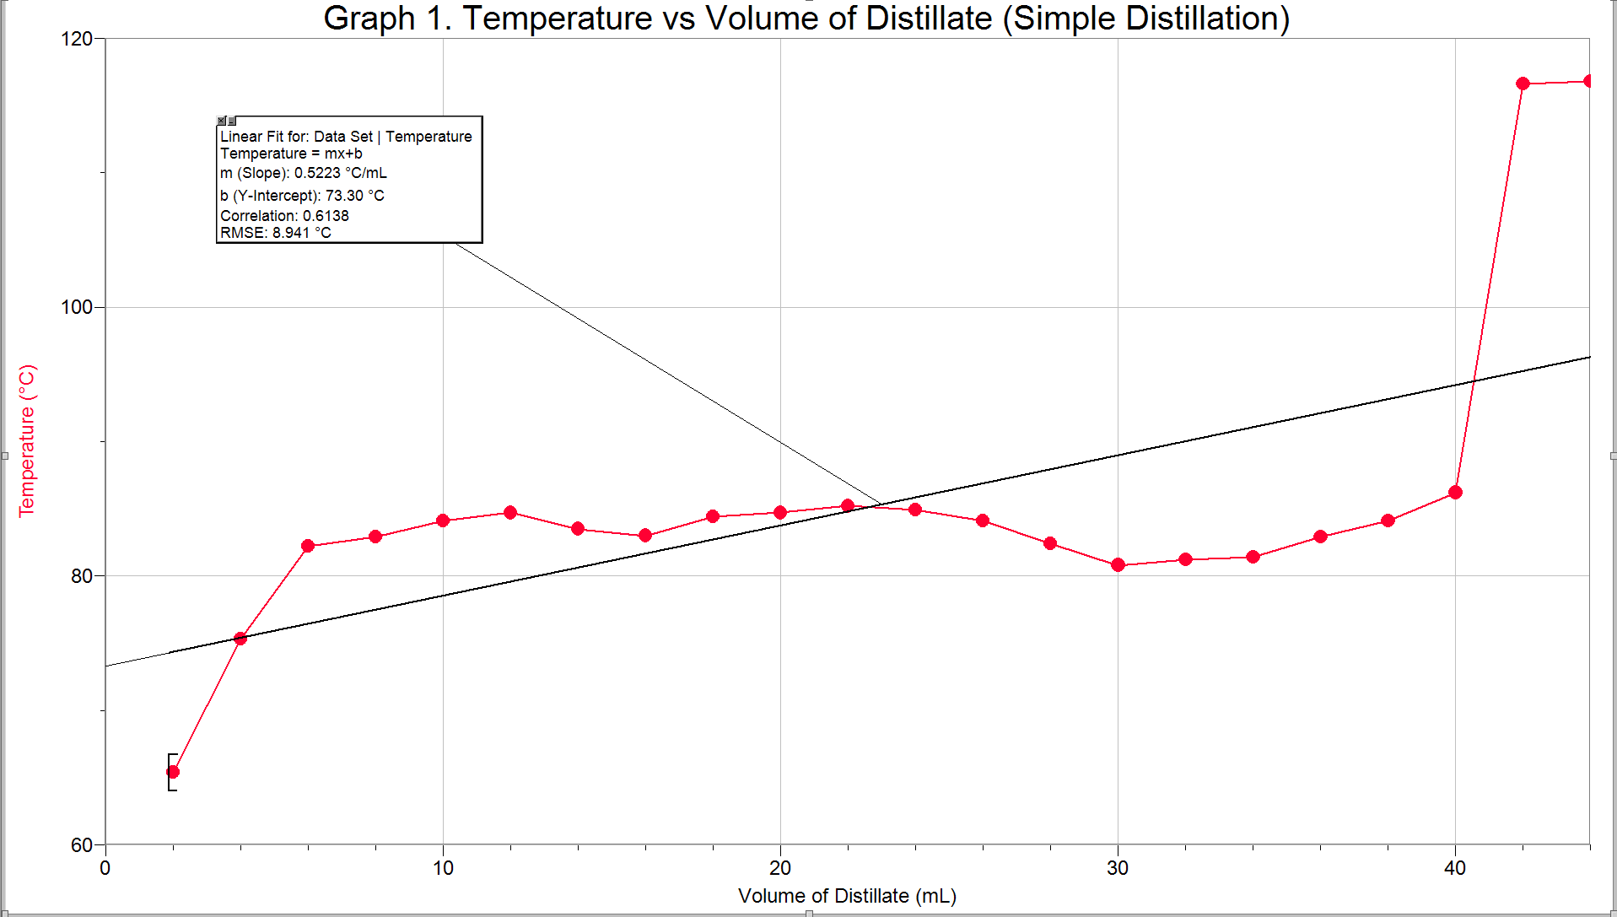

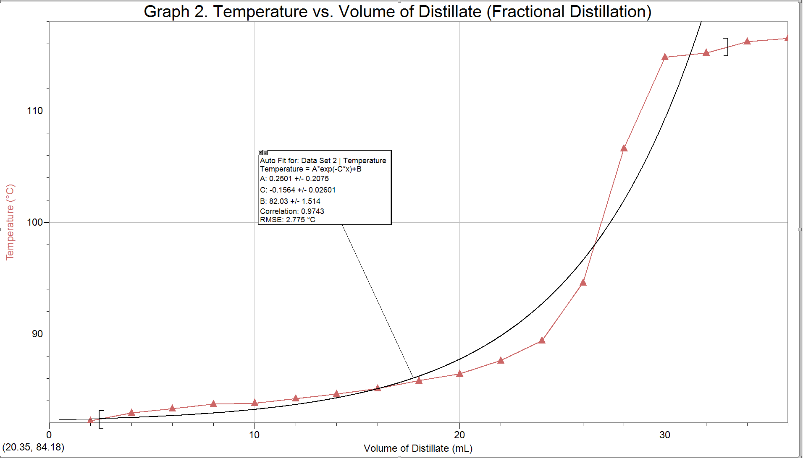
Discussion
During the experiment, two methods of distillations were used in order to separate the components of 50:50 mixture of 2-propanol and 1-butanol: simple distillation and fractional distillation. This was achieved because the components of the solution have different boiling points, therefore one compound could be evaporated, while the other would stay in liquid form.
Theoretically, a simple distillation should occur at a constant pace, therefore having a linear shape on a graph plotting Temperature vs Volume of Distillate in receiving flask. The reason for this is because when the temperature reaches the boiling point of the substance with the lowest boiling point, it will begin to evaporate and condense in the condenser. As the temperature gradually increases to the boiling point of the second component, it will begin to evaporate and condense into the receiving flask. Thus, the temperature increase and volume of distillate in the receiving flask is constant. The actual graph, however, is somewhat linear at the beginning and jumps up 20˚C, which means that there were errors during the distillation. The thermometer was placed too high in the apparatus so it was not completely surrounded by the hot vapours. This resulted in a temperature reading that was lower than the actual temperature. Once the thermometer was moved down into its proper position, the temperature spiked up.
The other distillation method performed was fractional distillation. This method differs from simple distillation with the addition of the fractionating column, which is a long column that contains a metal sponge core. The metal in the column provides a surface on which the solution can condense, re-evaporate and condense once again, distilling the compound over and over again. This method is much more efficient than simple distillation because the separation of the solutions is more accurate with the temperature gradient across the fractionating column. In an ideal fractional distillation, the graph would be horizontal at the beginning, rise exponentially, and then level off. The first horizontal line should represent the boiling point of the component with the lower boiling point, the increase represents the temperatures of both components in varying amounts, and the final horizontal line represents the boiling point of the component with the higher boiling point. The actual graph rises slightly at the beginning, then jumps exponentially and then levels off, therefore the distillation was successful. The possible sources of error in this part of the experiment is that the two components of the solution do not have a very large difference in boiling points. The boiling point of 2-propanol and 1-butanol is 82.6 ˚C and 117.4 ˚C, respectively, which gives a difference of only 34.8 ˚C. Such a small difference does not allow a completely clear separation.
Both techniques were simple to perform, however the fractional distillation required a closer watch. If the flask is heated too high, the liquid cannot drip down, resulting in a condition in which the liquid is trapped; this is called “flooding”. Fractional distillation also took longer, due to the multiple “mini-distillations” in the fractionating column. The products of fractional distillation, however, were much more pure than that of simple distillation.
Questions
1. It is important to have liquid flowing back through the fractionating column in order for the distillation to work and separate the solution efficiently. The fractionating column increases the contact surface area and cools some of the vapours down. Thus, the component with the higher boiling point will condense in the column and drip back down the distilling flask, while the component with the lower boiling point will continue to rise as a gas.
2. A uniform temperature gradient in the fractionating column is important to ensure that the solution with the higher boiling point drips back down and does not contaminate the receiving flask. At the bottom on the fractionating column, the packing will be the warmest and the top will be the coolest. The solution will evaporate, however, once the solution with the higher boiling point reaches a packing with a cool temperature, it will condense and drip. If the gradient is not uniform, there is a chance that the solutions will not separate correctly.
3. By definition, the boiling point of a pure liquid is the temperature at which the vapour pressure is equal to the pressure applied to the solution, which is atmospheric pressure (1 atm), in this case. The being said, the vapour pressure of benzene at its boiling point (81˚C) is 1 atm.
4. By increasing the atmospheric pressure, the boiling point of a liquid will increase. This is demonstrated with the ideal gas law.
Example:
P₁V = nRT₁ P₁/T₁ = nR/V
if P₂= 2P₁ and the other variables are kept constant, then:
nR/V = nR/V
P₁/T₁ = P₂/T₂
P₁/T₁ = 2P₁ /T₂
T₂ = 2T₁
5. It is important to have the cooling water enter the bottom of the condenser as opposed to the top in order to ensure that the condenser is completely filled with water. If it is not completely filled, the vapour may not condense correctly.

6. P_{A} = 350 mm Hg
P_{B} = 150 mm Hg
N_{A} = $\frac{3}{4}$ = 0.75
N_{B} = $\frac{1}{4}$ = 0.25
P_{A} = (P_{A˚})(N_{A}) and P_{B} = (P_{B˚})(N_{B})
P_{total} = P_{A} + P_{B}
Therefore, P_{total} = (P_{A})(N_{A}) + (P_{B})(N_{B})
P_{total} = (350 mm Hg)(0.75) + (150 mm Hg)(0.25)
P_{total} = 300 mm Hg
References
Vankateswaran, R. “Purifying Chemicals by Distillation”, Sept. 2014, Exp.2, p 19-27 , University of Ottawa.
CRC Handbook of Chemistry and Physics. 85th ed. CRC Press: Boca Raton, FL, 2004-2005


