Lesson 8

- humans depend on the social transmission of knowledge
- children cant grow up without help.
- Serena nanda argues:
‘The long period of dependency is the price Homo Sapiens pay for their big brain and its enormous potential for learning’.

Enculturation: when a child acquires his culture (by being taught or by observation)

Rite of passage: a ceremony that marks the transition from one phase of life to another

Common Types of Rites of Passage
The most common types of rites of passage include:
- Naming ceremonies, which confer social existence to the new member of the society.
- Puberty celebrations, which confer adult status.
- Marriage, which legitimizes one's sexual relationship and child rearing obligations.
- Funerals, which proclaim the loss of life and allow society to restructure in different ways.
Rites of passage can be religious or non-religious.

Social birth: when a child truly becomes a member of his society

Death Without Weeping – Nancy sheper Hughes :
A baby is not a human until it shows that it can survive
Women are too poor for baby sitters so they have to leave the child alone and if the child cant survive alone, it is too weak and the woman will distance herself from the baby emotionally and withdraw care.
These type of children are an aversion to life, when they die is it “nature taking its course”. Mothers do not greive

Adoption:

Adoption is the formal and permanent transfer of a child to the care of someone else. As with birthing, adoption varies cross-culturally and is often associated with the local conception of what a family is and where a child fits into it.

Puberty rituals

The most important puberty rituals are found in societies where social control of the children is the stronger, in terms of the children being expected to perform tasks and assuming responsibilities associated with age. F

Marriage:
In most societies, the marker for adulthood

Ghost marriage: married by proxy
Same sex marriage
Multiple partner marriage
Love marriage
Arranged

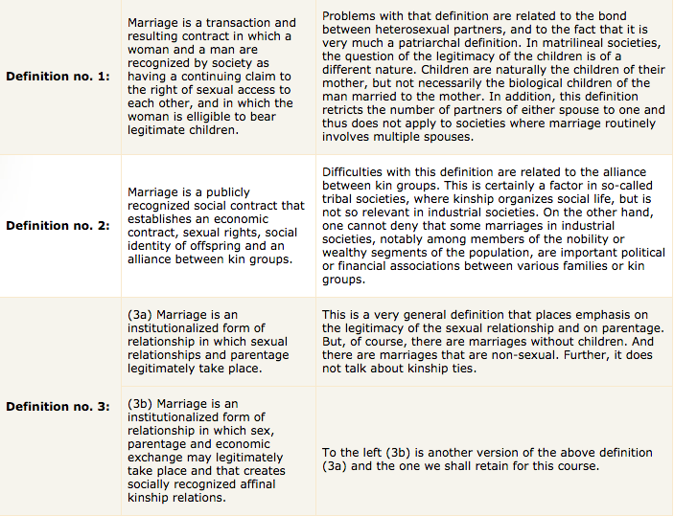

Affinal kin: marriage is established by inlaws
Sororate: another girl from the family can replace the wife if she dies (or a boy for the man called levirate)

Polygamy: having more than one spouse.
Polyginy – one man and multiple wives
Polyandry- one woman many husbands

Monogamy: one man and one woman (most common form cross-culturally)
Serial monogamy- married to one person at a given time, but have multiple marriages
Exogamy: almost like an exchange
Exogamy rules force the individual to seek a marriage partner outside a specific social group, such as a clan or a lineage that one belongs to.

Endogamy:

