Chapter 2: The Functioning Brain

Neurons & Neurological Communication

September 29, 2015
Lecture 6

Main Points
- The Nervous System
- Neurotransmission
- Study of the Brain (methods)
- Major Structures of the Brain
- Subcortical Structures & Function
- Organization of the Cortex

Cortex is where the executive processes are located (outer area of the brain)

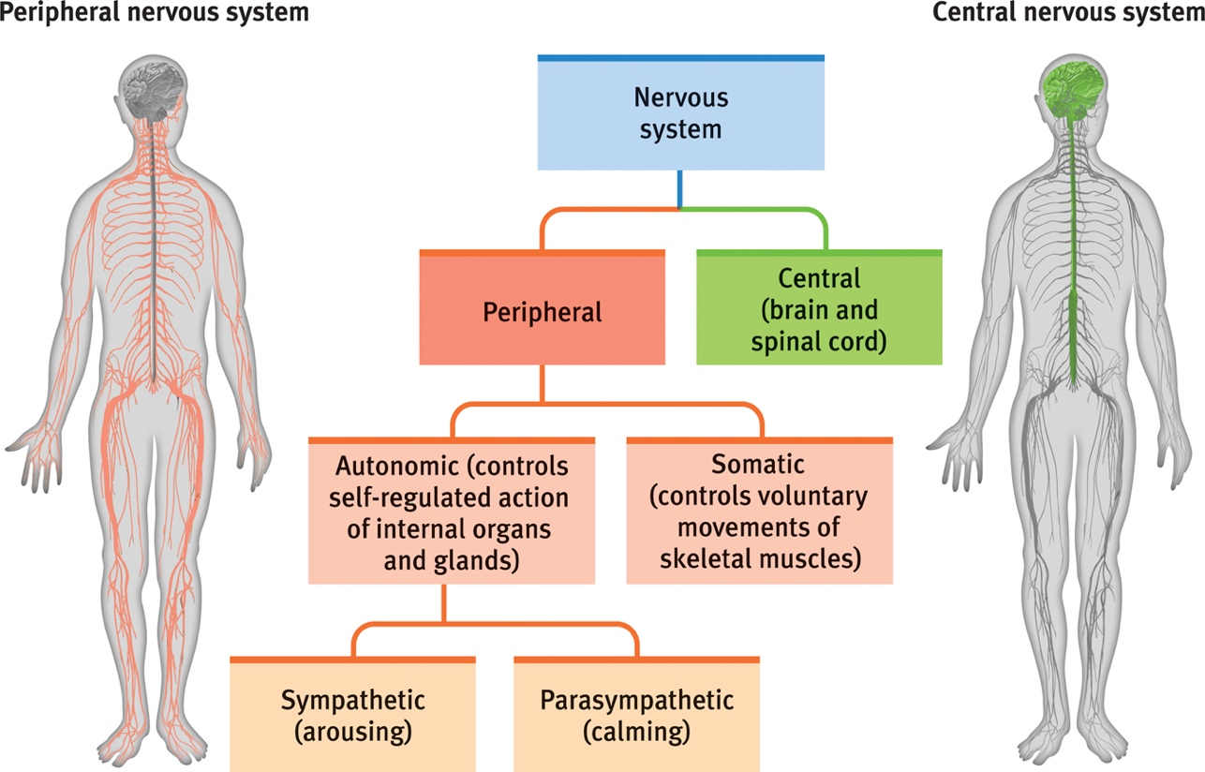

Central Nervous System

Neuron: one cell
Nerve: a group of axons that form a tract

Sensory Neurons
- Bring information to the central nervous system
- Afferent

Interneurons
- Associate sensory and motor activity in the central nervous system

Motor Neurons
- Send signals from the brain and spinal cord to muscles
- Efferent (Hint: to remember, it EXITS the CNS; therefore, efferent)

Neural Transmission (Synapse)
- Electrical impulses (action potentials) travel from one neuron to another across a tiny junction known as a synapse

Depolarization: cell becomes more positive inside the membrane
Repolarization: cell becomes more negative inside the membrane

Ion channels open and close and ion transporters regulate the number of ions inside and outside the axon

Reuptake
- Neurotransmitters in the synapse are reabsorbed into the sending neurons
- An enzyme breaks down the excess neurotransmitter so that another action potential can occur

Neurotransmitters
Bind to the receptors of the receiving neuron in a key-lock mechanism

Amino Acids
- Glutamate (excitatory, epilepsy)
- GABA (Gamma-amino Butyric Acid, Inhibitory)

Peptides
- Enkephalins (endorphins, natural opiates)

Systems
- Acetylcholine (attention, learning & memory muscles; AD)
- Dopamine (movement, pleasure, Schizophrenia; PD)
- Norepinephrine (alertness, panic)
- Serotonin (mood, depression, common disorders)

Neurotransmitters & Drugs
- Specific neurotransmitters work at specific synapses (lock & key)
- 15-20 neurotransmitters known at present
- Interactions between neurotransmitter circuits

Agonist mimics neurotransmitter action
Antagonist opposes action of a neurotransmitter (blocks)

Method of Neurological Investigation

CT (computed tomography) Scan
- Series of x-ray photographs taken from different angles and combined by computer into a composite representation of a slice through the body
- The denser the tissue, the lighter it appears

PET (position emission tomography) Scan
- Visual display of brain activity that detects where a radioactive form of glucose goes while the brain performs a given task
- The metabolism of glucose in the brain
- Inject radioactive isotope of glucose in the brain

MRI (magnetic resonance imaging)
- Technique that uses fields and radio waves to produce computer generate images that distinguish among different types of soft tissue
- Allows us to see structures within the brain

EEG (electroencephalography)
- Measures brain activity and action potentials
- Usually used for people with sleep disorders
- Amplitude and frequency are different between brain states

Discordant one twin has Schizophrenia and the other doesn’t
Concordant both twins have Schizophrenia

The Cerebral Cortex
The intricate fabric of interconnected neural cells that covers the cerebral hemispheres. The ultimate control and information processing center.

Hippocampus
- Linked to memory
- Linked to Alzheimer’s
- The smell goes through the hippocampus

Amygdala
- Linked to emotion
- Direct connection to the nervous system

Corpus Callosum
- Tract of fiber between the two hemispheres
- Connects the right and left hemispheres

Thalamus
- The hub of the brain
- Incoming information through physical energy
- Determine what kind of energy it is and directs it to the appropriate lobes
- Except for smell

Hypothalamus
- Endocrine system
- Control maintenance functions such as energy
- Linked to emotion and reward

Pituitary
- Master of endocrine gland

Reticular Formation
- Helps control arousal

Medulla
- Breathing, heart rate
- Top of the brain stem

Spinal Cord
- Pathway for neural fibers travelling to and from brain
- Controls simple reflexes

Cerebellum
- Coordinates voluntary movement and balance

Lobes of the Brain

Frontal
- Motor
- Higher processing
The lobes have to communicate to put all the information being processed together.

Temporal
- Memory
Occipital
- Vision
Parietal
- Spatial relations

October 6, 2015
Lecture 8

Specialization & Integration
- Brain activity when hearing, seeing, and speaking words

Left Hemisphere
- Gray matter (soma)
- Sequential
- Speech/symbols
- Verbal
- Analytical processes
Communicate by the Corpus Callosum

Right Hemisphere
- Larger
- White matter (myelinated axon)
- Holistic (big picture)
- Non-speech/emotion
- Spatial

