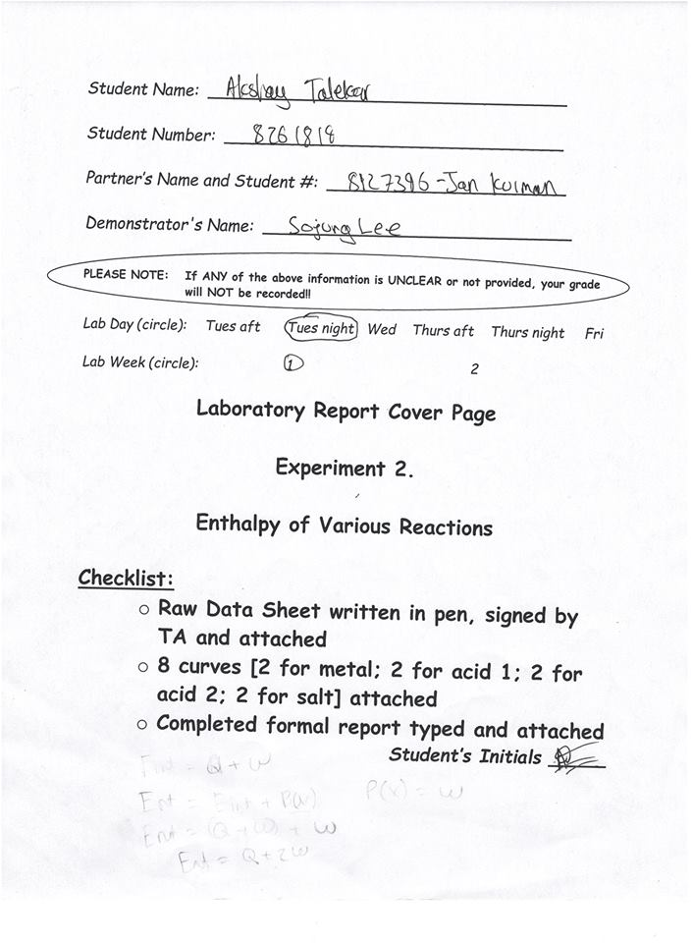Experiment2. “...BUT A HOT TEMPER LEAPS O’ER A COLD DECREE” Enthalpy Of Various Reactions

INTRODUCTION:
Heat affects human beings in everyday life through processes such as a hot shower or cooking, in which kinetic energy is transferred from one molecule to another due to difference in temperature. It is also important to understand that energy cannot be created or destroyed, meaning energy can only transfer forms (ex -kinetic energy to chemical potential energy) .
The enthalpy of an object is defined as the energy of a system and is the sum of the internal energy and work in a system at a constant pressure (ideally 1 bar at 25ºC). The change in enthalpy when one mole of substance is formed from its elements is known as the standard heat of formation (notation - ΔfHo), most of these values are found experimentally. The heat of formation of an element at standard state (1 bar at 25ºC) has the value of 0 assigned to it. A positive enthalpy value describes an endothermic reaction in which heat is absorbed, and a negative value indicates an exothermic reaction.
When changes in enthalpies are hard to measure, it is possible to measure the enthalpy of different reactions, which would then add up to give the original chemical formula and its enthalpy.
There are 3 main parts to the experiment, first determines the specific heat capacity of a metal, and the metal’s approximate molar mass. The second part the enthalpy of neutralization of a strong base and a strong acid is determined. In the third part the enthalpy of solution for an unknown salt is determined, and the identity of the salt.
Part 1: Specific heat capacity of a metal
Thermal energy is energy due to heat. One way to measure thermal energy is through the use of the specific heat capacity (energy needed to heat 1 gram of an object by 1 degree Celsius), the object’s mass and the change in temperature. The energy needed to change the temperature of an object is given by:
Q=m*c*ΔT
Where c is the specific heat capacity, m is the mass of the object in kilograms, and ΔT is the change in temperature. In the case of Part 1 of the experiment where a hot metal is dropped in water, no heat escapes the system, so therefore the energy lost from the metal must be absorbed by the water (which is at a lower temperature).
-(m_{metal}*c_{metal}* ΔT_{metal}) = m_{water}*c_{water}* ΔT_{water}
Once the specific heat capacity is determines, the molar mass of the metal can be determined through the approximation that metals have roughly the same capacity to absorb heat.
MM_{metal}= 25 j*mol⁻¹* ºC⁻¹ / c_{metal}
Where MM_{metal} stands for the molar mass of the metal.
Part 2: Enthalpy of Neutralization
Similar principles are applied to find the enthalpy of neutralization. The heat released by the reaction must be absorbed by the solution. Q of the reaction is negative as temperature is of the solution rising.
Q_{reaction} = -Q_{soluton}
Q_{solution} = M_{total}*c_{solution}* ΔT
Q_{neutralization}= - M_{total}*c_{solution}* ΔT
Enthalpy of reaction per mole can be determined by dividing the enthalpy by the number of moles of substance
Δ_{s}Hº = Q_{neutralization} / n_{substance}
Part 3: enthalpy of solution
The lattice energy of a salt is the energy required to vaporize 1 mole of salt to form gaseous ions. Lattice energy of a salt is an endothermic value. Hydration energy is the released when one mole of gaseous ions dissolve in the water to form aqueous ions, this value is exothermic. The enthalpy of the solution is the sum of the lattice energy and hydration energy. For the purposes of this lab, the temperature of the solution is measured to find the enthalpy of the solution as the other 2 values cannot be measured in the lab.
Δ_{s}Hº = -Q_{soluton} /n_{salt}
Δ_{s}Hº = - (m_{solution}*c_{solution}* ΔT_{solution}) / n_{salt}

PROCEDURE:
As described in the lab manual (Ref)

OBSERVATIONS/DATA/RESULTS: 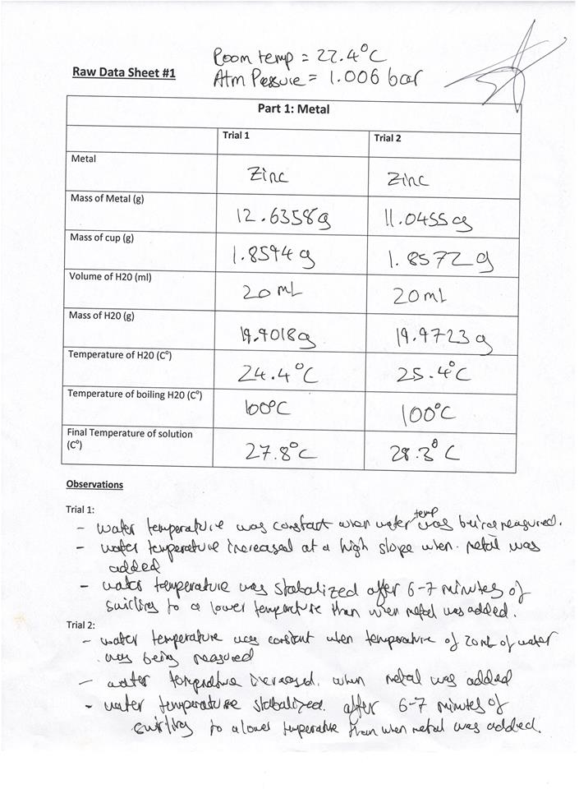
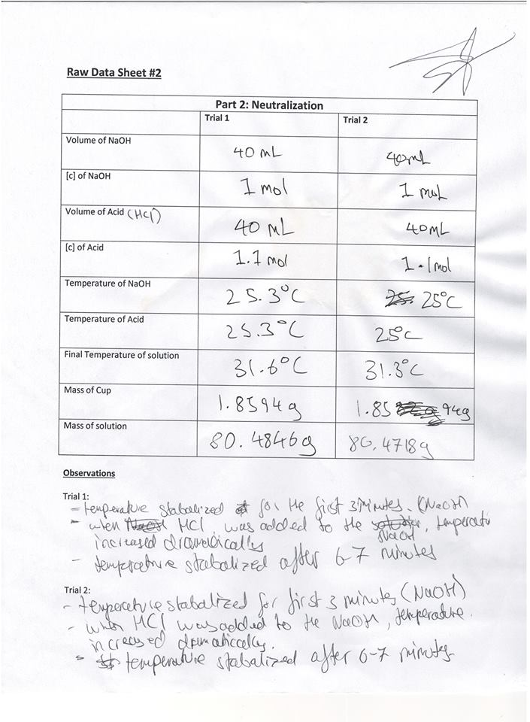
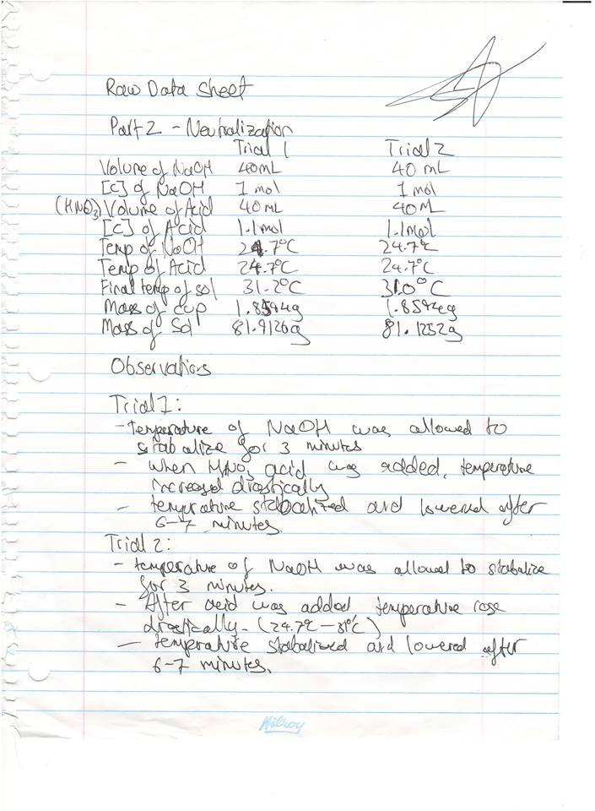
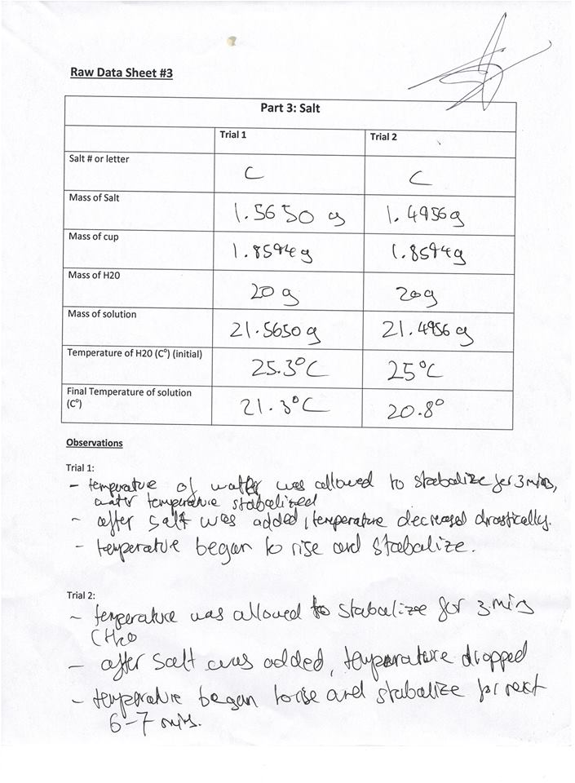
Raw Data Sheet #1

Part 1: Metal

 | Trial 1 | Trial 2
Metal | Zinc | Zinc
Mass of Metal (g) | 12.6358g | 11.0455g
Mass of cup (g) | 1.8594 g | 1.8572 g
Volume of H20 (ml) | 20 ml | 20 ml
Mass of H20 (g) | 19.9018 | 19.9723
Temperature of H20 (Cº) | 24.4 | 25.4
Temperature of boiling H20 (Cº) | 100 | 100
Final Temperature of solution (Cº) | 27.8 | 28.3

Observations

Trial 1:
- Water temperature was constant when water temperature was being measured
- Water temperature increased at a high slope when metal was added.
- Water temperature stabilized after 6-7 minutes of swirling to a lower temperature than when the metal was added.

Trial 2:
- Water temperature was constant when temperature of 200 ml of water was being measured
- Water temperature increased when metal was added
- Water temperature was stabilized 6-7 minutes of swirling.

Raw Data Sheet #2

Part 2: Neutralization
 | Trial 1 | Trial 2
Volume of NaOH | 40 ml | 40 ml
[c] of NaOH | 1 mol/l | 1mol/l
Volume of Acid (HCl) | 40 ml | 40 ml
[c] of Acid (HCl) | 1.1 mol/l | 1.1 mol/l
Temperature of NaOH | 25.3 | 25
Temperature of Acid | 25.3 | 25
Final Temperature of solution | 31.6 | 31.3
Mass of Cup | 1.8594 | 1.8594
Mass of solution | 80.5846 | 80.4718

Observations

Trial 1:
- temperature of water stabilized for the first 3 minutes of recording temperature. (NaOH)
- when HCl was added, the temperature increased at a high rate
- Temperature stabilized to a lower level after 6-7 minutes

Trial 2:

- temperature of water stabilized for the first 3 minutes of recording temperature. (NaOH)
- when HCl was added, the temperature increased at a high rate
- Temperature stabilized to a lower level after 6-7 minutes

Raw Data Sheet #3

Part 2: Neutralization
 | Trial 1 | Trial 2
Volume of NaOH (ml) | 40 ml | 40 ml
[c] of NaOH mol/L | 1mol/l | 1 mol/l
Volume of Acid (HNO₃) ml | 40 ml | 40 ml
[c] of Acid (HNO₃) mol/L | 1.1 mol/l | 1.1 mol/l
Temperature of NaOH ⁰C | 24.7 | 24.7
Temperature of Acid ºC | 24.7 | 24.7
Final Temperature of solution ºC | 31.2 | 31.0
Mass of Cup (g) | 1.8594 | 1.8594
Mass of solution (g) | 81.9126 | 81.1252

Observations

Trial 1:
- Temperature of NaOH was allowed to stabilize for 3 minutes
- When HNO₃ was added, temperature increased drastically
- Temperature stabilized and lowered after 6-7 minutes

Trial 2:
- Temperature of NaOH was allowed to stabilize for 3 minutes
- After acid was added, temperature increased at a high rate.
- Temperature stabilized and lowered after 6-7 minutes

Raw Data Sheet #4

Part 3: Salt

 | Trial 1 | Trial 2
Salt # or letter | C | C
Mass of Salt (g) | 1.5650 | 1.4956
Mass of cup (g) | 1.8594 | 1.8594
Mass of H20 (g) | 20 | 20
Mass of solution (g) | 21.5650 | 21.4956
Temperature of H20 (Cº) (initial) ºC | 25.3 | 25
Final Temperature of solution (ºC) | 21.3 | 20.8

Observations

Trial 1:

- Temperature of water was allowed to stbaalize for 3 minutes, water temperature stabalized
- After salt was added, temperature of the solution decreased at a quick rate
- Temperature began to rise and stbalize

Trial 2:
- Temperature was allowed to stabilize for 3 minutes
- After salt was added, temperature dropped
- Temperature began to rise and stabalize after 6-7 minutes

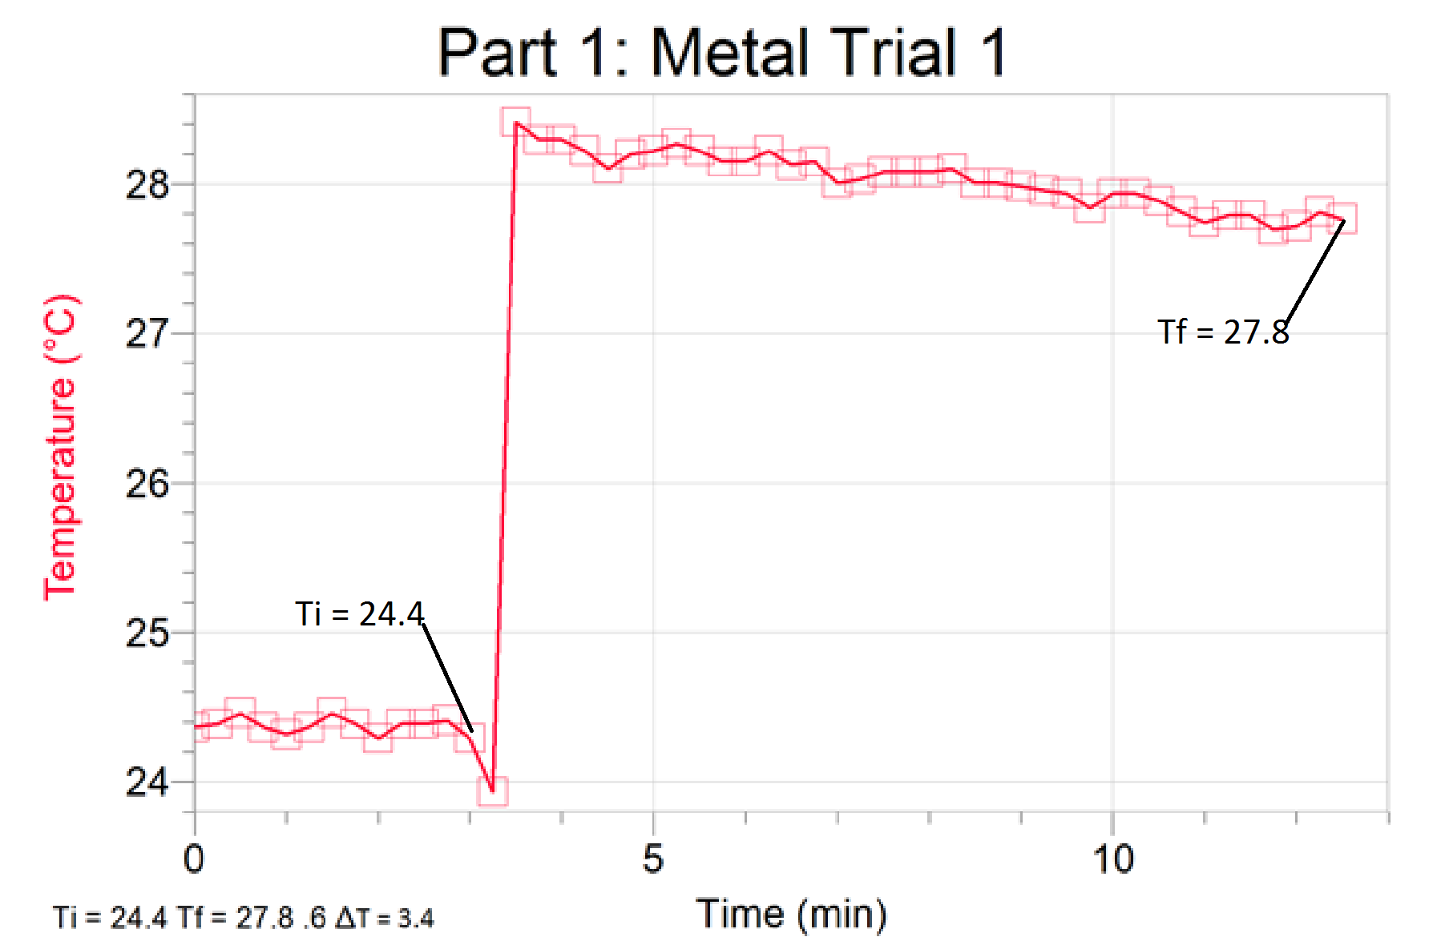
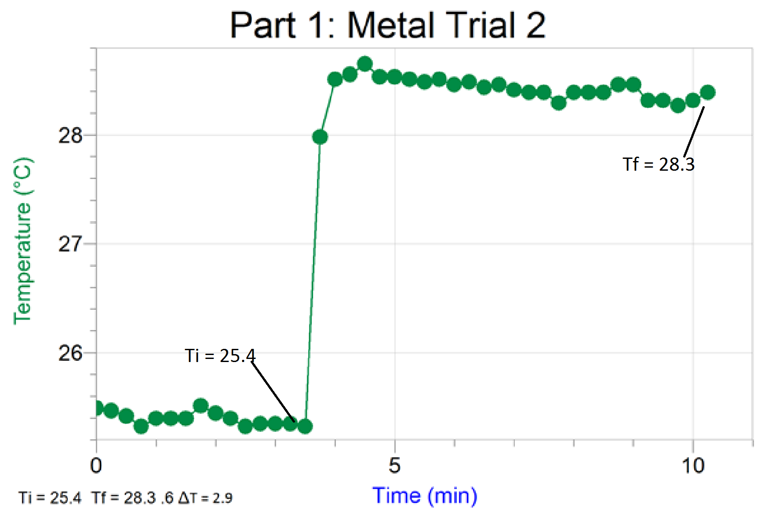

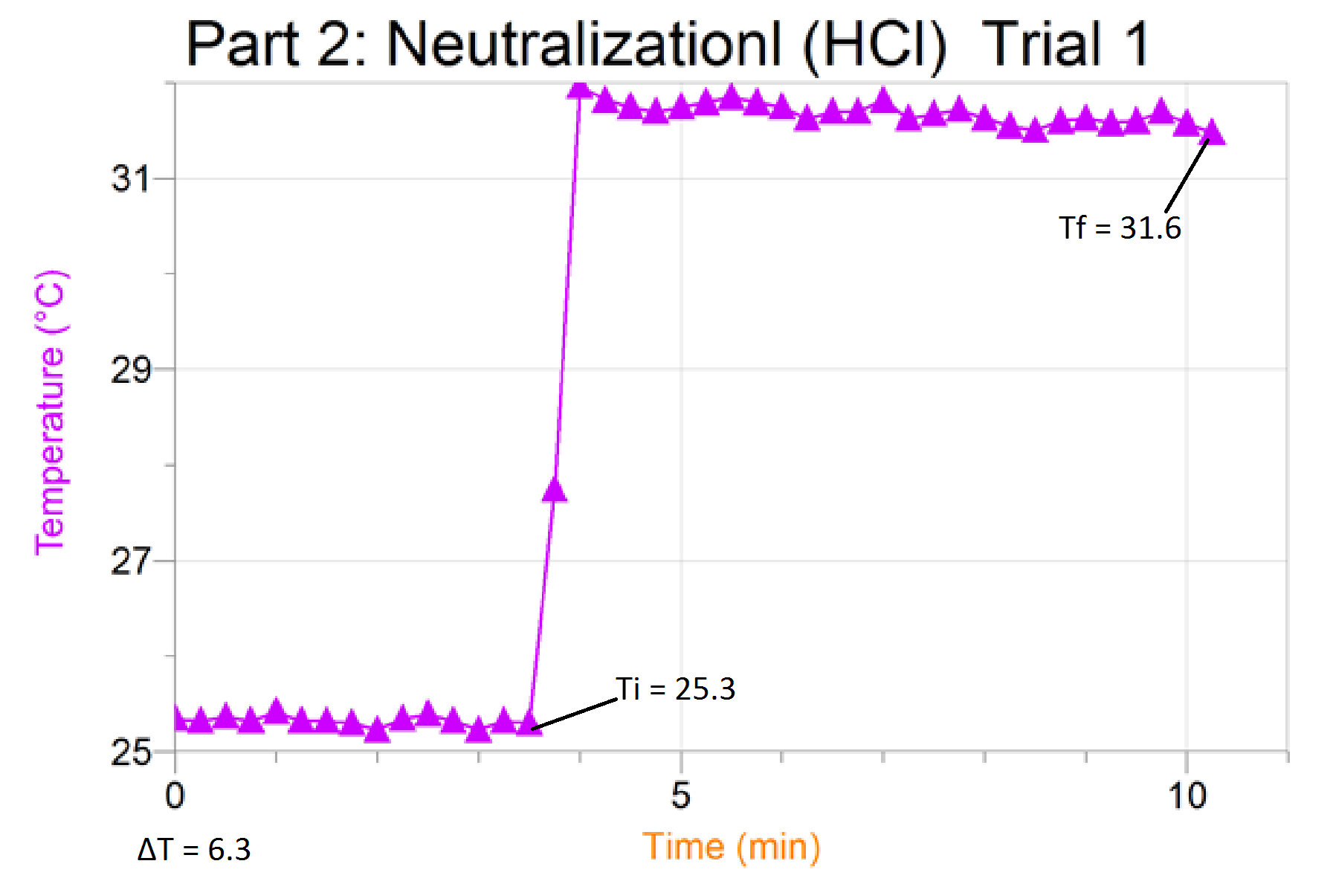
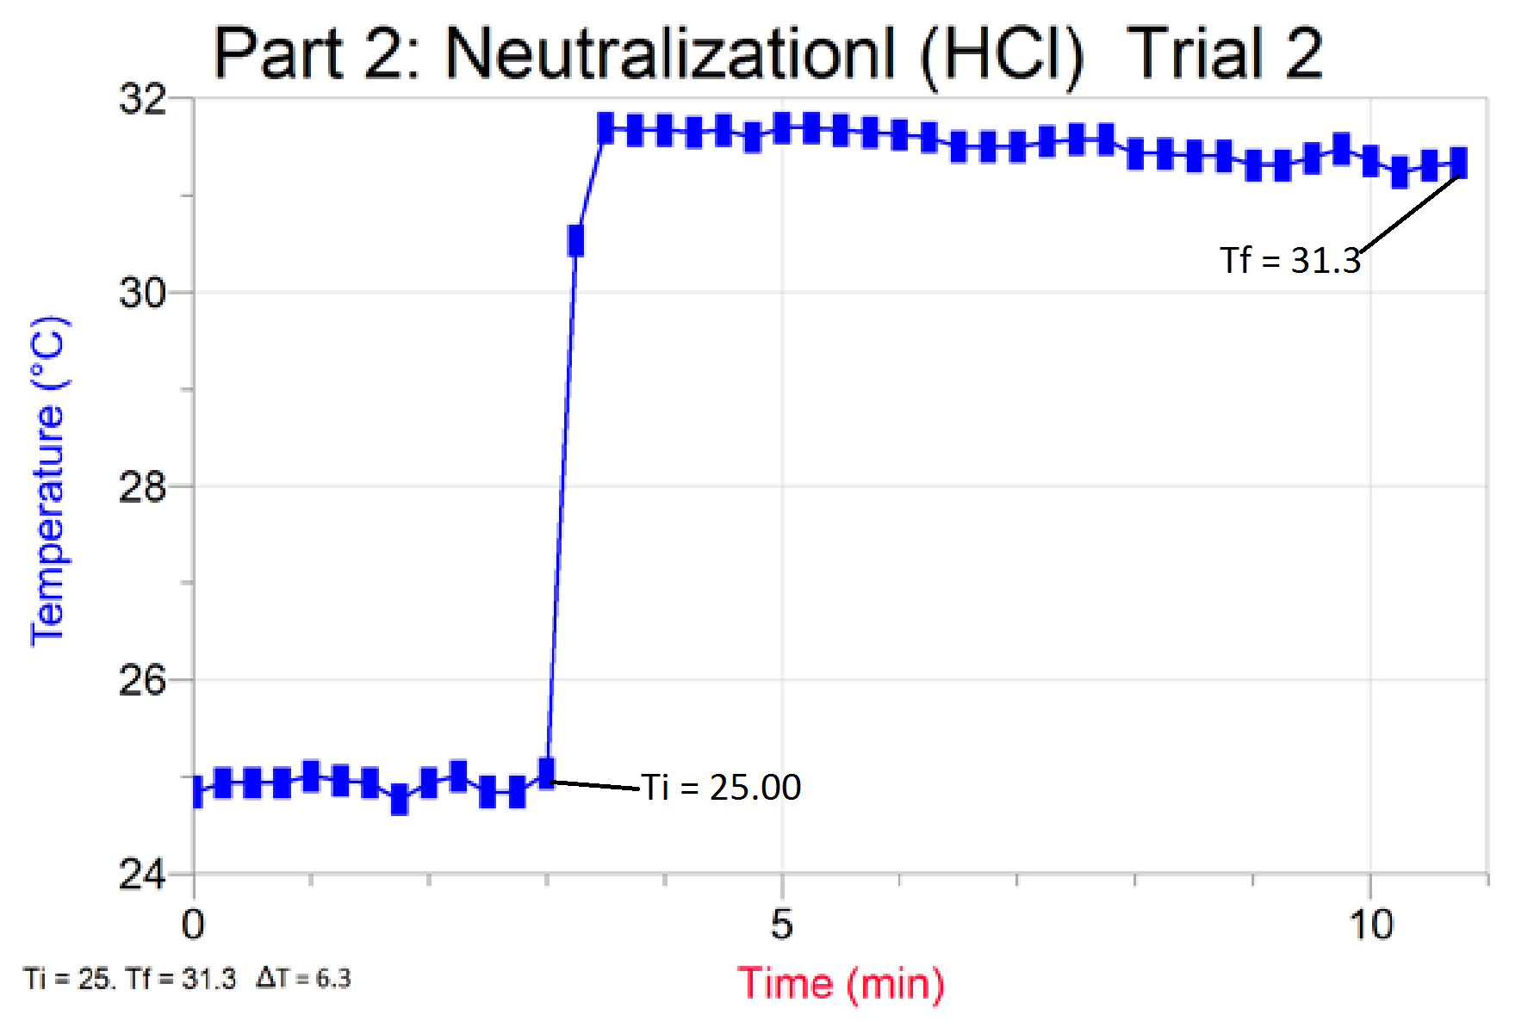
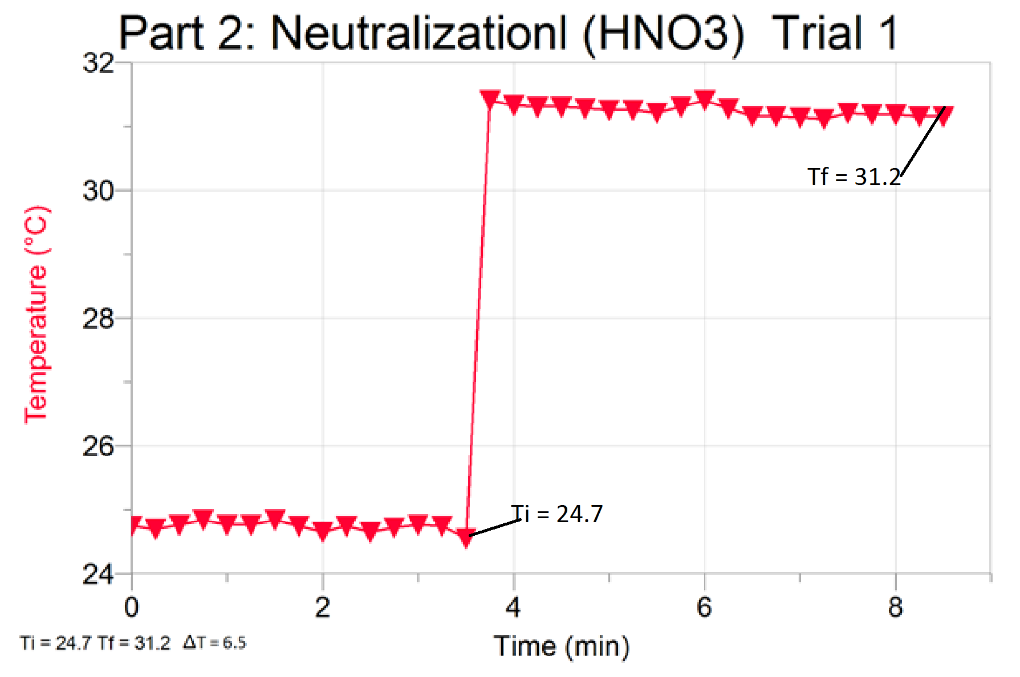

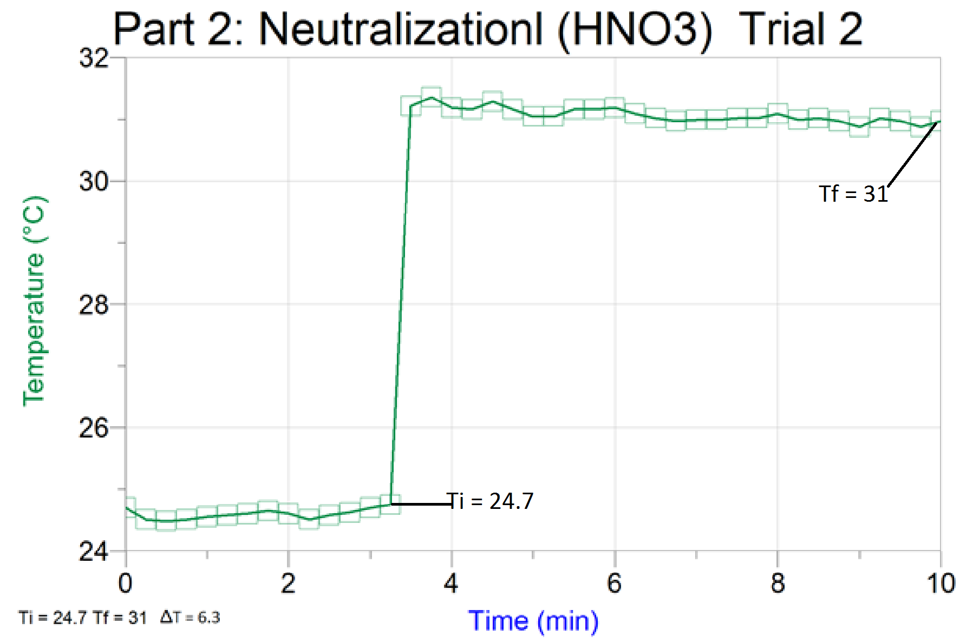

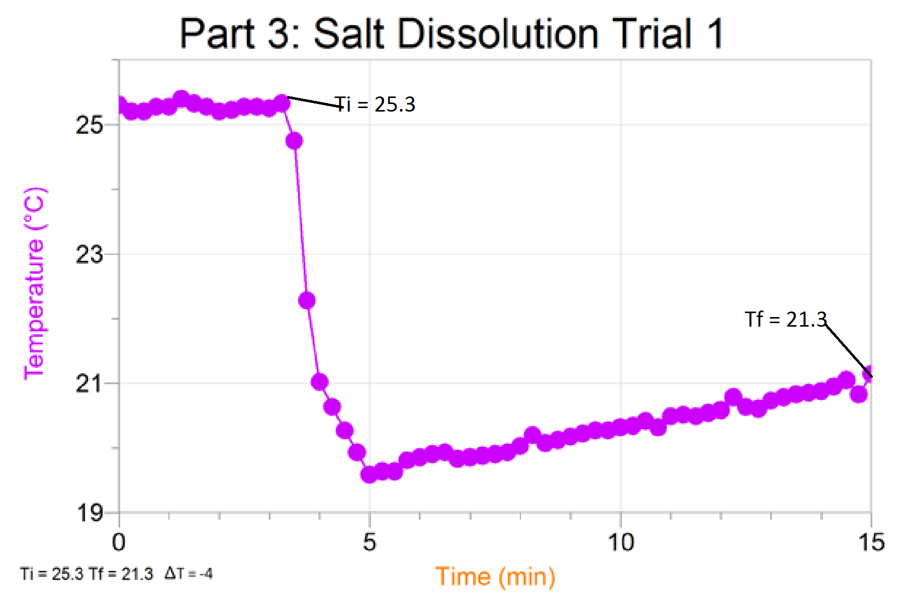
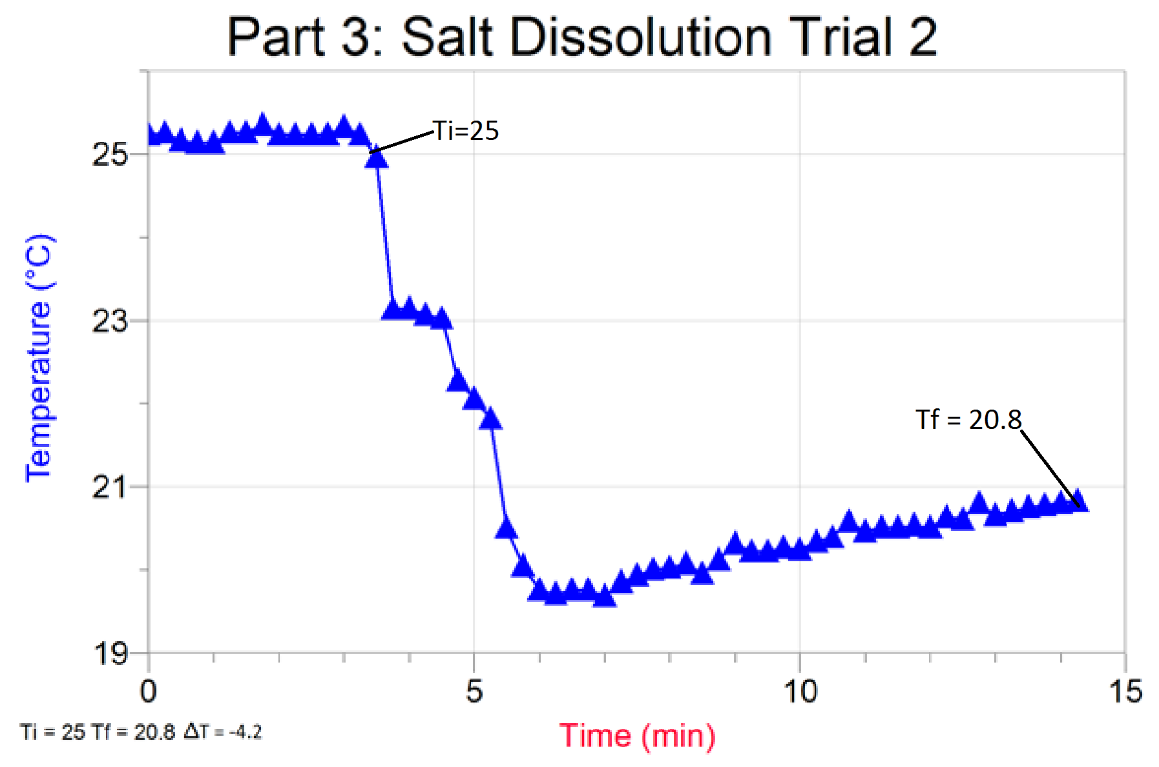

CALCULATIONS:
Part1: Metal
- ΔT_{water} = T_{f} - T_{i}
ΔT_{water} = 27.8ºC – 24.4ºC
ΔT_{water} = 3.4ºC

- Q_{water} = m_{water}*c_{water}* ΔT_{water}
Q_{water} = 19.901g * (4.184 Jg^{-1 o}C⁻¹)* 3.4ºC
Q_{water} = 283.115 J

- ΔT_{metal} = Tf_{metal} -Ti_{metal}
ΔT_{metal} = 27.8ºC -100ºC
ΔT_{metal} = -72.2 ºC

- Qwater = -Qmetal
283.115 J = -12.6358g *c*(-72.2ºC)
283.115J = 912.30430467 c
283.115/912.30430467 = c
C = .310329412 Jg⁻¹ ºC⁻¹

- Mm_{metal} = 25 JMolºC / c
Mm_{metal} = 25 / .310329412
Mm_{metal} = 80.56 g/mol

- %Error = ((value_{actual}-Value_{theoretical}) / Value_{theoritcal} ) *100%
%Error for c = ((.310329412 - .39)/.39) *100%
%Error for c = -20.4283559%

%Error for Mm_{metal} = ((80.560-65.38)/65.38 )*100%
%Error for Mm_{metal} = 23.21810951%

Part2: Enthalpy of neutralization
- ΔT_{solution} = Tf_{solution} -Ti_{solution}
ΔT_{solution} = 31.6ºC – 25.3ºC
ΔT_{solution} = 6.3 ºC

- V_{solution} = V_{acid} + V_{base}
V_{solution} = 40ml +40ml
V_{solution} = 80 ml

- d= m/V
M = dV
M = 1 g/ml(80ml)
M= 80 g

- Q_{neutralization} = - 80.484g *4.184 Jg^{-1 o}C⁻¹ * 3.6ºC
Q_{neutralizaton} = -2121.509668 J

- C = n/L
N_{acid} = C*L
n_{acid} = 1.1mol/L*.04 L
n_{acid} = .044 mol
n_{base} = 1mol/l *.04 mol
N_{base} =.04mol
Limiting Reagent is the base .004 moles of acid is not used

- HCl (aq) + NaOH (aq) NaCl (aq) + H₂O (l)
N_{water} = n_{base}
N_{water} = .04 mol

- Δ_{s}Hº = Q_{neutralization} / n_{substance}
Δ_{s}Hº = -2121.509668 J / .04 mol
Δ_{s}Hº = -53,037.7412 J

- For HNO₃
ΔT_{solution} = Tf_{solution} -Ti_{solution}
ΔT_{solution} = 31.2ºC-24.7ºC
ΔT_{solution} = 6.5 ºC

Q_{neutralization} = - 81.9126g * 4.184 Jg^{-1 o}C⁻¹ * 6.5ºC
Q_{neutralization} = -2227.69507 J

C = n/L
N_{acid} = C*L
n_{acid} = 1.1mol/L*.04 L
n_{acid} = .044 mol
n_{base} = 1mol/l *.04 mol
N_{base} =.04mol
Limiting reagent is base
N_{water} = n _{base}
N_{water} = .04 mol

Δ_{s}Hº = Q_{neutralization} / n_{substance}
Δ_{s}Hº = -2227.69507 j /.04mol
Δ_{s}Hº = -55,692.37673 j/mol

- Δ_{s}Hº_{literatureHCl} = -56.48 KJ [1]
%error_{HCl} = ((value_{actual}-Value_{theoretical}) / Value_{theoritcal} ) *100%
%error_{HCl} = ((-53037.7412 + 56480)/56480)*100%
%error_{HCl} = -6.09465%

Δ_{s}Hº_{literatureHNO3} = -55.8 KJ [2]
%error_{HNO3} = ((-55692.37673 +55,800)/-55800)*100%
%error_{HNO3} = .192873243%

Part 3: Enthalpy of Dissolution of a salt
- ΔT_{solution} = Tf_{solution} -Ti_{solution}
ΔT_{solution} = 21.3ºC -25.3ºC
ΔT_{solution} = -4ºC

- Q_{dissolution} = - m _{solution} *c_{solution} * ΔT_{solution}
Q_{dissoluton} = 21.560g * 3,877 Jg^{-1 o}C⁻¹ *-4ºC
Q_{dissolution} = +334.43002 J

- N=m/Mm
N=1.5650g/(101.11g/mol)
N= .015478192mol
Δ_{s}Hº_{dissolution}= 334.43002J/.015478192mol
Δ_{s}Hº_{dissolution} = 21,606.53001J/mol

- Identity of the salt, derived from molar mass is potassium nitrate
Δ_{s}Hº_{dissolution literature} = 34.89kJ/mol [3]
%error = ((21,606.53001-34890)/34890)*100
%error = -38.0724278%

- Trial 2:
Qtrial 2 = -21.4856g*3.877 Jg^{-1 o}C⁻¹ *-4.2
Qtrial2 = 350.021453J
N=m/mm
N= 1.4956/101.11
N=.01479181 mol
Δ_{s}Hº_{dissolution}= Q/n
Δ_{s}Hº_{dissolution}= 350.021453J/.01479181mol
Δ_{s}Hº_{dissolution}= 23663.19287 J/mol

DISCUSSION:
When the calculations for Trial 1 and Trial 2 were compared for Part 1 (which consisted of dropping a hot metal into cool water, and observing temperature change) the mass of the metal did make a difference in the specific heat capacity (Trial 2 c = .306 Jg-1 oC-1 ) and molar mass of the metal (Trial 2 Mm = 81.70 g/mol). The mass of the metal should not have had any consequence on properties such as the specific heat capacity or the molar mass, as these properties are intrinsic properties and do not change with volume, or mass. This change in intrinsic values may have happened due to an inconsistent amount of thermal energy escaping the system through the calorimeter, as the calorimeter still loses heat, heat may have also been lost when transferring metal from the boiling water to the calorimeter. The effect that loss of heat has on the calculations is that it gives a smaller number for ΔT, which then results in a smaller value specific heat capacity, and a larger value for the molar mass, which in this case seems to be true, and would explain the percent error calculated. The results of trial 1 and trial 2 were consistent with the expectations that the temperature would rise after metal was added, and then would stabilize to a lower value.

When Δ_{s}Hº for trial 1 and trial 2 for the neutralization reaction for HCl and HNO₃ were compared, results varied. The Δ_{s}Hº trial 2 was lower when compared to trial 1, this may be due to the accuracy with which the volume was measured, and due to human error. This difference in mass could have affected results for the both trials as it assumes that the same amount of water is produced for different masses of acid and base. The percent error for the two trials can be explained as volume is the about the same for both trials, but the mass changes, which indicates that the volume of the two trials is slightly different, but not different enough for the human eye to detect. This affects results as the volume used to determine moles of water produced does not match up with the mass of solution used to find out Q_{neutralization} which then gives an inaccurate number for the Δ_{s}Hº.

The Values of Δ_{s}Hº were different for the neutralization reaction between HCl and NaOH, and HNO₃ and NaOH. The value for Δ_{s}Hº of neutralization for HNO₃ was higher than HCl. This result was expected as the literature value for Δ_{s}Hº for neutralization for HNO₃ was higher than the Δ_{s}Hº value for neutralization for HCl.
The mass of the salt did have an effect on the Δ_{s}Hº for dissolution. The mass of the salt should not have affected the Δ_{s}Hº for dissolution as it is an intrinsic value and does not depend on the mass of the salt. The Δ_{s}Hº for trial 2 was higher than trial 1 which is odd as the mass of the salt in trial one is higher. One of the ways this could have happened s human error, which would be dropping some mass of the salt when adding it to the water, or not swirling the solution enough when salt was added to the water, which would then affect the Q value and therefore affect Δ_{s}Hº.

CONCLUSION:
The value of the specific heat capacity for Zinc obtained through the experiment is 310 Jg⁻¹ ºC⁻¹ along with a molar mass of 80.56 g/mol for trial 1. The Value of enthalpy for neutralization obtained through experiment for HCl is -53,037.7412 J and HNO₃ is -55,692.37673 j/mol for trial 1. The value for enthalpy of dissolution for salt C for trial 1 is 21,606.53001J/mol.

REFERENCES:
[1] http://www.nrcresearchpress.com/doi/pdf/10.1139/v56-216 , Canady, Laidler, Pappy, NRC Research Press.
[2] http://www.nrcresearchpress.com/doi/pdf/10.1139/v56-208 , Bidinosti, Biermann, NRC Research Press.
[3]http://sites.chem.colostate.edu/diverdi/all_courses/CRC%20reference%20data/enthalpies%20of%20solution%20of%20electrolytes.pdf , Colorado State University.

