What is the National Municipal Network for Crime Prevention?
- The network fosters a community of practice among Canadian municipalities to reduce and prevent crime and victimization:
- Launched by Institute for Prevention of Crime, University of Ottawa, which set up the network and collaborated on a report on municipal strategies, a status report on strategies in 15 municipalities, and action briefs for municipal stakeholders;
- Currently with 15 municipalities with comprehensive community safety strategies (CCSS).
Series 2 – Tackle Safety Successfully in the City
2.1 Safe Streets discusses effective ways to reduce youth and young adult violence, including violence around gangs. It highlights successful violence reduction in cities in Canada and abroad. It shows specific ways for municipalities to make streets safer.
2.2 Women’s Safety is often overlooked in cities. Municipal action in Canada and abroad has reduced physical and sexual violence against women as well as helped women of all ages feel safer. Municipal stakeholders must make investment decisions for safety that are more sensitive to women.
2. 3 Aboriginal Peoples’ Safety is a daunting challenge because of the intergenerational and acute nature of the risk factors that lead to violence. These problems cannot be solved by more police and imprisonment. The solutions lie in comprehensive actions identified in the other Action Briefs and engagement of Aboriginal leaders in using promising strategies.
2.4 Property Safety shows effective ways to reduce property crime such as theft from and of automobiles, break and enter and so on. It uses the inspiring example of the auto theft

reduction in the province of Manitoba. Cooperative planning using urban design, transportation policy, policing strategy and engaging practitioners are proven ways to succeed.
2.5 Policing for Safety encourages municipalities to use their current police resources more efficiently and effectively to reduce crime. Greater use should be made of best policing practices, identified internationally, including using crime analysis to guide strategies and partnering with social, school and other agencies.
What are effective strategies for Crime Prevention?
Waterloo Region- Crime Prevention Council:
- 40 year plan for community safety and security
- Increase community safety by making crime prevention everyone’s responsibility
- Public awareness campaigns, early education, accessible support services, harnessing specialized knowledge from immigrant communities and post-secondary institutions
Toronto Community Safety Plan:
- Vision for a community characterized by respect, equitable participation, and access to resources.
- Neighbourhoods with high rates of unemployment, illiteracy, and a high proportion of immigrants have been identified as key priority areas
- Balance between the importance of effective law enforcement and violence prevention
Montreal
- Project Tandem
- Collaboration between housing, social development and police
- Regionalized police stations with multi-sectoral representation and citizens
- Youth outreach in high priority areas
City of Edmonton Action Plan
Investing In Children, Youth and Families
- Family and Community Safety Focusing on Schools as Hubs
- A “Turn Away from Gangs” Initiative
- Community Coordination on Fetal Alcohol Spectrum Disorder
Catalyzing Change
- A 24/7 Service Delivery Model for High-Needs Populations
- Cultural Community Groups
6. Neighbourhood Organizing Initiatives
New Leadership
- A New Community Safety Coordinating Council to Integrate Sustainable Community Safety Effort
- A Sustainability Strategy for Prevention
9. An Innovative Evaluation Framework to Measure Success

Winnipeg Block-by-Block Also see Linden
- Within a disadvantaged and high crime 21-block area in the North End of Winnipeg,
- a collaborative strategy involves multiple social agencies and the police to tackle the social risk factors leading to rising crime rates.
- It gets funding from Manitoba with planned and integrated collaboration from City of Winnipeg and Winnipeg Police Services.
- It is built in part around the strategic plan developed by the City of Winnipeg called Live Safe, which was influenced by the uOttawa Ph.D. work of Lisa Monchalin on reducing violence affecting urban aboriginal. peoples.

A Tentative Comparison of Key Characteristics of
Two Types of Local Crime Prevention Strategies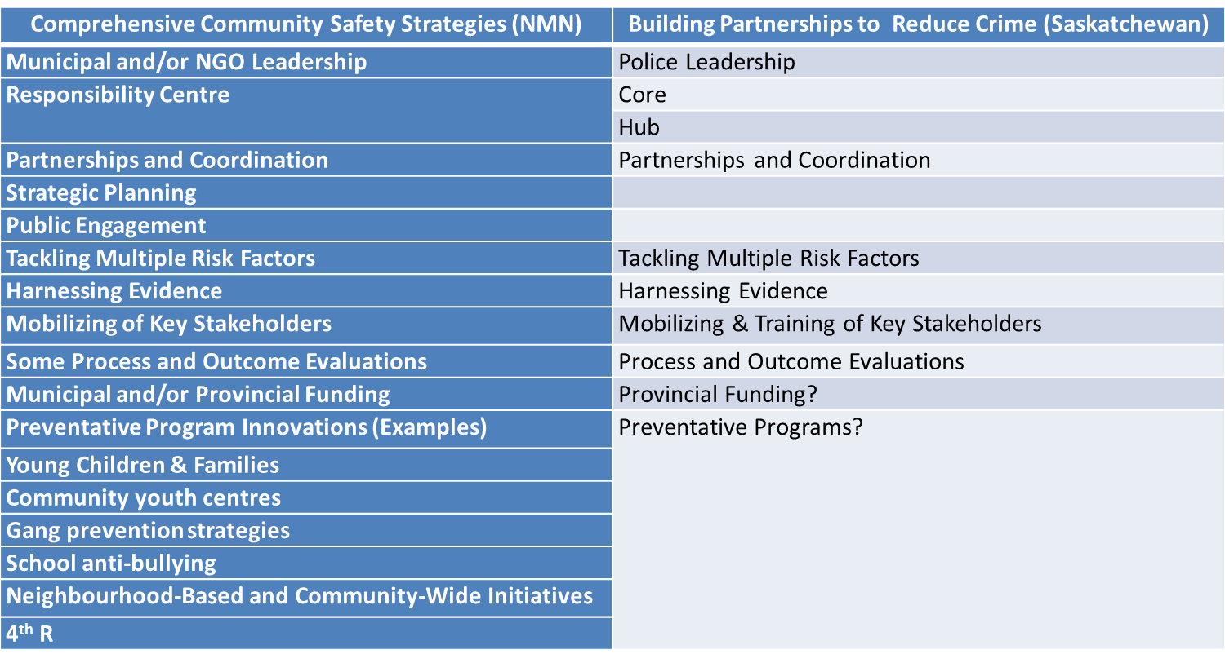

Shared Forward Agenda for Policing and Community Safety
- Public Safety Canada convened a Steering Committee comprised of
  - 3 champion provinces (British Columbia, Saskatchewan and Ontario),
  - 3 national policing associations (Canadian Association of Police Boards, Canadian Association of Chiefs of Police and the Canadian Police Association),
  - the Canadian Police College, the RCMP and an academic expert in policing.
- The framework is oriented around three pillars:
  - efficiencies within police services;
  - new models of community safety; and
  - efficiencies within the justice system.

Pillar 1: Efficiencies within Police Services
- Finding the Right Balance: Civilianization, privatization and tiered policing
- Collective Bargaining and Arbitration in Policing
- The Future of Policing
Pillar II: New Models of Community Safety
- Research, Policing and Crime Reduction
- New Models of Community Safety
Pillar III: Efficiencies within the Justice System
- Smarter Police Reform – Changing the Odds for Success
- Streamlining the Justice System to Reduce the Costs of Policing
Policing Canada in the 21st Century: New Policing for New Challenges
- Some highlights of The Expert Panel on the Future of Canadian Policing Models and reflections from Smarter Crime Control
Council of Canadian Academias
- Successful policing models require police to adapt to, and leverage, the specialized capabilities and resources in the new safety and security web.
- Evidence-based policing and increased professionalization of police would optimize their role in the safety and security web.
- The diversity of actors in the safety and security web creates accountability concerns that have yet to be addressed.
- Governments can serve as enablers of safety and security by ensuring that the safety and security web serves the public interest.
- Knowledge gaps hinder the optimization of the safety and security web.
- External Challenges to Policing
Changing Nature of Crime
- Persistent violent and interpersonal crime
- Concern for Intimate partner and sexual violence
- Traffic deaths greater than homicides
- Increasing a-spatial (e.g., cyber-based crime)
- Evolving threats (e.g., environmental, terrorism)
Changing Demand
- Urbanization of Aboriginal populations
- Incidents involving mental illness
- Rise of victim concerns and drop in reporting
- Changing perspective on illicit drugs
- Aging population
- Changing Knowledge and Technology
Significant knowledge about violence prevention
- Changing relationship between police and public
- Technology reshaping crime and how it is fought
Internal Challenges to Policing
- Accountability
  - Accountability problems persist despite wide ranging structures & efforts to improve them
  - Performance metrics fall short of measuring efficiency & effectiveness
- Human Resources
  - Aging and non-representative workforce
  - Low job satisfaction
  - Lack of necessary specialized skills
Professionalisation Solutions
  - Police efficiencies
  - Two tier policing
- Accreditation of police
  - Allows for professionalization of police
  - Supports skills specialization and new HR models
  - Strengthening applied research and links to police
  - Applied research a foundation for a system of accredited police professionals
  - College of public safety and security
  - Research and development with training and development of standards – inspired by British College of Policing but broader mandate.
Opportunities for the Police System
- These opportunities are for the police system rather than for individual police services and serve to support the ability of police services to pursue the opportunities identified in the previous slide. Accreditation of police and the strengthening of the research system to provide the knowledge base for skills specialization both allow for new HR models for example.
Research & Knowledge
- Data
  - Inadequate crime & victimization data
    - Annual general victimization surveys
    - Annual specialised surveys, particularly intimate partner and sexual violence
  - Data on policing costs
- Knowledge
  - Canada’s policing system
    - Effectiveness in responding to challenges
    - System level efficiency
    - Role clarity
  - How best to interface with & mobilize partners
- The Panel has identified several gaps in research and evidence on a wide range of issues related to its charge.
Data Gaps
- At a basic level, there are insufficient data on the incidence of crime to gain an accurate account of crime trends.
- There is also a lack of data and research on the cost of policing, making it difficult to arrive at a more detailed understanding of the problem.
Knowledge Gaps
- There is a lack of research on the safety and security web as it exists in Canada, and how police can operate effectively and more efficiently within this web environment.
- While much work has been done in Canada on questions of review of police propriety, notably by commissions of inquiry, more work is needed, particularly on the interaction of the multiple accountability systems now in place.
- In addition, research has not yet adequately addressed the sustainability of Canada’s policing system. Little is known about, for example, how the distinctive tripartite system, division of policing responsibilities, and the influential role of the RCMP affects the overall performance of Canada’s policing system.

