What is the National Intimate Partner and Sexual Violence Video
List of Recommendations – For uOttawa
- Create an action team responsible for implementing the Task Force recommendations.
- Demonstrate the university leadership's commitment to preventing sexual violence by having all members of the senior administration participate in awareness training by fall 2015.
  - When looking for change most important actions is to come up with recommendations and a task force.
- Adopt an explicit statement of values to clearly articulate and transmit the University's position regarding respect and equality and integrate this statement of values into Destination 2020.
- Adopt a new sexual violence policy and protocol that addresses the identified shortcomings of policies 67 and 67a.
- Arrange for the delivery of harassment and sexual violence training to a variety of specified groups.
- *Deliver a campus-wide bystander education program in French and English led jointly by students, staff and faculty based on the research-supported Bringing in the Bystander initiative.
- Collaborate with community-based organizations and experts regarding the delivery of support services to survivors of sexual violence and education for the University of Ottawa community.
- *Clarify and publicize the mandate and role of the Human Rights Office.
- *Collect and make public data on the number of harassment, sexual violence and discrimination complaints received by the University annually.
  - Data is a very hallow point, the US has created an amazing set list of surveys
- Mandate a gender audit of Sports Services and sexual violence training for student athletes and full-time coaching staff.
- Fund the development of new undergraduate courses that address sexual violence from an interdisciplinary perspective.
Green Dot
Increase of bystander action, but does not shows inconclusive in reducing sexual violence.
Green Dot implemented in schools. But not Universities.
- Focus on men and women as bystanders to change social norms in a peer culture that supports abusive behaviour
- Addresses participants not as potential victims or offenders but as third parties who have an important role to play and focus shifts to the community
- The central concern of most bystanders is not knowing how to respond
- Bystander intervention programs include role modeling exercises and opportunities to practice building bystanders skills and efficacy

7 Key Actions to Make Universities Smarter On Protection of Students from Sexual Assault.
- Universities must recognize the problem by establishing a Vice President responsible and advisory group from university and city communities
- Measure sexual and intimate partner violence of students (not just on campus) annually and evaluate innovations and attract funding for related research and development
- Privilege admissions who have taken 4th R or equivalent through $50 scholarships to reduce multiple predators
- Help men be part of solution (Men´s Project, Hockey/football and sports teams actions like BC Lions , Yes means Yes, Its on US, Katz TED talk and more)
- Bystander intervention, such as Green Dot,
- Support for survivors – confidential reporting, trained counsellors, and support in getting data to tackle persistent predators
- Use compulsory first year course to address responsibility issues – relationship training (violence prevention both non-violence and no sexual violence), mental health, alcohol and illicit drug use
Centers for Disease Control and Prevention and National Institute of Justice
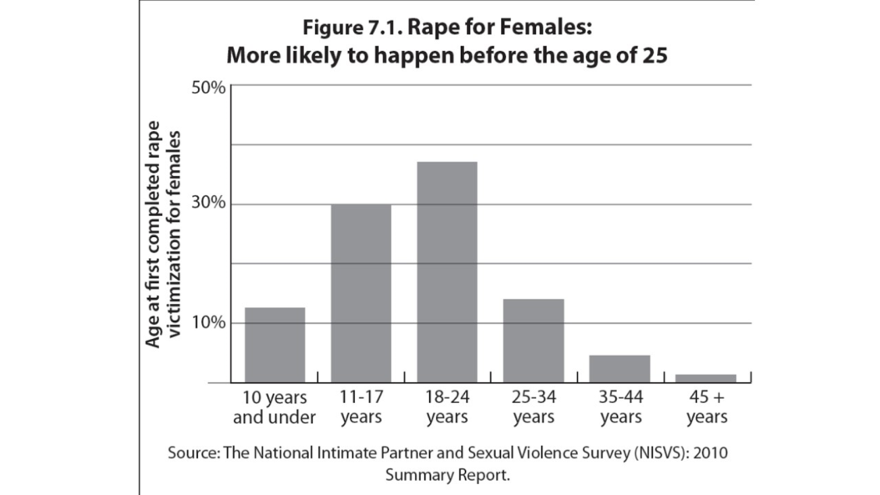
- National Intimate Partner & Sexual Violence Survey US
- Complete interviews were obtained from 16,507 adults
- 9,086 women and 7,421 men
- Nearly 1 in 5 women (18.3%) and 1 in 71 men (1.4%) in the United States have been raped at some time in their lives,
- including completed forced penetration, attempted forced penetration, or alcohol/drug facilitated completed penetration
- More than half (51.1%) of female victims of rape reported being raped by an intimate partner and 40.8% by an acquaintance;
- One in 6 women (16.2%) and 1 in 19 men (5.2%) have experienced stalking victimization at some point during their lifetime in which they felt very fearful or believed that they or someone close to them would be harmed or killed.

Agenda 2030
Goal: to change the world, specific target in eliminating violence against women and girls
67th World Health Assembly adopts historic resolution
"Strengthening the role of the health system in addressing violence, in particular against women and girls, and against children"
- Violence has health-related consequences including death, disability and physical injuries, mental health impacts and sexual and reproductive health consequences, as well as social consequences.
- Health systems are not adequately addressing the problem of violence, yet affirms the health system's role in preventing, responding, and advocating for interventions to combat the social acceptability and tolerance of interpersonal violence.
What Does Not Work – In preventing Sexual Assault
- Educating young women to avoid high-risk situations such as drinking or travelling alone
- Portraying all young men as potential rapists
- Simply providing information about rape myths
- Instructing young people on how to change their behaviour without opportunities to practice new behaviours
What has been Effective
- Change attitudes and beliefs among young people, their peer networks, and the broader community
- Include a gender component and discussions about gender roles and peer pressure
- Provide plenty of opportunities to practice new behaviours
- Provide repeated and sustained messages
- Approach men as allies and invite them to take an active role
- The Bystander approach (Green Dot)
The 4th R
- Reading, wRiting, arithmetic, RELATIONSHIPS
- Implementation in 11/22 schools.
- Changing attitudes and educating students on healthy relationships

Emma Fulu Analysis of the WHO
COP public planning- 2004 document, read it (crime prevention ottawa)

