Cure Violence.org
- Stopping youth from going into gangs in the first place – Interrupt video; does not harm!
- Victim and offender are interchangeable – in shootings, whether they are in gangs or not
- Must Measure outcome – CPO does not do that
- An evidence-based program
- Chicago Evaluation – highlights
  - 84% of people were high risk
  - reductions in shooting to 73%
  - 100% of homicide reduction in 5 of 8 communities
  - Overall the impact of the CeaseFire Program is significant and moderate-to-large in size
- Problem – NOT being used anymore – using reactive policing again and costs have gone up again
- Problem – not spread in Chicago
- Baltimore Evaluation – one of the most violent cities in the world.
  - Reduction in killings of up to 56% and shootings up to 44%
  - Norms on violence were changed – people in program site were much less likely to accept the use of a gun to dispute; 4x more likely to show little or no support for gun use
- Being implemented in Central America and Countries North of the Americas
- One of the reasons why the police are not supportive is due to the use of ex-gang members
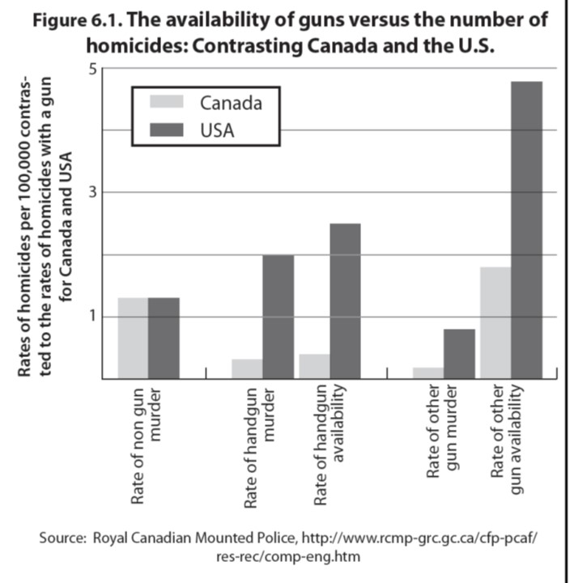
Guns and Gangs
- Gang related homicides approx. 1 in 5
- 20% of all homicides in Canada
- Street gangs use hand gun – caring them for protection
- Every city needs an office which deals with crime and a violence prevention plan
- Need a diagnosis, plan, series of sources (ex:hospital data)
- Investing in mental health services

All of these could be done in Ottawa
NCPC on 6 Safer Cities Volume II
Boston, Denver, Fort Worth, New York, San Diego
- Robust economy, demographics, and hyper-incarceration
- Police Problem Oriented
  - creating community-based offices
  - criminal justice agencies designing service projects for communities
- Youth oriented
  - faith leaders to provide after-school opportunities and to mentor at risk youth
  - Human service agencies partners among law enforcement and community members focus on graffiti, illegal dumping, abandoned properties.
- Coalitions
  - political leaders, law enforcement, government agency managers, business owners, faith-based organizations, and resident leaders together
  - take chances on new strategies, and ask community residents and agencies to join them in sharing responsibility for achieving success
  - repaired the bonds of community cohesion in crime-plagued neighborhoods
- recruited new resources dedicated to prevention priorities
- multi central strategies contribute to reduction
Problem - No partnerships in Ottawa

Strategic actions to reduce youth violence in Boston in 1990´s
- Collaboration between law enforcement (Boston PD, DEA plus), youth street workers, families and Harvard U.
Principles underlying success:
  - Gang members are young people in trouble: they do not want to die; they need help from adults.
  - Adults can begin to help when they work together toward a single, shared goal – keeping kids alive.
  - In the right circumstances, most young people will make good decisions: adults can create those circumstances by providing realistic alternatives to the life of violence in the streets, as well as unpleasant consequences for those who choose violence
- Process was collaborative problem-solving to develop and apply the principles
- Communicate a strong message from families and authorities that gun-related violence will not be tolerated.
- Conduct crackdowns to target gangs that persist in violence.
- Reduce the availability of firearms and disrupt gun markets
- Provide adult education, job training and job opportunities
Results (within 2 years – NB crime rates were dropping in US but over decade):
  - 71% reduction in homicides committed by youth aged 24 and under
  - 70% reduction in gun assaults for all ages (compared to the annual average during the 5 years prior).
Lessons from Boston for Ottawa – reduce the number of young men coming into hospitals who have been shot.
Call-In – call known offenders and let them know you watching them – focus deterrence, give opportunities to get out
What is a Comprehensive Community Safety Strategy (CCSS)
CPO is an example – just not a good one (Ottawa doesn’t do any of these)
- Comprehensive Community Safety Strategy (CCSS) organises sectors such as social services, housing and policing to collaborate on tackling identified risk factors for crime.
- It has reduced crime across cities such as Glasgow by 50% or more within five years.
- Leadership is lacking, doesn’t have diagnosis so no solution, doesn’t plan
It includes:
- Multi-sectoral solutions to diagnosed problems, including Health care (mental health), Addictions services, Child Welfare, Schools, Policing, Housing services, and Academics;
- Leadership to coordinate and implement;
- Planning, significant investment, early wins, capacity development, public engagement and measuring outcomes;
- Targeted social and situational crime prevention, and quality problem oriented policing.
Main Things Missing in Ottawa –
- Plan of Action: have strategic priorities but have no plan for them
- Diagnosis implied you’re gonna do something
- Insufficient funding for their diagnosis
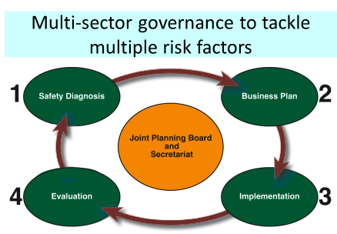

Model with influenced many Canadian Cities

Minneapolis is a CCSS
- Mayor concerned about youth Violence and cost to taxpayers
- Diagnosed the geographic prevalence and risk factors.
- Action to connect
  - youth to mentors
  - Intervene at first signs of risk
  - Reduce recidivism
  - Changing culture of Violence
  - Early intervention
- Established permanent office for Youth Violence Prevention
- Greater than 60% reduction in violence

Glasgow is a Comprehensive Community Safety Strategy (CCSS)
- Chief of Detectives calls for different way
- Recruits public Health epidemiologist
- Diagnoses geographic distribution of perpetrators and victims, their developmental history, the context of the Violence (weapons, alcohol, time ….)
- Mobilises agencies
- Early childhood – parent training, preschool stuff
- Hospital emergency – when the victim came in they would help them through and convince them to change their ways, ask how they got there and try to change the after
- Youth inclusion – 50% reductions
- Call ins
- Stop knife carrying – into the central entertainment districts,
- Measure outcomes – focused on stopping violence
  - People believed incredible strongly for change

Key Points for Smarter Prevention of Gun Violence
Legislators must
- invest now in the social agencies that are able to assist young men in problem places to choose a lifestyle free from handguns, including support legislation such as PROMISE, and encourage interventions following emergency department admissions;
- encourage cities to take a leadership role in “public health” strategies that reduce inner-city violence;
- encourage law enforcement to use smart, proven policing tactics but in sustained combination with the social agencies that can be targeted to problem places and neighborhoods;
- support the work of networks, such as the National League of Cities and UNITY, to share and implement best practices for comprehensive, evidence-based gun violence prevention.
  - The Department of Justice should add a section on its crimesolutions.gov website on gun violence that includes examples such as Minneapolis and Glasgow (which can never be random control trials but that logically are saving large numbers of lives).
  - Advocacy groups should extend their criticism of mass incarceration and the war on drugs as being racially biased to include criticism of the lack of prevention to save the lives of young black men getting shot.
  - State legislators should enact legislation in the five areas proposed by the Brady Center, which has been adopted by other states and is shown to correlate with fewer gun deaths.
  - Legislators should look for ways of reducing the numbers of guns, particularly handguns.

