Public Safety Reinvestment and Cost Effectiveness
Ontario Framework – Cost Effectiveness of Crime Prevention
- The overall financial and social costs of crime are increasingly important for society and government and it places a large financial burden on Ontarians.
- There are both tangible and intangible costs associated with crime:
    - Tangible costs can be assigned a financial value and include medical, mental health, criminal justice, victim services, protective services costs and the value of stolen or damaged property.
    - Intangible, or non-monetary costs, are more difficult to measure and include pain and suffering, fear of crime, hindering economic development and lost quality of life.
- A study released in 2009 showed that for an average municipality of 900,000 people, the estimated annual costs of crime to victims and the public is more than $1.3 billion.
Gaps
- No real funding, or capacity development – keys to implementation
- No mention of Life Skills or YIP – two programs which work and aren’t mentioned.
- No program that has been proven to work is mentioned
- No reference to crimesolutions.gov or popcenter.org
Extensive research shows that crime prevention programs have proven to have significant returns on investment and are a cost-effective manner in which to address crime.
    - For every dollar invested now in crime prevention and early intervention avoids seven dollars spent on incarceration, victim services and other associated costs in the future.
    - Another study found that one dollar allocated for enriched child care saves seventeen dollars in criminal justice costs in the future.
    - Thorough economic evaluation has shown that preventing just one career criminal can save society over $2 million.
  - Reduce harm to victims
  - If you reduce the crime rates you reduce need for policing
It is fiscally responsible to work collaboratively and allocate resources in a balanced manner to target the risk factors of crime

(Reference in midterm)
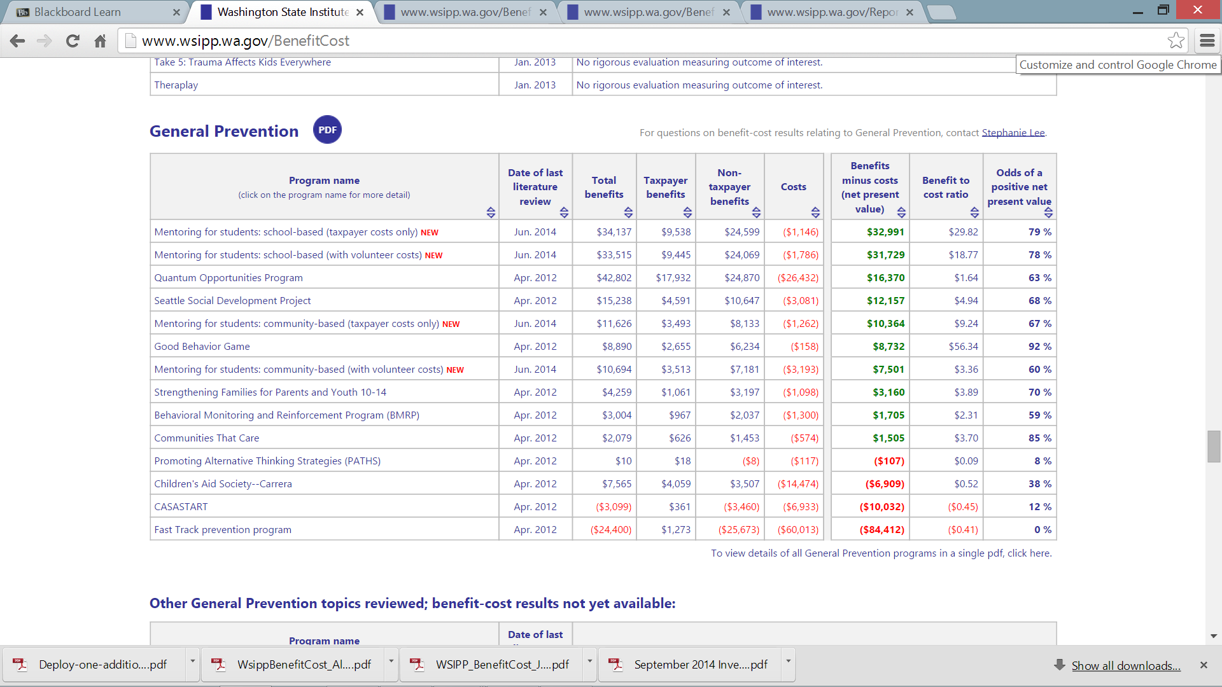
- create a budget of what you can do

Extracts From Drummond Report
- The government must constantly benchmark its effectiveness and efficiency against the private sector and against the best public services in the world. It must be prepared to shed old priorities (and offend their advocates) and set new priorities (which often have no advocates) as they arise.
- Accordingly, we recommend the following annual changes in program spending out to 2017–18: · Health care — plus 2.5 per cent; · Education — plus 1.0 per cent; · Post-secondary education (excluding training) — plus 1.5 per cent; · Social programs — plus 0.5 per cent; and · All other programs — minus 2.4 per cent.
- The spending reduction targets proposed in Chap. 1, The Need for Strong Fiscal Action, to get Ontario back to balance by 2017–18 illustrate that the sector needs to transform its service delivery and find efficiencies to meet its spending targets, while ensuring public confidence in the system and meeting the criminal justice system’s standards.
- Several of the Commission’s recommendations should assist the sector in reaching those objectives. Commission Principles and Goals for the Justice Sector Evidence-Based Data Collection Recommendation 14-1: Improve evidence-based data collection in the justice sector to achieve better outcomes in sector programs.
Drummond Report – Justice Sector page
2010-11 Spending
- Annual growth in spending, 2001-02 to 2010-11 SLIDE 9

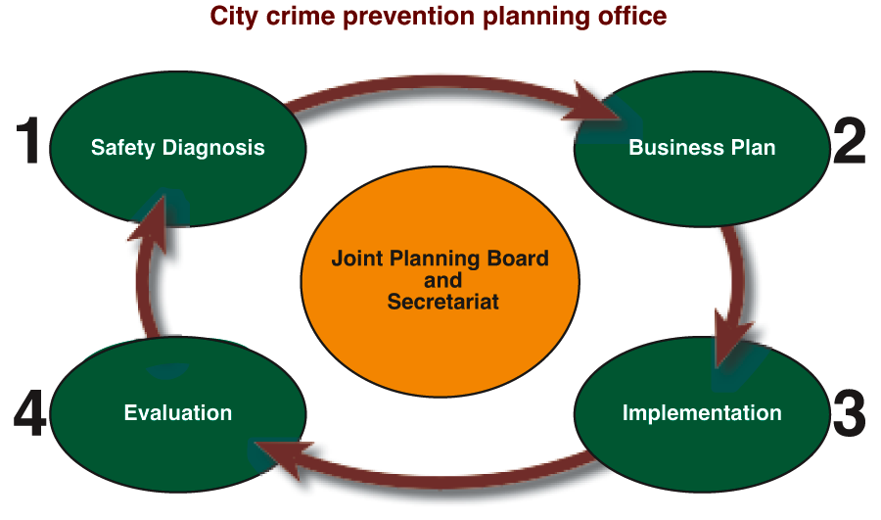
Horner Committee 1993 – Recommendation 1
The federal government, in cooperation with the provinces and municipalities, take on a national leadership role in crime prevention and develop a national crime prevention policy. The policy should set out the following principles and initiatives:
- Crime prevention will be included in the mandates of federal departments and agencies responsible for criminal justice, policing, immigration, housing, and social and economic development;
- All levels of government are responsible for crime and they must work together to prevent it's occurrence;
- Crime occurs in communities and priorities concerning crime prevention are best determined at the local level;
- The primary approach taken to prevent crime and create safer communities entails a coordinated, multidisciplinary effort to address the root causes of crime; and
- Prevention measures include law enforcement, community-based policing, social development and reduction of criminal opportunities. (Page 22)
Recommendation 2 – need a counsel / responsibility center
The federal government, in consultation with the provinces and territories and the Federation of Canadian Municipalities, support the development of a national crime prevention council. The council's mandate should deal mainly with issues of reducing crime. Specifically, it should:
- promote community safety;
- provide the federal government with advice and participate in policy development on matters related to safer communities;
- gather, analyze and disseminate knowledge about crime, crime trends and crime prevention;
- provide training, research, evaluation and public education on the prevention of crime;
- provide funding assistance to local governments and community organizations to implement community safety initiatives; and
- include membership from federal, provincial and municipal governments, and professionals and practitioners involved in crime prevention, health, social services, housing and education. (Page 23)
Recommendation 3.4.7 – Funding
- A share of the monies forfeited as proceeds of crime be allocated to crime prevention activities and that the federal government allocate 1 % a year of the current federal budget for police, courts and corrections to crime prevention over a five year period. At the end of five years, Canada should spend 5% of the current federal criminal justice budget on crime prevention. (Page 24)
- The Department of justice maintain its role as the Department responsible for crime prevention and that it appoint a senior official responsible for crime prevention policy and program development. (Page 25)
- The federal government expand Statistics Canada's program of victimization surveys to allow for the analysis of trends in crime victimizations at regular intervals and to allow for population samples sufficiently large to capture the experiences of important sub-groups of the Canadian population. The information collected from the victimizations surveys should be used to support the research agenda of the proposed national crime prevention centre. (Page 28)
(midterm use 500 million – not a lot, contrast and compare how much creating jails costs to create and maintain)
- Crime prevention to happen – need a deputy minister

