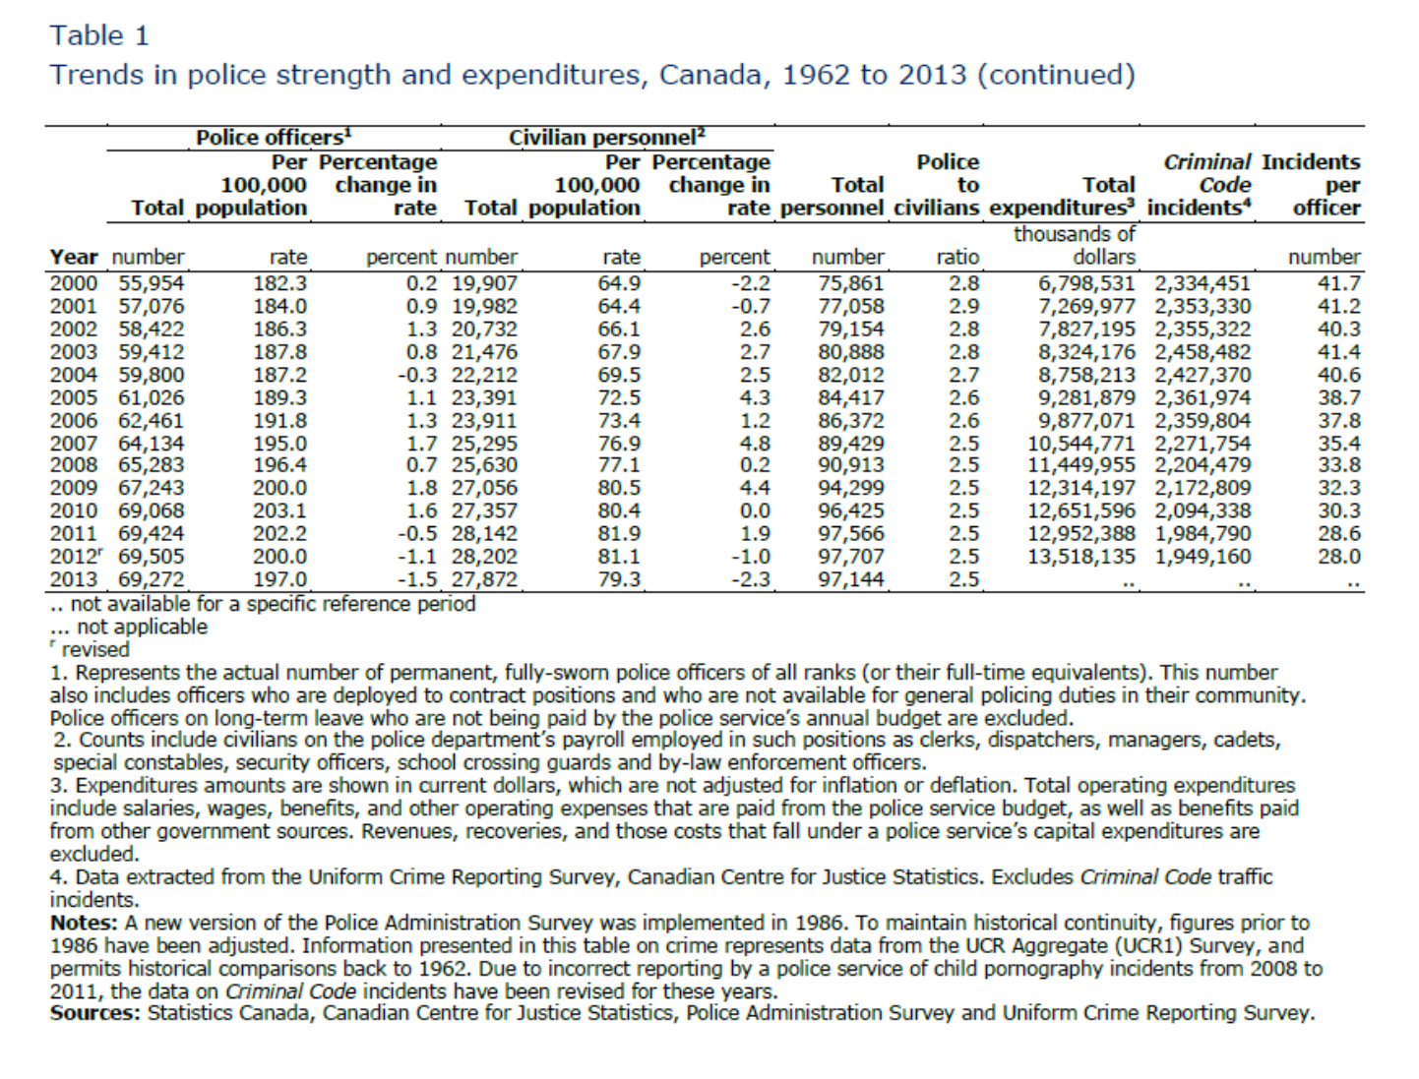
SOME STATISTICS

Proportion of adult Canadians who reported their victimization to police was
- 42% in 1993
- 37% in 1999
- 34% in 2004
- 31% in 2009
Community Policing vs Problem Oriented Policing
Beating Crime
- The first thematic inspection on the effectiveness of the police
- Chaired by John Stevens
  - Previously chief of police for Northumbria (see 100 programs, p. 133)
  - Later Commissioner of Scotland Yard (Metropolitan Police, London, England)
  - Just before the Act on (the reduction of) Crime and Disorder
Findings of Beating Crime
- Few police activities reduce crime
- Proof rarely exists for what succeeded
- Potential big for police to reduce crime by
- More strategic approaches
- Work in partnership
Community Policing
A concept that is fashionable but loosely defined and so may include
- Problem oriented policing
- Preventive policing
- Community police stations
- Neighborhood policing
- Foot patrol (also on bicycles, skates, four wheelers…)
- Public relations
- Victim assistance
Chicago’s Alternative Policing Startegy (CAPS)
Three main components:
  - Organizational decentralization: smaller districts & beats for accountability
  - Local problem-solving with crime data and community involvement
    - monthly meetings; projects; civilian outreach staff; court advocacy
  - City program with interagency coordination (ex: service blitzes)
Impacts: 5 pilot districts after 18 months
- Public confidence in police better for ethnic minorities
- Reduced car theft, street crime, gangs & drugs, decay, graffiti
Overall 1993-2002:
- Fear of crime down 20% among highest fear groups
- Recorded robbery down 58%, larger than other US cities
- Large improvements in disorder for African Americans
High Crime Neighbourhoods – CAPS
- Push the authority and accountability of the police down to the neighbourhood level
- Beat Teams to do local problem-solving using neighbourhood crime data and community involvement.
- Ensure interagency coordination by making it the “city’s program”, not a “police program”.
Impacts:
- The fear of crime down by 20% among groups most fearful of crime and victimization (ex: women and the elderly).
- Robbery recorded by police dropped by 58%, a reduction that is larger than in any other US city during that time.
- Reductions in other crimes, but not significantly different from reductions in other US cities.
Some Dominant Theories
Examples of Situational Risk Factors
Community guardian
- Lack of collective efficacy/guardianship
- Residences empty during day
- Lack of casual surveillance
Involvement with offenders
- Location near potential offenders
- Persons living with violence
- Previous victimization
Facilitators
- Easily transportable and cashable objects
- Excessive use of alcohol and other drugs
- Availability of knives, handguns and longguns
Development of POP and Situational Crime Prevention
- Eyes on the street - Jane Jacobs - 1961
- Steering wheel locks, Germany
- Defensible Space – Oscar Newman – 1972
- Firearm regulations, 1978, Canada
- Crime prevention through environmental design (CPTED) – Ray Jeffery - 1971
- Code for new housing, The Netherlands
- Problem oriented policing (POP) – Herman Goldstein – 1979
- Situational crime prevention – Ron Clarke – 1992
Deterrence Theory
- Similar to Beccaria which dominates our current retributive system
  - Punishment that is proportionate and certain
- Durlauf and Nagin review
  - Driving behaviour changed
  - Police strikes lead to looting and robberies
  - Minimum and severe penalties do not deter
  - Hot spots policing does
  - Individualised deterrence does
    - Boston, Winnipeg… Project Safe Neighborhood, combined with social better
    - Project Hope
Dominant Exemples
DIRECTIONS ON HOW TO INSTALL A SOUTHERN HOME SECURITY SYSTEM?!
1. Go to Goodwill and buy a pair of size 14 -16 men's work boots.
2. Place them on your front porch, along with a copy of Guns & Ammo Magazine.
3. Put four giant dog dishes next to the boots and magazines.
4. Leave a note on your door that reads......
- Bubba, Bertha, Duke, Slim & I went for more ammo and beer. Be back in an hour. Don't mess with the pit bulls. They got the mailman this morning and messed him up bad. I don't think Killer took part, but it was hard to tell from all the blood. Anyway, I locked all four of 'em in the house. Better wait outside. Be right back. Thanks Cooter
Proven Strategies for Reducing Crime; Seattle (1972-76)
Residential burglary - Cocoon Pro-active Neighbourhood Watch (not organised by police)
  - Mayor established Law and Justice Planning Office (LJPO)
  - LJPO analysed crime, victimization and public opinion data
  - LJPO presented plan to City council who approved priorities on burglaries, sexual assaults, and store robberies
  - LJPO analyzed risk factors causing each priority
  - LJPO implemented preventive solutions and evaluated success
  - Outcomes were large reductions in burglary (50% plus - RCT), sexual assault crisis centers, increased robbery arrests.
Proven Strategies: POP – Partnerships Local Government: Seattle
- Mayor established Law and Justice Planning Office
- Analysis
- analysed crime, victimization and public opinion data
- presented plan to City council who approved priorities on burglaries, sexual assaults, and store robberies
- analyzed risk factors causing each priority
- Plan
- implemented preventive solutions for each
- Solution
- Burglary targeted by paid workers
- Lived-in look plus, neighbhours supporting …
- Outcomes were scientifically evaluated
- large reductions (50% plus in RCT)
Seattle Risk Factors and Solutions
Risk factors vs Solutions
Did not lock door dead bolt locks
Stolen goods not marked goods engraved
Did not intervene social cohesion
House did not look lived in make house look lived in.
Problem Oriented Partnership England – Kirholt (1986-1990?)
- Analysis of burglary problem by academic, police, probation, municipal team
- Plan
  - focus on repeat residential burglary
- Solution
  - Gather neighbours to watch out for property
  - Remove known targets and improve physical security
  - Work with social/probation services to help high-risk offenders access services and positive opportunities
- Results
  - 58% reduction in burglary in first year
  - 75% over four years
  - 80% drop in repeat victimizations over 4 years
Proven Strategies: Kirholt (1986-88)
Repeat residential burglary
Multi-sector Cocoon Neighbourhood Watch
- Strong local partnership between police and other partners
- Main contribution was – repeat to victimization; certain res get broken into much more than others, now you have a general program to protect residences in higher crime areas, and then look at the ones who have already been broken into
  - Created a program to reduce the rates of vics (like Seattle)
  - Had a special program from people who had 3x the break in (windows, doors higher quality, and alarm systems etc.)
- Gather neighbours and encourage to watch out for property
- Remove known targets and improve physical security of area
- Work with social/probation services to help high-risk offenders access services and positive opportunities
What gets measured gets done
- Impacts: Kirkholt (Rochdale, UK):
      - 58% reduction in burglary in first year; 75% over four years
      - 80.5% drop in repeat victimizations over 4 years
- St-Henri (Montréal, QC):
      - 41% reduction in burglary after one year
Evaluation of Neighborhood Watch (Ottawa) Recommendations (Muller-Chang, M. Ca) **
- Develop strategies for safety diagnosis – to improve the knowledge of the causes and help key partners to acknowledge assets and resources to tackle the problem.
- Establish relationships with key partners victims service support… Probation services
- Improve the quality of components - higher participation in NW meetings, newsletters, Home Security Inspection and Operation Identification. Paid community workers who assume the role as crime prevention.
- Conduct an evidence-based evaluation –it should include the following: victimization surveys, displacement, follow up study, random control trials, regression analysis, and a comparison group.
Seattle Model*
- 3 crime problems; B&E’s had a committee to figure out the risk factors situational factors, hired people to coach the problem places to reduce crime
- Crime rates went down in B&E’s and Robberies – measured the reduction in victimization survey.
- Looked for displacement; and collected data before and afterwards
- Random control trial
- Important because it was separate from the police
Tandom – Montreal – not as well done as Seattle

