Module 1: Introduction September 14th 2015

Most victims want restitution for the crime not jail – something back or person stopped rarely prison.
“KNOW DO” – the gap the reason we can’t do it is the reactive system in Canada, in reacting we do somethings. Reactive system general deterrence, it does work incapacitation works ‘speeding tickets’
Incapacitation works to reduce crime b/c they are locked away can’t commit more crime but – it’s very expensive.
crimesolutions.gov
Dominant Public Policy To Respond to Crime is Law and Order
- a system of criminal law and procedure
  - Mainly reactive (+ possible deterrence and incapacitation) and guided by 911 and proactive vs drugs and driving
  - Applied by law enforcement officers in cars, judges and lawyers working in halls and/or criminal courts and a system of corrections
  - Professionalized in most affluent countries – not so much in others.
  - Private security bigger and still growing
- end result is
  - Some reduction in inter-personal crime
  - 11 million persons behind bars across the world – about a quarter on pre-trial detention
  - In the USA, taxpayers spend $270 billion a year for one million law enforcement officers (800k sworn) and 2.3 million persons behind bars – 20% of those incarcerated worldwide - $450 billion plus in harm to victims.
  - In Canada, taxpayers spend $20 billion a year for 70,000 police and 37,000 prisoners (fed 15K, prov 12K remand, 10Ksen - excessive numbers on remand) and $83 billion in harm to victims of crime.
  - 100,000 is average number of people incarcerated in an advance nation

After an Accumulation of 50 years of Criminological Research
- We know significant amounts about what
  - causes interpersonal violence
  - is effective in reducing it
  - is costly and ineffective in responding to it
- Much of this knowledge is
  - Endorsed by prestigious, governmental and inter governmental organizations who republish it
  - Easily available on the internet.
- This knowledge is not
  - Translated into actionable recommendations
  - Widely used to reduce violence or avoid waste of lives and taxes
  - Longitudinal studies – causes of interpersonal violence.
  - Ferringtion started a study 1000 under prevailed kids in London England – when do problems start (age) where they popular? How did they do in school?
  - Still following them to date. Gives us data to pre-courses of people becoming offenders. It correlates to what we have learned – child abuse, drinking early, dropping outta high school, being poor etc.
  - What is effective in reducing it – programs that are designed to reduce child abuse – public health workers going out to help mothers. (4th R)
  - 4th R – took 22 schools surveyed boys and girls grd 9-11 – involvement in sexual violence/victims of sexual violence. In 11 of school implemented a program about what is sexual violence, consence, year later surveyed the schools again and the stats dropped of being victims/engaging in sexual violence.
    - The Fourth R is an evidence-based program that uses best practice approaches to target multiple forms of violence, including bullying, dating violence, peer violence, and group violence. By building healthy school environments we provide opportunities to engage students in developing healthy relationships and decision-making to provide a solid foundation for their learning experiences. Increasing youth relationship skills and targeting risk behaviour with a harm reduction approach empowers adolescents to make healthier decisions about relationships, substance use, and sexual behaviour. (4th R website)
  - Pre-school programs – every 1$ invested – return of 7$ (its actually $17)- program as this help
  - Knowledge endorsed by – the US dept of Justice, if they say knowledge is the following works they’ve done well.
  - The WHO will tell us they can reduce violence – it’s a reliable source. Canadian gov republished it.

September 21st
Minister of Public Safety
Royal Canadian Mounted Police
Corrections Service of Canada
Canada Border Services Agency
Canadian Security Intelligence Service
National Parole Board
Department of PSC
Correctional Investigattor
RCMP External Review …

- National crime prevention Centre – doesn’t get put in any section under the Ministry
- 15 000 CSC
- 25 000 RCMP
- Very large ministry
- Nothing on crime prevention in the ministry of Public Safety – mainly ALL law enforcement.

What the ministry of Public Safety actually does – 2 themes
- Policing and Community Safety Research
  - Important because they think they’re talking about policing but the future needs to embrace community safety.
  - Started adding community safety because it’s driving by the economics of policing cost of policing has gone from 6 billion to 13.5 billion.
  - Public Safety had major summits to have a look of how to control costs of police in Canada
    - Freeze budget
    - Freeze hiring
    - And or – reduce demand for policing
  - PSC – looking at how to reduce the demand of policing
- Launched a Canadian Policing Catalogue – research done in Canada major limit is that we don’t do much research in Canada – we do nothing compared to any advanced nation.

- National Crime Prevention Centre (also in PSC) – spends 60 million a year – largest fund for applying criminology in Canada – significant crime prevention in Canada, not new research, testing programs that work, 7.5 million over 5 years / 1.5 million a year to re-test programs that have worked ( like 4R )
- Crime Prevention Ottawa – out of their budget have trained people for 4th R – but at some point how do you know it’s working in Ottawa? How do we know that teachers are even using 4th R?
- How many people can you employ with 1.5 million? = 30 people for $50 000 salary. Problem – only for specific programs – must apply for this ‘grant’ may need to wait 3-5 years.
- Harper Gov – $75 million for crime prevention, more than any gov in the past – cut the budget after 2 years because the money wasn’t being spent.
- National Crime Prevention Centre has the National Crime Prevention Strategy – but it isn’t very effective in implementing programs

- Minister of Community Safety in Ontario – Naqvi also MPP of Centre Town

One Ministry worries about courts, judges < – >other one worry about prisons and community safety
Yasir Naqvi – Minister of Community Safety & Corrections
- Aug. 13, 2015 –Province Developing a New Strategy for a Safer Ontario - Ontario to Modernize the Delivery of Community Safety
- Crime Prevention in Ontario: A Framework for Action (2012)
- Community Safety and Well-Being in Ontario: Booklet 2 - A Snapshot of Local Voices (2015)
- No money / not committed to measuring outcomes and hasn’t set up a national crime prevention board.
  - Issue is always – implementation – it requires money – significant money
  - We can slow down need for police and also relieve the overcrowded jails, choices creating 1500/1000 cell prisons or go more into crime prevention
  - 100 million to create a 1k jail – plus guards = mo money
- Second thing – what gets measured gets done
  - Best way to measure is through – Victimization Surveys
  - Problem – we only do it every 5 years
  - Need to do city survey’s – any major city of 500 000 pop.
  - Measure outcomes – aim to reduce the amount of violence
  - Identify many characteristic of victims – age, gender, income – ask questions of what they do at night – lock house/cars/go out/ where they go out etc.
  - ONE BIG Limitation of Victims Survey – not good on violence against women – can do a survey on violence against women. Like US centre of disease control centers – to see whether what we are doing is changing anything.
- Ontario Crime Prevention Board – want a responsibly centre – senior level of gov who looks at the surveys and can move things forward in prevention

(the two booklets do not say anything about the 3 things in them)
The Ministry of Community Safety and Correctional Services is committed to ensuring that Ontario's communities are supported and protected by law enforcement and public safety systems that are safe, secure, effective, efficient and accountable. The ministry's responsibilities fall into the following categories:
- Correctional Services
  - establishes, maintains, operates and monitors Ontario's adult correctional institutions and probation and parole offices
  - has jurisdiction over adult offenders under parole supervision, as granted by the Ontario Parole Board, and provides programs and facilities designed to assist in offender rehabilitation.

- Public Safety and Security
  - maintains the physical and economic security of Ontario, by coordinating public safety initiatives among municipal, fire and emergency services organizations within and outside of Ontario, and
  - Delivers programs and fosters partnerships to minimize or eliminate hazards to persons or property through public education initiatives, emergency measures, scientific investigations, coordination of fire safety services and the coroner's system.
- Policing Services
  - Oversees policing services throughout Ontario, including the OPP, and licenses, regulates and investigates the activities of private investigation and security agencies/individuals in Ontario.

Canadian Public Commision and Trudeau
- Archambault/Fauteux 1938/1956
  - Humanitarian and Rehabilitative ideal
  - No criminology without them – shift from 18th century crime thinking to today
- Ouimet 1969
  - Use of criminology to expand probation and parole
- Hugessen 1972
  - Parole and sentencing compromise between due process, rehabilitation and quantitative criminology
- Trudeau Era – Golden Age in Criminology
  - Abolition of death penalty, gun control, invest in criminological research and statistics, preventive policing, diversion
- Horner Parliamentary Committee 1993
  - National Crime Prevention Council, 5% of CJS $$, all orders of government
  - Right wing – believe in death penalty, multi-millionaire
  - If incarceration stopped crime – US would be the safest country in the world
  - Basically recommended 5 things
    - 5% of what we are spending on cops/courts – to prevention
      - Harper put it to 2% to prevention
    - Talked about victimization surveys every year
    - 2 things Federally
      - National Crime Prevention Counsel
      - Top Public Servant who know who they are doing to run it
    - National Plan – noting provincially let alone municipally
Government Reports
These strategies based on current knowledge are consistent with Canadian reports and innovations as well as public opinion
Saskatchewan Building Partnerships for Crime Reduction, 2013 -
- Ontario Crime Prevention Framework, 2011
- National Crime Prevention Centre, 2008 –
- Alberta Crime Reduction Task Force, 2007 – over a billion spent
National Crime Prevention Council, 1996
Parliamentary Reports, 1993/1997 - Horner
- Quebec Crime Prevention Policy, 1993, 2001
- United Nations Guidelines on Crime Prevention, 1996, 2002 (Canadian government initiative)
- Non-government Reports
- CACP and 40 member coalition 2004-
- FCM 1991-
- CCSD 1983- , CPHA 2007 –
  - McFee – wants HUBS and CORE
  - Merit – Ottawa version of the HUB – after the fact triage system, call 911
  - HUB principle – this man is acting crazy I take them to a mental health hospital
  - Someone is drunk and goes LCBO and steals more booze – police takes her to centre who deals with centre for women – or a rehab place

- The McFee – CORE Idea - Centre of Responsibility – this course – looks for at HUB cases and see there isn’t money.

- What it’s doing is planning how to avoid – mentally ill people, drunk, homeless cases
Evidence Based – uses numbers- self report offending – victims – using data to measure – random control trial.
- What is evidence based policy and criminological evidence?
- Uses results from scientific research and evaluations (random control trials and other) of what has reduced
  - Crime and victimization
  - Impact of crime and
  - Fear of crime
- Is based on relevant and reliable data
  - such as police data (with caution) and victimization surveys (not feel good, guess, opinion or populism) and self-report and …
- Evaluates both standard and innovative policy in terms of outcomes
  - such as rates of victimization, surveys of youth offending, costs to different government sectors and benefits to taxpayers (as well as processes such as arrests or meetings)
- Evidence based goes hand in hand with Evaluations
  - If we are trying to say – if we increase police or a prison term increase in CAN doesn’t work – we have no evidence for it.
- To justify spending the money – we need to evaluate if what we are spending on works.
- Secondary Prevention – targeting a certain group
- 4th R in Ottawa – illustrates 2 things about prevention
  - We don’t know if its implemented
  - If it was implemented – do we have evidence that it made a difference (surveys)
- Hospital Emergency Rooms – give us info on injuries – ask them for data so you know about how many people come with inmate violence partner’s violence or whatever.
- Calls For Service – range of priority calls, what is a priority call in Ottawa is different than TO, etc. etc.
- Crime Recorded By the Police – what gets measured gets done BUT what gets measured get focus.

Evaluations Were Scientific Studies of Outcome
- Comparisons of outcomes following
  - those who experienced a ¨prevention¨ program tackling risk factors (remedy for negative life experience)
  - With those who experienced the ¨standard¨ system of police, courts and corrections and ¨standard¨ social welfare and education programs
- Many experiments using ¨Random Control Trials¨
- Many using long term follow-up studies (longitudinal cohorts)
- Some using cost-benefit analyses
- Example:
  - Q1: Did we stop ‘stabbings’ through this program versus the standard?
  - Are we doing better than the current system
  - Q2: is the cost of this program less than the traditional system
  - Comparing the 2

CrimeSolutions.gov
- many projects have demonstrated that prevention which tackles the roots of violence reduces violence
- prevention is indeed the ounce that is worth the pound of cure
- Prevention that focuses on social risk factors not only avoids violence but benefits the individuals in a broader way
- Green check mark – promising
- Yellow – promising
- Red – not effective
  - 4th R – promising, no replications – NEED replications

The WHO treats violence like an epidemic – treats it with data and say we know how to reduce it.
- Focusing on early childhood
- Youth
- Guns and knives
- Changing male attitudes in terms of sexual violence

Sherman – most important person in Criminology
- Top Criminology school – Cambridge
- Random Control Experience – on Policing
- 1996 – Report – “What Works, What Doesn’t, What’s Promising”
- In 2011 – Lori Robinson took the things what Sherman did and updated it to 2011 and put it online.
- Approx. 400 projects of evaluations if projects work. Projects must be replicated
MODULE 2 : Crime Trends, Costs, Sources of Knowledge September 21st 2015
Too Many Victims of Crime with Unacceptable Costs & Consequences
On average, each year in a Canadian municipality of 1,000,000 persons
GSS, Victimization Surveys, Stats Canada – does these surveys
- In Stats Canada survey 2004 – 2009 – it hasn’t shifted gone up a small percentage
- The combination of all interpersonal crime will cause victims pain, suffering and loss equivalent to $2.5 billion, including;
  - 60,000 adults will be victims of assault
  - 16,000 victims of sexual assault, and
  - 18,000 victims of thefts from or of cars;
  - 10 homicide, 60 traffic fatalities (2 DWI)
- Ottawa has less than 10 homicides in a year – not always clear if it was a suicide
- Hard to estimate DD deaths – more people are killed by criminal acts on the road than homicides (dangerous driving, road rage etc.)

- Out of local taxes, police services will cost $250 million (and rising) in Ottawa 2008 data – $290 – $300 billion
- Out of federal and provincial taxes, policing will cost $100 million and correctional services will cost $180 million (and rising).
- Fewer than 1 in 3 will call the police; fewer than 3% will have ¨their¨ offender convicted

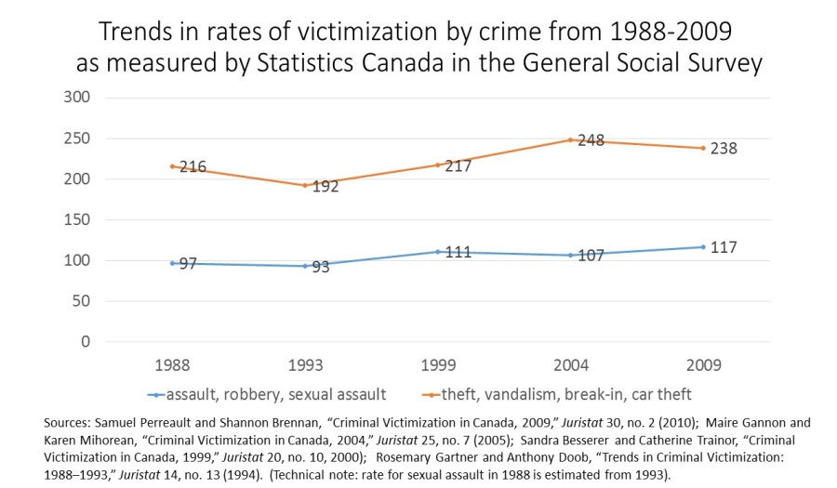
Important Right for Victims of Crime is Effective Violence Prevention – Rates of Violence Steady, Human Costs Huge
- 1 in 4 Canadians were the victims of at least one crime;
- nearly half a million
  - women were sexually assaulted;
  - households experienced a break-in or an attempted break-in; and
  - Households experienced a motor vehicle theft or theft of vehicle parts.
  - 20% increase in crimes in the 90’s steady since
  - Stats Can doesn’t produce user friendly data.
  - Crime goes up 20% so does cost for the Criminal Justice System
  - Spending more on crime doesn’t decrease crime.
  - Red- police reported crime dropped extremely
StatsCan survey of crime victimizations/ 100,000
  - Victims rates
are stedy

Taxes go to -
42% provinces
8% municipalities
50% federal

External Challenges to Policing
- Continuing Interpersonal crime but new types of crime
  - Persistent violent and interpersonal crime
  - Concern for Intimate partner and sexual violence
  - Traffic deaths greater than homicides
  - Increasing a-spatial (e.g., cyber-based crime, human trafficking)
  - Evolving threats (e.g., environmental, terrorism)
- Changing Demand
  - Urbanization of Aboriginal populations
  - Rise in street gang shootings
  - Incidents involving mental illness
  - Rise of victim concerns and drop in reporting
  - Changing perspective on illicit drugs
  - Aging population
  - Changing Knowledge and Technology and so Governance
  - Significant knowledge about violence prevention
  - Technology reshaping crime and how it is fought
  - Governance of policing by municipalities and other orders of government
Global Status Report on Violence Prevention (WHO, 2014)
- Epidemic rates of street violence in many countries in Latin America and some countries in Africa and elsewhere – more than 400,000 homicides;
- A quarter of all adults report having been physically abused as children.
- One in five women reports having been sexually abused as a child.
- One in three women has been a victim of physical or sexual violence by an intimate partner at some point in her lifetime.
- 1 in 17 older adults reported abuse in the past month

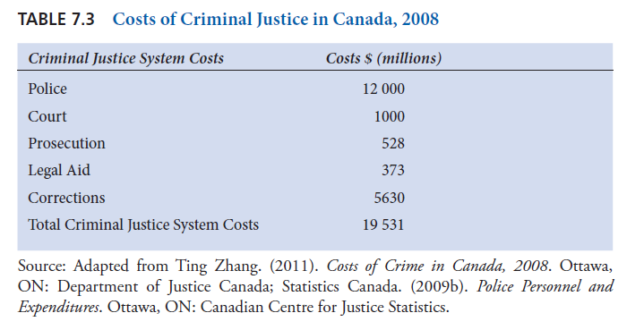
- $22 billion is the correct estimate – all after the fact
- Cost benefit argument – and compassion argument
- Investing in families and communities
- Take some of the 22 billion and spend it on prevention – even 5%
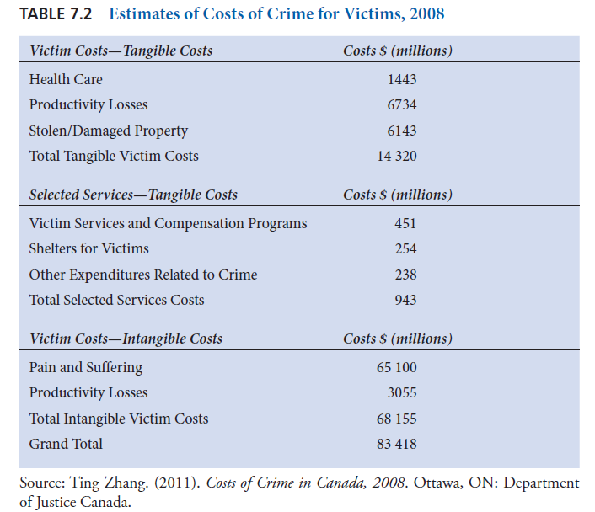
September 28th 2015
13.5 billion on policing – Canada
22 billion reactive actions; 4-5 billion courts, 5 billion corrections (prisons), 13.5 policing
Of the 13.5 billion 8.1 billion comes from municipalities
- Most municipalities have their own police force
- From taxes municipalities get the least amount of the taxes (8%) and pay 60% on police – significant amount of municipal taxes
- M-Taxes come from property taxes
- If you spend more on cops – less on diff things (roads etc.)
- Canadian levels of policing are moderate – but costs of salaries are going up.
- Rate of which victims report crime is dropping – policing as a solution to crime doesn’t work, in England police expenditure was cut by 25%
- Policing Canada in the 21st century – new policing challenges – one player of the CJS not the main player

Module 3: Social Control – Causes and Prevention of Offending September 28th 2015
Some Well Established Characteristics of Interpersonal Victimization
Most Provincial Governments think this way – minus the federal government
- Young single men living in disadvantaged areas are disproportionately offenders and victims
- Victims are disproportionately living in disadvantaged areas (poverty, family breakdown, mobile populations), including visible minorities and urban aboriginal peoples.
- Women (15-25) disproportionately victims of sexual assault, not just in disadvantaged areas also in schools and universities
- The poor and middle class near areas of disadvantage are more often victims of property offenses
- Victims and offenders tend to have experienced more negative life experiences such as child abuse, school dropout and so on.
- Violence main cause of harm to victims. Cyber and white collar crime likely significant cause of financial loss.
- Sensational and exceptional makes headlines not core problems
Aboriginal vs. Non Aboriginal
- 28% for non Aboriginal
- 6% for non Aboriginal
- 79% for non Aboriginal
- 4 in 10 Aboriginal people aged 15 and over reported that they were victimized at least once in the last 12 months.
- 21% report spousal violence in the past 5 years
- 62% of population Age 25-64 with High School Graduation or Higher (off reserve)

The WHO Risk Factors (Ecological Model)
INDIVIDUAL Ex: victimizations, witnessing, social problems, solving skills firearms at home
FAMILY: poor family cohesion
COMMUNITY: low cohesion, isolation of the women
ENVIRONMENTAL: gap between rich and poor, impunity
SLIDE 65 **
According to Longitudinal Studies
- Went to a disadvantaged area and followed a group for a long time. (in reading)
- Farrington – disadvantaged group from London England – birth info – every 2 years additional info – elementary, high school – correlated the data (negative life experience) to self-reporting of offending and arrests.

- Born into a family in relative poverty and inadequate housing;
- Brought up with inconsistent and uncaring parenting; A witness of intra-familial violence;
- Limited social and cognitive abilities;
- Presenting behavioral problems in primary school; black sheep
- Excluded from, or dropping-out of, school;
- Frequently unemployed and with relatively limited income;
- Living with a culture of violence on television and in the neighborhood
- Went to a disadvantaged area and followed a group for a long time. (in reading)
- Farrington – disadvantaged group from London England – birth info – every 2 years additional info – elementary, high school – correlated the data (negative life experience) to self-reporting of offending and arrests.

- Wolfgang – PHILLY study by 1000, roughly the same time
- Mac and uMTL does little studies but nothing large scales
Large Scale Data Sets to Confirm Social, Situatonal and Location of Crime
- 5% of youth account for 55% of offences
  - Longitudinal studies confirm 5% risk factors such as relative poverty, ineffective parenting and dropping out of school
  - If you want to reduce the number of victims – focus on the 5%
  - If you want to reduce the number of police – focus on the 5%
  - Are not random – have different characteristics than the others (list above)
- 4% of victims account for 44% of victimisation
  - Victimisation studies confirm 4% risk life routines such as not guarding goods, vulnerable to opportunity, close to offenders

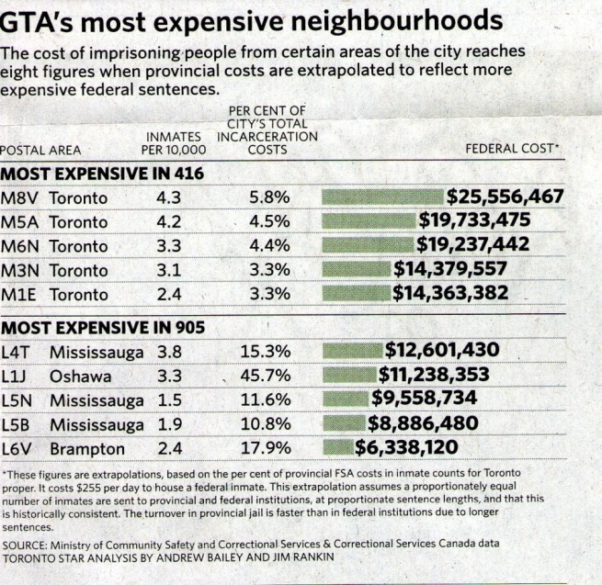
Jail Costs Calculated by Hoods: slide 75
Pointing out that crime is concentrated that we don’t do anything about those crimes in those areas.
Figures show total incarceration costs for all provincial inmates for the duration of their sentences from each postal code area. To calculate the cost to incarcerate each inmate, the sentence length was multiplied by the average cost per day – $160
Toronto star – on people in jails they had a look at the postal code – then looked at how many people coming from those area coded then mapped it
It’s all about risk factors – the WHO risk factor model lies underneath the problems.
Concentrated in certain parts of the city.
SLIDE 74 – risk factors
Social problem places – can’t solve the social problems by arresting and incarcerating
Need to engage in primary prevention (increase quality of life)
Secondary prevention (target these social factors)
Hot Spots – constant presents of emergency vehicles
- Primary in Health Area – Flu Shot
- Secondary in Health Area – everyone over 65 and nurses in ER and pregnant women
- Third in Health Area – after they got the flu
- Primary prevention - good schools, accessible to everybody
- Secondary Prevention – target risk factors ; outreaches (youth inclusion projects, public nurses)
- Thirdly – catch and convict

Replication is Key *
*High/Scope Perry Preschool
- Target 3-4 year olds African American from low income and marginalized families
- Provide 2 ½ hrs preschool 5 days/week for 2 school years
  - Participatory education model with highly trained teachers
  - Michigan USA
  - Focus on initiative, social skills, language, literacy, etc.
  - Weekly home visits (an hour)
  - Followed them for 27 years
  - 5% accounts for 50% of offending – wouldn’t do it in Canada
  - Toronto Star Study – postal codes of inmates of certain prisons (costs are concentrated in certain areas)
(midterm youth inclusion )
- Youth Justice Board – to reduce crime, this was the project used to reduce crime across the country in 72 ‘high crime areas’ in England and Wales
- It was a positive program and put to scale, when they did it across the country they found it worked – after – spread and expanded it (doubled it)
- Example a country that finds a program that works, expands it and doubles it, it happened b/c they had a board to do it and monitor it
Impacts:
Randomized Controlled Trial in Ypsilanti (MI) with African American children (N=123)

The Positive Parenting Program (Triple P)
- Longitudinal studies
- Developed a two gear system – one is trying to improve everyone’s parenting habits and at risk parenting
- Head Q – Ontario

Life Skills Training
- Getting kids away from drugs and drinking abuse

Crime soultions.gov 78 effective crime prevention projects

Brochure –look at it – requested by Luke ffrench

