Chapter 9
Product: anything that is of value to a consumer and can be offered through a voluntary marketing exchange
- includes: services, ideas, people, goods, organizations, people, communities
Product Assortment & Product Line Decisions
- Product assortment (product mix): the complete set of all products offered by a firm
- Product lines: groups of associated items such as those that consumers use together or think of as part of a group of similar items
- Product category: an assortment of items that the customer sees as reasonable substitutes for one another
- Brand: the name, term, design, symbol, or any other features that identify one sellers good or service as distinct from those of other sellers
- Product line breadth: the number of product lines, or variety, offered by the firm
- Product line depth: The number of categories within a product line
- Stock keeping units (SKUs): individual items within each product category; the smallest unit available for inventory control
- Category depth: the number of stock keeping units (SKUs) within a category
Change Product Mix Breadth
- Increase: to capture new or evolving markets, increase sales, and compete in new venues
- Decrease: to address changing market conditions or meet internal strategic priorities
Change Product Mix Depth
- Increase: to address changing consumer preferences or pre-empt competitors while boosting sales or to serve new target segments
- Decrease: to delete product categories to realign resources
Change Number of SKUs
- to stimulate sales
- to react to consumer demand
Branding: brand names, logos, symbols, characters, slogans, jingles, distinctive packaging

Value of Branding for the Customer and the Marketer
- Brands Facilitate Purchasing: easily recognizable by consumers and signify a certain quality level, familiar attributes. Help consumers make quick decisions
- Brands Establish Loyalty: over time and with continued use, consumers learn to trust certain brands
- Brands Protect from Competition and Price Competition
- Brands Reduce Marketing Costs: the brand sells itself
- Brands are Assets: can be legally protected through trademarks and copyrights and thus constitute a unique ownership for the firm. Firms sometimes have to fight to keep their brands "pure" (pg 244) - Ie. Rolex needs to fight to keep replicas off the black market
- Brands Impact Market Value
Brand Equity: the set of assets and liabilities linked to a brand that add to or subtract from the value provided by the product or service
- Brand awareness: measures how many consumers in a market are familiar with the brand and what it stands for; created through repeated exposures of the various brand elements (brand name, logo, symbol, character, packaging, or slogan) in the firms communications to consumers
- created through: repeated exposures of the various brand elements (logo, symbol, packaging, brand name)
- communicated through: advertising and promotions, personal selling, sponsorship, and event marketing, publicity, and public relations (PR)
- Brand association: The mental links that consumers make between a brand and its key product attributes; can involve a logo, slogan, or famous personality.
- often result from advertising and promotion
- created through positive consumer emotions such as: fun, friendship, good feelings, family gatherings, and parties
- Brand personality: Refers to a set of human characteristics associated with a brand, which has symbolic or self-expressive meanings for consumers.
- Perceived value: The relationship between a product or service’s benefits and its cost.
- Brand Loyalty: occurs when a consumer buys the same brand's product or service repeatedly over time rather than buying from multiple suppliers within the same category
- brand-loyal customers are less sensitive to price
- firms sometimes reward loyal customers - CRM customer relationship management programs (such as points at subway, advance notice of sale items)
- marketing costs decrease with loyal customers because customers do not need the extra push to buy the product
Branding Strategies
- the majority of brands marketed in Canada are manufacturer brands

Brand Ownership Strategies:
- manufacturer brands (national brands): brands owned and managed by the manufacturer (Nike)
- generic: a product sold without a brand name, typically in commodities markets (No Name)
- store or private label: brands developed and marketed by a retailer and available only from that retailer (Life – Shopper’s)
Naming Brands and Product Line:
- corporate or family brand: the use of a firms own corporate name to brand all of its product lines and products
- individual: the use of individual brand names for each of a firms products
- corporate and product line brand: the use of a combination of family brand name and individual brand name to distinguish a firms products
Choosing a Name
- the brand name should be: descriptive, suggestive of benefits and qualities associated with the product
- the brand name should be: easy to pronounce, recognize, and remember (Ie. tide, crest)
- the company should be able to register the brand name as a trademark & legally protect it
- should be easy to translate to other languages
Brand Extension: the use of the same brand name for new products being introduced to the same or new markets
Advantages:
- because the brand is already established - firms can spend less in developing consumer brand awareness and brand associations for the new product
- if the brand is known for its high quality, that perception will carry over to the new product
- marketing costs for a new product by an established brand are lower because consumers already know and understand the brand
- when brand extensions are used for complementary products, a synergy exists between the two products that can increase overall sales
- successful brand extensions can result in cross category trial and boost sales because adopters of the new extended brand may try other products in the brand family they are not already using

Disadvantages:
- brand dilution: occurs when a brand extension adversely affects consumer perceptions about the attributes the core brand is believed to hold
- unsuccessful brand extension that dilutes the brand’s equity
To prevent the potential negative consequences of brand extensions:
- evaluate the fit between the product class of the core brand and that of the extension
- evaluate consumer perceptions of the attributes of the core brand and seek out similar attributes for the extension (brand specific associations are very important for extensions)
- firms should refrain from extending the brand name to too many products and product categories to avoid diluting the brand and brand equity
- firms should consider whether the brand extension will be distanced from the core brand, especially if the firm wants to use some but not all of the existing brand associations
Cobranding: the practice of marketing two or more brands together, on the same package or promotion
Advantages:
- enhances consumers perceptions of product quality
- can be a prelude to an acquisition strategy
Disadvantages:
- may fail if customers from each brands are vastly different
- may fail if the brand owners cannot resolve financial disputes about revenue or royalty sharing
- the firms that own the brands may change their priorities in which case the cobranded product is discontinued
Brand Licensing: a contractual arrangement between firms, whereby one firm allows another to use its brand name, logo, symbols, or characters in exchange for a negotiated fee
- common for toys, apparel, accessories, entertainment products
- effective form of attracting visibility for the brand and thereby building brand equity while also generating additional revenue
Risks:
- for the licensor: dilution of the brand equity through over exposure of the brand, especially if the brand name and characters are used inappropriately
- improperly valuing their brand for licensing purposes or entering into the wrong type of licensing arrangement the success or failure of merchandise based on movies is directly related to the success or failure of the movie itself
Packaging
- more tangible/physical benefits than the other brand elements
- consumers seek convenience: storage, use, and consumption
- shows brand positioning
- last part of advertising as it promotes the product at the point of purchase
- may affect consumers emotions & drive impulse buying
- differentiates the product
- green biodegradable packaging: consumers are demanding less packaging and want it to be easily recyclable
Product Labeling
- provides information to consumers (communication tool):
- ingredients
- where the product was made
- directions for use
- safety precautions
- can be used for promotion
- communicate benefits of the product

Chapter 10
Innovation and Value
Innovation: the process by which ideas are transformed into new products and services that will help firms grow
- without innovation (new products) firms would have two choices:
- continue to market current products to current customers
- take the same product to another market with similar customers
- as new products are added:
- firms create and deliver value more effectively by satisfying the changing needs of their current and new customers or by keeping customers from getting bored with the current product or service offering
- the longer a product exists in the marketplace:
- the more likely the market will saturate
- without new products, the value of the firm will ultimately decline
- the portfolio of products that innovation can create helps:
- the firm diversify its risk and enhance firm value better than a single product
- if some products are doing poorly, others could be doing well
- firms with multiple products can withstand external shocks better
- in some industries (arts and software) most sales come from new products (innovation)
- new product introductions (especially new-to-the -world that create new markets) add a lot of value to the firm
Pioneers: new product introductions that establish a completely new market or radically change both the rules of competition and consumer preferences in a market; also called breakthroughs or "disruptive"
- disruptive products require a higher level of learning from consumers and offer more benefits than predecessor products
- imitators capitalize on the weaknesses of pioneers
- pioneer products usually have a less sophisticated design
As many as 95% of all consumer goods fail and products across all markets and industries suffer failure rates of 50 to 80%, WHY?
- they offer consumers too few benefits compared to existing products
- they are too complex or require substantial learning and effort before consumers can use them
- bad timing: being introduced at a time when consumers are not ready for such new products
First movers: product pioneers that are the first to create a market or product category, making them readily recognizable to consumers and thus establishing a commanding and early market share lead
Adoption of Innovation
Diffusion of Innovation: the process by which the use of an innovation spreads throughout a market group over time and over various categories of adopters
- helps marketers understand:
- the rate at which consumers are likely to adopt a new product or service
- identify potential markets
- predict potential sales before introducing innovations
Using the Adoption Cycle:
- Innovators: those buyers who want to be the first to have the new product or service
- innovators keep well informed (talk to experts, specialty magazines)
- their positive word of mouth is instrumental to the next adopter category
- Early adopters: the second group of consumers in the diffusion of innovation model, after innovators, to use a product or service innovation; generally don’t like to take as much risk as innovators
- Early Majority: a group of consumers in the diffusion of innovation model that represents approximately 34% of the population; members don’t like to take much risk and therefore tent to wait until bugs are worked out
- Late Minority: the last group of buyers to enter a new product market
- the product has achieved its full market potential
- sales are leveling off or declining
- Laggards: consumers who like to avoid change and rely on traditional products until they are no longer available
- sometimes never adopt the product
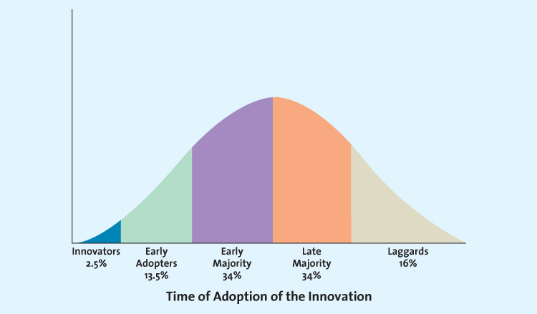
Factors Affecting Product Diffusion Speed
Firms can predict which types of consumers will buy their new product immediately after its introduction and later on. This way marketers can develop appropriate promotion, pricing and marketing strategies to push acceptance among each customer group.
The speed at which products are adopted depends on several characteristics:
- Relative Advantage: if a product is perceived to be better than substitutes, then the diffusion will be relatively quick
- Compatibility: most business professionals and executives have to make decisions in a timely fashion and be able to communicate their decisions in a timely manner - they need real time information in order to do this
- Observability: when products are easily observed, their benefits or uses are easily communicated to others, thus enhancing the diffusion process
- Complexity and Trialability: products that are relatively less complex are also relatively easy to try (these products will diffuse more quickly)

Product Development Process (not every product goes through every phase)
- Idea Generation: development of viable new product ideas (can come from employees, customers, suppliers, and partners or are generated by attending trade shows and conferences)
- Internal Research and Development: internal R&D develop new products, firms expect the revenue to make the expensive R&D costs worthwhile
- Licensing: firms buy the rights to use the technology or ideas from other research-intensive firms through a licensing agreement - saves the high costs of in-house R&D, but it means the firm is banking on a solution that already exist but has not been marketed yet
- Brainstorming: a group works together to formulate ideas (no idea is immediately accepted/rejected)
- Competitors Products: a new product entry by a competitor may trigger a market opportunity for a firm. use reverse engineering to understand the competitors product and then make an improved version
- Reverse engineering: involves taking apart a competitor's product, analyzing it, and creating an improved product that does not infringe on the competitors patents, if any exist.
- Customer Input: listening to the customer is essential for successful idea generation (85% of B2B product ideas come from customers)
- Lead users: innovative product users who modify existing products according to their own ideas to suit their specific needs
- Concept Testing: the process in which a concept statement that describes a product or a service is presented to potential buyers or users to obtain their reactions (testing the new product idea among a set of potential customers)
- reaction of consumers enables developers to estimate sales value
- Ex: exploratory research, in-depth interview, focus groups, then conclusive research
- Important questions: respondents purchase intentions, whether the product would satisfy a need that other products currently do not meet, expected frequency of purchase
- collect demographic information to know which market segments are interested
- Concept: brief written descriptions of a product or service; its technology, working principles, and forms; and what customer needs it would satisfy
- Product Development: entails a process of balancing various engineering, manufacturing, marketing, and economic considerations to develop a product (development of prototypes and/or the product)
- Prototype: the first physical form or service description of a new product, still in rough or tentative form, that has the same properties as a new product but it produced through different manufacturing processes sometimes even crafted individually
- Alpha Testing: an attempt by the firm to determine whether a product will perform according to its design and whether it satisfies the need for which it was intended; occurs in the firms R&D department
- Beta Testing: having potential consumers examine a product prototype in a real-use setting to determine its functionality, performance, potential problems, and other issues specific to its use
- Market Testing: testing the actual products in a few test markets
- Premarket tests: conducted before a product or service is brought to market to determine how many customers will try and then continue to use it
- potential customers are exposed to the marketing mix variables and then asked whether they would buy/use it again
- the second survey tells us an estimation of the probability of customer repeat purchase
- saves marketers costs of a nationwide launch if the product fails
- Test Marketing: introduces a new product or service to a limited geographical area (usually a few cities) prior to a national launch
- on basis of results: estimate demand for the entire market
- advantage: the firm can study actual consumer behavior which is more reliable than a simulated test
- Product Launch: full-scale commercialization of the product
- critical step: requires tremendous financial resources and coordination of all aspects of marketing mix
- decide on positioning for product
- Promotion- the test results help the firm determine an appropriate integrated marketing communications strategy (complex products may need to educate consumers)
- Price- sometimes easier to start with a higher price and offer promotions than try to raise it later
- Place- the firm must have an adequate quantity of products available for shipment and to keep in stock at relevant stores. product should be as complete as possible (i.e. printer needs ink)
- Timing
- Evaluation of Results: analysis of the performance of the new product and making appropriate modifications
Firms measure the success of a new product by three interrelated factors:
- its satisfaction of technical requirements, such as performance
- customer acceptance
- its satisfaction of the firm’s financial requirements, such as sales and profits

Product Life Cycle
Definition: defines the stages that new products move through has they enter, get established in, and ultimately leave the marketplace and thereby offers marketers a starting point for their strategy planning
- Introductory stage: innovators start buying the product
- usually starts with a single firm and innovators try it
- low sales, profits, few competitors
- Growth stage: the product gains acceptance, demand and sales increase, and competitors emerge in the product category
- product adopters
- new product versions
- market segments and consumer preferences vary
- increase potential for new markets or new uses for the product
- need to establish the firms brand
- Maturity stage: industry sales reach their peak, so firms try to rejuvenate their products by adding new features or repositioning them
- late majority
- intense competition for market share
- marketing costs increase to keep market share as competition increases
- market very saturated
- Entry into new markets or market segments- because the market is saturated, firms may attempt to enter new geographical markets that may be less saturated
- Development of new products- improve features or find new uses for existing products
- Decline stage: sales decline and the product eventually exits the market
- position in a niche segment of diehard consumers or those with special needs
- or exit the market
- laggards
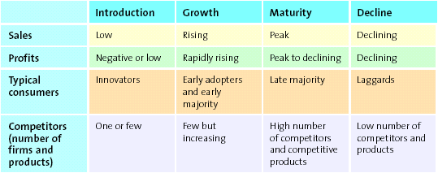
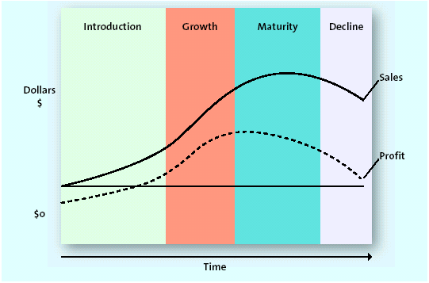

Chapter 11
Service: intangible customer benefits that are produced by people or machines and cannot be separated from the producer
Customer service: specifically refers to human or mechanical activities firms undertake to help satisfy their customer’s needs and wants
- good customer service adds value to products/services
- the dependence and growth of service-oriented economies in developed countries is because:
- it is less expensive for firms to manufacture in less developed countries
- household maintenance activities, which many people used to perform by themselves, have become quite specialized (lawn care, food prep, laundry, house cleaning)
- people place high value on convenience and leisure
- as the Canadian population ages, the need for healthcare professionals also increases
Services Marketing Differs from Product Marketing
- Intangible: services cannot be touched, tasted, or seen
- difficult to convey benefits of services
- difficult to promote as it cannot be shown directly
- marketers use symbols and images to sell services and reinforce the benefit/value
- Inseparable: services are inseparable from their providers as they are produced and consumed at the same time
- service marketers try to get their customers directly involved
- consumers rarely have the opportunity to try the service before purchase
- Variable (inconsistent): the quality of a service varies in consistency as it is provided by humans who are fallible
- ways to get over the variability:
- micromarketing segmentation strategy: can customize a service to meet customers' needs exactly (it can be expensive to produce)
- replace people with machines
- Perishable (inventory): services cannot be held in inventory for future use
- critical to match supply and demand
Providing Great Service: The Gaps Model
Service gap: results when a service fails to meet the expectations that customers have about how it should be delivered
- Knowledge gap: reflects the difference between customers’ expectations and the firms perception of those expectations
- understanding customer expectations
- based on their knowledge and experiences
- expectations vary according to the type of service
- expectations vary depending on the situation
- evaluating service quality
- to meet or exceed customers’ expectations, marketers must determine what those expectations are
- customers generally use five distance service dimensions to determine overall service quality:
- reliability: the ability to perform the service dependably and accurately
- responsiveness: the willingness to help customers and provide prompt service
- assurance: the knowledge of an courtesy by employees and their ability to convey trust and confidence
- empathy: the caring, individualized attention provided to customers
- tangible: the appearance of physical facilities, equipment, personnel, and communication materials
- service quality: customers perceptions of how well a service meets or exceeds their expectations
- Marketing research: understanding customers
- provides a means to better understand consumers service expectations and their perceptions of service quality
- extensive and expensive
- integrated into a firms everyday interactions with customers
- voice-of-customer (VOC) program: an ongoing marketing research system that collects customer inputs and integrates them into managerial decisions
- zone of tolerance: the area between customers’ expectations regarding their desired service and the minimum level of acceptable service - that is, the difference between what the customer really wants and what he or she will accept before going elsewhere
- evaluates how well firms perform on the "five service quality dimensions"
- to define the zone of tolerance, firms ask a series of questions about each service quality dimension that relate to:
- the desired and expected level of service for each dimension, from low to high
- customers perceptions of how well the focal service performs and how well a competitive service performs, from low to high
- the importance of each service quality dimension
- straightforward & inexpensive to collect consumers perceptions of service quality at time of sale
- another method is to use the customer complaint behavior

- Standards gap: pertains to the difference between the firms perceptions of customers’ expectations and the service standards it sets
- achieving service goals through training
- to deliver consistently high-quality service: firms must set specific, measurable goals based on customers' expectations; to help ensure that quality, the employees should be involved in the goal setting
- service providers generally want to do a good job, but need to know what is expected of them
- commitment to service quality
- service providers take their cues from management

- Delivery gap: the difference between the firms service standards and the actual service it provides to customers
- where the customer directly interacts with the service provider
- empowering service providers - empowerment becomes more important when price points edge higher and services are more individualized
- empowerment: in context of service delivery, means allowing employees to make decisions about how service is provided to customers
- providing support and incentives - to ensure that service is delivered properly, management needs to support the service provider
  - managers and coworkers should provide emotional support to service providers by demonstrating a concern for their well-being and standing behind their decisions
  - the support that managers provide must be consistent and coherent throughout the organization
  - a key part of any customer service program is providing rewards to employees for excellent service
- use of technology
- facilitates delivery systems - benefits:
- access a wider variety of services
- a greater degree of control by the customer over the services
- the ability to obtain information
- increased efficiency in service processes through reduced servicing costs
- develop a competitive advantage over less service-oriented competitors
- kiosks are convenient - open longer hours and consistent for users

- Communication gap: refers to the difference between the actual service provided to customers and the service that the firms promotion program promises
- promise only what you can deliver (or possibly even less, then they will be impressed)
- customer expectations are created through promotions and can be managed when the service is delivered

Service Recovery
- make amends with the customer and learn from the experience
- effective service recovery efforts can significantly increase customer satisfaction, purchase intentions, and positive word of mouth
- customers post recovery satisfaction levels usually fall lower than their satisfaction level prior to the service failure
- Effective service recovery entails:
- listening to the customer
- providing a fair solution
- resolving the problem quickly
Listening to the Customer
- service providers therefore should welcome the opportunity to be that sympathetic ear, listen carefully, and appear anxious to rectify the situation to ensure it doesn’t happen again
Finding a Fair Solution
- perceptions of what "fair" means is based on their previous experience with other firms
- Distributive fairness: Pertains to a customer’s perception of the benefits he or she received compared with the costs (inconvenience or loss) that resulted from a service failure
- Procedural fairness: Refers to the customer’s perception of the fairness of the process used to resolve complaints about service.
Resolving Problems Quickly
- the longer it takes to resolve a service failure, the more irritated the customer will become and the more people he or she is likely to tell about the problem
- to resolve service failures quickly firms need: clear policies, adequate training for their employees, and empowered employees
- firms must listen to customer complaints and act on them

Chapter 12
Price: the overall sacrifice a consumer is willing to make - money, time, energy - to acquire a specific product or service
- consumers aren’t always necessarily looking for the lowest price
- price is the only element in the marketing mix that generates revenue
- research shows consumers rank price as one of the most important factors in their purchase decisions
- price is the most challenging of the four p's to manage, partly because it is the least understood
- information cue
- pricing is a strategic opportunity
The 5 C's of Pricing
1. Company Objectives - not as simple as they might first appear; they often can be expressed in slightly different forms that mean very different things
Profit-Orientation: a company objective that can be implemented by focusing on target profit, pricing, maximizing profits, or target return pricing
- target profit pricing: A pricing strategy implemented by firms when they have a particular profit goal as their overriding concern; uses price to stimulate a certain level of sales at a certain profit per unit.
- maximizing profits strategy: a mathematical model that captures all the factors required to explain and predict sales and profits, which should be able to identify the price at which its profits are maximized
- relies primarily on economic theory
- extremely difficult to gather information on all relevant factors
- target return pricing: A pricing strategy implemented by firms less concerned with the absolute level of profits and more interested in the rate at which their profits are generated relative to their investments; designed to produce a specific return on investment.
Sales-Orientation: a company objective based on the belief that increasing sales will help the firm more than will increasing profits
- Ie. a new health club might focus on unit sales or market share and therefore be willing to set a lower membership fee and accept less profit at first
Competitor-Oriented: a company objective based on the premise that the firm should measure itself primarily against its competitor
- competitive parity: a firms strategy of setting prices that are similar to those of major competitors
- value is only implicitly considered in competitor-oriented strategies, in the sense that competitors may be using value as part of their pricing strategies, so copying their strategy might provide value
Customer-Oriented: pricing orientation that explicitly invokes the concept of customer value and setting prices to match consumer expectations
- "no haggle" price structure: make the purchase process simpler and easier for consumers, thereby lowering the overall price and ultimately increasing value
- "state-of-the-art" products or services: in full anticipation of limited sales, designed to enhance the company's reputation and image and thereby increase the company's value in the minds of consumers
2. Customers - the most important because it is about understanding consumers reactions to different prices. consumers want value, and as you may recall, price is half of the value equation
Demand Curves and Pricing
- Demand curve: Shows how many units of a product or service consumers will demand during a specific period at different prices.
- Prestige products or services: those that consumers purchase for status rather than functionality
- higher price leads to greater quantity sold (until a certain point)
- the higher the price, the greater the status associated with it and the greater the exclusivity because fewer can afford it
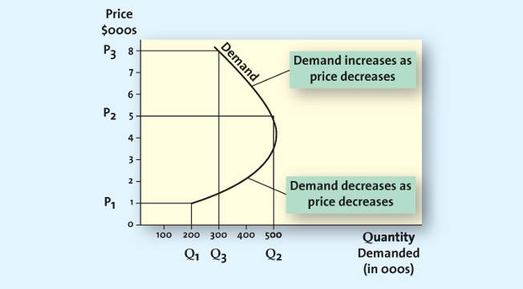
Regular Prestige
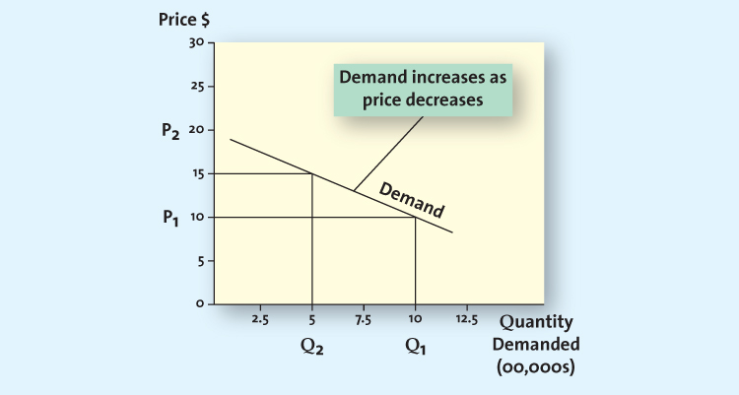
Price Elasticity of Demand: measures how changes in a price affect the quantity of the product demanded; specifically, the ratio of percentage change in quantity demanded to the percentage change in price
Price elasticity of demand = % change in quantity demanded
% change in price
- consumers are generally less sensitive to price increases for necessary items, like milk, because they have to purchase these items even if the price climbs
- consumers are generally more sensitive to price increases than decreases
- price elasticity of demand usually changes at different points in the demand curve unless the curve is actually a straight line
- elastic: refers to a market for a product or service hat is price sensitive; that is, relatively small changes in a price will generate fairly large changes in the quantity demanded
- 1% decrease in price produces more than 1% increase in quantity sold
- inelastic: refers to a market for a product or service that is price insensitive; that is, relatively small changes in price will not generate large changes in the quantity demanded
- 1% decrease in price produces less than 1% increase in quantity sold
Factors Influencing Price Elasticity of Demand
- Income effect: refers to the change in the quantity of a product demanded by consumers due to a change in their income
- generally as peoples income increases, their spending behavior changes: they tend to shift their demand from lower-priced products to higher priced alternatives
- Substitution effect: Refers to consumers’ ability to substitute other products for the focal brand, thus increasing the price elasticity of demand for the focal brand.
- the greater the availability of substitute products, the higher the price elasticity of demand for any given product will be
- Cross-price elasticity: The % change in demand for product A that occurs in response to a % change in price of product B.
- complementary products: products whose demand curves are positively related, such that they rise or fall together; a percentage increase in demand for one results in a percentage increase in demand for the other
- substitute products: products for which changes in demand are negatively related; that is, a percentage increase in the quantity demanded for product A results in a percentage decrease in the quantity demanded for product B
3. Costs
- firms must understand their cost structures so they can determine the degree to which their products or services will be profitable at different prices
- prices should not be based on costs, because consumers make purchase decisions based on their perceived value ( they care little about the firms cost to produce and sell a product)
- Variable Costs: those costs, primarily labor and materials, that vary with production volume
- as a firm produces more or less of a good, the total variable costs increase or decrease at the same time
- in the service industry variable costs are much more complicated
- variable costs per unit may go up or down (for all units) with significant changes in volume
- Fixed Costs: those costs that remain essentially at the same level, regardless of any changes in the volume of production
- Total Cost: the sum of the variable and fixed costs
Breakeven Analysis & Decision Making
- Break-even point: the point at which the number of units sold generates just enough revenue to equal the total costs; at this point, profits are zero
- powerful tool when performed on a range of possible prices for comparative purposes
- does not help managers set prices, but it helps them access their pricing strategies
- it clarifies conditions in which different prices may make a product profitable
- Contribution per unit: equals the price less the variable cost per unit. variable used to determine the break-even point in units
Break-even point (units) = fixed costs
contribution per unit
4. Competition
Price war: occurs when two or more firms compete primarily by lowering their prices
- Oligopolistic Competition: occurs when only a few firms dominate a market
- Monopolistic competition: occurs when there are many firms that sell closely related but not homogeneous products; these products may be viewed as substitutes but are not perfect substitutes
- when so many firms compete, product differentiation rather than a strict pricing competition tends to appeal to consumers
- Pure competition: occurs when different companies sell commodity products that consumers perceive as substitutable
  - price usually is set according to the laws of supply and demand

- Channel Members - manufacturers, wholesalers, retailers - can have different perspectives when it comes to pricing strategies
Grey market: Employs irregular but not necessarily illegal methods; generally, it legally circumvents authorized channels of distribution to sell goods at prices lower than those intended by the manufacturer.

Other Influences on Pricing
- The Internet
- more products, services, and information online has made them more price sensitive and opened new categories of products to those who could not access them previously
- gourmet foods, books, music, movies, electronics, even prescription drugs present a significant online presence
- search engines allow consumers to find the best price for any product quickly, which increases their price sensitivity and reduces the costs associated with finding lower-price alternatives
- firms also know more about competitors’ products
- Economic Factors
- increase in consumers disposable income and status consciousness
- products once considered only for the very rich such as Rolex watches are now owned by more working professionals, more consumers are making the financial leap to attain them
- trends also find consumers trying to shop cheap
- cross-shopping: the pattern of buying both premium and low-priced merchandise or patronizing both expensive status-oriented retailers and price-oriented retailers
- the impact: prestige items are more expensive, whereas other items are cheaper
Pricing Strategies
- Cost-based methods: determines the final price to charge by starting with the cost, without recognizing the role that consumers or competitors prices play in the marketplace
- Competitor-based methods: an approach that attempts to reflect how the firm wants consumers to interpret its products relative to the competitors offerings
- setting a price very close to a competitors price signals to consumers that the product is similar, whereas setting the price much higher signals greater features, better quality, or some other valued benefit
- Premium pricing: A competitor-based pricing method by which the firm deliberately prices a product above the prices set for competing products to capture those consumers who always shop for the best or for whom price does not matter.
- Value-based methods: focuses on the overall value of the product offering as perceived by consumers, who determine value by comparing the benefits they expect the product to deliver with the sacrifice they will need to make to acquire the product
- improvement value method: represents an estimate of how much more (or less) consumers are willing to pay for a product relative to other comparable products
- cost of ownership method: a value-based method for setting prices that determines the total cost of owning the product over its useful life

New Product Pricing
- developing pricing strategies for new products is one of the most challenging tasks a manager can undertake
- "me-too" product: similar to what already appears on the market - easier to price because its approximate value has already been established
- "new to the world": determining consumers perceptions of the value is more difficult

- Price skimming: A strategy of selling a new product or service at a high price that innovators and early adopters are willing to pay in order to obtain it; after the high-price market segment becomes saturated and sales begin to slow down, the firm generally lowers the price to capture (or skim) the next most price sensitive segment.
- the product has to be perceived as a breakthrough, offering consumers new benefits
- competitors may be prevented from entering into the market because of patent protections
- can cause discontent to consumers buying at full cost
- profits are generated through margin
- Firms use skimming strategies for different reasons:
- to signal high quality to the market
- to limit demand
- to quickly earn back some of the R&D investments
- to test consumers price sensitivity
- Drawbacks:
  - High unit costs due to producing small volumes of the product
    - Which is more important, earning higher price or paying higher production costs?
  - Discontent among consumers because those who buy early end up paying more for the product than those who buy later when the price has been lowered

- Market Penetration Pricing: A pricing strategy of setting the initial price low for the introduction of the new product or service, with the objective of building sales, market share, and profits quickly.
- encourages consumers to purchase the product immediately
- profits are generated through volume (opposite to price skimming - margin)
- experience curve effect: refers to the drop in unit cost as the accumulated volume sold increases; as sales continue to grow, the costs continue to drop, allowing even further reductions in the price
- discourages competitors from entering the market because the profit margin is low
- drawbacks: (1) the firm must have the capacity to satisfy a rapid rise in demand (2) low price does not signal high quality (3) firms should avoid a penetration strategy if some segments of the market are willing to pay more for the product

Psychological Factors Affecting Value-based Pricing Strategies
- Consumers Use of Reference Prices
- Reference price: The price against which buyers compare the actual selling price of the product and that facilitates their evaluation process.
- External reference price: a higher price to which the consumer can compare the selling price to evaluate the purchase
- typically the seller labels the external reference price as the "regular price"
- external reference prices influence internal reference prices (when people are continuously exposed to higher reference prices, their internal reference prices shift toward the higher external reference prices, assuming their initial internal reference price was not too far away from it
- Everyday Low Pricing (EDLP): A strategy companies use to emphasize the continuity of their retail prices at a level somewhere between the regular, non-sale price and the deep-discount sale prices their competitors may offer.
- by reducing search costs, EDLP adds value
- High/Low Pricing: A pricing strategy that relies on the promotion of sales, during which prices are temporarily reduced to encourage purchases.
- Odd Prices: Prices that end in off numbers, usually 9
- today it is "traditional" so marketers are afraid not to because they are unsure of how consumers will react
- odd prices signal to the consumer that the price is low
- Price-Quality Relationship
- not all consumers rely on price to judge quality
- the store, brand name, warranty/guarantees, and where the product was produced also represent information consumers use to judge quality
- when consumers know the brand, or experience with the product, they are better able to judge the quality of products objectively
Pricing Tactics: : Short-term methods, in contract to long-term pricing strategies, used to focus on company objectives, costs, customers, competition, or channel members; can be responses to competitive threats (e.g., lowering price temporarily to meet a competitor’s price reduction) or broadly accepted methods of calculating a final price for the customer that is short term in nature.
Business-to-Business (B2B)
- seasonal discounts: pricing tactic of offering an additional reduction as an incentive to retailers to order merchandise in advance of the normal buying season
- cash discounts: tactic of offering a reduction in the invoice cost if the buyer pays the invoice prior to the end of the discount period
- Allowances
- advertising allowances: tactic of offering a price reduction to channel members if they agree to feature the manufacturers product in their advertising and promotional efforts
- listing allowances: fees paid to retailers simply to get new products into stores or to gain more or better shelf space for their products
- quantity discount: pricing tactic of offering a reduced price according to the amount purchased; the more the buyer purchases, the higher the discount and, of course, the greater the value
- cumulative quantity discount: pricing tactic that offers a discount based on the amount purchased over a specified period and usually involves several transactions
- noncumulative quantity discount: pricing tactic that offers a discount based on only the amount purchased in a single order
- Uniform delivered pricing: the shipper charges one rate, no matter where the buyer is located
- Geographic pricing: the setting of difference prices depending on a geographical division of the delivery areas
Aimed at Consumers (B2C)
- price lining: consumer market pricing tactic of establishing a price floor and a price ceiling for an entire line of similar products and then setting a few other price points in between to represent distinct differences in quality
- price bundling: consumer pricing tactic of selling more than one product for a single, lower price than what the items would cost sold separately; can be used to sell slow moving items, to encourage customers to stock up so they won't purchase competing brands, to encourage trial of a new product, or to provide an incentive to purchase a less desirable product or service to obtain a more desirable one in the same bundle
- leader pricing: consumer pricing tactic that attempts to build store traffic by aggressively pricing and advertising a regularly purchased item, often priced at or just above the stores cost
Consumer Price Reductions
- markdowns: reductions retailers take on the initial selling price of the product or service
- quantity discount/size discount: the most common implementation of a quantity discount at the consumer level; the larger the quantity bought, the less the cost per unit
- seasonal discounts: aims at stimulating demand during off-peak seasons
- coupons: provides a stated discount to consumers on the final selling price of a specific item; the retailer handles the discount
- rebate: a consumer discount in which a portion of the purchase price is returned to the buyer in cash; the manufacturer, not the retailer, issues the refund
Legal Aspects and Ethics of Pricing
Deceptive or illegal price advertising
- "Puffery" is typically allowed, but price advertisements should never deceive consumers to the point of causing harm!
- deceptive reference prices
- loss leader pricing: takes the tactic of leader pricing one step further by lowering the price below the stores cost
- bait and switch: a deceptive practice of luring customers into the store with a very low advertised price on an item (the bait), only to aggressively pressure them into purchasing a higher-priced (switch) by disparaging the low-priced item, comparing it unfavorably with the higher-priced model, or professing an inadequate supply of the lower-priced item
Predatory Pricing: a firms practice of setting very low price for one or more of its products with the intent to drive its competition out of business; illegal under the competition Act.
Price Discrimination: the practice of selling the same product to different resellers (wholesalers, distributors, or retailers) or to the ultimate consumer at different prices; some, but not all, forms of price discrimination are illegal
Price Fixing: the practice of colluding with other firms to control prices
- horizontal price fixing: occurs when competitors that produce and sell competing products collude, or work together, to control prices, effectively taking price out of the decision process for consumers
- vertical price fixing: occurs when parties at different levels of the same marketing channel collude to control the prices passed on to consumers

Chapter 13
Distribution Channels, Supply Chain, and Logistics are Related
- Distribution Channel: the set of institutions that transfer the ownership of and move goods from the point of production to the point of consumption
  - make products available to consumers
  - wholesalers/retailers
  - direct or indirect
- Supply Chain Management: a set of approaches and techniques firms employ to efficiently and effectively integrate their suppliers, manufacturers, warehouses, stores, and transportation intermediaries into a seamless value chain in which merchandise is produced and distributed in the right quantities, to the right locations, and at the right time, as well as to minimize costs while satisfying the service levels customers require.
  - Suppliers and supplier networks
- Logistics management: integration of two or more activities for the purpose of planning, implementing, and controlling the efficient flow of raw materials, in-process inventory, and finished goods from the point of origin to the point of consumption
  - Customer service, demand forecasting, packaging, procurement, warehousing and storage…
Designing Distribution Channels
Distribution Channel Structure
- Direct Distribution
  - Manufacturers deal directly with customers
  - Some use this because they cannot secure shelf space, or cannot afford high listing fees for space
- Indirect Distribution
  - One or more intermediaries work with manufacturers to provide goods and services to consumers
  - Eg. Manufacturer wholesaler retailer consumer
- Push Strategy: focus promotional efforts on channel members to convince them to carry the product
- Pull Strategy: promotional efforts focused on consumers to generate demand and force channel members to hold the product
- Multi-Channel Distribution
  - Using a combination of both direct and indirect forms of distribution
Distribution Intensity
- The number of supply chain members to use at each level of the supply chain
Intensive Distribution Strategy: designed to get products into as many outlets as possible
Exclusive Distribution: granting exclusive rights to sell to one or very few retail customers so no other customers can sell a particular brand
Selective Distribution: between intensive and exclusive; uses a few selected customers in a territory
Managing Channels through Vertical Marketing Systems
- Supply chain members work as a unified system
Administered Vertical System
- No common ownership and no contractual relationships, but the dominant channel member controls the channel relationship
Contractual Vertical System
- Independent firms at different levels of the supply chain join together through contracts to obtain economies of scale and coordination and to reduce conflict
- Franchising is an example of this
Corporate Vertical System
- The parent company has complete control and can dictate the priorities and objectives of the supply chain; it may own facilities

Chapter 14
The Wheel of Retailing
- Illustrates how retailers evolve over time
- Retailers enter with low prices, margins, and status
- Over time they add more and more service and other improvements
- Able to raise prices, earn higher margins, and achieve higher status with consumers
- Due to the additions of services and improvements that expand the mix of merchandise, and upgrade facilities, it generally adds to their costs which causes higher prices
  - This opens opportunities for new entrants at the beginning of the wheel
Developing Retailing Strategies
- Retailers must determine their target markets and then select the segments they want to serve
- The retailers must then develop the four P’s to reach these customers
- Merchandising strategies pertain to breadth and depth of product assortments available to customers as well as the range of customer service
- Pricing strategies include premium pricing, discount pricing, EDLP
- Place strategies refers to store image and atmospherics in order to establish emotional connection to customers
  - Layout, lighting, music, location, sales associates
- Integrated multichannel strategy involves not only reaching customers through the physical store but also through the Internet, kiosk, and catalogues.
  - this offers more service and flexibility to customers
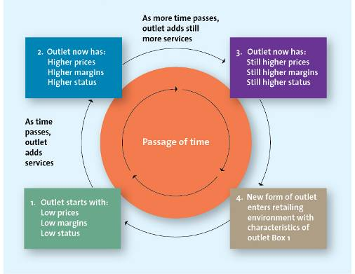
  - increases shopping efficiency

Chapter 15
The Stages of Buyer Readiness
- The buyer readiness stages help to determine communication objectives
- At each stage, consumers need information to make judgments to progress to the next stage
- Awareness Knowledge Liking Preference Commitment Buy
- Different IMC tools move consumers to different stages
  - Advertising can create awareness and knowledge of the product, while a direct mail offer may push consumers to the buying stage
  - Sales promotions can lead to liking, publicity can create a preference
  - Personal selling can also cause consumers to buy right away
  - A mix of tools is needed by firms to push consumers from awareness to buying
Integrated Marketing Communication Tools
IMC: promotion dimension of the four P’s; encompasses a variety of communication disciplines to create a clear and consistent communicative impact
Advertising
- Paid form of communication from an identifiable source, delivered through a communication channel and designed to persuade the receiver to take action
- Print (newspapers and magazines)
- Television and radio commercials
- Outdoor advertising (billboards, signs, posters)
Personal Selling
- Two-way flow of communication between a buyer and a seller that is designed to influence the buyer’s purchase decision
- Sales calls
- Telemarketing
Sales Promotions
- Special incentives or excitement-building programs that encourage the purchase of a product
- Coupons, deals, contests, samples, premiums…
Direct Response Marketing
- Sales and promotional techniques that deliver communications to individual prospective consumers
- Direct mail, catalogues, kiosks, email
Public Relations
- Organizational function that manages the firm’s communications to achieve a variety of objectives
- Media relations, news releases, annual reports, press kits
Electronic Media
- Tools including email, website content, blogs, online games, text messaging, and social media

Steps in Planning and IMC Campaign
- Identify Target Audience
- Set Objectives – includes the buyer readiness stages
- Determine the Budget
  - Objective-and-task method: determines the cost required to undertake specific tasks to accomplish communication objectives
  - Rule of thumb method: bases the IMC budget on either the firm’s share of the market in relation to competition, a fixed percentage of sales, or what is left after other operating costs have been budgeted
- Convey the Message
- Evaluate and Select Media
- Create Communication
- Assess Impact

Chapter 16
The AIDA Model
- A common model of the series of mental stages through which consumers move as a result of marketing communications
  - Attention leads to Interests which lead to Desire which leads to Action
  - At each step consumers decide whether or not to take the next step
- Attention
  - The sender of communication must grab the attention of the consumer or it is wasted
  - Use many channels of advertising like TV, print, radio, and Internet
    - Increases likelihood of message being received
- Interest
  - Once a consumer is aware, communication must work to interest, persuade to buy
  - Message should include attributes that are of importance to the target market
  - Must pique interest so they can act on it
- Desire
  - Moving from “I like it” to “I want it”
- Action
  - Ultimate goal is to drive the consumer to action
  - Message must catch attention and pique enough interest to consider the product as a means to satisfy needs, in order for consumers to act
Types of Sales Promotions
Promotion | Objective | Pros | Cons
Coupons | Stimulate demand | - encourage retailer support  - allows for direct tracing of sales | - has low redemption rates  - has high cost
Deals (BOGO) | Encourage trial | - reduces consumer risk  - retaliates against comp. action | - may reduce perception of value
Premiums (free perfume offers) | Build good will | - increases perception of value | - consumers by for the premium  - has to be managed carefully
Contests (Pillsbury bakeoff) | Increase consumer involvement | - generates excitement | - requires creativity  - must be monitored
Sweepstakes (prize draw) | Encourage higher consumption | - minimizes brand switching among existing customers | - sales often decline after
Samples (Costco) | Encourage trial | - offers direct involvement | - has high cost to the firm
Loyalty Programs (CTire money) | Encourage repurchase | - creates loyalty | - has high cost to the firm

Personal Selling Process
- Salespeople selling products or services to customers whether they are consumers or businesses
Stages of Personal Selling | Decisions | Activities
Generate and Qualify Leads | - Generate list of potential customers and assess potential  - Worthwhile to pursue leads?  - Does the product fit the needs and are they able to buy?  - May not need this step if customer base is already established | - Cold calls  - Telemarketing  - Trade shows
Preapproach | - Decide what to research and how to plan  - Prepare before initial meeting with customer  - Back up decision to meet with leads | - Conduct additional research  - Develop plans for meeting
Sales Presentation and Overcoming Objections | - Establish where customer is in buying process  - Cater presentation to stage in buying process  - Determine nature of objection by listening  - Ask questions and clarify | - Show that offering fulfills a need  - Show the value and advantages of offering  - Address objections from buyer  - Offer deals or incentives
Closing the Sale | - Listen carefully and read body language to ensure interest level  - Reinforce that this fills need and they are making the right decision | - Achieve commitment to buy
Follow-Up | - Solidify customer relationship through great service quality  - Determine if customer is satisfied | - Handle complaints  - Follow-up call, email, letter immediately to show caring
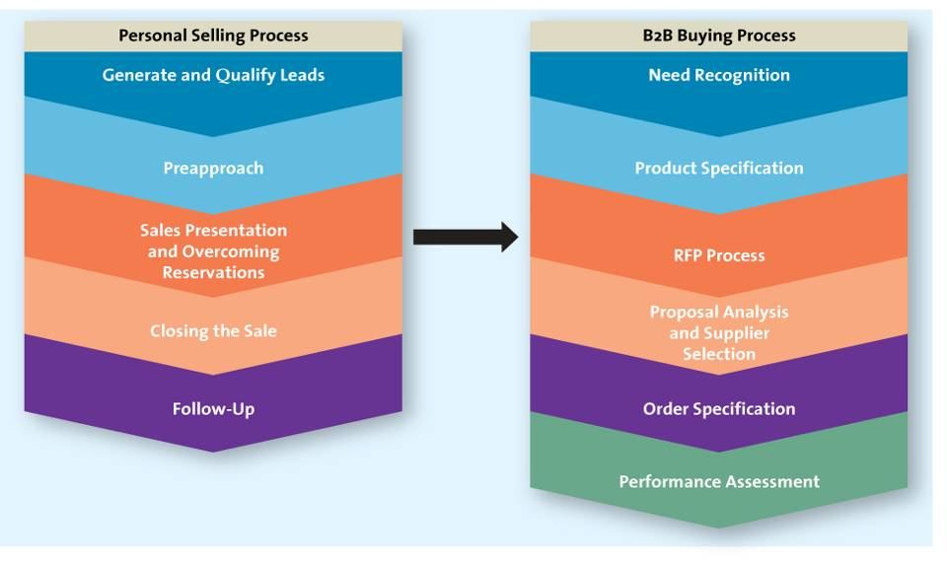

Objections

