ANP1106
LECTURE FOUR – ANATOMY OF THE SKELETAL SYSTEM

The Skeleton
- 206 bones making up 20% of body weight.
- Axial skeleton
  - Bones of skull, vertebral column, rib cage
- Appendicular skeleton
  - Bones of upper and lower limbs
  - Pectoral and pelvic girdles – attached limbs to axial skeleton
Axial Skeleton
- Total 80 bones
- Skull
  - Two sets of bones
    - Cranial and facial (22 bones)
  - Most skull bones are flat bones (except mandible) united by sutures
  - Facial bones form anterior part of skull and cranial bones form the rest
  - Consists of
    - Eye orbits
    - Paranasal sinus
    - Houses organs of hearing
    - 85 openings for nerves, BV, and spinal cord
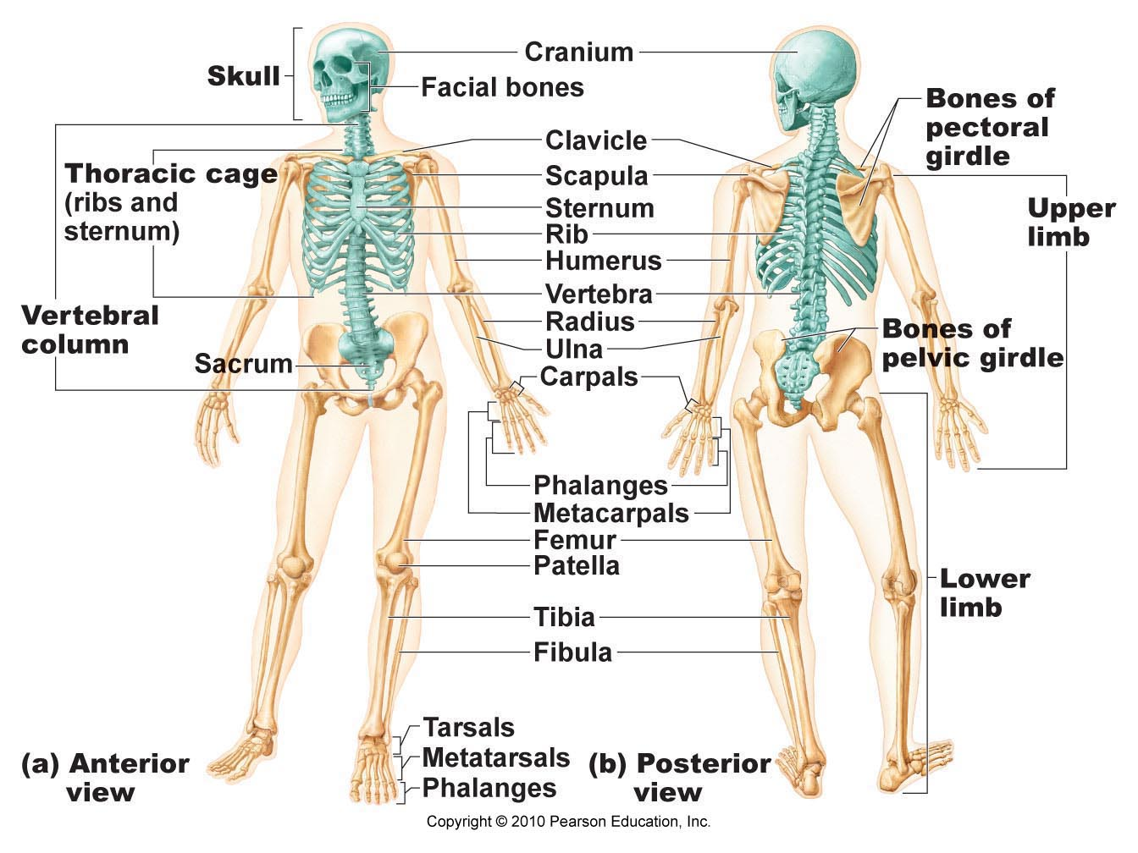
Cranium
- Divided into vault and base
  - Vault
    - Forms superior, lateral and posterior aspects and the forehead
  - Base
    - Inferior aspect of skull
  - Function
    - Surround and protects brain, organs of hearing and balance
  - Structure
    - Internally consist of
      - Three bony ridges divide the cranial base into three distinct areas
        - Anterior fossa
        - Middle fossa
        - Posterior fossa
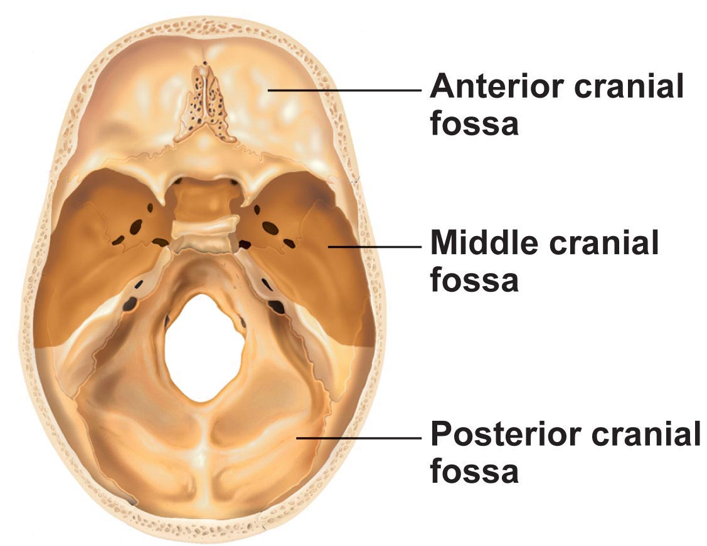
- Total of eight cranial bones
  - Paired bones
    - Parietal and temporal bones
  - Unpaired bones
    - Frontal, occipital, sphenoid and eithmoid bones
  - The curvature allows them to be self-bracing meaning that though they are thin they are quite strong
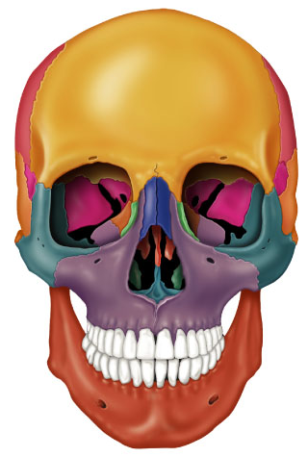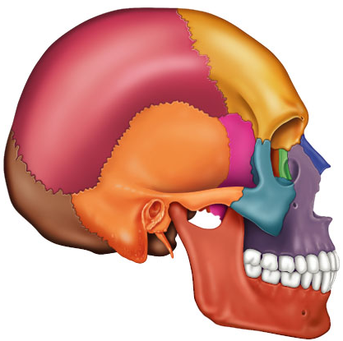

- Frontal bone (YELLOW)
  - Dome shaped bone forming the roof of the orbits and anterior cranial fossa articulates with paired parietal bones posteriorly
  - Note location of
    - Supraorbital margin
    - Supraorbital foramen
    - Glabella area lateral to glabella which has left and right frontal sinus within bone
- Parietal Bones (RED)
  - Paired forms superior and lateral aspects of skull
  - Forms bulk of cranial vault
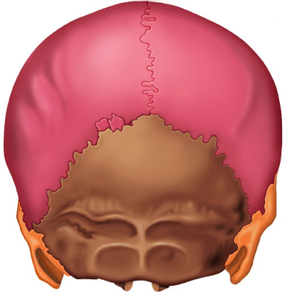
- Occipital bone (BROWN)
  - Single bone at base of skull which aids form post aspect of skull
  - Forms walls of post cranial fossa
  - Attaches anteriorly to the two parietals and two temporals while also attaches to sphenoid bone
  - Large hole at base known as foramen magnum for passage of spinal cord
  - Occipital condyles
    - On each side of foramen magnum which is site of articulation with first cervical vertebra
  - External occipital protuberance which is the projection at back of the skull and is more prominent in males
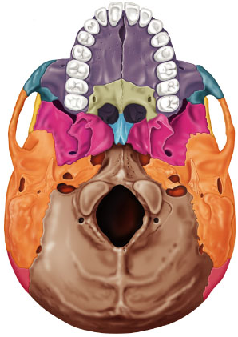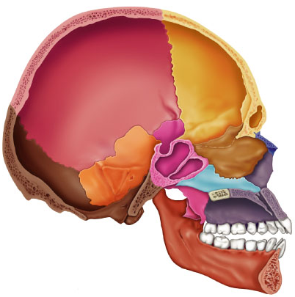
- Temporal bones (ORANGE)
  - Paired forming the inferior and lateral aspects of skull and part of cranial floor
  - Located just below the parietal bones with three distinct regions
    - Squamous region
      - Flattened zygomatic process to cheekbone (zygomatic bone)
      - Mandibular fossa receives condyle of mandible
    - Tympanic region
      - Surrounds external acoustic meatus
    - Petrous region
      - On internal aspect of temporal bone
      - Contributes to cranial base and houses middle and inner ear cavities
      - Mastoid process
        - Attachment site for some neck muscles
      - Styloid process
        - Attachment area for muscles of tongue
        - Important foramina associated
          - Jugular foramen
          - Carotid canal
          - Internal acoustic meatus
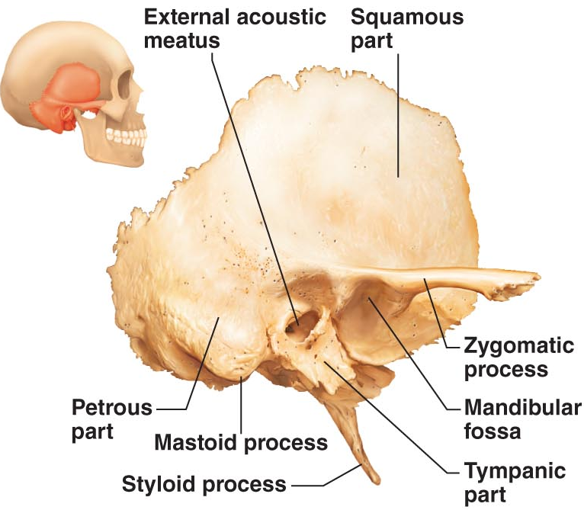
- Sphenoid bone (PINK)
  - Complex bone which articulates with all other cranial bones
  - Forms base od middle cranial fossa
  - Contributes to base of anterior cranial fossa
  - Central body contains sphenoid sinuses
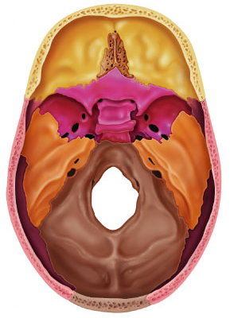
  - Three projections
    - Greater and lesser wings
      - Orbits
      - MCF and ACF
    - Pterygoid processes
      - Muscles FOR
    - Optic foramina (canals)
      - Optic nerve
    - Superior orbital fissure
      - Between greater and lesser wings (cranial nerve for eye movement)
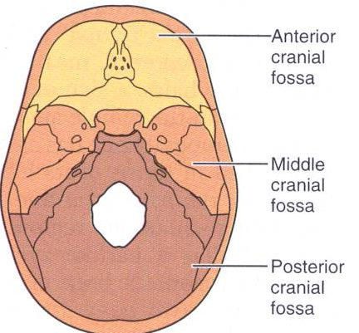
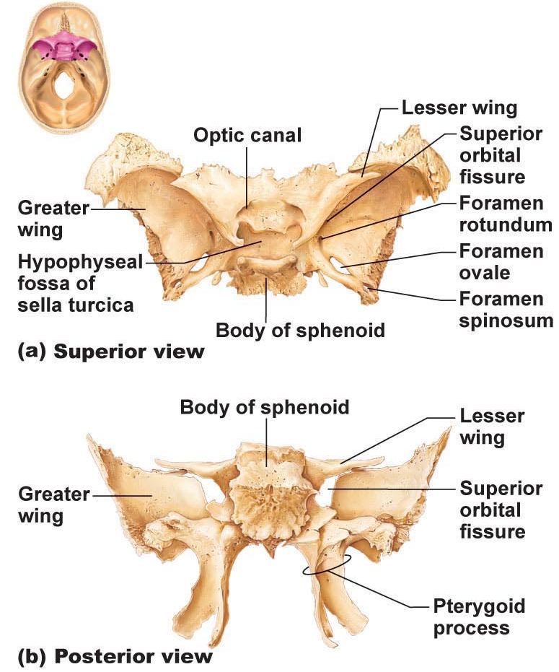
- Ethmoid bone
  - Approximates a cube lies deep between orbits and nasal cavities
  - Cribriform plate
    - Forms roof of nasal cavity and floor of anterior cranial fossa
    - Tiny holes (olfactory foramina) transmit olfactory nerves
  - Perpendicular plate
    - Projects inferiorly to contribute to nasal septum
  - Crista galli
    - Projects superiorly to attach to dura mater of brain
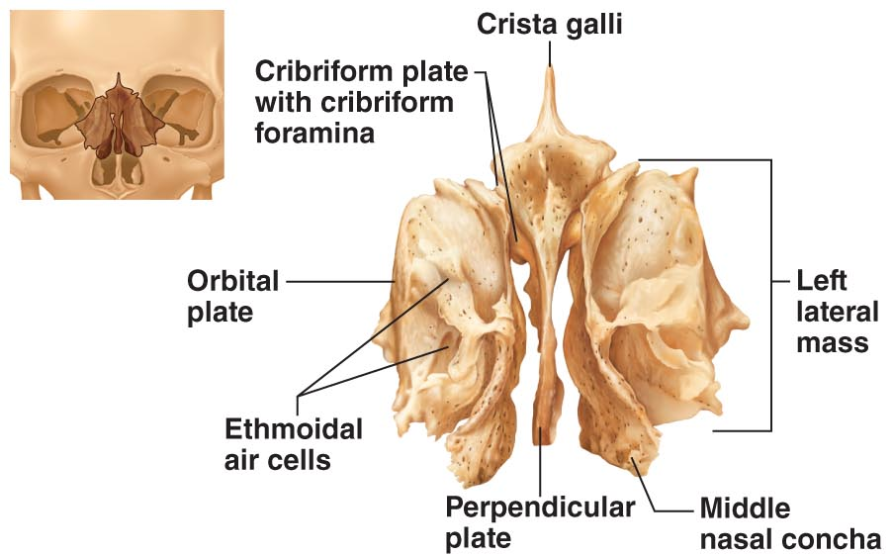
  - Lateral masses contain ethmoid sinuses
  - Medially are superior and middle nasal conchae
  - Laterally are orbital plates which contribute to medial walls of the orbits.

Facial bones
- Structure
  - Contains cavities for sensory organs of sight, smell and taste
- Function
  - Forms framework of face
  - Provides opening fro passage of food and air
  - Anchors the facial muscles used in demonstrating emotions
- 14 facial bones
  - Unpaired are the mandible and vomer
  - Paired bones are the maxillae, zygomatic, nasal, lacrimal, palatine and inferior conchae
- Mandible
  - Lower jaw bone – strongest and largest bone of the face
  - Body is horizontal part and contains chin
  - Left and right rami join body at mandibular angle
    - Mandibular notch
    - Coronoid process (insertion of temporalis muscle) – red arrow
    - Mandibular condyle
      - Green arrow
    - Alveolar margin (contains tooth sockets)
    - Mandibular foramina
      - Nerves to teeth in lower jaw
    - Mental foramina
      - Blood vessels and nerve to chin and lower lip
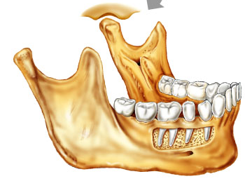
- Maxillary bones
  - Fused medially
  - Alveolar margins hold teeth of upper jaw
  - Palatine processes project posteriorly forming anterior 2/3 of hard palate
  - Joins with frontal bone and will join laterally with cheekbones
    - Meets the orbital plates
  - Incisive fossa
    - Passage of blood vessels and nerves
  - Frontal process
    - Upward on either side to join with frontal cavities
  - Zygomatic processes
  - Main portion on each side has maxillary sinuses that get affected
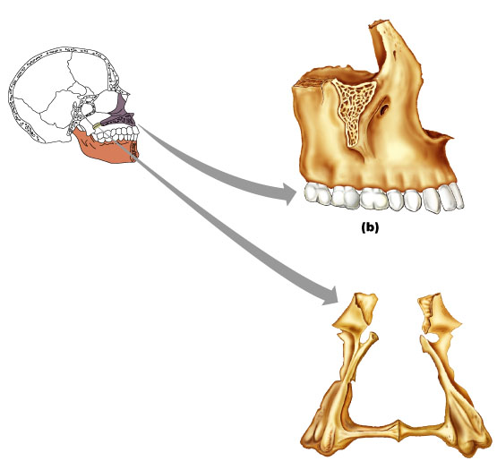
- Zygomatic bones
  - Articulates with zygomatic processes of maxilla, frontal and temporal bones
  - Contribute to inferolateral margins of orbit
  - Three zygomatic processes which extend from each attachment point to a central point and will knit together
- Nasal bones
  - Two small, rectangular bones that fuse medially to form bridge of nose
  - Articulates with frontal bone superiorly and maxillary bones laterally
- Lacrimal bones
  - Two fingernail-shaped bones in anterior, medial portion of orbit
    - Frontal bone
    - Ethmoid bone
    - Maxillae
  - Each has a depression (lacrimal fossa) for lacrimal sacs
  - Medially are the lacrimal sacs which lie in shallow depression which collect the tears and drains them
Major Cranial Sutures
- Bones of the adult skull are firmly united by sutures
- Four main structures that connect cranial bones
  - Coronal sutures
    - Frontal ones and two parietal bones
  - Squamous suture
    - Parietal bone and temporal bones
  - Lambdoid suture
    - Occipital bone and two parietal bones
  - Sagittal suture
    - Connects two parietal bones
- Sutural bones
  - Tiny irregular bones
  - Can occur within cranial suture additional ossification centres that appeared rapidly during fetal development
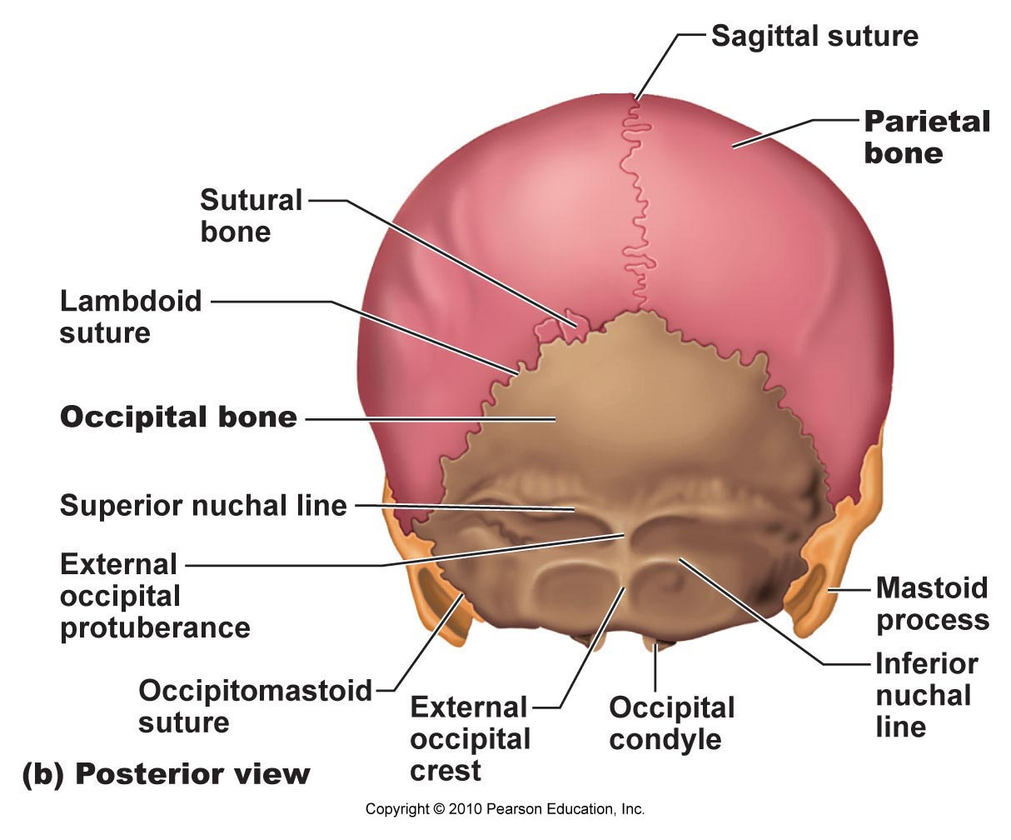
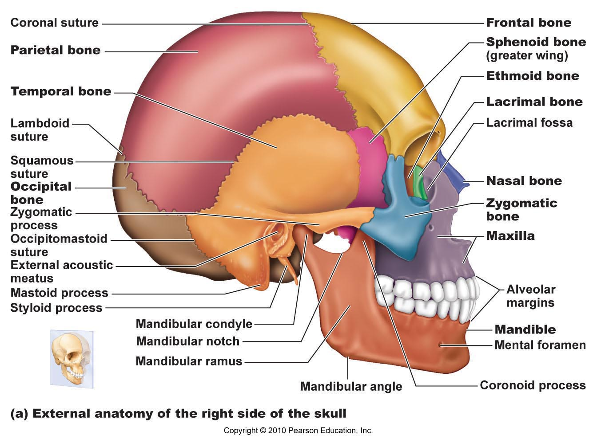
Orbits
- Composed of the
  - Zygomatic
  - Frontal
  - Maxilla
  - Ethmoid
  - Lacrimal
  - Sphenoid
  - Palatine (orbital processes)
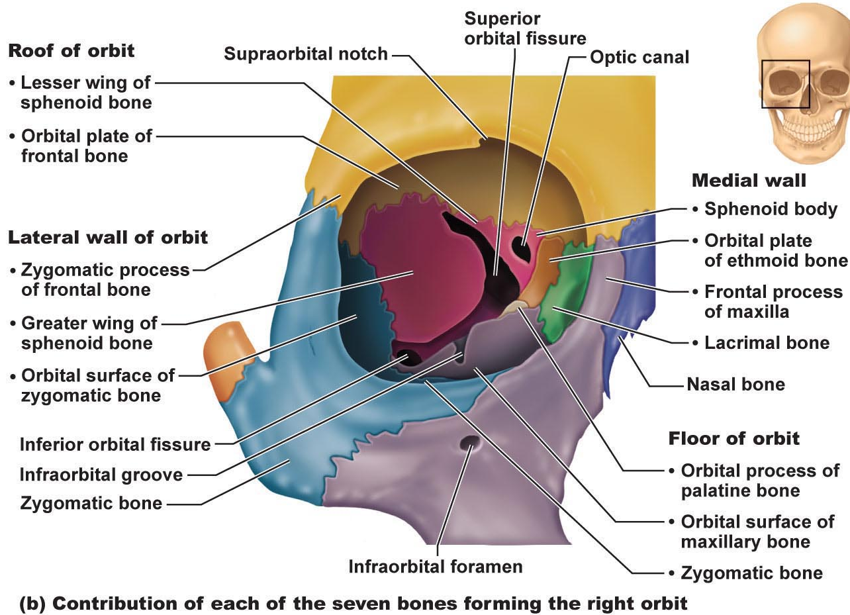
- Palatine bones
  - 2-L shaped bones
  - horizontal plates form part of the hard palate
  - Vertical plates – nasal cavity & orbit
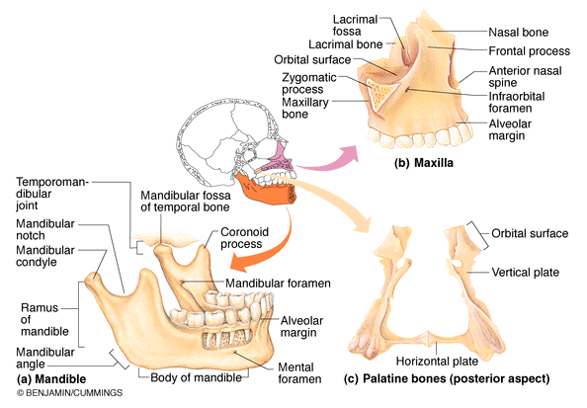
- Vomer
  - Single thin bones forms nasal septum
- Inferior nasal conchae
  - Superior and middle nasal conchae from ethmoid bone
  - Thin, curved bones – projects medially
  - Largest of three paired conchae
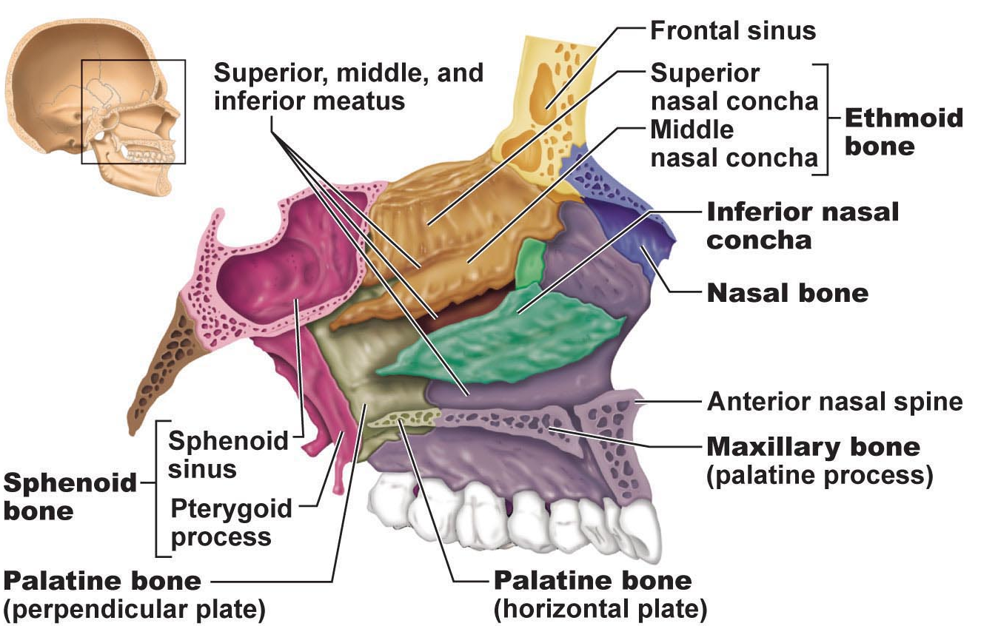
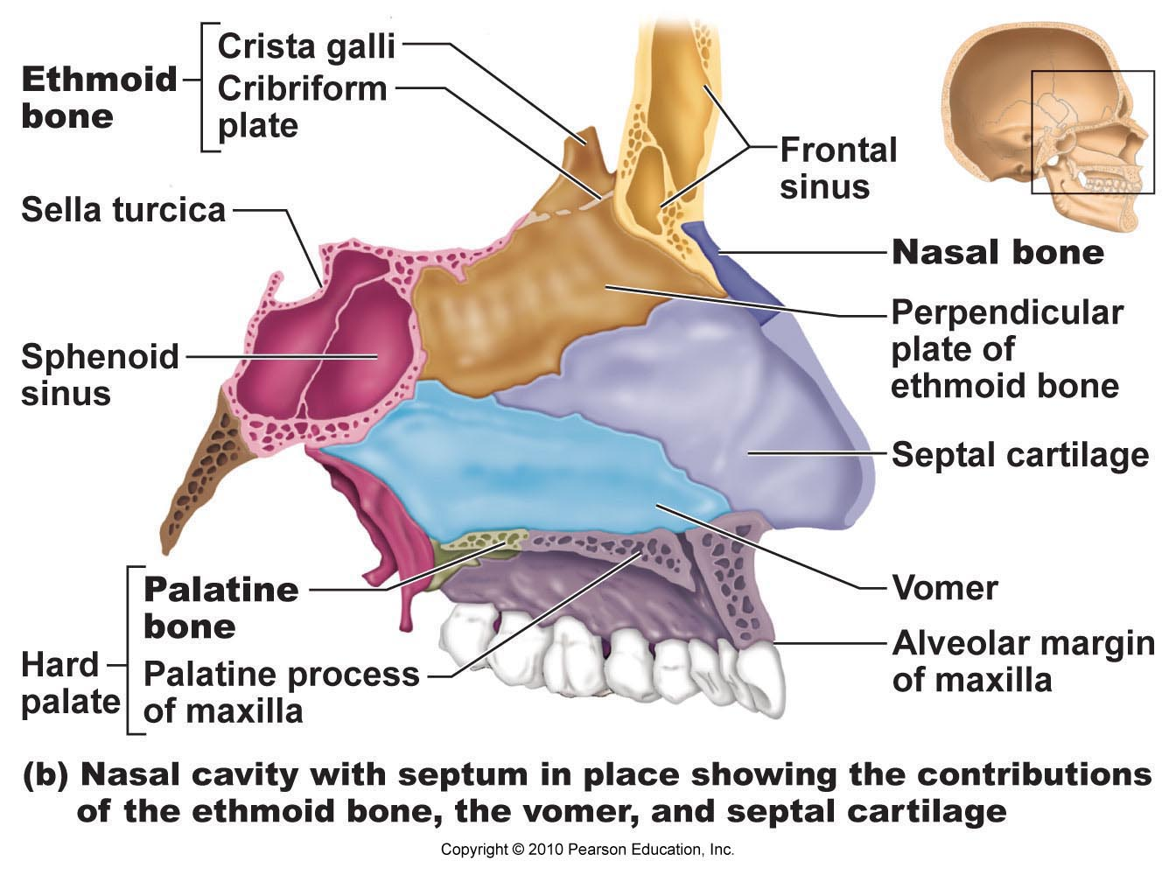
Paranasal sinuses
- Frontal
- Maxillary
- Sphenoid
- Ethmoid
- Structure
  - Mucosa-lined, air filled
- Function
  - Lightens skull and enhances resonance of voice
  - Connect to nasal cavity so also helps to warm and humidify incoming air
Hyoid
- Only bone that does not articulate with any other bone
- Supports tongue and gives attachment to muscles for swallowing and speech
- Horseshoe-shaped with a body with two pairs of horns

