Differences between the polytene chromosomes of the salivary glands from the fruit fly larvae of Drosophila virilis exposed to room temperature and heat shock treatment.

By XXXXXXX
(XXXXX)
XXXXXXX

Bio2133 Section C4

Corrector:
Emily Cooper
Suqi Liu
Lubna Salman

February 25th, 2015

Department of Biology

University of Ottawa

Introduction:
The purpose of this lab is to isolate and observe the differences between the polytene chromosomes of the salivary glands from the fruit fly larvae of Drosophila virilis exposed to room temperature and heat shock treatment.
In order to truly grasp the purpose of this lab, we started by isolating the salivary glands from the fruit fly larvae of Drosophila virilis. We then proceeded in increasing the expression of certain genes and inducing puffing of polytene chromosomes by using heat shock treatment. Next, we prepared and observed stained wet mounts of the polytene chromosomes from salivary gland cells with and without heat shock treatments in order to understand and compare their structures. Lastly, we previewed, captured and saved our white-balanced digital, microscopic images.

Results:

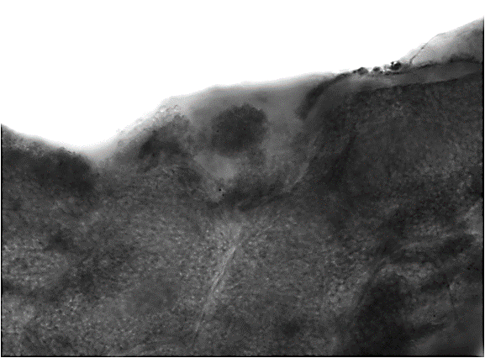
B
I
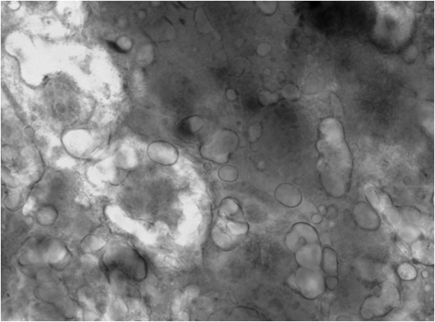
B
I

Caption:
Figure 1. Polytene Chromosome from the salivary glands from the fruit fly larvae of Drosophila virilis with (A) and without heat shock treatment (B). I is the symbol that represents the location where DNA is less densely packed, interbands (light regions) in the chromosome and B is the symbol that represents where DNA is more densely packed, bands (dark regions) in the chromosome. Scale bar = 24 μm.

Verbalization:
The observed differences between the two structures of polytene chromosomes is that the heat shock treated chromosomes (Figure 1B) had an increase in puffing and hence darker regions that were easier to identify than in the polytene chromosomes at room temperature (Figure 1A).

Discussion:
- Give three biological processes or phenomena’s that were discovered through the study of polytene chromosomes?
- By using the band patterns of polytene chromosomes, it became possible to study the activation cascade in activation of the steroid hormone ecdysone (Zhimulev et al., 2004)
- By using polytene chromosomes, it became possible to analyse the general organization of replication and transcription at the cytological level (Zhimulev et al., 2004)
- The phenomena of cellular stress response due to heat shock was discovered using polytene chromosomes as well as chromatin boundaries (insulators) that flanked the heat shock puffs (Zhimulev et al., 2004)
- Give three major differences between cells with polytene chromosomes and cells with normal chromosomes (that divide mitotically)?
- Cells with polytene chromosomes are much larger than normal cells
- Cells with polytene chromosomes will allow for a much faster growth of an organism because each cell has many copies of each gene and can transcribe at a much higher rate (Hartwell et al., 2011)
- Normal chromosomes are made from single DNA replication, but the potylene chromosomes are developed with repeated replications without cell division (endomitosis) (Hartwell et al., 2011)

- Why do you think that enzymes in salivary glands are produced more efficiently from polytene chromosomes rather than through normal chromosomes (i.e. in normal cells)?
Due to the multiple copies of genes over the normal chromosome, polytene chromosomes have high levels of gene expression. This high level of gene expression causes the proteins and enzymes to be produced much more efficiently (Hartwell et al., 2011).
- Explain briefly why an increase in temperature at 37 ºC induces puffing in polytene chromosomes?
In polytene chromosomes, puffs are diffused uncoiled regions that contain genes that are very actively involved in DNA transcription that produces RNA. This puffing is caused by the aggregation of protein which lead to a higher level of gene expression in a certain area. The increased temperature produces a heat shock response which encodes heat shock proteins which act as a repair mechanism for the cell and as a secondary effect of this increased DNA transcription it creates puffing (Guisbert et al., 2008).
- Give two other environmental factors that can also induce puffing?
Changes in osmolality and pH fluctuations are other environmental factors that can also induce stress in a polytene chromosome and therefore induce puffing through similar processes as heat shock (Cohen et al., 2006).

References:
Cohen E., Bieschke J., Perciavalle R.M., Kelly J.W., Dillin A. 2006. Opposing activities protect against age-onset proteotoxicity. Science. 313: 1604–1610.

Guisbert E., Yura T., Rhodius V.A., Gross C.A. 2008. Convergence of molecular, modeling and systems approaches for an understanding of the Escherichia coli heat shock response. Micro. Mol. Biol. Rev. 72: 545-554

Hartwell, L, Leroy H, Michael L.G., Ann E.R., Lee M.S. (2011).Genetics: From Genes to Genomes; Fourth Edition. McGraw-Hill, New York

Perin, S., Drouin, G., Heinermann, P.H., Montpetit, C. Bio2133 Genetics Lab Manual. pp. 23-37[online] ed.1. [Ottawa, Canada] University of Ottawa, February 2015 [cited February 2nd 2015] Available on World Wide Web: <https://uottawa.blackboard.com/bbcswebdav/pid-687603-dt-content-rid-4100732_1/courses/20151_PS31030_BIO2133_A/Bio2133_Lab%201_Polytene%20Chromosome_2015.pdf>

Zhimulev I.F., Belyaeva E.S., Semeshin V.F., Koryakov D.E., Demakov S.A., Demakova O.V., Pokholkova G.V., Andreyeva E.N. 2004. Polytene chromosomes: 70 years of genetic research. International review of cytology. 241:203-275

