CMN 1160 – Module 4
Canadian Media Ownership
February 1st – February 8th

4.1 – Who Owns the Media in Canada?
- Media Conglomerates: large companies that own many smaller entities, subsidiaries or outlets within the same or different sectors of the media, such as radio, television, Internet, print, wireless, etc.
- This usually comes about as a result of mergers and acquisitions
- There are clear trends of convergence and consolidation in the media industry

4.1.1 – Canada’s Private Media Conglomerates
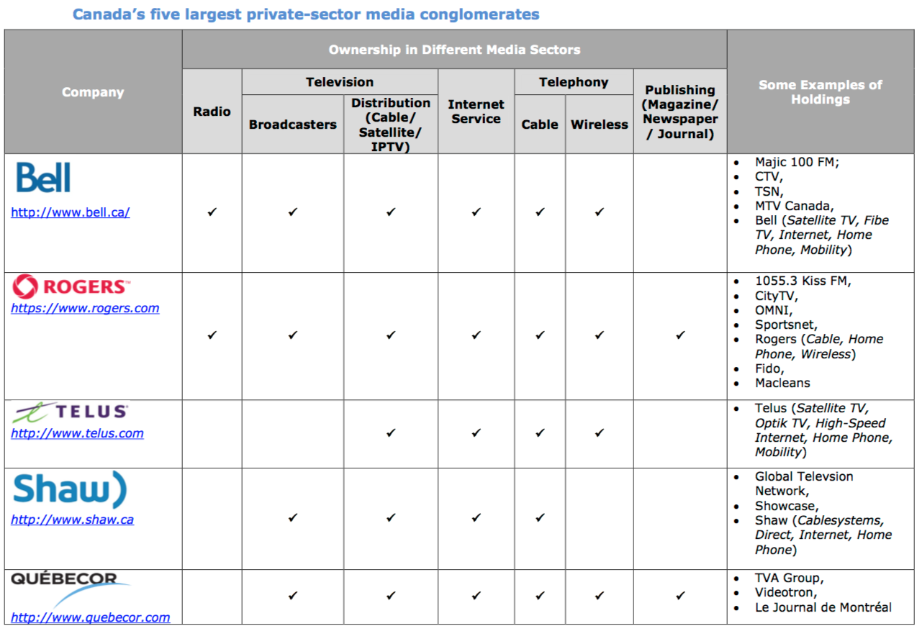

- Canada’s largest media conglomerates telecommunications and broadcasting services. This is known as cross-media ownership

4.1.2 – Canada’s Public Media Conglomerate
- The CBC/Radio-Canada is Canada’s largest public conglomerate with its comprehensive rage of radio, television, internet, and satellite-based services
- The CBC currently operates:
- 88 radio stations
- 27 television stations
- 10 digital platforms in the country, providing its services in both official languages (as well as eight aboriginal languages in the North and Mandarin, Spanish and Arabic on radio Canada International)
- However, the CBC is unique in that it is the only conglomerate mandated by law to have a presence from coast to coast, as Canada’s national public broadcaster

4.2 – Concentration of Media Ownership
- Without the exception of magazines, ownership of most sectors of the media industry (telecom, wireless internet, cable, broadcasting, newspapers, etc.) is highly concentrated in the hands of the five private media conglomerates (Bell, Rogers, Telus, Shaw and Quebecor
- These companies are large, horizontally, and vertically integrated entities often owning subsidiaries across different sectors of the media industry
- In 2014, the annual revenues of these top five conglomerates accounted for approximately 84% of the total revenues of the entire Canadian media sector. This amounts to $56.88 billion
- The next five largest companies are Bragg, Cogeco Cable Inc., MTS Allstream, Saskatchewan Telecommunications and Telesat Canada which accounted for 8%
- Together, all other companies also accounted for 8%

4.3 – Forms of Concentrated Ownership
- Media conglomerates engage in 3 main forms of concentrated ownership
- Horizontal Integration
- When one parent company owns a similar subsidiaries operating at the same level and sector of the media industry
- This increases the company’s market share in that sector
- Ex. Rogers – while providing its own wireless telephone service, it has also acquired several other wireless telephone services providers over the years
- In 2004, Rogers acquired Fido for an estimated $1.4 billion and also bought Sprint Canada in 2005
- Most Canadian media conglomerates have engaged in horizontal integration at some point, either through mergers or acquisitions
- Vertical Integration
- When one parent company owns subsidiaries operating within the same sector of the media industry, but at different levels
- This can also increase the company’s market share in that sector, as it can use its ownership over services (ex. By providing exclusive content)
- Ex. Bell Media – not only does it own television broadcasters such as CTV and TSN which produce content but it also owns Bell satellite and Bell Fibe TV services, which distribute that television content to consumers
- However, Bell is not the only Canadian media conglomerate to be vertically integrated

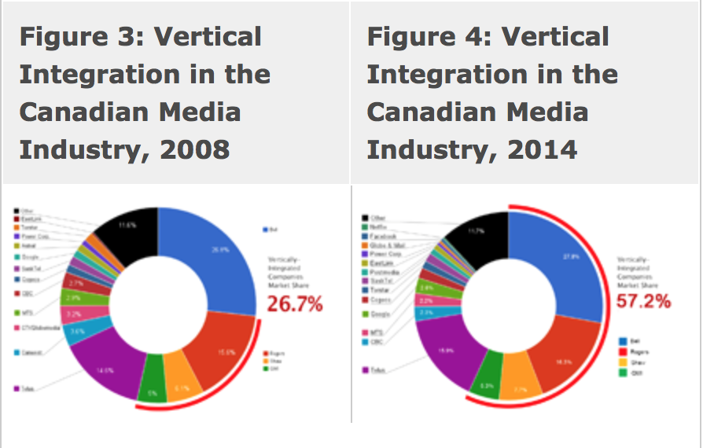

- Cross-Media Ownership
- When one parent company owns subsidiaries in multiple sectors of the media industry
- This increases the company’s market share in the media industry as a whole in that conglomerates are thus able to:
  - offer consumers bundles (ex. Discounts for subscribing to a range of services)
  - provide advertisers with package deals
  - achieve efficiencies by sharing resources and content between media
  - engage in cross-promotion
- Ex. Rogers – owning various radio stations, television broadcasters and magazines. In fact, all 5 major conglomerates own assets in at least a few different media sectors
- What is the overall impact of these forms of concentrated ownership on the media industry?
- A reduction in competition and diversity

4.4 – CRTC Regulations: Concentration and Competition
- Media ownership of broadcasting and telecommunications in Canada is governed by the CRTC
- CRTC does not regulate ownership of newspapers or Internet media, but ownership in those sectors may be taken into consideration in decisions pertaining to a licensee’s broadcasting or telecom operations
- Industry Canada’s Competition Bureau is an independent law enforcement agency which ensures that Canadian businesses and consumers have a competitive marketplace
- The Bureau has the power to reverse agreements concerning mergers or acquisitions if it believes that they are contrary to the principles of healthy competition
- In 2008, the CRTC brought in new regulations to restrict cross-media ownership in an effort to limit concentration, promote competition and ensure a diversity of editorial voices in the same market
- Among the most important changes are:
- Sector Restrictions:
- A company can now only own a maximum of two types of media, out of three (radio, television and newspapers) in a given market (ex. One city)
- Ex. A company may own television and radio assets in one city or radio and newspaper, or television and newspaper; but it may not own all three simultaneously
- Market Share Cap
- No company can own broadcasting assets which hold more than 45% of the country’s total television viewership
- Television Distribution Restrictions
- The CRTC will not approve transactions between cable and satellite companies that would result in one group effectively controlling the delivery of television programming in a market
- New regulations have no effect on past mergers or acquisitions, but rather, were designed to prevent further concentration of the Canadian media industry
- They have played a major role in the approval of recent mergers and acquisitions as well as when companies have had to renew their licenses

Case Study – Quebecor Radio
- Quebecor owns many different media assets, but the sector in which conglomerate is not involved is radio
- Since Quebecor already owns various television services (such as TVA, TVA Sports, Le Canal Argent) and various newspapers (such as Journal de Montreal) in Quebec, they are prevented from owning any radio stations in the Quebec market

