CMN 1160 – Module 2
CRTC
January 18th – 25th

- CRTC: in Canada, the vast majority of media legislation is created by the federal government and administered by an organization called the Canadian Radio-Television and Telecommunications Commission.
- The CRTC are responsible for regulating the practices of companies that work within the industries of broadcasting and telecommunications
- Through public consolations, the CRTC aims to ensure that every Canadian consumer with a television, radio, mobile phone or internet service, receives quality service at an affordable price
- These companies must respect the requirements of this administrative tribunal especially regarding the Canadian content quotas for radio and television
- The CRTC can have significant influence over all of the services and content to which we have access as well as their cost

2.1 – Key Terms
- Telecommunications: generally, encompass communication over long distances by telephone, cable or broadcasting through the transmission of electromagnetic signals.
- The CRTC regulates telecommunications by governing, overseeing and establishing conditions for all companies working in the field, with respect to rights, needs and expectations of Canadian regardless of where they live
- Broadcasting: transmission of programs by means of telecommunication for reception by the public
- Broadcast Distribution Undertaking (BDU): refers to a cable or satellite service provider
- Public Broadcasters: receive most of their funding from taxpayers (ex. CBC)
- Private Broadcasters: receive most of their funding from advertising subscription revenues (ex. Rogers, Shaw, Bell Media)
- Cable: refers to the transmission of television programs to a subscriber network via coaxial cable

2.2 – Public vs. Private Broadcasting
- As per the Broadcasting Act of 1991, radio and television broadcasting industries are divided into public and private. Both are entirely regulated by the CRTC

Features | Public Broadcasting | Private Broadcasting
Ownership | - Owned by the public (established by law – neither commercially-owned nor government-owned) | - Owned by private corporations  - Most times, they are listed on the stock exchange
Funding | - Financed by tax-payers through either a combination of government subsidies, licencing fees and individual subscriptions  - In many cases, can be partially ad-funded without being fully dependent on it | - Financed by commercial revenues through: advertisements investments and subscription revenues (from cable and satellite providers)  - In certain cases, can receive public funding; but are not dependent on it
Accountability | - Accountable to the public  - Subject to broad oversight by the government (CRTC) while remaining independent | - Accountable to advertisers and investors
Purpose | - Non-for-profit – serve the public (inform, educate and entertain)  - Acquire money to invest into programs  - See “the public” as citizens | - For profit – entertain the public and attract as many viewers as possible  - Make programs to generate profits  - See “the public” as consumers
Advantages | - Informative and educational content  - Little to no advertisements  - Non-partisan – free from political interference or pressure from commercial forces  - Can create quality, niche programming aimed at smaller audiences (particularly minorities)  - Can contribute to the national economy by funding, supporting and broadcasting homegrown content | - Entertaining content with broad appeal  - Generally have more funding than public broadcasters which can be used to invest in programming
Disadvantages | - The focus on information and education can result in less entertaining content with lower ratings  - Generally have less funding than private broadcasters, which can affect the resources available to invest into programming | - The ratings-driven focus can result in the production of mediocre, commercialized content  - Many advertisements  - Owned by large media conglomerates who can have their own agendas and partisan interests  - Can threaten the national economy by principally purchasing and broadcasting foreign programs (from the US)
Canadian Examples | - CBC (Canadian Broadcasting Corporation)  - TVO (Television Ontario)  - Tele-Quebec  - Alberta’s CKUA Radio Network  - British Columbia’s Knowledge Network | - CTV; Majic 100 FM (and many others) owned by Bell Media  - Global – owned by Shaw Media Inc.  - City; Kiss FM (and many others) – owned by Rogers Communications Inc.  - Hot 89.9 FM (and many others) – owned by Newcap Radio
- Private broadcasting is the dominant type in Canada and internationally, although many countries have some form of public broadcasting
2.3 – What is the CRTC?
- The CRTC is an administrative tribunal that regulates and supervises broadcasting and telecommunications in the public interest
- Regulatory organization born out of a long series of attempts to preserve and promote Canadian culture and industries in broadcasting and telecommunications
- The public interest continues to guide the CRTC today
- The companies that make up the Canadian media landscape must meet various requirements and conditions designed to ensure that the industry compiles with CRTC regulations

2.4 – The Structure of the CRTC
- CRTC is an independent federal body under the responsibility of the Department of Canadian Heritage, reporting to the Government of Canada
- The CRTC is composed of:
- One chairman or chief executive officer
- Two vice-chairpersons (one for broadcasting and one for telecommunications)
- Up to 10 national and regional commissioners
- One secretary general of corporate services and operations
- One senior general counsel
- One executive director for broadcasting
- One executive director for telecommunications
- One executive director of communications and external relations
- One chief consumer officer
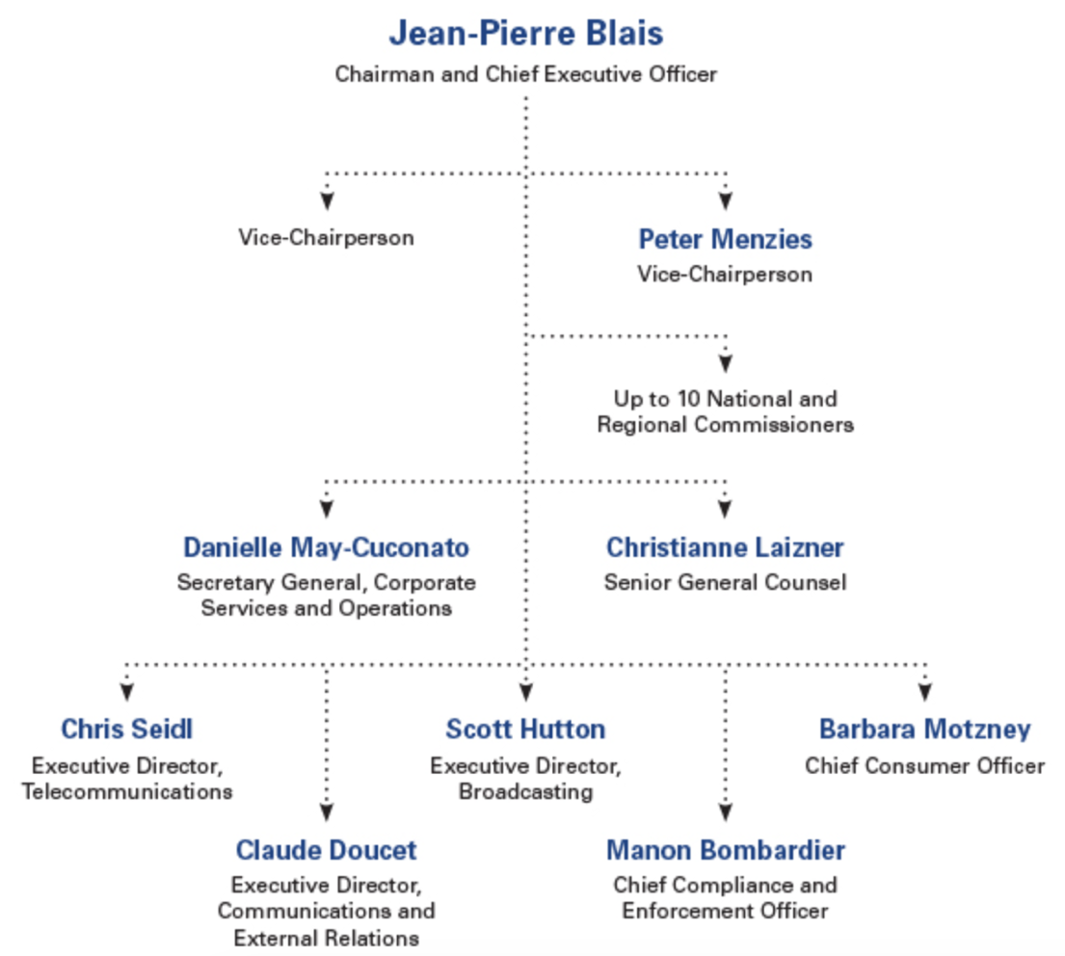
- One chief compliance and enforcement officer
2.5 – The Role of the CRTC
- Mandate: achieving the policy objectives established in Broadcasting Act, Telecommunications Act and Canada’s Anti-Span Legislation (CASL)
- Mission: ensuing that Canadians have access to and are at the centre of a world-class communication system, supported by three pillars:
- Create: promote compelling and diverse content
- Connect: ensure quality and affordable service options
- Protect: provide a safe environment for commercial and personal activities
- Main Activities: the CRTC has a broad mandate including the following main activities and responsibilities
- Licensing: issuing, reviewing, renewing (every 5-7) years, amending and revoking Canadian broadcasting licences regulating the types of content broadcast by those broadcasting distribution undertakings BDU’s)
- Compliance: encouraging and enforcing compliance with various regulations and legislation, such as the Broadcasting Act; Telecommunications Act Canada’s Anti-Span Legislations, etc.
- Providing Approval: making decisions on mergers, acquisitions and changes of ownership in the broadcasting sector; approving tariffs and certain agreements for the telecommunications sector
- Encouraging Competition: ensuring that Canadians have a choice of innovative and affordable services in telecommunications markets
- Providing Information and Taking Complaints: responding to requests for information and concerns about broadcasting and telecommunications issues
- Public Consultations: holding public consultations and open hearings, listening to the views of Canadian and interested parties to uncover the public interest and how best it can be served

2.6 – What the CRTC Does NOT Do
- The CRTC does not regulate Internet content
- Ex. Netflix does not have to abide to Canadian regulation in either broadcasting or telecommunication
- However, the CRTC does regulate Internet Service Providers (ISP’s) to ensure that Canadians have affordable access to quality high-speed Internet

2.7 – Canadian Content (CanCon)
- Promotion of Canadian content, commonly referred to as CanCon
- This element of our Canadian broadcasting policies aims to encourage the development, exposure and availability of Canadian talent in radio, television and film
- The ultimate goal is to ensure that cultural products consumed by Canadians on Canadian media be predominantly Canadian in nature
- The CRTC defines itself as promotionist, not protectionist
- Quotas: mandated quotas of content that qualifies as being “Canadian” according to the CRTC’s standards
- Investment: requiring Canadian media companies to invest a percentage of their revenues in the development of Canadian programming
- Licensing Conditions: when a broadcaster seeks the renewal of its license every 5 to 7 years, the CRTC can impose licensing conditions directly related to CanCon
Ex. When the CBC renewed its licenses in November 2013, the CRTC imposed the following condition: during each broadcast year, the license must spend a minimum of 75% of the broadcast day and a minimum of 80% of prime time on Canadian programming
- The long-term effects of new media on the visibility and prevalence of Canadian content in the Canadian media landscape remains a largely open question
- As stated by Jean-Pierre Blais in the video, CRTC is adapting to the evolving media landscape. They have loosened CanCon quotas for TV broadcasters but maintained the requirement to spend a certain amount of their revenue on Canadian TV production
- This will allow broadcasters to spend more creating fewer, and hopefully better, TV shows if they so choose
- New CRTC focus: promoting quality over quantity

